DDL Statement

-Data definition language
-subset of sql stmt that change the structure of the database schema objects such as db,tb and views.
-Most impala ddl stmt starts with create,drop,atler,grant,revoke.
-After impala exec ddl cmd, info about available tables,col,views,partiton... is automatically synchronized between all impala nodes in a cluster.
-If the timing of metadata updates is significant, for example if you use round-robin scheduling where each query could be issued through a different Impala node, you can enable the SYNC_DDL query option to make the DDL statement wait until all nodes have been notified about the metadata changes.
-Insert statement is officially classified as a DML stmt.
-Because the SYNC_DDL query option makes each DDL operation take longer than normal, you might only enable it before the last DDL operation in a sequence
-For example, if you are running a script that issues multiple of DDL operations to set up an entire new schema, add several new partitions, and so on, you might minimize the performance overhead by enabling the query option only before the last CREATE, DROP,ALTER, orINSERT statement. The script only finishes when all the relevant metadata changes are recognized by all the Impala nodes, so you could connect to any node and issue queries through it

DATA MODEL
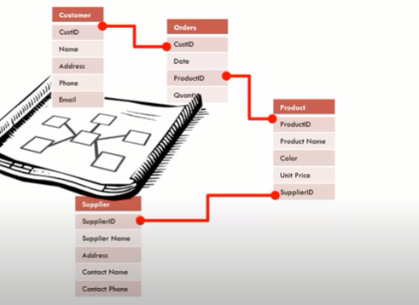
It’s a structure that supports the analytical means of a decision maker. This step requires the business ppl to engage in the process by participating in facilated session with our data architect.

The amount effort it takes for you to invent a package data model, to ensure it fit your business is the same amount of effort it takes to go and design that is specifically for your business.
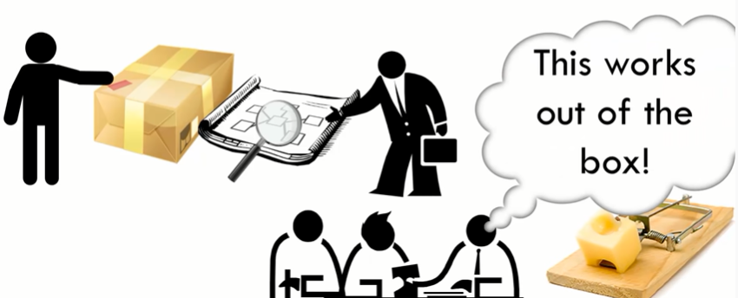
Use packaged data model as a guide. If you gonna use it pls vet it first.

