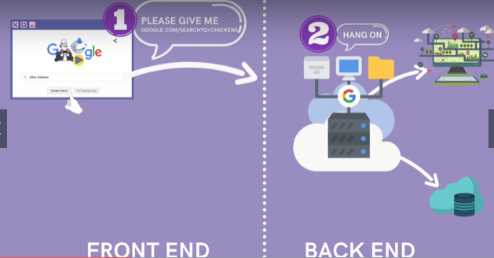

The google servers are gonna see for a query what are the results, rank the results then build the webpage then send back the html+css+js.
Dyanmic site: is every page on website is constructed when it’s requested.



Node.js Node.js

which is js that runs outside of browser, it means we miss some of the browser specific stuffs like events, working with the dom, plus some additional features in the language that we dont have in the browser.
The Node REPL:
is just a js console but for node.
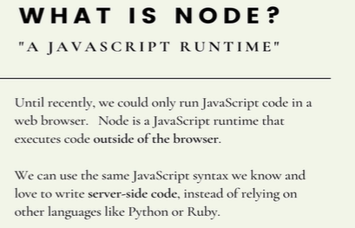

create web servers, interact with file-system, command line tools, videogames.
Node is implementation of js that run outside of browser
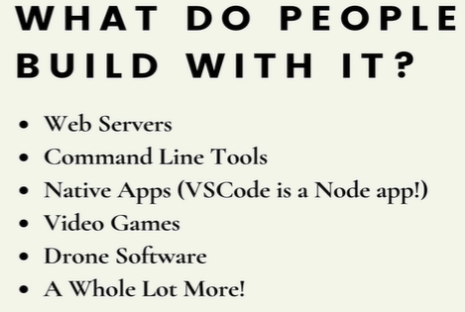

Writing server side logic for a full stack application.
What if I wanna to make my own api, what if I wanna work with db and connect that db to my Web server.
Vs code is written using Node.js
Electron: by single codebase it’s gonna work on browser and native app.
Build cross-platform desktop with js,html,and css.
To start Node.js. Type node in cli. To exit type ctrl+c.
When you in node, thats called REPL.
The js console in our browser is a REPL(read, evaluate, print, loop) .
-I can type some code in, it could read it, evaluate it, print smthg back, loop continues.
-Unlike how we typically runs a script that it executes one time, we include a script and html file, we open it up in the browser it executes it and its done.
-REPL is there for continiously listen and wait for us to input smthg so it can evaluate back.
Command
.help
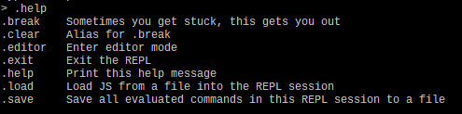



a window is a global object, top level of everything to represent a browser window, hence termed window. It’s where all func lives, a global scope.
-In Node.js, it’s called global not window.
-We do have console.log() even if our console is different.
-In Node.js we have builtin modules that help us to interact with files, folders and os.
- what we used to do, was create some sort of index(html file) and link js file and open the html file.
-Now we can, write js file and just run: node file1.js

In real world, you may want multiple versions of node on one machine, you can use NVM, node version manager.

Process Process
process.version
process.release
process.cwd()
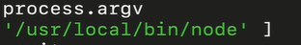

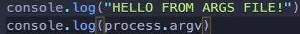

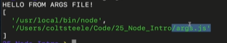
>>>

process.argv
We got same String from the beginning and second value in this array I.e path to the file.
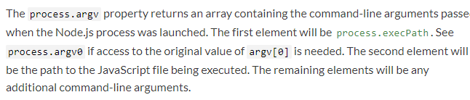
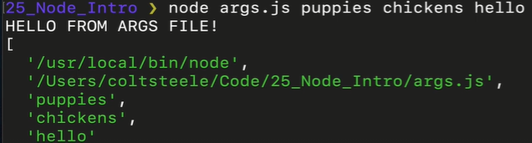
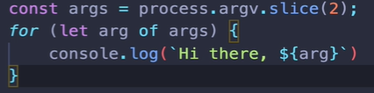

File system file-system

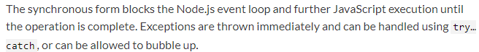
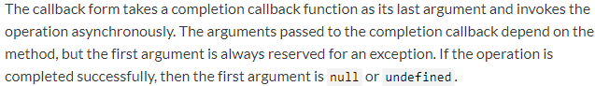
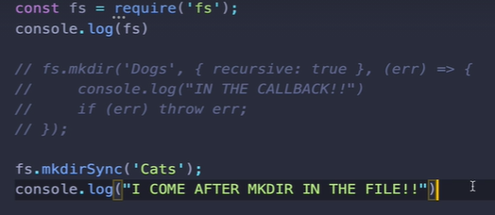

if there is no arg specified, the default value is ‘Project’.

---------------------------
Working with module.exports

sharing js code between files.
Outside of node in the world of browser, client side js.

If we have different js files we include them in the same html file.
Assuming in right order,Then we have all the variables and functions defined.
In Node we can be very particulate what a single files share and what it does not share and we can require code from other files.
Express is just js code written by other people.

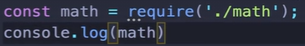
Above, when we request a file rather than a module, we need to put specific with our location.

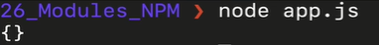

We able to require that file, but when we require what we got is an empty object. The content of file isn’t available everywhere when require that file.

If we have two files in the same index.html (2 scripts), they gonna both load all their stuff, all their variables, all their functions.
The second one have access to whatever was defined on the first one.

In Node.js, I am not get anything from js file unless I explicitly say what I want to export in a file.
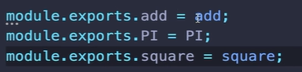
It’s a object.

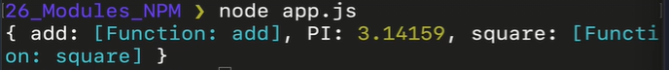

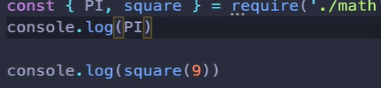
Different ways of using module.exports.

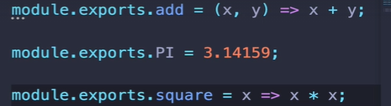

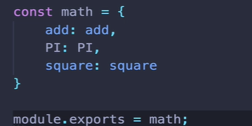

-----------
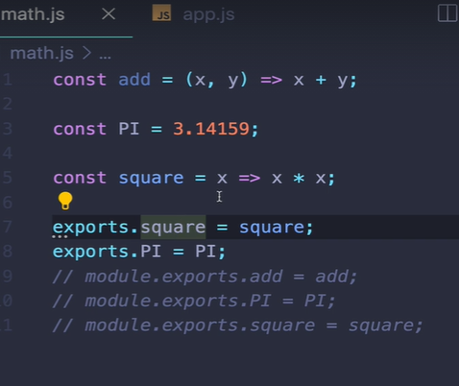
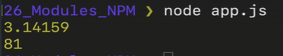

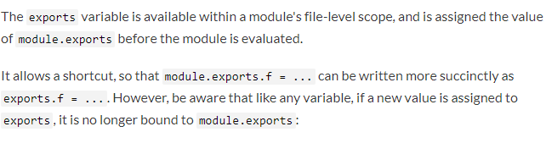
-----
Any files in a dir, index.js represent the main file. It’s sort of the entry point.
So when I require an entire dir, Node is gonna look for a index file, whatever that file exports, the directory gonna export.
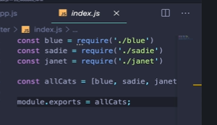

Node package Manager
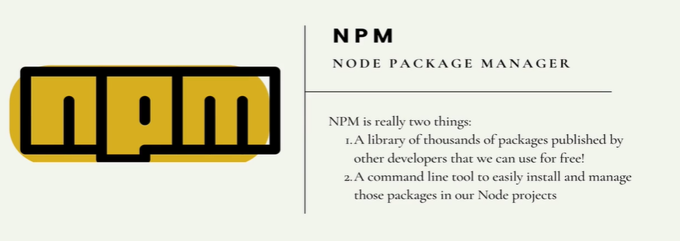
There is a package for react or express or silly things like making rainbow color text.
We have npm with node not in node.
A package is code that somebody else is written, it’s written in a way it’s easy to integerate in our own project. Npm is a standarized repository for those stored packages.
Node come with npm command line tool so we can easily install and manage those packages.

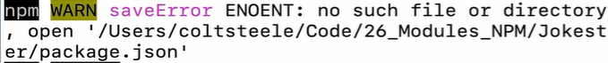


whenever you install smthg, the core code is put into node_modules.
Dont touch both the dir and file.
In the same dir, to require a package we dont give relative/absolute url, it directly checks the package in node_modules. We only need to specify package name.
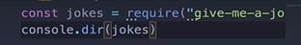

Above, we get 4 methods which are exported by that package.


LOCAL VS GLOBAL Installation of packages
When you do “npm install … “, it install packages for use in this one directory. So what we have done here install packages locally to this one directory.
This is what we want for most of the time.
1) we dont want have access to every single package to every single file.
2) But we may want different version for different projects you working on. There is significant difference in older and newer version of react.so we want to manage which version we using.
3) You can install packages globally.

To install something globally we install the -g flag

It’s trying to add node module directory at the highest level of my machine.

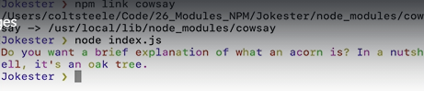

Package.json
If you install a package in node, for e.g “give me a joke” it will have a index.js but it also have package.json
-It contains metadata about this particular project.
-It has desc,license,name,version etc.
-Dependencies
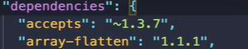
~ around 1.3.7
specific 1.1.1

creating package.json

npm init
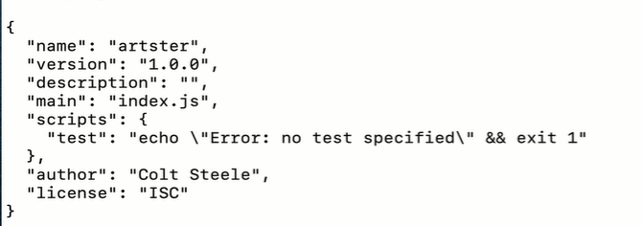
-first create package.json then install the dependencies
-if we have package.json and we have dependencies the dependencies will be automatically added to package.json
- we dont share node_modules



we extracted some1 code, we are in the dir where we have package.json, if we run npm install, it will install all dependencies.
Install multiple lib.
Express
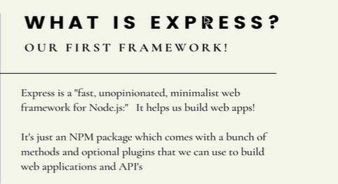

It’s gives us methods, addons, plugins that we can use to build web application to make our own api and whole bunch of other things.
We give a query, the server see what to response with and build respond and send it back.
Express: listening for incoming request, figuring out what they asking for, what resource they searching, what form data they submiting, whats the username and password.
Often will do, check info in db, save smthg in db. Then we build the response and send that back to the client.
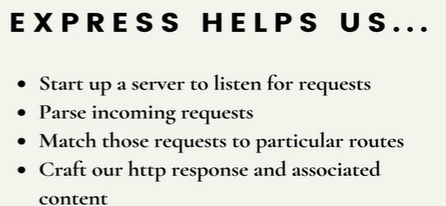
2) cuz http methods are text info they arent json, it helps us turn request into object.
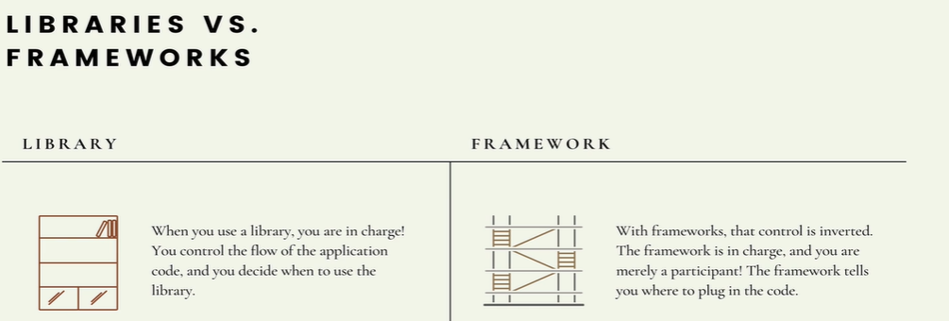
Library and framework are just code that other people had written for us.
We typically download using npm or a script in client side js we include.
e.g bootrap,axios >>>lib

The difference is in the scope that they aspire to, their dreams, what they do for you. There smthg called inversion of control.
A lib is smthg you can integerate to your code at any point. It’’s upto you to decide when to incorporate and how to use it.

With framework, it invert the flow of control, the framework is actually providing the structure or the framwork for an application and you are merely participating in it. You are writing your code according to how the framework works. Frameworks are geared to make full applications.
You trade your flexibility of how you code for speed of development and bunch of features framework generally provide for us.
There are lots of framwork and they range from how controlling they are.
Express is verylightweight. Express
Ruby on rail is very every framworky, where it controls what you name your files, what you put in those files, what folder those files goes in. You have to giveup a lot of control. It helps you make apps very quickly, when you pass that learning curve.

Express is much simpler and easier to learn, but it’s still a framework. It’s not something we choose to use a single method from. We really need to incorporate in our application or think the other way we need to incorporate our code in the flow of the framework.
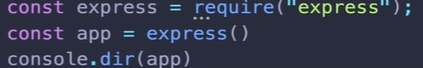

>>>bunch of methods
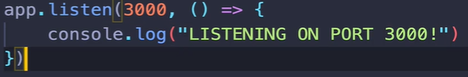
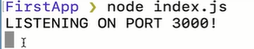

You’ll see the cursor changes, my app is not done. It’s sitting there listening for any incoming request. Next thing we should do is sending request to our new server we setup.
But where do I send the req to, what url should I request.

This says we didnt get a response, but there is a server there listening.


This say there is nothing there at all. There’s no server nothing to request.

Our goal is incoming request and a outgoing response
app.use(callback) is whenever we have a request this callback is gonna run. It doesnt matter what type of request. It accepts all.
You need to restart your server everytime you made changes.
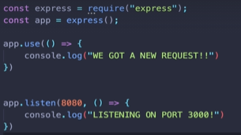
Port no’s are 3000,8080. They are addresses to connection on your machine. So instead of all traffic from email, file-transfer, http-request.
Instead of all go to the same port,addresses. There are different addresses in your machine, that have unique no to identify them and refer to them. If you have a seperate app , you need to put it on different port.
That’s the whole point of ports, that we have different servers on different port. So we can have seperate traffic.
For every incoming request, There is two objects: (1)Incoming request(req) (2)Outgoing response(res)
These are objects made by express and passed in app.use(callback).
A Http request is not a js object, it’s text info. It’s not particular to any programming language. But express takes that data and parsed it into an object and pass into our app.use(callback).


Express creates a js object, by parsing the incoming http request info and then it parses it as first argument to this callback.
The response object (res) has methods on it. res-methods
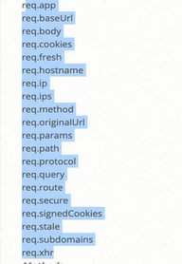
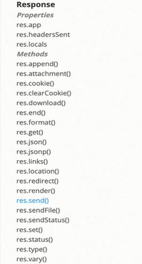

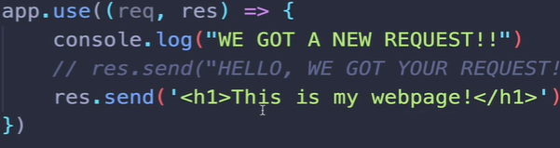

Routing is taking incoming request and a path that is requested and matching that to some code and response.
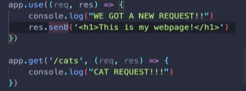
We need to comment the res.send() cuz whenever we send we are done. We can’t have a Http response more than once. Also, app.use() matches every single request so we need to comment app.use().
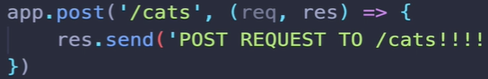

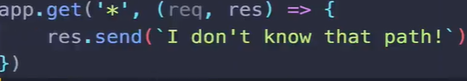
put “get *” at the very end to match all req. At end cuz you can only match once

The way we do that in express, is by using a colon to designate that’s a variable.
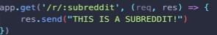
Often we need to use the variable in the path, for e.g to say welcome to “cat subredit”
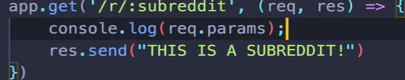
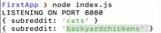

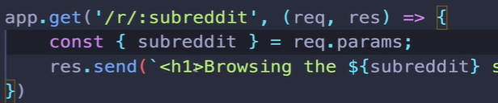

In comment box
comments/id/topic

-----
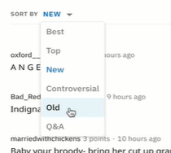


If we define a route we do not add anything to the path here in terms of matching a query string, instead the request object that express constructs for us. This req obejct have a particular property called query, in that property we will find key:value pair based on query string.
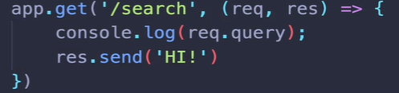

AutoRestart with Nodemon Nodemon
-install it globally.
- run ur server by using nodemon app.js
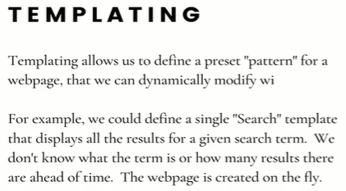





Each of this, has his own route or it’s own path, and we talk about we wont do seperate route for each of this. Soccer and MightHarvest … follow the same pattern. Both pages have different colors and different theming going on



They both follow the same format.
Templating: instead of writing static html code, we can embed info and logic. The end goal is to combine logic with html responses.
Embedded js, nunjuck,pug, handlebars.

To tell your app to use ejs
Use app.set() , it takes two arg, the key you wanna set and the corresponding value
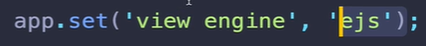

You don’t need to require ejs.

By default when we create a new express app and we are using some view engine. Express is gonna assume that our template ,views exist in a directory called views.

Now inside of app.js or any route, instead of sending string as response we can send a file. The method for this is render.
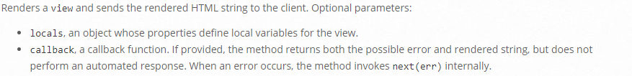
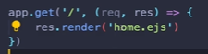
What happen with ejs, when its time to render this template, it takes our template and it’s gonna evaluate it. At any places it sees js. It will run the js and spit out html.

The default views directory that express is looking for, it’s only going to work if I am running my app from within the same directory where my views folder is.
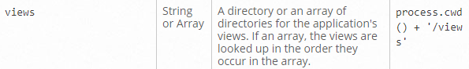
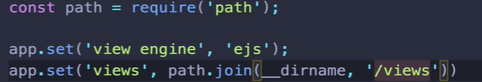

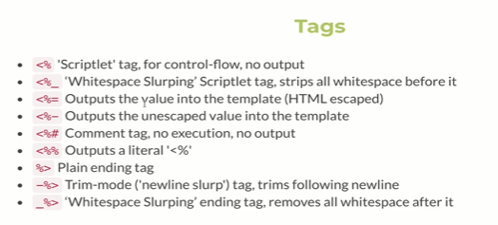

Install ejs theme extension in visual studio..

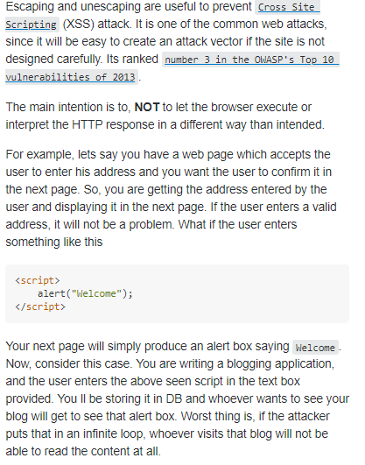

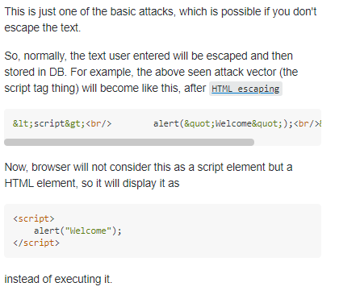

Generally, we want to remove as much logic as possible from a template, a template can be as stupid as possible you can make them, it just display things. So you can do is do the logic somewhere else and pass it into the template.
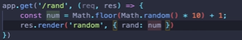
Here, whatever “num” is, it will be available in our template with the name “rand”.

---
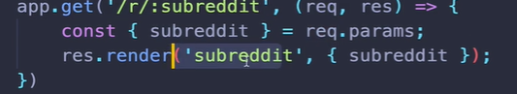

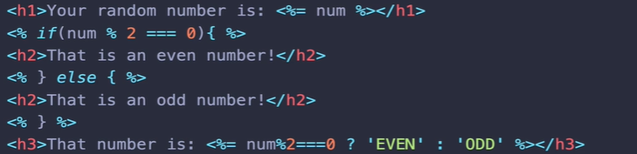
This will help to us to use individually the json data.

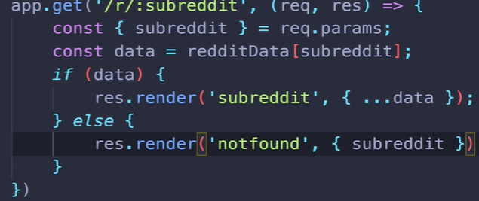
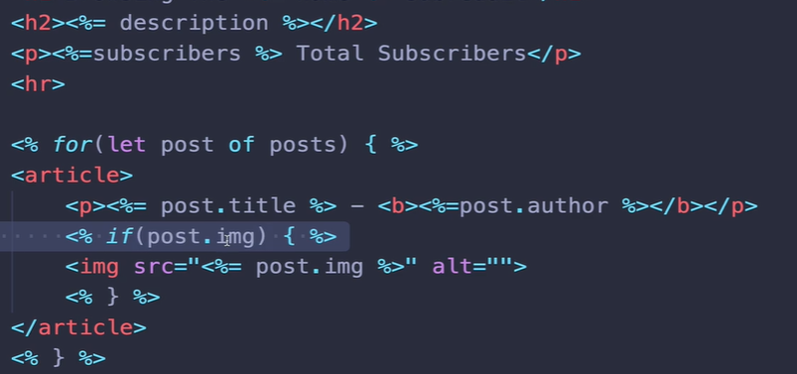
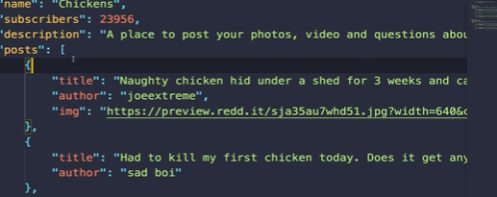

Serving static Assets in Express

Static files: css, js include in response to client side.

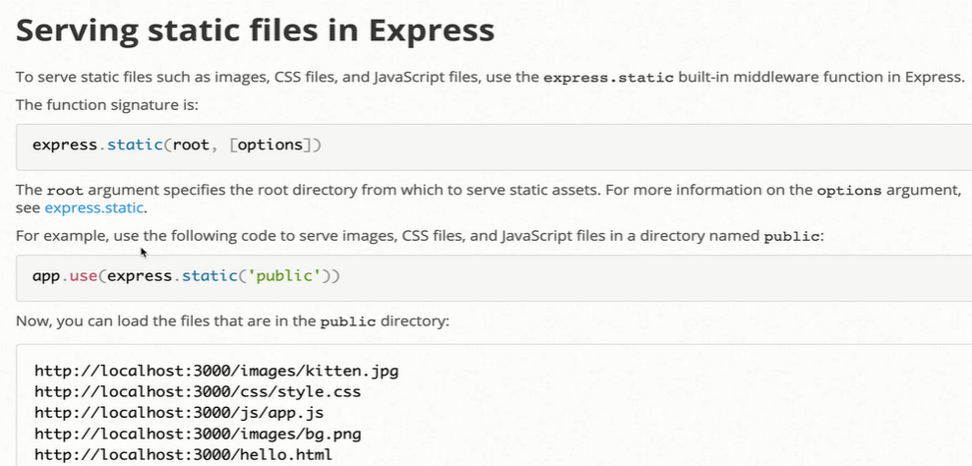
express.static is a middleware.
App.use() it ran every single time we have any request.
So express.static is gonna be ran every single request.
This is a middleware, it’s gonna run between a request coming in and response going out.
And we pass an arg of the folder that we wanna serve our assets from.
So we are telling express to use directory “public” to serve any css,images,scripts. And that directory will be at root directory of our application.
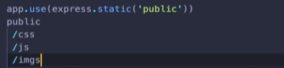

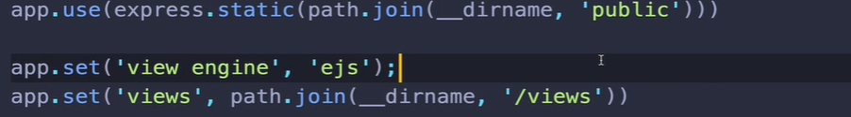
In views we used app.set, but for assets we dont have to cuz we need to specify the path.

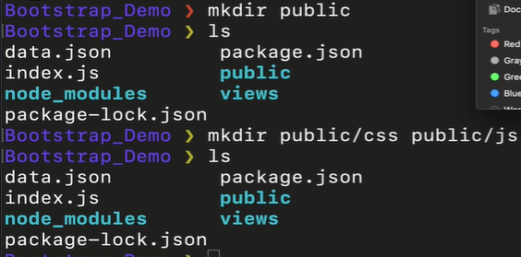
Download Bootstrap, copy bootstrap.min.css to public/css and bootstrap.min.js to public/js
Note: bootstrap also need jquery jquery
-add jquery to js folder.

------
EJS AND PARTIALS

Partials: Technincally ejs calls them include its a away of including template into other template.
If we have some markup we duplicating, it’s a very repititive task to update if any new version is to be used.
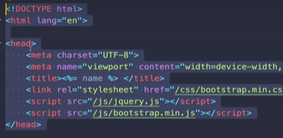

so what we do is create something that our template has in common and we just include it into our sub-template.
So inside views create a folder called “partials”

make a template also for navbar.
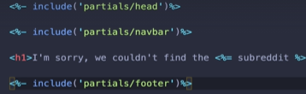

escaping means if there is html what we outputing, it’s not going to escape it. Escaping content means that we are treating it as a string, and we are not gonna treat it as html and render it.
when we use = (equal sign) the content wont be treated as html.
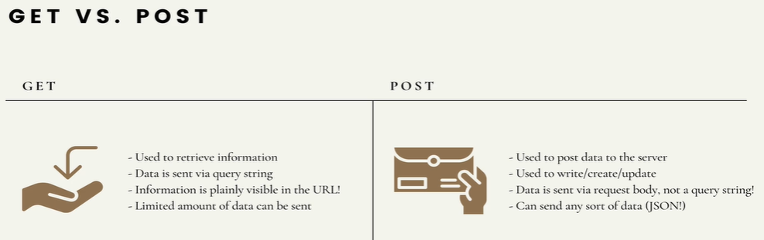
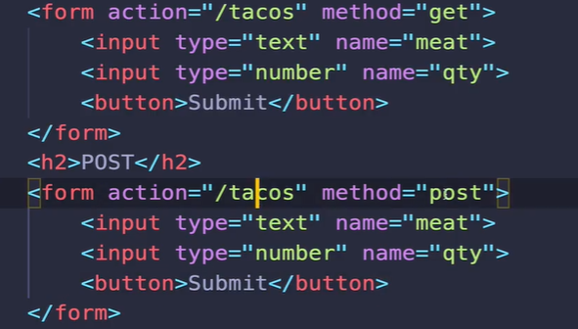
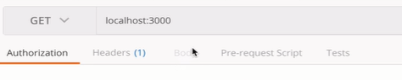

Notice that, the body is greyed out. I dont have request body i can fill.
I can add data in but the data is part of the query string.
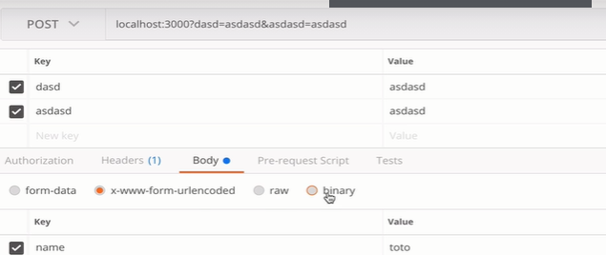
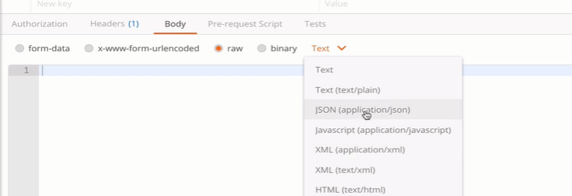
we can send json,... and that data isn’t part of the query string but it’s the payload of the request. When you submit (post request) form,the data is still there but you can’t see in it the url.

the payload is the part of transmitted data that is the actual intended message. Headers and metadata are sent only to enable payload delivery
Post request is use for uploading, posting, comment, updating.
Post request, the data is in the body which is a great flexibility in terms of the size of data we can send.
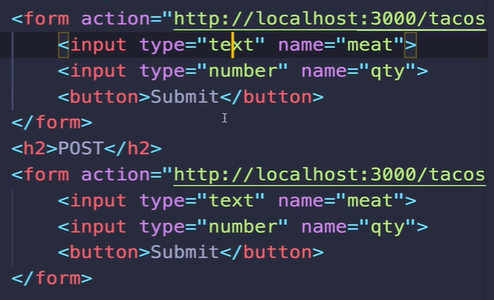

To access data when post,

just like if we have query string data it gets automatically parsed into request object in the get route of some path.
In case of post request, we have req.body
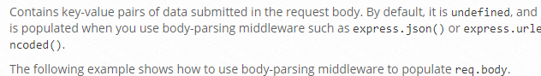
we can send data in different formats req.body

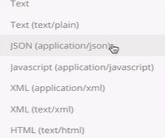

They all have to be parsed differently, cuz they are coming as text. They follow all these formats and how they are encoded. Express needs to know how to treat them, knows what that info is in the body. We need to explicitly tell it how to parse request body.

All we need to do is tell express to parse form encoded information from the req body
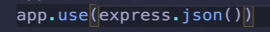
to parse json data.

You can add multiple middleware.
--------
REST
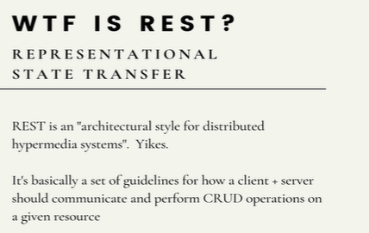
REST is this idea, guildlines,standards and principles.

Something that is called RESTFUL system complies with this rules of REST.

We gonna create API and routes that are consider restful.
Lets say i am creating a server, i have tweets stored somewhere in the db.i have an application. Lets say i am making an Api, i want anybody to create new tweets, view existing tweets, update existing tweets, delete exisiting tweets.(CRUD)
So how am i gonna go and implementing different routes to allow users to do CRUD on a resource. To read REST(CLICK ME)
-having a client server architecture, where our client and server our seperated, swap in for different client i can make a req from either the browser or the post man. HTTP is a stateless protocol. Uniform interface:consistent url pattern match with different http verbs.
-Combining some base URL with different http methods to expose full crud operations over http.

Github gist
Github gist: gist are files anybody can share on github, it’s like really big tweet, anybody can share,post them

github has an api that exposes crud functionality for gist, so if i want to view gist. This is the endpoint i request, this will give all of the gist for some user.

If i want to create a new1; same url; same resource.
A post request to the same endpoint, is how we create new gist.

If i wanna get a specific gist, use id

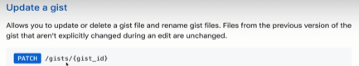

Still same url, same path, with some id.

Rest-Api-for-instagram for comments

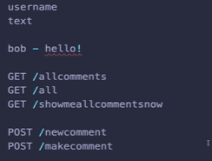
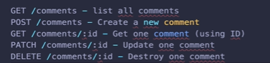

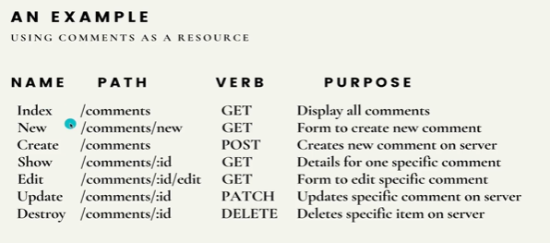
views>comments>index.ejs
comments can have a index.
Post can have a index.
Dogs can have a index.
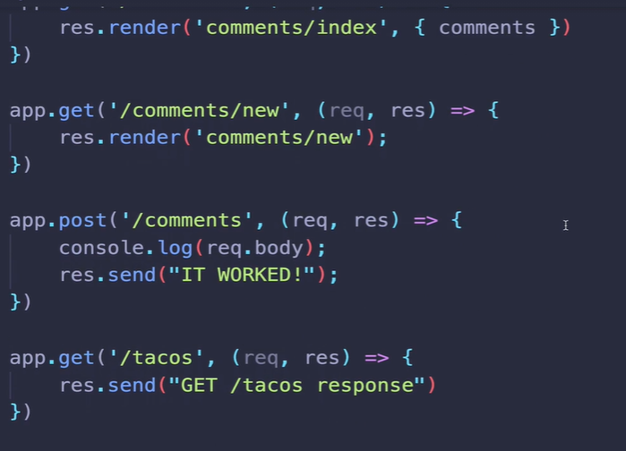

We can take the request.body and push it onto the array, but there could be other stuff in req.body that we dont want, somebody could use postman and add-in some other field.
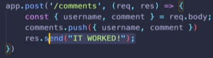

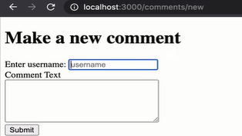
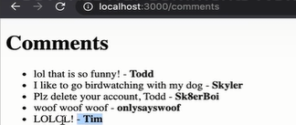

post> was send to somewhere and then enter on the post-path to get to comments.

Express Redirects


if i instead of pressing enter on the path, if i refresh.

Result:



Response redirect
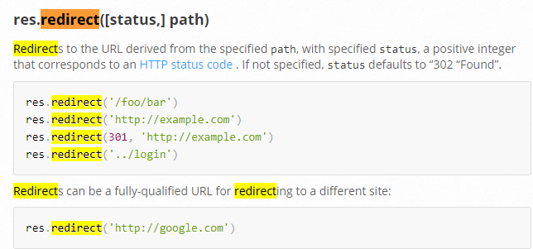
The default status code res would send back is 302, what happens when your browser gets a 302 status code, it actually follows up and make a second request bases upon on the location was sent back from initial response.

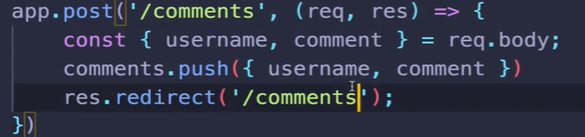
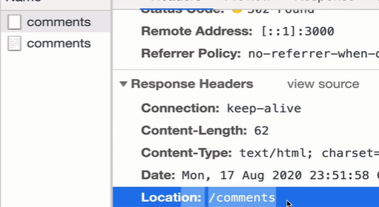
302 FOUND

In network tab, 2 things happen. I got my first response that gave us 302 status code(redirect) it also included header “location” and makes a get request to /comments .

Res.redirect(“/path”) by specifying a path and using redirect method, the response that generate would include redirect status code 302, the response would include a path under the location header which your browser used to automatically quickly make a request to comments.

Restful comments Show

Show route or details route, basically info related to one particular resource. That could be one user, one dress, ..
Whatever it is, we are showing details usually in a expanded view about one thing in particular.
The idea is anytime i make a request, comments/7 , whatever the unique identifier is, i should always get the same info, the same result. That needs to be some identifier that needs to stay the same. More importantly is unique.

What we do is use req.params and lookup the corresponding comment in db, build a webpage and respond with that.

Reddit
would use this id to for some post.
Reddit also put some info, so it would be easier to look in bookmarks. But i am good with just id to get to that post.
This has 2 id, a post id and a comment id. The comment id is reference to one comment in particular. This is what we call a nested route. Where we have one id for a resource and a comment.

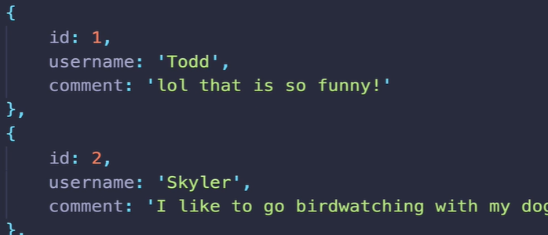

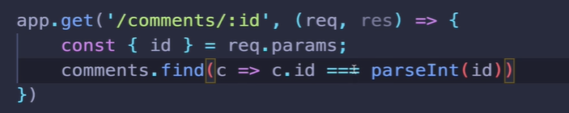

The UUID Package
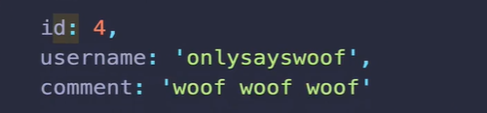
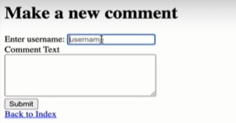
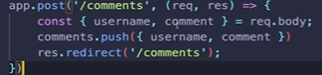

to insert id, we have to hardcoded or incremenet a pointer. Best practice is to use
UUID package UUID package

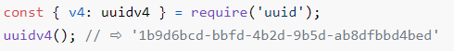

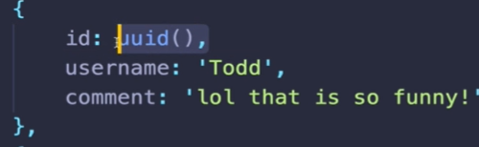

HTTP request methods. Http request methods
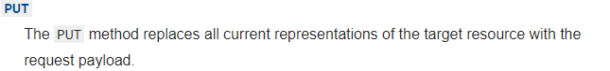
put request:- gonna completely update an entire thing. So if we have a comment, a put request to update that comment, would take whatever payload was included on the request and that would be the new edit of that comment.
In put request, even the id is replaced.
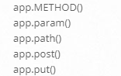
You will find app.patch inside app.method().

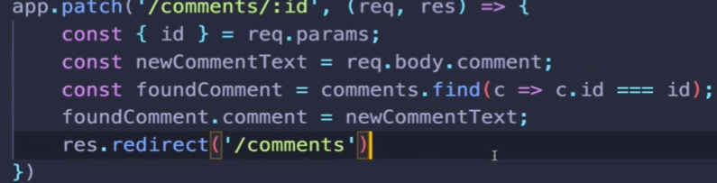

Express Method Override method override

Html forms in our browsers can only send get and post request. They can’t send put or patch or delete request. Fortunately we can fake it.


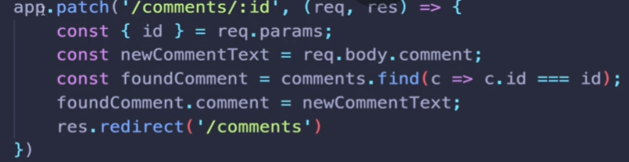

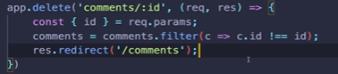

This would be weird to copy everything in a new array. The idea here is immutabiltiy. In the world of react there is many reason to make a copy of an array and make changes to the new array.

New and edit route, they just renders forms. It depends on what you’re doing if you are making an api and you are expecting data to be sent via axios, postman.

We can’t send patch,put,delete request from html forms without method override. We can send those type of req using axios

