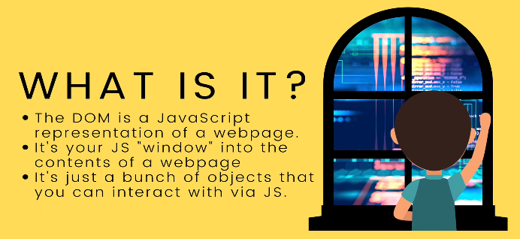
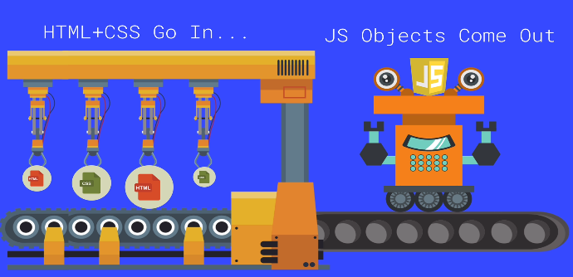
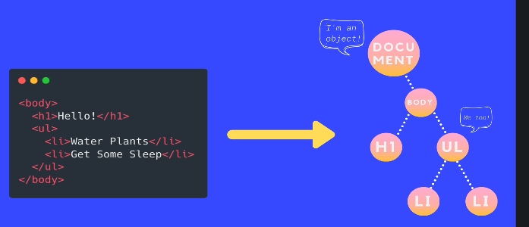

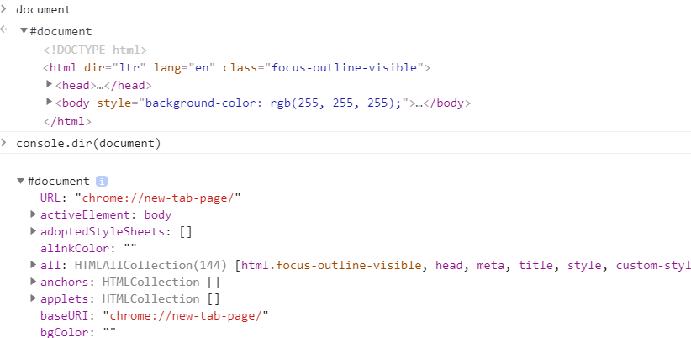
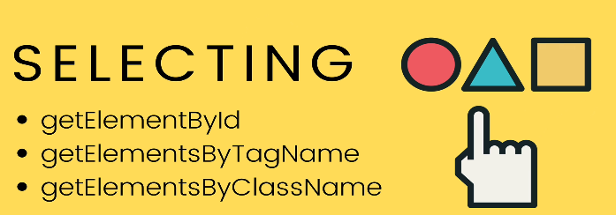
Like
document
>>> gives u the html
so u have to do
console.dir(document)
>>> to get the object

Likewise
whenever you use select elements using Dom, you have to use console.dir to view the object.

It’s iterable but itsn’t an array so u can’t use map,reduce..
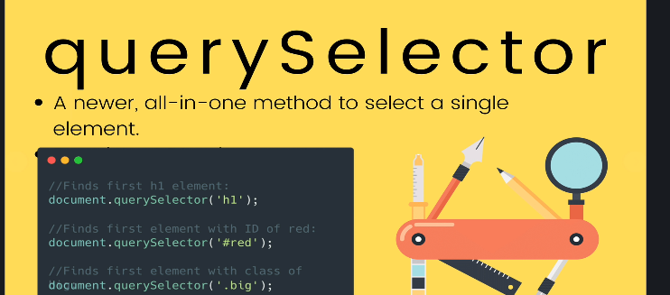
In query selector, we pass the “sameway of selector we pass in Css”
queryselector only selects one elements and return.
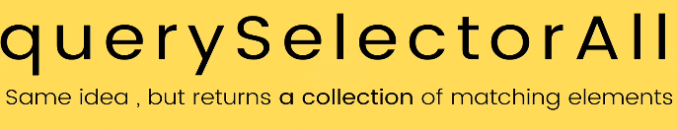
innerHtml , textContent & InnerText
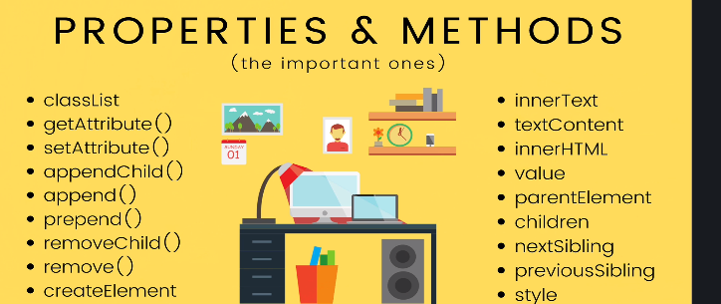
textContent: is gonna look like the how u written your html content.even though any <span> is display:none , You can see in the textContent.
So every piece of content is gonna show.
innerHtml:what you see on the browser exactly like that. It is sensitive to what is showing on the moment .

e.g
const x=document.querySelector(“nav a”);
x.innerText=”<b> mumbai_foodbasket </b>”
<!-- this will not work, it will consider b tag as string.
//so use
x.innerHtml=”<b> mumbai_foodbasket </b>”
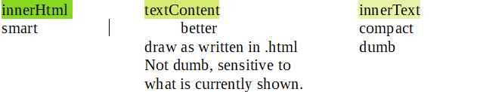
Attributes
--------------
const firstlink=document.querySelector(“a”).src
firstlink.setAttribute(‘href’,’https://www.udemy.com/course/the-web-developer-bootcamp/learn/lecture/22003782#overview’)

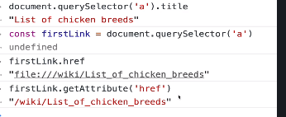

when you use .getAttribute() you are getting directly from the html itself.
& when you access property directly on the element like “.href” i.e is going through js. So we can see we got different value.

Styles
-----------
selected element object has a property i.e style
h1.style <!-- In Css we have background-color, but in the style object
we dont have “-”. Instead its camelcase
i.e backgroundColor
h1.style <!-- only stores inline style, not from our stylesheet

Here, you whatever you do would be inline style, you should avoid using inline style.
i.e h1.style.color=blue;
-Better way to apply styles to elements is to use a class
Issues with style property:
-inlines are bad
-using style property you can only see style attribute.
So unless you wrote the style inline, you can’t read the style.I cant tell what is the fontSize of the element...
So what if i wanna make something the same font-size idk how big it is, atleast by not looking at my css

So there is another way. To find the actual computed style once everything is applied. It’s not as easy just to look at your .css copying the style over.
Because you can have multiple stylesheet n they may have conflicting sytles and specificity.
-You have to wait until everything is loaded and computed to figure out actual style.you can do by using
window.getComputedStyle(h1).fontSize
This is not a query selector, this is the actual element object in dom
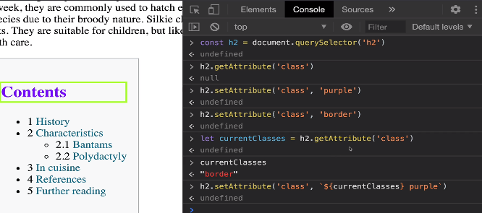
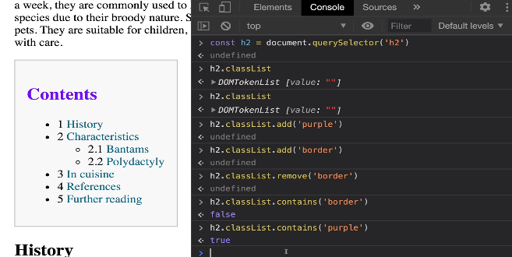
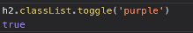

It might seems easier to change style using style property but by classlist its much more simple where u can apply bunch of property by adding class or multiple classes.You can also remove class and toggle.

Traversing parent/child/sibling
-------------
i.e
parentElement Last child
Children LastElementChild
nextElementSibling NextSibling
previousElementSibling
All this property allows us to navigate,traverse,move from one element to some relative or to it’s parent or to it’s parent parent.
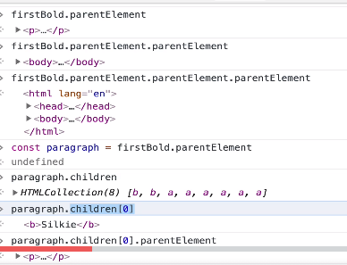

nextSibling and previousSibling is gonna give us a node.
For e.g inside <h1>...</h1> we have a text node.
Somebrowser make new lines a text node.
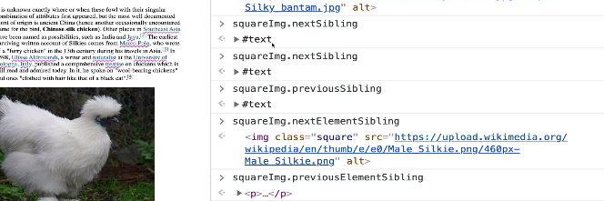

createElement
const newImg=document.createElement(‘img’)
console.dir(‘newImg’) <!--to view
newImg.src=”<someurl>”
document.body.appendChild(newImg)
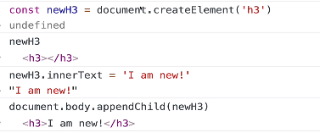

appendChild
------
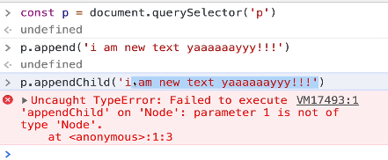

It allow us to insert more than one thing at a time
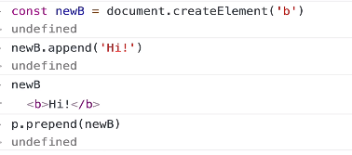

Element.insertAdjacentElement click
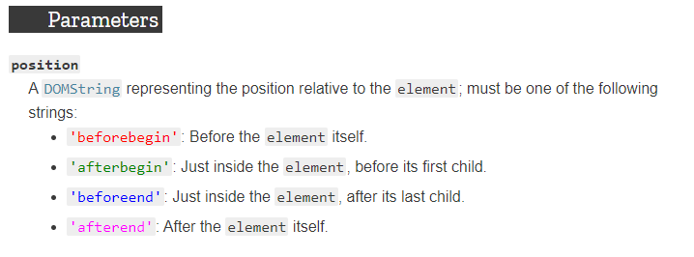
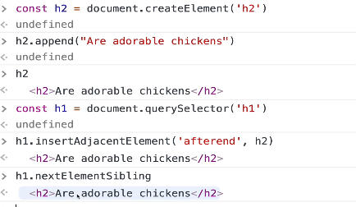

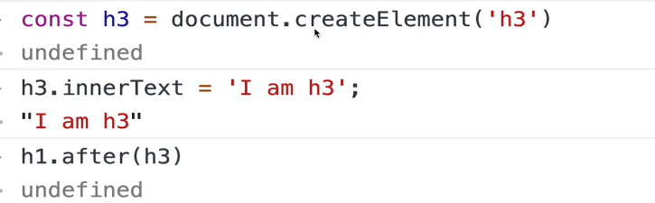
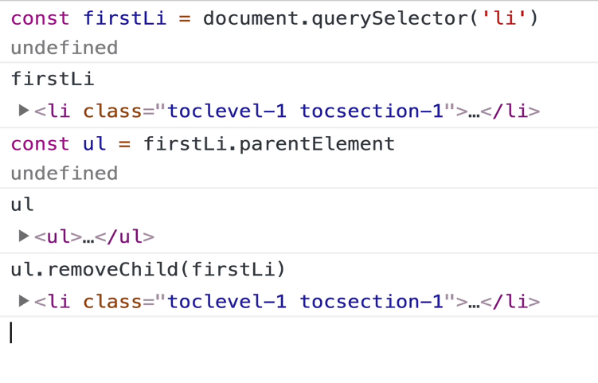

Another way

firstLi.parentElement.removeChild(firstLi)
<!-- This works but isn’t considered best practice
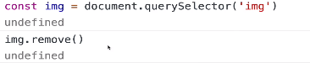
Another way

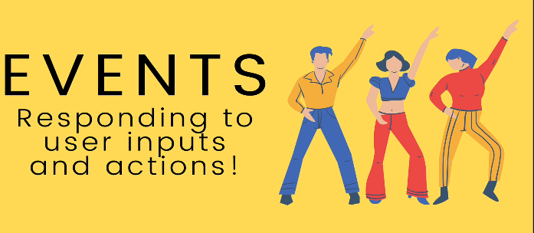
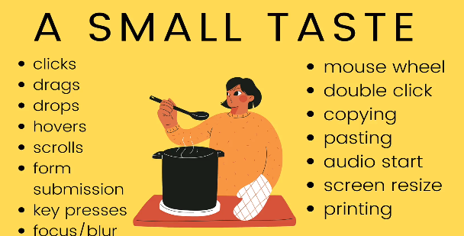
Inline event
for e.g
<button onclick=”alert(‘you clicked a button’)”>click Me </button>
If you wanna write multiple lines in you have to make seperation using “;”
i.e
for double click
<button ondblclick=”alert(‘you clicked a button’) ;alert(‘stop clicking me’)”>click Me </button>

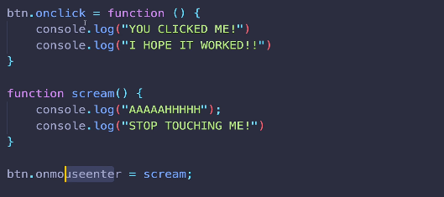

See Above, u r passing the function on the event but you aren’t executing.
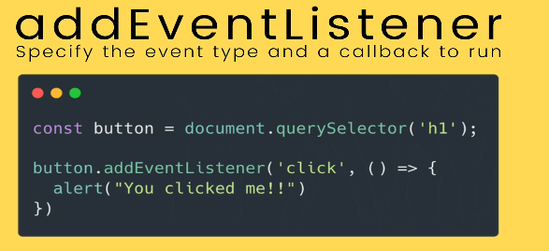
Not all events works on every elemnent . For e.g keypress doesn’t work on a button.
You wanna use addEventListener over onclick/....... cuz you can’t have two callback functions on the same event for e.g click.
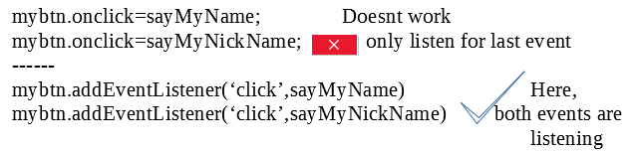
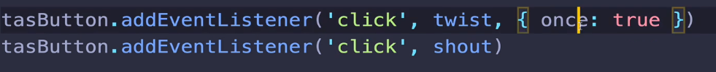
Tip: when you set property
document.body.backgroundColor=’rgb(200,255,300)’; <!-- key:value(str)
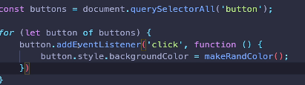

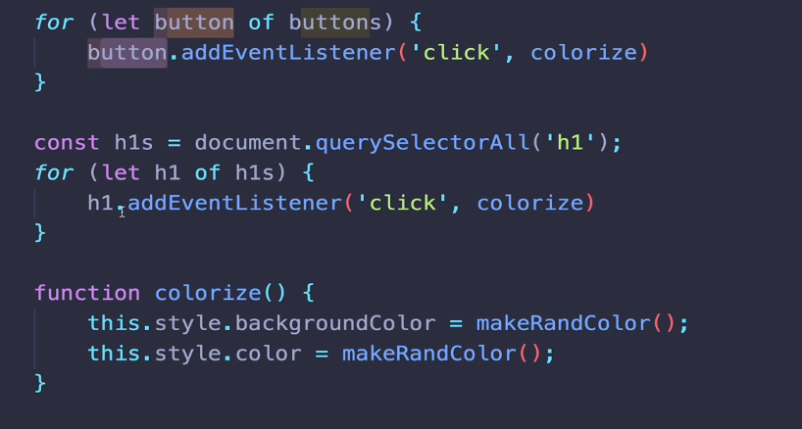

The keyword ‘this’ when You have it inside a callback ,that is invoked by some event handler, ‘this’ refers to the
element the eventlistener was listening.
If u change ur language settings, so where your is w,a,s,d maybe anywhere.
But if i use ‘code’ it doesn’t matter. So if we care about position on keyboard use ‘code’. But what you care about is the ‘char’, use ‘key’.
Again, if you dont care which button you pressed to generate the char use ‘key’ then.
Keyloggers
Use window.Eventlistener()
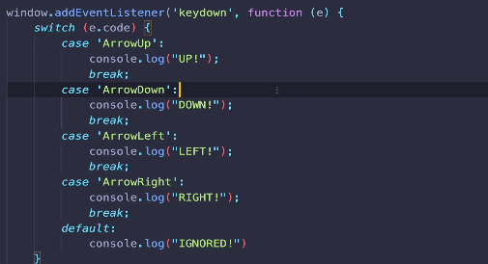

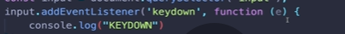
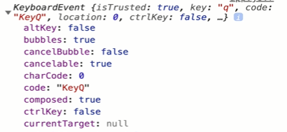

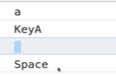
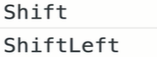
Key
Code
Key
code
Key

Code

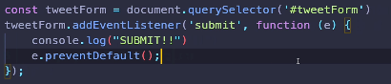
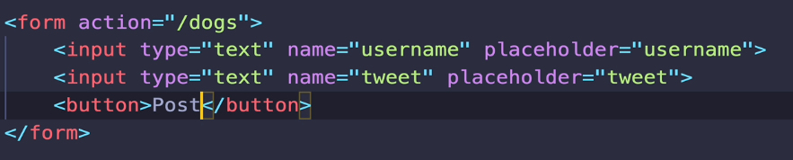

if action isn’t specified it will send data to the page you are on rightnow.

In below, put e.preventDefault() afterbegin inside eventlistener.
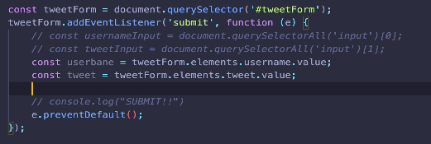

Tip: The form is submitted by pressing ‘Enter’ not just by clicking the Submit button.

Input & Change events
------------
There is copy/paste using mouse or voice over utility, so there are different ways of updating a input and keydown/keyup doesn’t encompass all.

EVENT

change:-only fires when you go in and out of input element that is only if the input was different before you enter the input.
input:-everytime there is a change not just when you go in or out of an input. For e.g: shift or arrow keys wont fire this event. If you cut and paste that will fire this event.

Event bubbling
---------
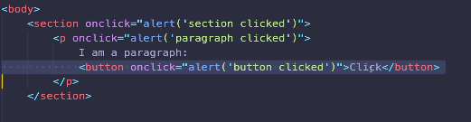

Above, button triggered > para triggered > section triggered.
-Use e.stopPropogation();

Event Delegation
---------
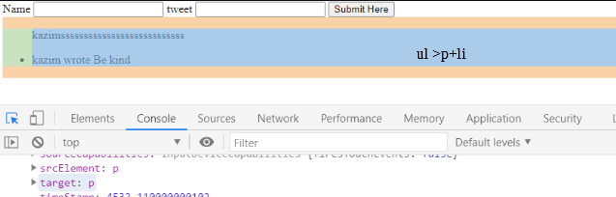
Above, on li we have listener which on click are removed. But above if we submit and create a new li, it will not have a listener. So here, we placing a listener on ul.

It means we gonna add event listener to some element that is a parent.
Here, We gonna listen click on ul but specifically on li that is in ul.
So even though i have eventListener on ul, but the target is p here.
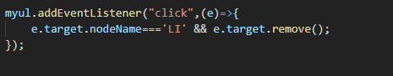

Working with select
