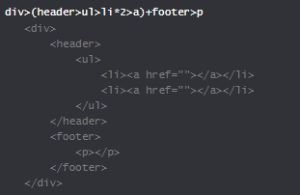
Grouping:()
To whatever I put this (), whatever come next, I am it’s sibling.
e.g

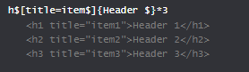

$ represent a unknown value.
If $$$*3 then its 001,002,003

Above to pass value in a element use {}
Also, $$$@3 means start with 003.
Also, $$$@-3*5 ,means ends with 003 and there will be 003-007.

You can do
here, title is empty. Here many attribute are defined.

