Event-loop
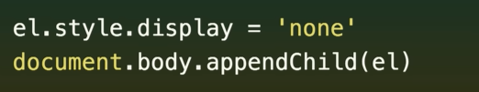

There is no race condition here, the timing of running code and rendering is tightly defined. Cuz of Event-loop.
Web pages have main thread.
We call it main thread cuz loads of stuffs happens here, this is where js, rendering , where dom lives. Bulk of stuff on the web have deterministic order. So we don’t have two loc edit the same dom element at the same time.

For netwroking, encoding and decoding, crypto, monitoring input devices.


When the threads have done something that the page
needs to hear about, they come back to main-thread.
It’s the event loop that orcheastrate all of this.

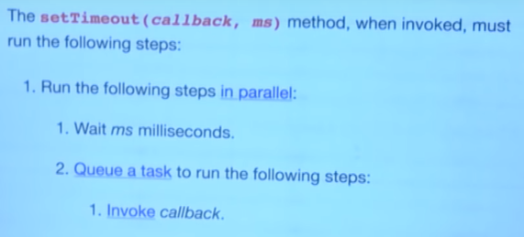


The event loop just runs round n round in a cpu
efficient manner. This visualization is running a fraction of real time.


When we queued a task, the event loop takes a detour. Browser is like “hey event-loop”, I have a job for u. Event loop add the taks to the to-do list. I’ll get around it at some-time, np.

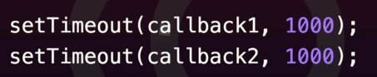


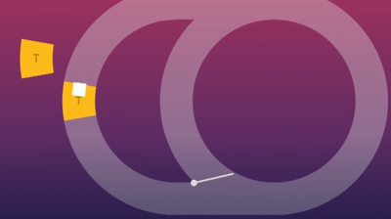
At pass 1s, the browser is like I wanna do a main thread work, infact I have 2 & add 2 items in the todo-list.

The render Steps
Browser uses render steps to update what’s on the screen.
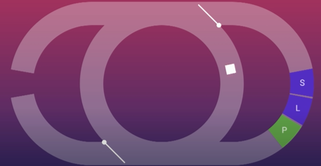
Render steps are another detour that involves style calc, looking at all the css what apples to each element, layout , creating a render tree, figuring out where everything is on the page and where is postioned. Creating pixel data uk doing actual painting.

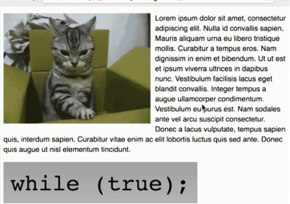
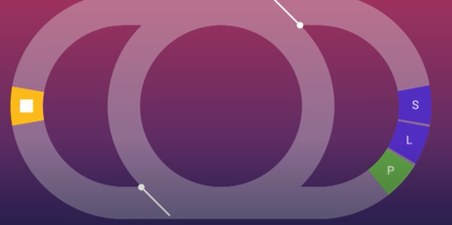

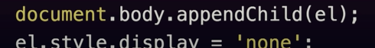

I was worried, this code will result in flash of content, but it can’t.
This script run as a part of a task, and that must run to completion before
browser can get back around the render steps.
The event loop gurantee the task will complete before rendering happens.
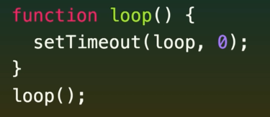
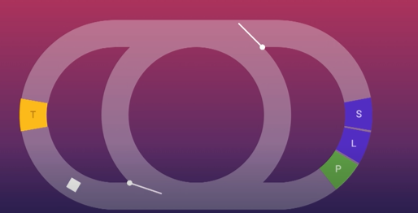

We queue a task, go around the eventloop
When it complete a task, it has to go all the way around a eventloop to complete the next task.

Only one task can be processed at a time.
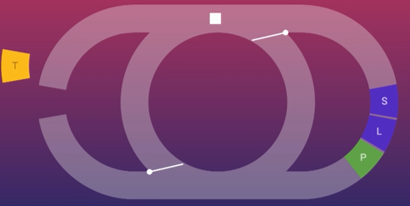
When it complete the first task, it’s like huh we should update the display the cat gif as well and it can. So it goes around and update the display and that’s why a setTimeout loop is not render blocking.

But if you wanna run code that has anything to do with rendering.
A task is really the wrong place to do it because a task is on the opposite side of the world to all of the rendering stuff as far as the event loop is concerned.
What we want to do is we want to run code in the render steps.
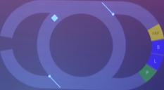
The browser let us to do that using a request animation frame(rAF callbacks). They happen as part of the render steps and to show why this is useful.

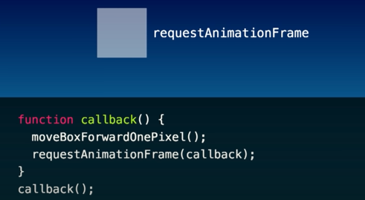
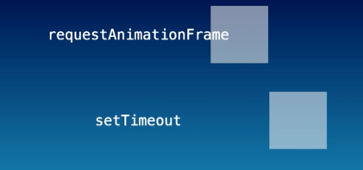

We saw earlier rendering can happen in between task, just bcuz it can happen, doesn’t mean it must.
Many task can happen b4 updating display.
The browser decide when to do this and it tries to be as efficient as possible.
The render steps only happen if there’s something actually worth updating . If nothing’s changed. It won’t bother.
Like the browser tab is in background if it isn’t visible it will never run the render steps because there’s no point.
But also the majority of screen updates at a set frequency in most cases.
For e.g 60 times a second some screens go faster some screens go slower.
So if we change page styles thousand times a sec, it’s not gonna run the render steps a thousand times a second. It will synch itself with the display and only render up to a freq the display is capable of. Otherwise, it’s waste of time. There is no point rendering stuff, the user will never see.

SetTimeout is moving faster, because it’s updating the position of box more times than the user can see.
more times than the display is capable of showing us.

SetTimout is used as shorthand to queue a task, it isn’t really.
Even if we put ms as Zero, it’s more like 4.7ms.

Rendering can happen bet task, but you can have 10-1000 of task between rendering.
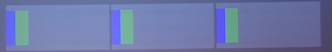

Frames are displayed to the user.Rendering happens at the start of each frame that includes style calc,layout,paint.

Event loop make sure the task are in order they were queued. But in terms of timing in a frame, there’s no order.


SetTimeout (here, 3 of them are wasted effort in terms of rendering)

Set Time out messed up.


Another ex

requestAnimationFrame


Everything is within timing of the frame, even this longer task.

You can’t avoid task at all. Things like click event need to be delivered to you in task. Generally you wanna respond to those quickly.
If you have timers, or smthg coming from network, It’s really recommend to use requestAnimationFrame to batch that work together.
RequestAnimationFrame come’s before processing css and painting.
Just like stuntman throwing punches and you filming from behind and the other person dodging.you want to exactly time when he throw punches.
Request Animation frame take a function before throwing css and giving a headsup and processing.
Again,
RequestAnimationFrame come’s before processing css and painting.
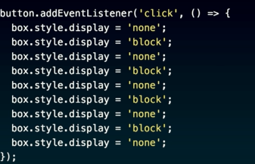
Browser just sits back, lets you have your fun and doesn’t think about css at all.
At the end, it comes around the render steps. Browser is like right what you actually changed, in the end. You are saying just the final-line.

Event-loop falls animation (1000 to 500px)
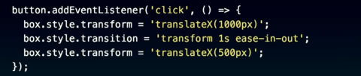



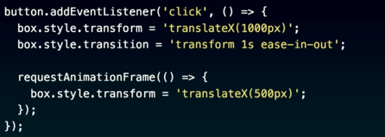

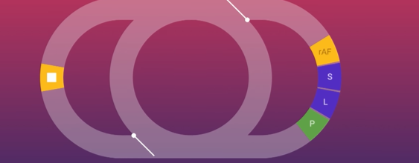

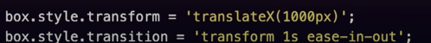

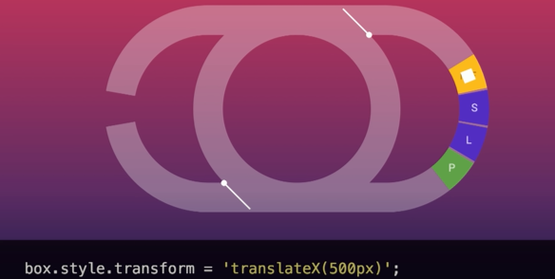

so use
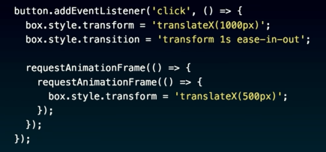

hacky alternative
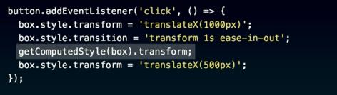

This forces to the browser to do style calc Alot earlier than it naturally would. It notes what all things you set up to that point.
Be careful doing this, you would force browser to do alot of style work that it do that once per frame.

MiCrotask
back in 90’s , browser wanna give developer a way to monitor DOM changes and w3c okey and they gave us mutation events.
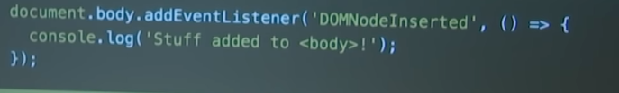
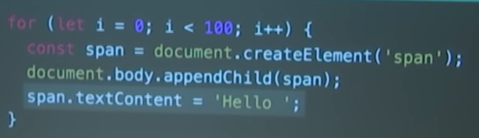

you’ll get 200 console log for DOMNodeInserted, when the content is going to the actual span, also.

Microtask:

happen every turn of the event loop,after a task, also whenever js finish executing that is call stack is empty, render steps as a part of rAF.

Refresh fireship-video
Js is a single threaded programming lang, yet anything we do on the web happen to be blocking or time consuming. Which means async programming is an essential skill.
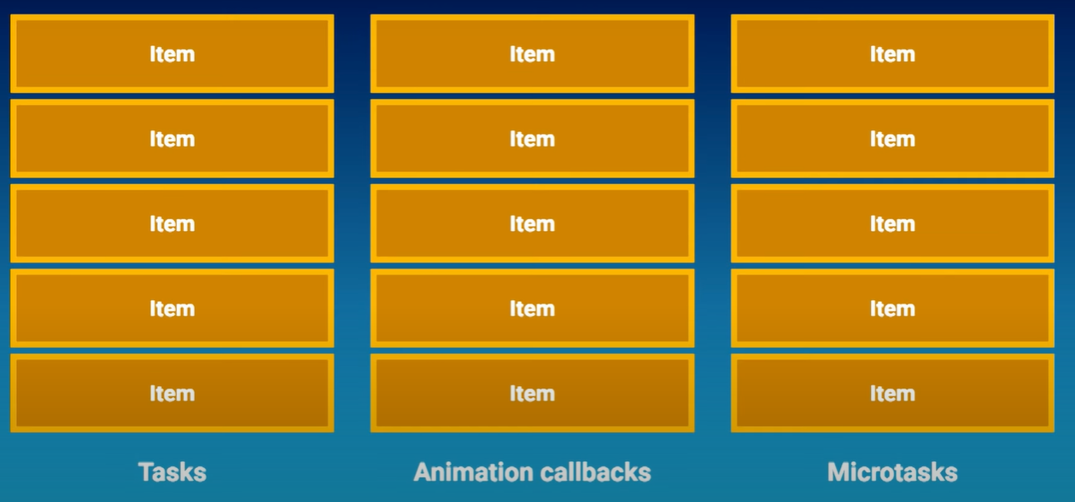

They all process very differently.
Task:queue, one at a time.
Animation-callback: queue happen until completion,except the one happen when we are processing animation.They are defer to the next frame.
Microtask:they are processed to completion,including additional items. The event loop can’t continue until that queue is empty.that’s it blocks renderig.

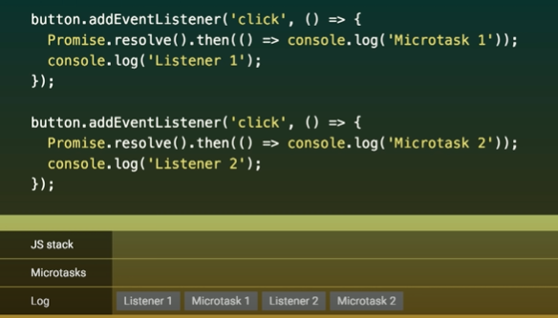

Above is when user clicked the btn, what if the btn is clicked by js.
Oh yes, it’s different.
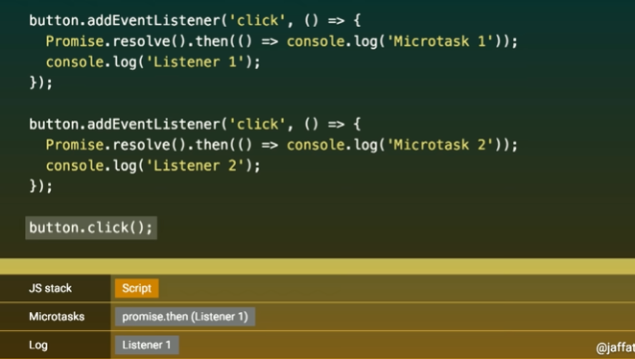
JS stack isn’t empty so,
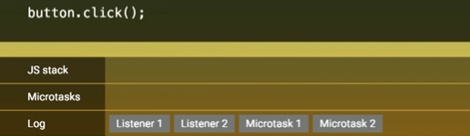

If you are automating testing, you are likely to use js which can change the behaviour of your code.

Another e.g
video time:33:00
To read (1)addEventlistener property (2) cancelled flag (3)preventDefault

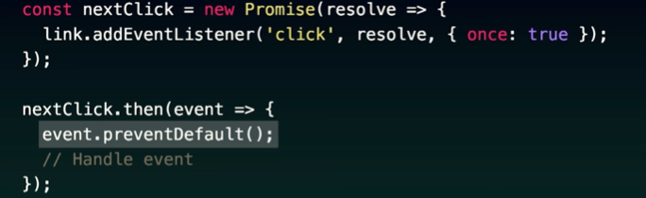
will event.preventDefault() have effect >>> Yes
promise are async have we missed our chance to preventDefault()

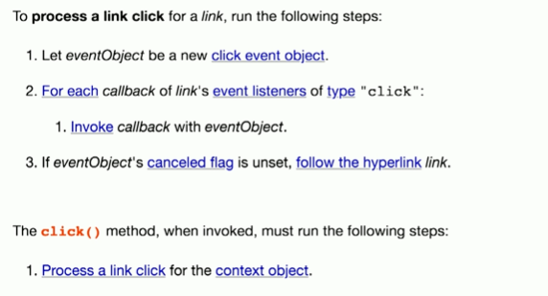
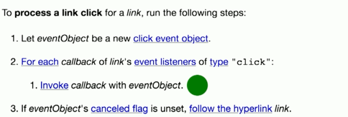

in click(), js stack is never emptied, so our microtask can’t happend.

