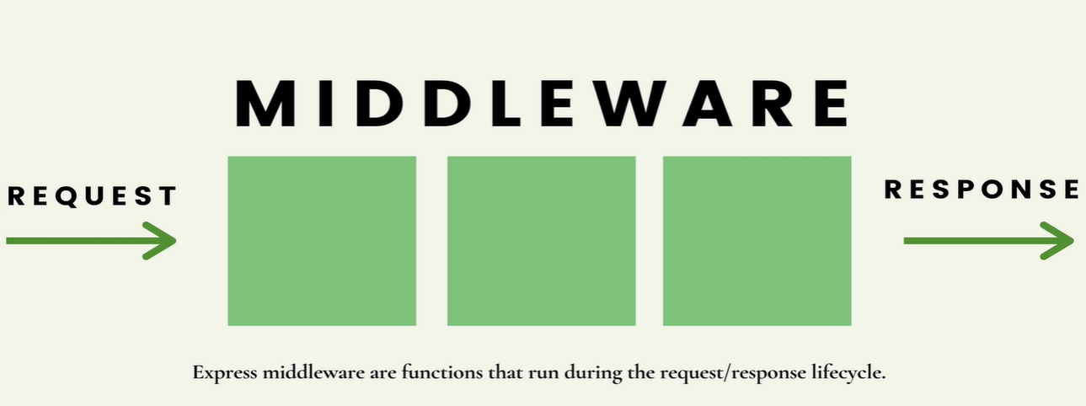
Things like parsing the body, we talked about using the built-injson middleware to pass the request.body or to pass static files our css, images and js, we use the express static middleware.
I think they are just building block of everything in express. They are functions that run at some point during the request and response lifecycle.
So they run between the time a request enters express and by the time the response leaves and our code stops executing.
Middleware is just a function or functions that run in between those two things and each middleware function has access to the request object into the response object.
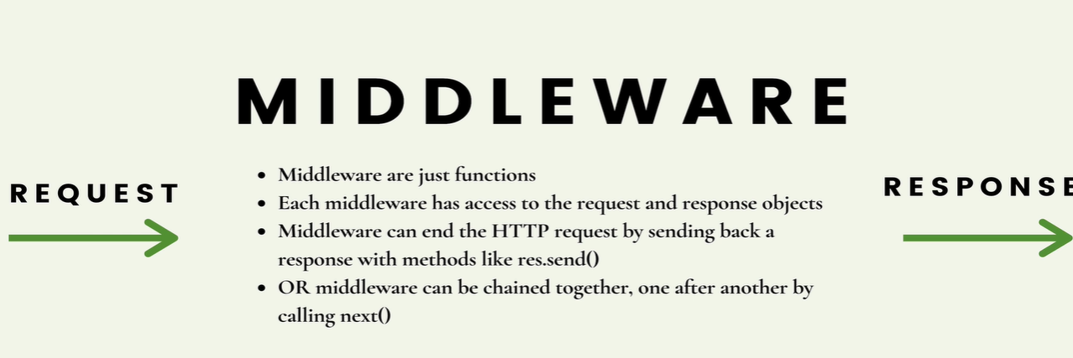
They can make changes to it, and thats exactly what something like parsing the body. We talked abt parsing form data and parsing json data with express built-in middleware. The job of those middleware is to parse the incoming body of the request and add it to the request object so that we can use it as js object. And what’s most important to understand about middleware is that when an incoming request comes in. I guess that’s encapsulated by the term incoming and we hit the first middleware or lets say any middleware that’s been defined, that middleware can end the whole cycle. It can be the end of the line and send back some response, or it can just be one link in a chain of middleware and it can call the next middleware and the next middleware after that.And that’s where things get interesting so that we can write these tiny little pieces, these middleware that might do one thing and then we can change a whole bunch of them together to build something larger.

Guide using express middleware middleware
whatever colt said is in this guide.
Middleware are functions in express and have access to all the stuff we normally have access to in express. In fact, our route handlers are considered middleware.
They have access to the request and response object, they can call the next middleware after them or they can just respond and stop the lifecycle there.

External middleware
Using Morgan -logger Middleware
It helps us log Http request info to our terminal,useful when debugging, it’s something a lot of ppl like to include when developing an app.
>npm install morgan
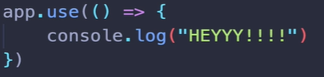
<e.g nothing to do with morgan, but app.use is for every single incoming request no matter what.
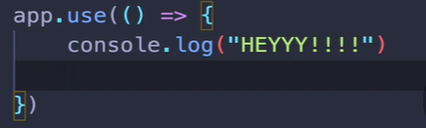

The problem is we aren’t sending anything back,
so it’s just going to time out over here and eventually, you know we’ll get some sort of error and the browser will tell we couldnt get a response.
This is telling the express to serve static files on every request.
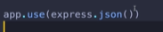
We are telling express to pass the body as json on every request.

so use
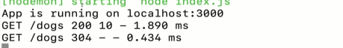

It’s logging info about the request. What we have done is we have injected it in the middle, that it’s just logging every single request. Morgan runs and says move on to whatever comes next.
Whatever next matching middleware or route handler is.
You can customize the log.
Also,
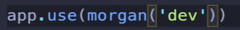

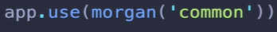

Defining our own middleware.
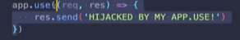
No matter what type of request, I am a hijack by app.use. Whatver func you put in app.use() will be call for every request. But this middleware is not calling the next middleware that we often wanna do.
Express: how to define middleware middleware
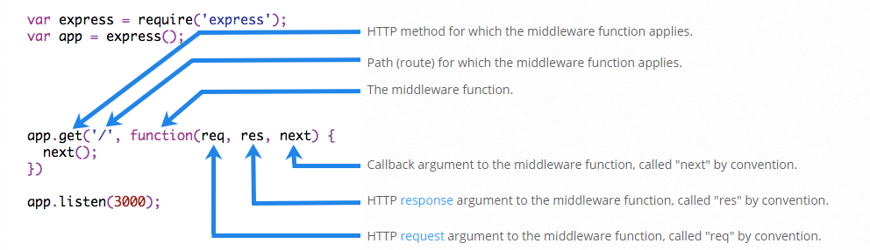

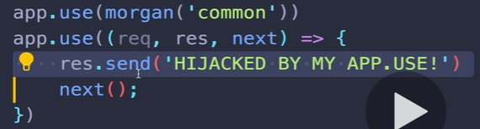
You can only have one response per request/response cycle so u have remove res.send() if you want to call the next middleware or path route.
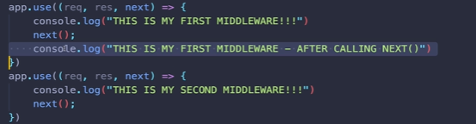
Above code will be run eventually.
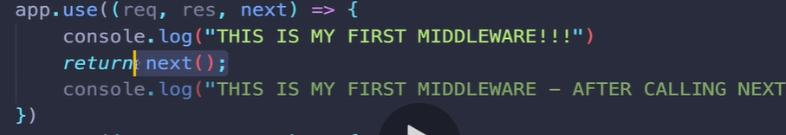
This is the way to make sure nothing happens after next.

Morgan is actually logging info about the incoming request.
That’s where will get to the utility of writing middleware, is that we can access info from the request and we can modify or add data to the request object before any of our root handlers are executed. So we can define things, for e.g, that will check to see if a user is authenticated, which is a whole big topic we will cover, but we know later.
The request object once when we get to authentication, we’ll have credentials, it will have a signifier that somebody is authenticated. And if that’s missing, then we dont want them to be able to got to a particular route. Well we can write a middeware that will check to see if request dot whatevever if exist. If authentication sort of token is on that request. Another thing that we could do, and they show this on their documentation, a very simple example is to add the current time.
Another thing that we could do , and they show this on their documentation,a very simple e.g is to add the current time.
The request time is what they’re calling it to the request object, so on every single request, they are just taking data now and you know there’s a whole lot of really not very fun stuff around dates and js. But Date.now gives the current dates. That’s not a thing that exist, we just add that on there. Well, instead of whatever route handler is matched, next, we have access to request.requestTime. So thats something that we will see pretty
commonly I guess you would call it decorating or adding onto
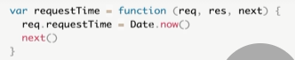
the request object.some info that we will use inside the

routehandler we match next.
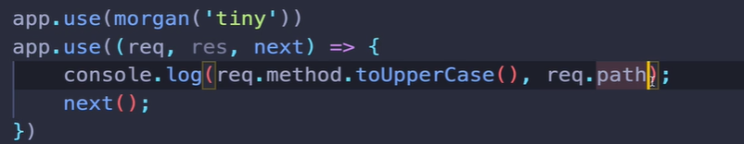
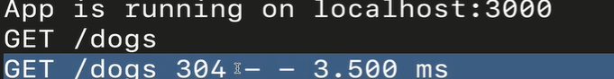
Here, I am trying to recreate what morgan does, accessing info from the req and It prints it out.
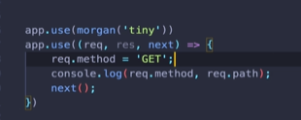
Here, I am doing smthg mischievious, I am making all request a get request.

ORDERS MATTERS BELOW

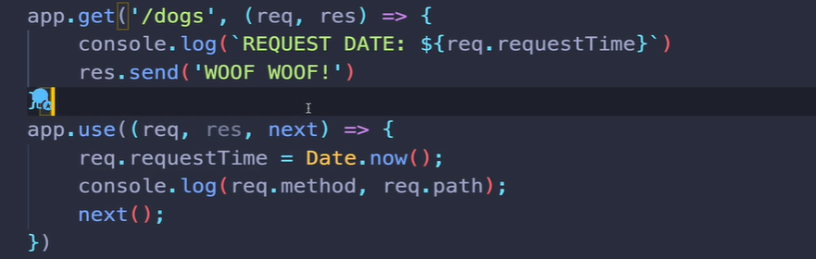

App.use App.use
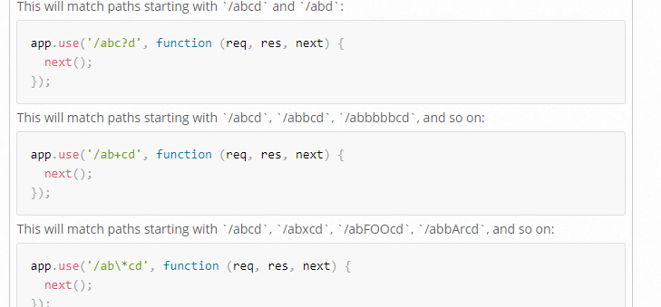
this can be useful , if u have some set of route in your API that started with /Api for e.g. So you have your regular app and then your /Api or internal routes or you have, you know, authenticated routes that all start with /auth.
There’s different situation where you may want to use middleware on a particular route or particular path. Also, you know u have fancier pattern.
Anyway, the other thing that we use app.use for is to define a 404 last ditch thing at the very end.
So usually down here we’ll do something like this if nothing else was matched
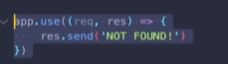
Place this at very end.

So typically, middleware we call next and then in a root handler, we send something back or in a route handler or we redirect, we somehow stop the cycle. If no routes or middeware are match, this will match it and we’ll get a 404 not found.
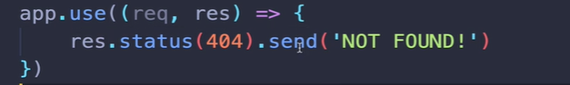
And you probably in a real nice consumer facing application, we would have polished 404 template that we would render instead of sending back not found.
Password middeware demo
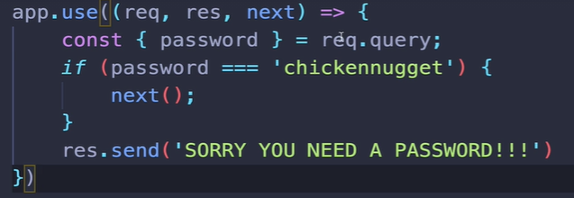
The above is checking on every single route

Protecting specific routes.
App.get
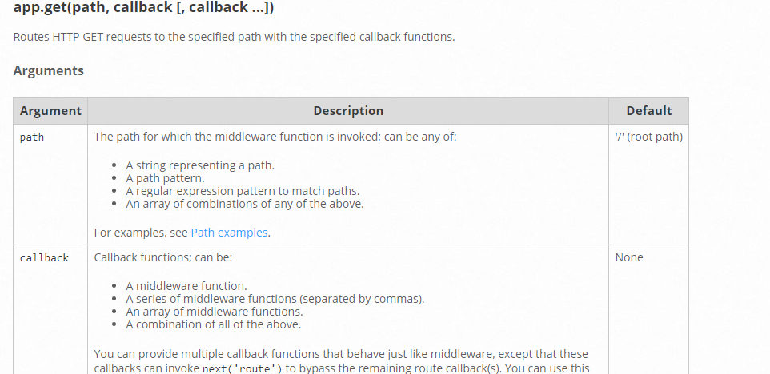
when we call a app.get and pass in a path and optionally multiple callback func can be call and passed in
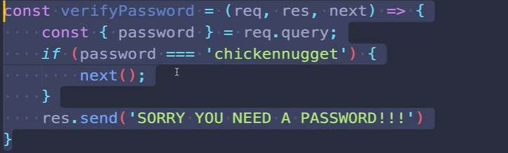
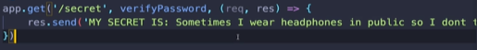

verify pwd is a middleware we define and as long as it call next somwhere in there, If it ever does,then next will go to next-callback. If it doesn’t call next and instead it sends somethig back then the next callback will never executes.
Sometimes you are authenticated but you may not have access to some resource. For e.g even if you are logged in you can’t delete anyone comments.
So above we add middleware that we can use selectively.not on every single request. If thats what you want, we’ll use app.use

