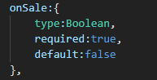
Here, {} this is used to define constraints on onSale
field.

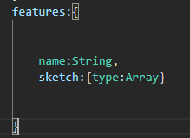
Here, since there is a field within a field, its a
object for usre{}.
I.e features:{}
so, features:{name:’ ‘, ?? }
here for sketch, curly braces is used to define constraints on sketch field.

Same As Without
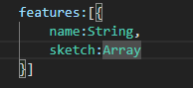

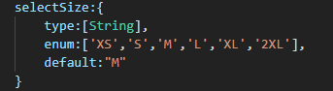
Here,
SelectSize:[]
enum and default are putting constraints on the String.

Above works ^
below Doesn’t v
