Resources
Data_anomalies:(1st page,2nd page)

Normalization
-------
Anomalies
Insertion Anomaly: happen when inserting vital data into the database is not possible because other data is not already there.
For e.g:
Suppose a new employee joins the company, who is under training and currently not assigned to any department then we would not be able to insert the data into the table if emp_dept field doesn’t allow nulls.
If a system is designed to require that a customer be on file before a sale can be made to that customer, but you cannot add a customer until they have bought something, then you have an insert anomaly. It is the classic "catch-22" situation.
An insertion anomaly is the inability to add data to the database due to absence of other data.
Updation Anomaly: happen when the person charged with the task of keeping all the records current and accurate, is asked, for example, to change an employee’s title due to a promotion. If the data is stored redundantly in the same table, and the person misses any of them, then there will be multiple titles associated with the employee. The end user has no way of knowing which is the correct title.
An update anomaly is a data inconsistency that results from data redundancy and a partial update.
Deletion Anomaly: happen when the deletion of unwanted information causes desired information to be deleted as well.This results in database inconsistencies and is an example of how combining information that does not really belong together into one table can cause problems.

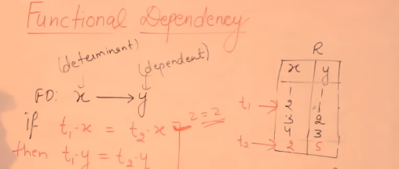
Here,
if t₁x==t₂x <!-- If Any Two row of x have the same value
&& t₁y==t₂y <!-- If Any Two row of y have the same value
Then only x----→y

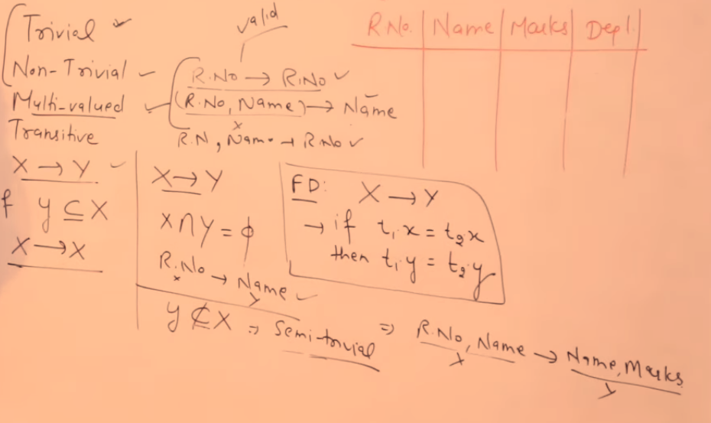

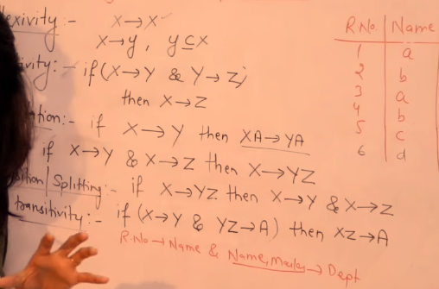
Reflexivity
transivity
Augmentation
Union
Decompostion/splitting
Psuedo Transitivity

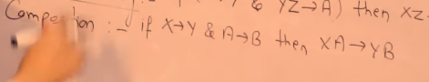


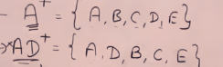
Candidate key
AD isn’t a candidate key,cuz a candidate key are keys in which there is no proper subset in the list of
superkeys.

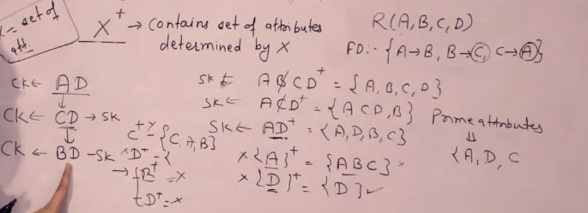
To find primary key or minimal candidate key , delete an attribute and check all attributes are determined, If yes delete that attribute
or
To find candidate key, delete the leaf key only if the leaf attribute Is determined by the some other attribute in the composed key.
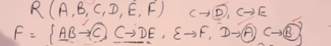

If you got only single attribute, check is it a dependant of some other attribute or attribute’s
for e.g
You got c as minimal super key aka primary key.
AB--→C
so
AB
DB AC <!-- AC is removed
DB is checked whether it’s a candidate key
By checking is there a proper subset that is a super key
D:{A}
B:{}
So our candidate keys are
{c,AB,DB}
Now DB
CB DC <!-- both dropped

Ans:) So our candidate keys are {c,AB,DB}

Functional Dependency functional dependency
-relationship bet two attributes
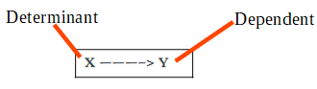
-

for any relation R, attribute Y is functionally dependant on attribute X.
for every instance, the value of x uniquely determines the value of Y.
