YelpcCamp_CRUD
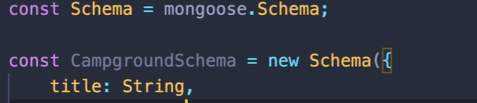

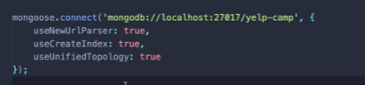

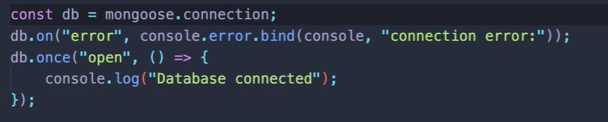
> mkdir seeds
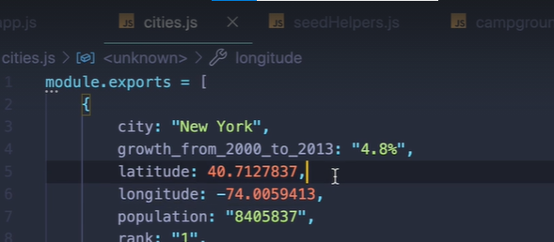

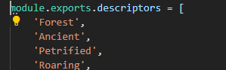

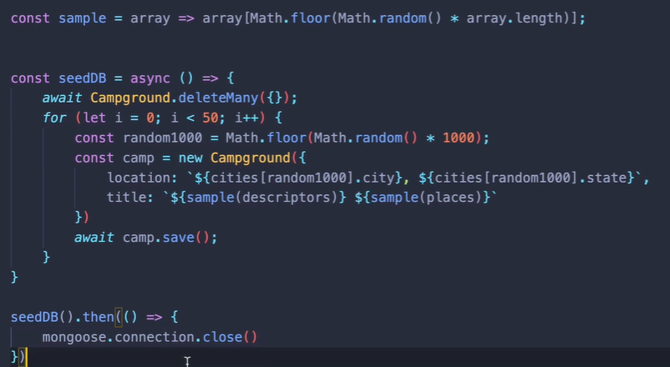

Tip: make seperate folder for each type
for e.g views/campground/index.ejs

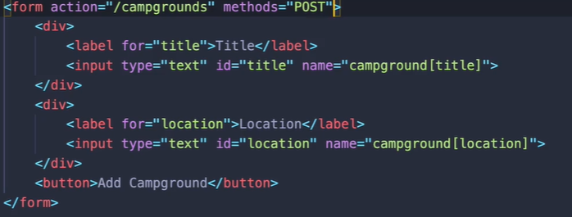

Above, I am grouping things under campground, so if I have multiple campground square brackets, something else, title location, when our data is sent via post request to our express app to the server, everything in the request, our body will be stored under campground.

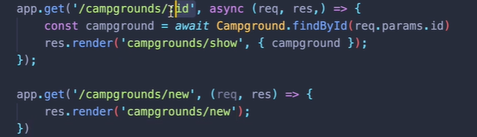
ERROR HERE
The problem here is the order, cuz we have app.get(‘/campgrounds/:id’) and app.get(‘/campgrounds/new’), it’s treating the “new” as the “id”. So we are heading to “campgrounds/:id”
So order does matter
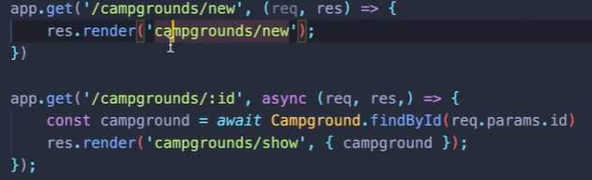
Dont forget
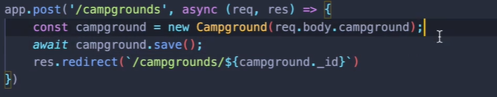
for method override

app.use(methodOverride(“_method”))
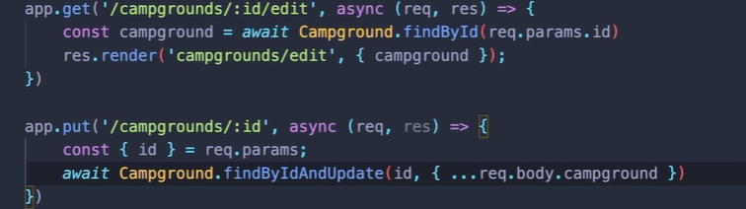
-----------
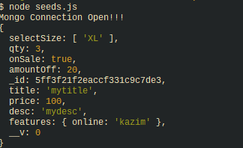
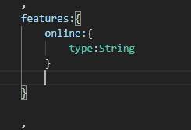
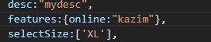

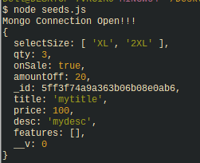
------------
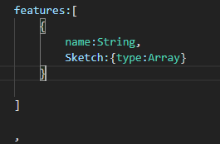
Features is an array

-------
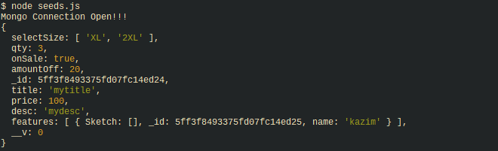
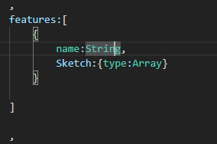

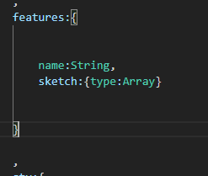
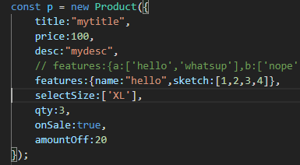
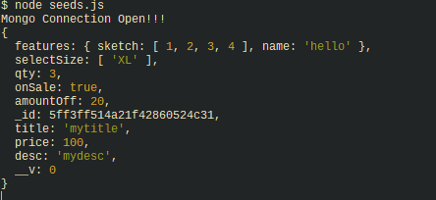

Now if I wanna store smthg like this
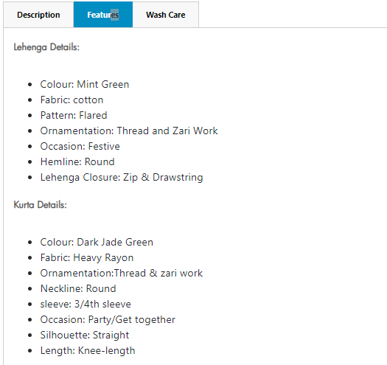

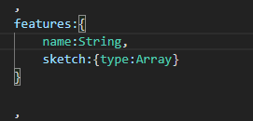
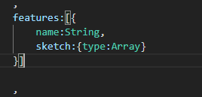
To convert to

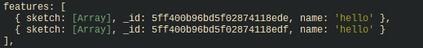
NewOne:

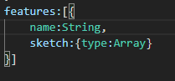
<<< You can now put constraints like enum or type on the key value name and sketch.

You may not be able to when you do
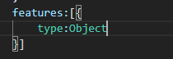

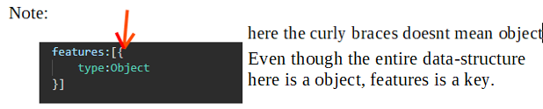

Ejs mate ejs mate
Ejs mate allows us to add some fun useful pieces of functionality to ejs and the one we care about is something called layout. Layout is going to allows us to define some boilerplates where we can have code that we insert in between some content
You can have partials for header and footer and then I have to use include on my ejs. When I can do Instead, if I use this package is I can define a basic boilerplate template that basically everything will use or optionally everything could use and its goind to just have a little variable in the middle called body and I can dynamically add content in there and where
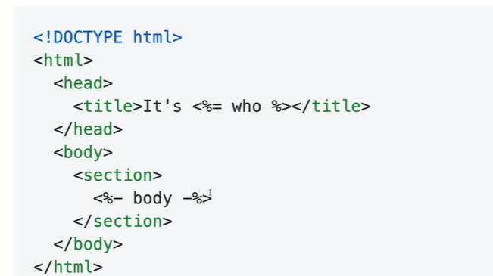
that bodyis .

This is one of many engines that are used to run or pass and basically make sense of ejs, we need to tell ejs that’s the one we want to use instead of the defualt one its relying on.
< keep this L.o.c

>mkdir layout; touch boilerplate.ejs

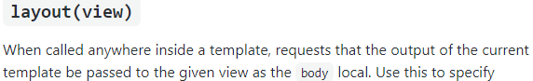
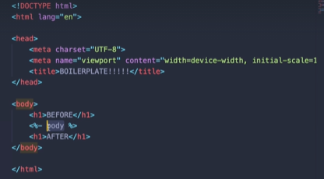

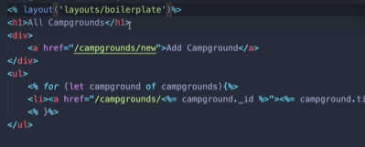
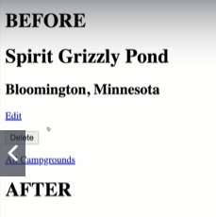

Bootstrap v5
-Remove jquery dependencies

