Asynchronous Js
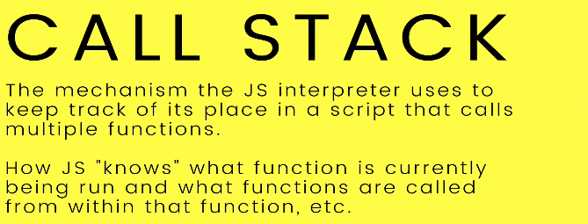
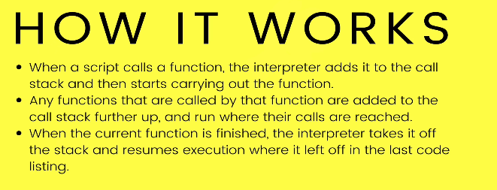
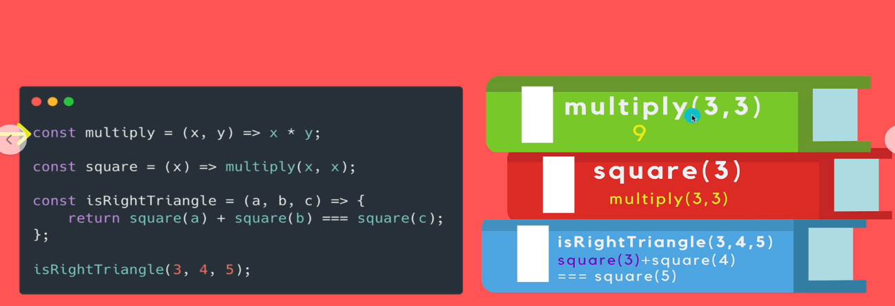

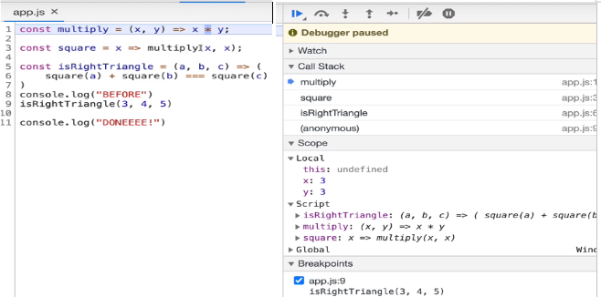

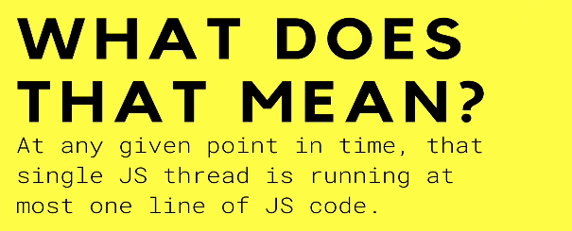


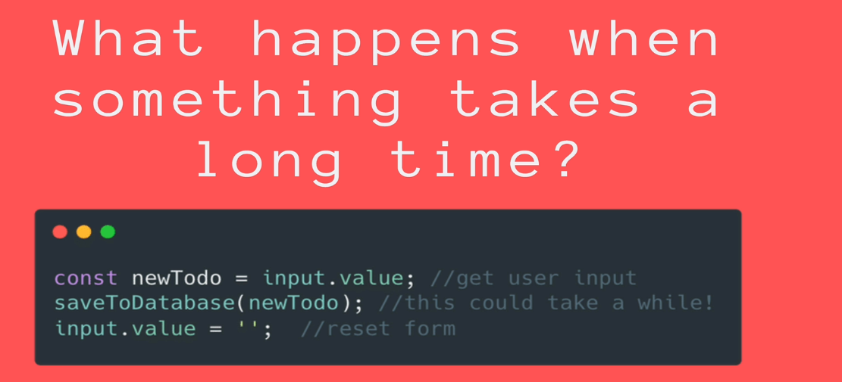
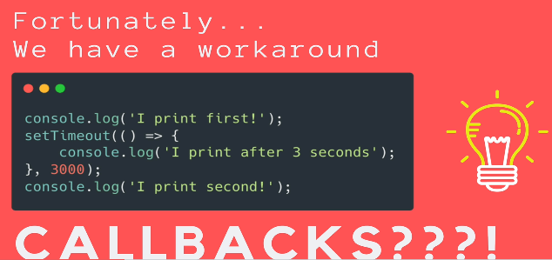
setTimeout is a way of running a code after a delay
If js is single threaded shouldnt it setTimeout just stop everything for 3s
Ans:- The browser does the work
Your browser is written typically in C++, it can do things that js can’t do.
What happen is js, hands off certain task to the browser to take care of.
Browser comes with something called web Api.
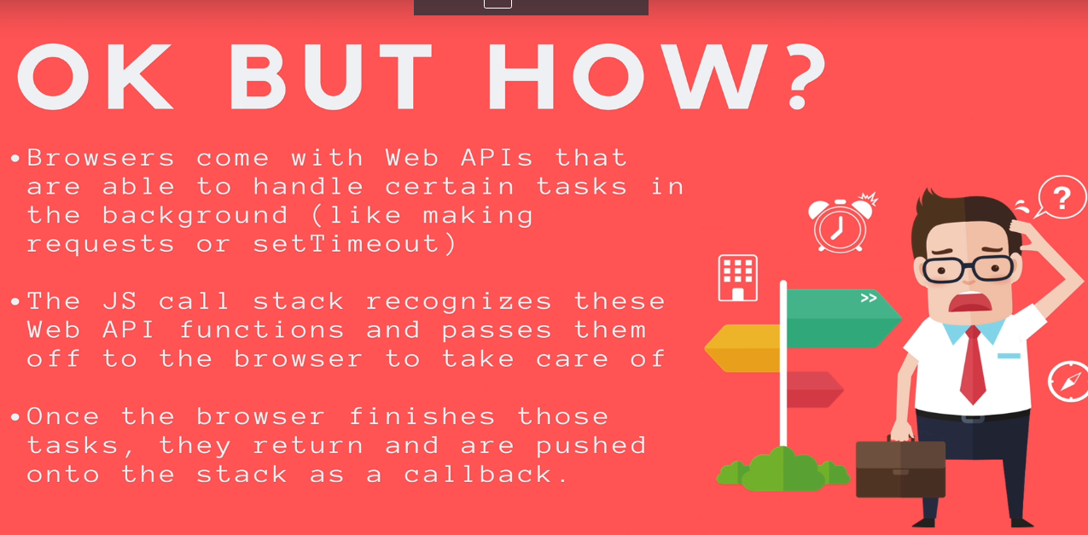
Video:js asyn

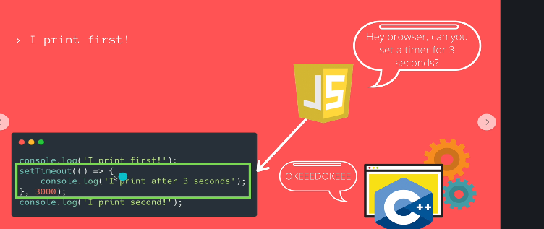
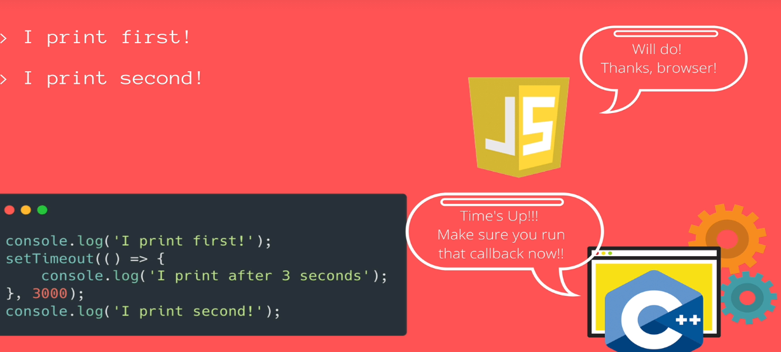
The whole mechanism it works, is just 2 things:
1) The browser comes with function, this thing that browser can do for us aka for js
2)
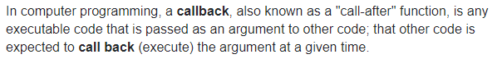
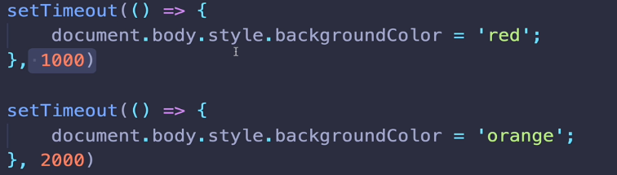
red took 1s.orange run 1s later.
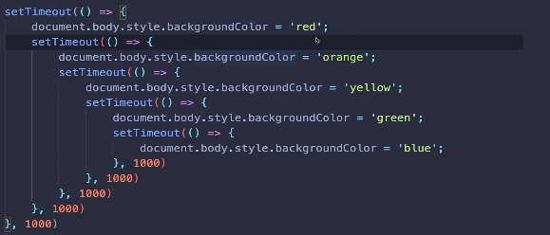

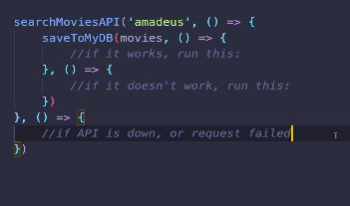

Asynchronous client is when u make a request, say whenever you ready whether you failed or success, just call this function – i am gonna give you a handle aka callback & i am go and do my job.
So there is a thread executing and doing its thing in background.

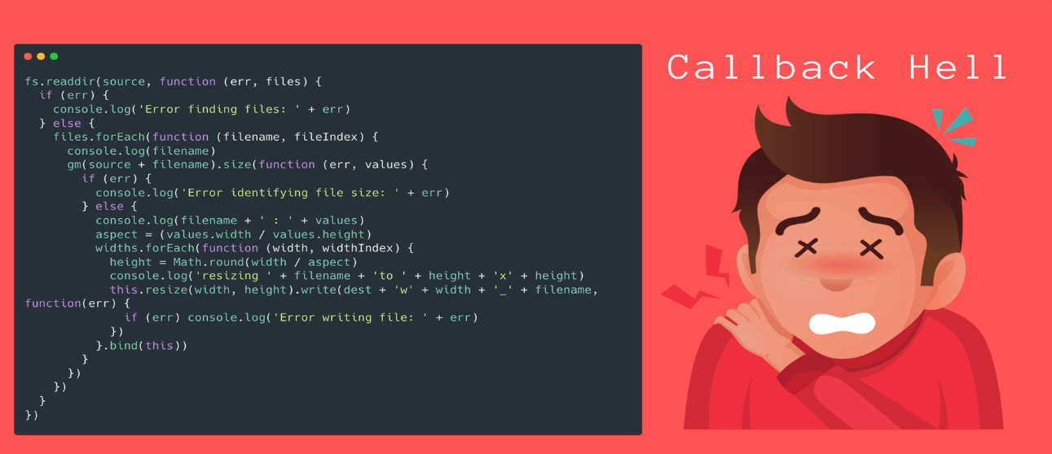
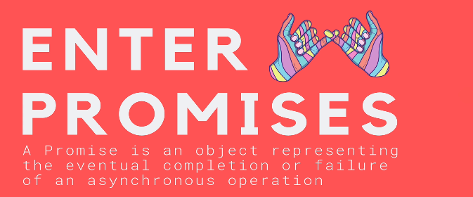
MDN:PROMISE

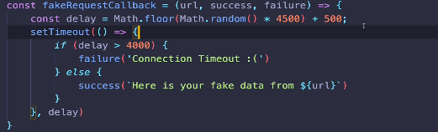

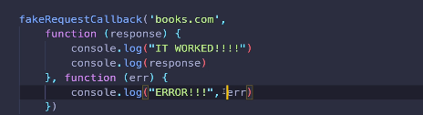

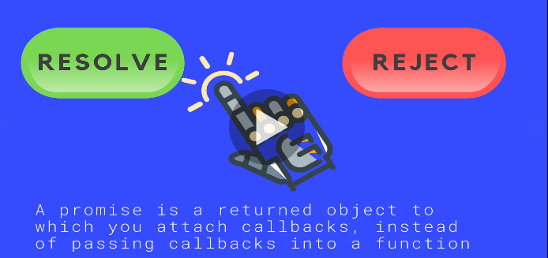
Asynchronous
so pending
and then either resolved or rejected.
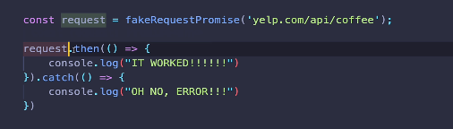

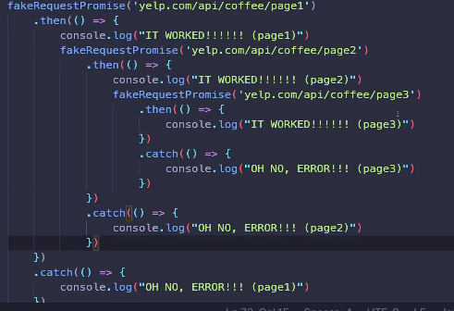

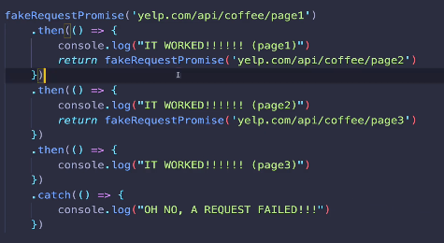

whats extra nice you can catch failure with a single catch().
So we can make no of sequential request.That only if the first one works then the second one and so on.
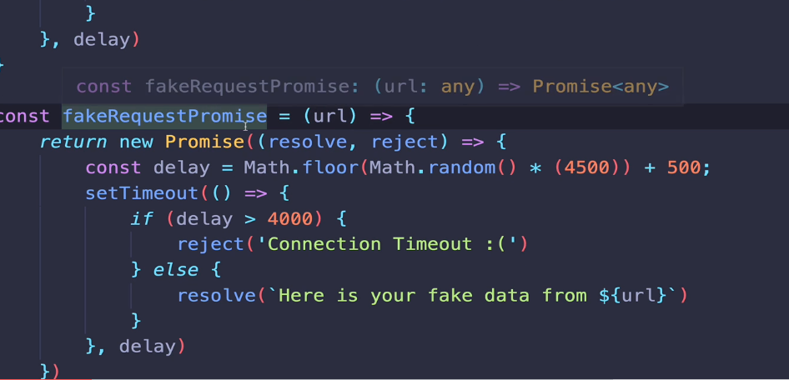

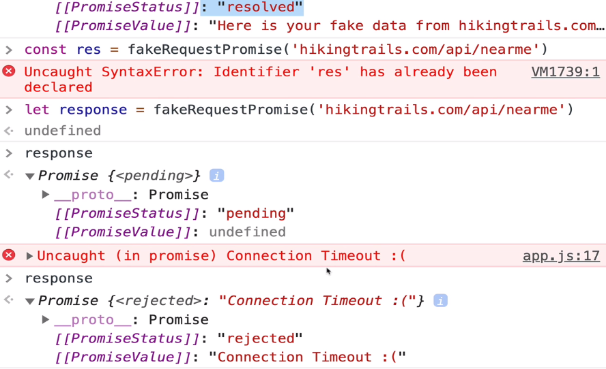

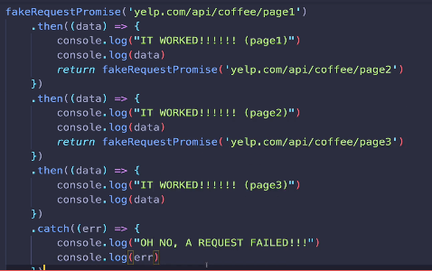

A promise can be rejected or resolved with a value passed to it.
Creating our promises
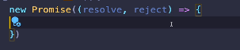
A promise expects a function with two parameters that is called resolve or reject.
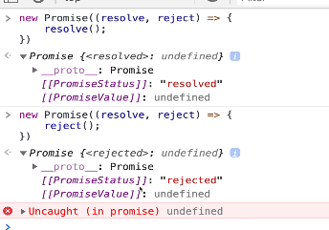
These 2 parameters are actually function that we can call inside our promise.

new Promise ( (resolve,reject)=>{
reject()
})

<<<

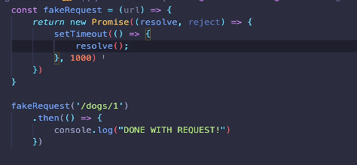
If any parameter isn’t called promiseStatus: “pending”

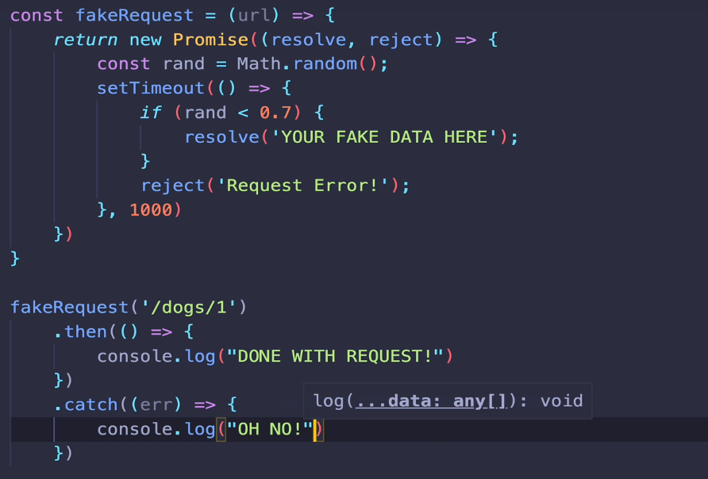
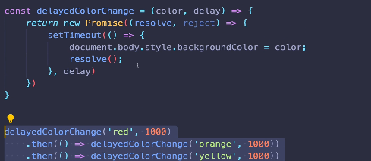

working with them when promises are returned to us, where we calling .then/.catch and passing callback, but the promises will be working with are coming from some library or some func we didn’t write.

Promises Restart

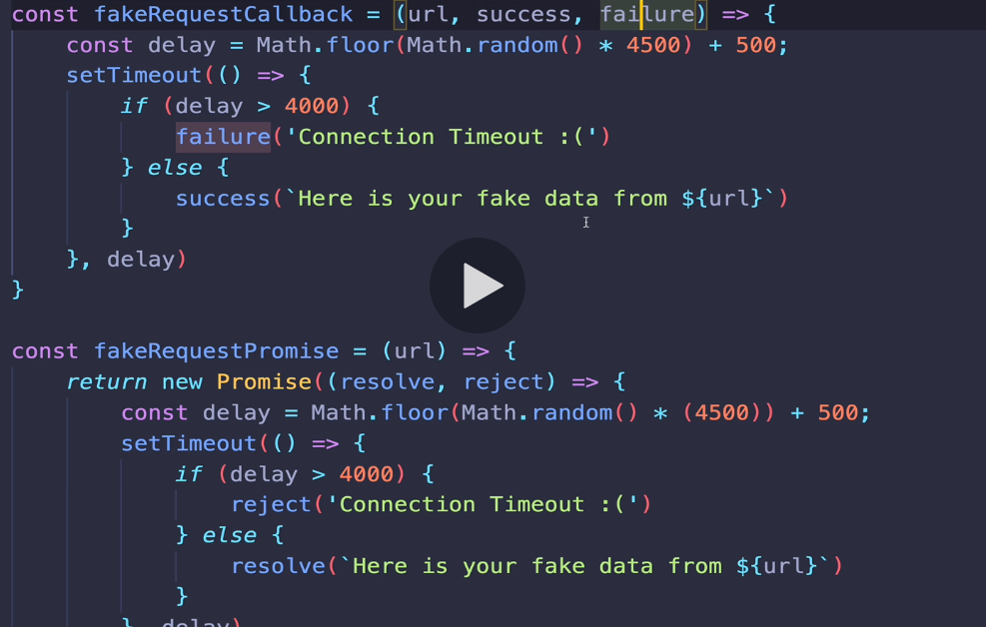
Well, you noticed something it doesn’t expect success or failure. It doesn’t expect callbacks at all.
If You call the func, the return value is a promise.
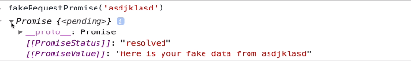

A promise represents a value that is unknown now that may become known in the future. I.O.W a Asychronous value.
For e.g
when you request a ride hailing, the driver makes a promise to pick you up.While you waiting the ride is pending.
In future all goes to plan, the driver will resolve to pick you up & take you somewhere.At which point your ride is been fulfilled. In some cases, the driver may reject your ride that means you need to catch one somewhere else.Either way the original request is finally settled.
As a Developer you wanna create a promise to represent a asynchronous value. But more often than not you will be consuming promises to use the result of asynchronous operation in your code.

Promise create
At start, the promise is in pending state, it’s your job to define a callback func, call the executer to define when to resolve or reject the promise.
This is where you kick off your asynchronous work.
The other side, the consumer of a promise has called it’s ‘then’ method
Then: function that handles fulfillment
It’s waiting for it’s asynchronous value to be fulfilled.
when that happend we will call “then” this func with the value as an arg.
We fulfill the promise by calling resolve.
There is always a possibility of exeception in that case, we can reject the promise and send the error back to the consumer. Which can use the catch method and a entirely diff func for handling exception.
If you want to run the code no matter what, you can use finally() to handle both possibility.
All these method return promises they can be chain together to handle multiple asynchrnous operations in a row.
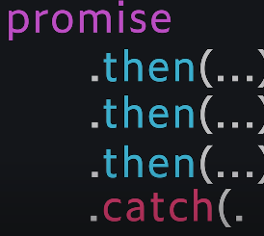

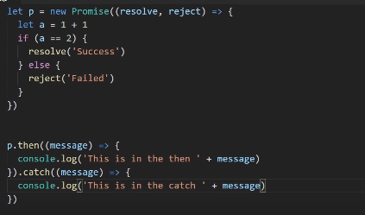

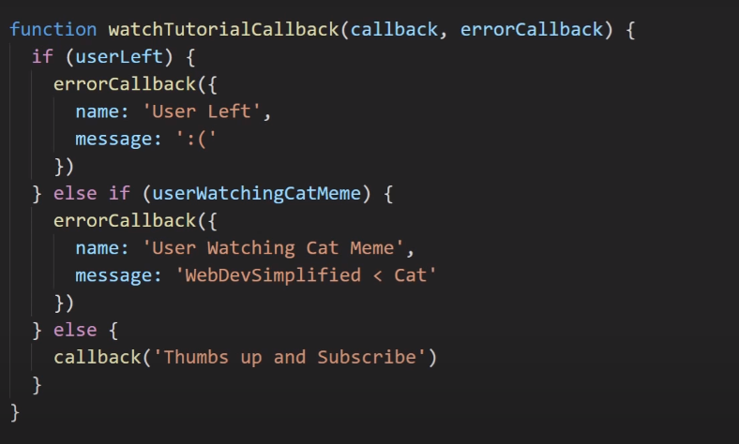

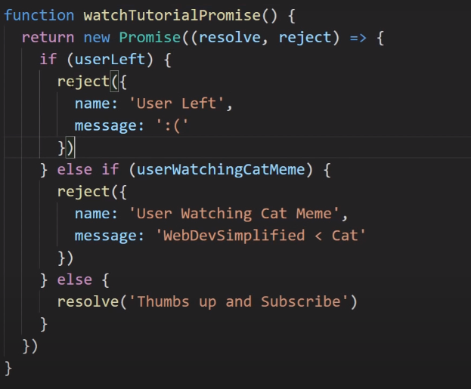

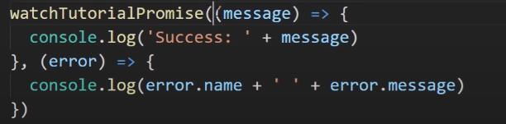
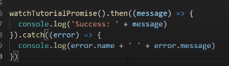

Lets say i wanna do something after i recorded all 3 videos
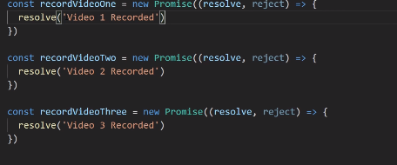

To run all 3 together in parallel, i mean we dont have to wait for one to start next.
So,
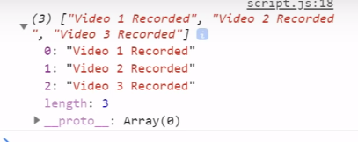

promise.all

All three Asynchronous func runs paralled. If the first one is slower than other2, the other dont need to wait for the 1st one to finish.
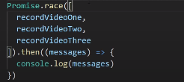
promise.race is like promise.all but it returns as soon as first one9(any) is completed, instead of waiting for everyone to complete.So it will return a single value in fulfilled callback(.then)
The Async keyword
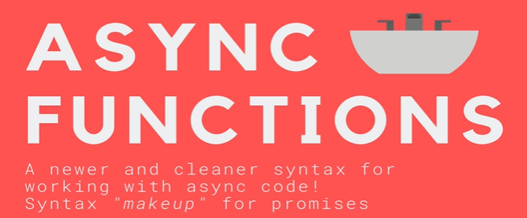
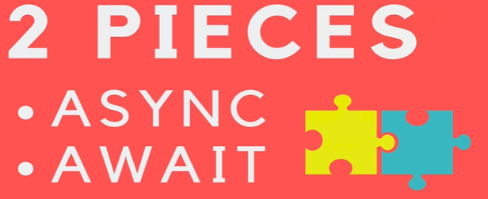
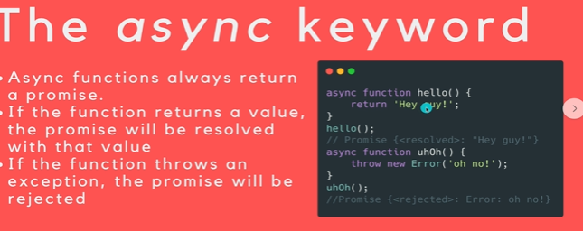
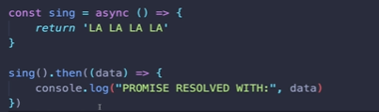

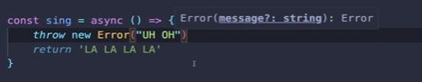

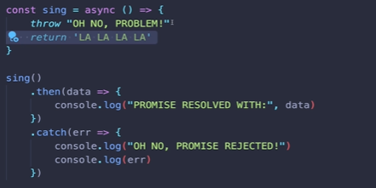

>>>
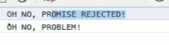

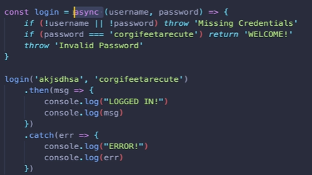

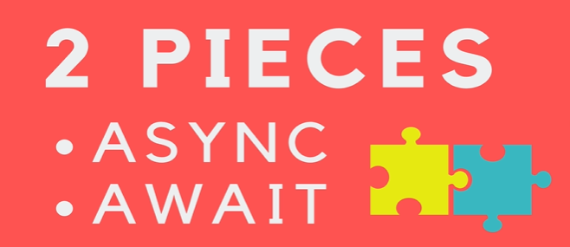
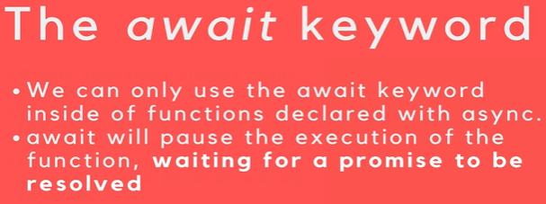
Above, await is by far common use with async.
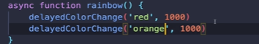

Above wont work, cuz both happen at the same time.
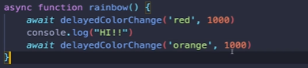

If i we use await keyword, its gonna wait for a promise to be resolved.

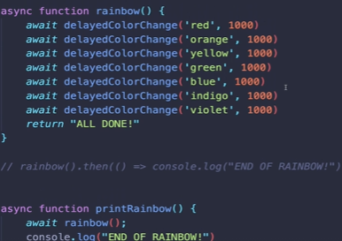

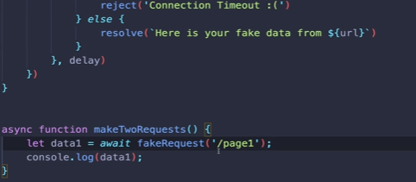

>>>
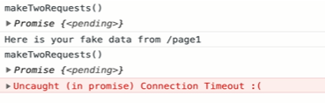

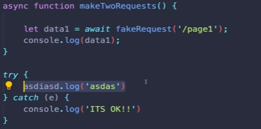

AJAX and API
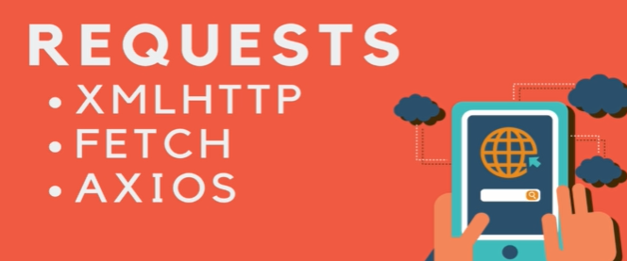

Making request to load information or to send information to save something basically behind the scenes on a given website or on a given application, seamlessly behind the scenes interacting with a server somewhere.
In Reddit, you scroll down, more and more content is loaded and displayed
.Infinite scroll
In devtools > network>
you’ll see any new request has been made on this page or any new info that has been loaded.
Alot of request has been made to reddit server to load new post.
Ajax refers to making request on page while it’s already been loaded or after it’s been loaded, making request behind the scenes.
It allow us to do things that users in the past would have to click around
and you know go to a new page.
For e.g i can do live search.
Whats happening is as i am typing request are being made to a server somewhere.
Alot of time when we are working with js what we want is just data.
So if i want an app that would show you the current bitcoin price every 2mins or 30s whatever. I dont have to refresh the page. I Could use a setTimeout or make a request to this Api below. This is an endpoint that i can make request on, it response back in json
Using js we can load data or fetch info or send data to save progress behind the scene without refresh.

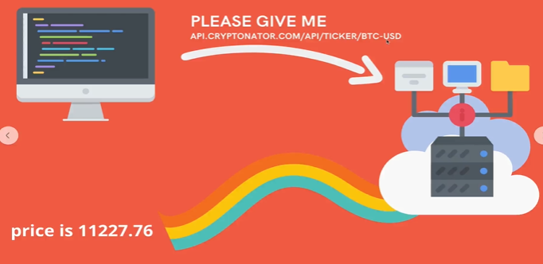

Intro to Api

We know the request response cycle and for typical webpage we are loading html+css+js .
When we make request using js, when we are making ajax request. We are looking for barebone of info. We dont want the html or Css or Js.
We just want the data.This is where API comes in.
It refers to any interface where one software communicates with another software.
Web Api are interface that are Web based.
Companies with api have endpoints, this endpoint response with some info for code or other peice of software to consume. A webapi is a portal to diff application or db somewhere or dataset.
A bitcoin app, every 2min to get new price of bitcoin and display it. Using js update the dom and selcect the element and update the current price.
Api is an interface for our applications.

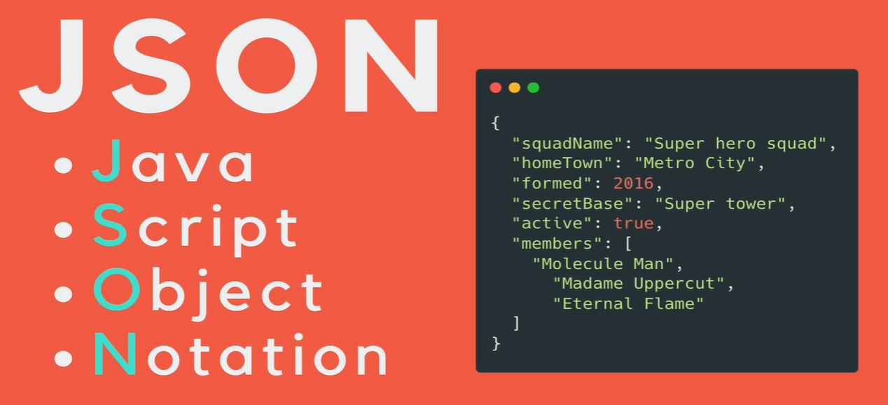
Json.org json_formater json_mdn
Note:
-every key has to be a double quoted string.
-Json doesn’t have undefined, undefined turn into a String.
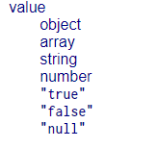

-Json works with other lang such as python, ruby.... and not just js. We still work with api that is json api. They all have their own way of parsing json and turning into python code or js code..
-When we make request to an Api what we get is a giant string.
Json parser
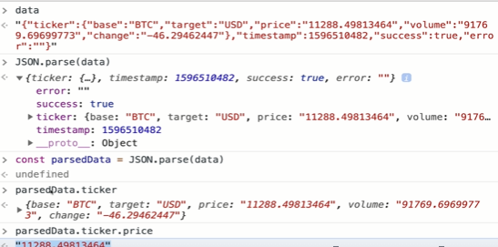

-If we have info that is in js object and we wanna turn it into json.
This is useful when we want to send info to an api
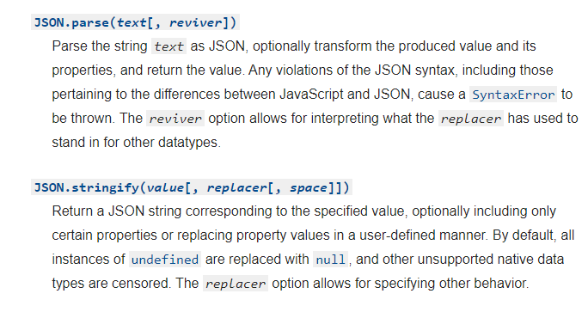
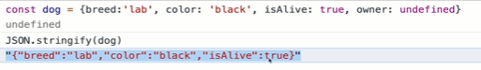

Postman

You can do by going through devtools>network.
We can see the response and header but this isn’t best way.
Doesn’t allow save request and easily modify or redo request.
Post man is a great tool for testing api.
-So much what you do when you work with an Api is reading the docs and tesitng it out and verifying things work as the way you expect and then writing code to make those request.

Http methods:
Get: retrieving or getting info or asking for smthg.
Post: request which we use for sending data that we intent to somehow impact the server-side (insert,update)
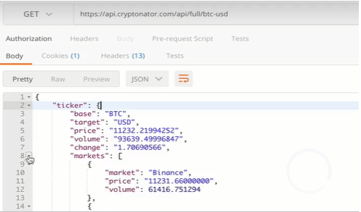

Body is the intended msg and status code
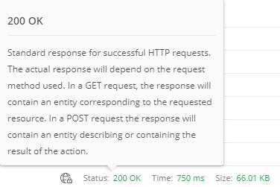

HTTP Status code

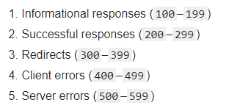

Headers: are bunch of key-value pairs. They are kind of metadata for the response and also for the request.
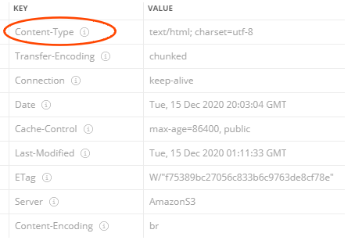

Content-Type:text/html for web resource
Content-Type:application/json response from an api

Query String and headers
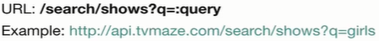

Whenever you see a colon in a URL in Api documentation, it’s a way of saying this is a variable, It’s something that you provide.
?q=<something> <!-- query string

/search/shows which is relative to base url.
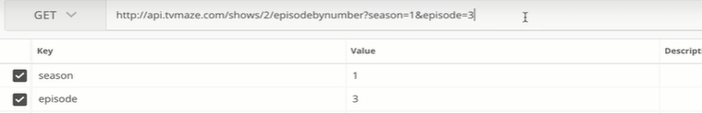
The Api is listening for query string for e.g season it works on. Else which it doesn’t works on, are ignored.

Website
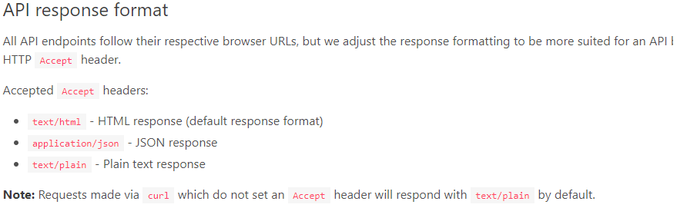

The default it’s gonna response with is html.
Here, we can send our own header

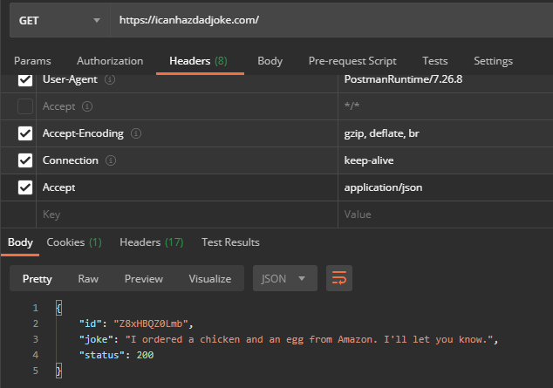
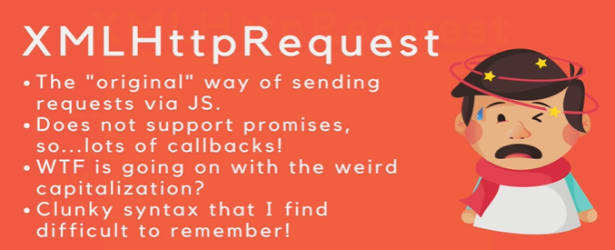
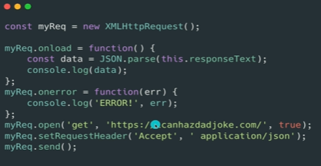

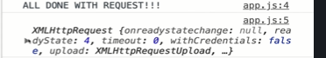

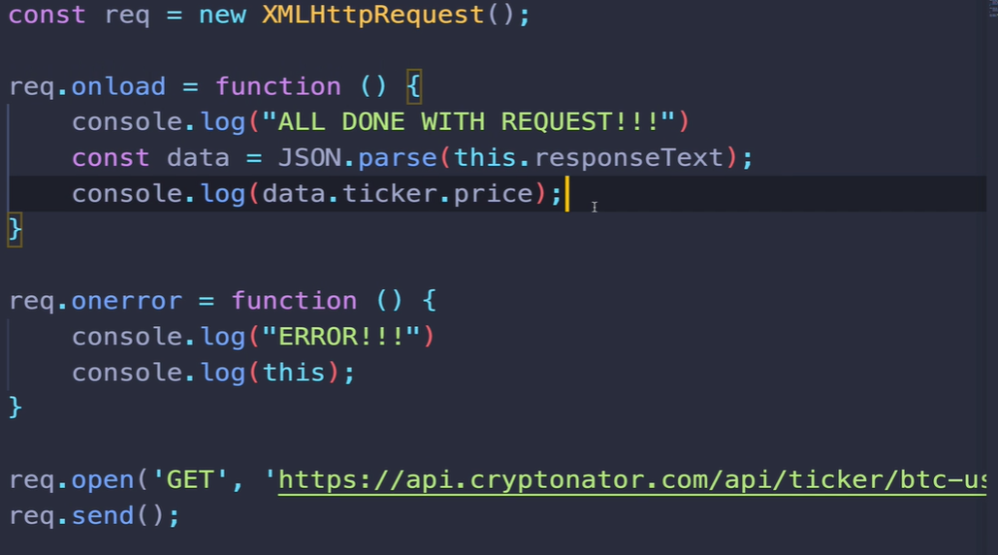
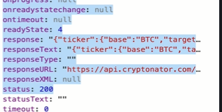

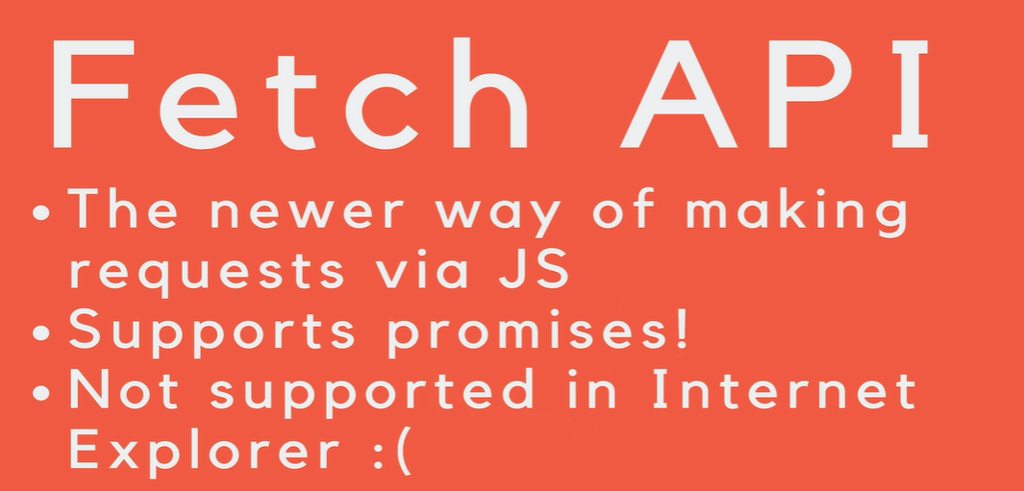
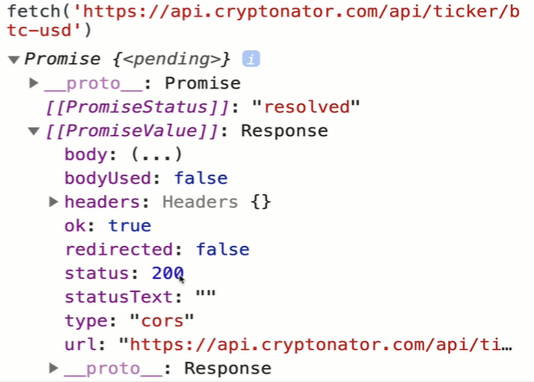

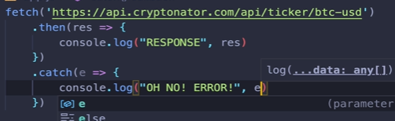

fetch returns a promise.
Fetch Api is promise based so we dont have to worry abt callback hell.
- fetch is gonna resolve the promise, triggering the .then as soon as it recieves the header coming from the Api. So it doesn’t wait all of the data is back, the body is back.
-Information is send in streams, it takes time, all doesn’t arrive at once.
-As soon as it get few bits of headers, fetch is gonna resolve the promise.
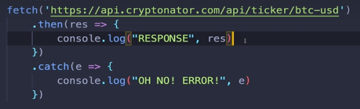
< At this point of
Code i am not
Guarantee to have the
body

That is where, we use a second method, res.json()
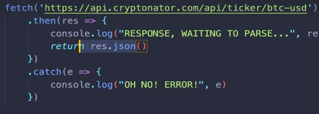

res.json() is another promise and we have to wait for it to finish.
fetch returns a promise cuz it is sychronous it’s waiting for the body to arrive.
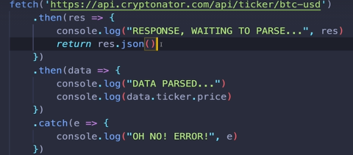

res.json returns a promise.
If you return res.json, then you can chain on.

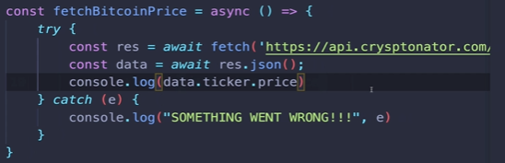
Above was using promises and below was using async-await


github/axios
Axios is a code that some-other people have written that is turn into a library that we can include, which gives us handful of useful methods to make request. It’s built on top of fetch. Using Axios is easier.
For post request, include query string, change headers
You can put the axios cdn in either script or the head. It doesn’t matter.Cuz these are external scripts they dont depend on the dom being loaded.

Axios works with both client side (js) and (node.js) server side where we install lib or import them manually.
Axios is used on both side with the same syntax.
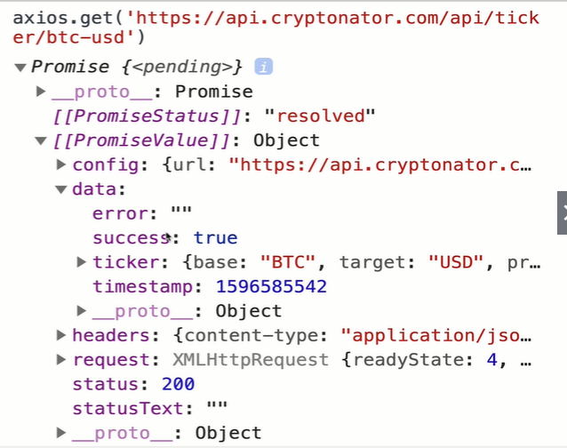

-No res.join() like in fetch
-The promise is resolved once everything is finished.
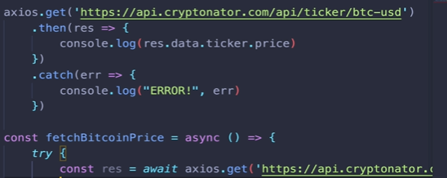
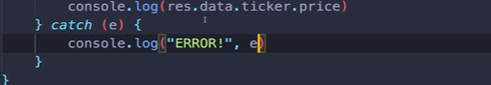

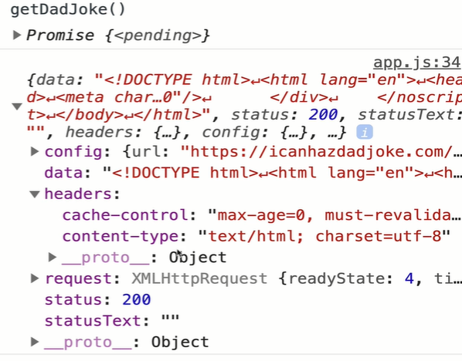

Here, you made a get request on the endpoint, the api is configured so as to use Headers where Accept:application/json to get json . You gotta read the documentation to know this.
To get json, it’s different for Api to Api.
Some may have an endpoint :
‘..../json’
‘.../?type=json’
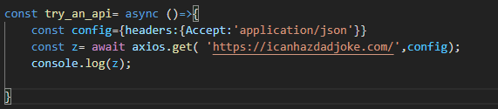

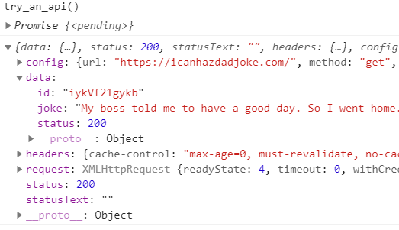

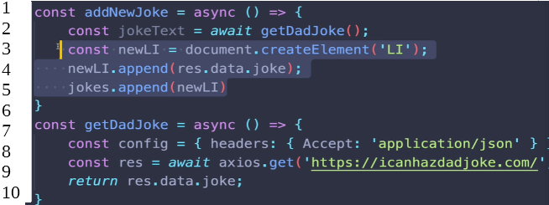
At line 1, There is async cuz we gonna return a promise with some data.
At line 2, Await is used cuz
1.is used in func getDadJoke
At line 9: telling to wait till the json or text/html is resolved and unlike fetch() , Axios only returns promise with data only when it’s resolved.
2. At line 2, to wait till a promise is settled.

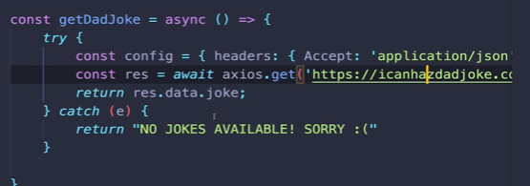



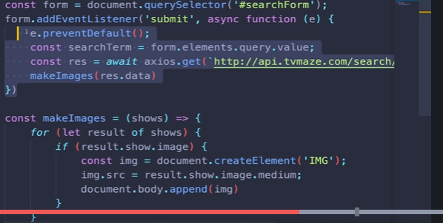
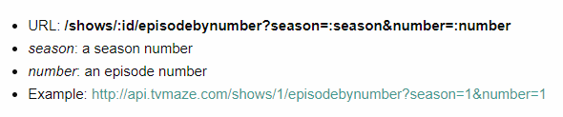
tvmaze.com/api
When you make request to an api, you often have multiple params with data in the query-string Like Above so u does that like below.
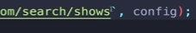
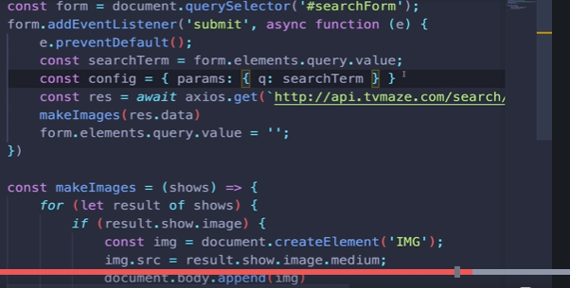

We can also add headers in

for a live search, ppl usually request their own api and or have some functionaliy so they don’t overload an api.

Prototype, Classes & OOP
How does an array and objects have dozen of methods every single time we make.
How do we replicate that functionality ourselves or a method or property in our repeatable and reusable recipe.

Object Prototypes object prototype
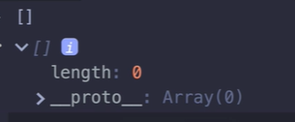

What is this __proto__ ?

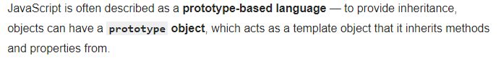
If we look about Array in MDN, we see there is so many methods like
Array.prototype.push()
The push is method isn’t defined as a method on this array.
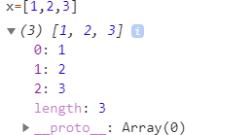
I don’t see any methods right here.

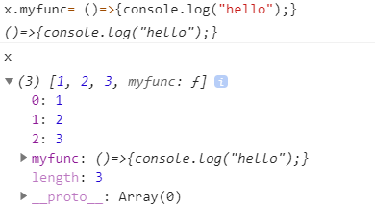
Here, if i add my own func, but i dont see myarray.push() func listed here. So a prototype is a template
obj, it contains bunch of methods that every array have access to.

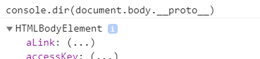

document.body prototype is HTMLBodyElement. There are bunch of properties and methods that refers to this template.
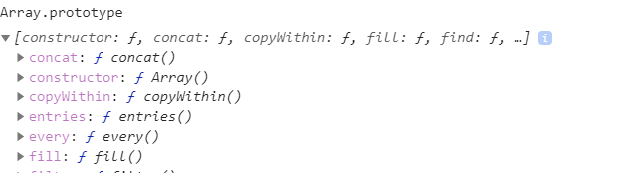
Here is everything on the array prototype, i can define my own brand new object and set its prototype to Array.prototype and i would have access to those array methods.

Prototype are like template objects, they contain typically a bunch of methods, we can create bunch of objects that share the same prototype, so that all have access to the same method.

We can add our own methods and properties to the array prototype
-We also have String.prototype, as we talk abt String are primitive types, in js they all get an intermediate object wrappers.
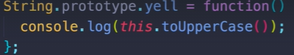

Here, “this” refers to whatever is on left side.
You can also overide template func, pls dont but.

Here this is actual template object where we add methods to all objects of that type.
<<<

>>> this a reference to the template obj

All has to do with one central idea, which is organizing our code, designing and structuring our application, by breaking things up into distinct pattern of objects. When i say pattern of objects you can also think of recipes of objects.
See this page for class and objects:
Even a dom element like h1 is some object created with same cookie-cutter i.e for h1 is called HtmlHeadingElement.

Factory functions
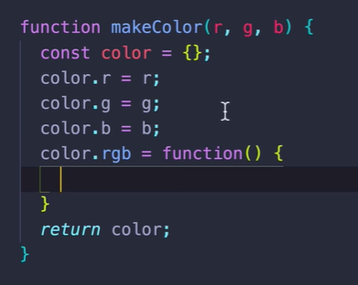
Here, you building up a object hence the word Factory.

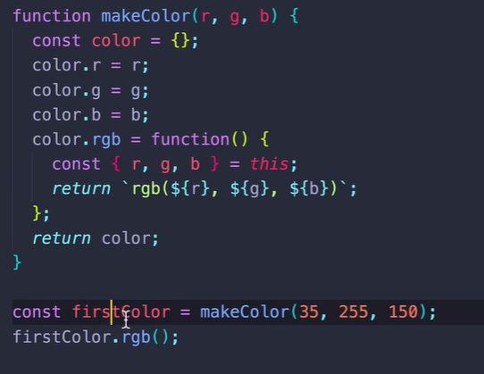
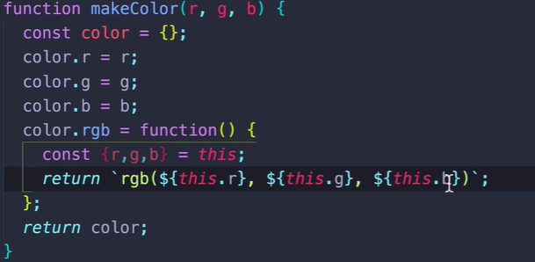

We use Object destructor and this keyword <!-- Very Smart

the ‘this’ keyword inside a func, refers to object calling that func, in above e.g it refers to firstColor.
Here,
const {r,g,b}=this
is Object Destructor where we retrive our wanted properties.

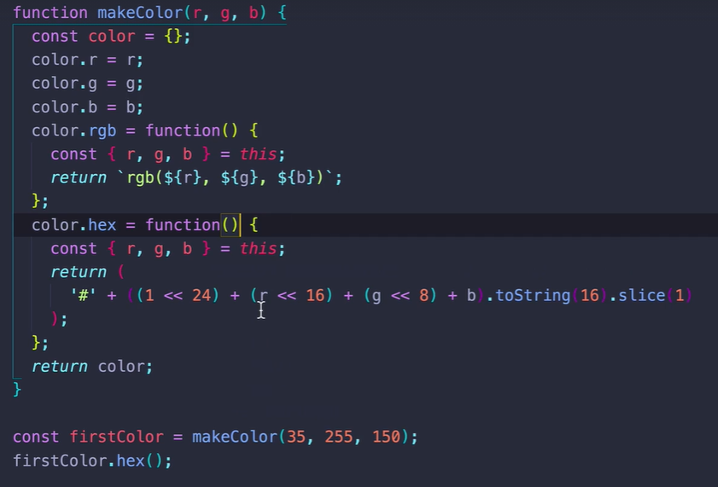
The problem is, you start with an empty object, 3 unique property is added to that object, and these functions are re-created and a unique copy is added to each color object. So each color object has his own rgb func.
The properties is gonna be different for all colors. But there is no reason to have a unique copy of the func itself.
So for everyColor we dont want a own seperate func, which is by work similar to all Color objects.
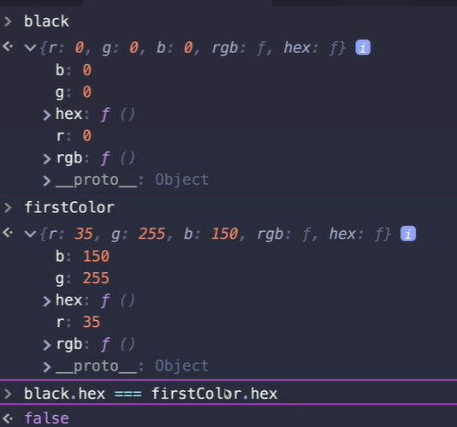

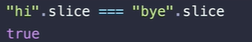

This string “hi” doesn’t have his own copy of slice. Neither string “bye” too.
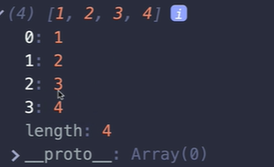

Array built-in methods aren’t defined for individual objects
but __proto__ is used as a reference to access methods from Array.prototype Object.

Constructor functions
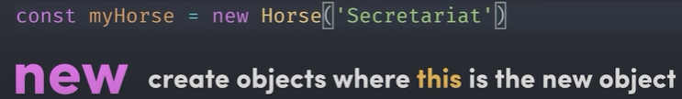
The new keyword allows you to call func that creates an object where this is automatically bound to the newly created object. That means you can create property and methods like many other OOP languages.
So we can define a property name and a func sayHello and use “this.name” to reference the name property in this object.
This is a nice way to keep the data and functionality of the object tightly coupled to each other.
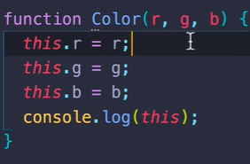
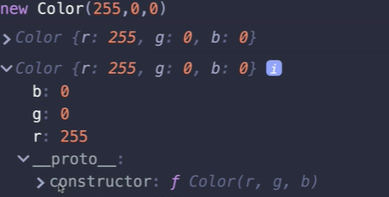

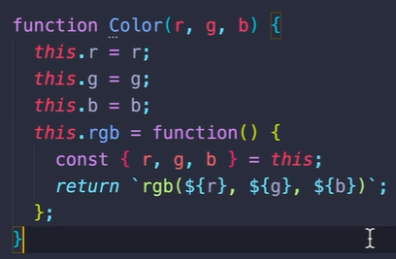

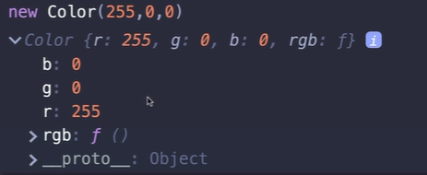

The rgb isn’t defined on the prototype
So,
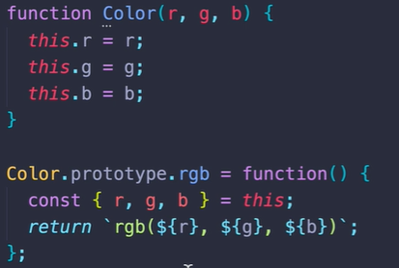
<<< dont use arrow function here.

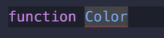
here the function name with capital letter that’s just a way of indicating a regular function. It is a function that helps you create an Object. Its’s a constructor function.

JavaScript Classes

Syntactic sugar is a cleaner, cuter way of writing something that behind the scene is gonna turn into what we have here(smthg not nice)

Using Class benefits are, u dont have to add methods to prototype manually. You dont have to breakup constructor functions and seperately add functions. Cuz you end up with a nice little compact function that explain the property of that object. But then you are OoOo There is also methods, they are on the prototype. They are defined seperately and individually.
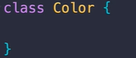
We CamelCase when there is a class or constructor function.
Constructor is executed whenever a instance is created.
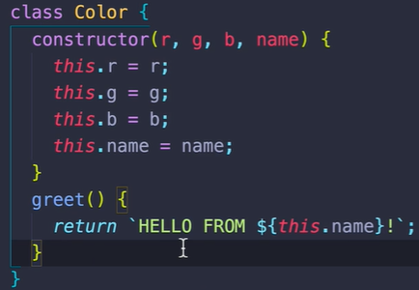

The new keyword allows you to call func that creates an object where this is automatically bound to the newly created object.
Mybook1.getName() <!-- here the “this” keyword insided the func
getName refers to the object calling that function. Anyway “this” was already bing
the object btw.
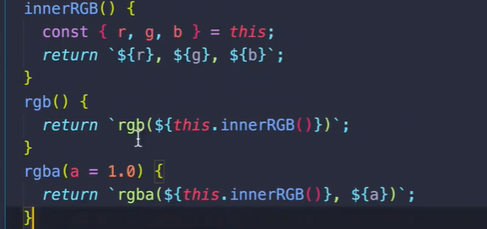
Above is, how to call a method is inside a method during Class creation.

---------------------------
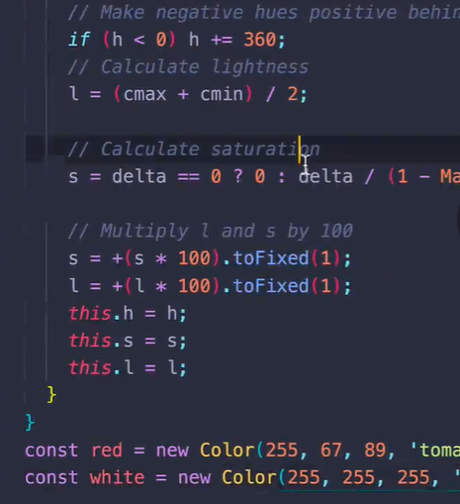
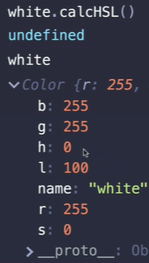
This is a nice way of creating properties when a func is called.

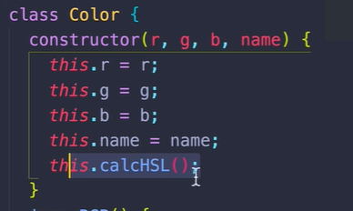
You can call a method inside a constructor.

Extends and Super keywords.

They both have to do with subclasses, especially inheritance.
This is the way of sharing functionalities between classes.


