e.g1 Problem: div penetrates the section
/home/kazim/html5/dump_test/delete1.html
<section><div></section>
So, consider section as a wrapper to hold elements, or tells you its different section.
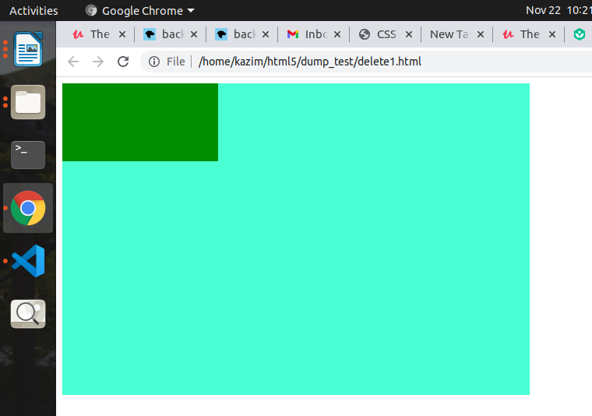
Section{ background-color:aquamarine;}
div{background-color:green;}
So, when hover
div:hover{margin-top:50px}, it penetrates like the section isn’t there.
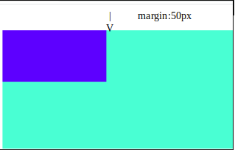

e.g2 Be careful using float file:///home/kazim/html5/dump_test/see_expand.html
e.g3 html vs body vs :root
Regarding specificity
:root>body>html
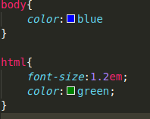

1.if u wanna interfere with rem use html
2.body is wrapper to fit the data so use html as background color
for e.g body vs html background color , body vs html

