Javascript
typeof (2)
>number
To create a variable use “let”
let x=3; <!-- js will append “;” if missing
x+=5;
e.g
5*’5’
>>>25
clear()
num--; <!-- js return the value b4 decrementing by 1.
const pi=3.14;
Booleans
let z=true;
js data-types are totally mutable

Strings
strings are indexed,starting from index no ‘1’
name[0];
>>> k
Concatenation
“kazim” +” “ +”syed”
>>> kazim syed
e.g
let x=’River’
x=’river’
>>>river <!-- here u can’t update the first char but u could reassign the var.
e.g
let x=1;
x+=’kazim’
typeof(x)
>>> string

String methods
x.length <!-- property
x.toUpperCase() <!-- method

x.trim().toUpperCase() <!-- applying multiple func
x.indexof(‘’) <!-- since 0 is for index 0,so -1 for not found.
>>>4
slice is [)
“kazim”.slice(begin-index[,end-index])
<!-- This is the way docs tell us this is optional i,e [,.....] .
begin-index:0 by default
end-index:somvalue-1
“kazim”.replace(“kaz”,”kas”);
>>>kasim <!-- it’s only gonna replace the first matching instance
“kazim”.repeat(10)
>>>kazimkazimkazim.........

Template literals
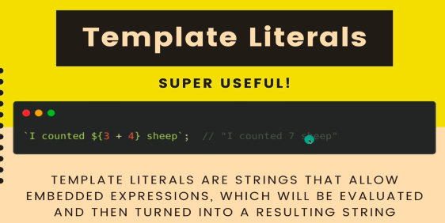

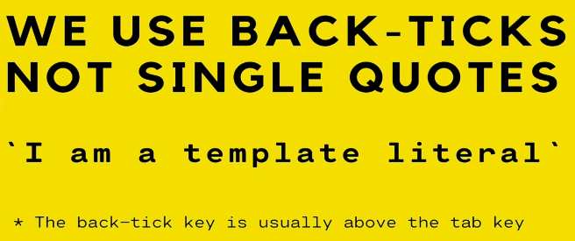

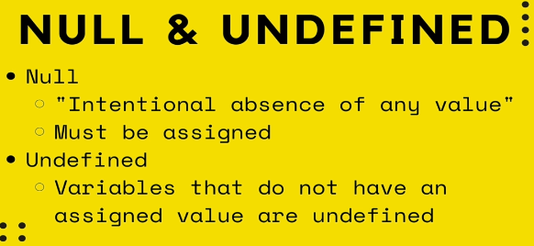
Math.PI <!-- use math class for math related calc
Math.random() <!-- this return bet 0 and 1
e.g
Math.floor((Math.random)*4)) +1
<!-- bet 1 and 5
or
Math.floor((Math.random)*6)
<!-- bet 0 and 5
why is 1 not inside arg cuz
5.99+1=6.999 i.e 6
(5)+1=6
so why then, lol.
‘A’ < ‘a’
>>>true

== equal
=== strictly equal
!== not equals strictly
e.g
5==’5’
>>>true

0==false | null==undefined
>>>true | >>>true

console.log(“hey”,”there”)
>>> hey there <!-- like a print statement.
alert(“”) <!-- just draws attention

parseInt(prompt(“enter a no”)) <!-- takes a input

Note: Always put script at end of the body.Reason is you want ur html load before ur js.

If(){
}
else if(){
}
else{
}

&&, ||, ! <!-- and ,or, not
let x=[] <!-- array

e.g
x=[’jon’,’danerys’,’bran’];
x[10]=’khal drogo’;
x
>>> [’jon’,’danerys’,’bran’,empty x 7, ‘khal drogo’ ]
x.length
>>>11
even though index [3,9] is undefined, the length is still 11.
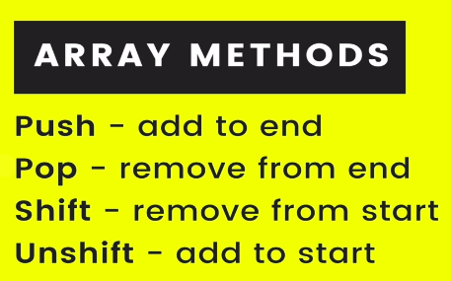

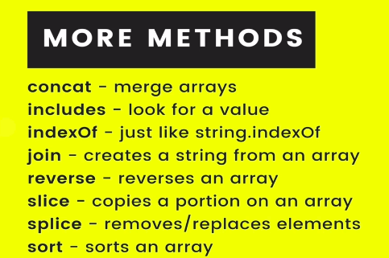

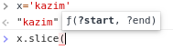

slice: is like give me a slice it cuts offs value within a range.
Push pop add , remove from end
unshift shift add, remove from start
Array
slice(start,?delete count, ....items);
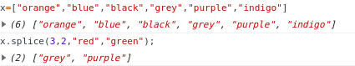

x.sort() is stupid.

Identifier: seq of char in code,identifies a var,f(),property
naming conventions:
What is valid identifier?
- $ , _ , digits
- dont start with a digit

Javascript object literals.
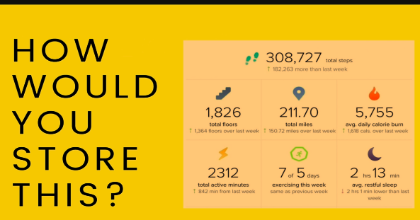

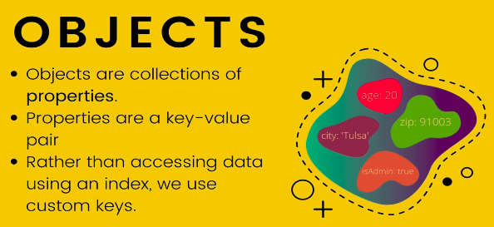
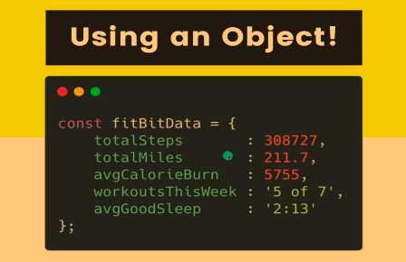

weird
fitbitData[‘total’+’Steps’]
>>>308727

Dot vs Bracket Notation in Accessing Javascript object. Dot vs bracket


e.g

var obj={
123:123
}
Here, this is a vaild identifier in array somehow
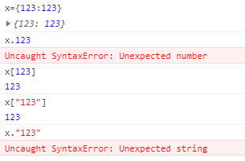

every key is turned into string.
Bracket notation is use whenever property name is a invalid identifier
Dot vs bracket Accesing data
use ‘’ in creation and accessing.
You can access variables in bracket notation aka no quotation also tells why actual numbers works cuz they can’t be variables, n convert it to string.

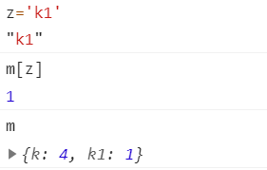

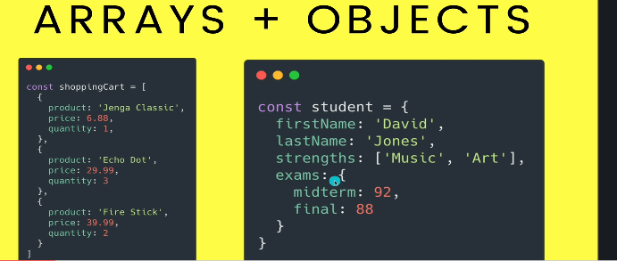
In js, objects are considered iterables.
So use
for (let e in x){statement} <!-- Array negative, Obj positive
instead of
for (let e of x){ statement} <!-- common now
e.g
to get all the keys use
Array Object.keys(testscores)
Array Object.values(testscores)
nestedArray Object.entries(testscores)
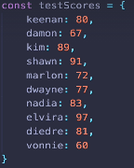

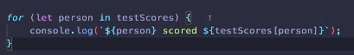

Hoisting is js default behaviour to move declaration to the top.But you should always put declaration before calling.

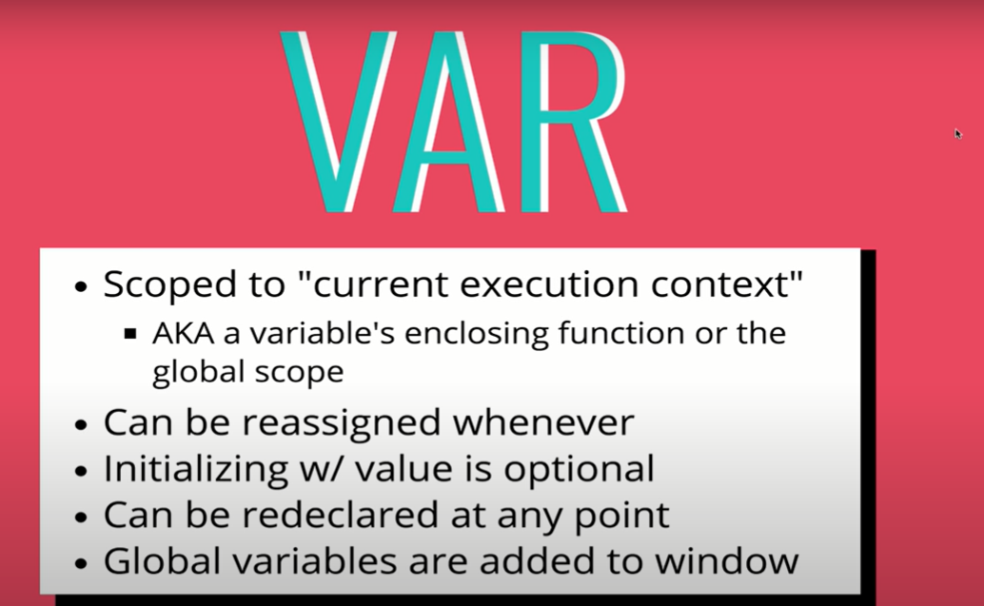

let and const are block scope and var is not.
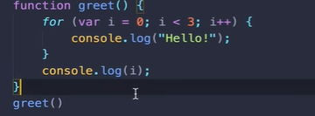

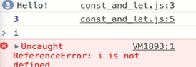
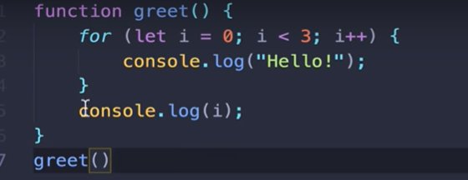
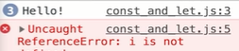

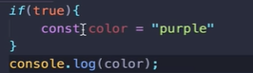
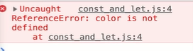

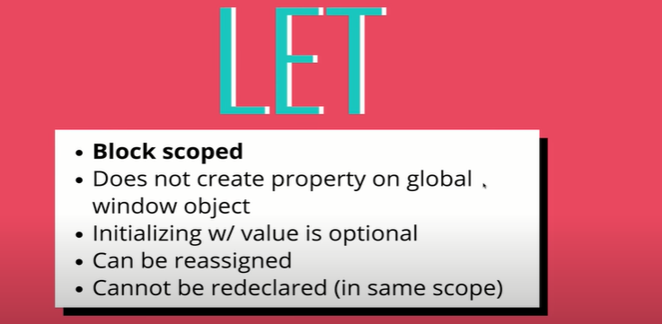
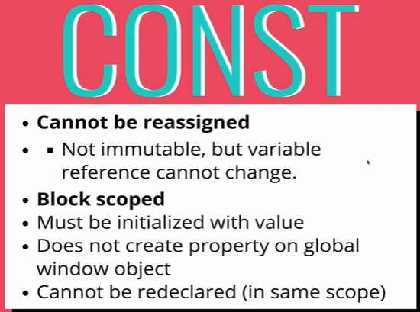

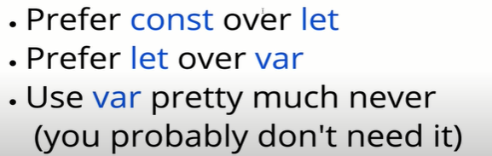

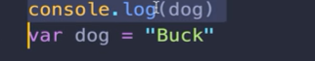
>No error
THIS WORKS
what happen is
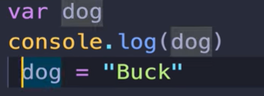
What happen is js is aware of this variable and gives it a value of undefined at the begining before this console.log before it’s initialized.
Your variables are not physically move to the top of scope, Your variable declaration happens first.
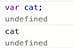
Same as this, its just making space in memory whatever variable you have. Its not that code is re-arranged. It’s just multiple-step process, when your code is run, there is a step of creating space for all the variables in memory and thats is done before they are given a value.
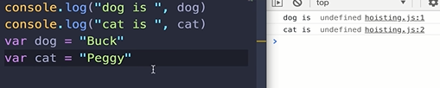

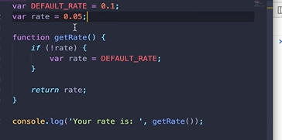

Here, 2 things are happening, one is scope and other is hoist.
The var rate is not scope to this conditional not this block

but this entire func getRate().

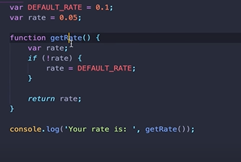
Two var define, the one define inside take precedence.
Easiest way of to get around this problem is to let and const.

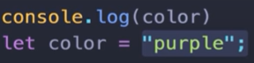
Alot of ppl thing let and cost are not hoisted, thats not true. They are hoisted but they are not assigned undefined.
Ik its confusing.

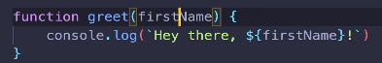

Here, the firstname is called a parameter, the name that we use in function definition.
And when we actually call greet n pass the value e.g
greet(‘kazim’)

argument

for e.g
repeat(name,numTimes){ statement}
<!-- js doesnt care if u didnt give an argument, but if there is use of arg in code it will cause an error.

- when you use ur return statement, You can only return a single value.
Well that one could be an array or object n u have whole bunch of values.
- the func stops when a func return’s.

Levelling up our functions

Scope: variable visibity: where we define our varibles in js impacts where we have access to it.
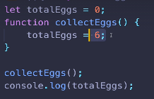
>>> 0
6

changes made on a global variables in a func is global.
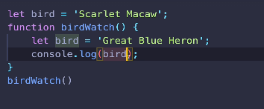

if there is a variable define with the name “bird” in the closest enclosing, we will reference to that variable.if not walk through the closest enclosing brackets all the way to see global variables.
Block scope:
Block scope where the visibility of declared var is within blocks only i.e (anything enclosing except func) like loops and conditional.
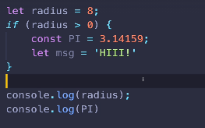
>>> 8
error pi isn’t defined

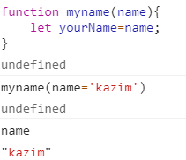

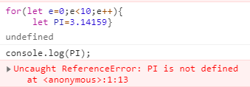

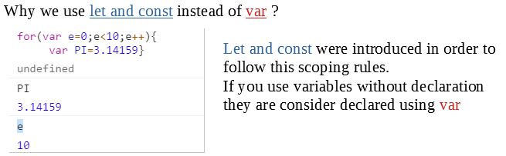
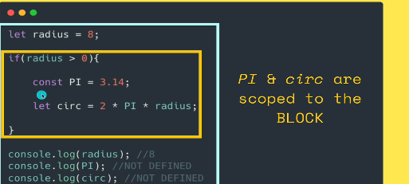

Lexical scope

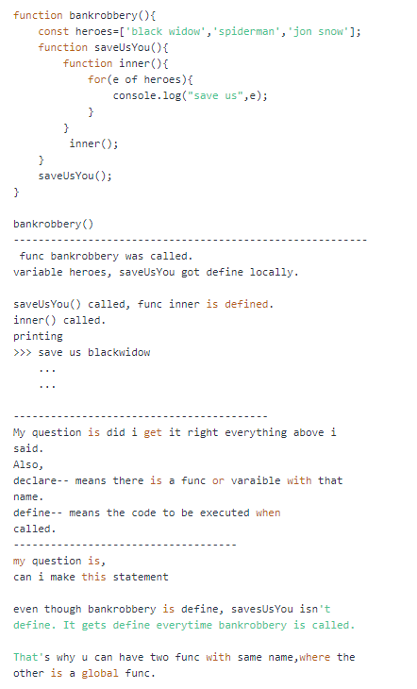

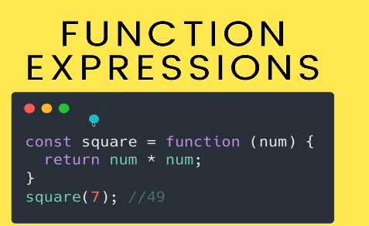

functions are object behind the scene. So we can store them, pass them around.we can pass func as an argument or return functions as a number.
We can use a function as the value in a property in a object.
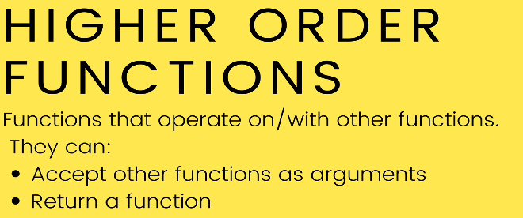

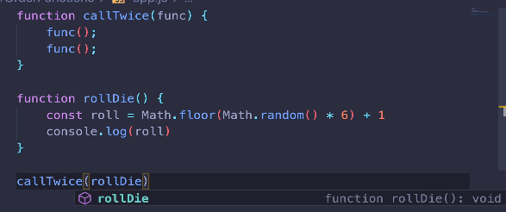
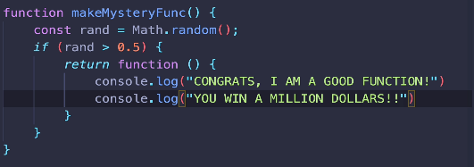

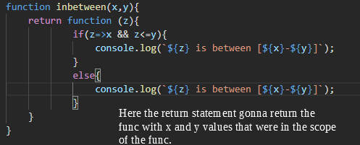

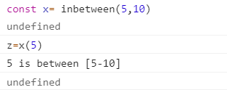

A factory func is a func thats gonna make a func for me.
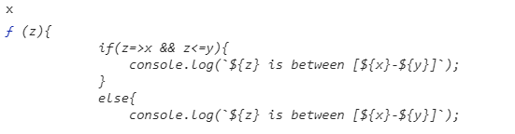

It maynot seem x and y are 5,10 here. They are.

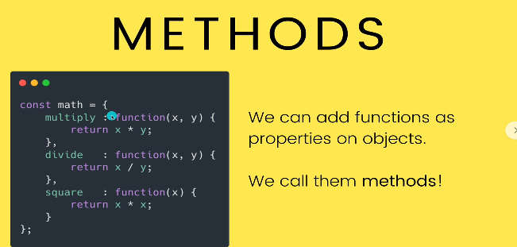
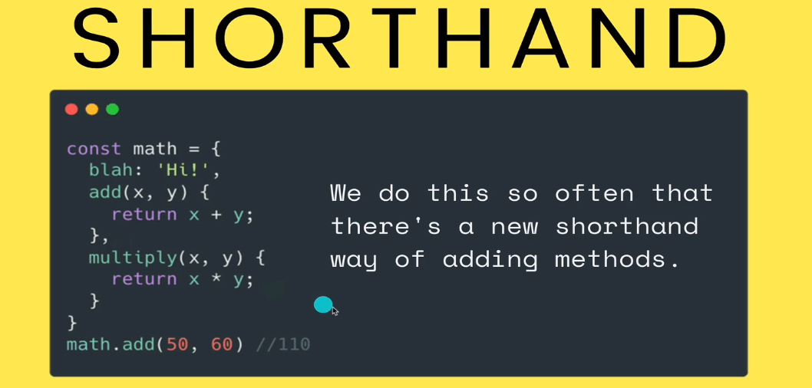
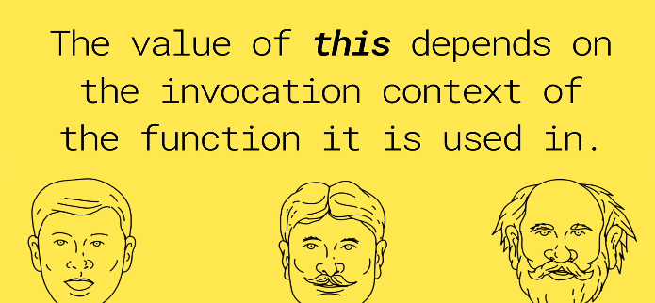

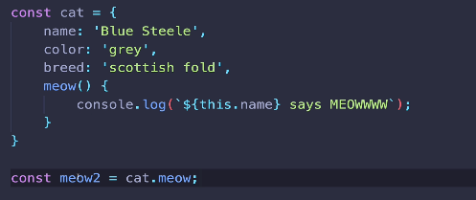

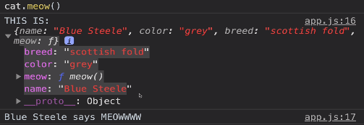

You kinda feel meow2 is reference to the same object.
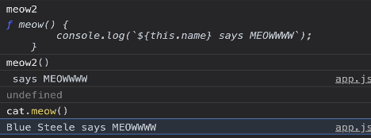

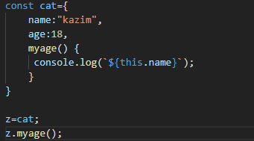

It’s different.

Why different results?
The difference is in “ The value of ‘this’ depends on the invocation context of the function it is used in.
When we invoke the func cat.meow() , ‘this’ refers to the left of the ‘.’
and
when i ran meow2(), the keyword ‘this’ isn’t gonna refer to cat object.
It refers to window object i.e top level object or root object.
It is a pool of all objects.
Try,Catch
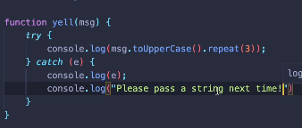

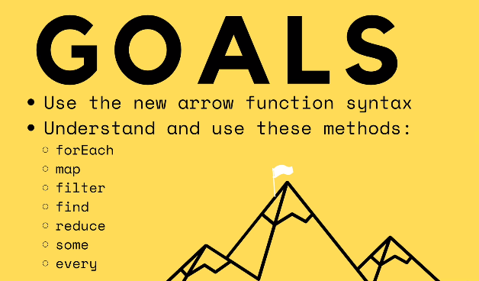

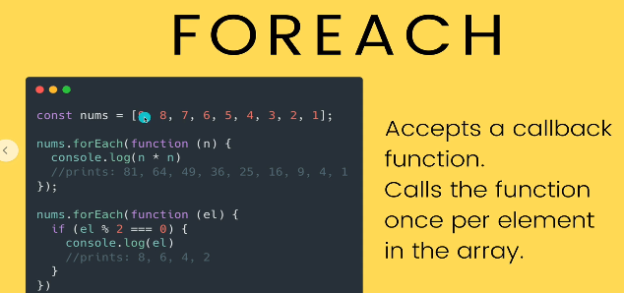
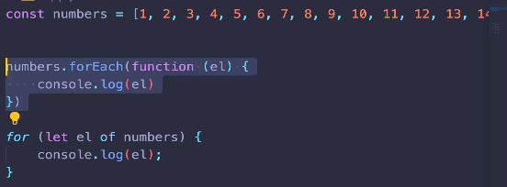

for each is older way of looping.
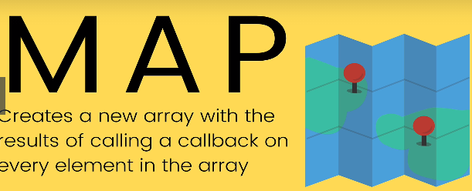

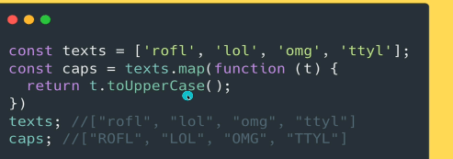

Arrow functions:are newer alternative i.e more compact to write functions
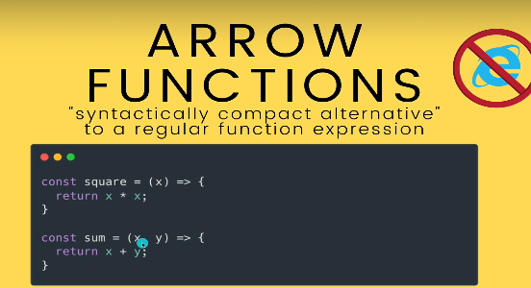
If you have no parameters to input, you still have to give empty ()
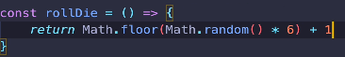

You can only skip paranthesis when there is only one parameter.
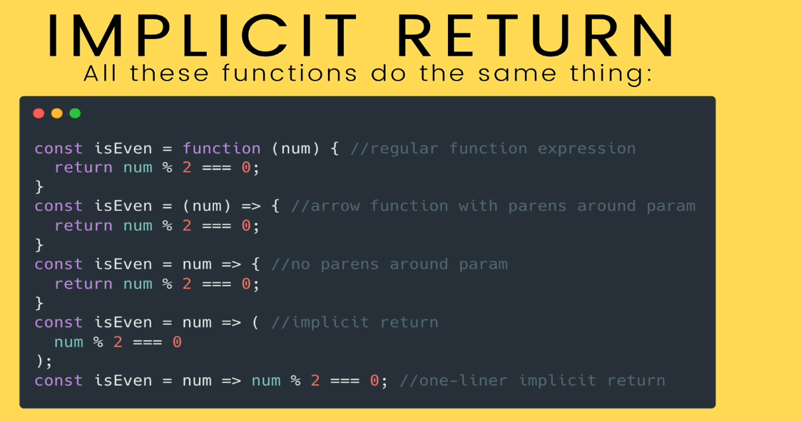

SetInterval and setTimeout
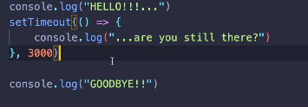

>>> Hello
GOODBYE!!
... are you still there?
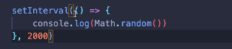

setInterval runs that func every 2s.
So
0.12132421
0.4231313
0.5323324
...
...
...

How to stop? Is by using #id and how to do that
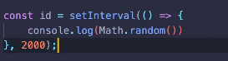

i.e
clearInterval(id)

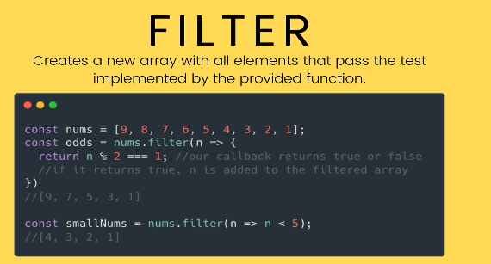
You can also indent
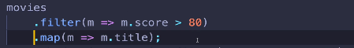

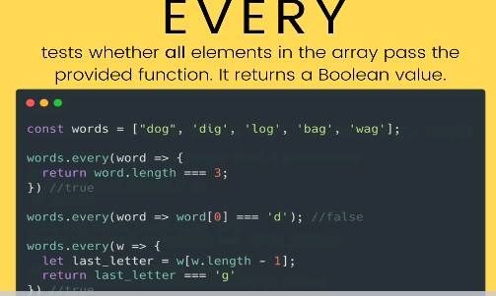

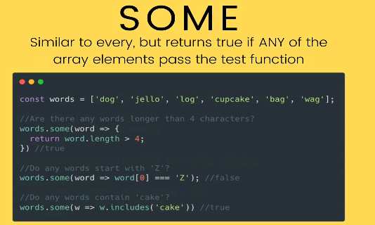

So, some and any are like filter but with AND and OR operator.

Reduce
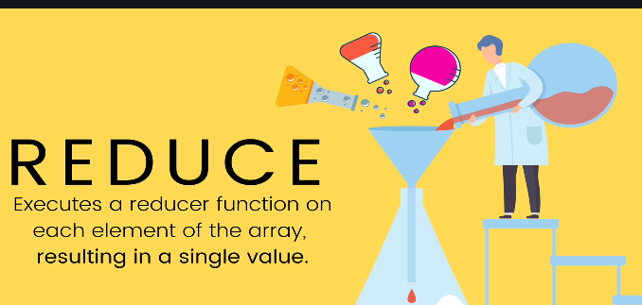
how it does that, is up to us.
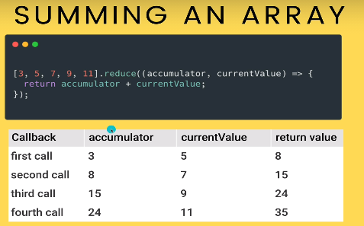
We have to provide a Reducer func wher we have 2 parameters.

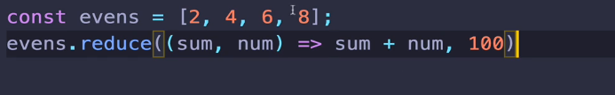
Here, we are setting the inital value of sum i.e 100.
Arrow function and this
youtube video
at time 5:52,

Use arrow func with ‘this’ keyword.
They allow you to have access to this keyword that in this case refer to person object within the func.
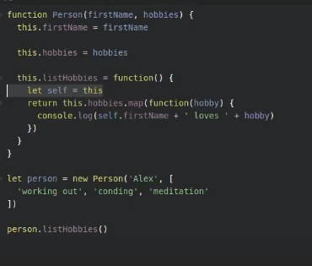

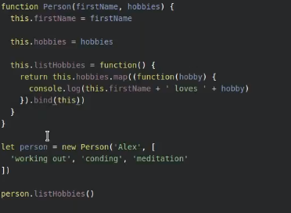
basically the bind tells the this keyword is the same this within the outer func.just like above

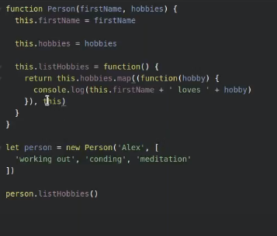

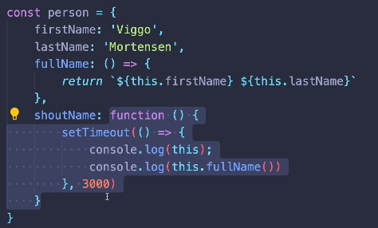

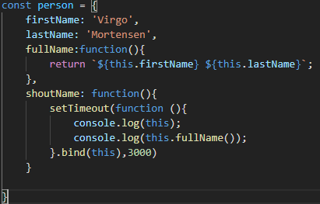

Inside an arrow func, this refers to where the function was created so,
considering person so at level 0 i.e window
whereas in non-arrow func, it works fine.
window.setTimeout() > function ,this doesn’t make sense cuz it looks at window level.
So using arrow func will take us out n look where the func was created.
i.e at level 1. i.e window.person.firstname.
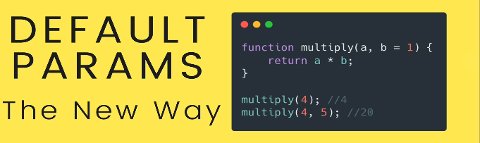
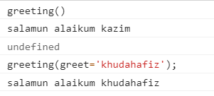
Here, i try to change ‘greet’ but it change the ‘name’.
Tip: put your tobe default paramater to the end.so if u dont pass it doesn’t get taken by other parameters.

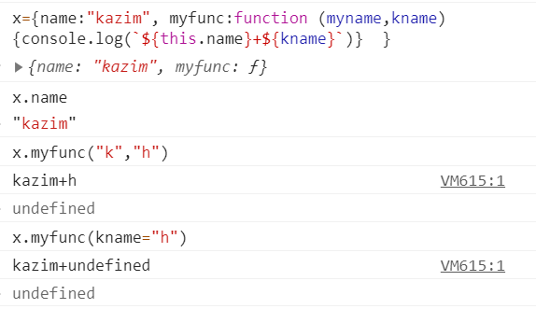

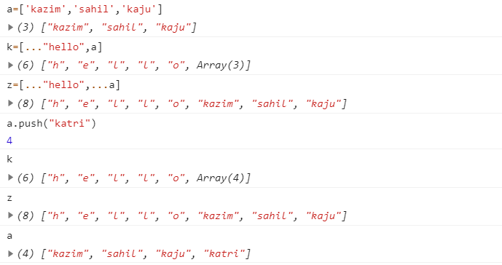
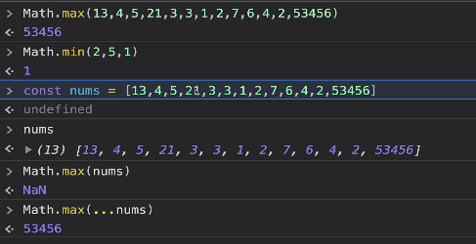

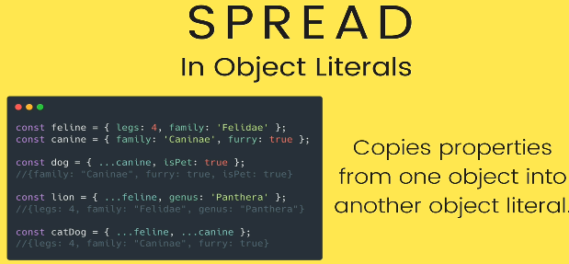
if there is a conflict, the newest property wins.
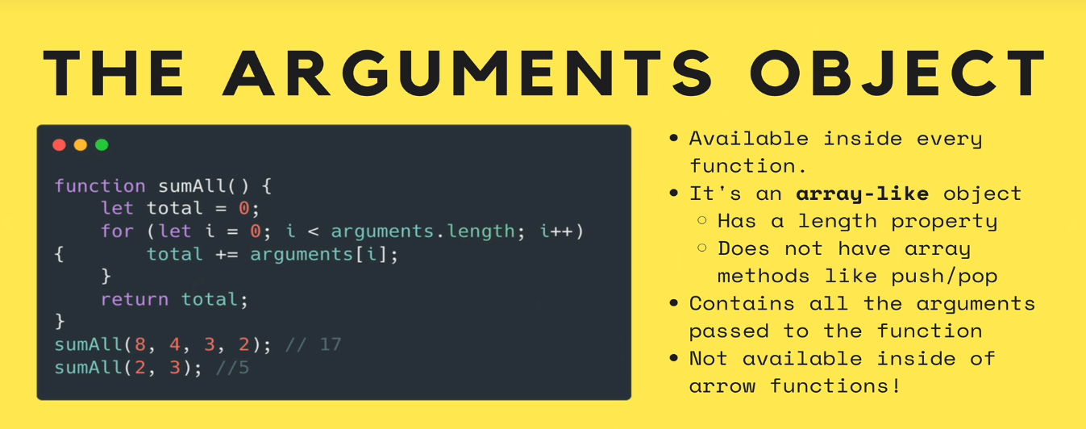
In arguments object isnt an array. so you can’t use map,reduce,sort.
So what you could do is..
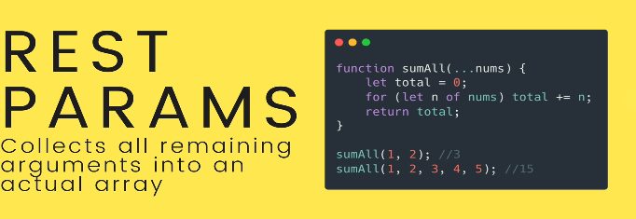

function x(num){
...
}
x(3,5) <!-- here num is 3 and 5 is ingored.

function x(...num){ <!-- here all arg are considered and put in
array
console.log(num)
}
x(3,35,12,22)
>>> [3,35,12,22]
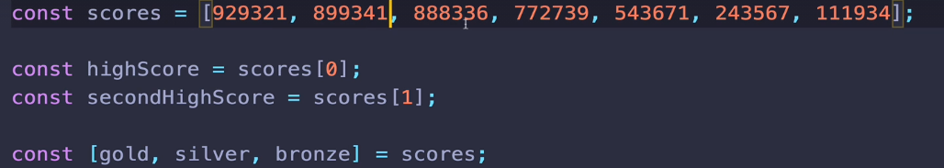
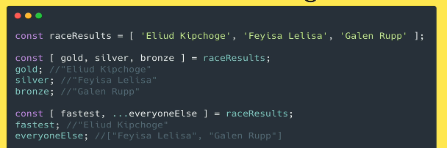
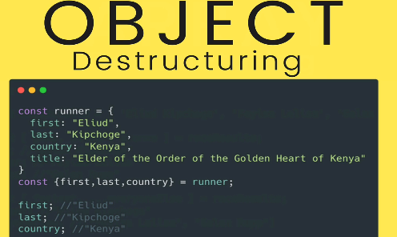

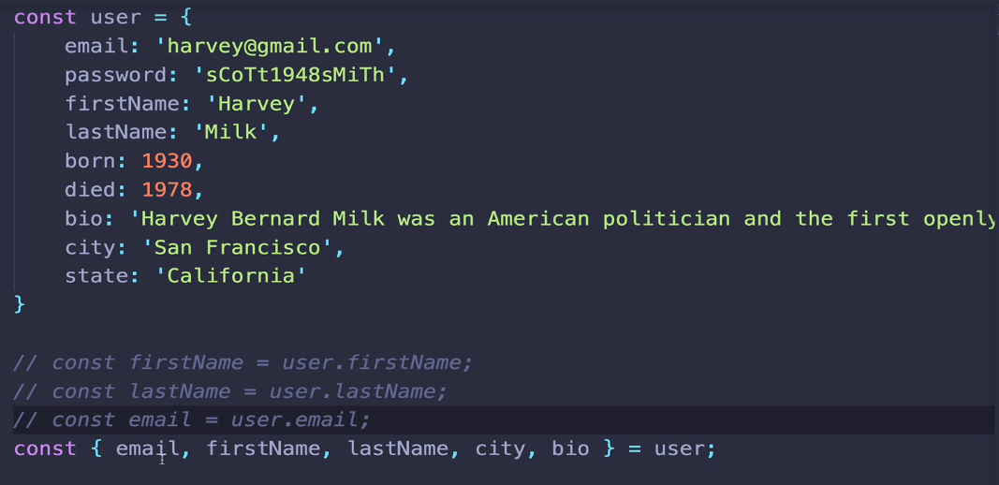

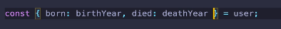

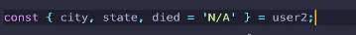

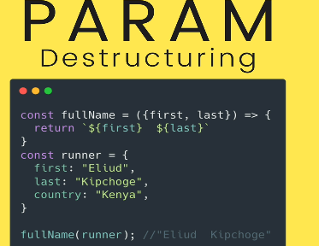

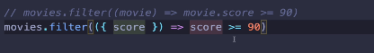

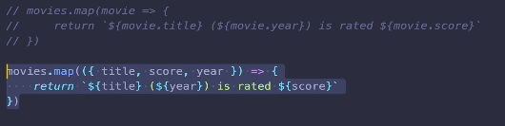

SCOPE

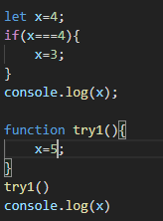

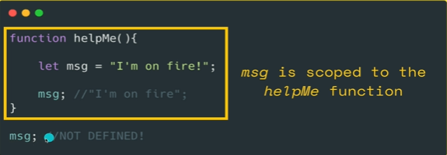
variable defined globally are mutable in any enclosing brackets.

Var is scoped to the enclosing function if they are not they are part of the global scope.
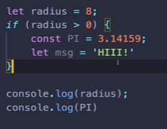
> 8
error

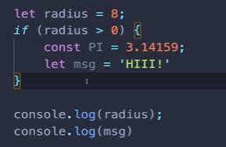
Block refers to any time u see curly braces but except for a fucntion. Block includes conditional most commonly but also loop.

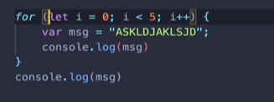
When i use var, my variables are scoped to function but they are not scoped to block.

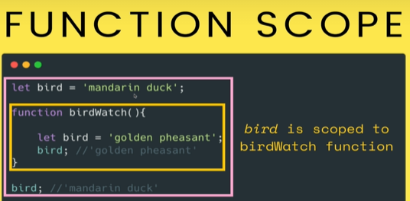

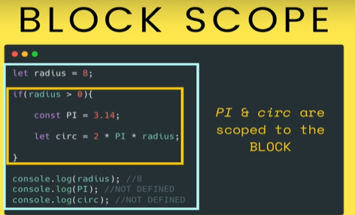

Lexical scope

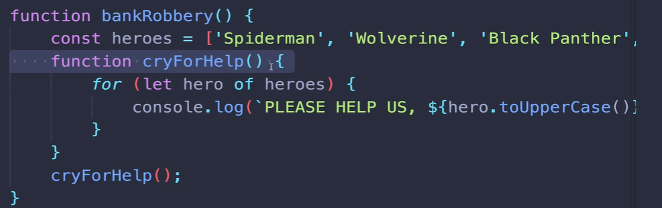
Some inner func nested inside a parent func has access to the scope the var define in the scope of the outer func.
Above works as you imagine
but what about below e.g
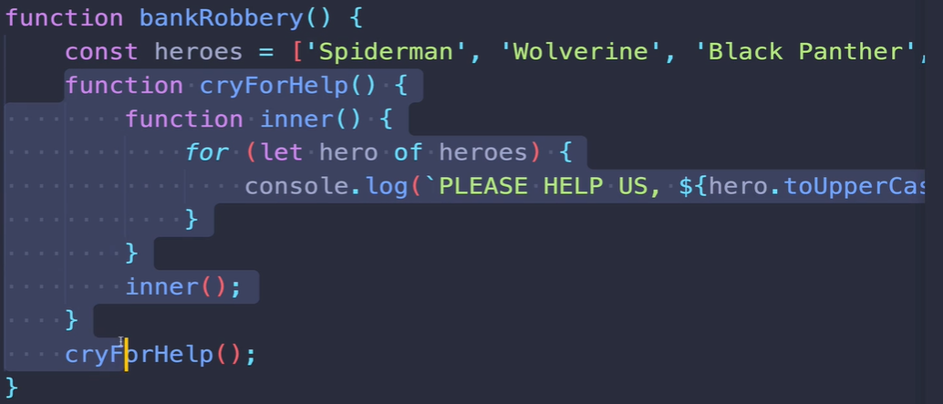

Yes, that also work as you imagine, lol.

Another weird
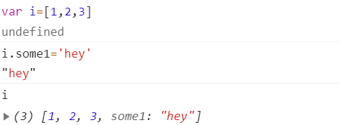

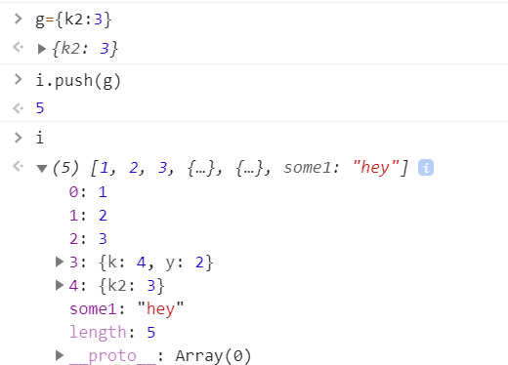

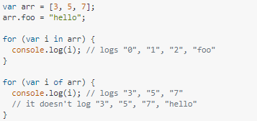

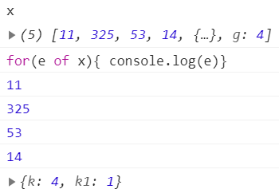

for of iterates over whatever have an index.
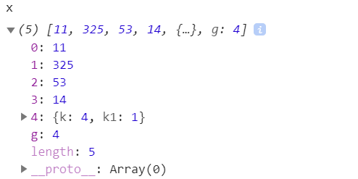

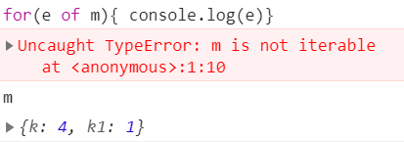

Iterating over objects

An array behind the scene is a object, a string is a object too, map and sets are objects behind the scene.

But when we talk about an actual object literal with key:value pair if we wanna iterate over them.
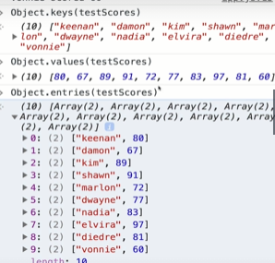
Entries gives a nested array of key value pairs.

Two ways:
(1)you can use for ( in) to get keys and use keys to get values out of objects.
(2) you can use Object.keys() to get keys and do ur work.

