Dot vs bracket Accesing data
Property:number or float or string
use ‘’ in creation and accessing.
You can access variables in bracket notation aka no quotation also tells why actual numbers works cuz they can’t be variables.
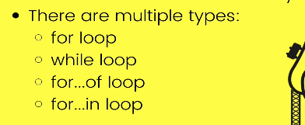

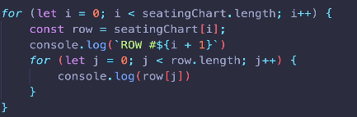

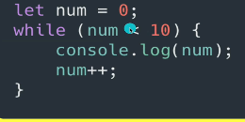

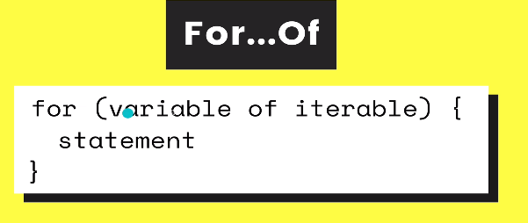

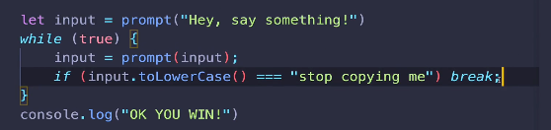
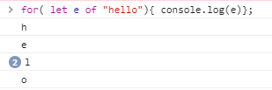

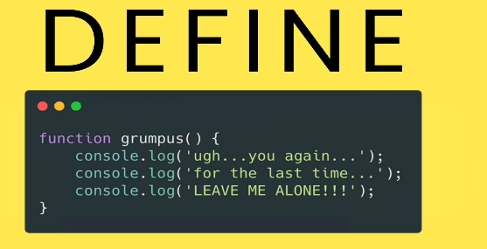

Regarding onclick event
tips: -Your script tag should be beforend in the body
-Provide a function for .onclick
This doesnt work
