- Khan Academy : SQL
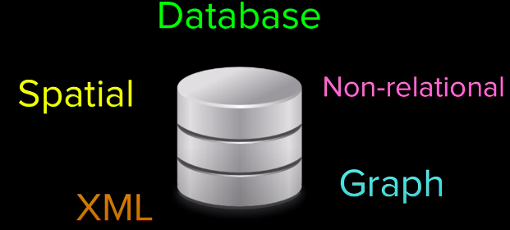
create table groceries (id integer primary key autoincrement , food text,quantity integer, aisle integer);
insert into groceries values (1,’rice’,3,4);
select * from groceries;
select aisle, sum(quantity) from groceries group by aisle;

e.g
if u dont know the aisle
insert into groceries(id,food,quantity) values(2,’wheat’,2)
>>>Null entry

e.g
select * from groceries where type=’biking’ or type=’hiking’ or type=’row climbing’ or type=’rowing’;

Instead,

select * from groceries where type in (‘biking’,’row climbing’,’rowing’);

e.g
select * from groceries where type in (select type from doctor_favourites);

//query within a query is called a subquery

e.g
Wildcard
where type like “%cardiovascular%”;

e.g
To count entries
count(*)

e.g
https://www.khanacademy.org/computing/computer-programming/sql/more-advanced-sql-queries/pt/calculating-results-with-case
select type,heart_rate,
case
when <condition> then “”
when <condition> then “”
when <condition> then “”
else “”
end as “name_the_new_column”
from exercise_logs

e.g
https://www.khanacademy.org/computing/computer-programming/sql/more-advanced-sql-queries/pt/restricting-grouped-results-with-having
Having clause
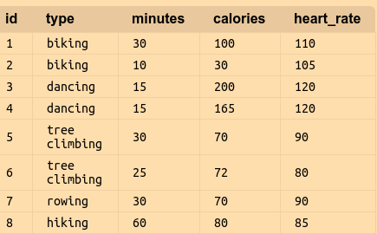

now, if we wanna filter results where we burn 150 cal total, across all the time i have done exercise



this is cuz, it filters each individual rows as it comes in, and dancing is the only activity which has calories burn ina individual log >150

i wanna find where i have burn >150 cal over all of the logs of a type
{here we use having clause instead of where and it’s placed after group-by
i.e
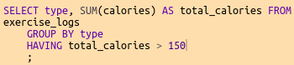

when we are using having clause, we are applying condition to the group values and not the individual values of the individual rows.
}*

Relational queries
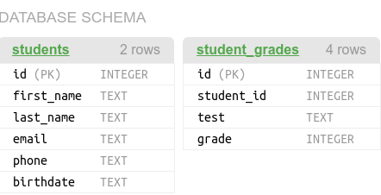

Cross join
select * from students,student_grades
//2*4 rows

Inner join
select * from student,student_grades where students.id=student_grades.student_id; //implicit inner join
//explicit inner join
select * from students join student_grades on students.id=student_grades.student_id;

//Left outer join
{A inner join only creates row if there is matching records in both tables}*
We want
Left outer
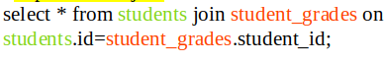


The left tells Sql to make sure it retains every row from the left table and outer tells it should retain rows even if there is no match.

//Self join
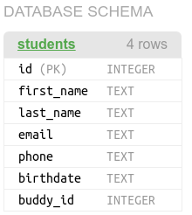

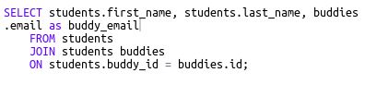
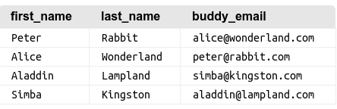

//Multiple joins
https://www.khanacademy.org/computing/computer-programming/sql/relational-queries-in-sql/pt/combining-multiple-joins
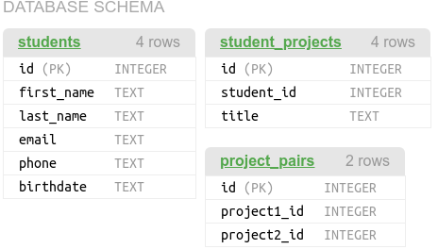

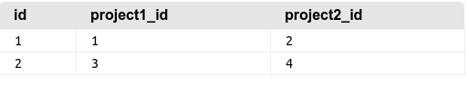

select a.title,b.title from project_pairs as p join student_projects as a on
p.project1_id= a.id
join student_projects as b on p.project2_id=b.id

#Try it out challenge
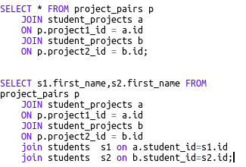

Modifying databases with Sql

changing rows with update and delete

update <table-name> set <column_name>=’wonderful’ where id=2;
delete from table where id=3;

Altering table

consider you have a diary app, a user designer suggest adding a how u feeling drop down to each entry(happy,sad,confused)

alter table <table-name> add <column-name> <datatype> default “empty”

