Khan Academy—HTML/CSS/JS

<!DOCTYPE html> tells the browser u are using morden html.
<head> helps the browser to render the page but doesnt contain anything that the user actually sees.
<meta charset=’utf-8’ > gives more details how to render the page.
If u r using common char from english language and not hard to render characters from arabic language, you gonna use “utf-8”.

Properties
color:green
color:rgb()
background-color:yellow
font-family:”helvetica”,”sans-serif”
font-size:11px{even the headings got smaller cuz heading are relative unit “em” }
font-weight:bold
font-style:italic
OR
font:italic 13px fantasy
line-height:1.5em {spacing between line}
text-align:center
text-decoration:underline
width:300px
height:70%
overlfow:visible,hidden,auto(adds a scrollbar)
overflow-x:hidden
margin:top right bottom left
margin:auto (center;equal margin on either side)
border:thickness(px) style(solid) color
border-top:10px solid purple

Selector:- id (#logo) or class(.group1)
Css inheritance Css inheritance
body{color:green;} <!-- Css file
<body><h1><form><input> <!-- html file
here, <h1> element,<form> element,<label> element will have the same color.This is Css inheritance, not all property are inherited like <button> element,input element.
So,For button and input,
button,input {color:inherit;} <!-- Css file, add this -->
now, button and input will have the color green.
what is HTML?
Markup language: is using tags to markup content
HyperText: text connected to other text located anywhere in the world, how? by a hyperlink.
Link:
https://developer.mozilla.org/en-US/docs/Web/HTML/Element
protocol: domain: path
if specify all thats called an absolute url.
if we only specify the “ path “ it’s called relative URL, that tells browser to say on the current domain look for different path on that domain.
Generally, if a link is going on a page on the same domain, it should open on the same tab else a different tab i.e “target=’_blank’ “.
Table
<table><thead><tbody><tr>
comment
<!--
group elements/block-element grouping text/inline-element
<div> <span>
2types of elements :- inline/block element
inline:doesnt have a “\n” after it
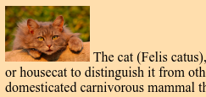

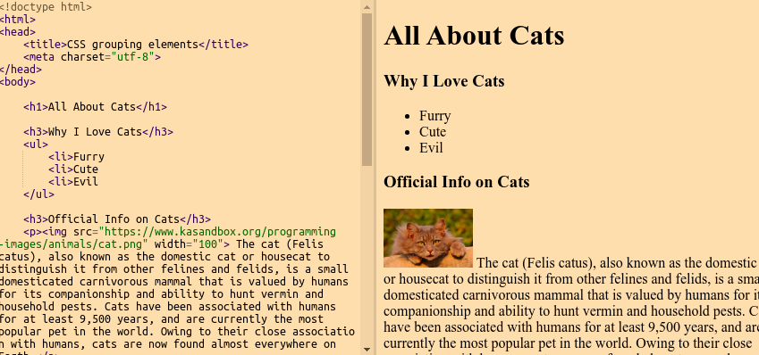
Link:
http://www.csszengarden.com/213/
Orange:margin, green:padding, blue:content
By default, ur webpage has some margin
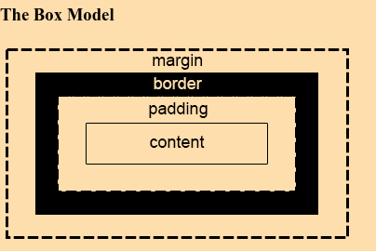
Css position
Default positioning strategy is Static which is
inline elements are laid out left to right
block elements are laid out top to bottom
relative is like offset by
e.g
position:relative (position like u do normally and offset by)
top:20px;right:12px;
absolute makes it wrap-through
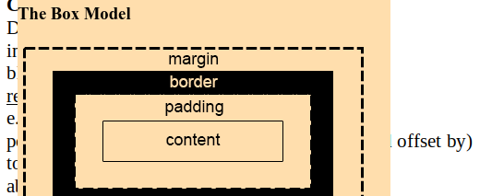
ex:-

There’s a fight in wrap-through and the newest LOC comes on top.
Better alternative is use “z-index”
fixed for e.g ads

Css floating elements
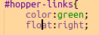
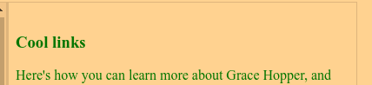

float is like wrap, use width cuz div take entire space
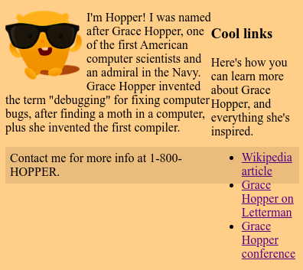
Also,

here the footer is overlapping with #hopper-links, to make it not wrap with anything.
Use clear:both
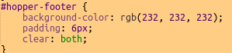

clear:left when we dont wanna wrap around left floating elements.
Css selectors
p ul li{} <!-- <p> <ul> <li> descendant selector ,generic rule
Be careful using this, cuz if ur structure of ur page changes, ur old css rules might not apply. So use classes if u wanna be less dependent on the structure of your page.
So if u r not sure, use
p.spacey ul li{}
-------
p.warning{} <!-- tell apply the properties to the para which has a warning class.
{You shouldn’t group selector if they happen to have the same properties, you should group selector they always have the same properties ex:- h1,h2}*
pseudo classes

colon: all those that start with a colon are called pseudo class
A pseudo class is used to select elements based on info that isnt part of the webpage structure or cant be expressed using other selectors.

To style link based on their state
a:link{} <!-- to style not visited
a:visited{}
a:hover{} <!-- slide through
a.focus{} <!-- when the user uses the tab key
a.active{} <!-- clicked hold, like i used to do in shadowgun game, see
here .
Css specificity
<p id=’k1’class=’group1 group2’>
here, if all have color properties
id>class>element
it’s more complicated, the browser calc a specificity score.
For equally specific selector, the newest wins.
e.g if .k1 specificity score equals to .k2
by just adding p element p .k1 wins .k2 lose
Also, if multiple stylesheets for a page, the newest wins.
But it doesn’t mean the losing selectors is completely neglected, the properties of losing selectors, on which there isn’t a conflict still is applicable.
Even if there is 28 elements and only 1 class selector aka 10, class selector has still a higher priority , use css specificity calculator
Udemy:Css specificity
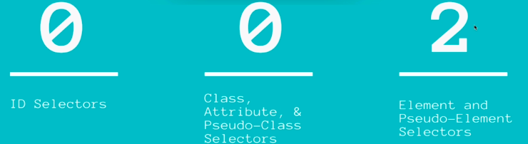

Css Font size property
body{font-size:11px;}
Everything on the webpage got smaller, cuz the browser use a default unit that is relative.That is ‘em’. That makes the heading size to scale proportionally to the body font.
Imagine:
body.font-size=12px;
h1=4*12=4em
h2=3*12=3em
h3=3.5*12=3.5em
h4=3*12=3em
h5=2*12=2em
h6=1.5*12=1.5em
Inline Css
use for performance reasons; avoid cuz messier webpage
<span style=”background:green;”>
External stylesheet
<link rel=”stylesheet” type=’text/css’ href=”/Documents/web”>
Link tag is used when bringing in files
Link:
https://www.khanacademy.org/computing/computer-programming/html-css/html-css-further-learning/a/webpage-design

