Request Animation frame: click
This is a method belonging to the window object, which help you do a more accurate version of setInterval.
It runs on regular interval, and regular interval it’s not gonna always be exactly what you want.
Imagine if you are creating a movie, you have a stuntman throwin punches and you’re filming from behind, and you want it to time it perfectly so the other person can dodge.
You can have the stuntman punching every so oftenly, you give them an exact interval. I want you to punch every 1s,
so the stuntman does throw punches evry 1s, but the person who is dodging the punch if they every get tired or distracted, they aren’t gonna be using the same timing and they endup getting hit instead.

With request animation frame, everytime the screen is gonna be repainted (the browser is ready todo a paint) here’s a func I want you to run. So it’s not an exact amount of time in-between. It’s when the browser is ready, we gonna try to this on a very regular interval. It’s gonna be a much smoother animation or transtion.
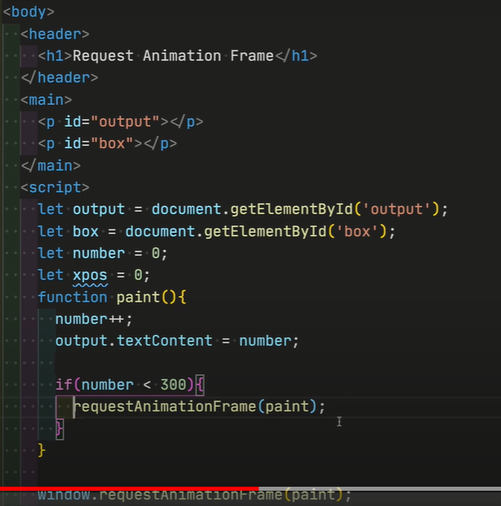
Interesting
requestAnimationFrame for better perfomance, browser gonna pause it whenever the tab is switched unlike setInterval which run in the background.

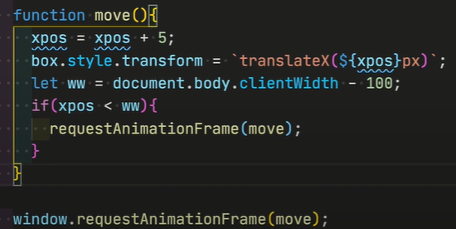
If you wanna know how long each of this frames are taking or is there any issue, you can actually track that.
There is a value.
Everytime you call requestAnimationFrame you pass in the func, there is a value that get pass into the function. That is a high-resolution-timestamp.
It’s in ms to tell us how long it took.
