Bootstrap

container ----> is with margin:auto
container-fluid -----> to the size of viewport

img-fluid --->scale based on size of containing element
e.g
container-md
.container +tab <div class=’container’>
button.btn.btn-primary <button class=’btn btn-primary’>

blockquote

blockquote.blockquote>p.mb-0+footer.blockquote-footer
text-right
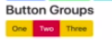

.btn-group
role=’group’ <!-- For screen readers telling its a group
aria-hidden=’true’ <!-- for screen reader this shouldn’t be seen at all.
aria-label=’Close’ <!-- use this as a label
aria-label=’toggle navigation’ <!-- use this as a label
data-dismiss=’alert’ <!-- this will work fine
data-dismissable fade show <!--guess?

Grid sys
1. works only on a row just like flex
2.you have 12 blocks in a actual row,to divide space between other <elements>
e.g
div.container>div.row> div.col-4+div.col-4+div.col-4
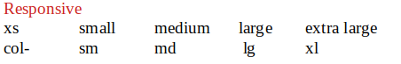

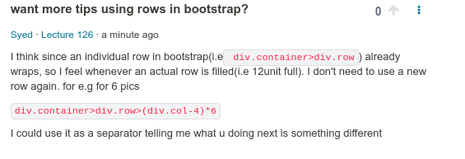
.no-gutters <!-- eliminates the space between in flex container’s.

.align-item-center,
.align-item-flexstart,
a.lign-item-flexend.

For inline
.align-self-end

similarly
.justify-content-sm-between //use the docs

.form-group <!-- groups a Label & Input
.form-row <!-- tweaks a bit the defaullt gutter size.

d-none <!-- display:none for xs
d-lg-block <!-- display:block for block

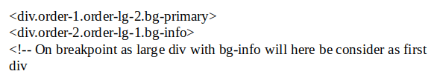
Icons: fontawesome.com
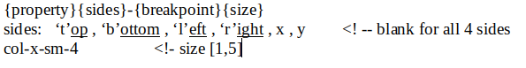
Navbar
nav.navbar.navbar-dark.bg-light.navbar-expand-md
a.navbar-brand
button.navbar-toggler[data-toggle=’collapse][data-target=’’][aria-label=’toggle navigation’]

ul.navbar-nav>li.nav-item>a.nav-link*3

