Web Developer Bootcamp

Internet: global network of networks, infrastructure that carries. It enables www. Www is a information system where documents and other resources are available over the internet.Resources are identified by Url.
Documents are transferred via Http
front end: focus on the tools that runs on the browser.
Back end: runs on a server.
https://developer.mozilla.org/en-US/docs/Web
html entity codes to use {>,&,spades,integration}
All look like &<Some-char>; link:-html_entity_code
Semantic markup: Semanitc_markup
Its adding meaning to the markup.
when drawing ur page, dont use meaningless markup
e.g use <main> instead of <div>, does the same exact thing,but also tells us this is the main content.
<section>,<nav> for navigation links,<footer>
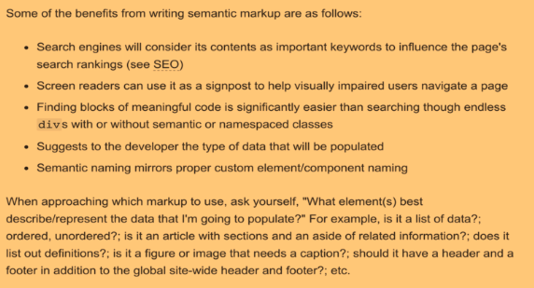
<nav>:- navigation links could be internal links or external resource.
<article>:- self independent compostion which is intended to be highly distributed, e.g in syndication
<aside>:-not essential or maybe indirectly related.so when u using ur cellphone thats the part that disappears
<time>,<figure>....

Emmet Emmet :
built in vs-code

Tables:
<table><thead><tr><td><tbody><tr><td>
Forms:The action attribute specifies where the data to be sent.This attribute specifies which http method to be used.

Html5 input types Html5 input types
<input type=’email’ >
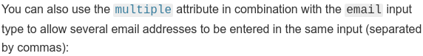
<input type=’tel’> //telephone dialpad
<input type=’url’>
<input type=’number’>
slider:
<input type=’range’>
problem with slider:doesn’t offer what the current value is
That’s why, <output> it works similar as label.
It take a for-attribute that allows you to associate with elements that the input value came from.
Date and time pickers:
<input type=’datetime-local’> //no specific time zone
others are month,time,week.
Use label like,
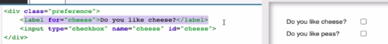

If u click on the label on the webpage, the associated elements will get focused.
If u have button in a form,its always gonna submit by default.
That is: <button></button>
which is same as <button type=’submit’></buton>

So, for ur button to perform as a button only
Then:<button type=’button’></button>

Other way is <input type=’button’ value=’click me’>
when you submit data of a form,you’ll see the data in the url, like:
url?q=’youtube’
If multiple terms then url?name=joey,password=food

You group radiobuttons by giving them all same name;
If all the radiobutton in a group doesnt have a value-attribute,so after clicking any, it will send groupname=on. So use value-attribute.To send data associated to that radiobutton.Use id-attribute to identify the radiobutton.
Dropdown:
<select> <option>what user sees</option> .... </select>

color:https://htmlcolorcodes.com/
hexadecimal color:-#** ** ** | * belongs to {1-9}+{A-F}
e.g #c5e is same as #cc55ee

Properties
color:green
color:rgb()
background-color:yellow
font-family:”helvetica”,”sans-serif”
font-size:11px{even the headings got smaller cuz heading are relative unit “em” }
font-weight:bold
font-style:italic
OR
font:italic 13px fantasy
line-height:1.5em {spacing between line}
text-align:center
text-decoration:underline
width:300px
height:70%
overlfow:visible,hidden,auto(adds a scrollbar)
overflow-x:hidden
margin:top right bottom left
margin:auto (center;equal margin on either side)
border:thickness(px) style(solid) color
border-top:10px solid purple
letter-spacing:2px
word-spacing:4px
rgba:(255,255,255,0.7)

hsl( [0-360] ,50%,60%) <!--first param:- color, second param:- saturation , third param:- lightness

Css text properties Css text properties
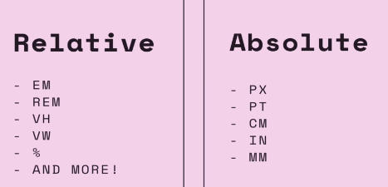
line-height:2em // you’ll see when you highlight the text on the page, the highlight extend far beyond the text,the height of the line.

Color palette: color palette
Controls: use alt+click to write multiple places in Vs.
Css specificity : Css specificity
Specificity calculator: specificity calculator

E.g
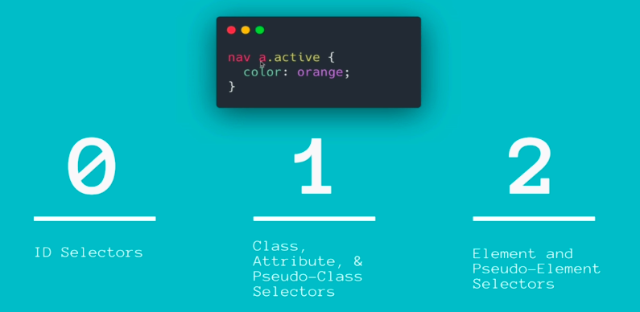
selector{
color: green !important; //this beats all even inline properties
}
Css selectors 30 Css selectors MDN selectors

combinator selectors
#no1 id
.group1 class
.group1.group2 select elements having both classes.
section[class=’group1’] every section where class=’group1’
section.group1 every section where class=’group1’
section:hover div select the section being hovered and apply
properties on the descendant div tag.
section:first-of-type div:nth-of-type(2)
h1,h2
li a //descendant selector
ul+p //right next to it, together . Applied to <p>
#container1>ul //direct children
ul~p //similar to ul+p,less strict,just have2 be followed by ul.Applied to <p>
x[title] e.g:-a[title] // anchor tag with an atrribute of title.
x[href=’some-url’]
x[href^=’http’]
x[href*=’udemy’]
x[href$=’com’]
x:checked e.g:- input[type=radio]:checked
15,18
x:not(selector) e.g div:not(#container1) // all div except the one which has id #contianer.
X::firstline
X::firstletter
li:nth-child(3)
li:nth-child(3n) <!-- for (3,3*3,3*3*3,.....)
li:nth-last-child(3)
X:nth-of-type(4) // imagine if we have 5 ul, we wanna select the 3 ul.
X:nth-last-of-type(n)
ol:first-child // only the first child
ul:last-child //only the last child
X:only-child
X:only-of-type
e.g ul > li:only-of-type //target elements that do not have siblings
within it’s parent container,lets target all ul’s which have only a single list item.
X:first-of-type
X:first-of-type //first sibling of its type,cuz it could be nested by a descendant selector.

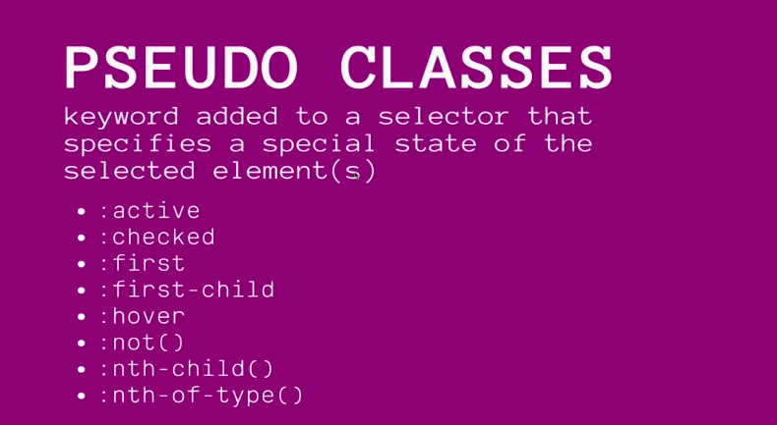

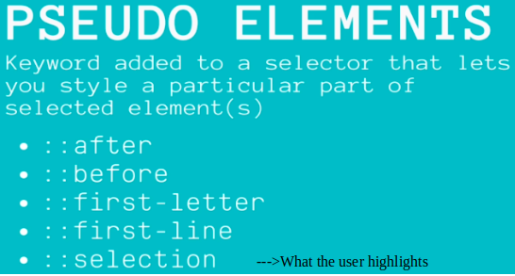

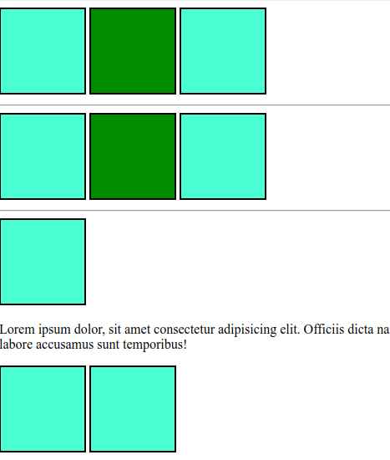
X:nth child
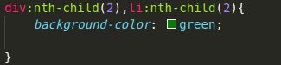
X:nth-child
------------------> It’s applied for all seperate section.thats interesting.it works for actual stacks only.

<----- here it didnt work

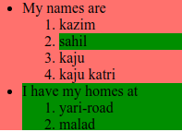

Another example
<---nested stack

X:nth-of-type
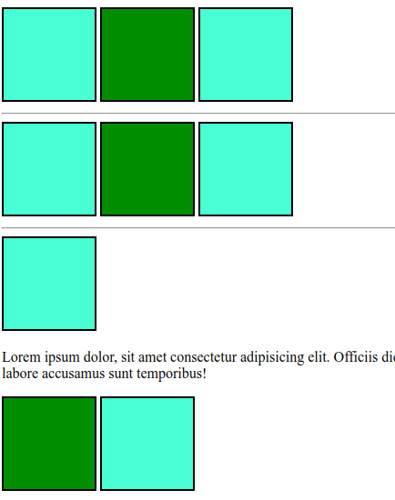
Here, it doesnt have to be a stack of consecutive elements of same type.
Another example,nested works here too
|
|
V

Css Box Model Css box model
Border:- also use for bringing attention to certain elements on the page.
Like if i hover,they tell us that the element is clickable or selectable to interact.
Border properties: border properties
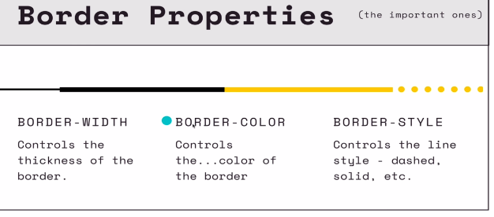
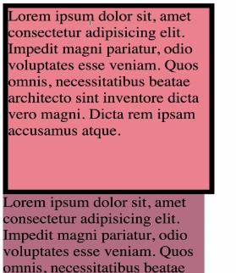
Here the width is:
200px + 2*border-thickness.
To make sure the box object take the space specified i.e 200px.
Use property,
box-sizing:border-box;

border-width:5px;
border-color:green;
border-style:dashed groove dotted none //different style to all 4 sides
border-radius:15% 20% 12% 10% //rounds the corner
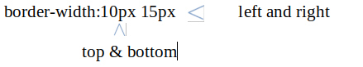

Css Display property Css Display property
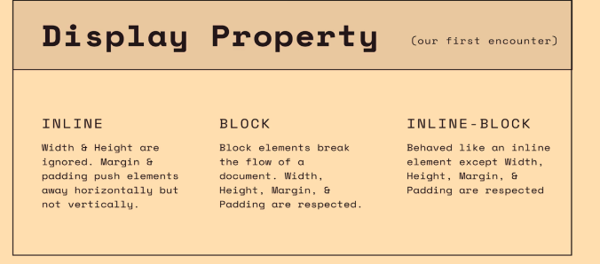
span{display:inline; } <!-- imagine <p> <span> </p>
which makes sense cuz its an inline element.
And only dimension it can push(M+P) is
horizontally.
span{display:block} <!-- turn an inline element into a block element.
Inline element:fits the data.
Block elements:follows the dimension(Width+height)
so if u have a three green block (50px width and 50px height)literally and visually.
If you use display:inline on this, it will ignored the (width+height) .
So use display:inline-block, it will tell dress like you normally would (as a block) and make it inline.
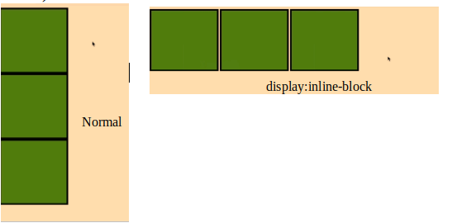
display:none

Relative units Relative unit
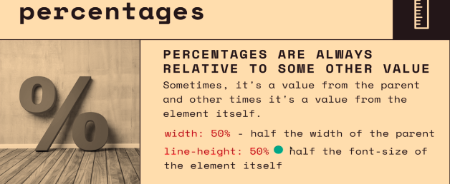
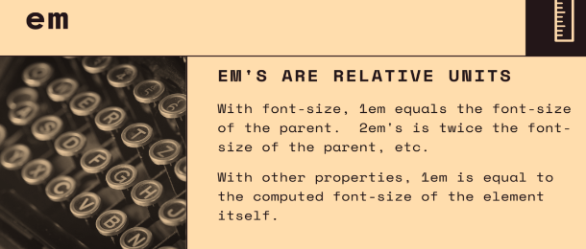
e.g
h2{
font-size:2em;
margin-left:1em; //i.e 1em=1* 2em
}
e.g
body{font-size:12px;}
article{font-size:14px;}
p{font-size:1.5em;} <!-- that is 1.5*14px
<article>><p>

e.g
section div{
background-color:magenta;
font-size:1.5em;
border-radius:0.5em;
}
if u wanna preserve the shape when u scale up and down,use relative unit for all shape-properties.
Rem
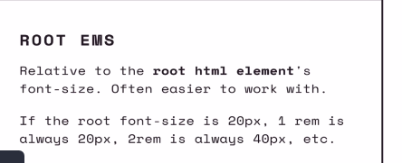

Often you’ll see people mix, people mixing rems and em together.
Cuz there are times when you wanna be situationally dependent.


Maybe the font-size is based on rem, but the border radius or padding should change depending on the acutal font-size computed to be.
Opacity and alpha channel
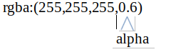

0 -completely transparent <!-- consider not there is 0
1 -not transparent at all <!-- like a wall there is 1
background color:white is same as rgba(255,255,255,1)
opacity:0 <!-- it range from 0 to 1
background:#ffffff00 <!-- that is white transparent


alpha:1 is not transparent
alpha:0 is completely transparent
Above you have alpha 0.5 imagine looking through a mountain dew bottle.
Opacity:
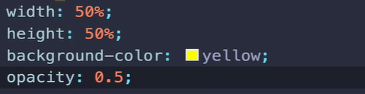

opacity on a div make it how you imagine,
rgba is a property on either background-color or color
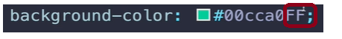

Above, for hexadecimal: alpha channel ranges from 00 to FF.

Position position video

In relative, why left:30px moves to the right?
In my brain, I think position as u normally do and then offset by 30px to the left
now, I have to make an assumption,
like, consider the top-left vertex as 0,0 and bottom left vertex as 0,x of our squares
meaning you are in the 4th quadrant while plotting and the left here tells you the axis are to the left(the x and y).
and similarly for right.
Is it me just feeling this way, also am I interpreting correctly?
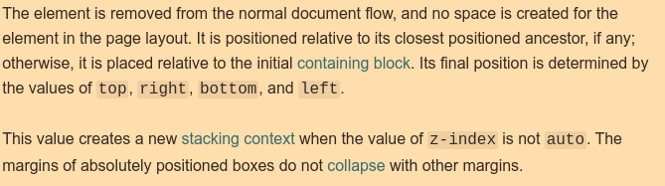
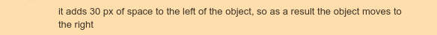
Here, positioned ancestor refers to a element that is postioned anything but static. Else, w.r.t initial containing block i.e the body.
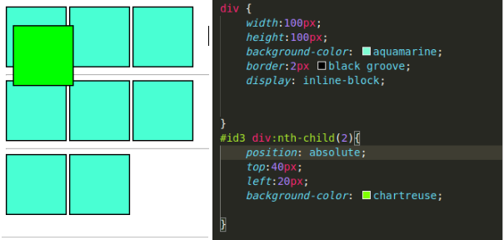

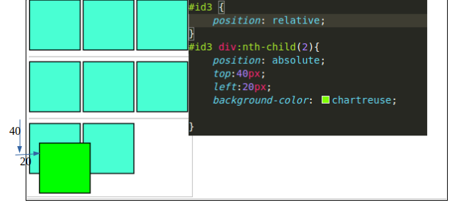
position:fixed
position:sticky
It stay at place when scroll, when the scrollbar hits the top,it moves with the scrollbar.That is, start being not-fixed and get fixed when the scrollbar hit the top.

Transitions transition video myhtml
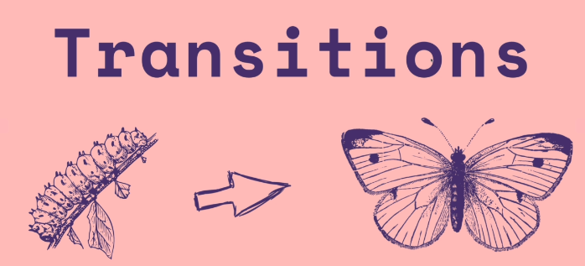
Transition helps you animate the transition of one property into another property value.
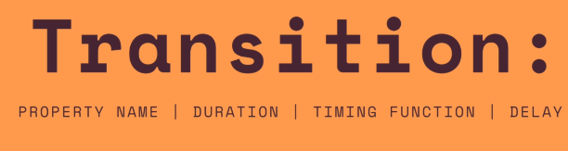
To conisder all properties: use all keyword
e.g:
transition:background-color 10s,border-radius 2s;
You’ll see control when you use ease-in,ease-out
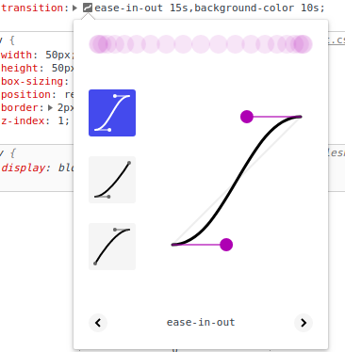

Transform tranform-funcitions
status:-pending
Background background video
status:pending
Responsive Css & Flexbox
what is flexbox? >>> flexbox flexbox
display property is used on the container.
& evrything below is done to the container rather than individual div’s.
display:flex <!-- kinda like inline but with more controls
flex-direction:row <!-- default
flex-direction:row-reverse,column,column-reverse
<!-- note if there is a overflow, flex will change the dimensions to fit in the
container -->
justify-content:flex-start <!-- default
justify-content:flex-end,center,space-between,space-around,space-evenly
flex-wrap:wrap,wrap-reverse
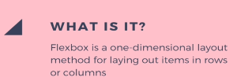

<!-- if there is a overflow, By using flex-wrap ,it will wrap which is based on justify-content
&
wrap-reverse is like a reflection of wrap where line of reflection is known by flex-direction i.e row or column
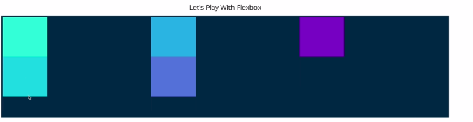

Align-items:baseline,flex-start,flex-end
challenge E.g for Align items
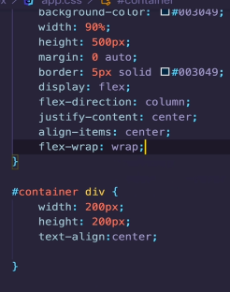
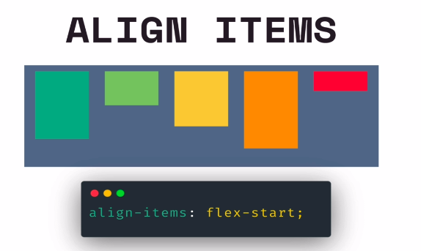



justify-content changes w.r.t row and column.
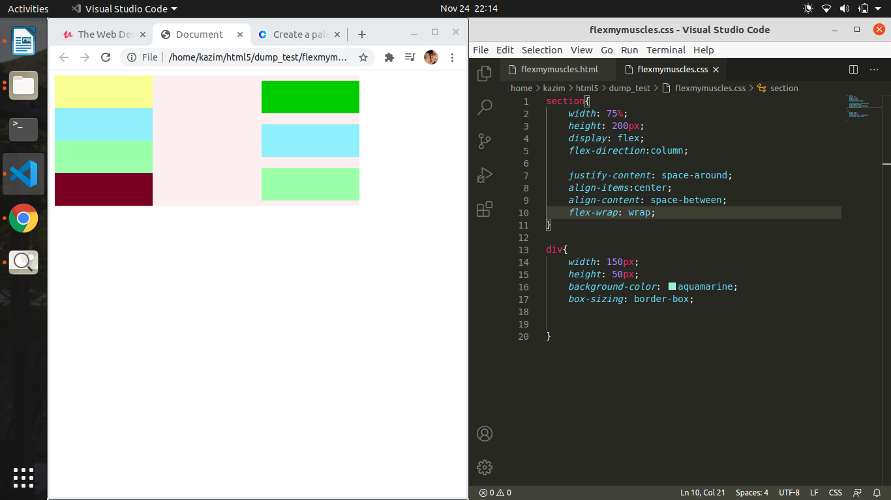

align-self:flex-start <!-- inline css.
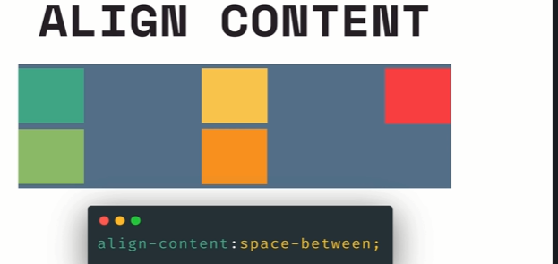

We have align-content use to distribute space between cross axis, but only when we have multiple rows or columns depending on if you r on row or column based layout, basically if we are in columns, align columns controls the space between those columns.
If we are in a row, we are controlling the space between rows.
Align -content: space-around,space-between, flex-start, flex-end, center
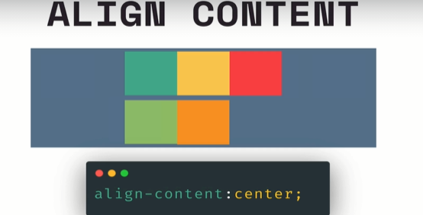
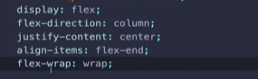



align-content:center;

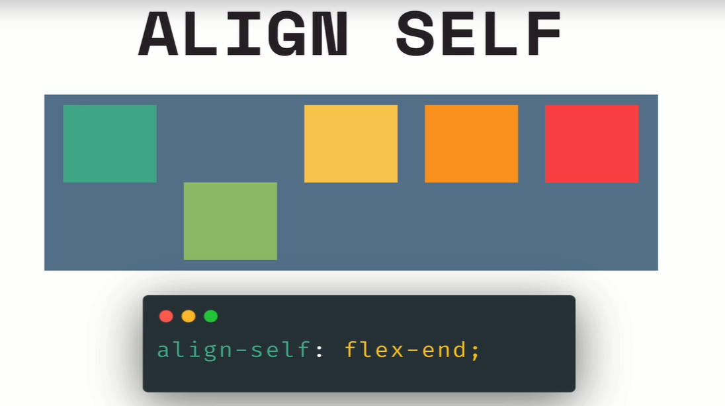

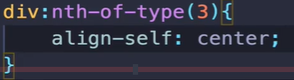
align self is applied to single element not the flex container.
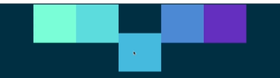

Flex basis, grow & shrink
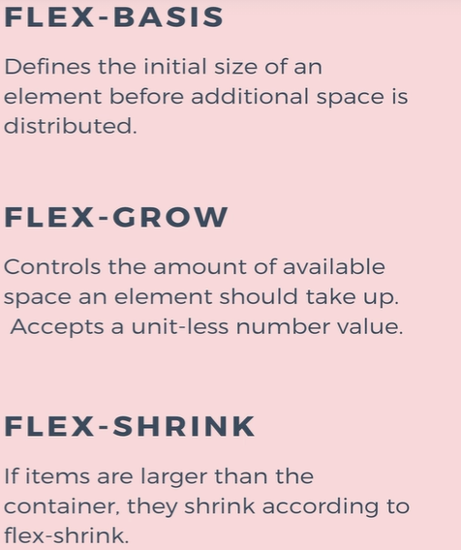

flex-basis:200px
is the initial size that is given and it can shrink or grow from there.
if a div in a flex-container, is given width and height.
Flow direction:row ----> width=flex-basis:200px
Flow direciton:column -------> height=flex-basis:200px

for e.g, if container height isn’t specified, it’ll take as much height is needed for the div to fit-in.
If specifed then, if there isn’t enough space it’ll overflow.

min-width:200 <!-- Min-width i.e given to div to specify minimum width,
no matter what
max-width:200 <!-- max width i.e given to div to specify maximum width,
no matter what

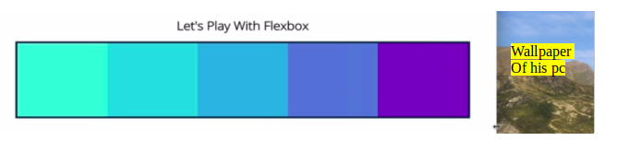
if max width is used. e.g max-width:300px
So when u maximize the window screen using cursor, the div will grow and when it reaches 300px width it stays there.


Flex-grow is used when there is extra space
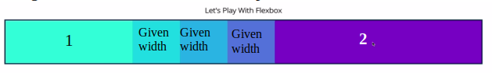
Here,

2
whatever space is left
1/3 is given to div-1
2/3 is given to div-5

flex-shrink:1 <!--default given to all
flex-shrink:0 <!-- to mantain it’s given dimension
flex-shrink:2,3.. <!-- smaller than others, if there isn’t enough space , this1 is the one that will shrink. We aren’t telling how
many px to shrink, we are saying with relative to
others to shrink. for example
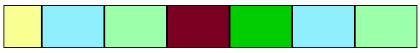

flex shorthand
flex: flex-grow flex-shrink flex-basis
e.g flex:1 0 200px
Responsive design and Media queries Intro
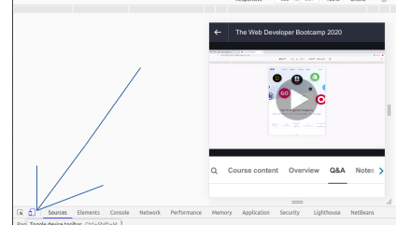



Media queries Media @media
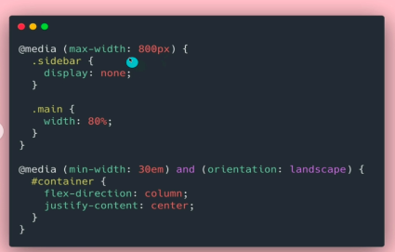

h1{color:red
}
@media (min-width:300px){
h1{color:blue;}
}
@media(min-width:500 and orientation:landscape){
h1{color:orange}
}

--pricing panel code along
CSS Reset CSS Reset
The goal is to normalize how browser styles works across the browser.They give u a clean slate.

Flex- Repeat
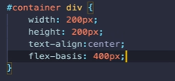

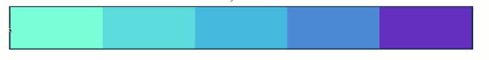
You’ll see all div are set to 400px, is along the main-axis. Flex-basis is the initial size that is given, it might be a width or height depending on the flex-direction.
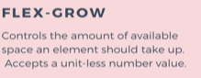


I can assign flex-grow property to any element.
Flex-grow:1 <!-- takes all the available space left-->

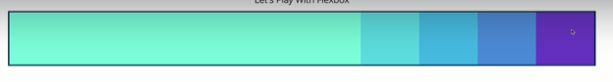
div {flex-grow:1,width:120px}
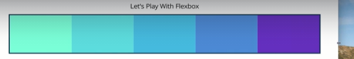

They share space equally and responsively.
Above, width is ignored.
But as we spill over
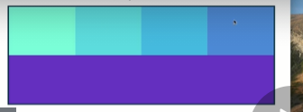

Note:
You can use min-width and max-width to control how big they scale.
Examples:
...
div:nth-child(1){ flex-grow:1}
div:nth-child(5){flex-grow:2}
They both will eat up space, but the 5th div will take twice as much space to 1st div.
Understand the maths
all div take 100px
remaining space left was 150
div-5 extra-width=2*(150/3) <!-- divide by 3 cuz 3 slice -->
div-5 extra-width=100
final div-5 width=100+100=200

div-1 extra-width=1*(150/3)
div-1 extra-width=50
final div-1 width=150

another e.g

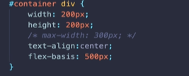
if flex-wrap:wrap

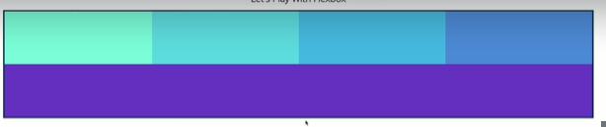

Above, violet flex-grow:

flex-shrink:0 <!-- means they not gonna shrink
others have defaullt value:1 <!-- they all shrink at same rate.
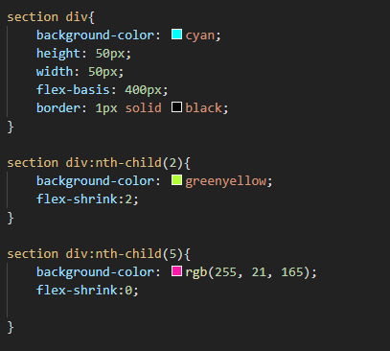

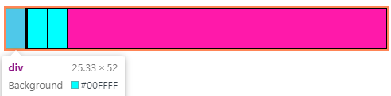

Flex-shrink governs the rate at which elements shrink when there isn’t enough space in the container. Above cyan block width are 50px but it shrink to 25.33, where as pink block maintained his flex-basis width.
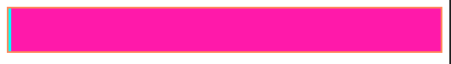

all elements are default at flex-shrink:1

another example
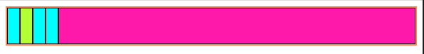
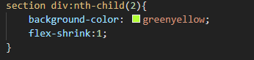

Flex-shorthand
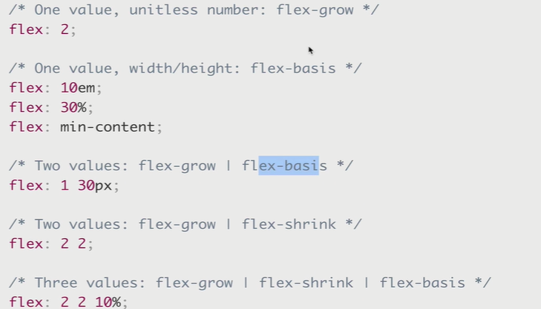

Responsive design and media queries

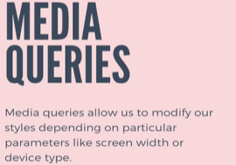

depending on screen-width, device type, device orientation, landscapevs portrait.
If it’s on landscape mode or portrait mode do this, like show it on landscape and hide it on portrait. If we are in super tiny screen, collapse the navbar so it doesn’t take too much space.



It’s pretty large up there

At small it becomes scrollable.

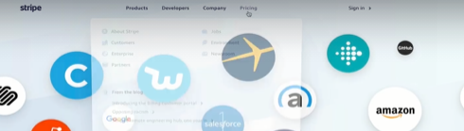






V
V
V

It stacked

Media queries
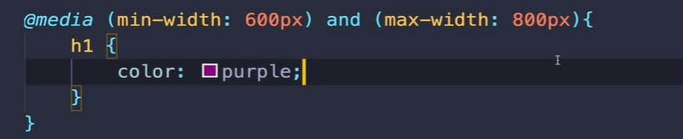

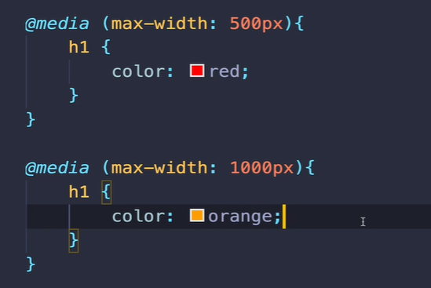


we are constantly orange why?
We are overwriting
1st media queries say before 500px we gonna be red.
2nd media queries say before 1000px we gonna be orange.

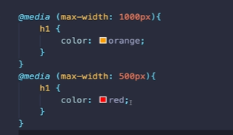
This is gonna work

Basically, max width overlaps and cause problem. So above way works if we arranged properly.
Use min-width to create a starting point and above.
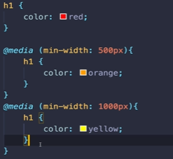
Before and after psuedo elements
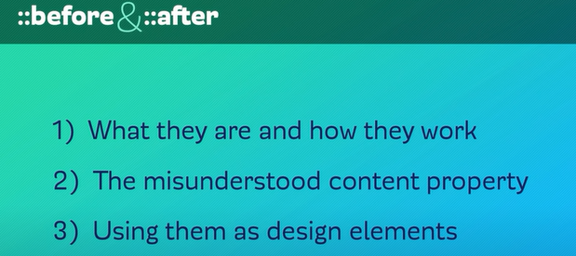
are really good ways to add extra style to your website without adding extra markup u dont really need.

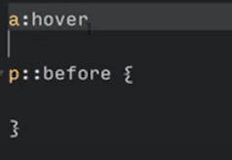
Pseudo class

Pseudo element

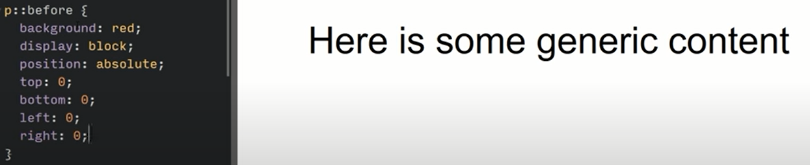
Cuz ur psuedo element is not their.
For your pseudo element to exist, do This
Weird

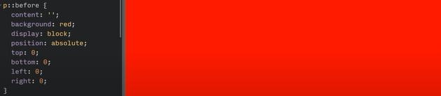
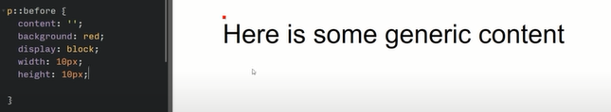
content tell there should be some content if we dont add this, it default to none.
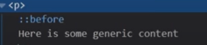
In Dev tools, u’ll see there is a b4 inside of it.

Alot of ppl misconception, if they use before they think its before p, but thats not true, it get inserted before the content of p.
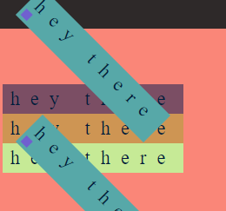

Similary with after,
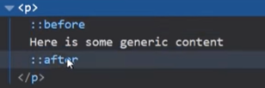

For images, the image source is the content, short story is ::before and ::after doesnt work with images.

Example
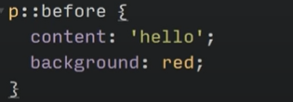
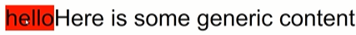

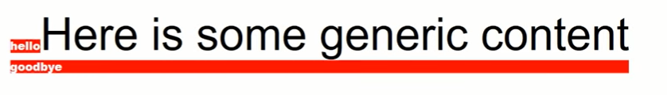
Notes: you can easily see this as a design element instead of putting it as text.
It lets u add things without adding extra markup.
For e.g u dont want a empty div for just for design elements, i dont have to do that i could use my before and after to do that

Content property:
-The pseudo element, content is not selectable.
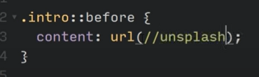

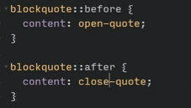

example
so if we have a link if i hover over, i want a little extra info to show up.

----
Something different
this were added to create to customized as how we want, mostly used for js purposes.

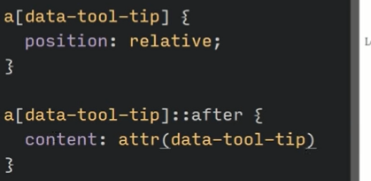

It’s taking data tool tip attribute value, and its putting into there.

See video at time 7:52
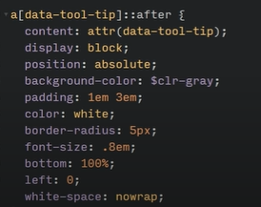

final piece
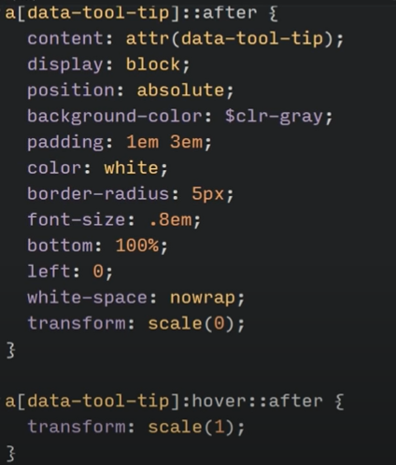
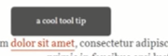

-----
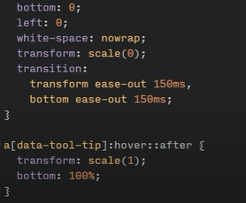
we want the info to look like it’s coming from the element, not from above.

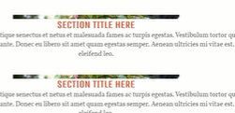
Ideas
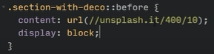
1)

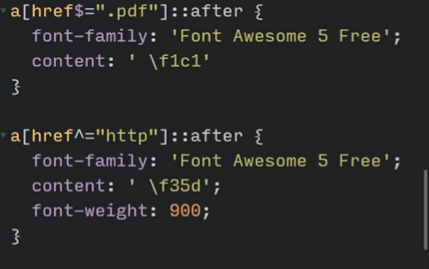
2) At time 13:00, i am confused a bit

>>>
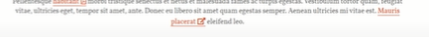

, < do this, if you find icon a little too big.

----
Counter-Reset Counter-Reset
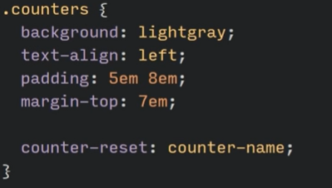
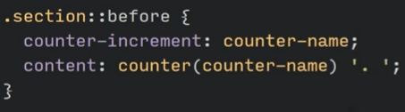
The way is counter-reset is, you need to give your counter a name, why it’s counter reset is : everytime it gets to a class of counter it resets itself, here that is counter_name.

Imagine ur div, getting drawn, whenever it gets to the div with class “counter” it resets a variable whatever manner.

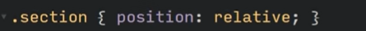
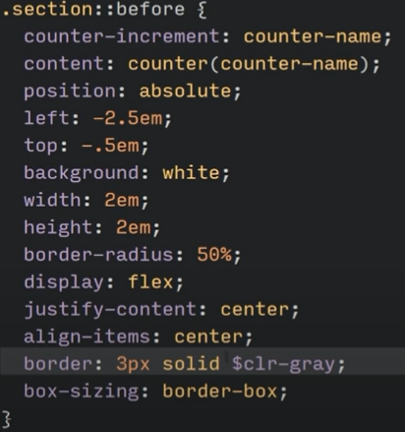
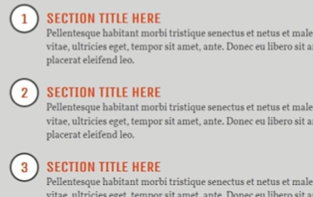

Hover effect ideas: hover effect ideas

Video: video
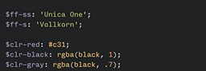

if u use ::before and ::after psuedo element it wont be a subset of universal selector, you need to explicitly add *::before and *::after

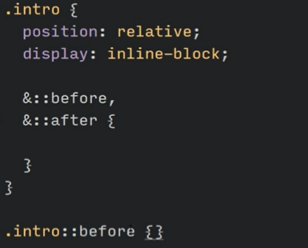

Same


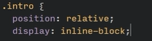

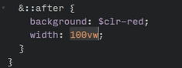


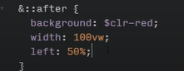
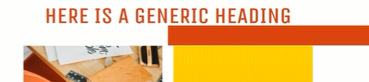

it’s gonna put right into the middle, cuz the intro-text is center-align.


Below .intro has z-index:1 that’s why red and white background is -2
and -1

So code final
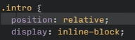

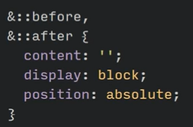

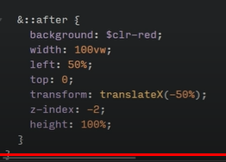
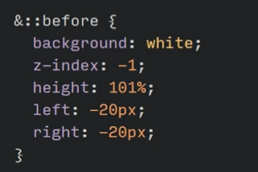

The thing is it’s gonna grow and and shrink
with the content.
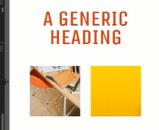

Flaw: if it breaks into two lines, the background thing gonna disappears because the way inline block is working and couple of other things.
It’s too large now, u can work with media queries and play around with it. The white padding(left and right) is gone too big.

