

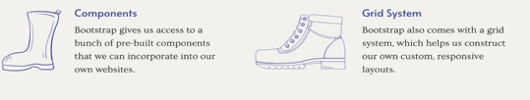
others like bootstrap: foundation, semantic ui
websites that use bootstrap blackbox.cool.
Nintendo.co.uk/Games/Nintendo-Switch/Super mario
taskade.com
CDN:content delivery network.

The container have breakpoints, when you go from large to md, md to sm. Sm to xs.
Container-fluid is gonna be a full-width container and it’s gonna span the entire width of the viewport. There is a container: by that I mean there is some margin and padding.
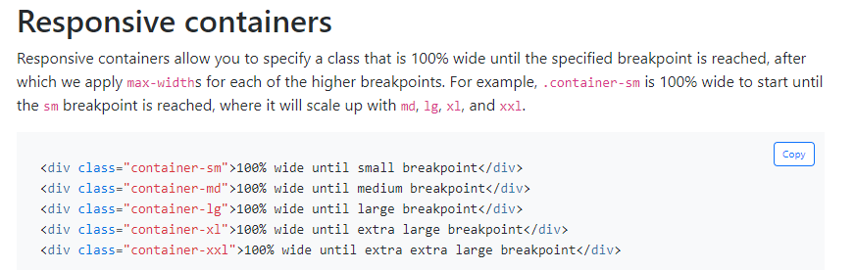
Responsive Containers

Bootstrap button

btn class btn-color btn-size

Bootstrap typography and utilites
Typography:
display-1,
lead<!-- add font-weight, font-size>,
blockquote <!-- add this class to blockquote
blockquote-footer <!-- blockquote+footer
mb-0,
text-right, text-center,
Utilities
text-primary,
bg-primary,

Badges, Alert and button groups

Badges are used to display some count, no of notifications on ur profile.
Class: badge badge-primary badge-pill

button group

if you do for e.g div.btn-group[role=group] > btn.btn.btn_secondary*3
Accessibility: use role=group to help screen readers.

Alert: is used to provide some feedback to the user, typically after some action or the page loads, this was saved, this was failed to saved, loggin u out, u dont have permission to do that, welcome back.
div.alert.alert-danger[role=alert]>(h4.alert-heading)+{"hello"}

Dimissing alert



The x above is build using entity code.
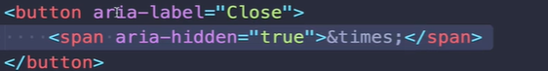
Accesibility and screen-readers:
aria-hidden: tells on screen readers this should not need to display at all.
Aria-label:that would the screen reader would read out loud.
Bootstrap Self-attribute:
data-dismiis=’alert’ <!-- on the btn next to aria-label
just like Ms team when recording starts
it shows dismiss button with dismiss logo-->
It works and the span used a class “close” for look n feel.
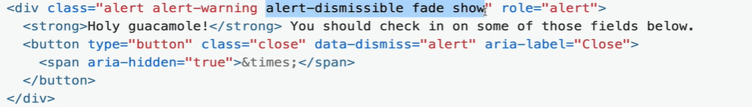
You can add “alert-dismissible fade-show” thats gonna move the btn to top right corner and fades out when you click on it.

Info:
role=’alert’ this indicates to the screen readers that this is imp info. Often this alert will show up on the page after the page is loaded, it will do something and the page is loaded and the alert appears. If we working at it, it’s easy to see there is new stuff on the screen. But most screen readers are not gonna read out content or changes unless we add the role=’alert’.

Bootstrap Grid
1.Only works inside a container or container-fluid or you can nest containers, ( div.container)
2.You need a row,(div.container > div.row)
NOTE: -
Every row in bootstrap have 12 units of space.
Every piece you wanna give out in a given row is a column.
3.So if you wanna give 3 div same space, and u want them to occupy the complete row. (div.container > div.row> div.col-4 +div.col-4 +div.col-4 )
4.
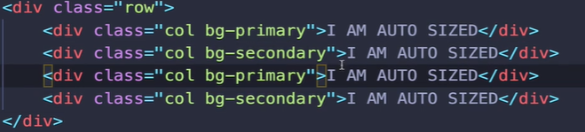
Above if u didn’t specify col unit taken by div, it will share that space.
Above code is same as
( div.container > div.row > div.col-4*4 )
------
Responsive bootstrap Grid

col-8
col-sm-8
col-md-8
col-lg-8
col-xl-8
To read this, for e.g col-md-8, if viewport >= medium viewport make that column 8 units.

info:I Could have 50,50 split in large and extra-large screen, but on small and extra-small I might have a 12 units (basically a stack).

Responsive images (div.col.img-fluid)
if we have an image and that column change size we want the image to change it’s size too. Basically it makes the image scales based upon the size of it’s containing element.

Note: If you are using different images with different size, they aren’t gonna be magically be of same height in a row. You can change how image displays or cut some part of it off, or stretch it, so they all are of the same-height.
Inside layout –> grid> aside note has gutters
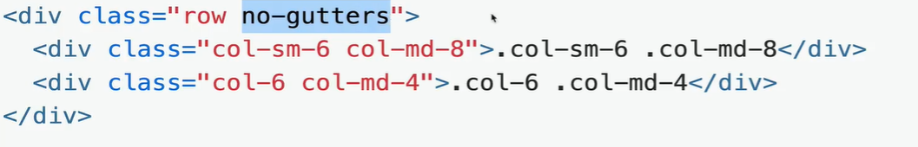

This removes the same between.
-----

Useful grid utilites
bootstrap-flex, bootstrap-flex <!-- the second page is too good -->
d-flex
----
d-inline-flex


---
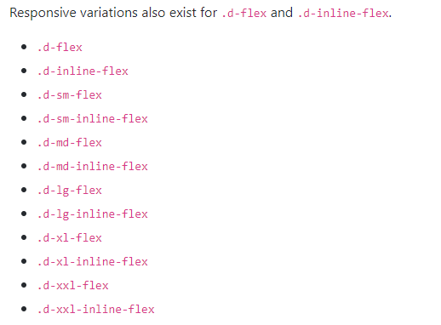
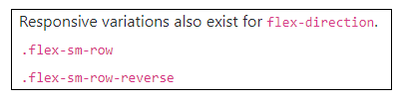

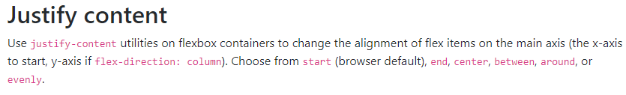
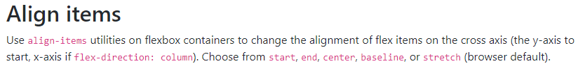
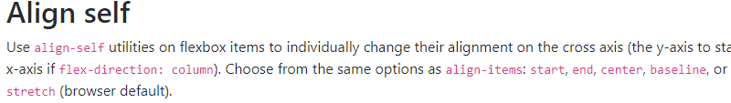
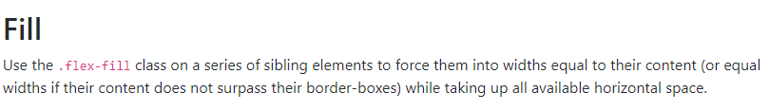
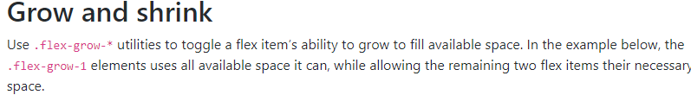
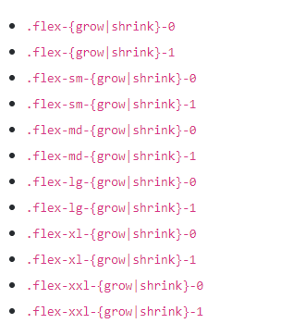

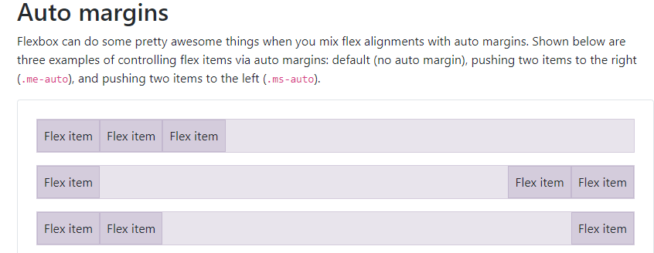
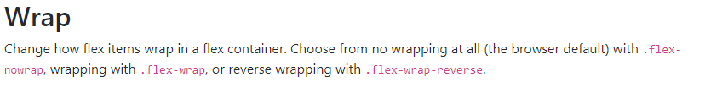
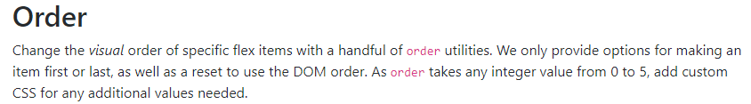
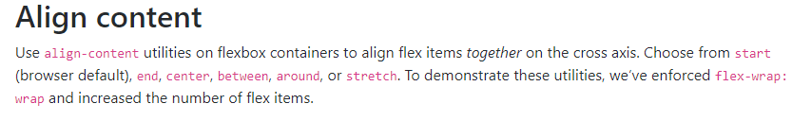
In Grid system,
the class “row” has displayed set to flex, u dont have to do that.
Bootstrapforms
class=’form-control’ we put this on the input itself.
class=’form-group’ used to group together a label and input.
class=’form-row’, basically it reduces the defaullt gutter size, so our forms look a little compact.
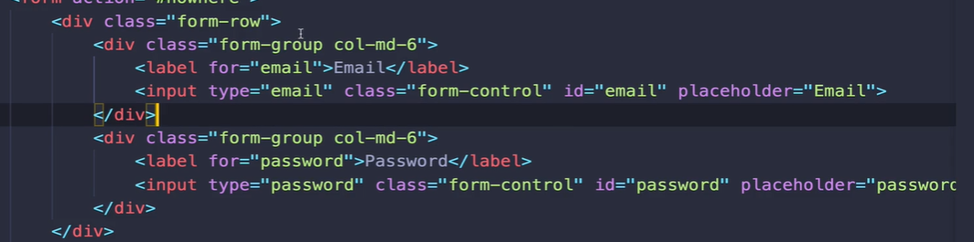
Here, when it hits medium, they will share the space.

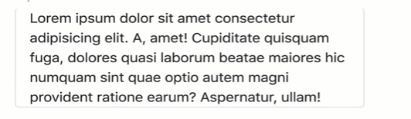
Border

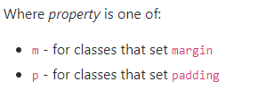

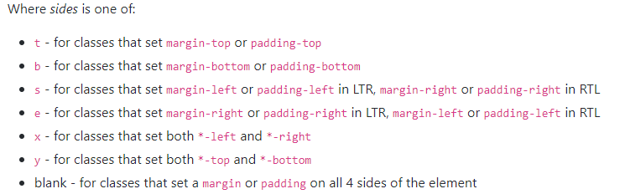
Sizes range from 0-5

Display

Bootstrap navbar

navbar-brand:title
navbar-dark:use light color
navbar-light: use dark color
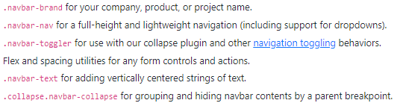

collapse.navbar-collapse works with navbar-expand-lg

---
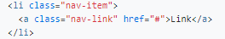

---
btn.navbar-toggler[type=’button’ data-bs-toggle=’collapse’ data-bs-target]
> span.navbar-toggler-icon
<!-- above, data-target is referencing the id of what we want to expand or collapse.

Use fixed-top,fixed-bottom, sticky-top

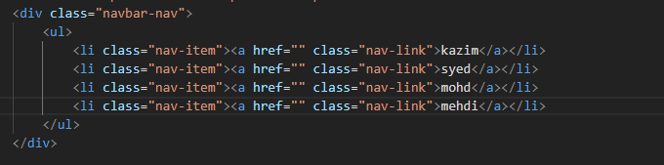
Problem up is that add navbar-nav to the container containing nav-items

