MongoDb
mongodb

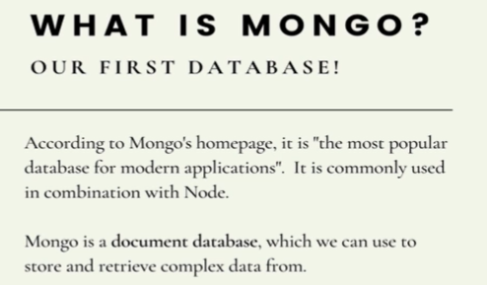

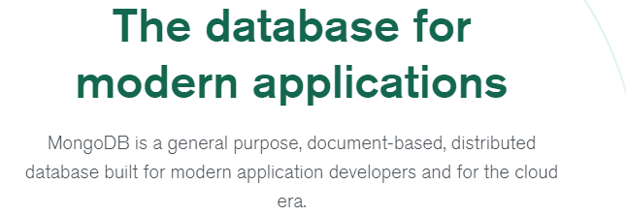
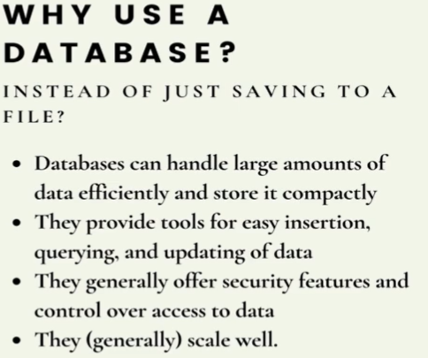

We need some data persistence, we want data to continue to exist, be safe, restarting our server, changing things, deploying our code. We want things to be consistently be there, not just dissapear. We could accomplish that by writing data to the file. Couldn’t I just store data in a file.
Yes, you could, but in general you dont wanna do that. Db are more than ways to save data and have it persist. Theyare also able to work with ton of data at once. They can store data efficiently, access efficiently, compact it down and make it pretty manageable.They also provide bunch of tools, basically different methods or a language you used on top of databases to easily insert,query,update,delete your db. We can do sort,filter..
A layer on top of db, call dbms.
Where the actual db, the pure data is being stored. There is some stuff on top including security features, adminsitrative access, controlling access.

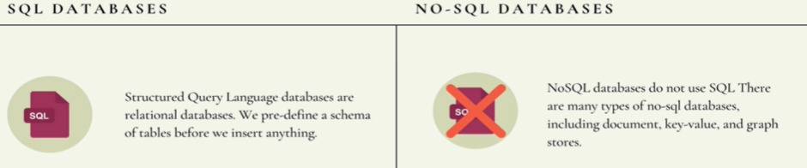
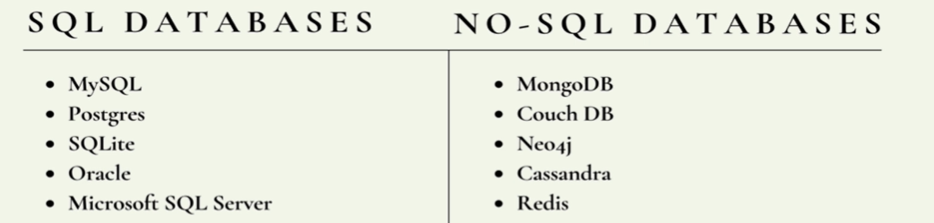
SQL uses structureed query language, basic syntax they share and they are relational databases. Everything is done in tables, we define a schema, we define preset tables before we add anything into our database. Everything has to conform to a pattern.

Document oriented databases, is that they store info in json,xml,yaml…
The main idea is we dont have to split our data into seperate tables, we dont have to predefine some schema or pattern that we have to follow, instead we can take data as it is and store all of that relevant info for some given thing in a single instance in a db.

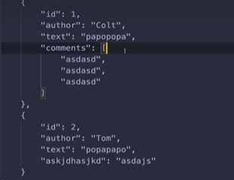

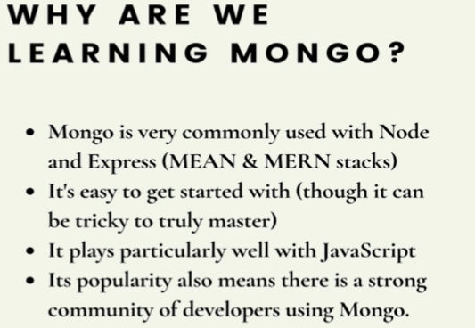

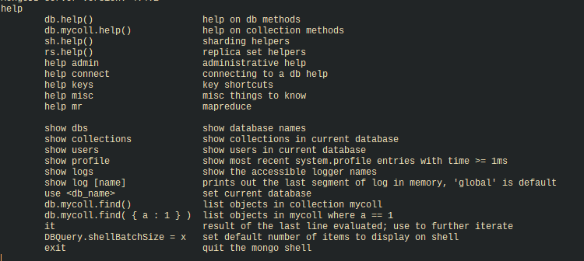

Note: Empty db will be not seen using “show dbs”
Note: what data looks like in mongodb and what mongo expect, the answer is bson(JSON and BSON)
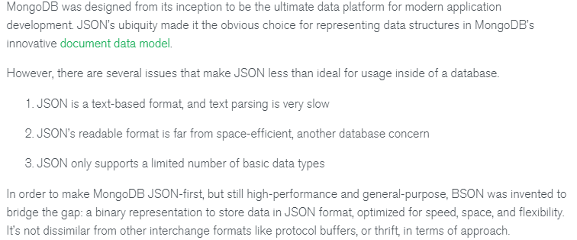
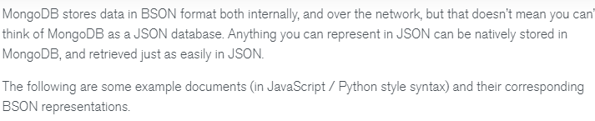
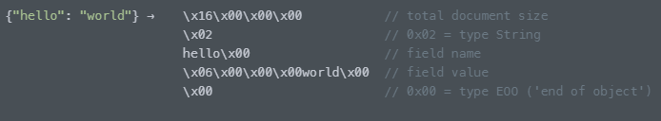
It look like it’s taking a lot more space, physically on file yes it takes more characters but in memory it takes a lot less space.
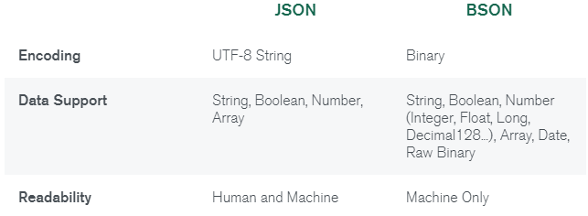
Mongo docs mongo docs

Queries
show dbs; show databases;
use <dbname> <!-- create dbs If not exist.
db.getName() ; db <!-- to get db name
show collections;
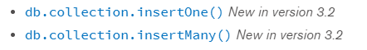
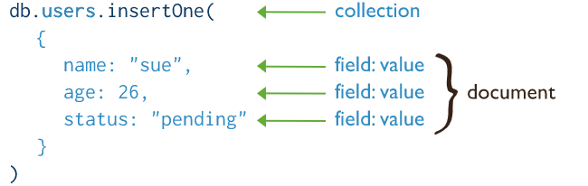

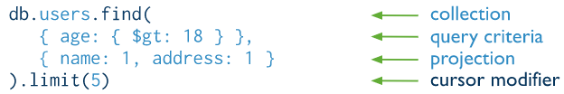

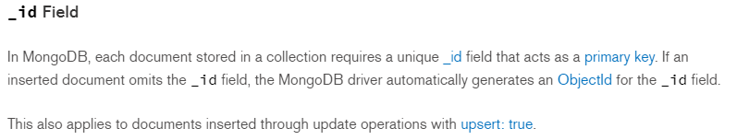
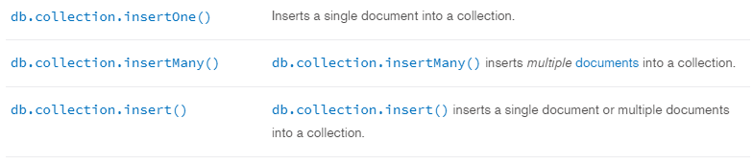
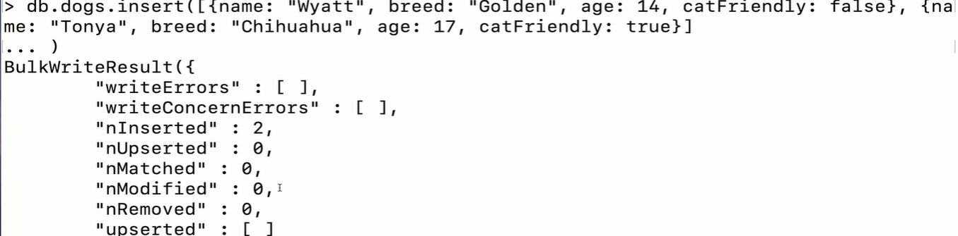
Query
Reddit


if there is a post, and we click on the user, now we looking at give me all post of that user.
.findOne() returns the actual doc, where as .find() returns a cursor.
Cursor: things like as a pointer or reference to the result, it’s not the same as having the results immediately.
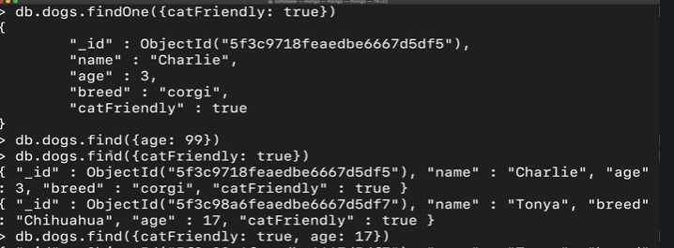
Thats why we have different looking result.

Query: Query in mongoDb (amazing)

Specify equally condition

Specifiy condition using query operators

same as

Specify AND conditions

same as

Specify Or conditions
same as

Update
updata a single document
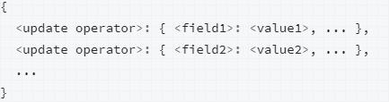

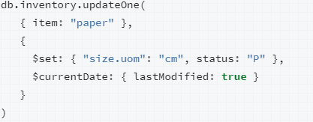

Update Multiple documents
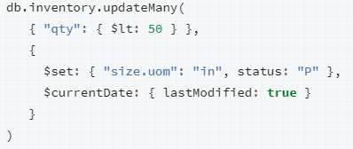

Replace a Document
Interesting note: This wont work with put cuz put replace id too.
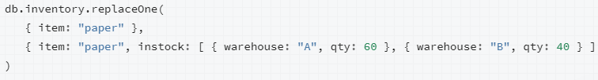

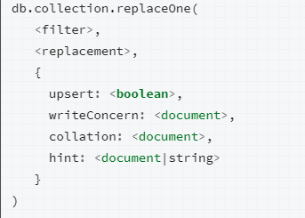

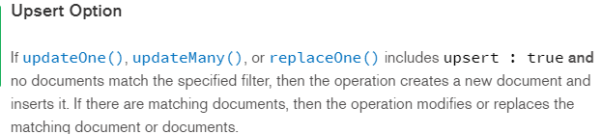
Delete
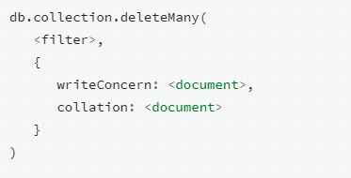

to delete all documents in a collection.

db.cats.deleteMany({})
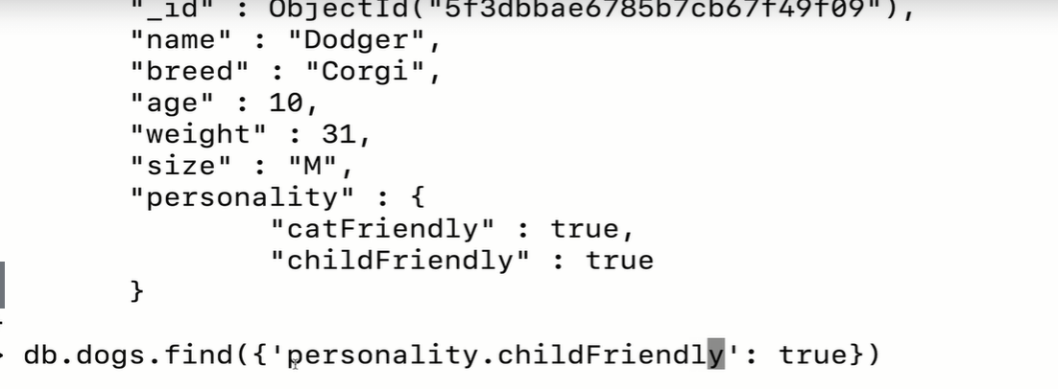
query and projection operators query and projection operators
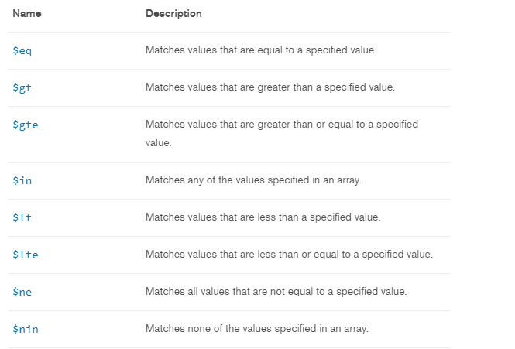
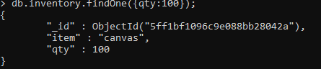
Mongoose mongoose
we need a way to connect express app, a node application with mongo, th
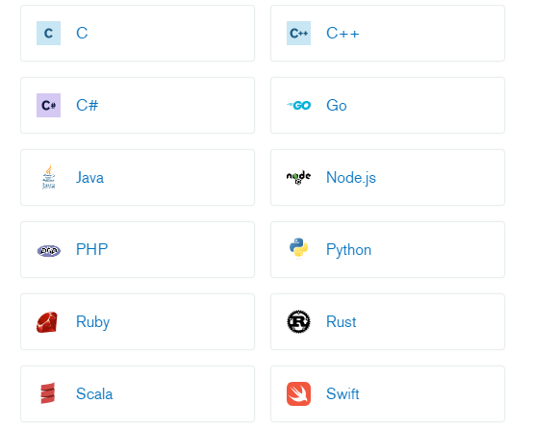
are bunch of drivers, these are ways to connect mongo with programming languages.
There is a node.js driver, that we can use to connect via node to our mongodb.

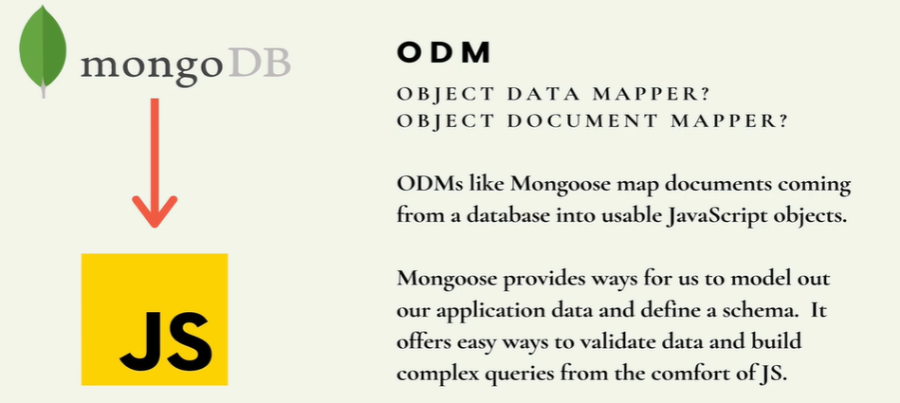

Mongoose is smthg called a ODM, a ODM like mongoose there are many other options like it. It’s sort of general concept not just for mongo for other db will have their own flavour and tools called ODM for different languages. Mongoose is for mongo and node.js. It’s more than a basic driver that connects node to mongodb. It provides a lot of functionality that are useful on the js side of things. It maps the data that come back from mongo and the data we want to insert into mongo, it map those in useful js object, where we can add methods to, we can add validation to, we can make sure this is required or price has to be greater than zero, before you insert something. We also have the ability to define a preset schema ahead of time. So we can enforce that our data conforms to the schema we layout using mongoose. It also help us to build more complicated queries. The goal of mongoose is to take plain old mongo and kinda scoop it up and make it more friendlier and powerful on js side of things. There’s nothing that we wouldn’t be able to do that we couldn’t do without it. It just make experience a bit better. It adds on nice features that we have to create ourselves. ODM will map data to js objects. For sql based db the term we use for this type of software is ORM, Object Relational mapper. It will take sequel info and map that for js,…
All this tools translates from db to some programming languages.
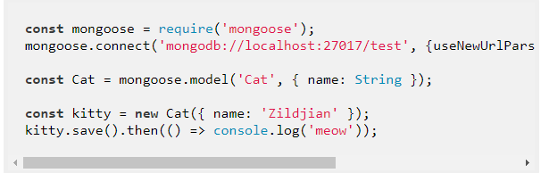
Above the db is test.
If you forgot useUnifiedTopology:true it will give deprecation warning.

When you run. There is a change in cursor telling smthg is going on or the server has started or it hasn’t finished running. That’s bcoz we have hopefully connection to this db.
There are couple of option to know this.
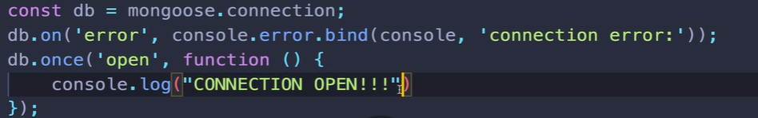
Better way below
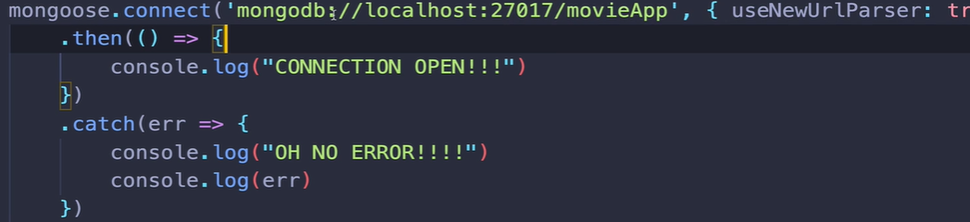
The goal of mongoose is to have a easier way of interacting with mongodb
from js.
Models: Are js classes that we make with the assistance of mongoose, that represent info in a mongodb, more speciifically in some collection.
Under Api>model
you can see whole list of different methods and functionality for every model we make, will have access to.
If its the js we will be making, which should model the info coming back from the mongo database.It also helps us to interact and send new info to the db,query,delete,update things.
So for every single resource or collection we working on mongo db,we plan on accessing it or working with that data in js and we using mongoose we need to define a model for each. The first thing we do to define this model is to define a schema.

What is schema, think of it as scematic or blueprint or game-plan.
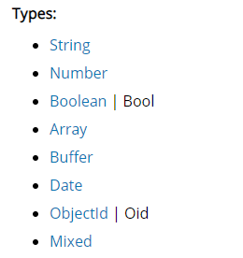
What it is mapping of different collecion keys from mongo to different types in js. Remmember we taking data from mongo, which has different types that js or whatever language we working in may have and also may not have. By defining schema we provide constraints on attributes.

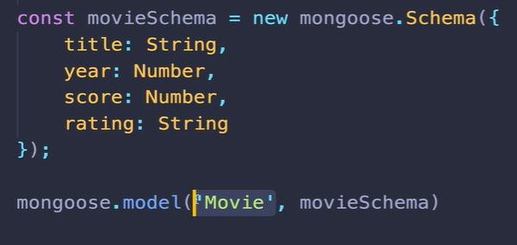

Above, the name of the model “Movie” must be singular and pascalcase.
Mongoose will take that class name and pluraize that and create a collection for us called movies.

Now, we can make instances of our Movie Class and I can save them to my mongo db.

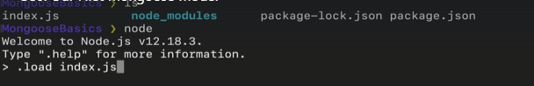
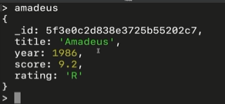

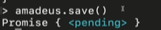

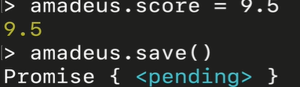

It created a collection for us automatically.
So we have our js object that I can manipulate and change and save it on any point, which will commit those changes over mongo.
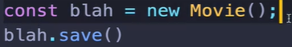

InsertMany insertMany

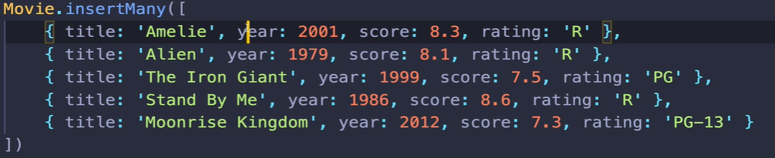
This is gonna take time, it’s smthg that wont happen immediately. As we know in js, when we have things take time, often we have to work with callback or promises.
Note: when you do insertMany, you dont have to save().
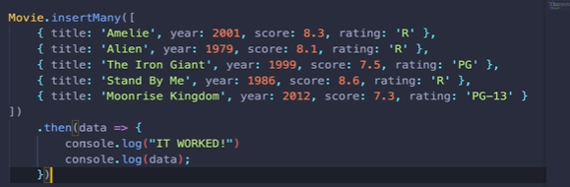
Finding in mongoose (find,insert,update,delete,...)

Just like mongo, this operations takes time. Finding something involves waiting for mongo to gives us some data back, so we have couple of options for how we wait and how know for sure we have data back.
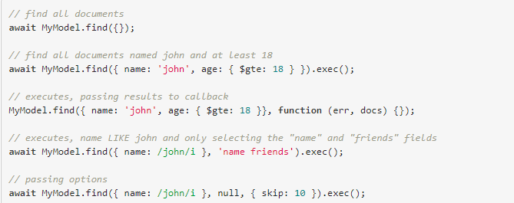
Also read this : queries are not promises
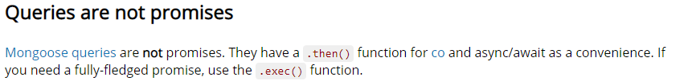
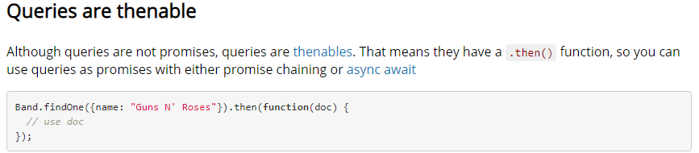
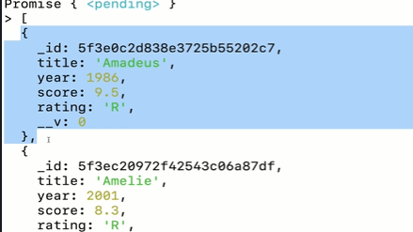

It’s gonna select the first one.

The second parameter will be any docs, any doc that we get back, the data coming back.
You should use .exec() because it gives you a better stack trace. It gives you sort of better trace of where things went wrong if you have something go wrong.
---------
Updating with Mongoose
What’s a little bit confusing about them is that they dont actually return or they’re not resolved with the updated information, just like in mongo itself. Like when we update smthg in mongo, it doesnt return or doesnt show us what was updated. Instead, it just tells us updated or “n” updated.
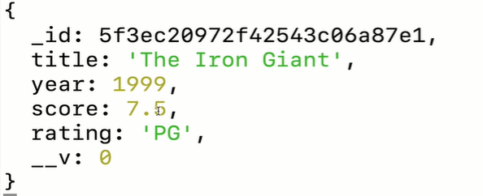
wait this is the old version, I set score:7
But if you check in db, the changes were successful.

So why did it give me old version?
Thats the default behaviour of findOneandUpdate().
So if we want the updated version to be given to us, when the query is done, we actually have to specify an options so we can pass in options as the third argument

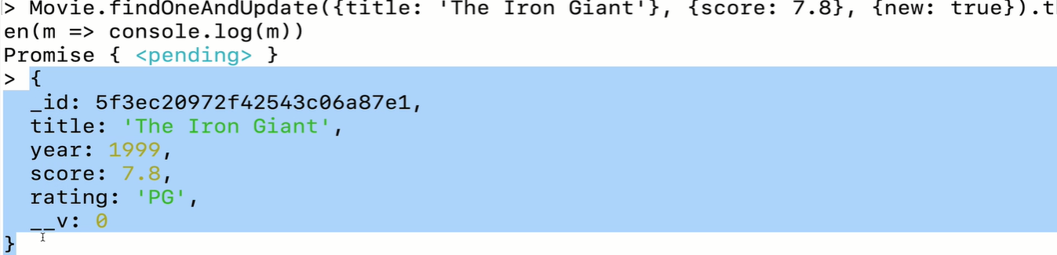
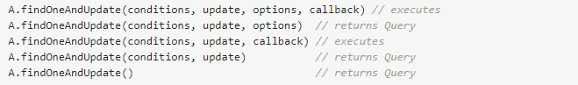
for deprecation warning.

Deleting with mongoose.

Method remove is not going to give us back any information or any documents that were involved. So it just sends a remove command directly to mongoDb
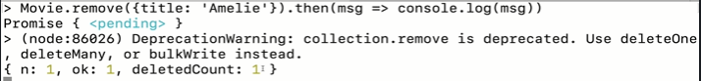
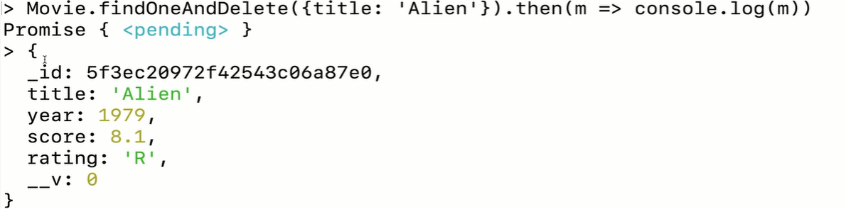

we dont get doc back when update and delete, but we do get when findOneandUpdate() or findOneandDelete() or basically update/delete with find.

Mongoose Schema validations
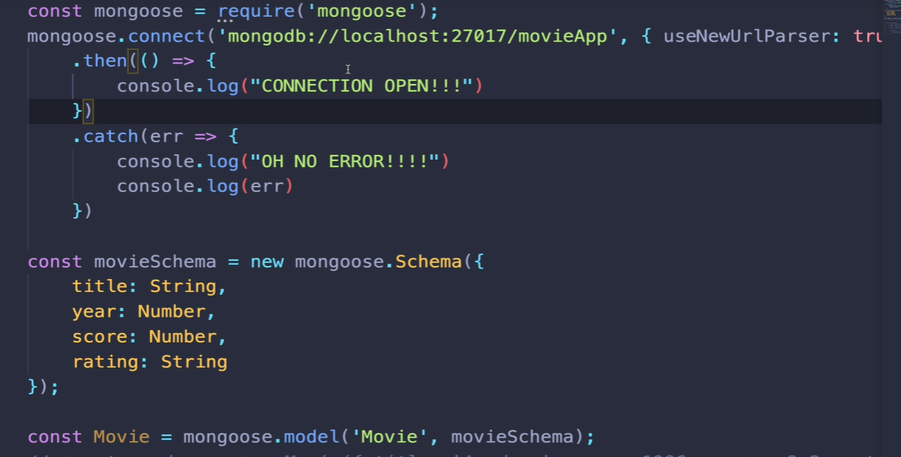
You may wondering how could I run code here, if I dont know for sure if I am connected or not. Cuz it takes time to establish connection.
So you might think we need to put code in then() of connection to guarantee that it’s run after mongoose.connect finishes.
Its actually the way mongoose is setup it does something called operation buffering which allow us to start using the model immediately without wait for mongoose to be connected so we dont have nest all of our code here in “.then of connect”.
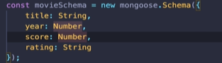
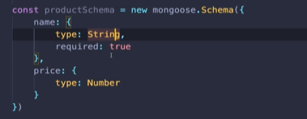

This syntax allow me to add additional info, including things some of the built-in validation that come with mongoose.

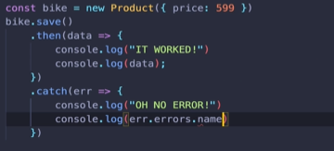
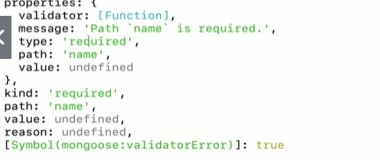

In schema,
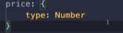
if save anything else than a number I.e err.errors.name.properties.message:”product validation failed.’
if you put a string ‘599’ for price, it will be accepted.

here, color field isn’t in schema we define.
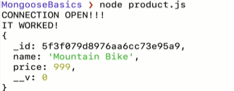
Ans:)
Here, the color field is ignored. But it also didnt trigger err code.

Additional Schema constraint schema constraint
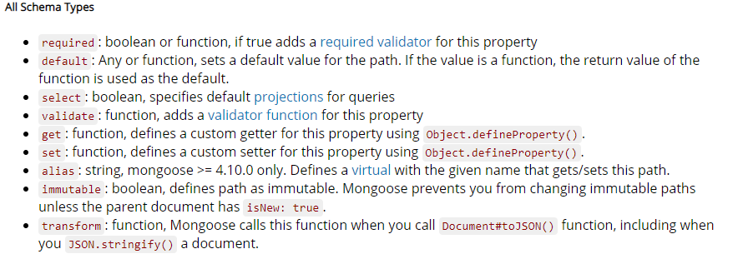
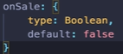
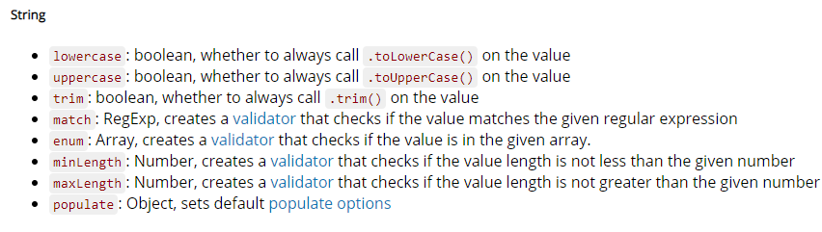
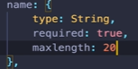

so what if I want 2 have a product to have categories, so I want an array of strings.
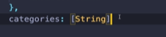

numbers can be cast into string.

Categories instead of being list, it could be an array of objects and each object can have it’s own schema we can define.
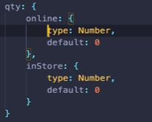

Validating Mongoose updates

The schema is working when we create products, they wont when we update
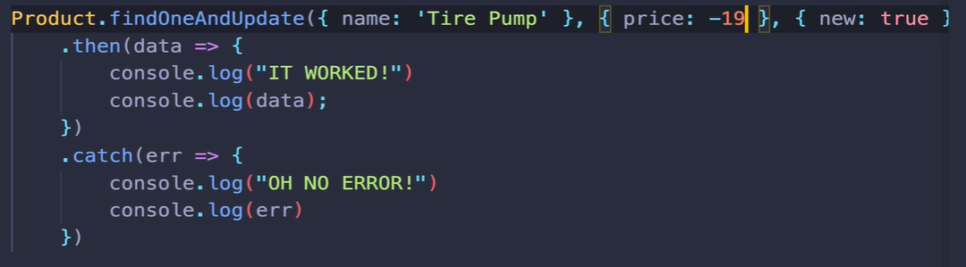
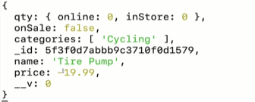

ERROR here is price is negative value.

The problem is the way mongoose is setup, it’s also not unique to mongoose. With a lot of this odm and orm, validation is applied automatically when something is created and when its updated you need to tell mongoose we need to still apply our validation.
Mongoose validation error validation error
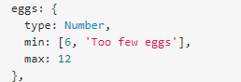
here, in the min array, the first value is our minimum and second value is our error msg.
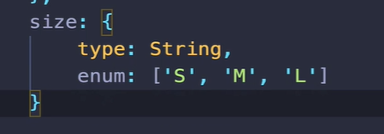

Model instance Method instance method

Adding our own custom method to our schema, it’s really really common, it’s a way of defining or adding functionality onto the model in addition to whatever mongoose already provides.
Instance method is a method available on every single instance versus a class or static method are basically all the methods that start with
Product.find() that’s a method that’s on product class or just on product in general
then we do “new Product().save” that save is a method on instance of product.
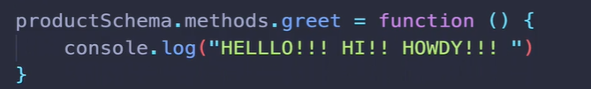
>node
>.load product.js
>const p=new Product( { name:”chips”,price:10} )
>p.greet()
Hello!!! HI!! HOWDY!!!
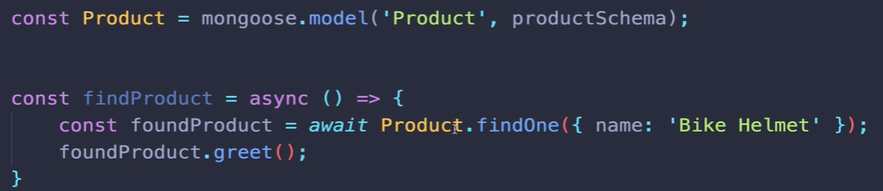
When we work on authentication, we will have user model and a user will have an email and a password and we will create a method check credential or authenticate or validate. Where it will check password input against where we have stored in the db. We dont actually store password in db.
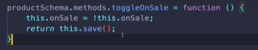
Here, onSale is a boolean.

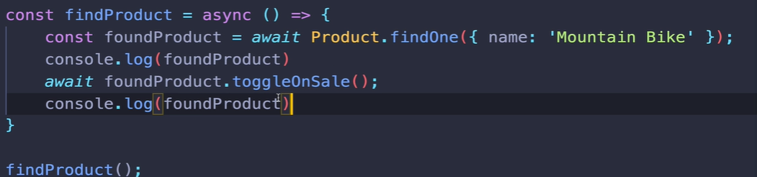

The whole point of methods and function is to reduce duplication, to make our code, more reusable, more modular. This is a nice way of organizing and associating logic, that has to do with the model with the actual model itself and the info contain.
In general, if it has to do with manipulating data or with the info contained in a model, then put it on the model.

Adding model Static methods

Static methods: are method that lives on the model itself, not on the instances of the model. Usually this methods wont act upon individual instances, we dont have access to this whereas the keyword this in instance method refers to an individual instance.
I was incorrect what I should said, the keyword this inside a static method refers to the model class itself.
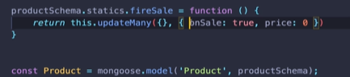
Here I use “this” instead of Product cuz I dont want to hardcode that cuz I may change the name.

Often when we create a static method, we are either doing something that is basically a fancy find or a fancy update or removal where we’are just customizing we’re adding methods on to the product class.
In other words, fire sale has nothing to do with one particular product. It has to do with in our case, all products or just the product model in general.
We could do above methods without static methods, but if we do make a static method it’s nicer way of approaching.
Static methods are built upon existing model methods like products,find products, update products,..
Instance methods act upon individual instance of a model.

Mongoose Virtuals mongoose virtual

Mongoose virtual gives us the ability to add properties to a schema that dont actually exist in the database itself, but we have access to, thanks to mongoose.
So these are usually a synthesis of multiple properties in a database or something that could be derived from the database.
A person model has a first name and a last name, we dont need to store the fullname in the db, but it would be nice to have a property that I could access as if fullname was in the database.
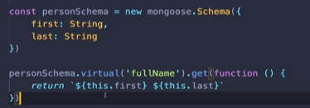
We are defining a set and a getter so when I call .fullName, I want to retrieve some value that is first name +last name combine with space in between.
Here, this refers to individual instance and it’s different from instead of adding instance method, although we could just write a method on the schema, an instance method called full or get full name. What’s differnet though is tha it will behavae as if it’s an actual property,which is why its called a virtual.
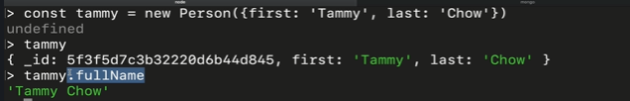
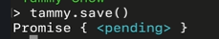


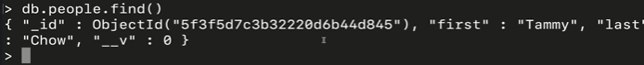
we just have first and last name, there is no fullname.
Remmember, the idea is that this property exist not in the database at all, but only on the mongoose side of things in js.
But we usually use these if we have some common info that we’re accessing pretty commonly that we can derive from existing data. We could store full name in db, but why bother. We already have that data, so no reason to take up more space now.
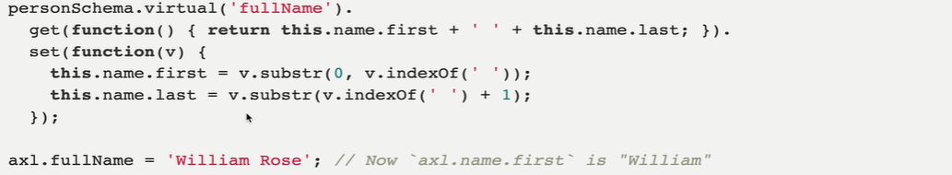
What this does, it takes the property, the value we are setting for fullName, and then we can use that to update first Name and last Name.

Defining Mongoose middleware
Mongoose gives us the ability to run code before and after certain things are executed. Certain mongoose methods are called. So I can run some code right before something is removed or something is saved or any time we call updatemany or find or whatever it is.
We can run a pre or post hook or middleware before and after(just like trigger)
for e.g if you’re deleting a user from your app, you may also need to delete all associated comments or post and photos or whatever else they’ve created over the years.
We could use a mongoose middleware to help us whenever remove is called on the user.
In order for this to all workout, we have two options. One is to accept a parameter, we’ll call it next in out callback and then execute next at the very end of our function.
Alternatively we need to return a promise from our function.
This both options are about making sure that this code runs in the middle of something and then something continues to run after it.
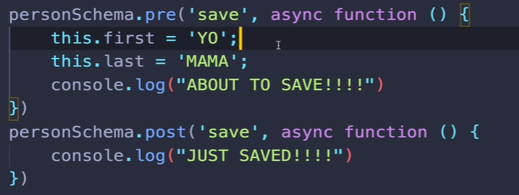

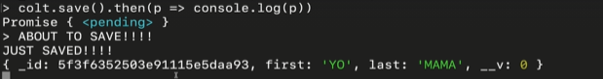
This sort of thing can be useful not to overirde first and last name, but run code some code before something happens like saving or removing or updating. Theres all these different places that we can hook into with thes middleware and then afterwards as well.
Lets say we have a review model, and any time you create a new review, I alos want to update some average review. I want to be able to keep track of the average score for all of my reviews. Whenever you update or save a particular review, we can take that score and then added onto the average and divide and do the math.

