Binary trees

If we have a tree where a leaf node has
No Children OR 2 Children it is a Full tree.


Complete binary trees are binary heaps, it means when we fill out the nodes, we go top to bottom and we go left to right.

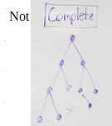

Perfect binary tree is where all the leaf are at the same level and all of the nodes that decides that decides to have descendants have exactly two children.


A perfect binary tree is both complete and full.

If we are very flexible to traverse our binary structure, it becomes much easier to solve problem recursively, iteratively with a stack.

Three fundamental ways to traverse a tree.
Pre-order : root left right
In- order : left root right
Post-order: left right root

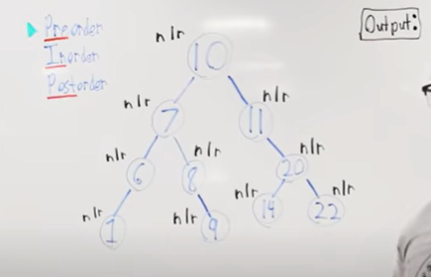

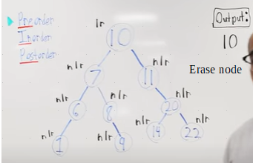

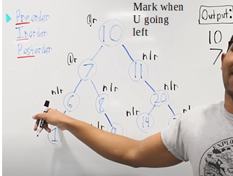

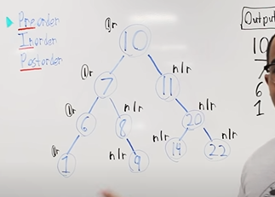

-------------------------------------------------------------------------------------------
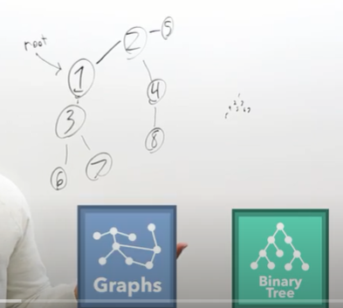

A tree is a acyclic connected graph.
DFS: we use a stack ( Call stack(recursion) or Our Own stack)
BFS: we use a queue.
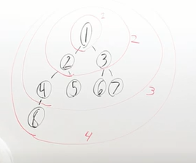

Link

Heaps:
Two forms , they are minHeap and maxHeap.

In a minHeap, the elements are essentially smaller than their children,
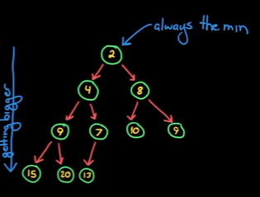

How we create and maintain such a data-Structure.
Insertion: Next empty spot, looking top to bottom and left to right.
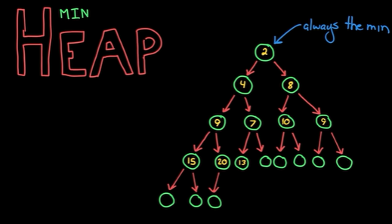

if the element doesnt work on that position.
Then ?
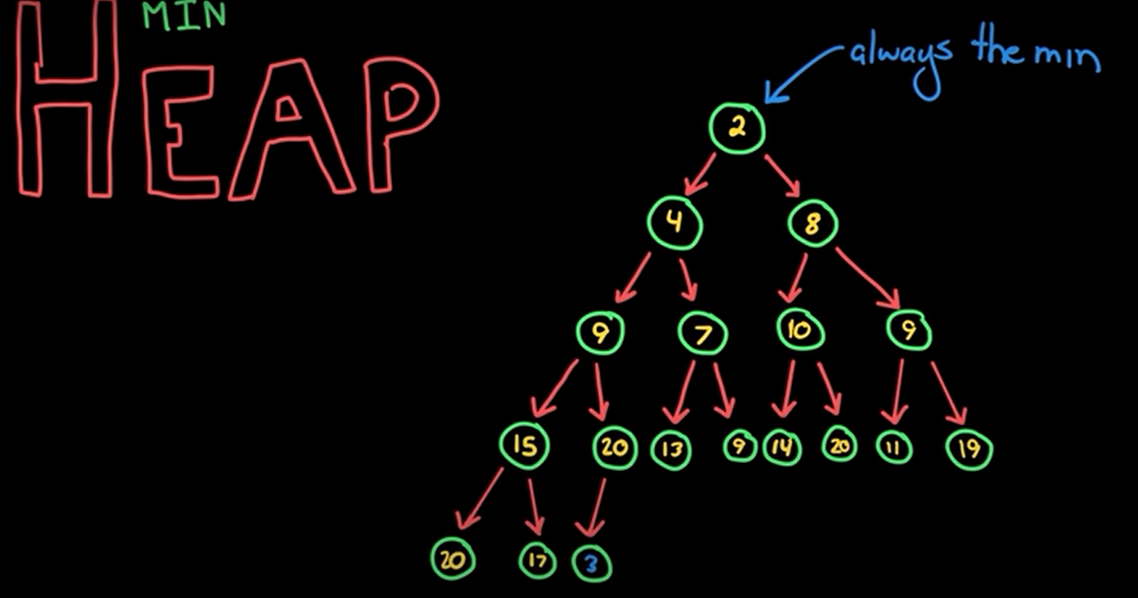
You can insert the element there, and bubble it up, until we get to the right place.
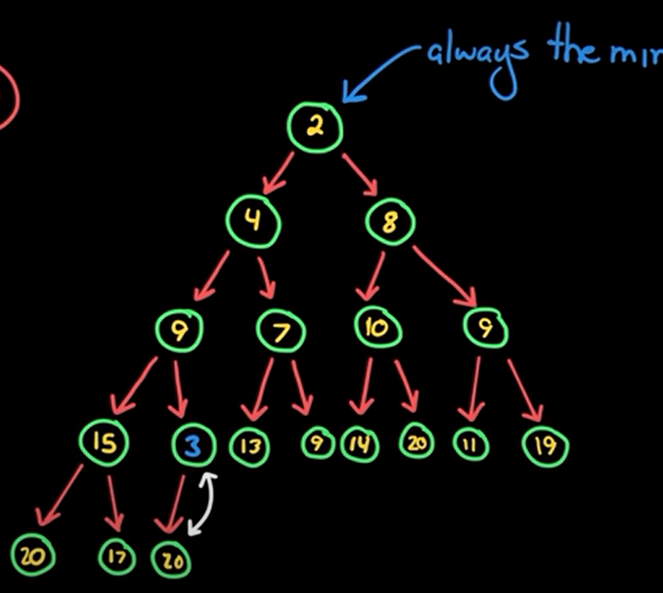

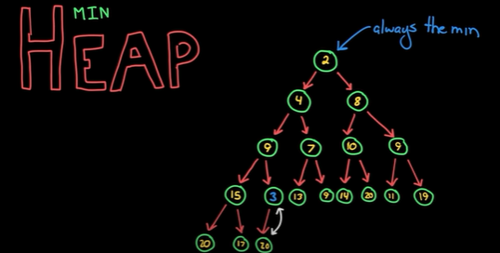

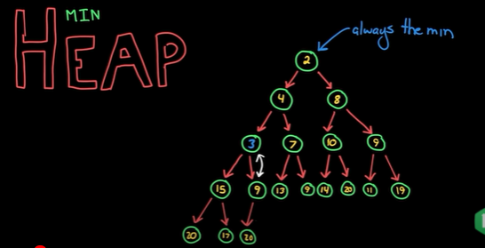

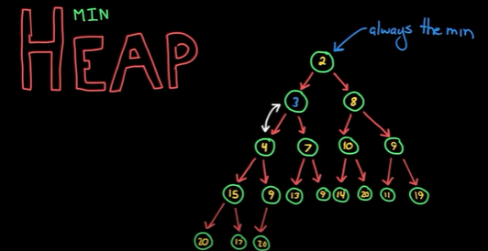

What about removing the minimum element?
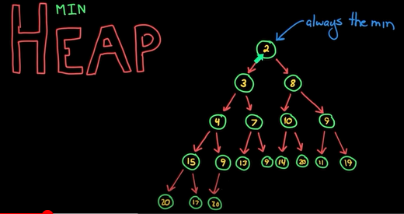

Thats easy to find and if we wanna remove it then we have an empty spot.
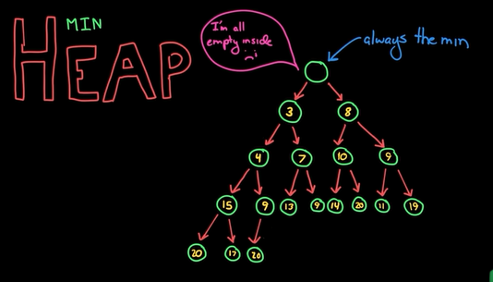
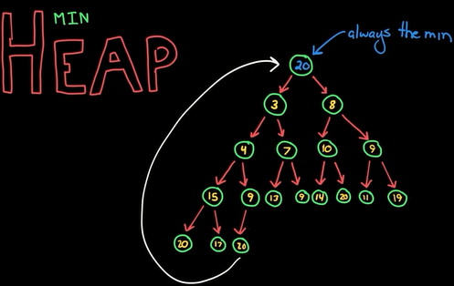
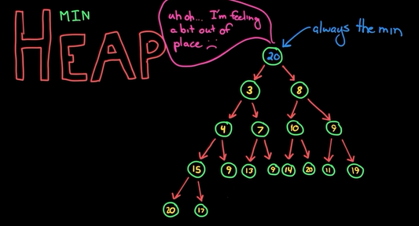
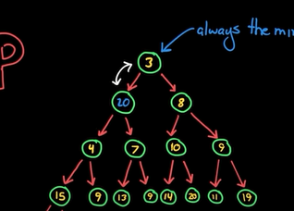

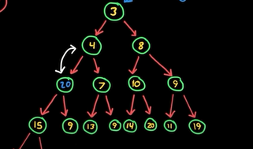
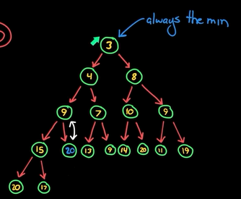

Implementation:
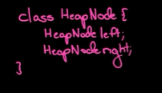

when we add elements to the heap they are added to a very particular spot.
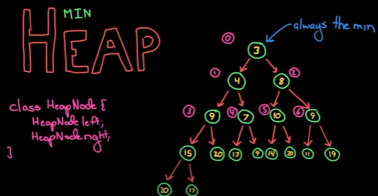

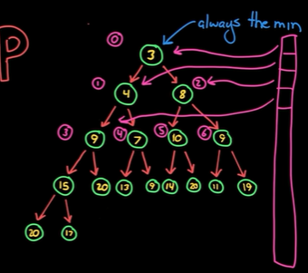
This mean that we can use an array which makes it really compact.

A simpler equation can map its left child and right child or its parent
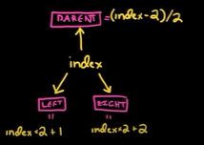

so we can get to its left child and right child, where we dont need to have a overhead of nodeClass.

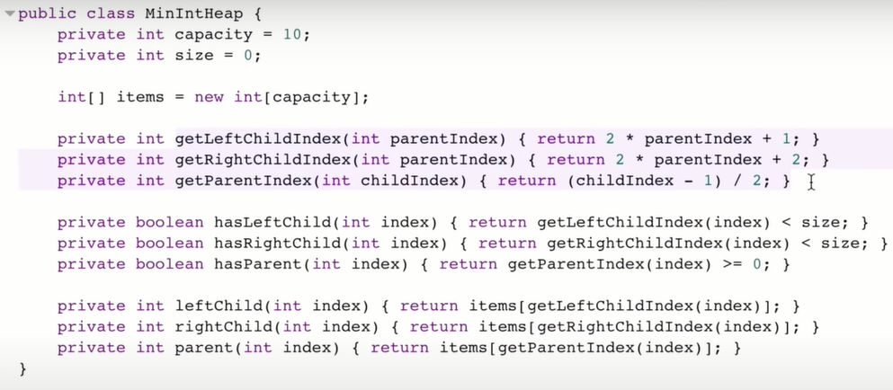
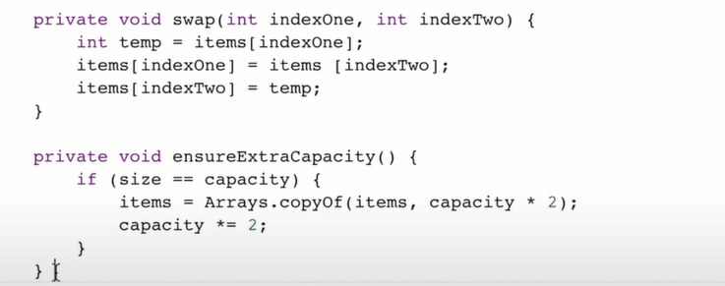
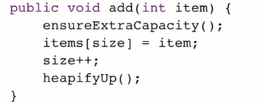

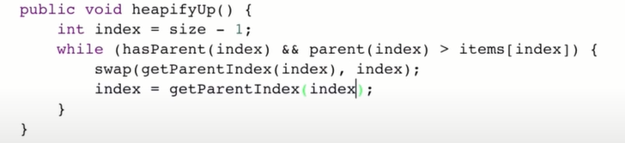

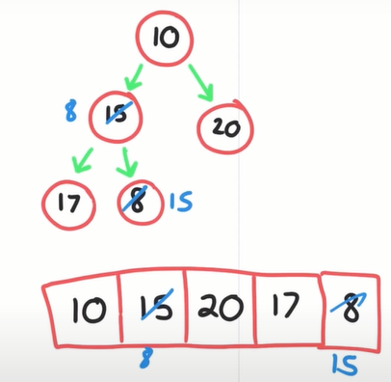
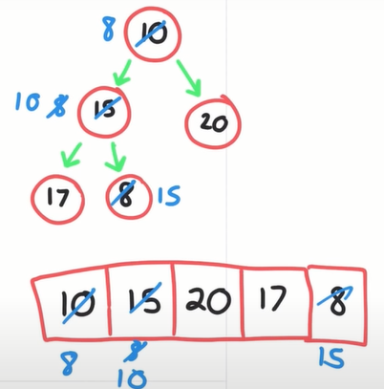

b)
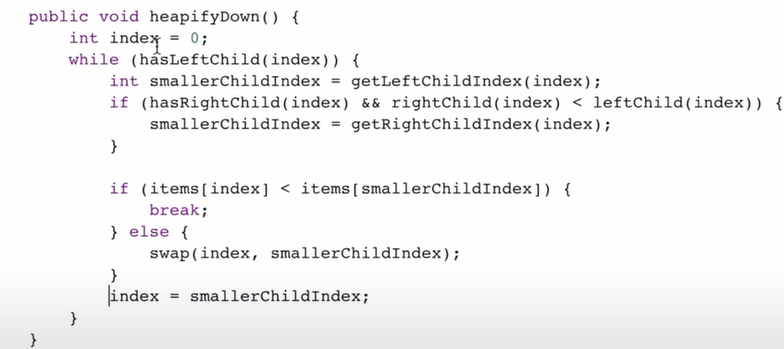
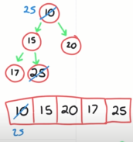
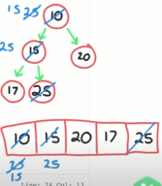
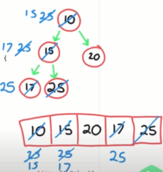

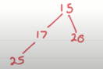

Binary Heap Video -2 : LINK
What heap offer us is the largest and the smallest number from the group of numbers.
To get the smallest element is super easy with time complexity of One.
A heap is a complete binary tree.
If heap is a data-Structure and is not an Abstract datatype, what is it?

Heap is an implementation fo Abstract data-type priority queue.

What is Abstract – Datatype:
Stack: push,pop
queue: enqueue ,dequeue
we create a core-Api that characterize that datatype.
Abstract cuz we want this behaviour and we dont worry about how u do it.
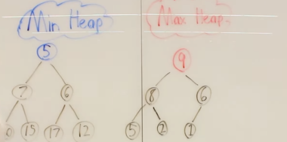

We can on constant time know 5 is the minimum element or 9 is the maximum element.
Insertion and removal from a binary tree is 0(logn)

Heap is about keeping quantities in gradually increasing and decreasing in order in data structure and constant time peek to the smallest element in MinHeap and biggest element in MaxHeap.
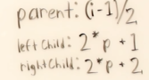


Heap Sort: Application of heap to sort data.
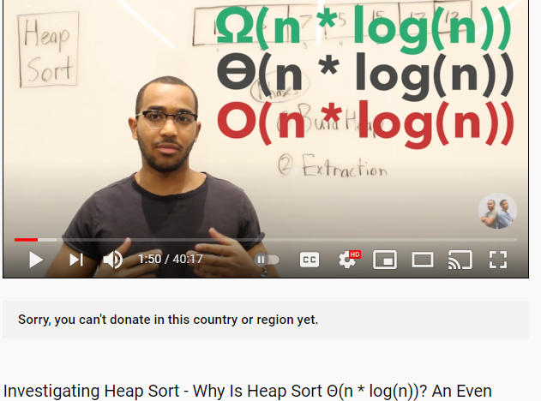

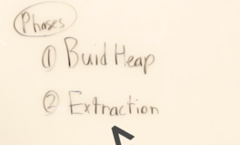

Intuition:
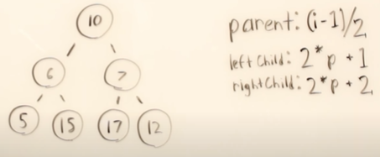

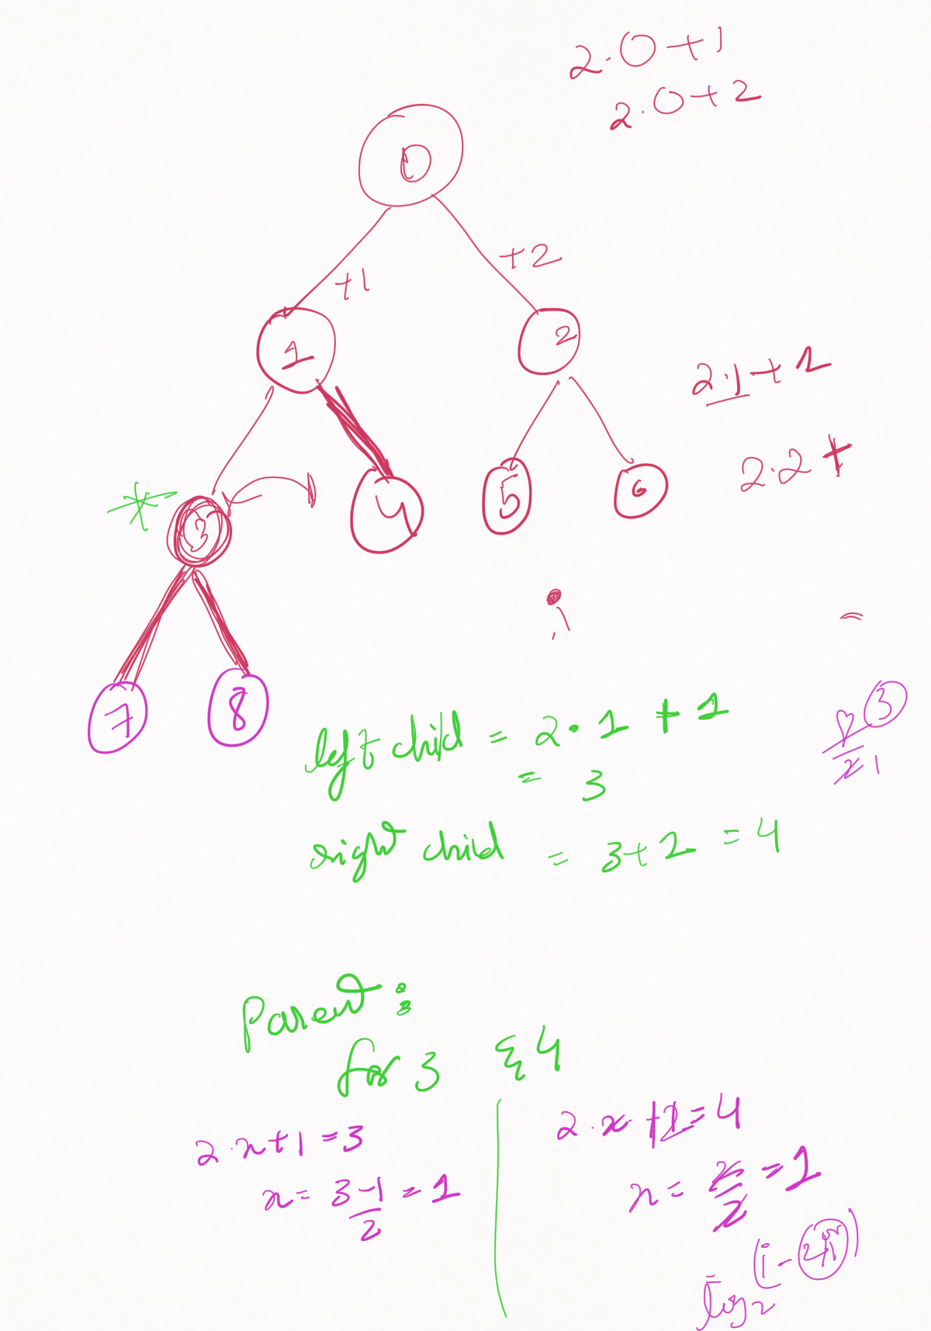

Tip:
Heap sort:
1) Imagine the array,
Idea is we dont need to start from bottom, we can start from the middle half of the tree and perform swap in the bottom half of the tree..
You can either

1) round( len(myarray)/2 )
e.g (7/2)=3.5= ground(3.5)
or
2) Considering length of array 7,
so index 0-6,
I.e round( 2.x+1)=6
…
7/2=3.5
it should have been 6-2/2=2.

e.g
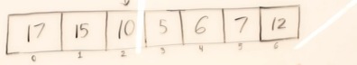

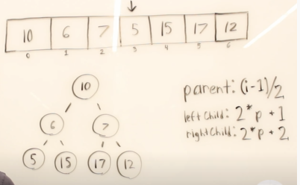

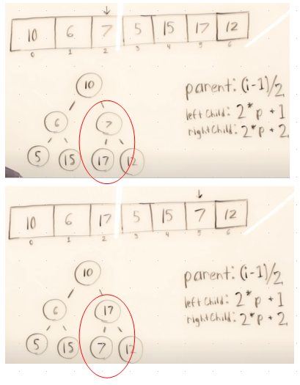

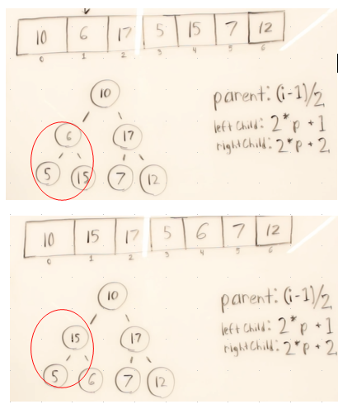

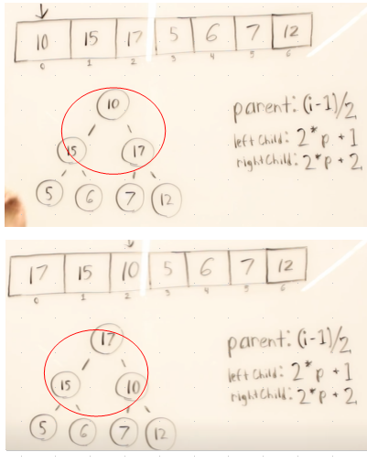

Above Max -Heap build
Extraction phase
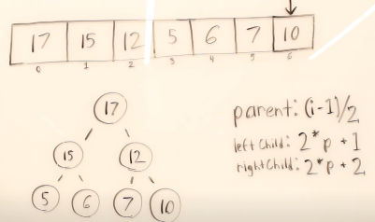

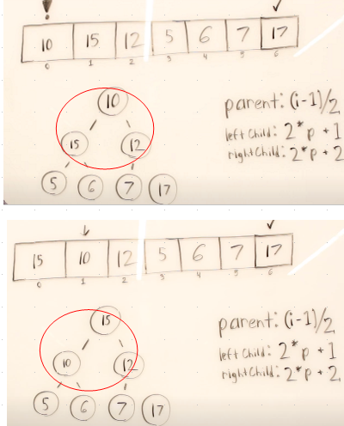

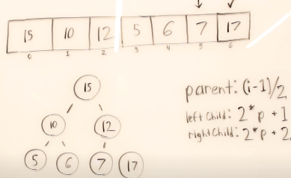

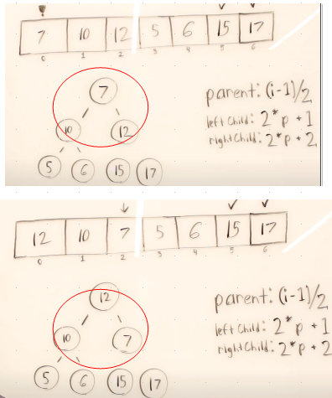

Similarly

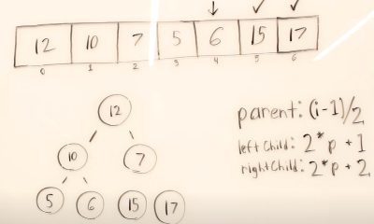

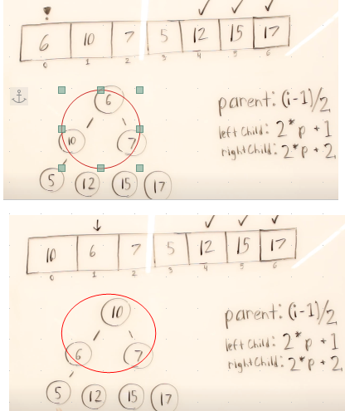

AGAIN

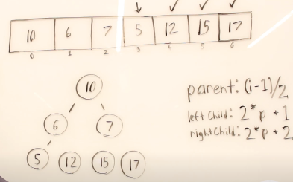

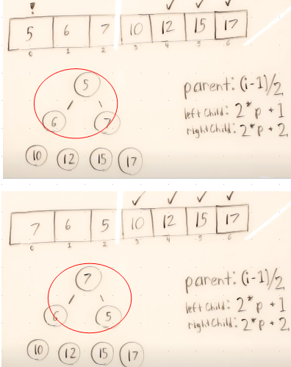

Similarly.

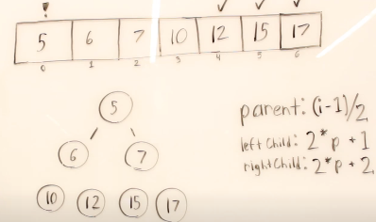

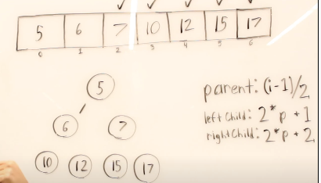

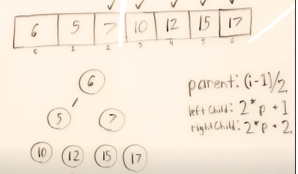

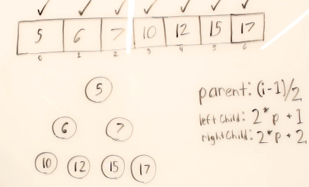

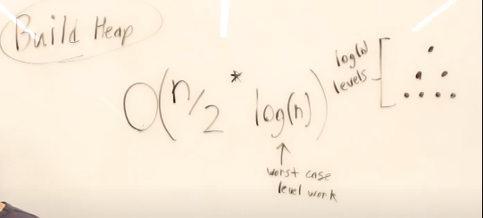
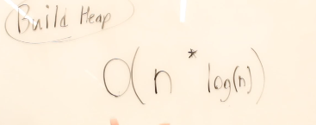

from time 25:00 I didnt understand



