Learn Notion
subtitle

lINK:CLICK

Heading 1

Heading 2

Heading 3

Heading 4

Notion training the basics
Whether u wanna manage projects, notes,
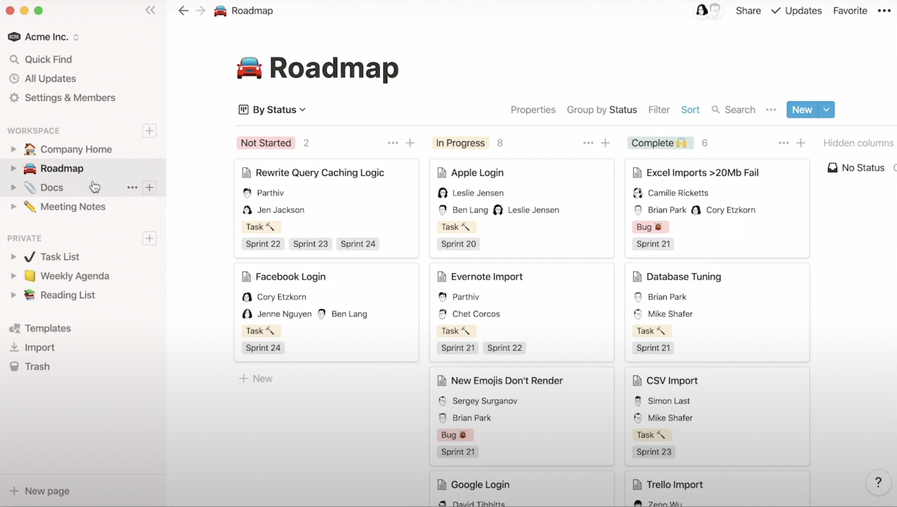Figure 1: Manage knowledge.

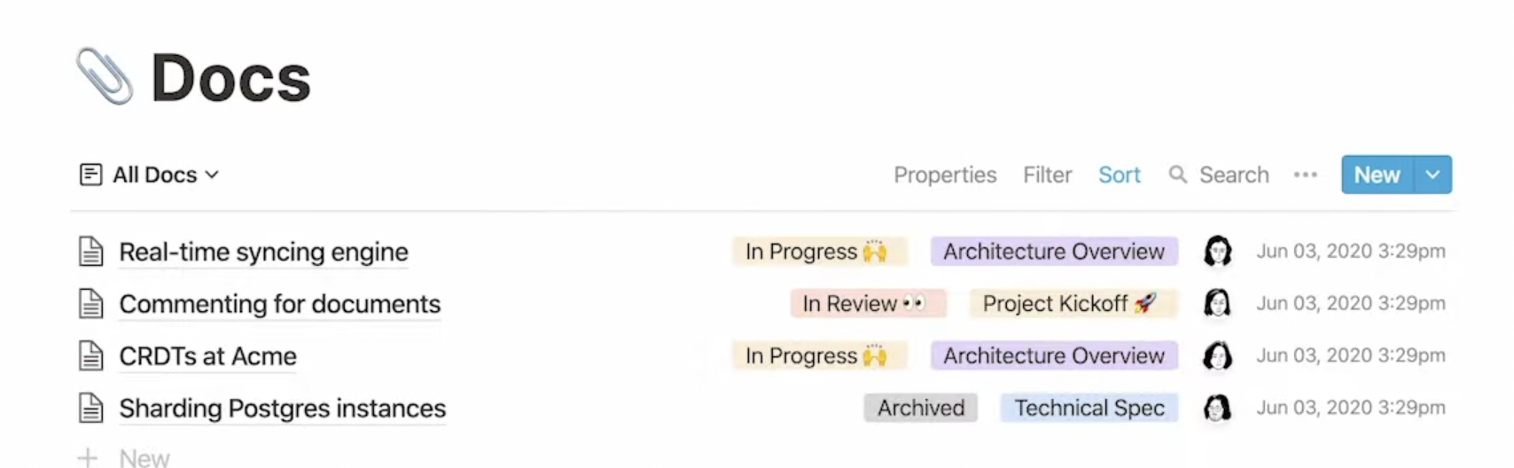Figure 2: Create Notes.

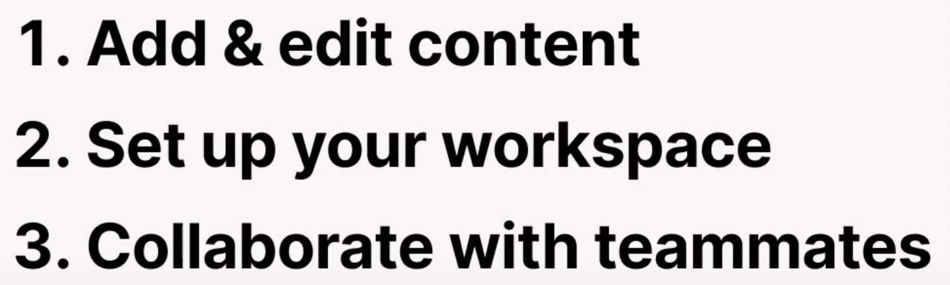

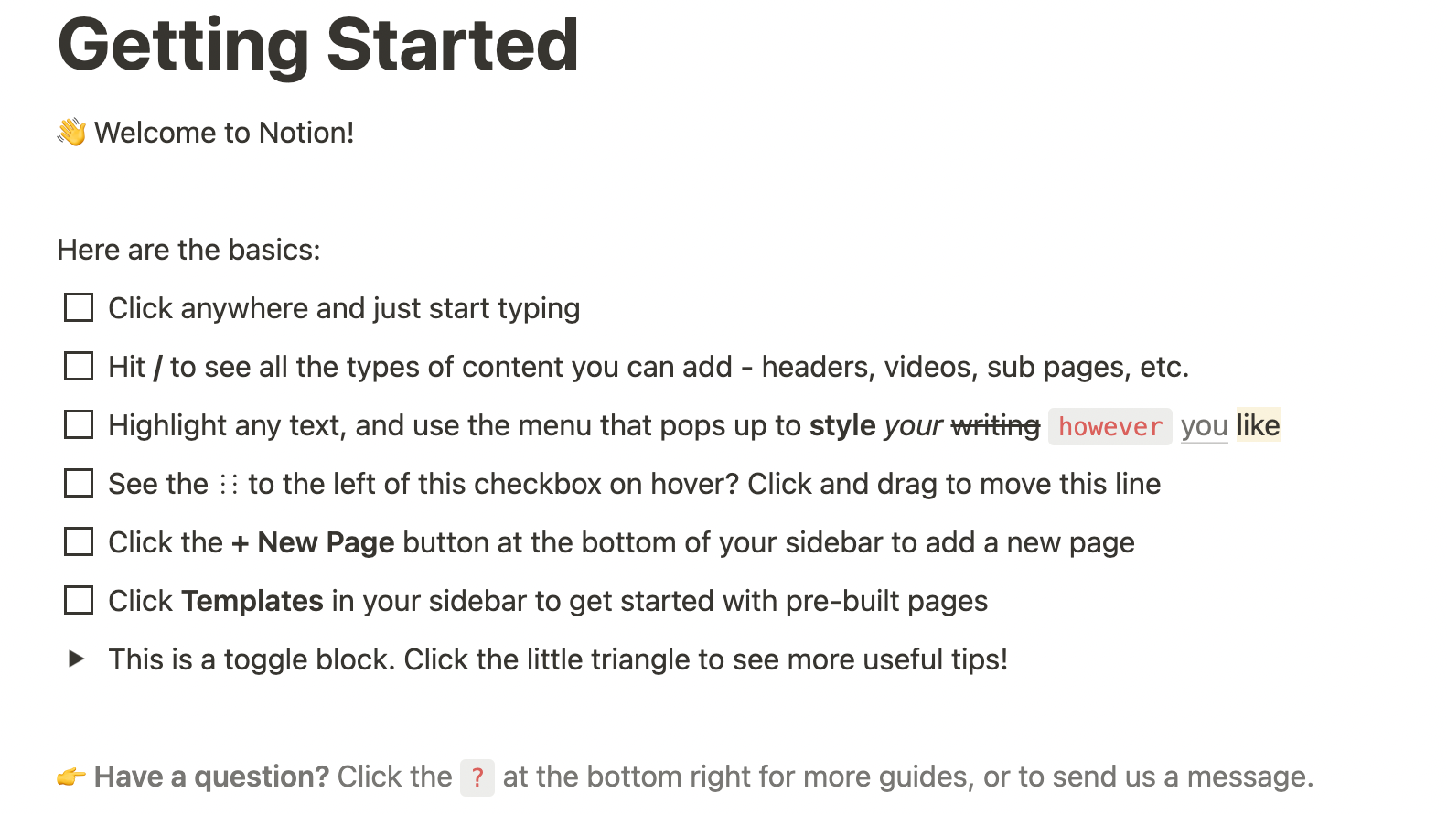

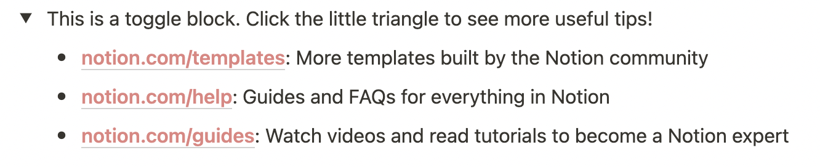

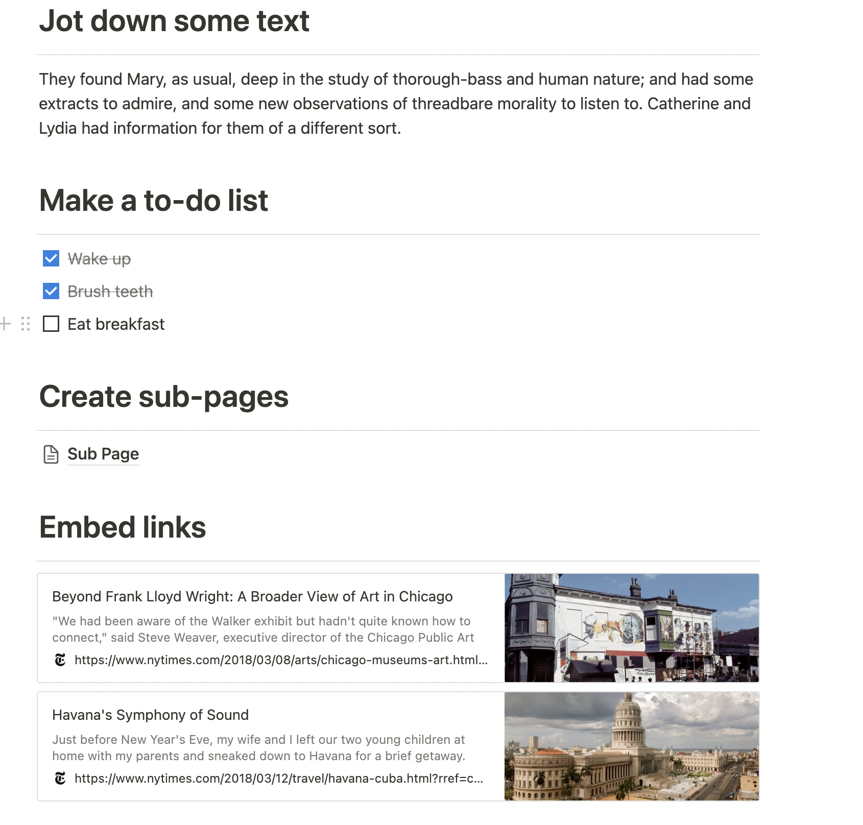

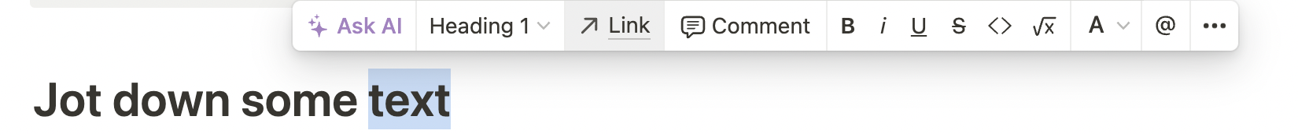
You can put a link to that very easily.

Create a db
Also you can create a database aka table with custom properties.
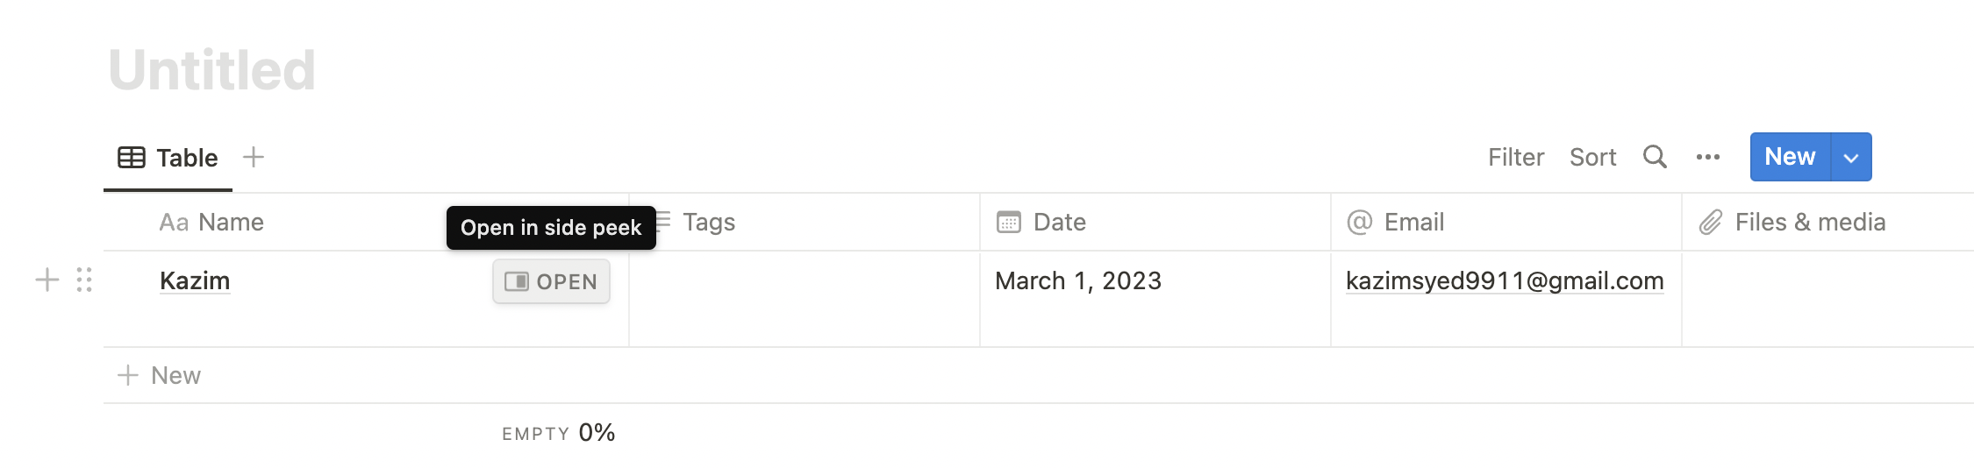
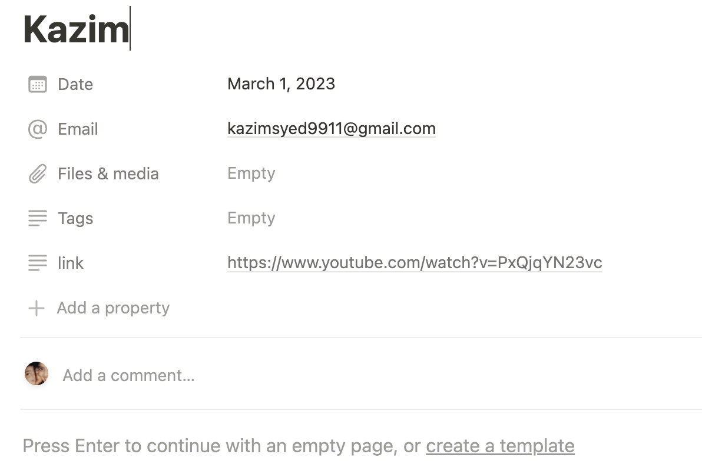

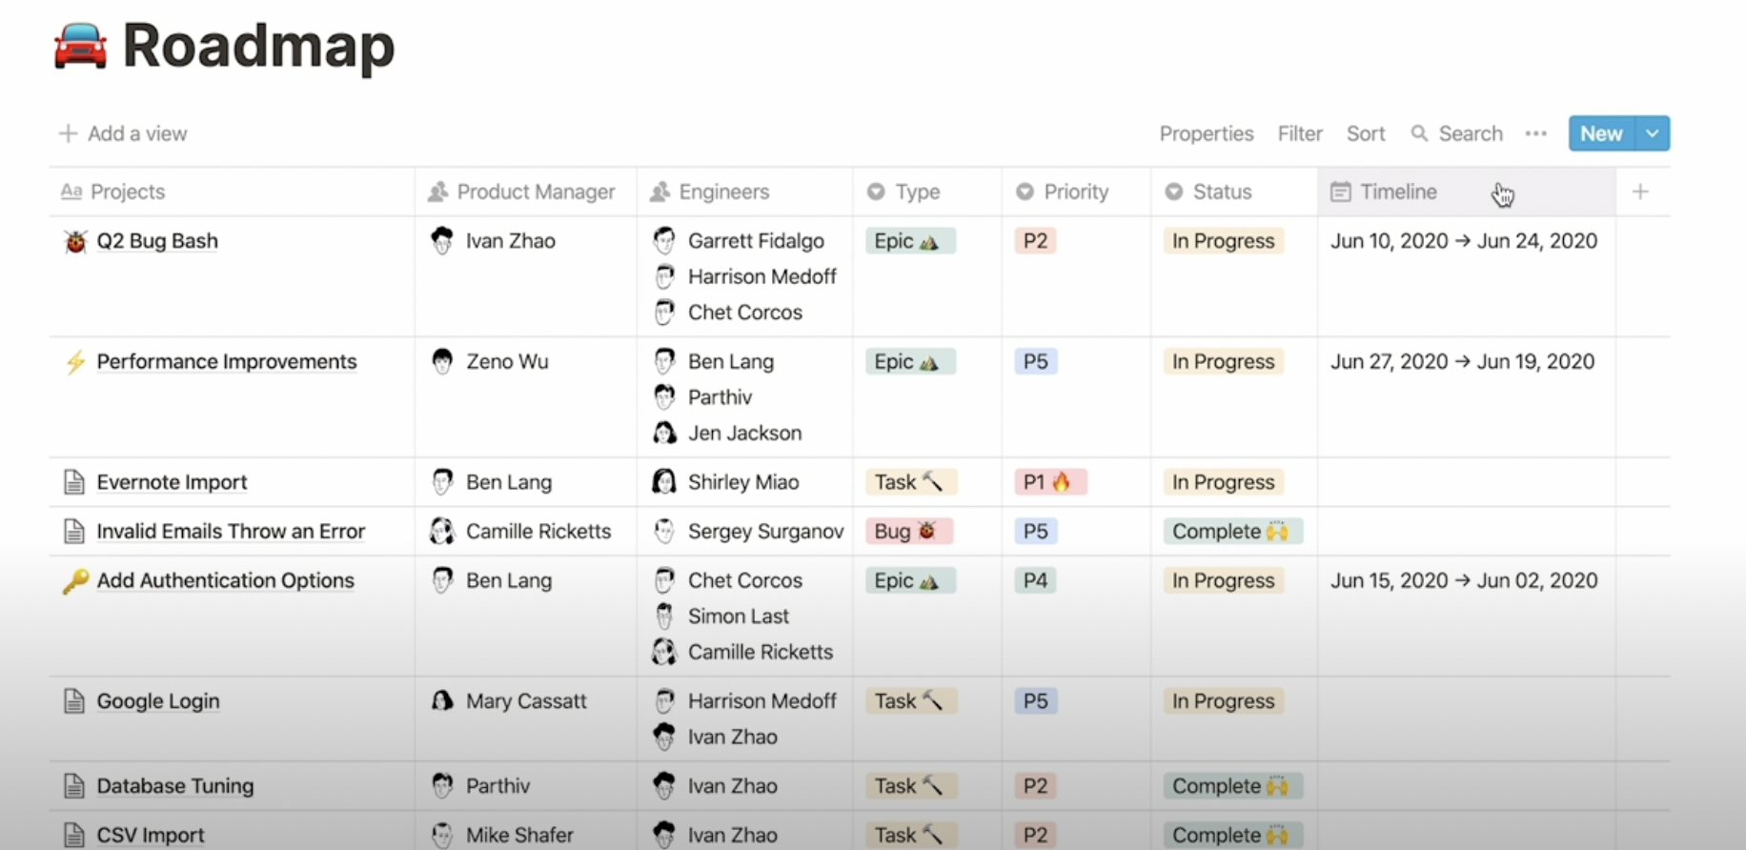
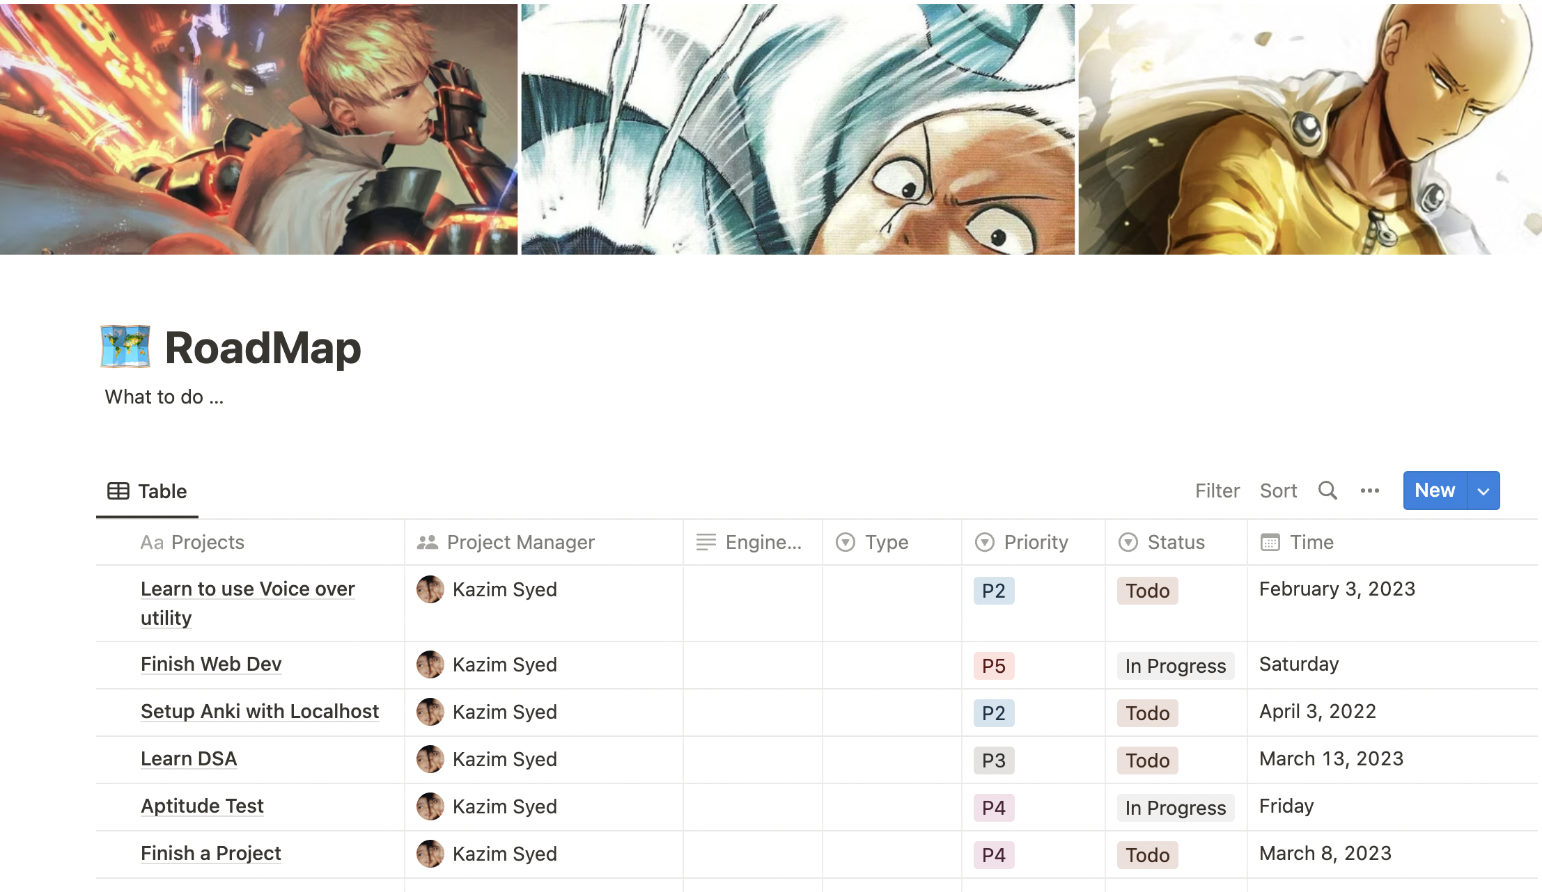

You can do relation join.
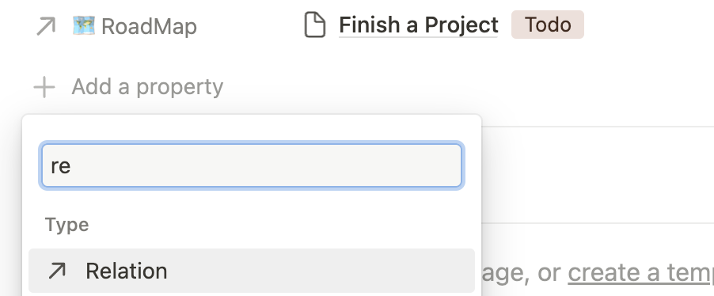

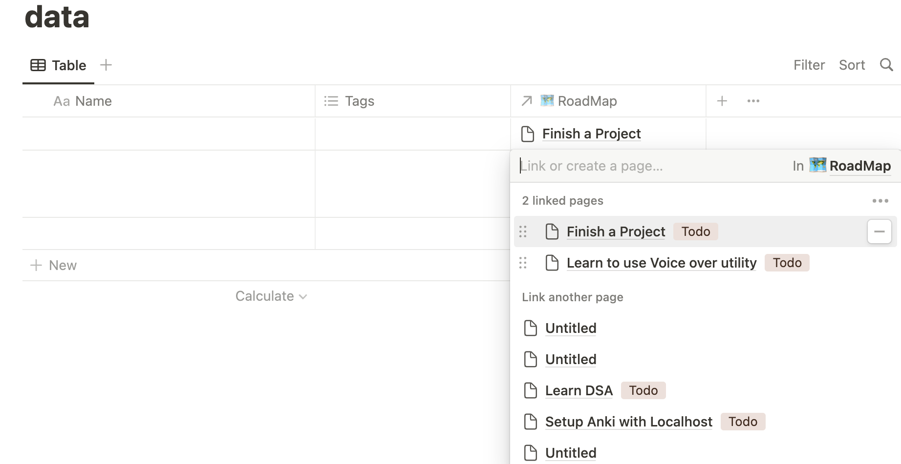

--
You can create a seperate db. If u wanna lock the main db. To prevent inadvertently changes.
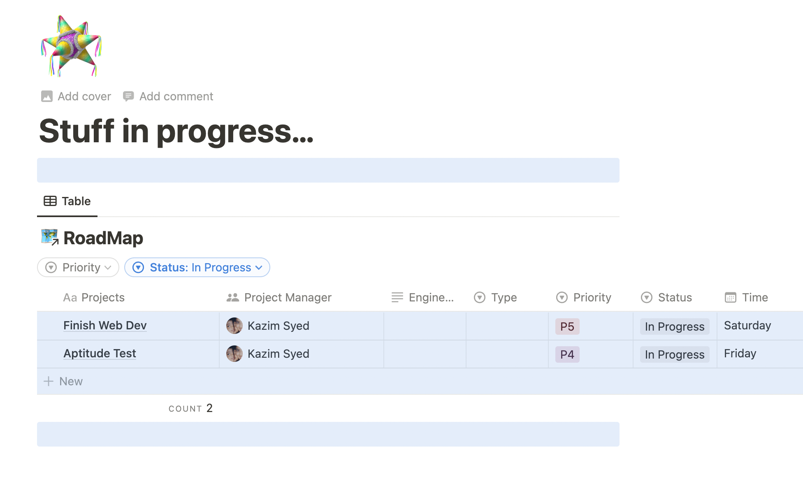

Steps:
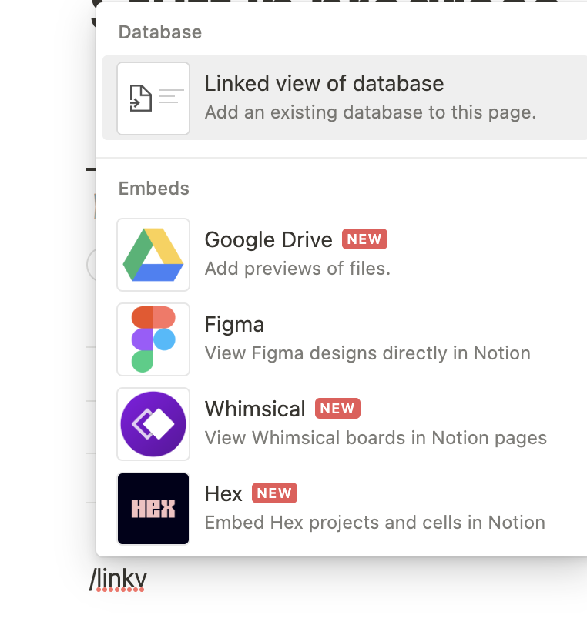  1. | 2. Select data source and u r done.

Top 14 Notion tips for productivity

Tip-1: /template button
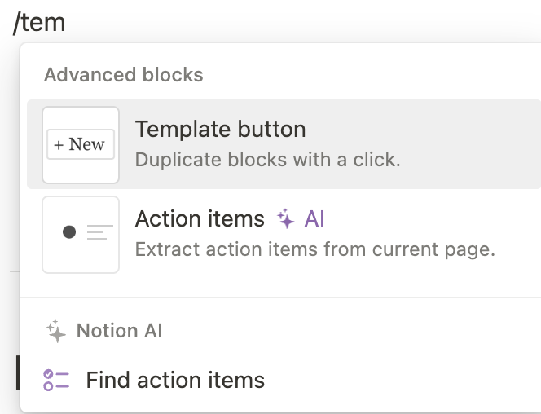  1. | 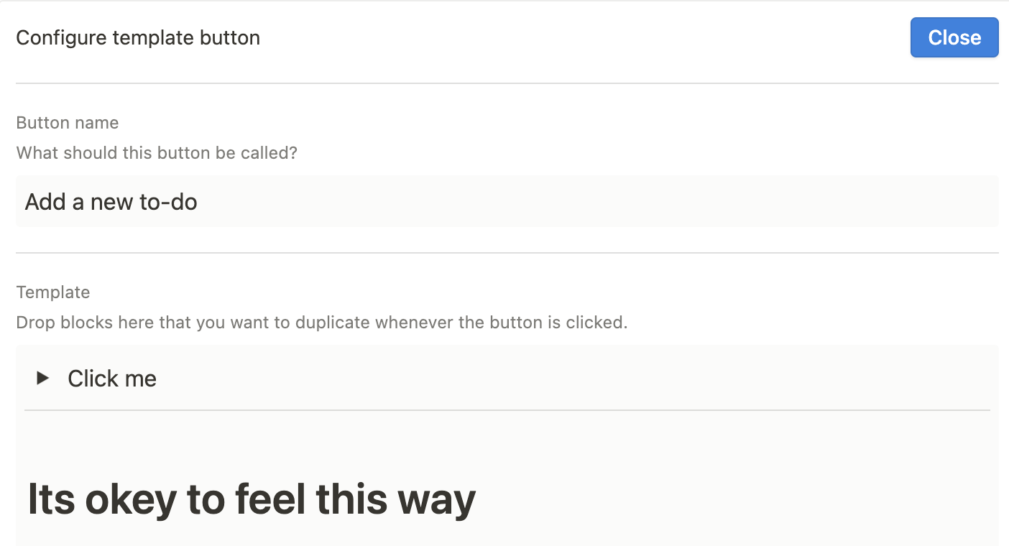  2.
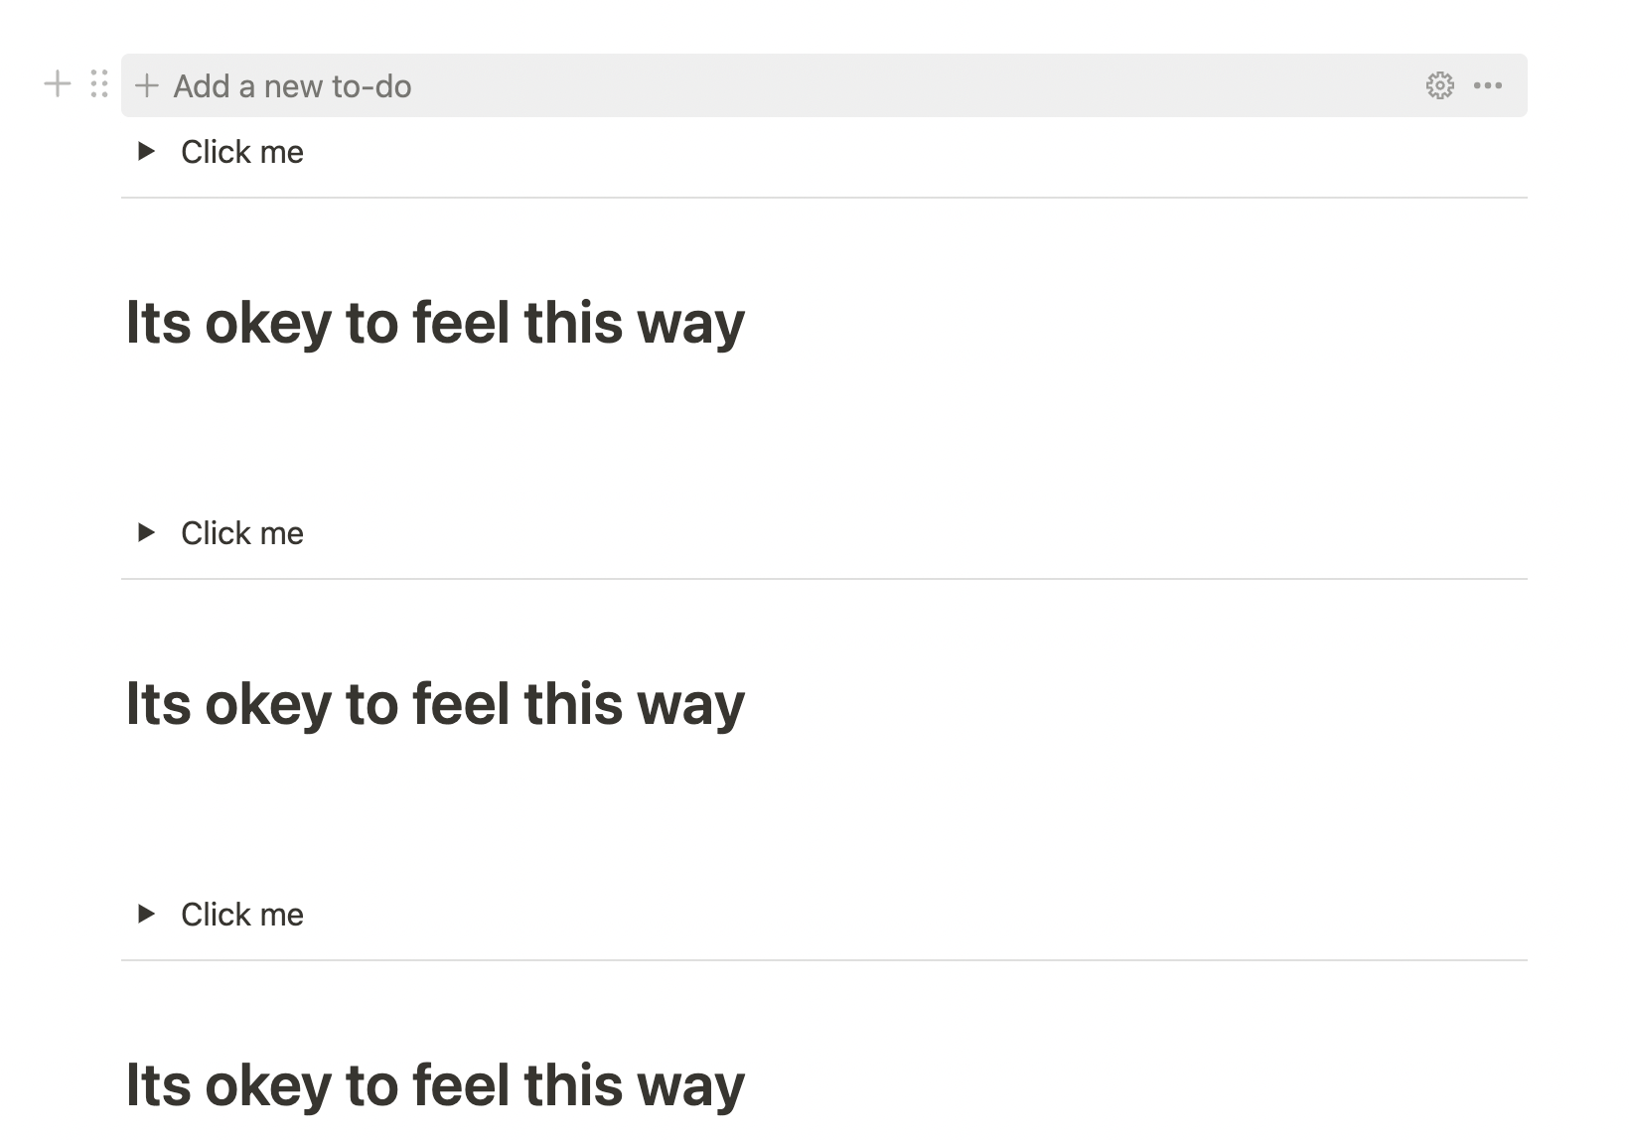  3. | Clicking on Add a new to do. Make things easier.

Tip2: Use Synced Blocks( correctly )
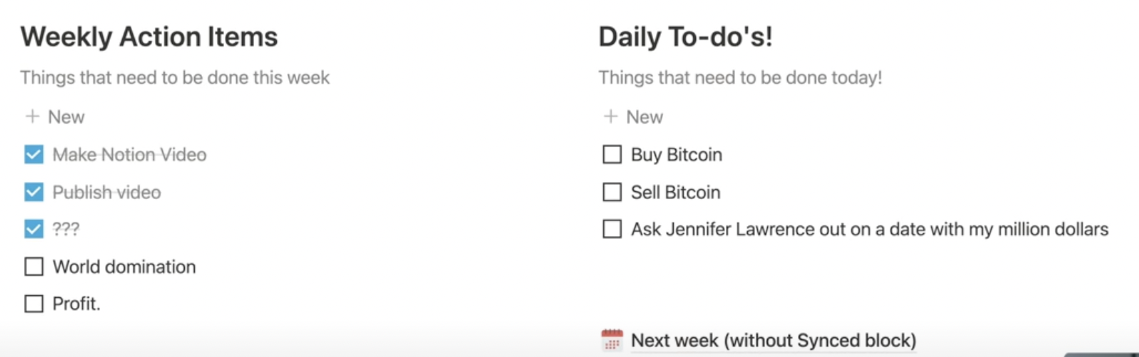

The instructor used to copy his todo list that is unchecked to the next day todo list. His todo list involves a page with some template.

 | Steps:
1. | 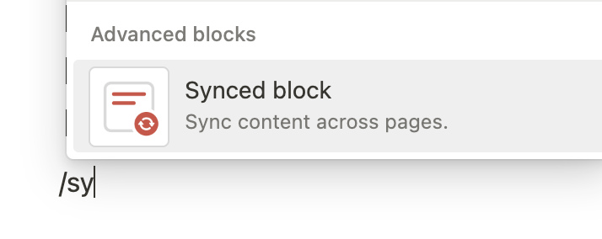  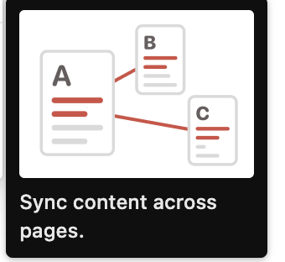
2. | 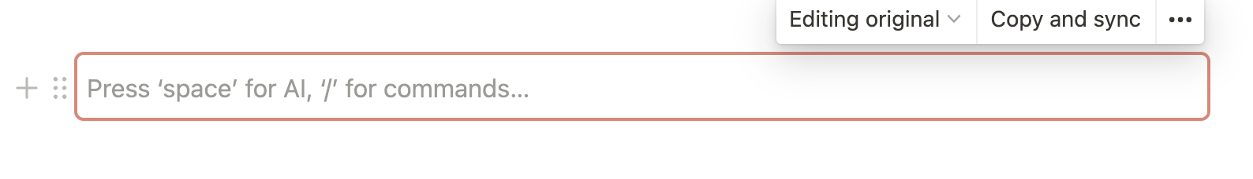
3. | 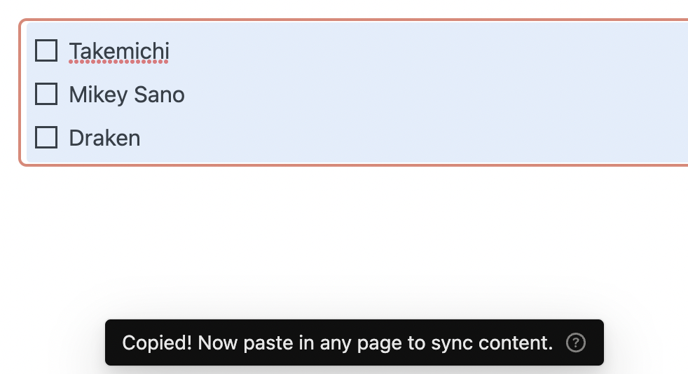
4. | 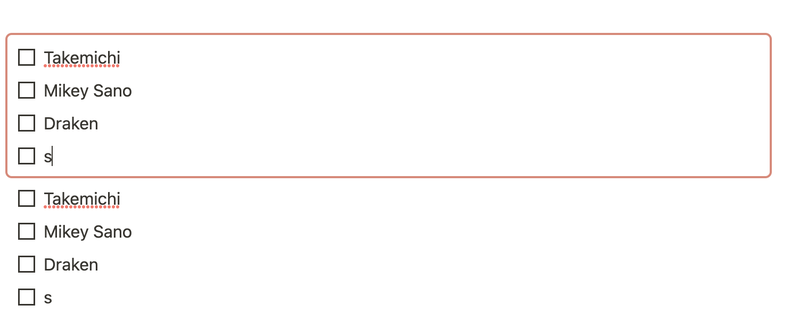
 | 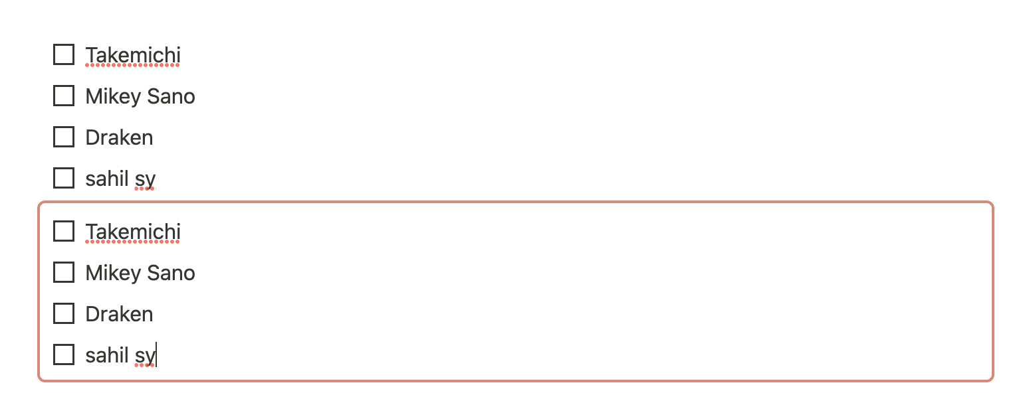
 | You can see changes are synced.

Tip-3: Set smart reminders
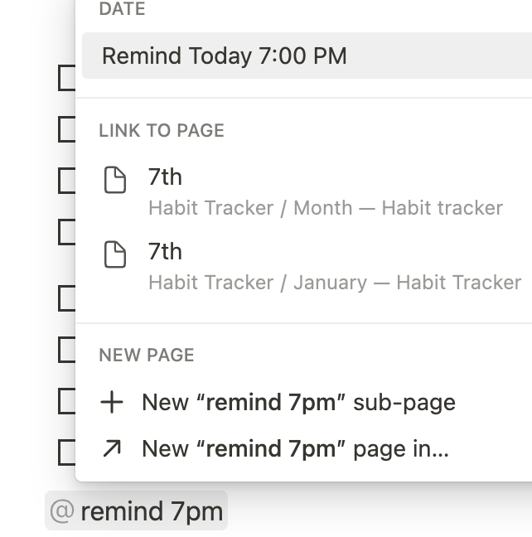 | 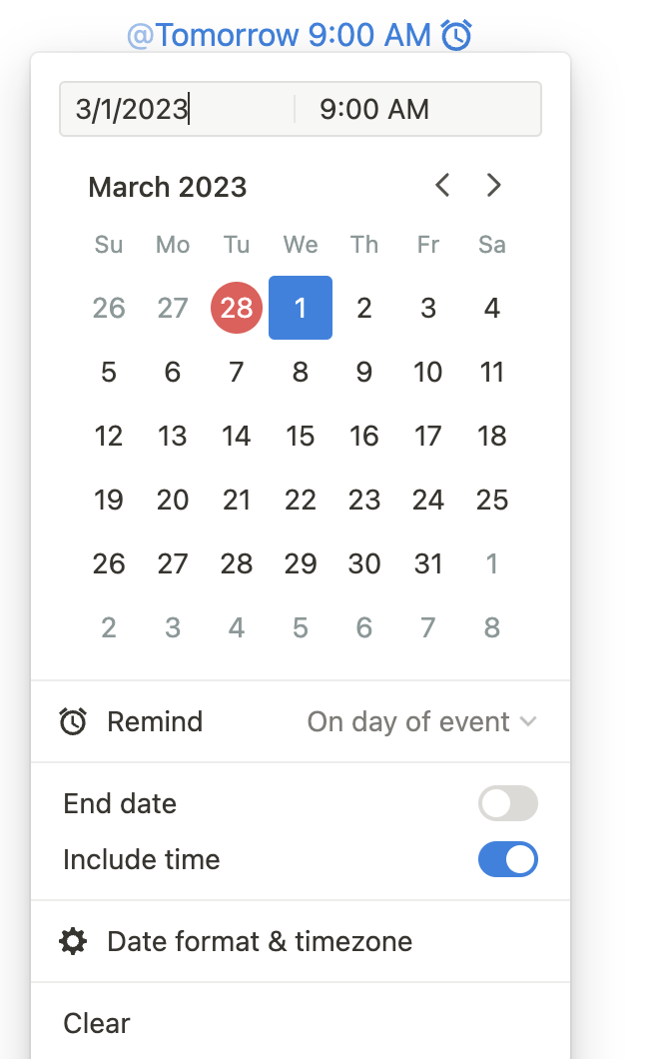

Tip4: Shortcuts:
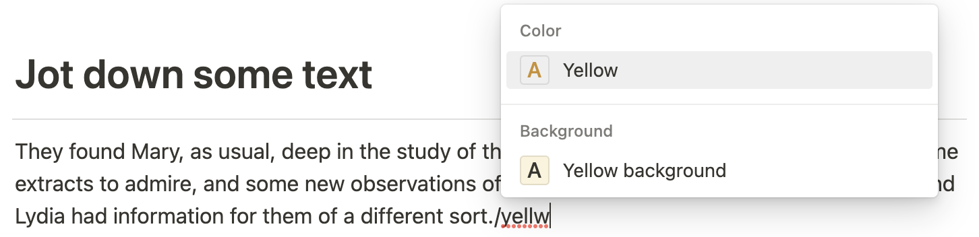

… for later.

Tip5: Hierarchical sort.
Having two sort.
Publish date and desc
if publish date is missing use the update date and desc
--
Have a created when and update when field and hide the properties.
Tip7: Archive
Table 1: h
Table 2: Here, i thought to use toggle but u can also use a link to a subpage.
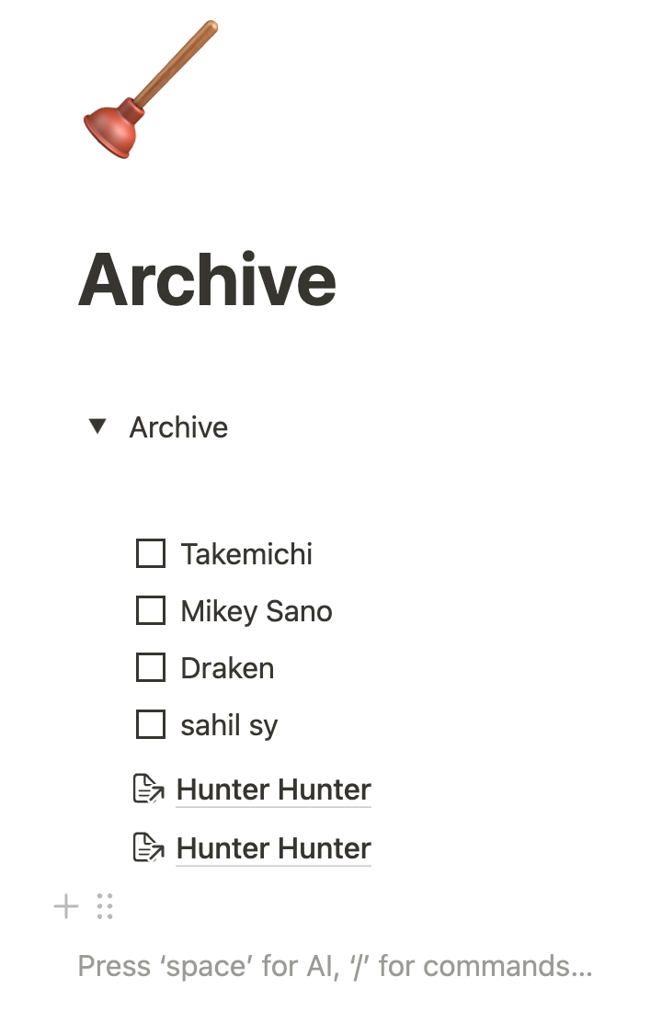 | 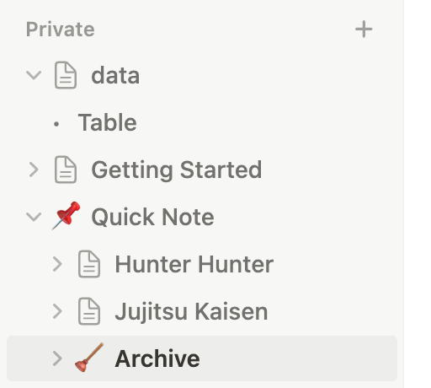

Tip-9:
Create Nested Columns
IDK

TIP10: Create internal links
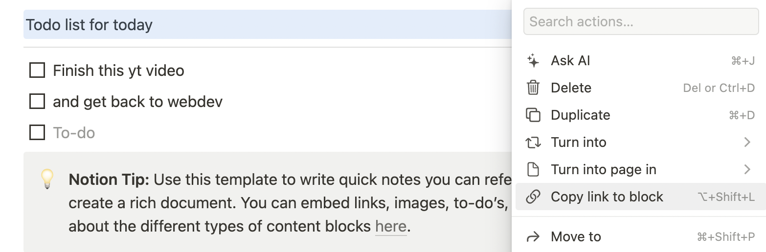
1.
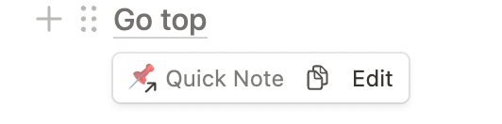

2.

