Learnign WebDev outside of bootcamp
subtitle

Heading 1

Heading 2

Heading 3

Heading 4

Link1: Flexbox or Grid how to decide?
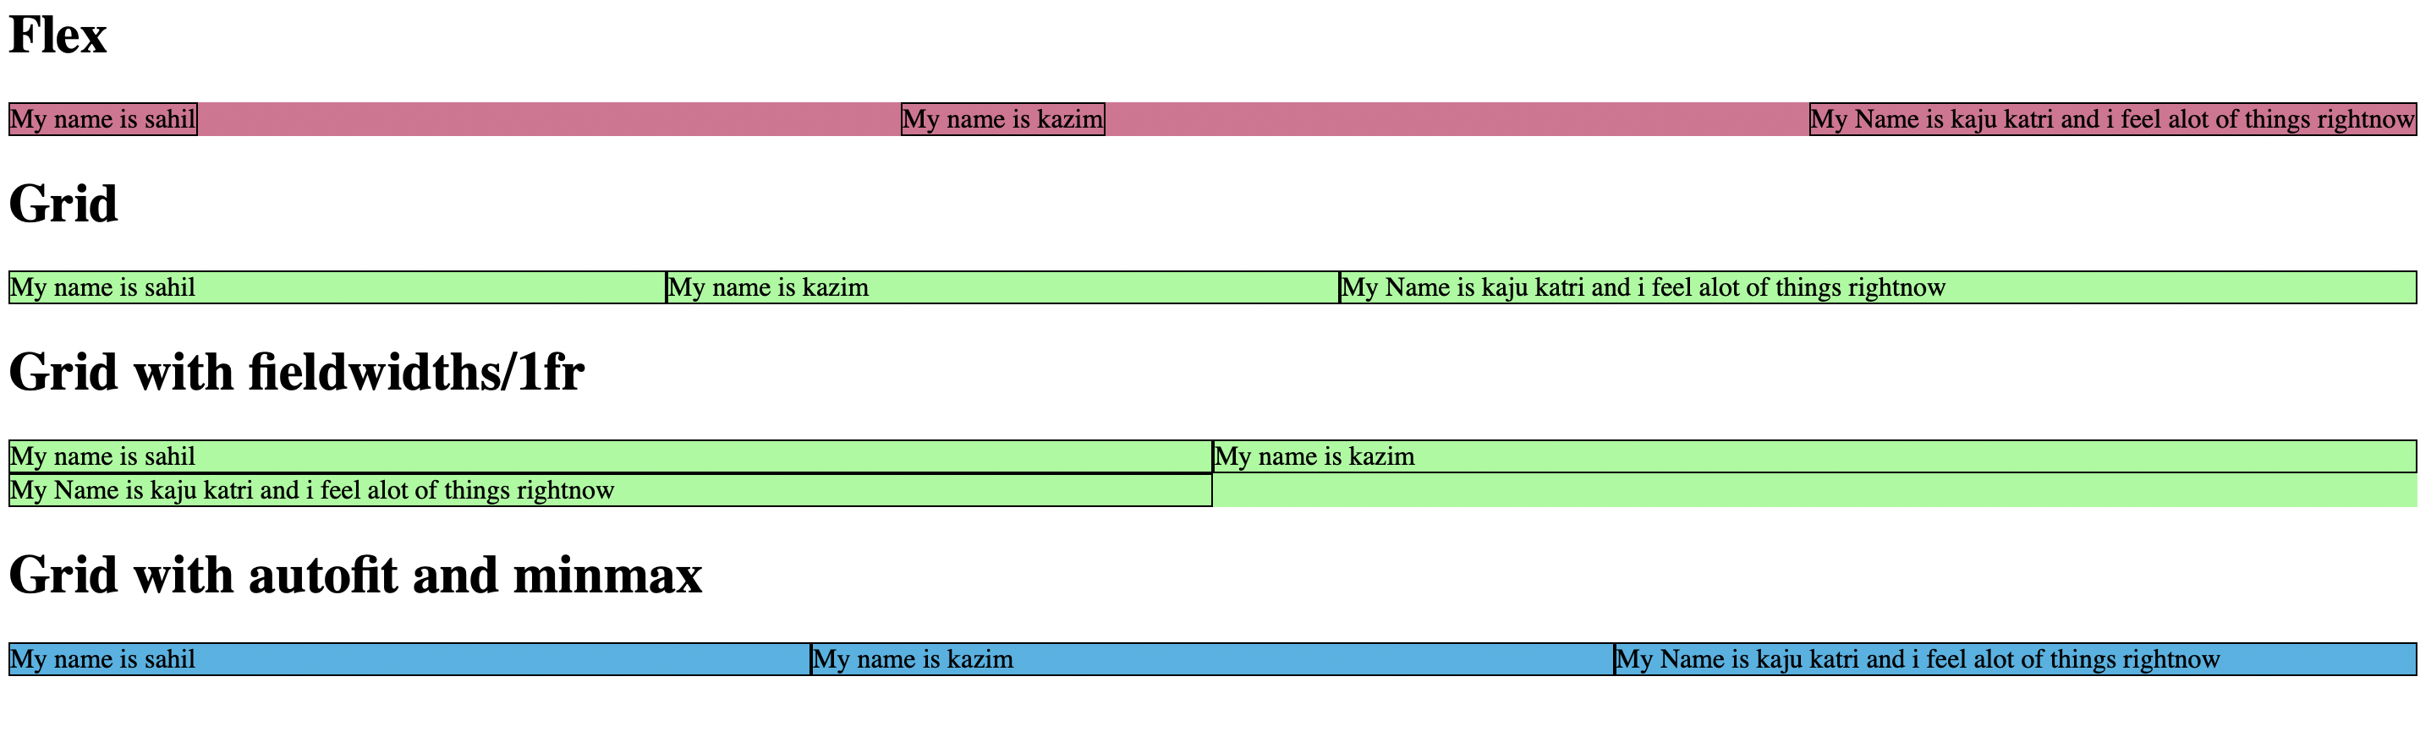
Difference:
Flexbox | Grid
The border fits to the data | It doesn’t
You have some control given to the child of the parent.  For e.g flexbasis:300px  flex-grow:1  flex-shrink:1 | Whereas  grid-template-columns: repeat(2,1fr);  there isn’t any need to access the child for except styling and other purposes.
Here, By default  the flex-direction:row  which populates the data in a row first | Here, By default is row here also.  Which does nothing and it feels like its as it that is stacked.  To populate columns we need to  grid-auto-flow: column;
Here you can’t control when to wrap | Here, you can tell how many cells will take a single row.  grid-template-columns: repeat(2,1fr);s  here two cells will take 1st row.  And it will follow the pattern till end  look at the image (Grid with fieldwidth)  There is a reason why its called a template.
 | grid-template-columns: repeat(auto-fit,minmax(150px, 1fr) );

You can use grid with flex.

Learn CSS grid the easy way
Link: Learn css grid the easy way
Table 1: Instead of margin use gap


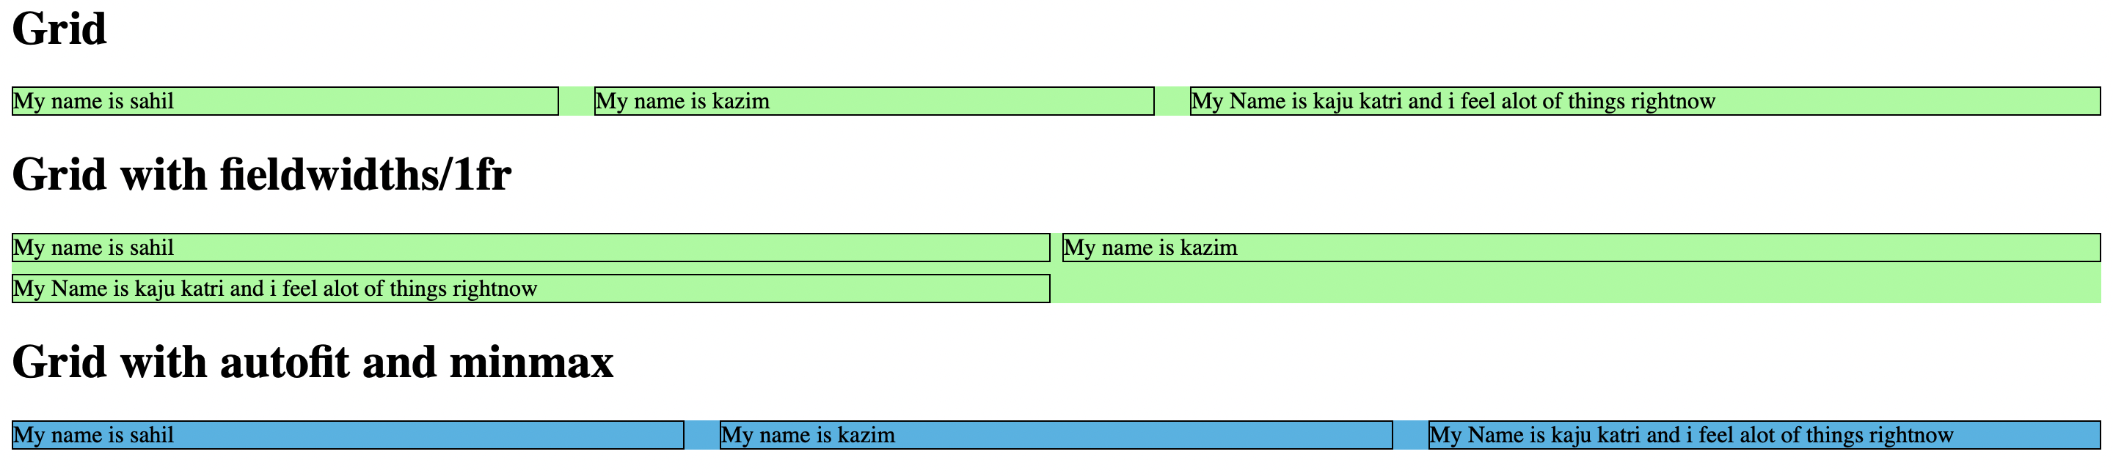

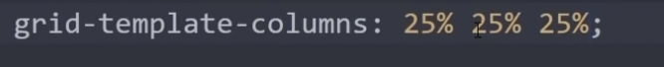

fr means fraction.
1fr 1fr 1fr means 33% 33% 33%. Basically divide equally.
Its a grid only unit.

in place of fr u can put 100px, 25% ...

Just like rowspan and colspan in tables.
We need to make this desired page:

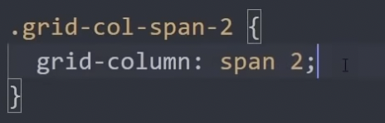

we will give it to the first article and the fourth article. Just like in tables.

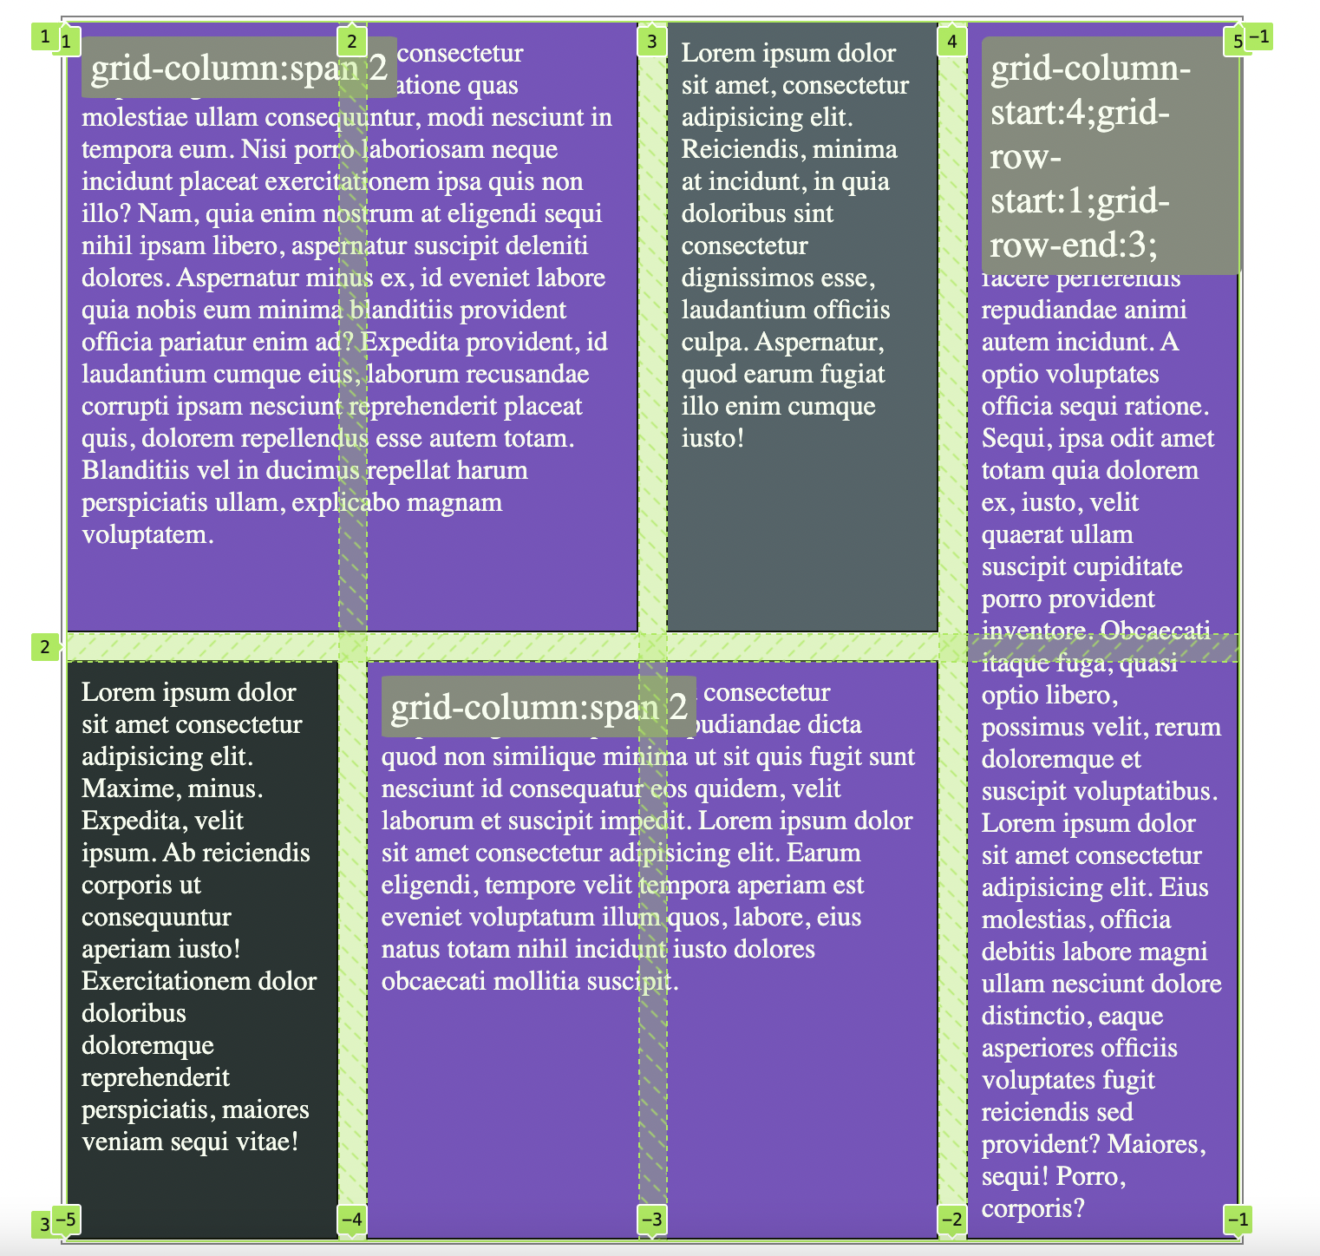

Grid shorthand:
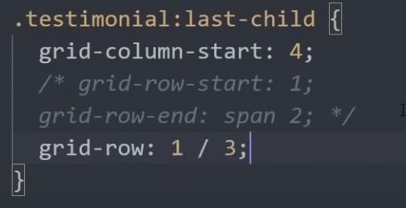

Or
