HTML Essential Learning
subtitle

Heading 1

Heading 2

Heading 3

Heading 4

Starts here

Formatting text

Lists:
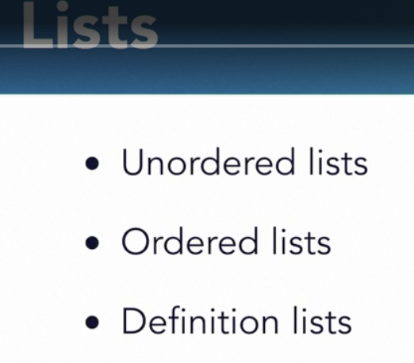

Definition list: is like a key-value pair.
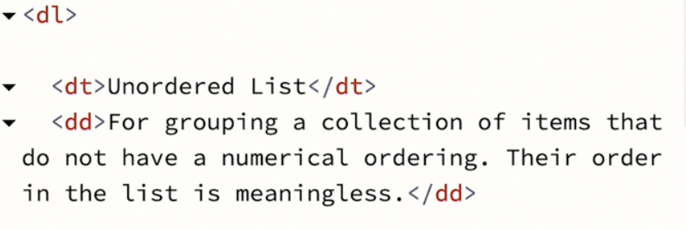

dt: definition term ; dd:definiton description
We can 1dd: Mdt relationship.
e.g
<dt>Kazim</dt> <dd>Faraaz<dd> <dd>Prerna<dd>
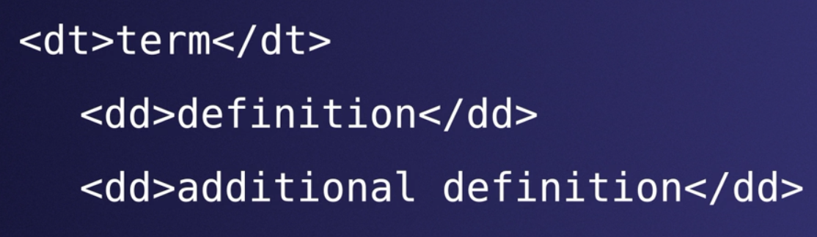

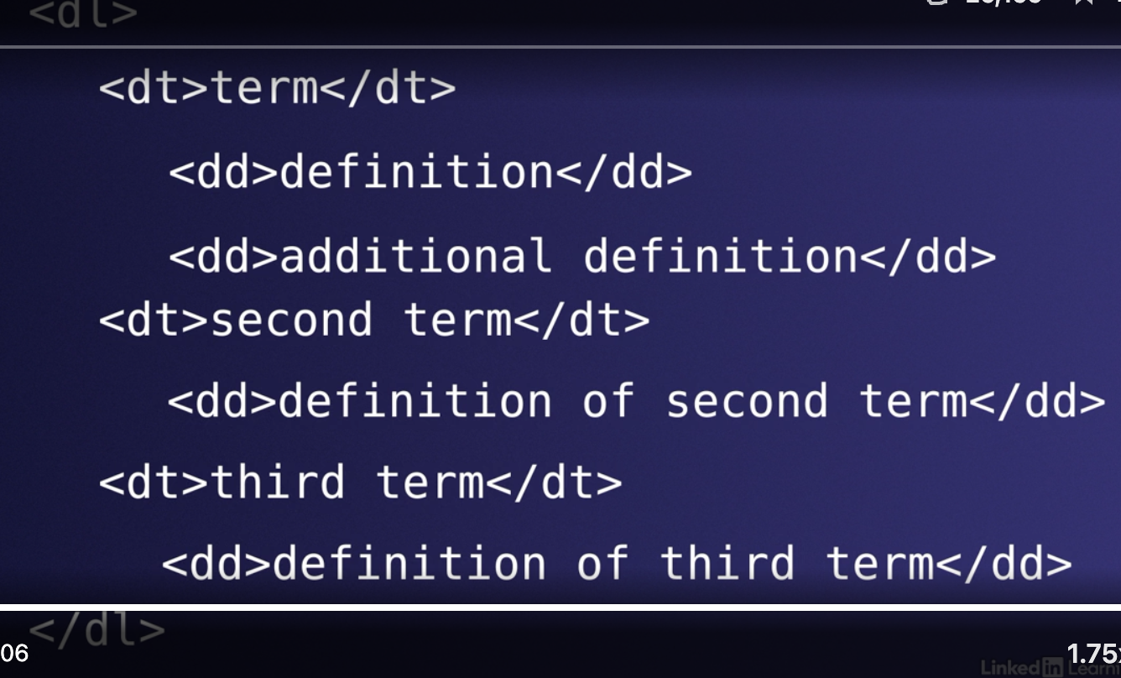

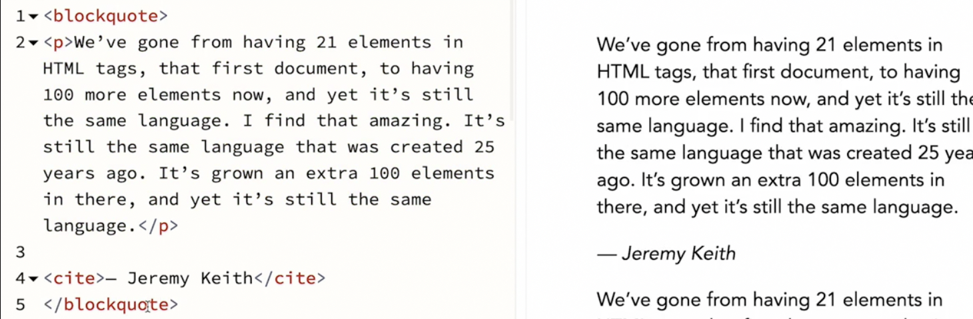Figure 1: Here, this screenshot i took for semantic markup.

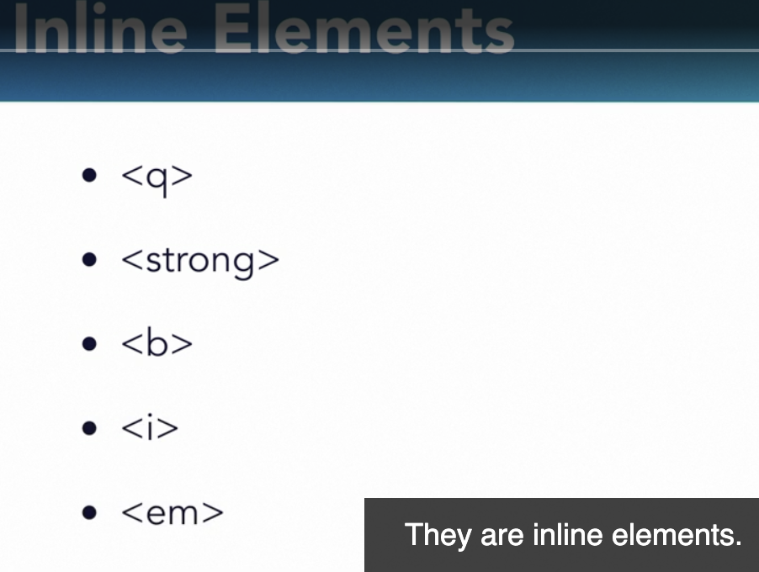
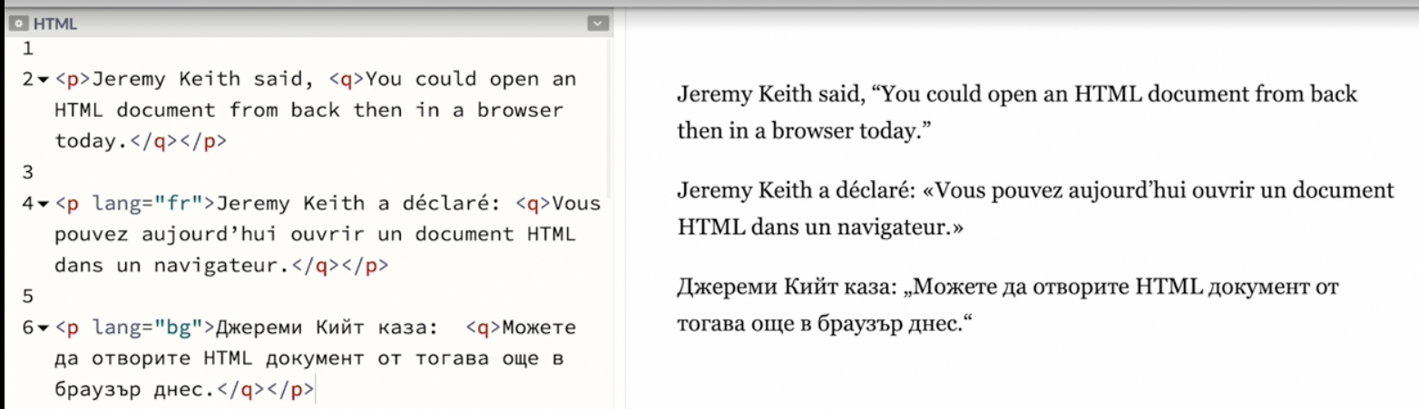Figure 2: Instead of manually putting quotes you should use the quote element. Cuz typography can be different based on region,language,script.

Inherit sense that you start to build up about some of these html elements. Some are to mark something that is part of the bigger thing and some are the bigger thing.

Date and times
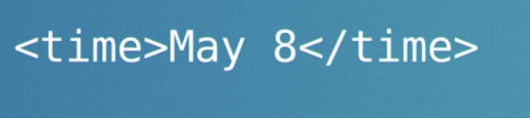

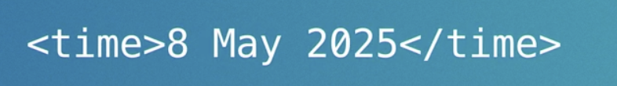

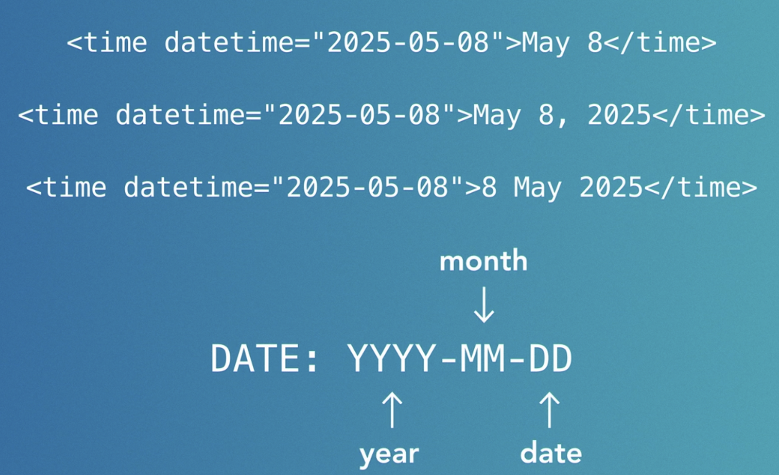

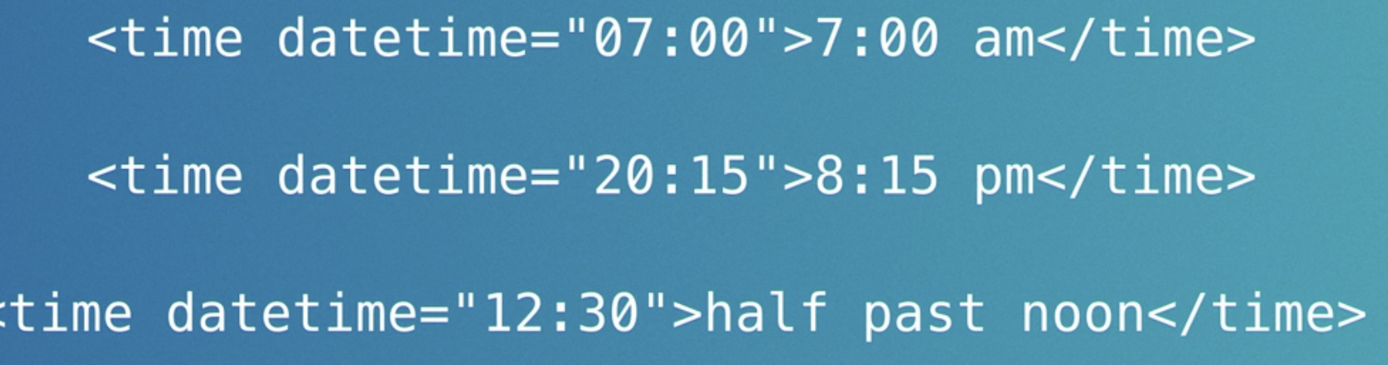
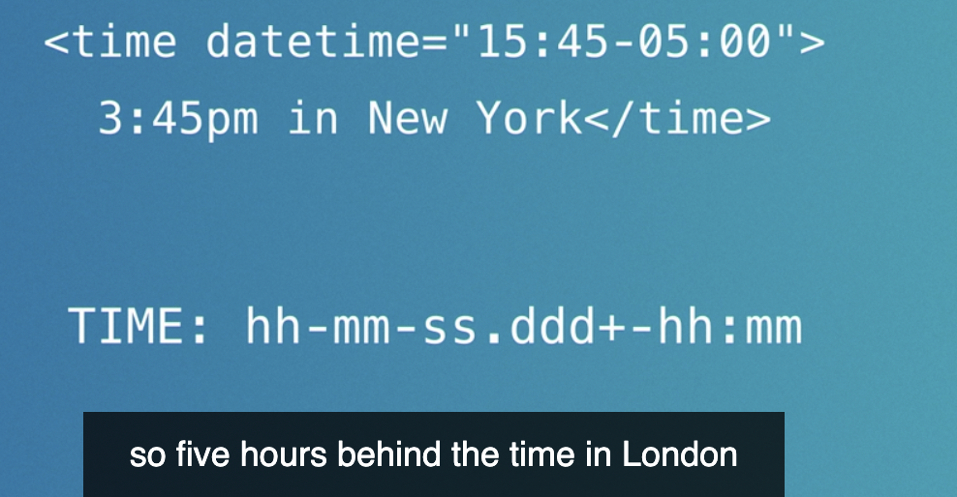

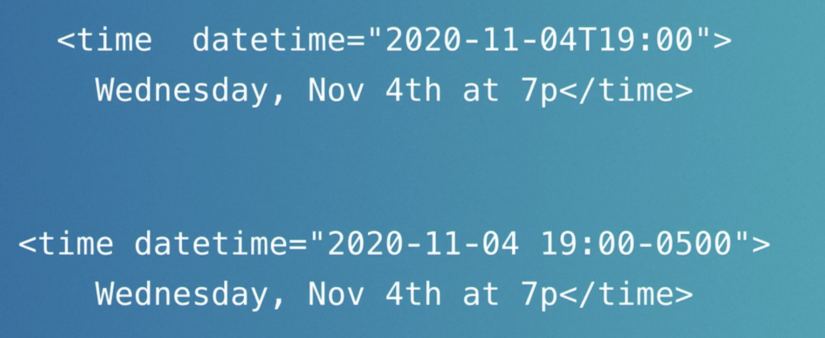

we want to put semantic knowledge for the computer, why idk.
But it adheres to a specific format. That maybe useful.

Code,pre and br
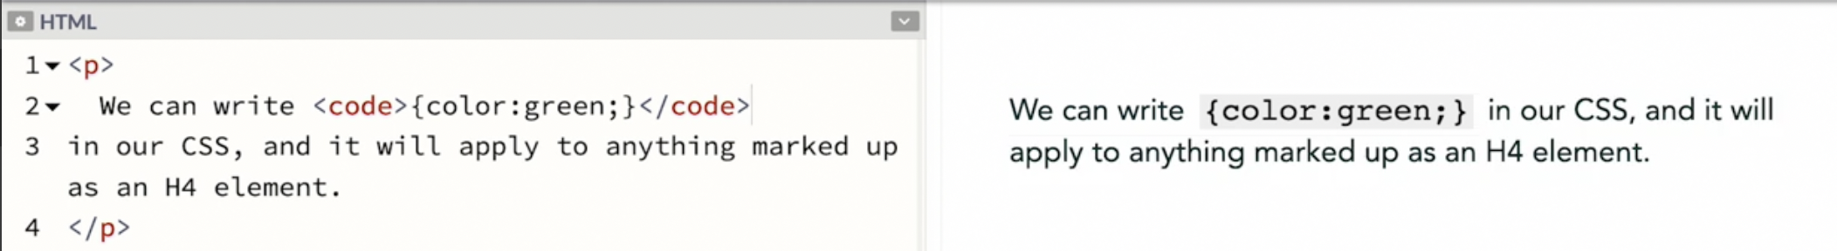
We can see that the styling changed. It switches to a monospace font.
Code tag is an inline elements.
HTML entity:
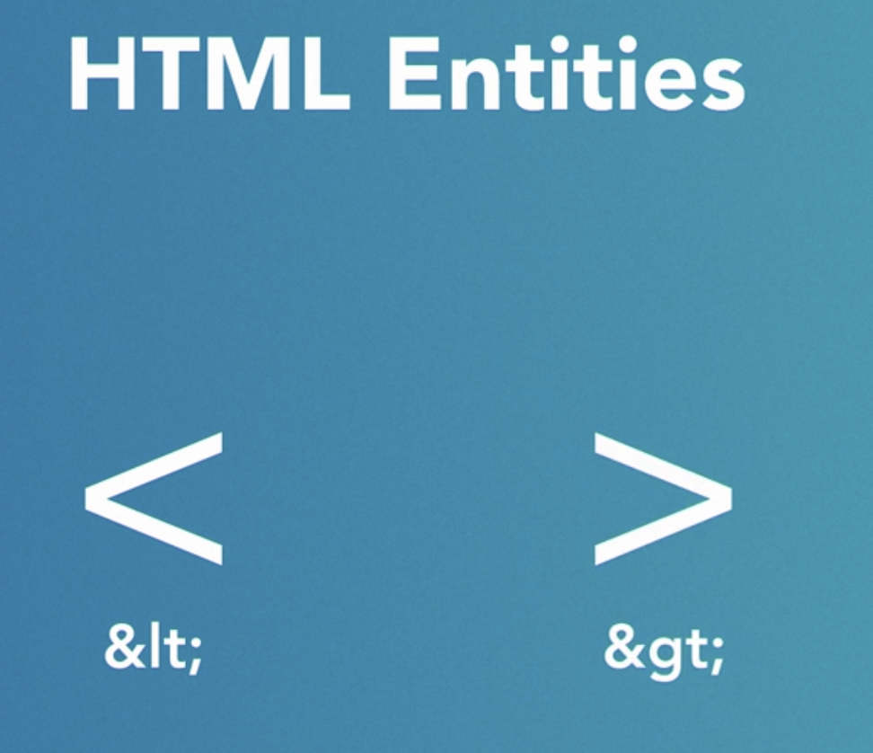

why its useful cause we can’t escape this.
So to write h1 element
we could &lt h1 &gt.
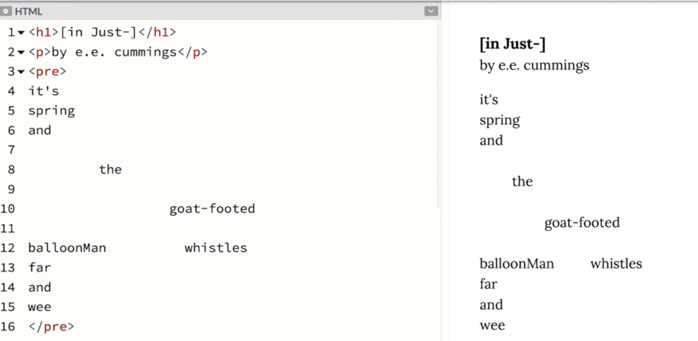Figure 3: We can see the browser now pay attention to the newlines and spaces and tabs,

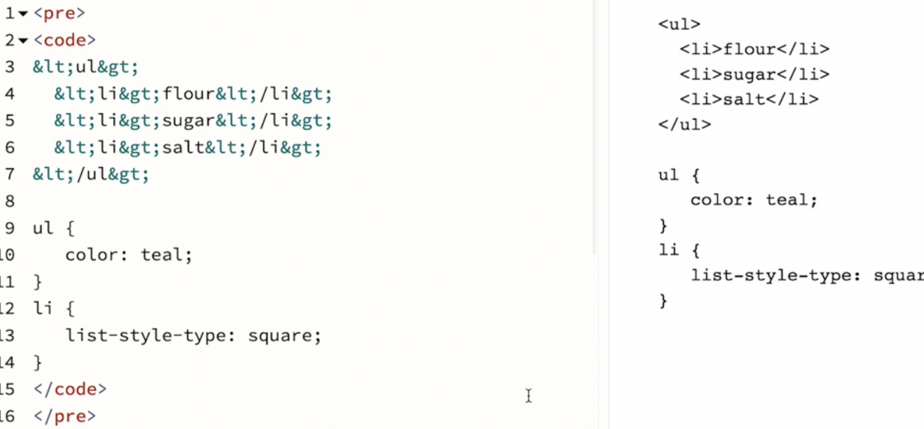Figure 4: This is the best thing ever. Semantic formatting

MathML is a specialized markup language for math.

Small tag
Things that are not important but needs to be tossed in there.
Like copyright info or other things that might need to be tossed in the bottom of the page.
So to tell the browser that it’s a very little prominence. We can mark it up with the small element.
We don’t use small to make a certain passage of text smaller. We adjust the size of the text to be any size that we want, large or small.
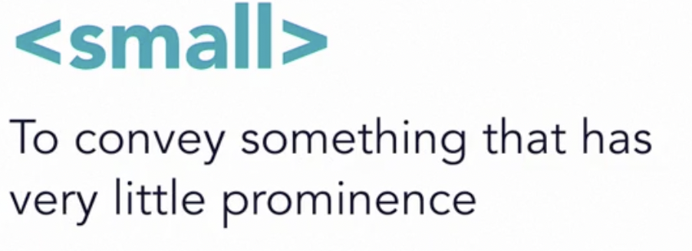

Understanding the power of html

Debugging html:
if u are creating a shopping website. You may wanna go to someone’s shopping website and inspect element and learn how they are doing the markup.
Looking at other people works help me better structure my html.

HTML Attributes

Global attributes
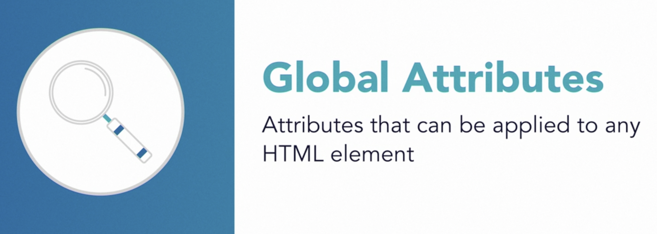

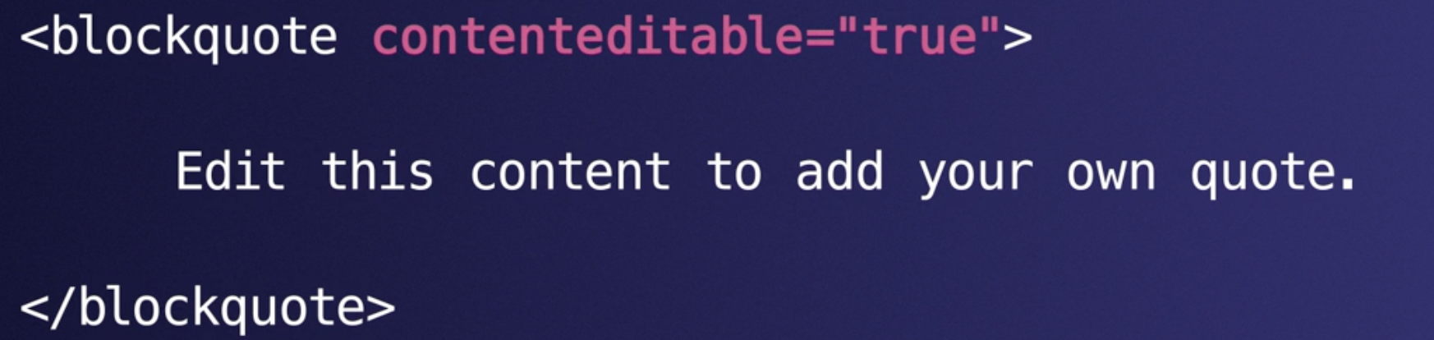

lets the user of the page edit the content of the page.
I love this.
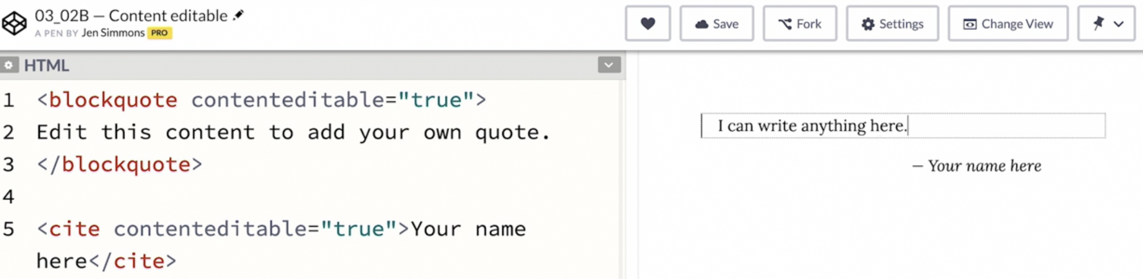Figure 5: contenteditable=true
It doesn’t change the content of the html, and if I refresh the page it goes the way it is.
Because Html alone only provides the functionality for editing.
Backend developers have to set up a way for that new content to be captured and saved.

there are many ways to handle saving content. So that needs to be uniquely programmed for each website usually in js.
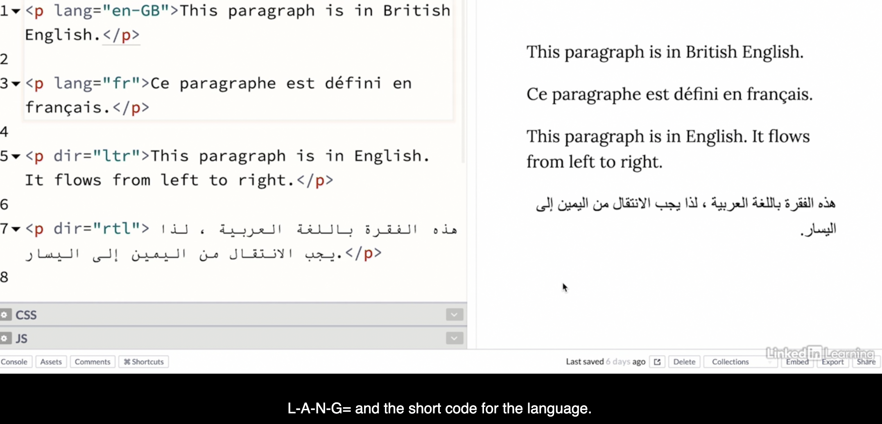
--
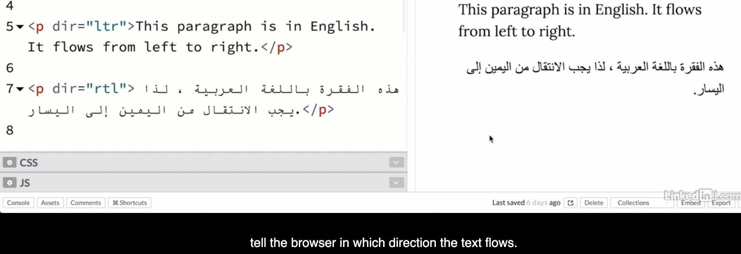
dir:direction.
These are global attributes. There is a list of all the global attributes on mdn.
The four most imp global attributes: class,id,lang,dir

Aria role
Aria-roles is another global attribute.
Purpose: to give it more meaning and to make sure browser understand what something is.
Ideally we won’t need Aria role.
If we use the proper html element we will communicate the write message about the semantics of the content.
Sometimes things are not ideal and we have to make compromises in our markup.

It is bad to make a website hard or impossible for a person with disability to use it.
Many places, it is illegal to make a website inaccessible to pwd.
Yeah, HTML can be a human right issue.
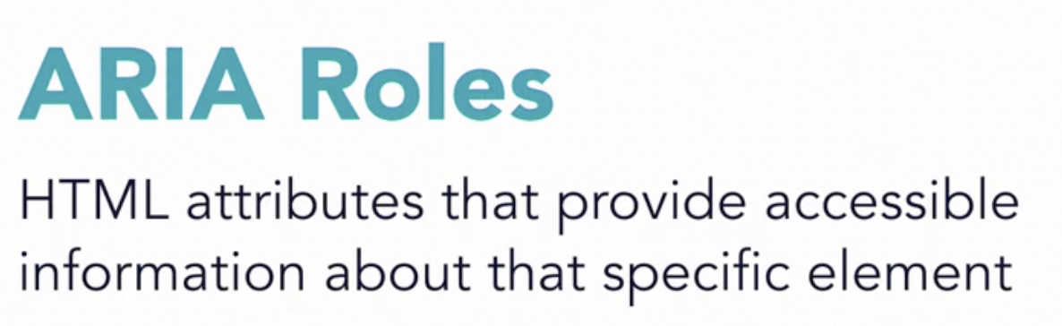

A braille display is one method blind or visually-impaired users can choose to interact with a computer as an alternative to a screen reader. A braille display consists of a rectangular device with grouped rows of pins. The pins are raised and lowered to spell out letters in the braille alphabet.

Aria roles tells screen readers, brialle displays, magnifiers and other assistive technology things they need to know to make the site fully accessible.

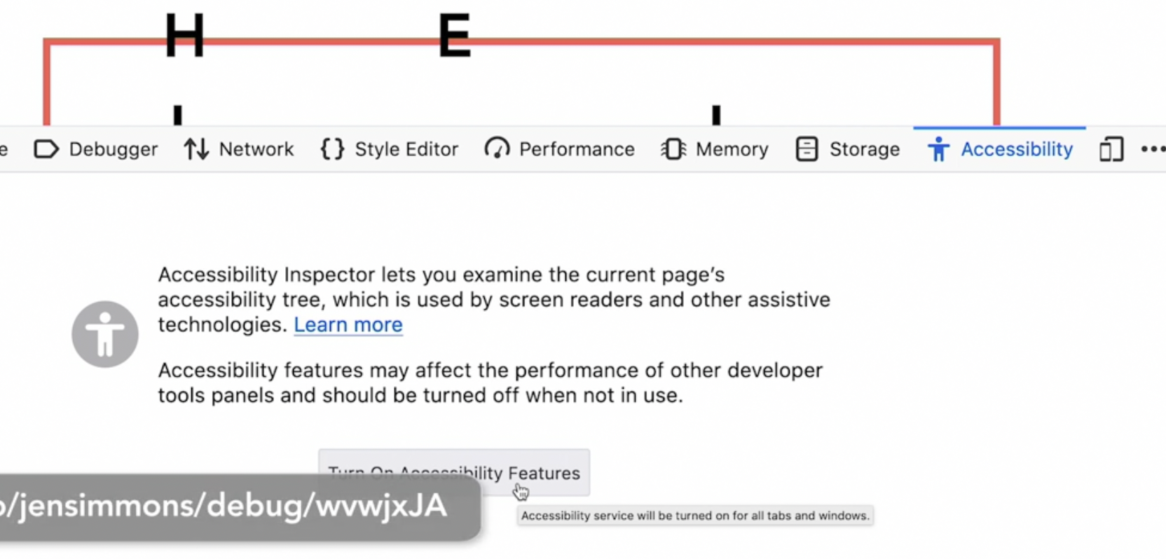
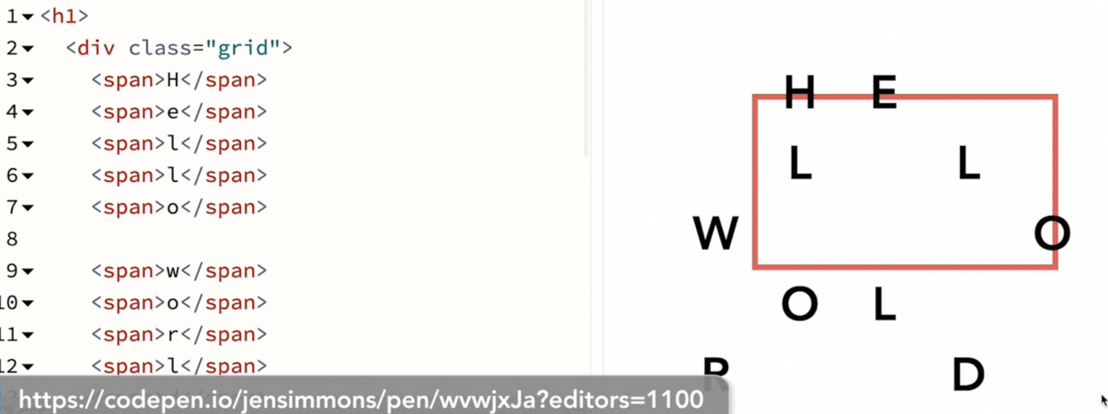Figure 6: This will be difficult for pwd

Accessibility tree is another tree that browser makes from the content.
HTML → DOM TREE → Accessibility tree.
Accessibility tree is what accessive devices use to provide an experience of the website through a screen reader.
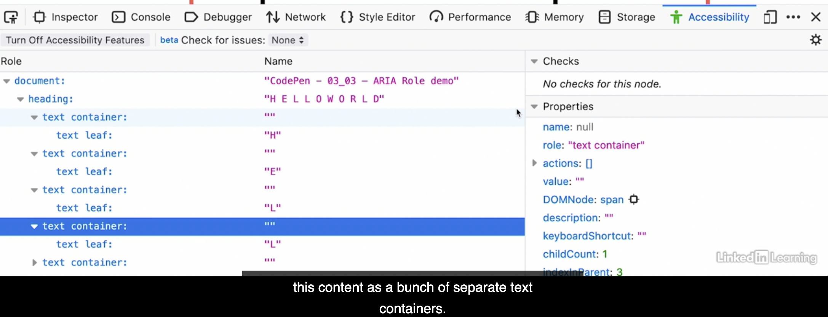

We can open this up and see this content as a bunch of seperate text containers.
Each with a text leaf.
Which will get read out as H-E-L-L-O-””-W-O-R-L-D
This is a terrible experience which we don’t want.
Let’s fix it using aria.
1. We will add the words that the screenreader will read by adding the aria label on the html.
2. Then we will hide the big massive spans in separate letters. So the accessibility tress ignores them.
So aria-hidden=true. Hide that element and all of its children from the accessibility tree.
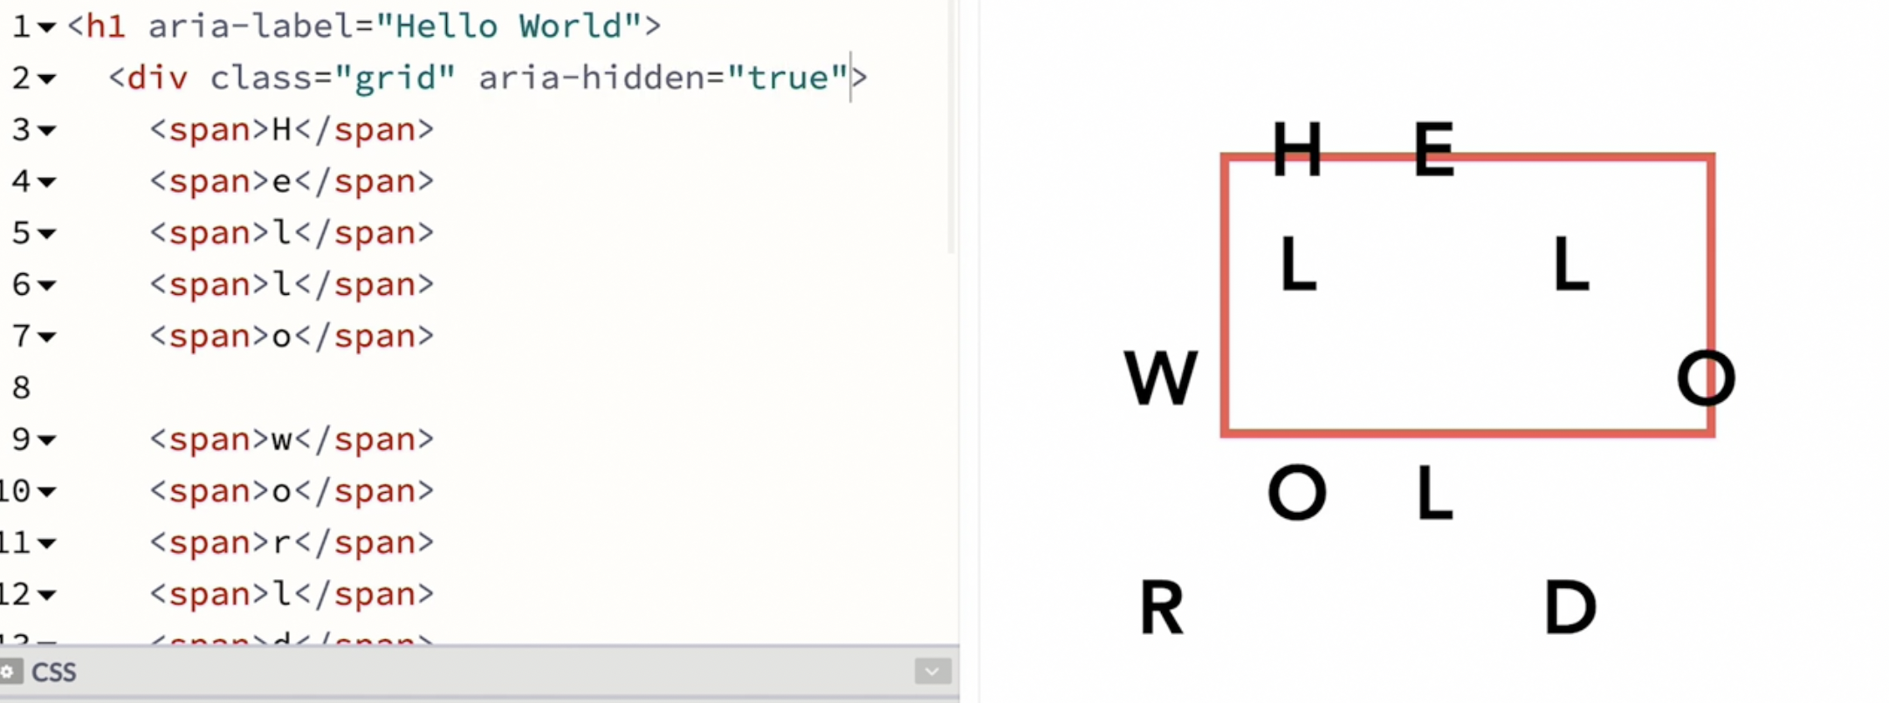
It’s still in the dom tree. But for the purpose of assistive devices its gone.
Which is why we aren’t gonna put it on the h1.
We want the h1 to be seen by the accessibility tree.
We just don’t want this spans to showup.
So we wrapped this span inside a div and we put aria-hidden=”true” on that div.

So lets now see the accessibility tree.
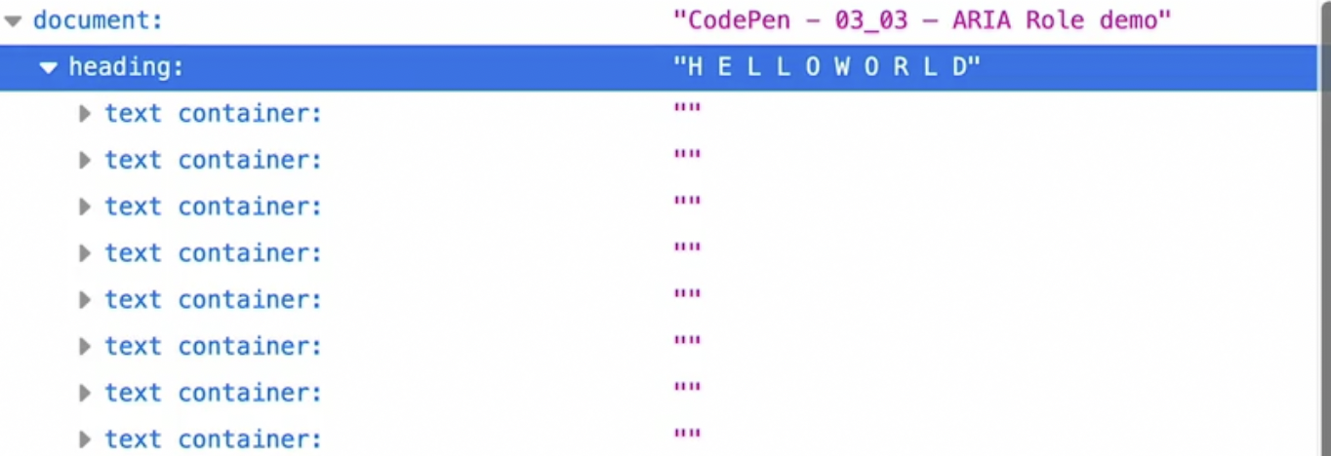
All those letter in seperate containers are gone.

Formatting html
Html dgaf about multiple spaces, tabs, carriage returns
There are few exception
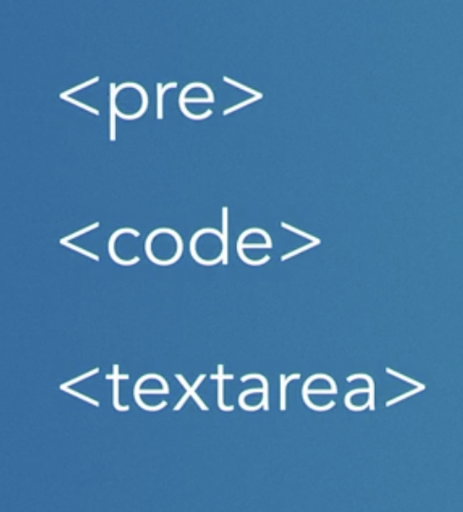
or use css to alter how space is handled in ur markup.

In those situations, whitespace, extra space, returns and indentations can count.
But most of the time browser will ignore everything having to do with spacing.
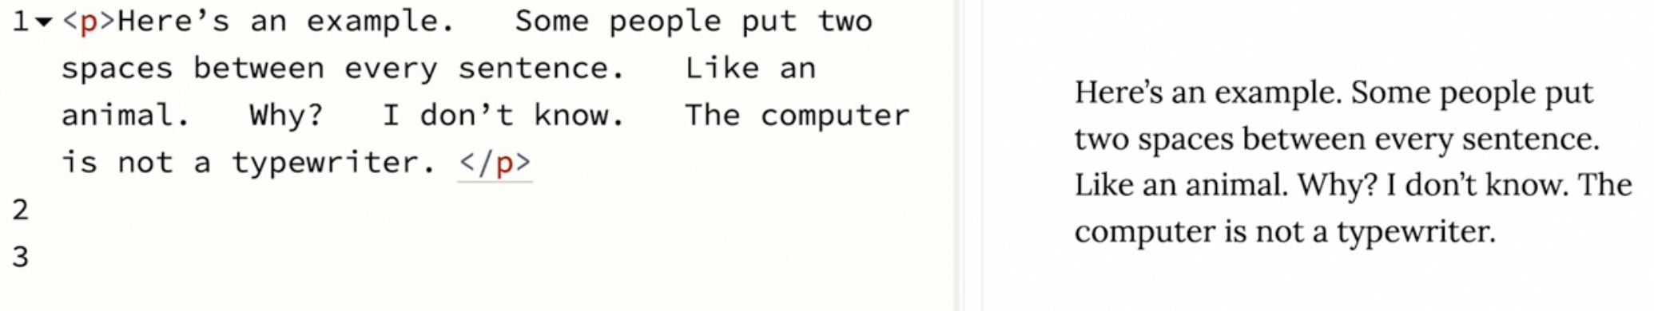

To make code easy to understand. You can document code.
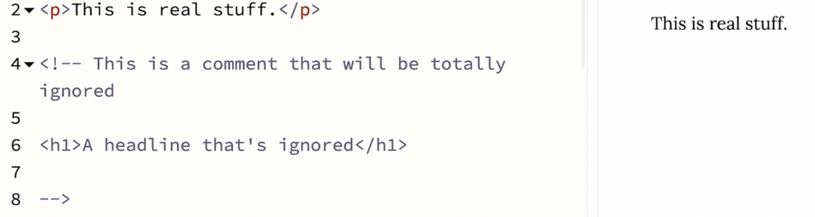Figure 7: documenting ur code.
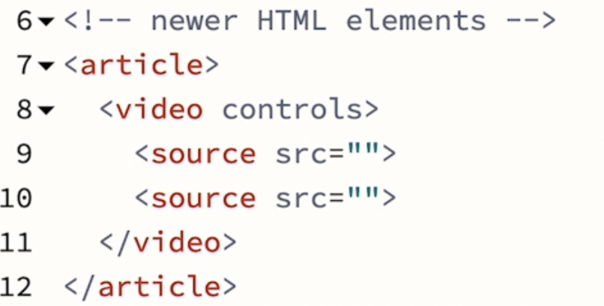Figure 8: here why it is called article and not just art just like p or h1 cause html was invented in 80s and 90s and memory issue.

length of an element is a clue how long the element is been around.
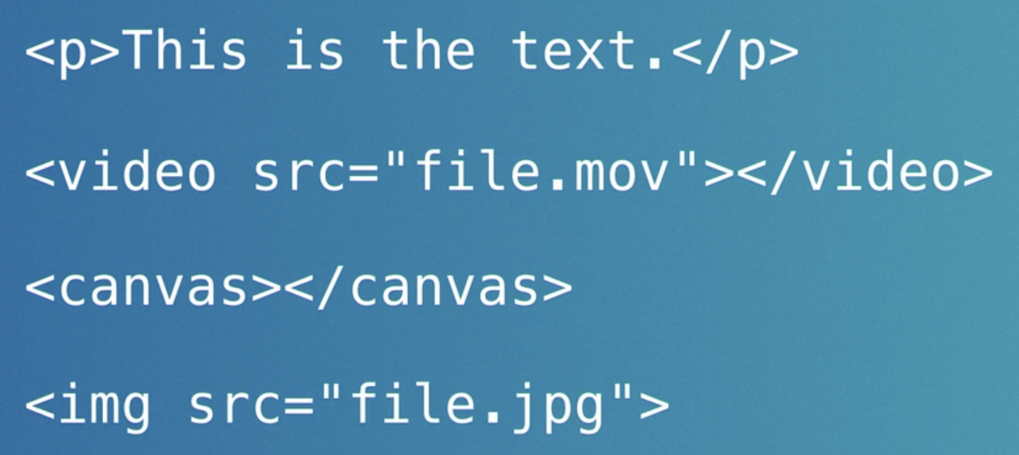Figure 9: every element has a opening anc closing tag. If there isn't a purpose so why have it.

Later thinking changed and best practice changed.
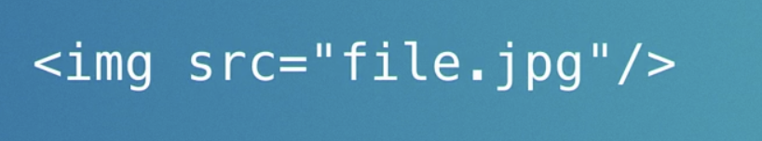Figure 10: to put / after any element that didnt have a closing tag.

Weird characters:
W3C keeps an entire of character entity.
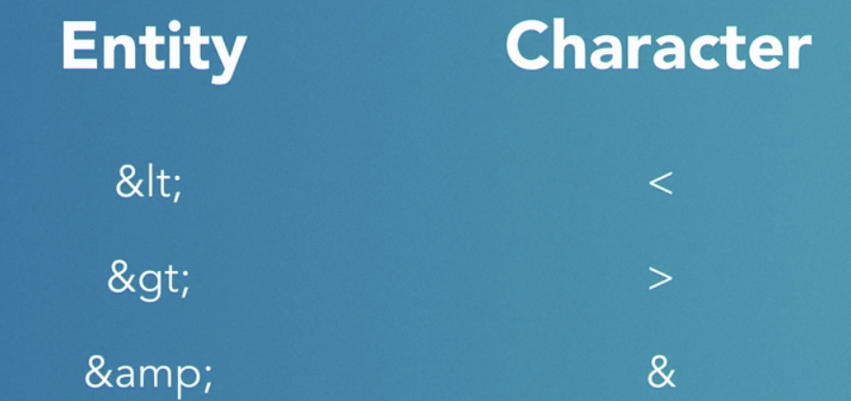

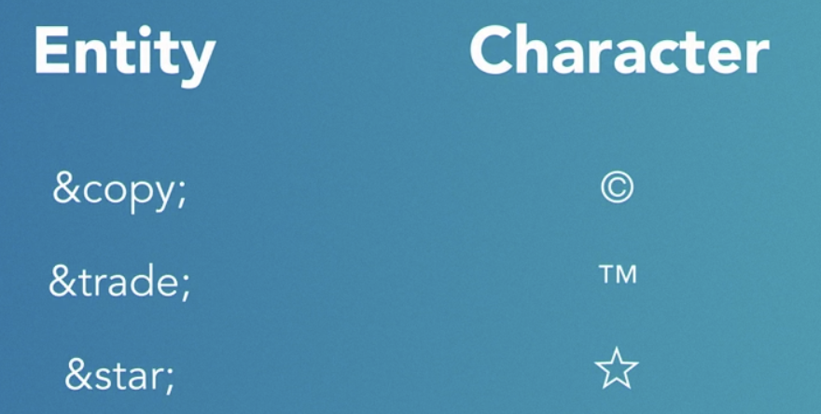Figure 11: entity codes

One special entity:

&nbsp:
Normally, spaces provides opportunity for text to wrap if there isnt enough room.
When there isnt enough room, the browser goes to wrap the line of text.
Figure 12: we can insert a &nbsp between two words instead of regular space and browser will know not to breakup the line there.
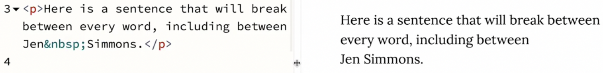
Figure 13: here we don’t want the browser to put my lastname on a separate line w.r.t to my firstname. so we insert &nbsp entity here.
People also use &nbsp; to make more than one space between words.
If u have more than one spaces in ur html, ur browser will ignore more than one space. Browser will not remove non-breaking space.
So u can put two spaces between sentences. If one of the spaces is a non-breaking space.
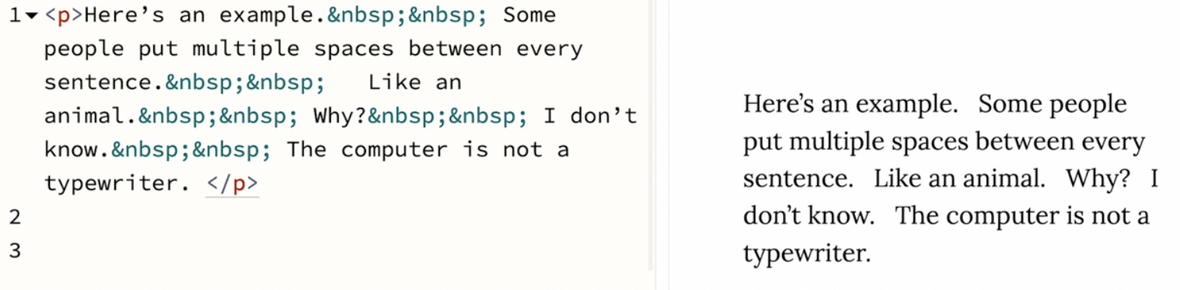

Linking and navigation
The anchor tag that is connecting different pages makes the web.
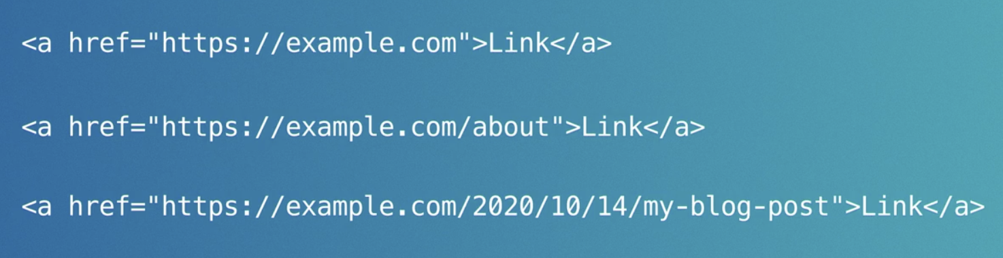Figure 14: Absolute urls
- Absolute URLs are just one way to form a link. Instead, whenever we are linking to something that's on the same site, in the same domain name as the page that has the link, we can use what's called a relative URL
Let's imagine we're building a big website. Eventually we're going to launch this site at http://www.awesomedogs.com but meanwhile I'm working on a copy of the site on my local computer, adding a menu bar. Later, we're going to put copies of the site on different servers with different URLs for testing and review. If you use the absolute URL for all the links, the browser will keep trying to get to the pages or files at http://www.awesomedogs.com, we don't want that. When I'm working locally, I want all the links to connect to the local copy of the files. When you put a copy of the site on a testing server, you want all the links to point at pages and files on the testing server. We want a way to leave out the http://www.awesomedogs.com part of the URL and have the browser still know where to find the files.

Creating a relative URL isn't just useful for the A element, this is a skill we'll use to point to image files, video files, CSS, JavaScript files, any time we need to specify a path to a file. So how do we form a URL from scratch? Well you need to understand how our files are organized. There are a bunch of files, organized into a bunch of directories or folders. If we want to link to the blog post from March 9th, we want to say, look inside the folder name blog, and find the folder named March-9.html. Filenames have an extension like .html or .jpg, .css, .js, folder names just have names, like blog or people, no extension. The slashes in a URL mean, look inside there, or go one level deeper. To create a relative URL we leave off the domain name, but we include the initial slash at the very beginning. That tells the browser, go to the root level of the file structure, the outermost top level and start from there, or we can write the path to be relative from the file in which the link is written. For example, the styles.css file is in a directory named CSS. Let's imagine we want to put a link in our CSS file that points to the logo.gif file, which is in the images folder. We could write /images/logo.gif, or we could write ../images/logo.gif. The first version creates a URL that's relative to the root level. The second version creates a URL that's relative to the file where the URL is typed out. The dot dot slash means go up a level. This whole path means go from where we are now, up one level, find the folder named images, and then look inside there for the file logo.gif. One more thing about URLs relative or absolute. This URL, http://www.awesomedogs.com/people is actually looking for a file at http://www.awesomedogs.com/people/index.html. People is a folder, and the URL http://www.awesomedogs.com/people points to a folder. Anytime the browser is told to go to a URL that is folder, it automatically looks for an index.html file and loads it. Index.html is a special file name. This gives us a way to make our URLs pretty or clean instead of creating file named people.html, we can create a folder called people, and inside that folder we put a file named index.html. This trick only works for HTML files, not other files. You don't want to do this with images or CSS. It also doesn't matter whether you include that trailing slash or not in a URL which means that these three URLs go to exactly the same place. Making a well structured, elegant URL to our webpages is an art. It's worth thinking about how your URLs effect user experience and search engine results, and craft them, the way that you create any content. Using relative URLs can be super helpful on a project that moves from server to server while it's being worked on.
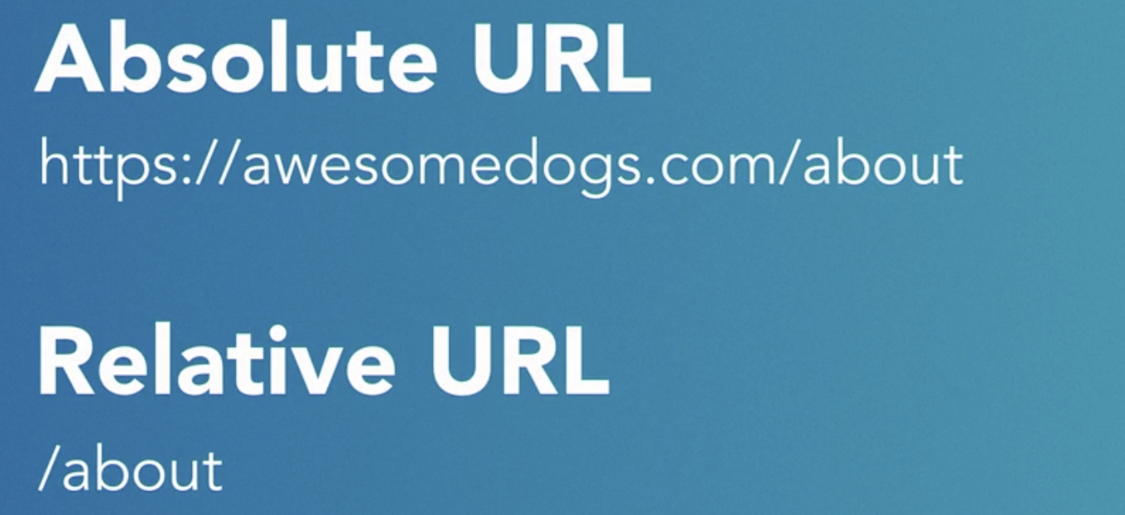

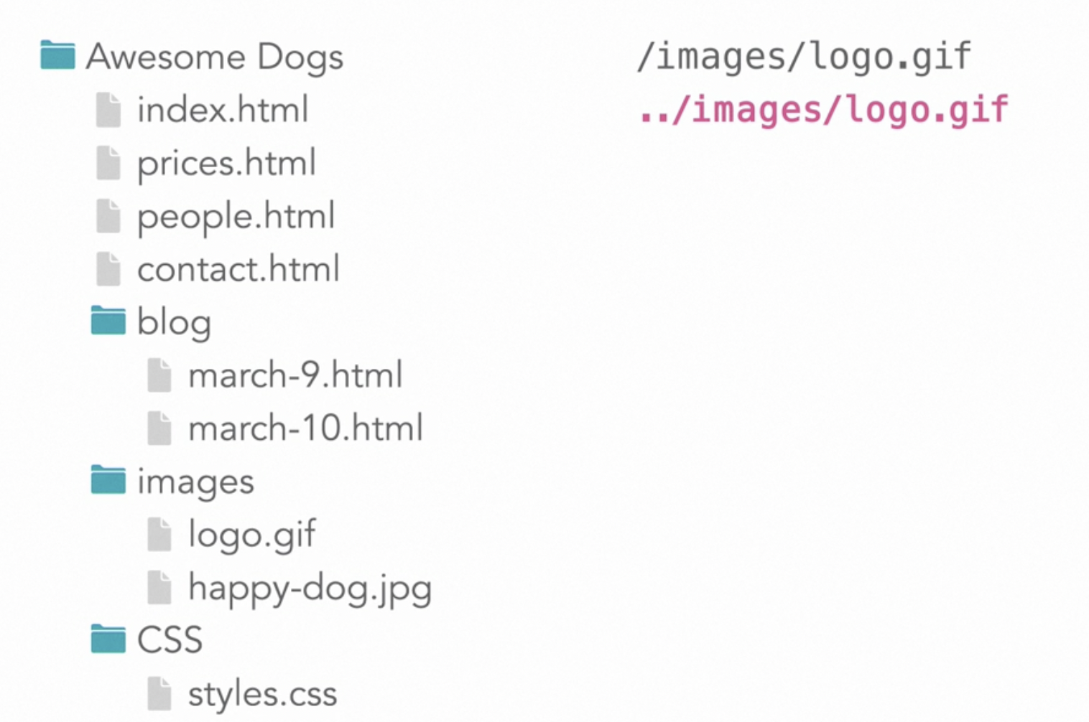

the first version creates a url that is relative from the root level.
The second one creates a one which is relative to the file.
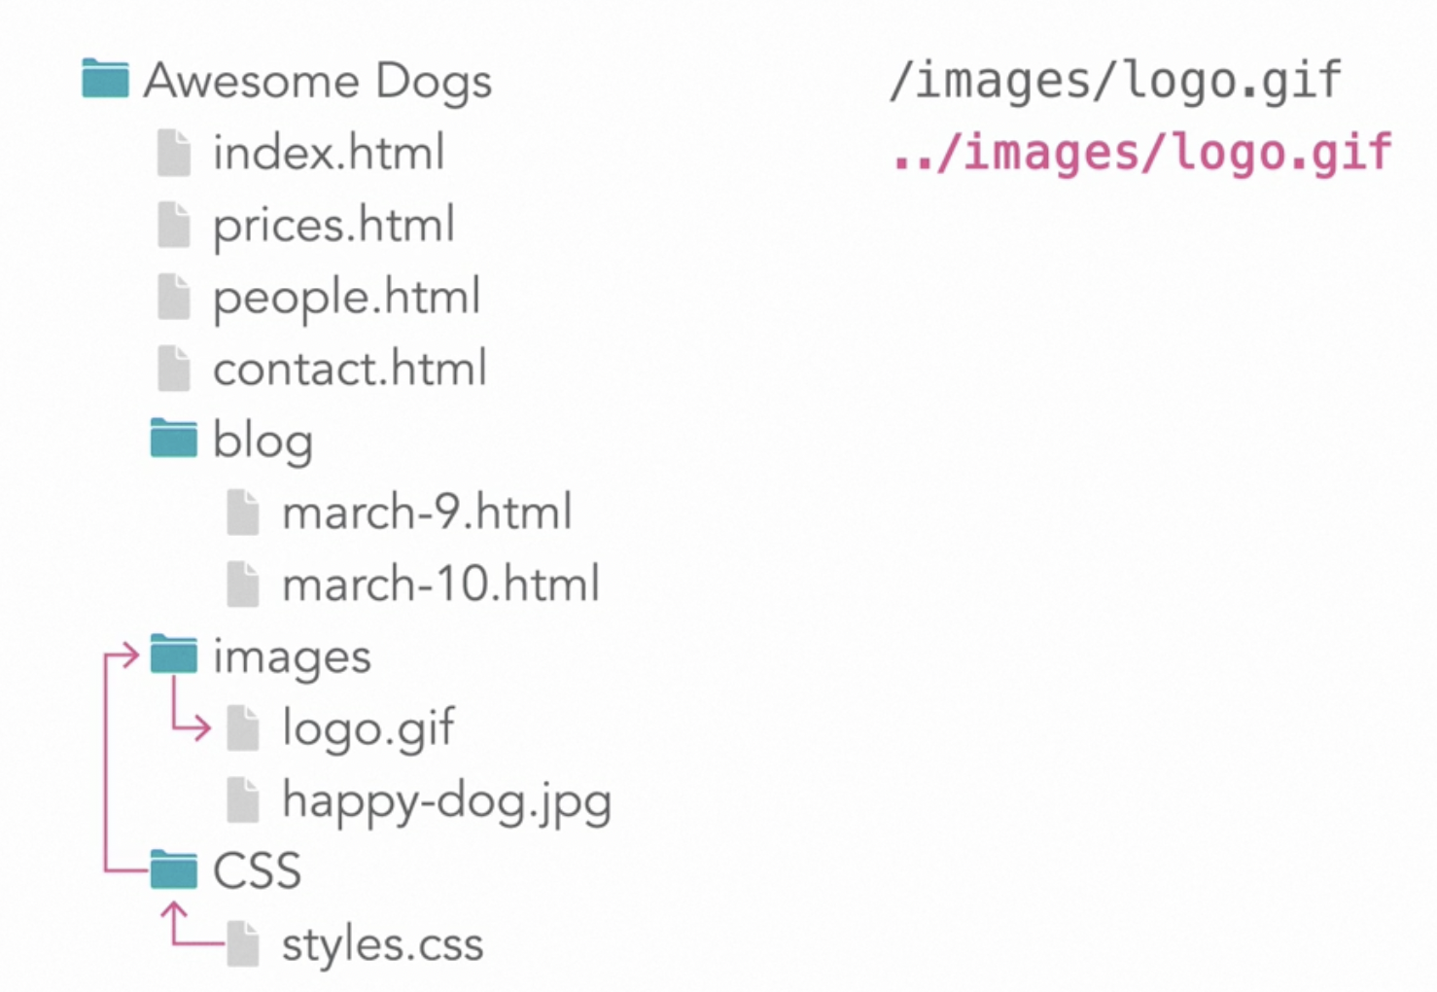

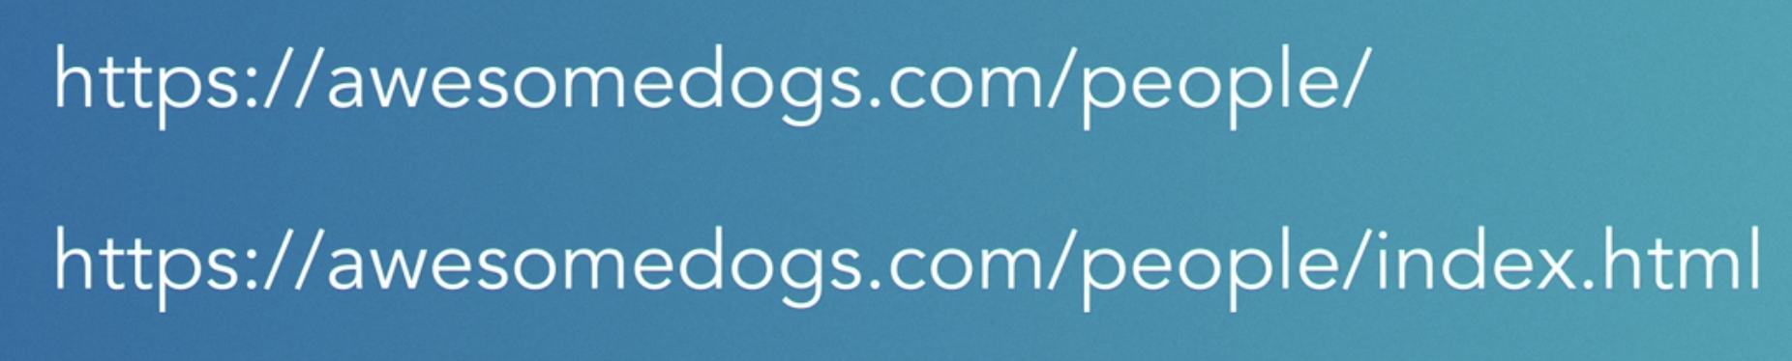
Any time it is told to browser to goto to a folders. It automatically looks for index.html and loads it.
So instead of creating a filename called people.html. We can create a folder called people. And inside that folder we can put a file name index.html.
It only works for html files.
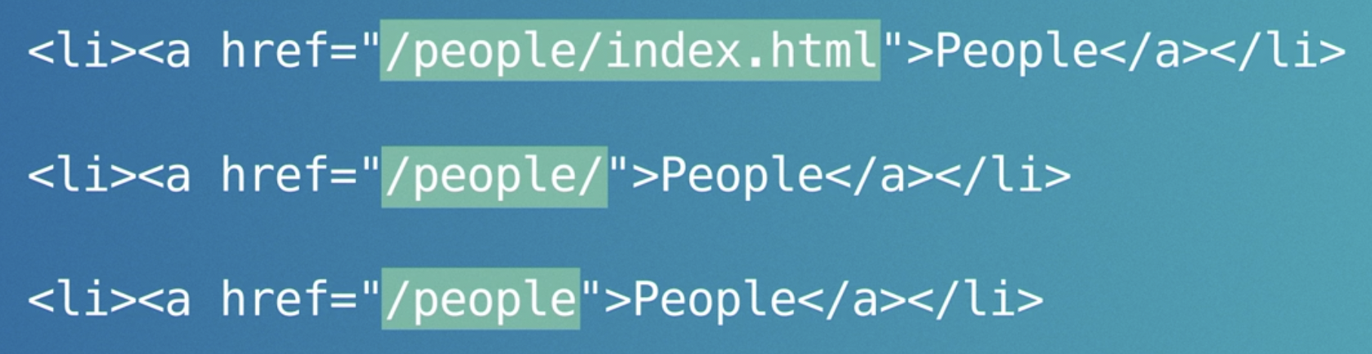Figure 15: they all the same.
How ur url affects user-experience and search end results.

Navigation
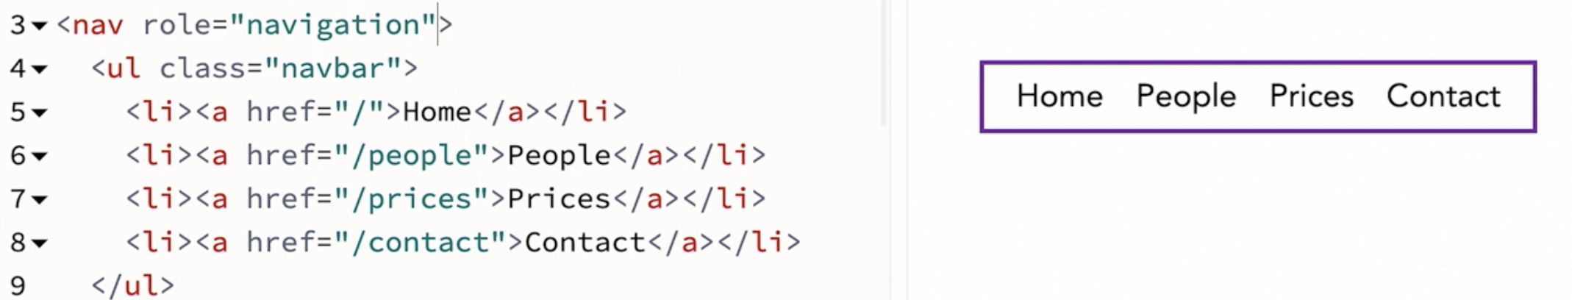Figure 16: its an aria-role

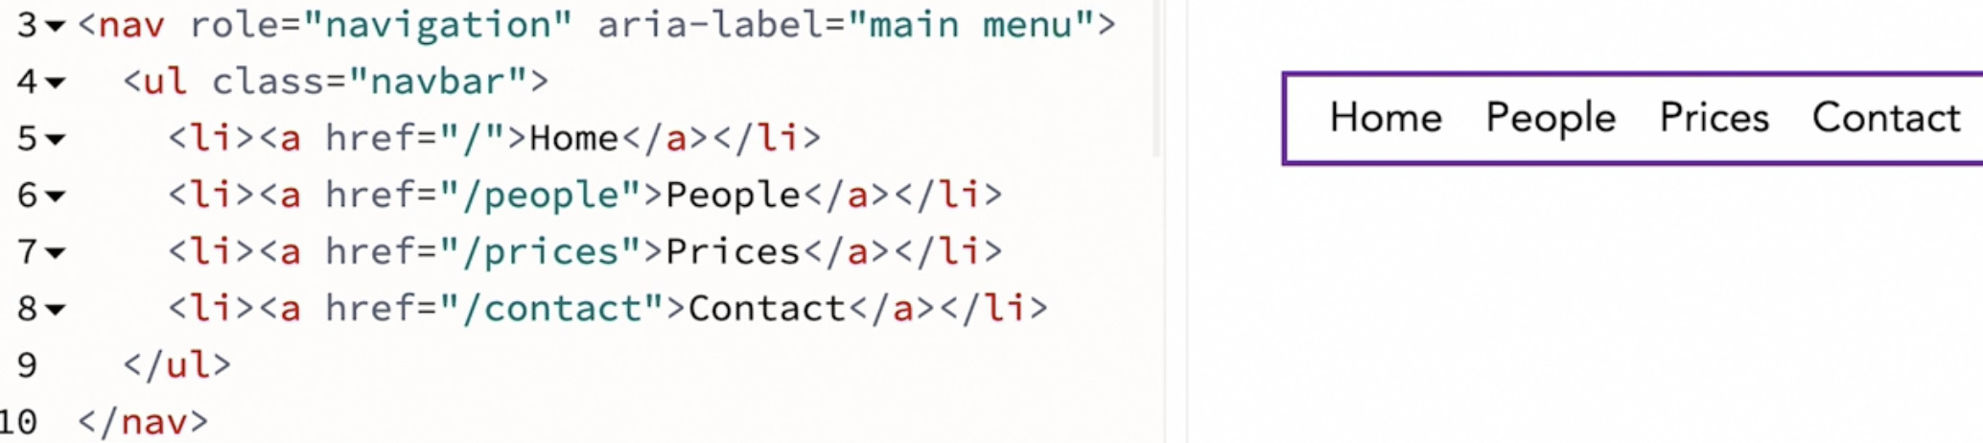
That provides aria-label that can be read out by screen-reader to tell what this is and give them more context.
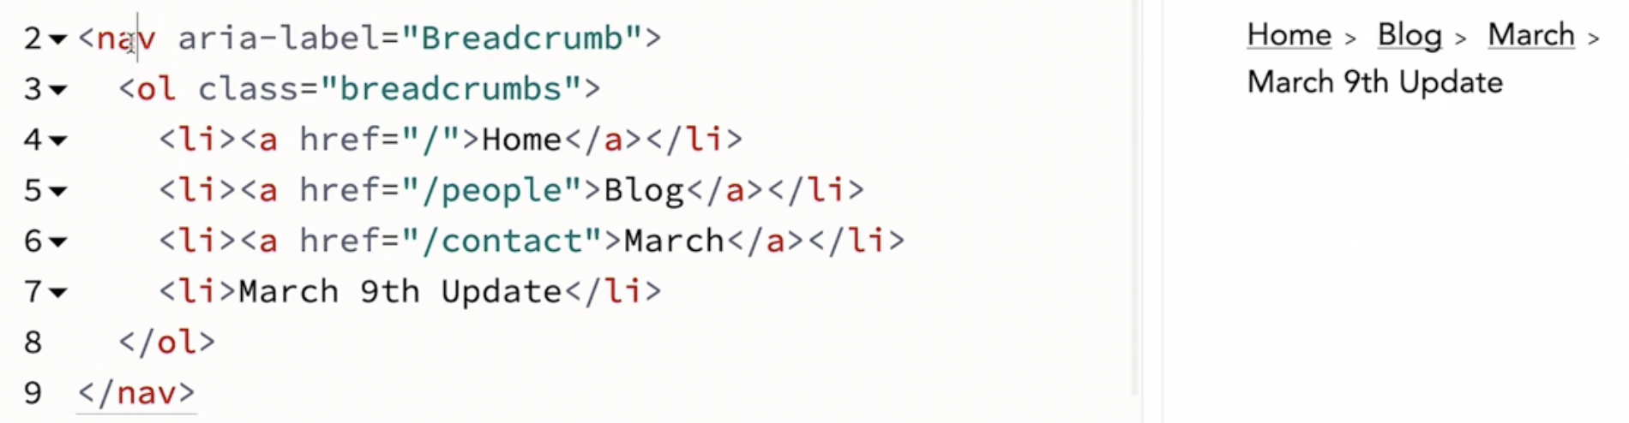Figure 17: she isnt gonna put role of navigation cause it isnt as important.
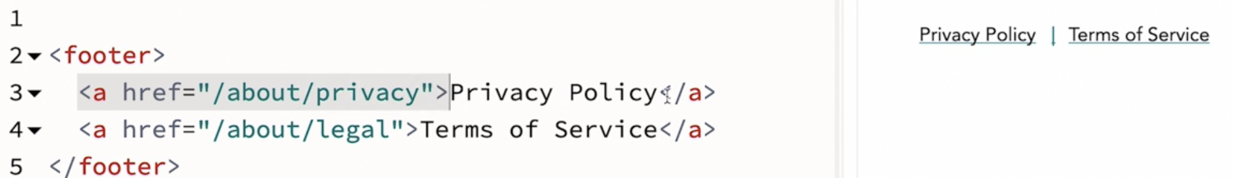

Images and Graphics

Responsive images

- Sometimes, we want to display a big, beautiful, high resolution image for people with big screens and then, shrink it way down for people on phones, on small screens. CSS can do this. One image file can be shown at any size. But there's a problem. A big, high resolution image contains millions of pixels. And all that data can make the file size pretty big. Which takes a lot of time to download on a slow network connection and can use up people's data plans and in some markets, cost them a lot of money. We don't want to deliver unneeded high resolution data to small screens. Instead, maybe we should just make all of our images much, much smaller. Physically smaller, less colored data, fewer pixels, more compressed, that will work well for a smaller screen. But then if we send that file to everybody, people with big desktop monitors won't get to see a large, glorious photo. They'll get a low quality photo blown up really big. Or our web designs are limited to keeping every image physically really small. So, what can we do? Well, we can use the power of HTML to deliver different image files to different size screens. We can make several different files and list them as a set of options in our HTML and let the browser decide which image to download. It can do so in coordination with the operating system while taking the device hardware capabilities and the network speed into account as well. Let's first start with the basic code for loading an image on the page. I have an image element with a source attribute that points to an image file with the alt text and the width and the height. Just like we talked about when I first introduced the image element. You can see here that I wrote 480, in the big white text on the image itself. So it's obvious which image has loaded when. Now, this image is 480 pixels wide. And it will look good when it's displayed at 480 pixels or smaller on some devices. More and more screen these days however, are not 1X screens. The retina screens, high density, DPI, super retina, ultra fancy billions of whatever the latest name is for these amazing screens. Basically, there are a bunch of screens out there with a pixel density, is 2X, 3X, 4X where more data can be displayed by the screen. Right now, my older computer has a 1X screen. My newer computer has a 2X screen. I think my phone has a 3X screen and I'm not really sure what the rest of my devices are. I just know that I want photos to look good. The simplest way to support these different screens is to create multiple copies of our image in different resolutions and then tell the browser that those copies are available. The device can then decide what it wants to do. The browser will look at the screen density, the network connection, the users settings and decide which image to use. Even if someone has a high resolution screen, the browser might decide to download a lower resolution image. I've created four copies of this photo at 480, and 960, 1440 and 1920 pixels wide. Let me duplicate this basic HTML for displaying an image. So we can change the second one and compare the results. We're going to still write the code for displaying the image in a normal way. This is good for older browsers. We need the source attribute and we'll put our 1X version of the image here. We need the alt text just like before and the width and the height. It will definitely still improve in performance, keep that. It's OK that the pixel numbers won't always be accurate. The aspect ratio is what's important here. And 480 by 360 calculates to a four by three aspect ratio. All of these photos are four by three. Now, let's add a source set attribute. Inside of it, we'll list the images that we are offering the browser as choices. It's a comma separated list. With a URL to a file, a space, the resolution, like 2X, 3X, 4X, 1.5X, whatever, a comma, and the next one. Now, the browser will swap out one version of this image for another based on what it thinks is best. This is a great solution for providing different size images to handle retina and high DPI screens. But what about handling different size images based on the layout? Based on the width of the page? Let's look at that next.
Selecting transcript lines in this section will navigate to timestamp in the video
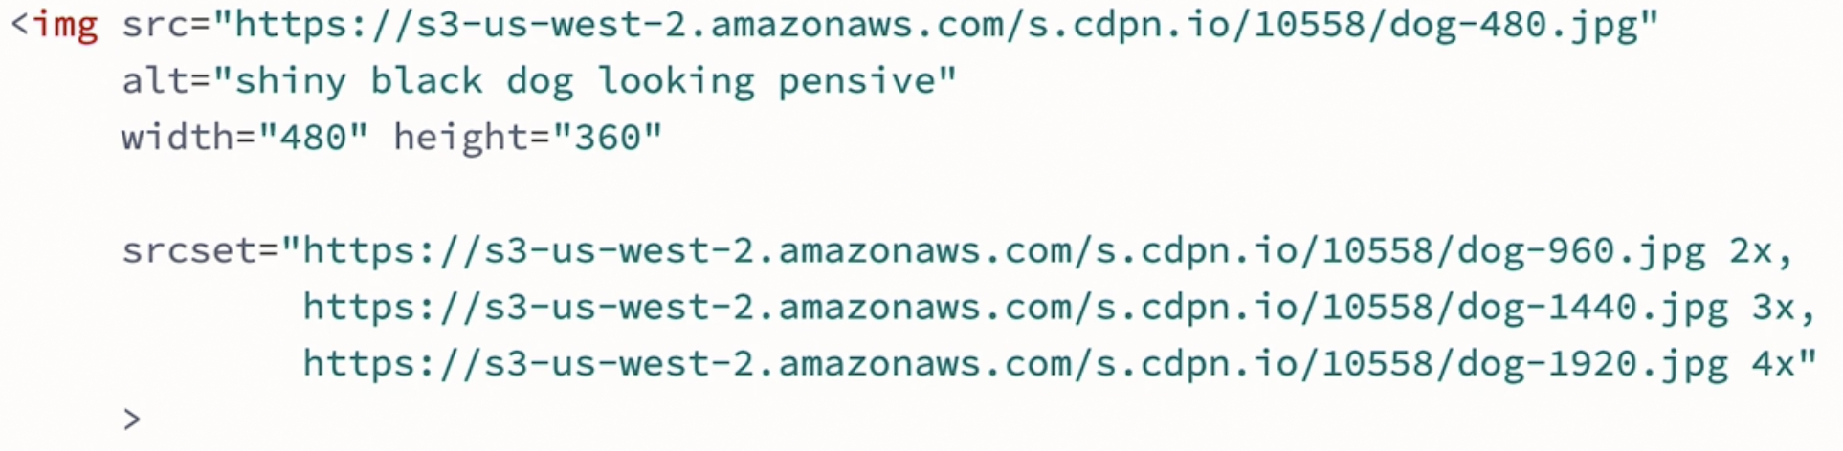

Image format:

- Let's talk about the image file itself. To put an image on a webpage, it has to be in a file format that web browsers will understand and there are several options. We keep inventing new ones in a quest for the perfect balance between tiny file sizes and gorgeous-looking images. We want as much data as possible, so that it'll look amazing. But we want as little data as possible so images will download faster and not eat through people's data plans. The goal is to have the highest quality possible with the smallest file size possible. Each file format takes a different approach to solving this. Each uses a different technique for compressing the image. There are four main file formats commonly used on the web today. Each is good at compressing certain types of images and not as good at compressing others. The GIF is one of the oldest. It's good at compressing illustrations that have large areas of a single color. It has a limited color space. It only has 256 colors, so your image can only use those colors. This can make photographs fairly pixelated. So it's a bad choice for photographs unless you're looking for a retro look. One of those colors is clear. So the GIF can be transparent, but the edges between the transparent part and the solid part tend to be usually quite jagged. Of these four, the GIF is the favorite for making small movies, the animated GIF. SVG is great for logos, icons, and other kinds of illustration. Instead of the file being made up of individual pixels, it's a vector file. It contains instructions for a drawing. Make a square. Make it this color. Put it here. Because SVGs are made of vector and math, these images can scale to be physically quite large or very small without ever losing any quality. It won't get pixelated because there aren't any pixels. This makes the file size very small. If you can use an SVG, you definitely should. SVG stands for Scalable Vector Graphic, and it's actually a whole other language, a programming language for graphics. If you're interested into diving into the SVG language, there are whole other courses on it. Meanwhile, you can export an SVG file from Illustrator, Sketch, or other vector graphics programs, and handle them much like you handle any of the other file formats on the web. JPG is known for being a great format for compressing photographs. Most digital cameras in fact save photos that you shoot as JPG files. When you put a JPG image on the web, you want to make sure that either a human or robot resizes the image to an appropriate physical size and compresses it for the web. Don't just stick a 5000 pixel wide, half-compressed JPG on your website. They are far, far too big for users to download and will make your site very slow. JPGs can be compressed to much smaller sizes, by simplifying the color information in the file. You can pick a balance between the quality and the file size. You can do that manually or rely on software on your web service to handle the task. Either way, when JPG files are prepared for the web, they are good solid reliable way to deliver a photo. PNGs are newer format for the web than GIFs or JPGs. They're a good solution when you have a photograph and you need part of the photo to be transparent. The PNG sometimes does a better job than a GIF at compressing the kind of images that the GIF format likes, and sometimes it does a better job than a JPG than compressing the kind of images that the JPG format likes, but not always. If you're manually compressing files, you should try several options and see which results in the small file. There will be other image formats coming in the future, ones that'll do an even better job of compressing millions of pixels into smaller and smaller files. So keep an eye out. Consider the physical size of an image, the file format and the compressing settings when making your image files. Aim to make them download as fast as possible. The HTML that we use is the same no matter which kind of file format you use.

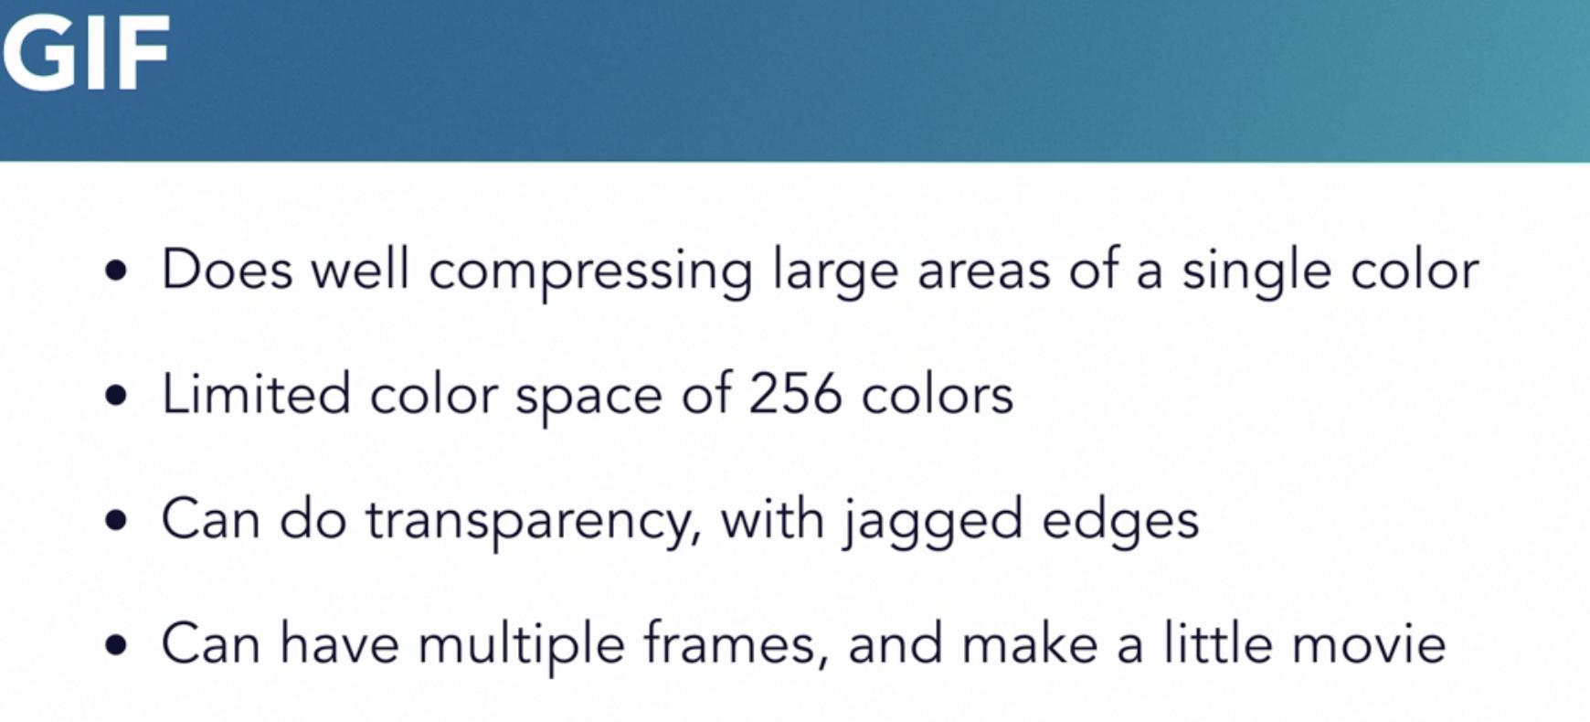

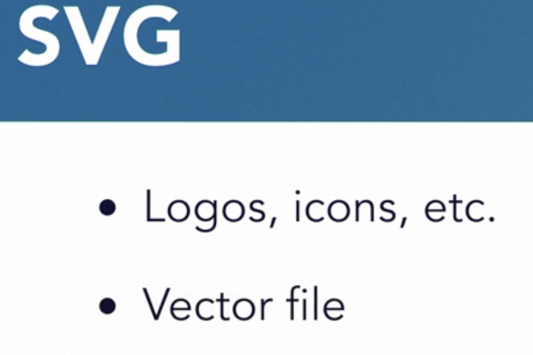

These images can scale. This makes the filesize very small.


Do resize the photo and compress it for the web.

Responsive width:
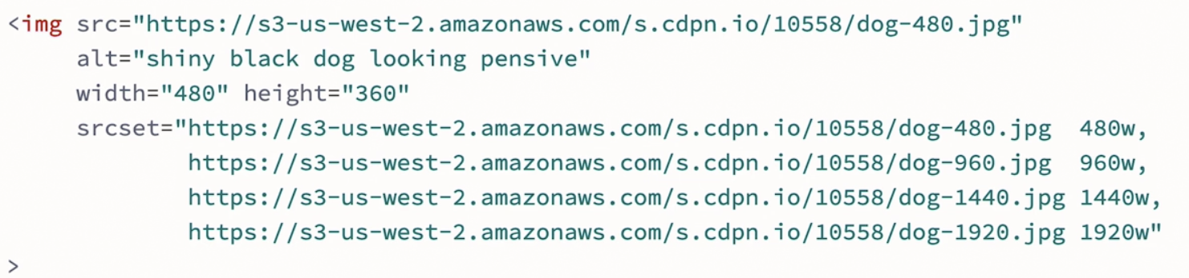
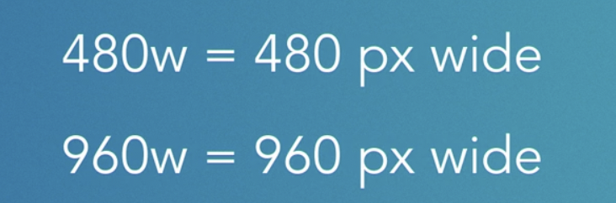

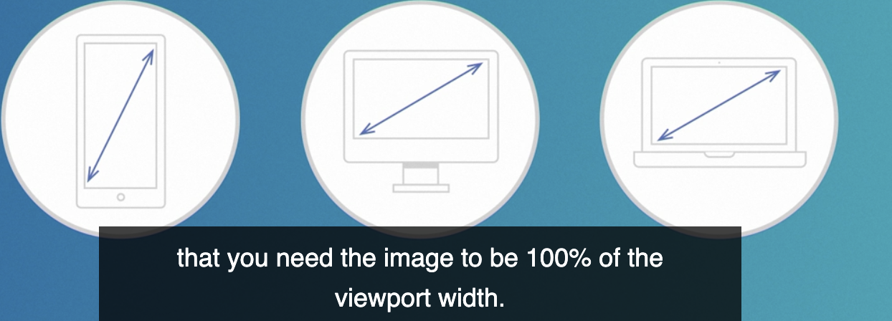Figure 18: not based on the layout

It chooses the image before css is parsed and before layout is happened.

If we know the image is gonna be a lot of smaller than the width of the whole page.

We probably wanna add more information here for the browser to choose
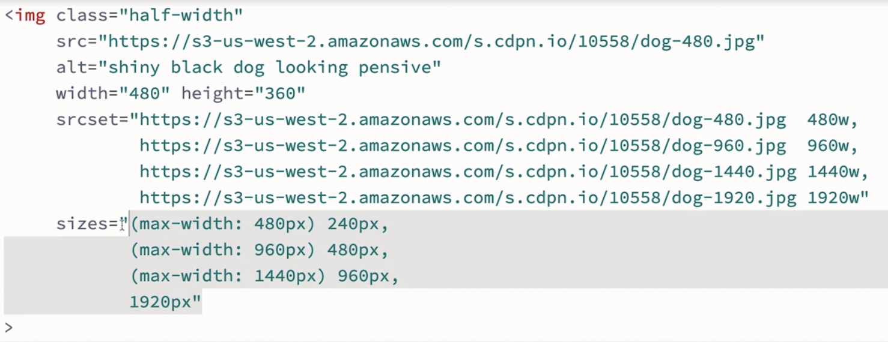
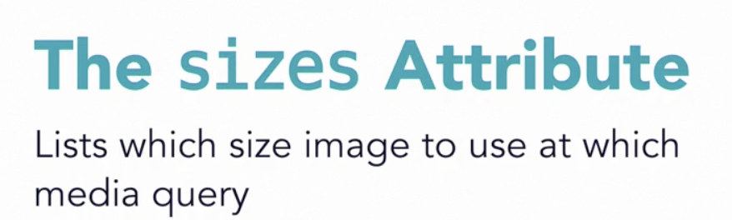

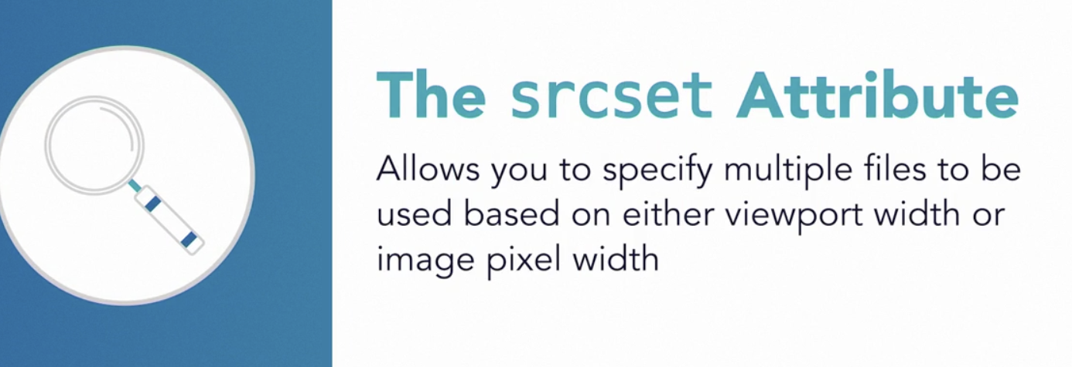

- In the last video, we just looked at how we can use the image element and the srcset attribute to list a set of image files and have the browser decide which file to download and display considering the pixel density of the screen. What if instead we want the browser to consider the width of the viewport and to choose a file based on the size of the screen as well as the density? Let's look at a demo. It's very similar to the one I just showed in the last video with four images listed inside of a srcset attribute. But this time instead of saying one x, two x, three x, four x, we'll tell the browser how wide each file is, 480w, 960w. That means 480 pixels wide, 960 pixels wide. Now the browser will dynamically choose which image to display based on a combination of device density and viewport width. This is not going to pick the right size image for the layout that you have. It's choosing the image based on an assumption that you need the image to be 100% of the viewport width. So why? Well, this system is designed to be fast and for the browser to make a decision about which image to download as early as possible in the page loading process. It chooses the image file before the CSS has been parsed and before layout has happened. So the browser has no idea what you're going to do with that image. It doesn't know what the size of the box is going to be where the image is going. If we know the image is going to be a lot smaller than the width of the whole page, we probably want to add more information here for the browser to use when it's making its choice about which file to grab. Here, I've used CSS to make this image half the width it was in the last demo, but the browser is still loading the bigger files. We don't need so much data, so let's tell the browser when to use the file. We'll use the sizes attribute for this, listing which size image to use at which media query. You can see now that the second photo looks just as good, but it's using the smaller files. It's using the files that are the right size for the layout that we have. HTML has a lot of power when it comes to providing options to the browser for downloading different size files of the same photo. Srcset gives you two options for communicating to the browser that there are a set of images available to use. You can specify which images are for which resolution of screen, or you can indicate which image has how many pixels and let the browser choose an image based on the combination of screen density and viewport width. The sizes attribute gives you a way to specify for the browser how much of the viewport's width that image will take up at which break point. In every case, you're giving the browser information in the HTML so it can decide intelligently which image file to download, especially considering the network conditions and the user's preferences.

Responsive pictures:

- In the last two videos, I showed you the source set in sizes attribute for the image element and how they could be used to provide multiple image files to the browser and let it decide which one to load and display. In all of those examples, the image itself, the photo of a dog was the same photograph. It'd been saved as many different copies with more pixels or fewer pixels, but the content in the photo was the same the whole entire time. The way it was cropped, its aspect ratio. But what if we want to do more than swap out a low-res file for a high-res file? What if we want to use a different image on a small screen versus a big screen? Maybe we want the image to be tall and narrow on mobile where it's short and wide on desktop. Or even use a completely different photo altogether. Let's look at another example. How about for this photo, on big screens, will show some of the field and her whole body, but on small screens, will crop in and focus on her face? The image element alone, even with the source set or sizes attributes, can't do this. For this, we use the picture element. We'll start with the good old image element as always with the alt text and a URL to a file that will be used by any browser that doesn't understand the picture element. Like Internet Explorer 11. Even if you don't care about old browsers, you still have to have an image element. If you leave it out, none of this is going to work. Then, let's wrap this image element with a picture element. Now that we have a wrapper for the whole thing, we can list alternative options through the sources element. I want to provide two options, so I'll create two source elements. First, let's point to an image file with the source set attribute on the sources element. Here, we'll pick our mobile image at the cropped version of the photo at 320 pixels wide. Now, let's put a kind of media query in the other source element and point that to an image that we want to use on bigger screens. When the viewport is a minimum of 600, 600 hundred pixels wide or bigger, the landscape version of this photo loads. When the viewport is smaller than 600 pixels, the cropped version loads. It's pretty fantastic. Now you notice, we're using source set on the sources element. It works exactly the same way it does on the image element. Which means we can take everything that we learned from the last two videos and apply it here. In this demo, I combined multiple techniques using picture, source, source set and providing multiple file options in each source set telling the browser how wide each file is. The browser swaps from one file to another only using the bigger files when they're needed. It's taking both the viewport size and the retina screen into account. Then when the viewport becomes 600 pixels wide, it switches from the cropped version to the wide version. Of course, because I keep changing the viewport as I'm showing you this demo, this browser is downloading all of these different files. And that's not the point of this HTML. Normally, a person is looking at a web page through one screen. Their viewport is staying one size and they just get the one image file. The one that's best for them. None of the rest of the files are downloaded. Which is the whole point to save on downloads. HTML gives us a powerful set of options for optimizing images on the web. So we can send the smallest file possible while still publishing gorgeous images that are sometimes displayed quite large. Now, you might be thinking, wow that's a lot of files to create. There's a lot of math involved in figuring out all these numbers. Yeah. On most sites though, the work needed to publish each image in this way is automated. A person who adds content to the site just uploads one large image. And then magical robots on the server do all the work of creating the image files and writing out all the code. Those magical robots do need to be told what to do of course and perhaps, that will be your job, to figure out how this should work for your team's website. And then, you set it up for everyone else. It's definitely worth doing. The image files for this demo range in size from 27k to 593k. That's half a megabyte difference per photo. If we created a web page that has six photos on it, and save our users 500k per photo, that's three megabytes of data we've saved. Definitely worth doing. If you want to learn more about how to use this HTML, there's another course on responsive images that goes even deeper into the details.




--
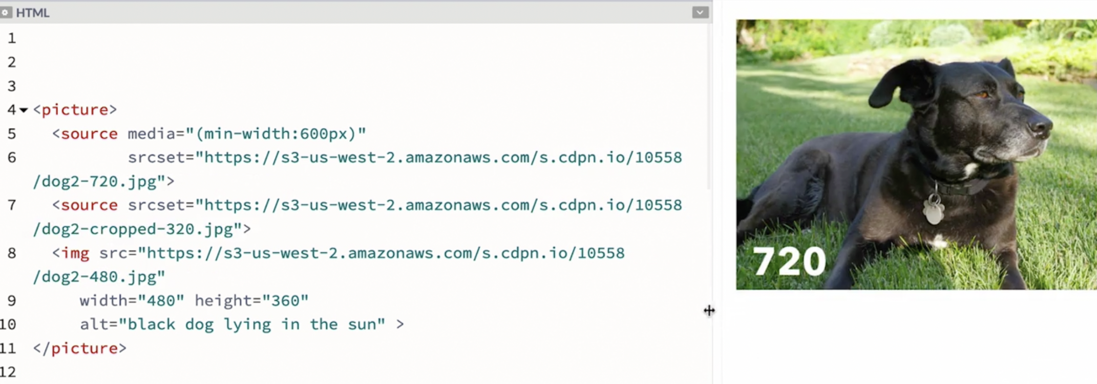

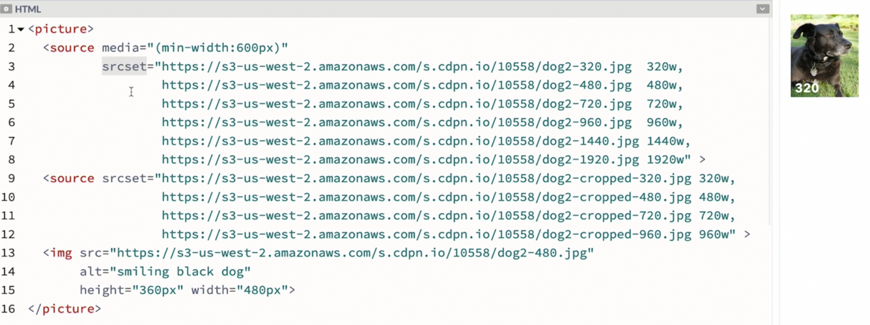
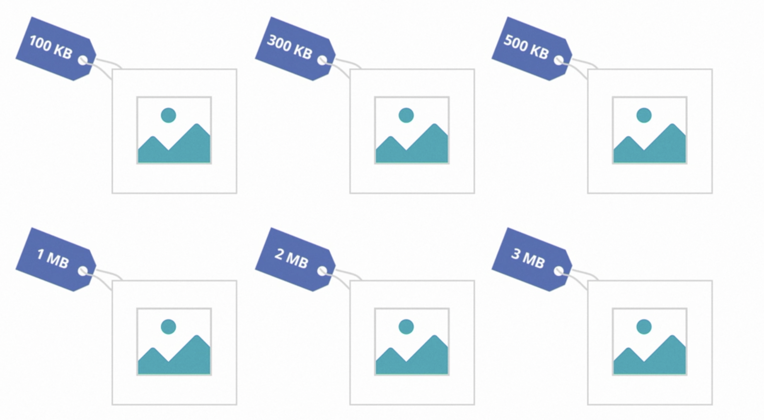

Fig and figcaption:
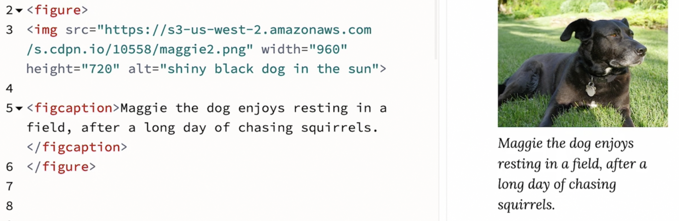
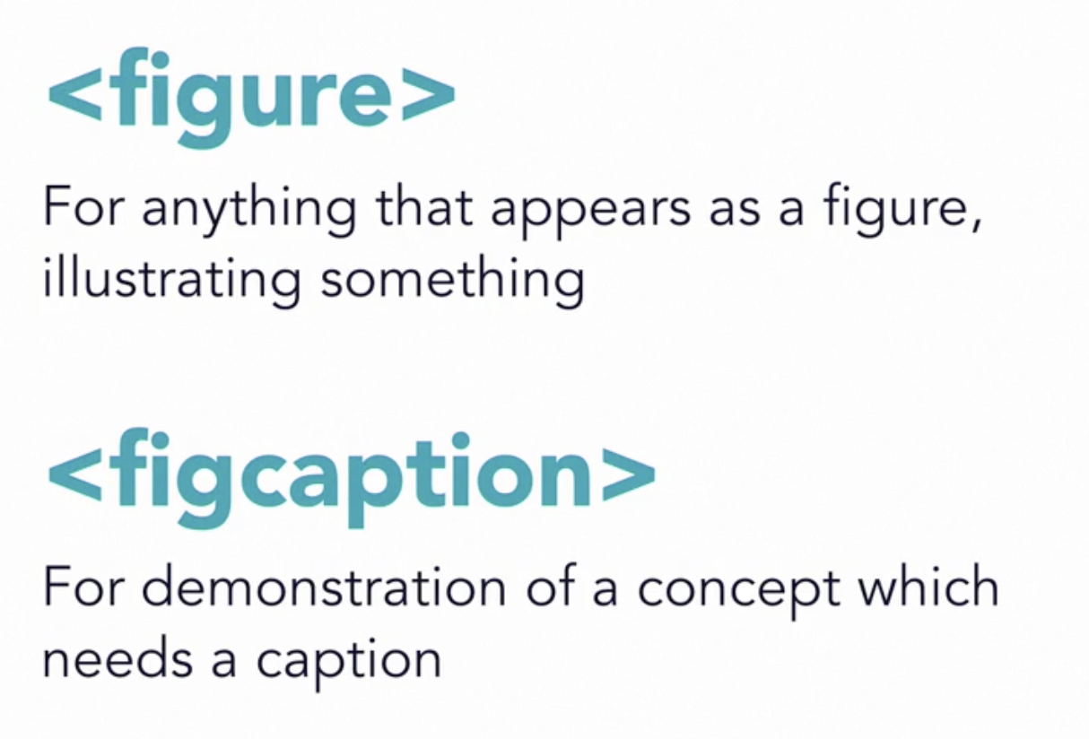

- Now that we've dug fairly deep into how to put an image on a web page, let's look at how to pair a caption for that image with the image itself. There are two more elements related to images, or really rather, related to figures. Here's a simple example. We'll start with the image of our dog and a caption for this image. Maggie the dog enjoys resting in a field after a long day of chasing squirrels. Now let's wrap this text in the figcaption element. That designates it is a caption. And we'll wrap the image and the caption together in a figure element. This provides the browser with more semantic information about this content. More context than if we'd only use a paragraph element or generic divs. Search engines in AI will now know that these two pieces of content have a relationship to each other. We could also use figure for things besides images, like an interactive graphic. We'll put it where the image element is in this markup. The figure and figcaption elements are handy for anything that appears as a figure illustrating something, or anything that's a demonstration of a concept which needs a caption.

Audio

- Earlier, we talked about how to put an image on a webpage. Images aren't the only kind of media you can put on a site, audio and video files are supported by HTML as well. Let's first take a look at audio. We can use the audio element to put audio files on a webpage. The HTML is fairly simple and it can trigger the browser to create an entire audio play or interface for us. The structure of the audio element is similar to the image element with a few differences. Unlike image, the audio element has both an opening and a closing tag. It's more modern and having both an opening and closing tag gives it more power and flexibility. Now just like the image element, we use a source attribute to provide the URL to the file. In this case, an audio file. There's more than one audio file format we can use and I'll talk about which formats are best in a few minutes. For now let's just link to this MP3 file. So what does this do? Well, actually nothing very useful yet. We need to tell the browser that yes, in fact we do want the browser to provide some controls. A play button, a timeline, a volume control. Using the controls that are built into the browser is optional. We could instead make our own custom controls using JavaScript and the HTML media element API. But let's not do that. Let's add the word controls as an attribute. If controls is there, it means true, yes please do include them. Boom! Now we cave an audio player on the page. We can play, pause, and change the volume, see the time code, jump around in the timeline. The audio element is a good example of the power of HTML to provide a bunch of functionality that maybe we just don't want to bother to build ourselves. We can use what the browser provides. There are several other attributes that we can use with audio. Loop will make the file loop. When it gets to the end, it starts playing from the beginning again. Autoplay will cause the audio to be played automatically as soon as the page loads, at least in some browsers. Now be careful with autoplay. Most people actually hate it when the audio starts playing automatically when they land on a webpage, so maybe don't use that one. So why do we have both an opening and closing tag? That's so that we can use the source element to specify more than one audio file, much like we could with the picture element. Perhaps you want to use a new file format that's not supported in every browser while providing a fallback for the older browsers. Let's remove the source attribute from the audio element and instead put it on a source element. This will do the exact same thing as our previous example but now we can add additional source elements with alternative audio file formats. MP3s are supported in most modern browsers today. OGG is another file format that had some advantages but it never became very popular. It seems that a new format may come out soon, the cousin to the AV1 video file format. But it's not quite here yet. So I don't really have a second audio file format to recommend using at the moment. But I want to show you the syntax for supporting multiple formats since it was important for a while and it's likely to be very useful again sometime in the near future. We can make multiple files and list them in separate source elements. The browser will use the first file that it understands in the list. This is how the syntax works. You can also provide some fallback text in here that will only be displayed if the audio element is not understood by the browser at all. This is a good example of the resilience built into HTML where you can write one set of code and provide a wide variety or browsers what each of them need to give some kind of experience to their users. The audio element is a great way to get an audio file along with a player onto a webpage.
Selecting transcript lines in this section will navigate to timestamp in the video

Video

- The power of the web has revolutionized the way that we connect and share experiences. Film, television and, well, teaching have all been transformed by the ability of the web to transmit video. One way to put video content on a webpage is to use the video element in HTML. Just like the audio element, we can create a video element with both an opening and a closing tag. We use the source attribute to point to a video file. And, we add the controls attribute to tell the browser to create a video player for us. Great, we're done now, right? Well, maybe, this is pretty cool. It's very simple. There are a couple problems though for us to solve. The first has to do with how videos are encoded. For the simplest version of this demo, I've made a video file that 480p compressed using the H.264 codec delivered as an MP4 file. 480p means that there are 480 lines of resolution or 720 pixels wide by 400 pixels tall. It's standard depth, not HD, not 4K. I'm using the H.264 codec because it has the widest support across browsers at the moment, much like choosing between PNG, JPEG, GIF, or SVG for images, there are a bunch of different codecs which a video file might be encoded. Video files contain a lot of data and can get incredibly big when they aren't compressed, far too big to travel across the internet. So, any internet video is using a pretty hefty mechanism for smashing all the data into the smallest possible package. There've been many attempts to make the ultimate codec, Real Video, Sorenson, Windows Media, Flash, H.263, there've been a lot of codecs. From about 2015 to 2020, the H.264 codec is the one that's dominated. It's the codec that most of us are using most of the time. But the thing is, it's not open source, it's patented. It's owned by a consortium that charges fees for every device, every operating system, every browser, every camera, anything that wants to be able to record, compress or play H.264 files. And, they are about to charge way more for H.265 None of the image file formats that we use are owned by someone who's charging licensing fees. They're all public, anyone can use JPEG or GIF. None of the underlying technology on the web should be patented. HTML isn't patented. You don't have to pay to use CSS. Why should video codecs be different? To fix this, a lot of effort has gone into creating a truly open, not patented, but still super awesome video codec. Folks had hoped that WebM would emerge the winner, but it's still unclear if it will. More recently, there's great hope that we finally solved this with AV1. It's looking like AV1 is a better codec than H.264 and is truly royalty free. Time will tell on how things shake out. The good thing is that the video element has the ability for us to point to multiple source files. We can use more than one codec at the same time. We can use H.264 and WebM. And, once there're tools for making AV1 files, we can use AV1. This works the same way as it does for the audio and picture elements. We use a source element to list the multiple file formats, with the source attribute to link to the file, and the type attribute to tell the browser which type of file it is. The browser will play the first file that it understands. Which brings us to the second problem to solve. I've got a 480p file here and this is probably a good choice for users who have a smaller screen and a slower network connection. Although, maybe an even smaller video would be good for them, 360p or 240p. What about the people who have a faster connection and want HD or 4K? We'd like to send them a pretty big file. We have a solution for this with images. With the image source set and picture, but there's nothing in HTML that will allow us to send different sizes of video under different network conditions. In part, that's because we don't want the device to get only one moment to make a choice between, say, standard def and high def. We want it to make that choice over and over and over again. Maybe, someone has an HD screen, but the network is kind of slow, so instead of sending them a 1080p file, we want to send them a 720 video, but then, as soon as their network speed improves, we want to switch from 720 to 1080. This is how Netflix, Hulu, HBO, YouTube, Vimeo and all those TV apps work. They're constantly switching from one resolution to another as people watch, using a technique called adaptive bitrate streaming. The whole thing is really complicated and basically, it requires a server farm of transcoding robots, which is why when you go to put video on a website, it's likely you might not use the video element. There's a good chance you'll use embed code from a video hosting service, which I'll talk about right after we talked about captions.
Selecting transcript lines in this section will navigate to timestamp in the video

Captions and subtitles

- It's pretty amazing that we can put audio and video on a website. But not everyone can always hear or understand the audio. Some people are completely deaf. Other people can hear sometimes certain things and certain conditions but not all the time. And for people who can hear, well they can't always listen. Sometimes people would listen to a video, but they're some place where they can't use speakers and they don't have headphones. Or they are listening, but they can't really understand the people who are talking because of an unfamiliar accent, or maybe the person who is talking is talking way too fast. There's a good chance that you're experiencing any of theses conditions right now. And you're using the captions for this video. On the web we have the power that we need to provide content in multiple ways simultaneously. So let's add captions and make our video more accessible to everyone. To do this we'll use the track element and point to a text file. The video player will provide all the functionality so a viewer can turn captioning on and off or switch from one set of subtitles to another. There are many file formats for captions. But on the web, we want to use webvtt, web video text tracks. It's basically a plain text file with a vtt extension that uses a certain convention for providing the information. You can see here each line of text with the time code information that tells the video player when to show each line. To get these captions to show up on our video we put a track element inside the video element. Just like the sources element, it's part of the list of options for the browser to use while rendering the video player. On the track element, we'll use the source attribute to point to the file itself. We'll use the kind attribute to tell the browser that this is captions. We'll add a label of english that will show up in the player as a label for this choice. We'll use a source lang attribute to specify which language this is. And we'll put a default attribute on this track element to specify that this track is the one we want to use by default when a user turns on captions. We can see now that a little captioning icon has appeared. And when we click on it, we have options for off, auto, and English. The word English shows up because that's what I put in my label. Now I'll add a translation into Spanish and offer some options for subtitles. I've got another vtt file this time in Spanish. And we'll add another track element inside this same video element. This time we'll set kind to subtitles, set source lang to es for espagnole, and create a label of espagnole. Now we can see that there's a second choice in the list of subtitles. And we have Spanish subtitles. There are a few other options for the kind attribute. We could create a vtt file that has descriptive information about what's happening visually in the video, and use kind=descriptions. This gives people the option of playing a track that reads aloud descriptions of what you miss if you aren't looking at the video. For instance, the astronaut jumps off the ladder and bounces a bit as he hits the ground. This makes a video more accessible to the blind and the visually impaired. Kind=chapters gives us a way to provide a text file that lists the chapters in the video, giving users a way to jump from one section in the video to another. As I'll talk about in the next video, you might use YouTube, Vimeo, or another video hosting service instead of using the video element in html. All of those platforms have a way to upload caption files and provide the same kind of functionality. Captions and subtitles are powerful. And in many places they're actually required by law. By providing them, you'll make it far easier for more people to find, watch, or listen to your content. Add captions and your traffic will go up.
Selecting transcript lines in this section will navigate to timestamp in the video

Embedding other media through iframes

- Earlier, we took a look at the video element, and I mentioned that it's possible you're not going to to do video that way. It's likely that you'll use a video hosting service, and embed the video player that they provide onto your webpage. Embedding is taking content from one site and placing it into the middle of a page on another site. There's all kinds of content that you might want to embed onto a page. You can embed a map from Google or Mapbox. You can embed a code demo from CodePen or Glitch. You can embed a slide deck from Speaker Deck or Notist. It's common to embed something complex from a service that takes care of all the hard parts for you. You don't have to figure out how to build a mapping service, or a slide deck system, or a code demo platform, or an adaptive bitrate server. You go to someone else's toolkit and do all of that, and then embed the results onto your website. So what HTML do we need to know to help us do this? Well, basically, you get the HTML from the service that you are using. Let's use YouTube as an example. Here is a YouTube video that I made. And let's say I want to post it on my own website, so people can find it on my domain name and not have to go to the YouTube website. I'll look for a share button, or some other clue about where I can find the embed code. Here it is. Share. I see where it says Embed, and let me click that. And I see some options, Privacy Enhanced, that sounds good. I'll click Copy, and I'll get some code copied to my clipboard. I'll past this into my HTML, and voila, now I have a video embedded on the page. We don't really need to understand what all of this says. The engineers at YouTube wrote it all for us. Although, now that we know how to read HTML, we can see a lot here that we recognize. The iframe element has several attributes on it, including height and width. We could adjust those. Src is going to point to the source of the video file. Iframes are powerful. There are definitely some security considerations to be had about pulling in code from other sites like this. So if you're using a CMS that someone else set up, like it's your job to post content on a WordPress website, or a Drupal website, there's a good chance that you can't just paste some random embed code from another website into your system. There's a good chance that the CMS is set up with a different way to allow a URL or a shortcode from a specifically white-labeled source. And you'll want to talk to someone who knows how to use your CMS to find out how to embed things like YouTube videos. If you're the person building a site, you probably want to think about how security will work when it comes to the iframe element. If a bunch of different people are going to be entering content into a system, you're not going to want to just allow all iframes. Think about the security. If it's just you, posting your own videos on your own website, then it will be fine.
Selecting transcript lines in this section will navigate to timestamp in the video

Supporting languages

- The web, by its very nature, is global. We humans speak hundreds of different languages. There are several tools in HTML we want to use to make sure it's clear which language our content is in. If we set up things properly, search engines will know when to list our sites in which language. The right dictionaries will show up for the spell checkers. When content is read aloud by a browser, it's more likely that the words will get pronounced properly. We want computers who are involved to know which language the content is in. The lang attribute is what we use to do this. If our whole page is in the same language, then it's pretty simple. We can set the language on the outermost element that wraps all the other elements which, as we'll talk about more in chapter eight, is the HTML element. You may only need to set this once, perhaps in a template file that propagates to the whole site. Just don't forget. In this example, we have en-US, which stands for U.S. English. We could instead say en.GB, which will mark it as English in Great Britain. This especially matters for things like spell checkers. Does the word color have a U in it? Well, in the U.K., it does. Which dictionary do you want? Which pronunciation of things do you want? You could just say lang equals en for English, but it's better to be more specific. There are many options for the value of the lang attribute, not just to convey the language or the region-specific version of a language, but to also convey other qualities, like which kind of alphabet is being used to write a language. If your webpage has more than one language on it, you're going to want to specify the language for each particular part of the content. The lang attribute is a universal attribute, meaning you can put it on any element. If the majority of a page is written in Mexican Spanish, for instance, but there are several block quotes written in Nahuatl, we could put lang equals es-mx for Espanol Mexico on the outer HTML element and then put lang equals nah, N-A-H, on the block quote elements. We should also specify in which direction our content flows. Most languages in the world flow from a left-to-right direction in a horizontal direction, but some flow from right to left. Specify the direction with the dir attribute. It's a universal attribute that can go on any element. If all the content on your page is the same, define it once on the outer HTML element. Here, the first example says, Hey, this page is going to be in English, British English, and it flows left to right. The second example conveys this page is in Arabic, and the content flows from right to left. When you mix content, you want to mark each phrase with the change of directions. Lastly, make sure you set your charset for the project. What's that? Well, every human language is written in a script, the alphabet or the set of characters. There have been many attempts to represent all of the characters, letters, and symbols in our scripts in a format for computers to understand. The original digital character sets were pretty limited and only supported the Latin alphabet. You might have heard of ASCII. Created in the 1960s, it only has 128 characters,
Selecting transcript lines in this section will navigate to timestamp in the video

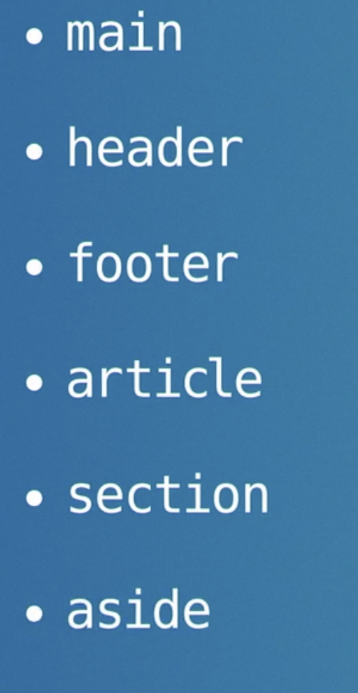

- We just took and in-depth look at what could happen in the document head. Now, what is the typical overall structure of what goes on inside body? There are six major elements here to learn, main, header, footer, article, section, and aside. The main element wraps around the main content of the page. It's only used once per webpage, and it tells the browser, this is where the main content is. The header and footer elements are used to mark places on the page where the content is a header or a footer. Now, don't confuse header with head. Head is part of our HTML document that's never displayed to users where the metadata for the file lives. Header is used to wrap site headers, article headers, headers in the content. Most web pages have a header at the top. Maybe with the logo, the site name, the navigation. That's a header. An article frequently starts with a title, maybe a subtitle, perhaps an author's name, publication date. That can be a header too. Many webpages end with a footer at the bottom, with lists of links, some copyright information, extra information about the company that would naturally be wrapped in a footer element. Footers don't have to go to the bottom though. Many articles start out with some metadata. A list of hashtags or group of share buttons. That kind of information is actually well-suited for a footer element. Perhaps we include the publication date here instead of as part of the header. The footer element conveys, hey, we have a few extra things to say about this. The fact that it might be displayed up at the top doesn't matter. It's the semantic meaning that matters, not the visual display. Article is wrapped around any instance of an article. It might be a long written article or blog post. It might be a very short snip. A teaser card can be marked up as an article element. A tweet or social media post, that can be an article. Perhaps there are no words at all. Perhaps you're marking up an app and somehow each unit of the stuff is best defined as an article. The article element just means, hey, this, this by itself, this is a unit of content. Consider this something that stands on its own as a useful or usable thing. Section is used to wrap around sections of content. If we have a long essay for instance, that's broken up into chunks with sub headlines, we can use the section element to mark each segment. Or we may have zones on our website. A section towards the top that's about one topic, and another section further down that's about something else. Section is a flexible element that means, okay, let's just start with another thing. Usually each section has its own headline marking the start of a new segment of content. Aside is for marking something that's off to the side. Perhaps in a side bar, or any content that's kind of not the main attraction. It could be an inset panel that goes with a big article giving additional information, but isn't quite part of the flow of the article itself. Or advertisements, they are a side thing perhaps best marked as an aside. Again, it's the semantic meaning that matters here, not the position on the page. Although frequently layout does convey meaning and these HTML elements are a way to transfer that meaning from the graphic design to the marked up content. The main element is used once per page to wrap around the main content on that page. The header, footer, article, section, and aside elements are the five sectioning elements in HTML. They are used together, nested inside of each other in patterns and combinations that give the content of a webpage its true structure.

Putting it all together

- Let's start putting the pieces together. I hope that gives you a sense of how we're going to assemble our webpages out of hundreds of nested elements, each conveying meaning and each playing off of each other, adding up to a whole. When I'm not sure what the best way to mark up a page is I travel around the web, finding similar sites, and I use developer tools to see how other folks have decided to use HTML elements in their content. The exact way we combine these HTML elements is different every time we make a webpage. It's hard to be if sure we're doing it right because the right way to do it always depends on what the content is, and what the page is for. In fact, usually there are several good ways to do it, and none of them are necessarily right or better. There's a bit of an art to structuring HTML. We have a lot of creative freedom here. We are, after all, trying to represent human communication in code, and while code maybe wants to be correct and perfect, human connection is not.

Forms and interactive elements

HTML FORM Basics
We login to sites through forms, request a search, purchase things from forms, add content to a site through form.
This type of things should happen through semantic form elements.
By using HTML form elements we tap into the power that is been built into form.
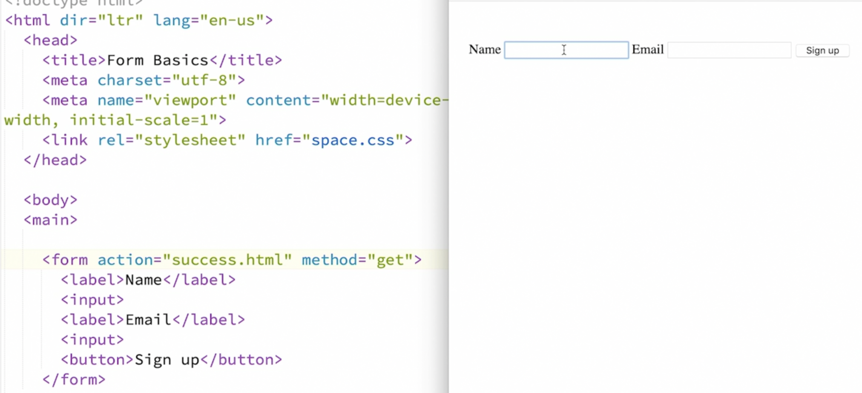
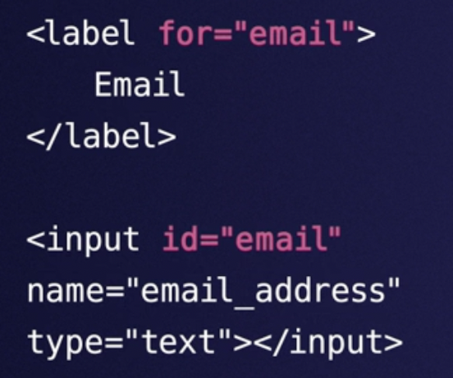
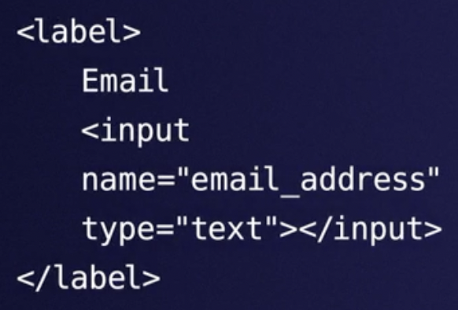

or

You shouldn’t fill default value as an e.g in the form, you should placeholder. It’s a suggestion and it should disappear.
And about auto-populating a field with real content.
if the application is smart it might fill the data in behalf of u but still be editable.
Value is helpful when u wanna auto-populate a form when u think its the right answer for that user.
For e.g. forms that auto-complete with users email, shipping address, credit card numbers.
The value is attribute is for including such data in the form.
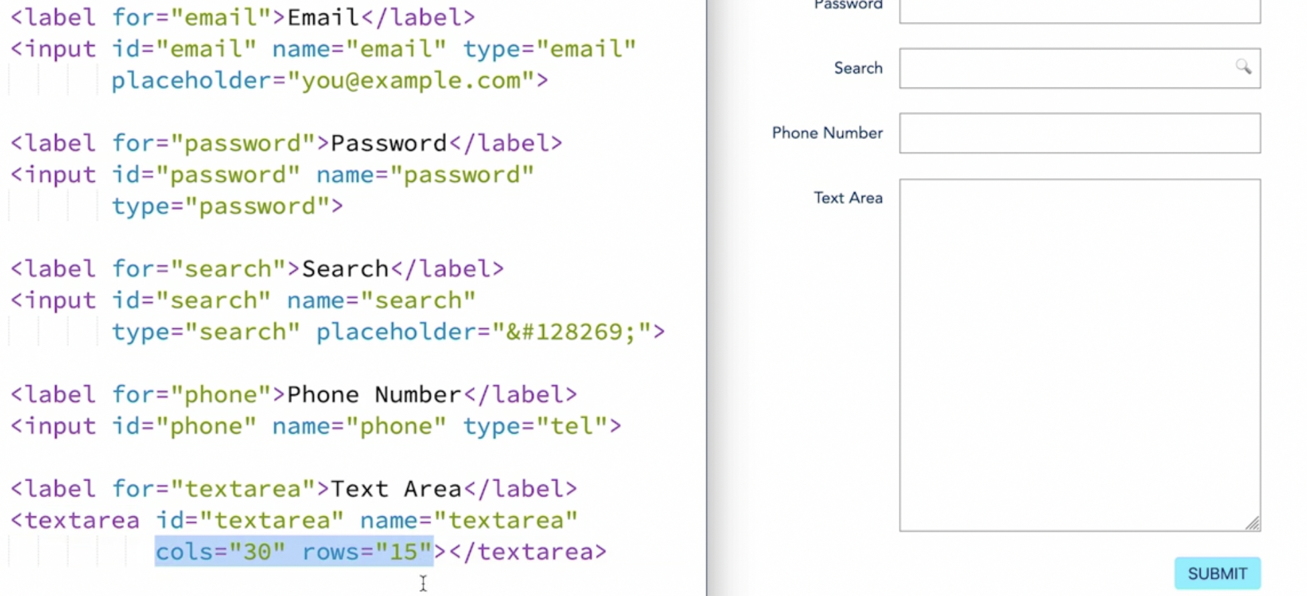Figure 19



