Learning_zsh_shell

Reference_book: shell_scripting_zsh
Reference_Online Source: Online Source

zsh-shell

History of zsh shell
-Open source unix shell developed by Paul Falstad.
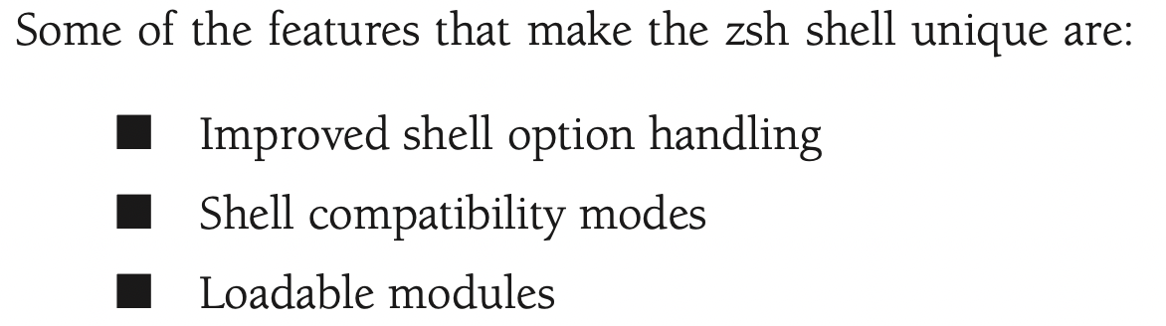

The benefit of built-in commands is execution speed.

Parts of the zsh shell
Upcoming built-in cmds, cli parameters and env variables.
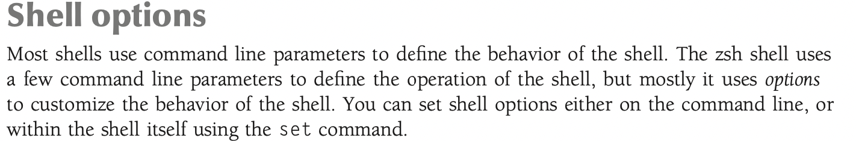
By far the zsh shell is the most customizable shell available.
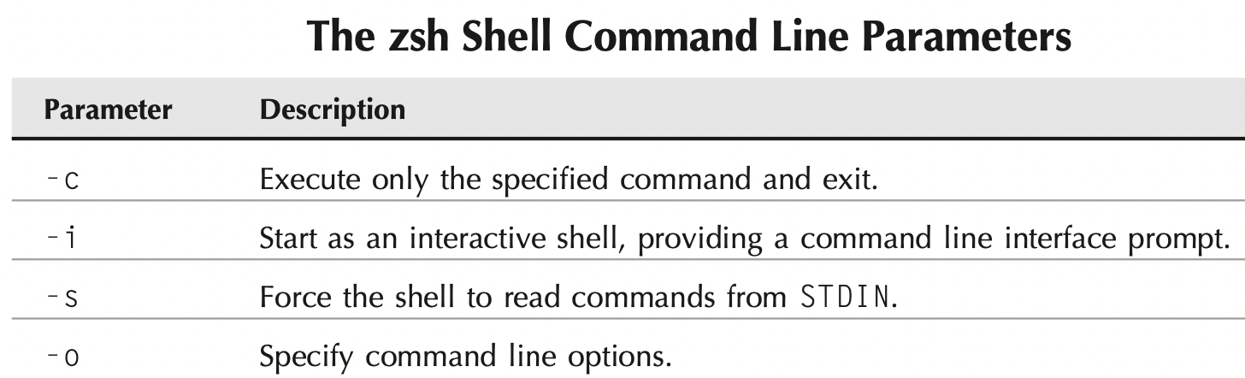

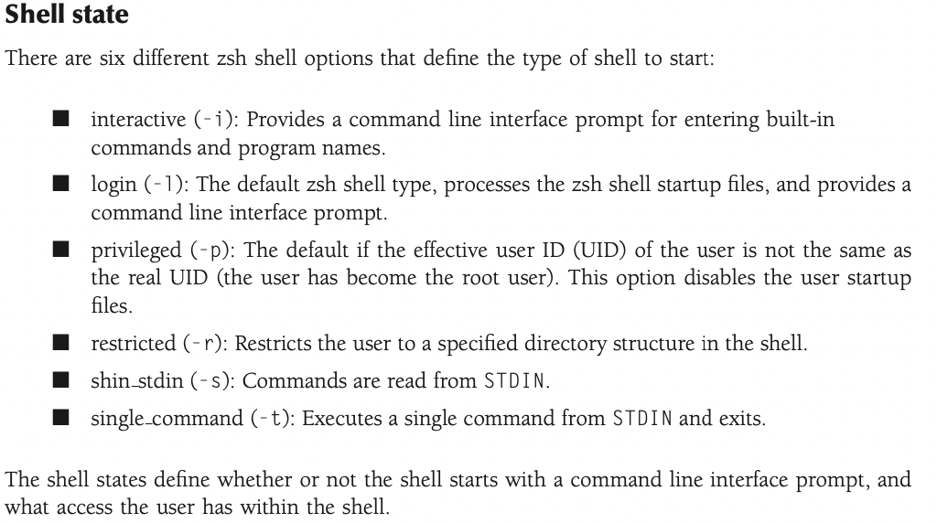

The zshell files
-The zsh shell uses files at both login and logout to allow you to preset variables and features of the zsh shell.
-automatically looks for default files for setting environment.
There are 4 types of zsh file that shell can handle.
- Shell startup file
- login file
- Interactive file
- logout file

1. The shell startup files
When you start a new zsh shell as a login shell (either by logging into the system, or by running the zsh shell program), the zsh shell looks for commands in two files.
The default system-wide zsh shell startup file is:
/etc/zshenv
After executing this file (if it exists), the zsh shell proceeds to the user’s $HOME directory and looks for the file:
$HOME/.zshenv
You can test the order in which the zsh shell executes these files by performing a simple test using the echo statement in each file:
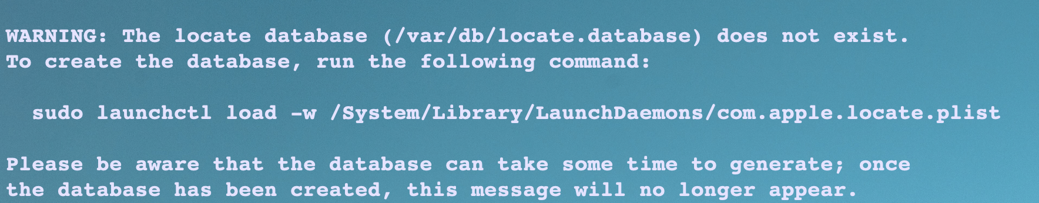

2. The shell login files
If u use the zsh shell as a login shell, it first looks for and executes two files.
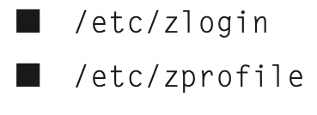

These files are executed for all users who use the zsh shell as their login shell. The files should contain system-wide environment variables that should be set for all users, and executable pro- grams that all users should use (such as the umask command to set default file and directory permissions). Most likely if you’re using a Linux distribution that supports the zsh shell, these files already exist for setting system environment variables at login.
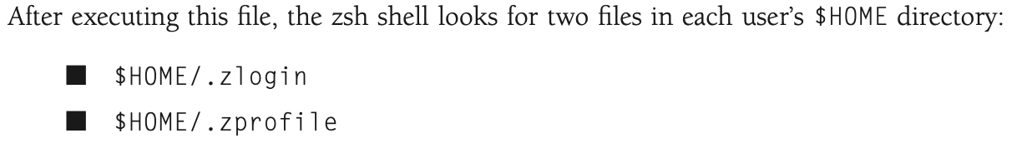
These files can contain user-specific environment variable settings, and executable commands that an individual user wants to run when logging in to the system, before the command line interface prompt appears.
Any environment variable settings you make in the $HOME/.zprofile shell will override any system-wide settings made in the /etc/zprofile file, and similarly for the .zlogin files.
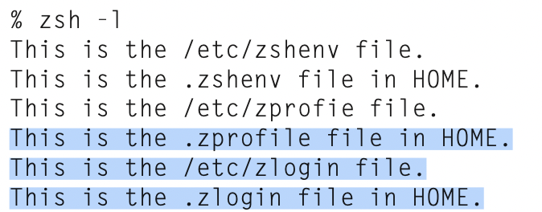

3. The interactive shell files
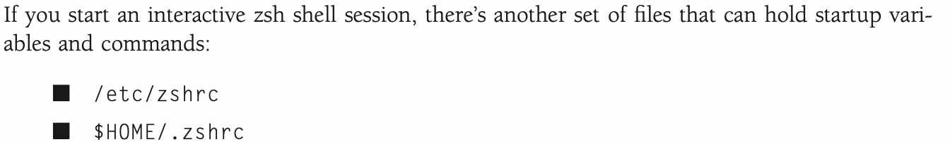
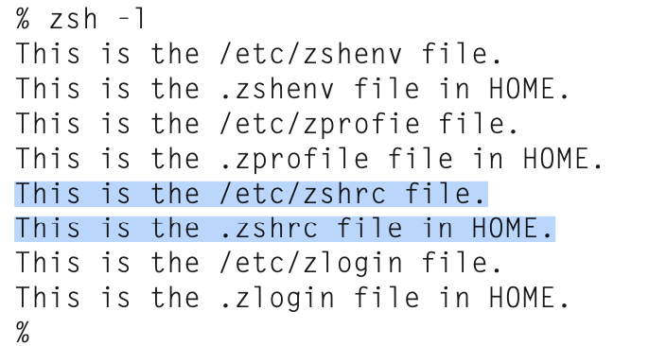

Notice the order in which the zsh shell executes the files. The zshrc file pair are executed after the zprofile files, but before the zlogin files.

4. The shell logout files
Besides the login and startup files, the zsh shell also has the ability to execute commands in files when you log out from an interactive or login shell session. These files can be in the following locations:
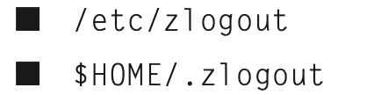

{As you probably figured out by now, every user on the system executes the commands in the /etc/zlogout file at logout, while each individual user has a unique $HOME/.zlogout file. The zsh shell will execute any commands in these files before logging out of the current shell. } its what the name says
{This doesn’t include just exiting from an interactive shell. Thus, if you just start another zsh shell from an existing shell session, the zsh shell won’t execute the logout files when you exit the shell. However, if you start a login shell, the logout files should execute upon exiting: } confusing

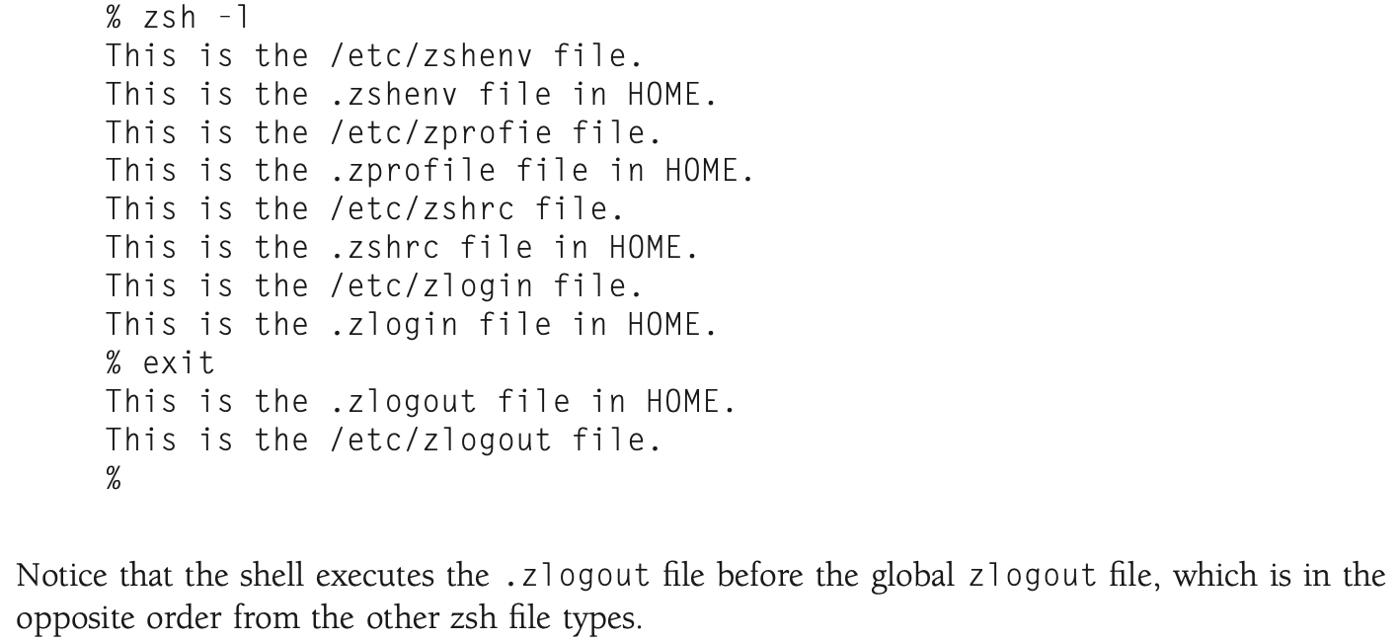
There are five startup files that zsh will read commands from:
$ZDOTDIR/.zshenv
$ZDOTDIR/.zprofile
$ZDOTDIR/.zshrc
$ZDOTDIR/.zlogin
$ZDOTDIR/.zlogout
If ZDOTDIR is not set, then the value of HOME is used; this is the usual case.
`.zshenv' is sourced on all invocations of the shell, unless the -f option is set. It should contain commands to set the command search path, plus other important environment variables. `.zshenv' should not contain commands that produce output or assume the shell is attached to a tty.
`.zshrc' is sourced in interactive shells. It should contain commands to set up aliases, functions, options, key bindings, etc.
`.zlogin' is sourced in login shells. It should contain commands that should be executed only in login shells. `.zlogout' is sourced when login shells exit. `.zprofile' is similar to `.zlogin', except that it is sourced before `.zshrc'. `.zprofile' is meant as an alternative to `.zlogin' for ksh fans; the two are not intended to be used together, although this could certainly be done if desired. `.zlogin' is not the place for alias definitions, options, environment variable settings, etc.; as a general rule, it should not change the shell environment at all. Rather, it should be used to set the terminal type and run a series of external commands (fortune, msgs, etc).

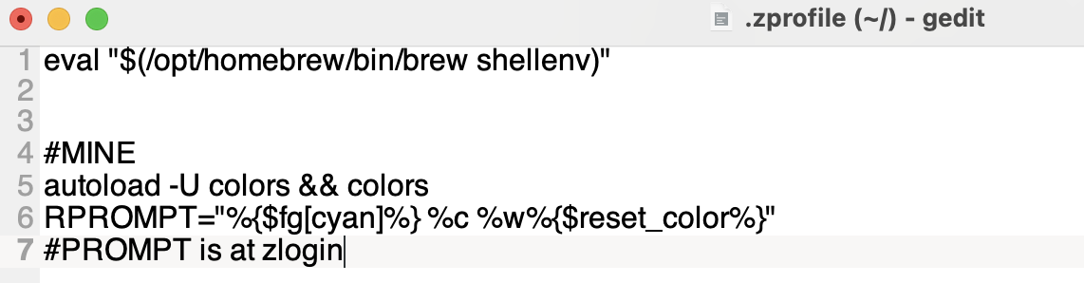
I think it takes few secs. So its better for zprofile to load my func into memory.

The zsh environment variables:
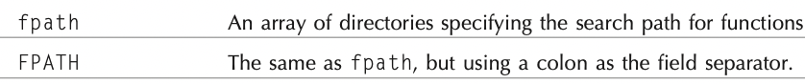
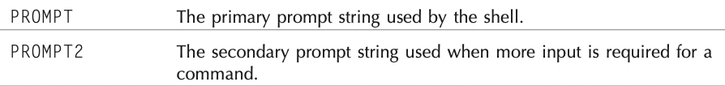
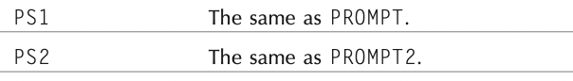

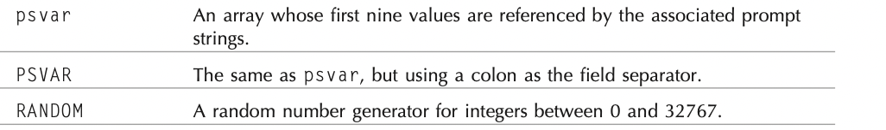
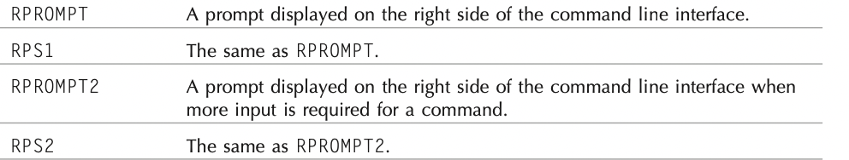

Typeset command
The zsh shell supports the typeset command, which allows you to declare attributes for a vari- able before using it. Table 23-3 show the options available for the zsh typeset command.

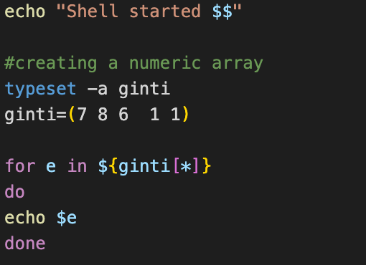

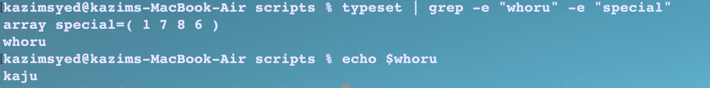Figure 1: -h whoru : to create a variable whose value is hidden
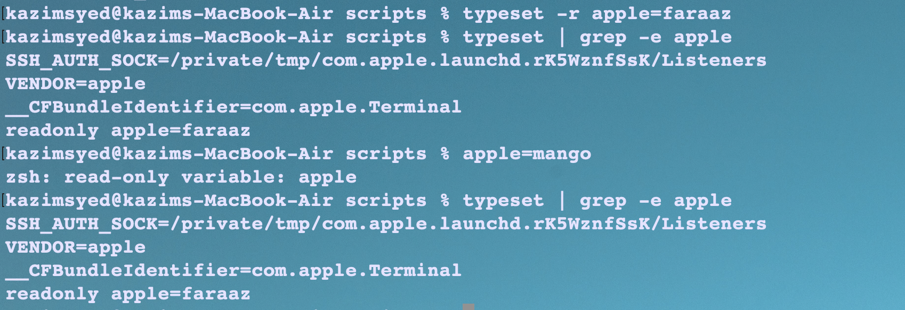Figure 2: using readonly variables
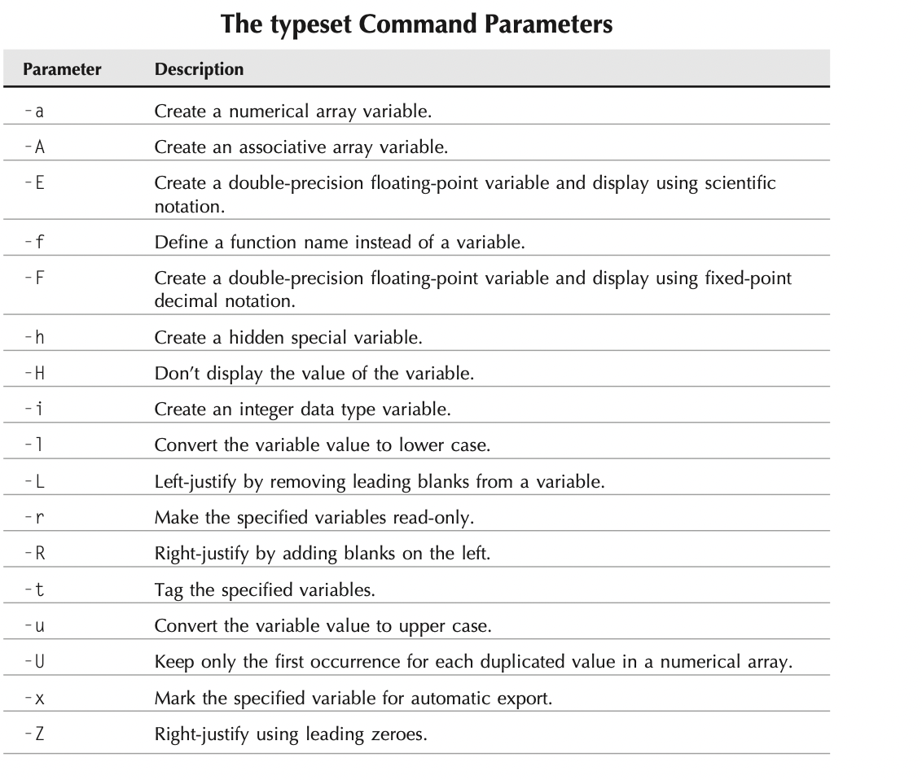

Built-in commands
The zsh shell is unique in that it allows you to expand the built-in commands available in the shell.
The zsh core built-in commands:

Index:
Title | Link | Reference
Filename Generation | Filename Generation
Startup file

Filename Generation
Commands | Working
Ls *.[co] | Files ending with c or o
Ls foo.? | Files ending with single letter
Ls *.[^c] | Files not ending with c

Also, if the EXTENDEDGLOB option is set, some new features are activated. For example, the^ character negates the pattern following it:
% setopt extendedglob

Commands | Working
Ls -d ^.*c | Not ending with c
Ls -d ^*.* | Not having an extension
Ls -d ^*.py | No python files are desired

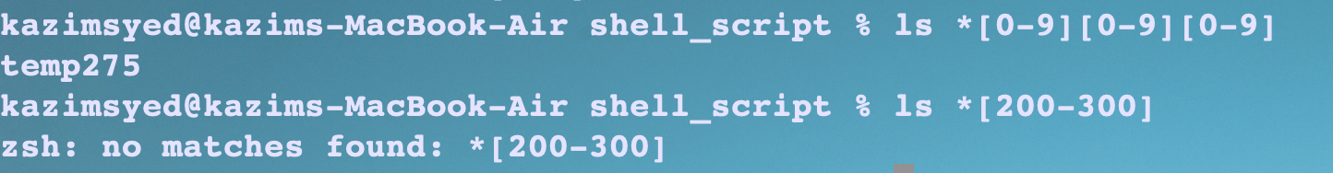
An expression of the form<x-y>matches a range of integers:

Commands | Working
ls run<200-300> | Run235
Ls run<-200> | run2

Grouping
*.(py|sh)

It is possible to exclude certain files from the patterns using the~character. A pattern of the form*.c~bar.c lists all files matching*.c, except for the file`bar.c'.
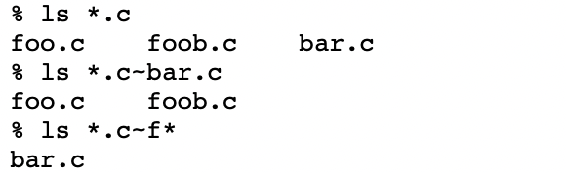

One can add a number of qualifiers to the end of any of these patterns, to restrict matches to certain file types. A qualified pattern is of the form.
Commands | Working
Ls -Fd *( \/ ) | To find all directories. Here -d is used, so it doesn’t expand.
Ls -F *(@) | Symbolic Link

Note that *(x) and *(*) both match executables. *(X) matches files executable by others, as opposed to *(x), which matches files executable by the owner. *(R) and *(r) match readable files; *(W) and *(w), which checks for writable files. *(W) is especially important, since it checks for world-writable files:
Commands | Working
Ls -F *(x) or Ls -F *(*) | Both match executables
Ls -F *(X) | This match files executable by owner
Ls -F *(R) or Ls -F(r) | readables
Similaryly *(w) | writable

*(U) matches all files owned by you. To search for all files not owned by you, use *(^U):
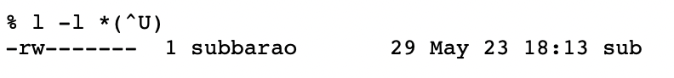

Startup Files
There are 5 startup files that zsh will read commands from:
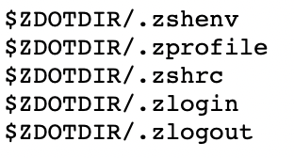

skip
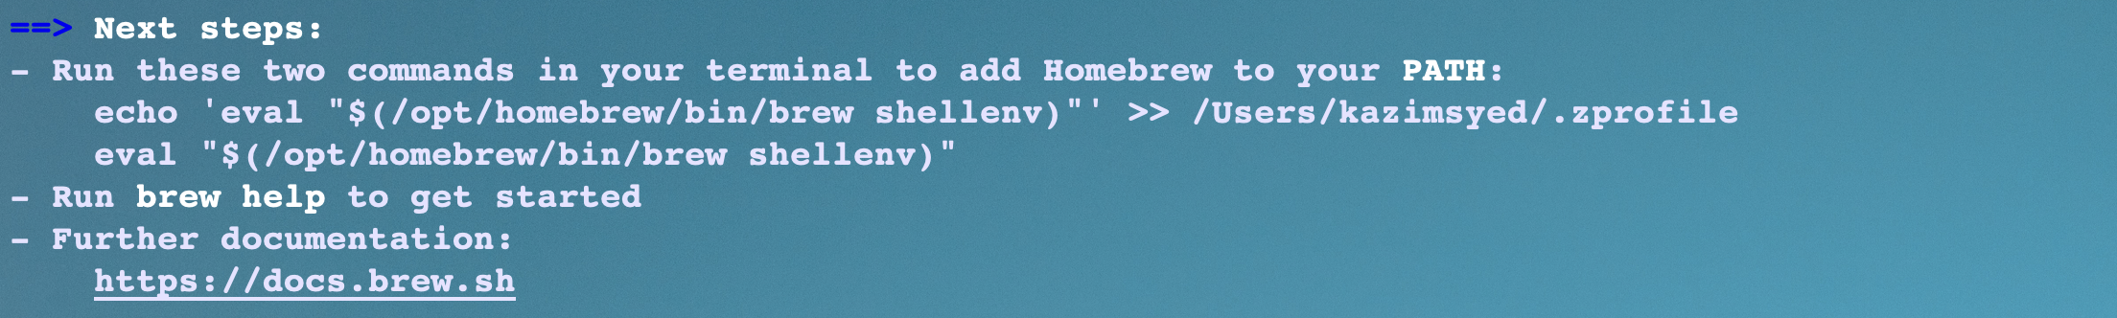

Shell functions
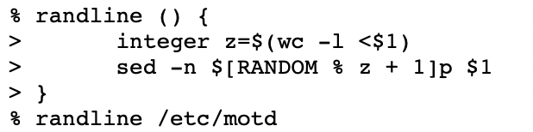

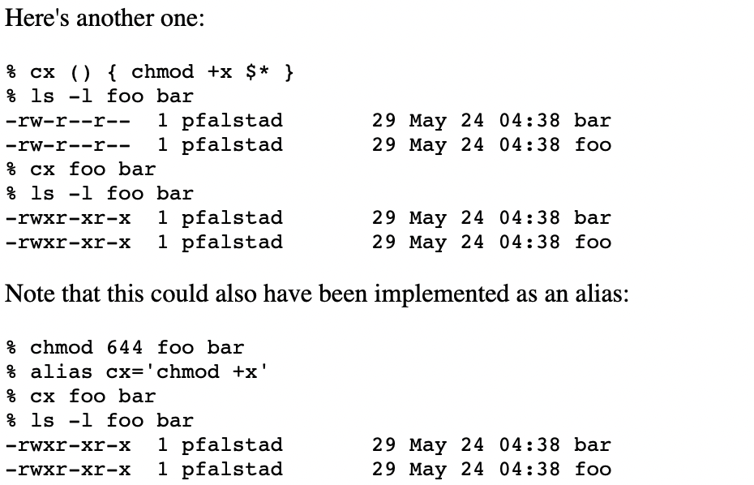

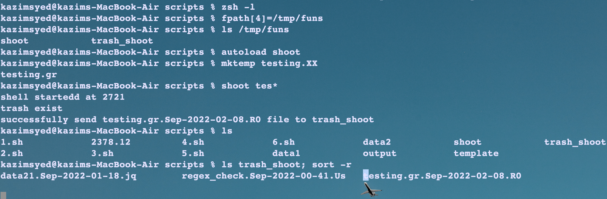Figure 3: How to use functions and autoload cmd

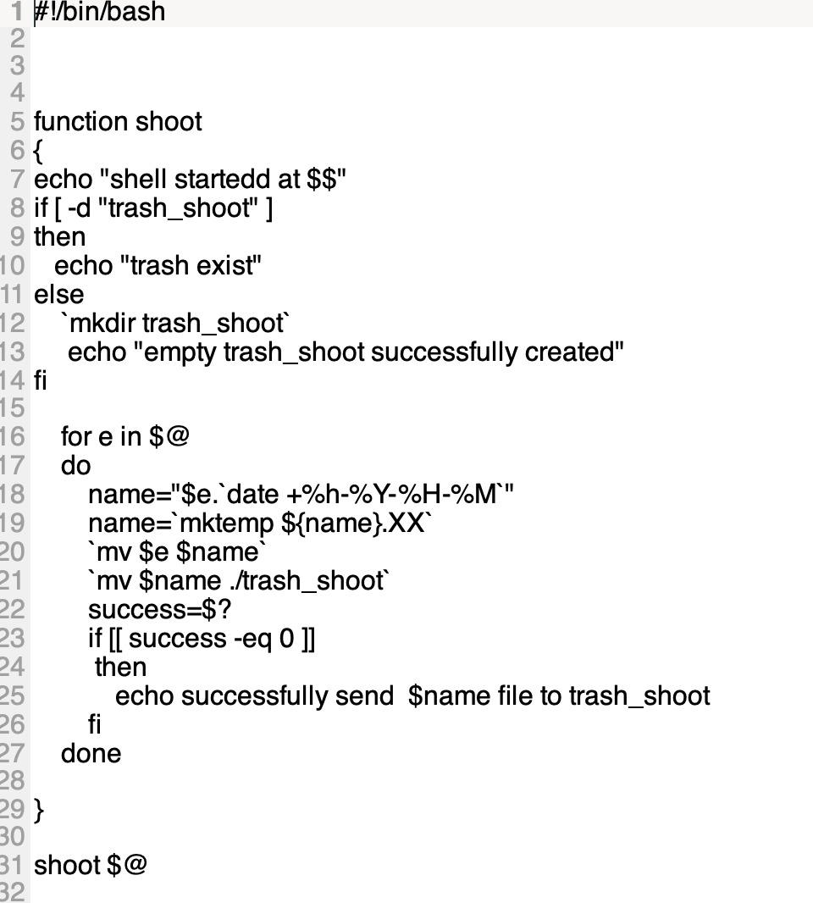

Another way:
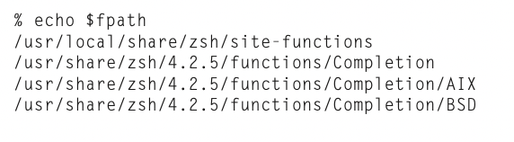

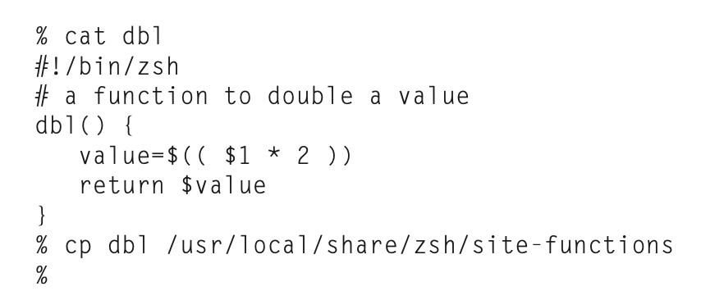Figure 4: this will make permanent by copying it to a directory.

Directory stacks:
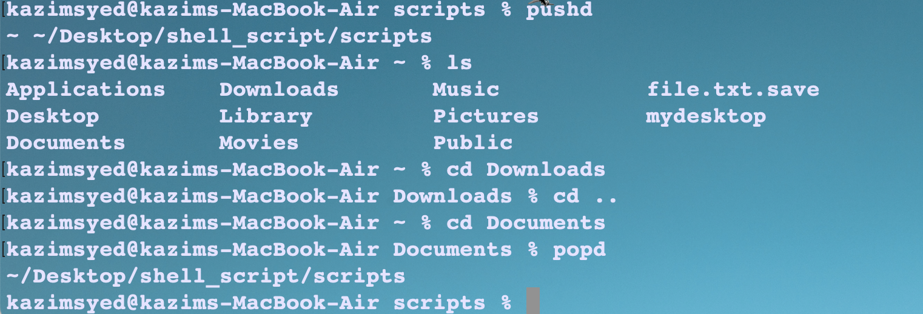Figure 5: Working of pushd and popd

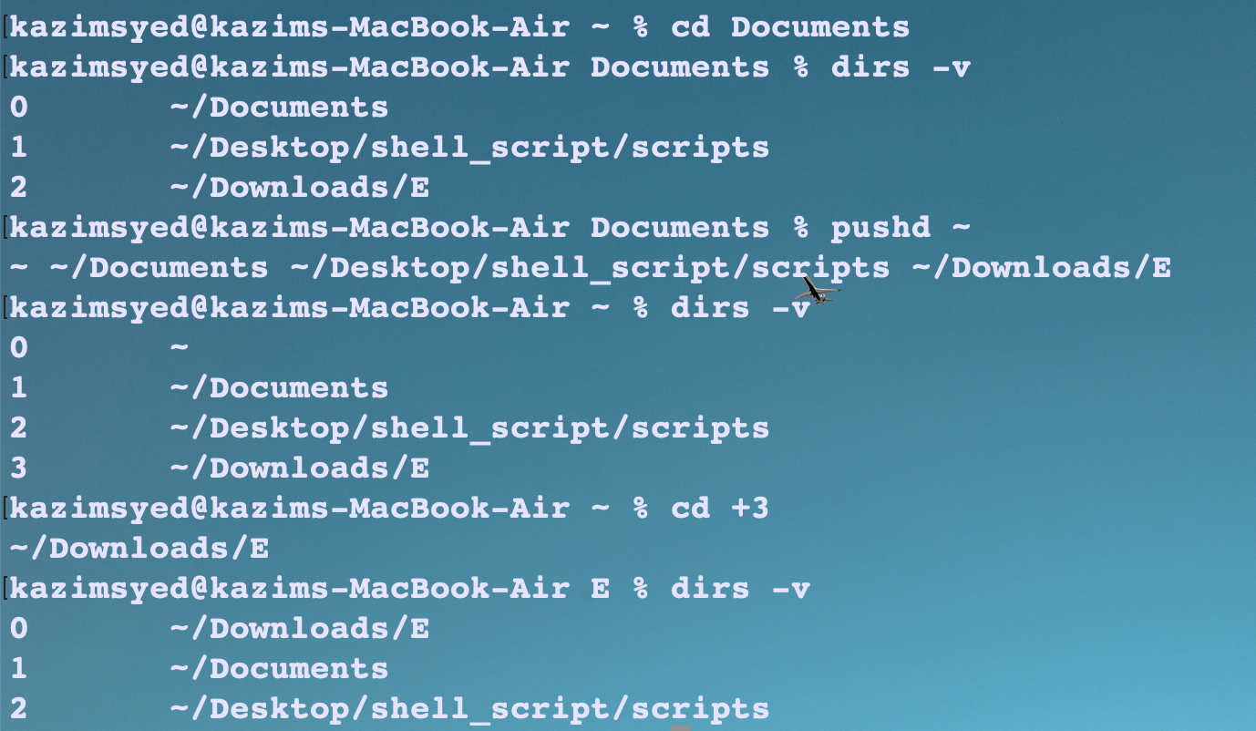Figure 6: instead of cd, we can use pushd, which will push the pwd and then cd to !:1

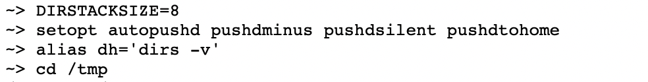
pushdminus not necessary.
Pushdsilent will not show the directory stack.
Autopushd will make cd to behave like pushd.

Directory stack works like this.

Present  0 | Modern  1 | Medieval  2 | Older  3 | Oldest  4

present is not included by pushd, while the rest are.
Use dirs -v cmd
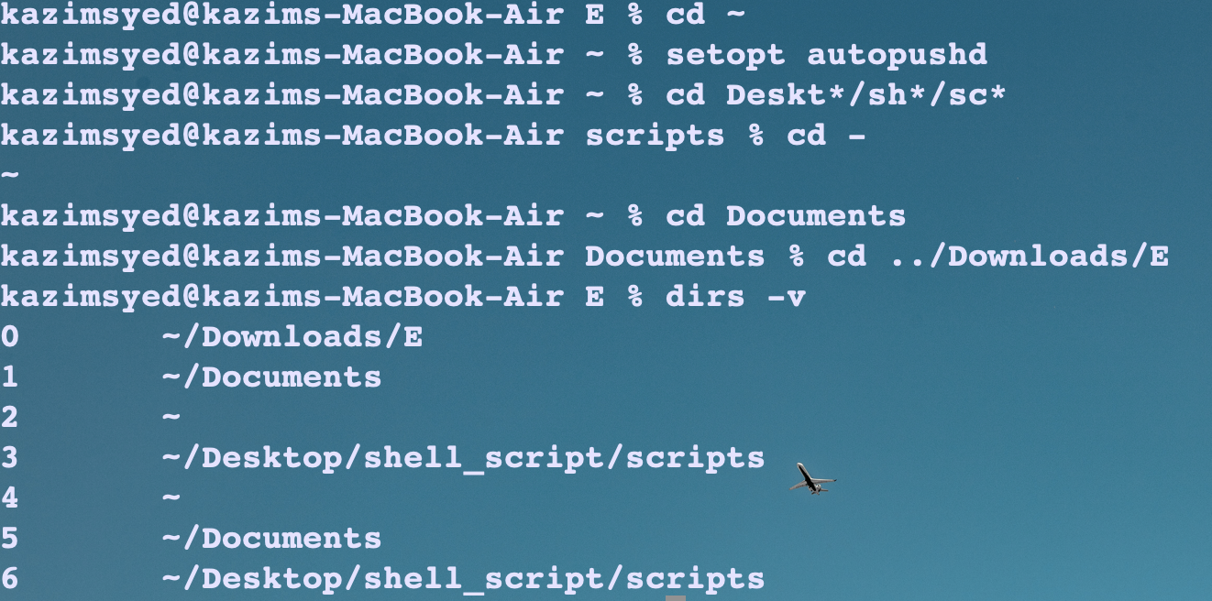Figure 7: setopt autopushd

Command substitution
Command substitution in zsh can take two forms. In the traditional form, a command enclosed in backquotes (`...`) is replaced on the command line with its output. This is the form used by the older shells. Newer shells (like zsh) also provide another form, $(...). This form is much easier to nest.
Old shell | ` ... ` | New shell | $(...)

--
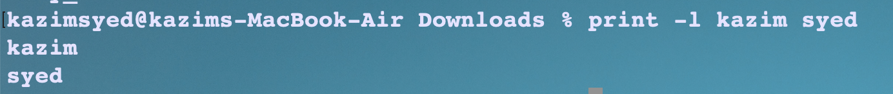Figure 8: print -l : prints its arguments one per line.
Figure 9: Use of grep -e command for search
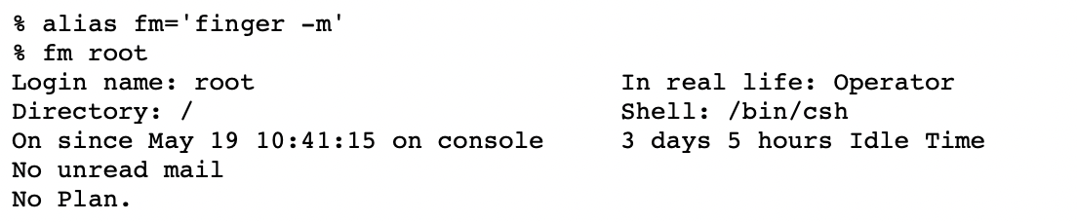

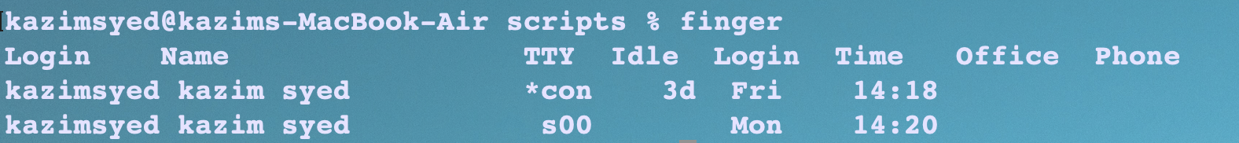

Table 1: use of remote command to learn about Remote users

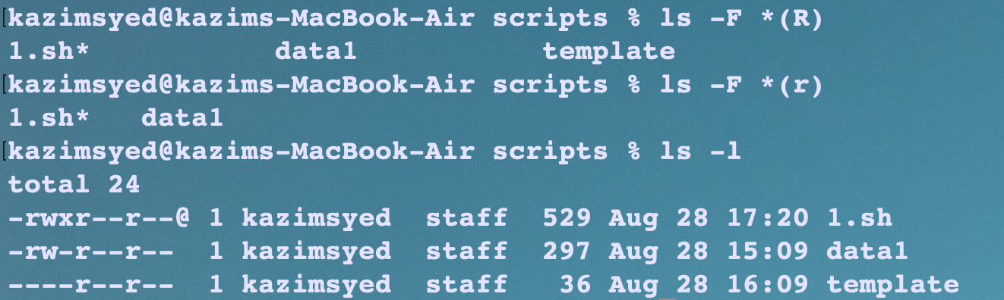Figure 10: *(r) readable by me
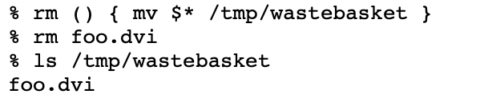Figure 11: Making rm safe by using a bit bucket

--

History:
typing fc will execute an editor on this command, allowing you to fix it. (The default editor is vi, by the way, not ed).

Binding
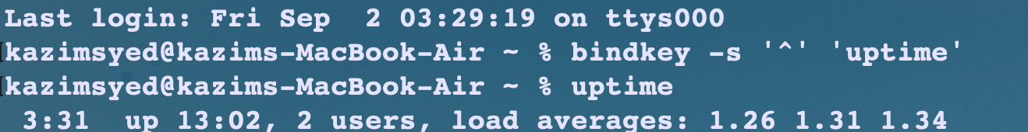Figure 12: creating shortcuts, I have used just caret instead of caret and T.
The -s flag to bindkey specifies that you are binding the key to a string, not a command. Thus bindkey -s '^T' 'uptime\n' lets you VMS lovers get the load average whenever you press ^T.
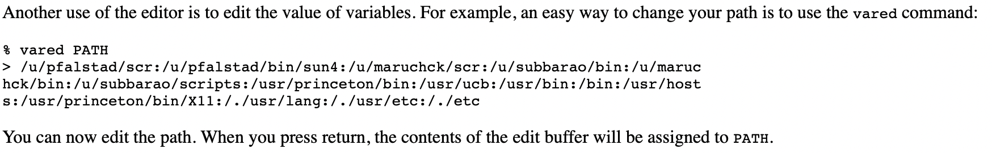Figure 13: Be cautius

Parameter substitution
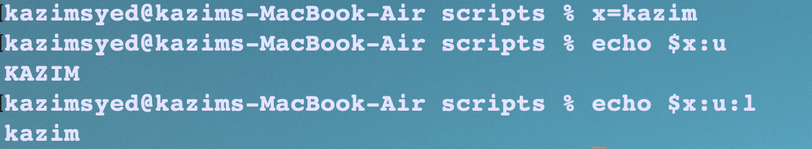

Shell parameter
In general, parameters with names in all lowercase are arrays; assignments to them take the form:
name=(elem ...)
Parameters with names in all uppercase are strings. If there is both an array and a string version of the same parameter, the string version is a colon-separated list, like PATH.
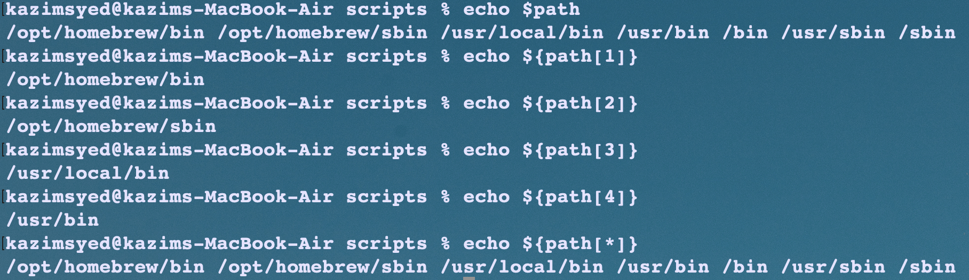

Prompting
Parameter | working | about
%m | hostname
%# | Stands for # or % | Depending on the shell whether its running a root user or not
%h | No of current history events | A number
%t | Clock | 12:00am/pm format
%w | Day and Date
%n | Name of the user
%~ | pwd(relative path)
%c | Absolute path

The POSTEDIT parameter is printed whenever the editor exits. This can be useful for termcap tricks. To highlight the prompt and command line while leaving command output unhighlighted, try this:
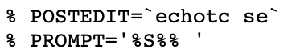
Usecase:
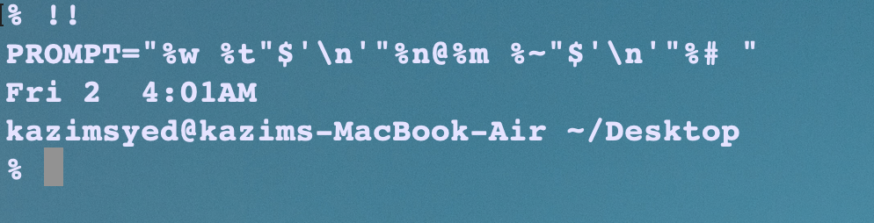

PROMPT="%w %t"$'\n'"%n@%m %~"$'\n'"%# "
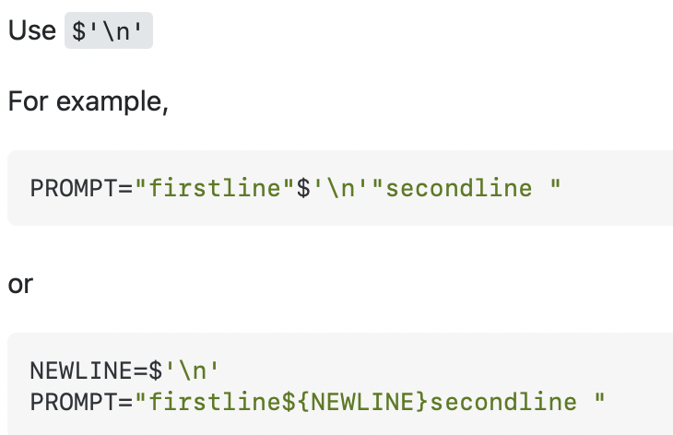
link:

Adding color:
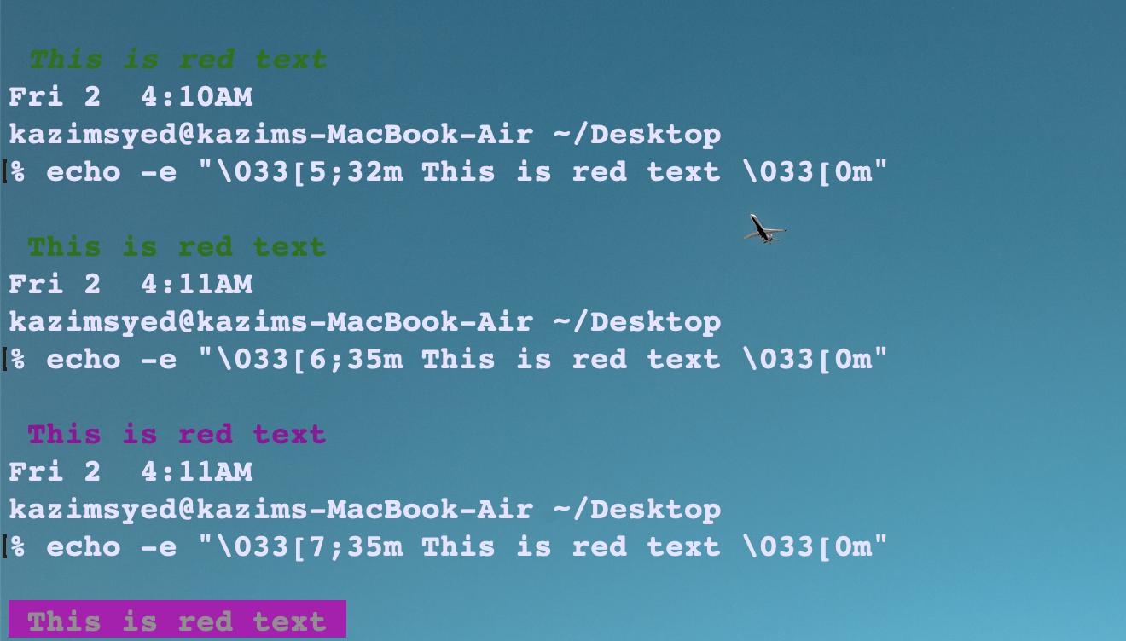

3: tells foreground e.g 35 tells magenta text
4: tells background
just 7: reverse foreground and background colors, blink fast, underline, bold,.. extra.

-----
"""
PS1="%{$fg[red]%}%n%{$reset_color%}@%{$fg[blue]%}%m %{$fg[yellow]%}%(5~|%-1~/.../%3~|%4~) %{$reset_color%}%% "

PROMPT=$"%{$fg[cyan]%}%w %t%{$reset_color%}"$'\n'"%{$fg[yellow]%}%n@%m%{$reset_color%} %~"$'\n'"%# "
"""

RPROMPT="%{$fg[cyan]%} %c %w%{$reset_color%}"
PROMPT="%{$fg[yellow]%}%n@%m%{$reset_color%} %~"$'\n'"%#"
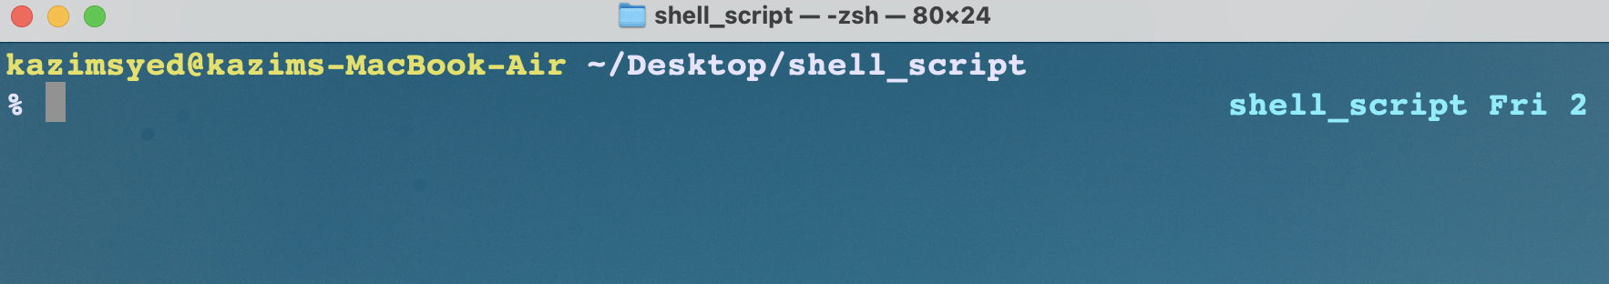

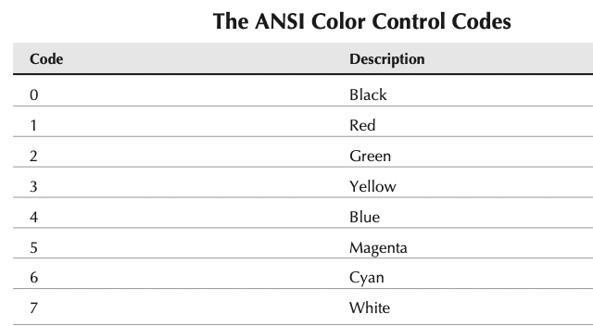

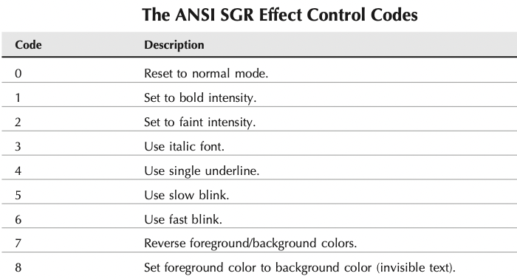

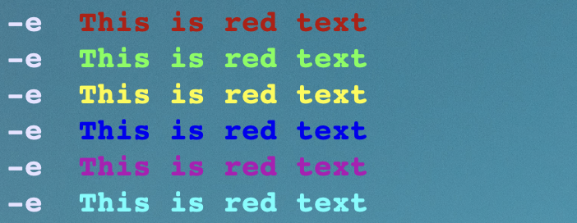

Login / Logout watching


