Learning One note
Video: How to Use One Note effectively
Video: 5 Tips to unlock the power of OneNote

How to use One Note effectively (1/2):

Hierarchy in One note:
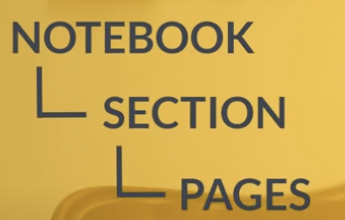Figure 1: Hierarchy

The instructor use sections for different things like brainstorming, research, scripting.
She has a notebook for private things like ideas, shopping, vacation and so on.
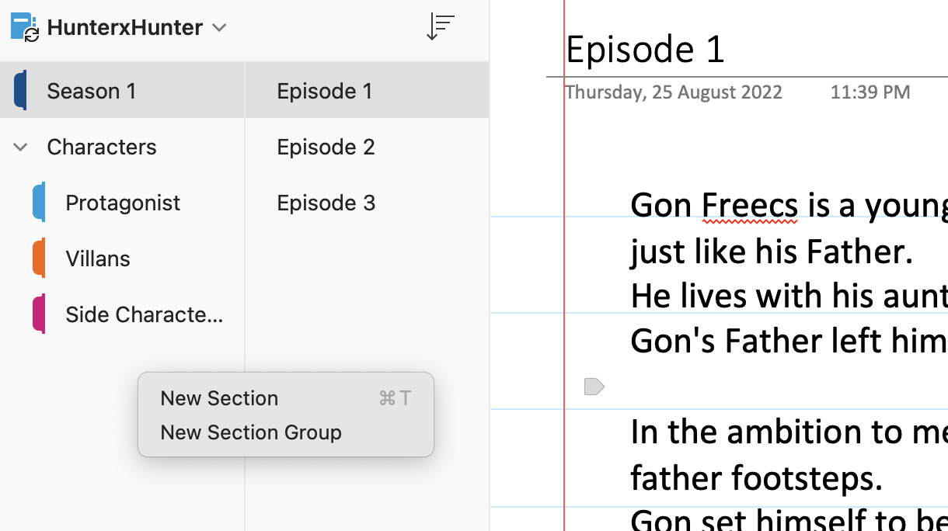Figure 2: Idea of Section Groups

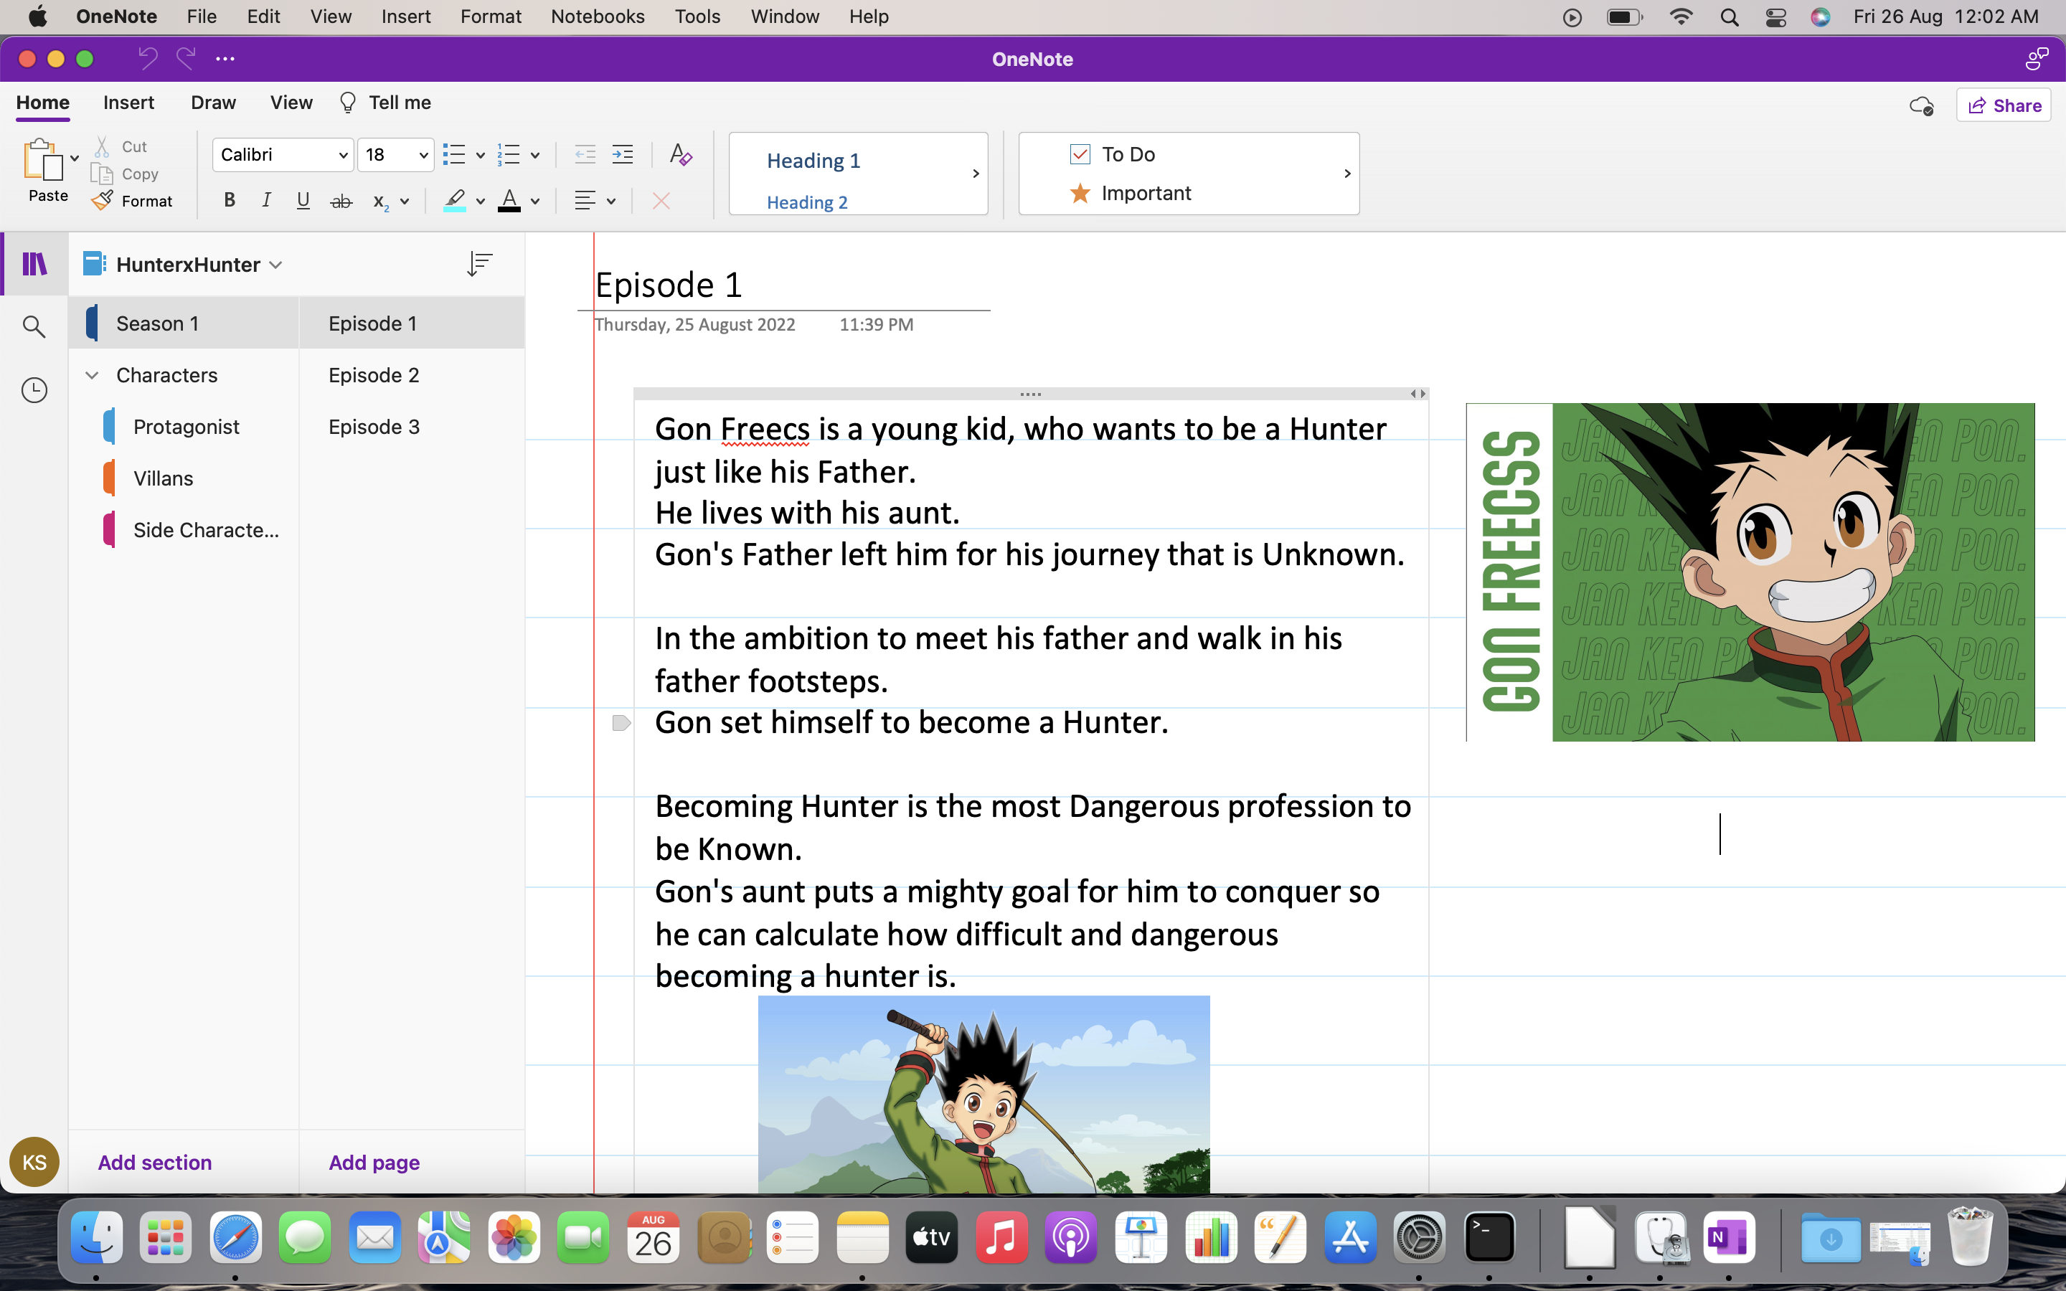
Another level we have is Sub pages.
To use subpages, you need to have atleast two pages in a specific section.
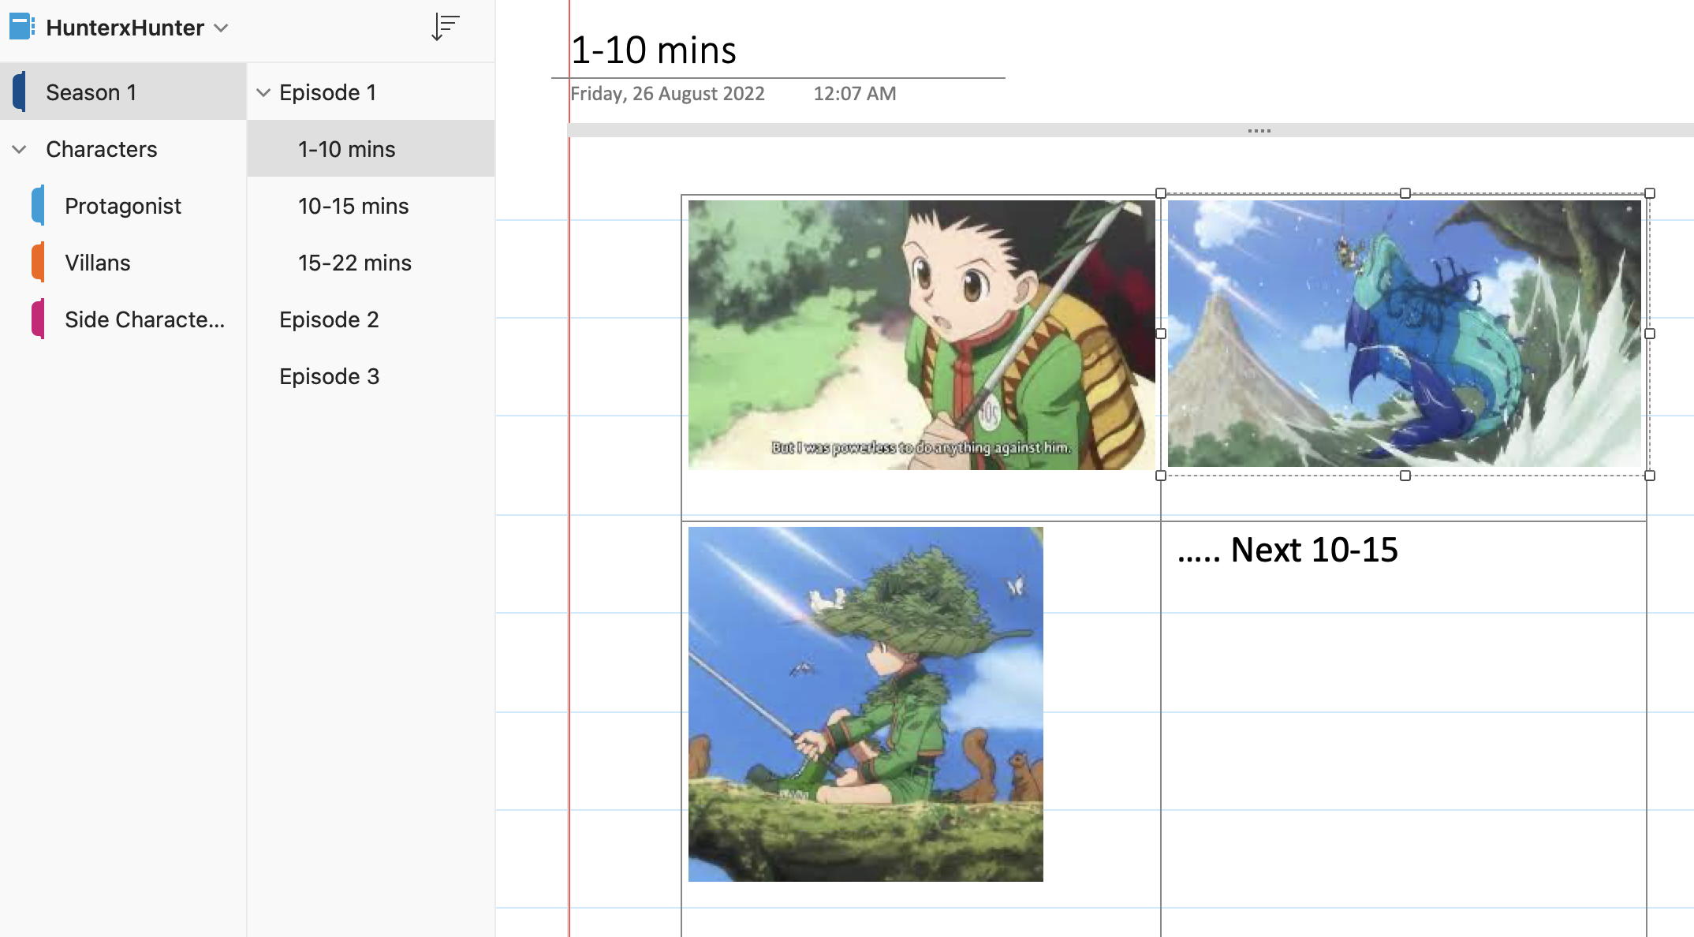
You can make a subpage.
{You right click on the below page to make it a subpage of the page above}*.

2. Use tags to find what you need


{Tags are great way to categorize and group notes together that aren’t in the same notebook or section}*.
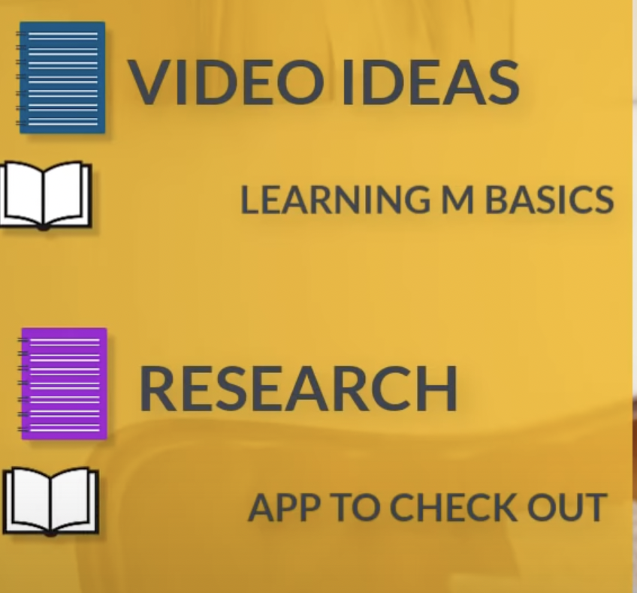
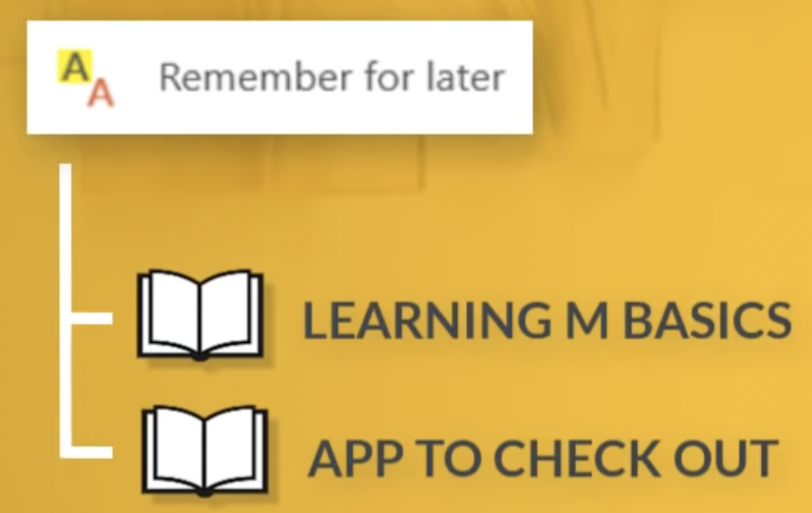

e.g.
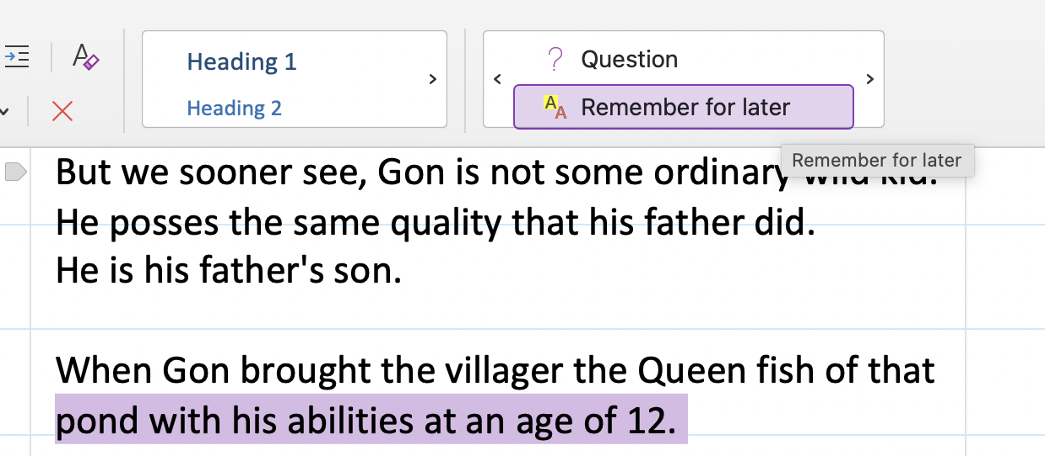Figure 3: Placing Remember for later tag

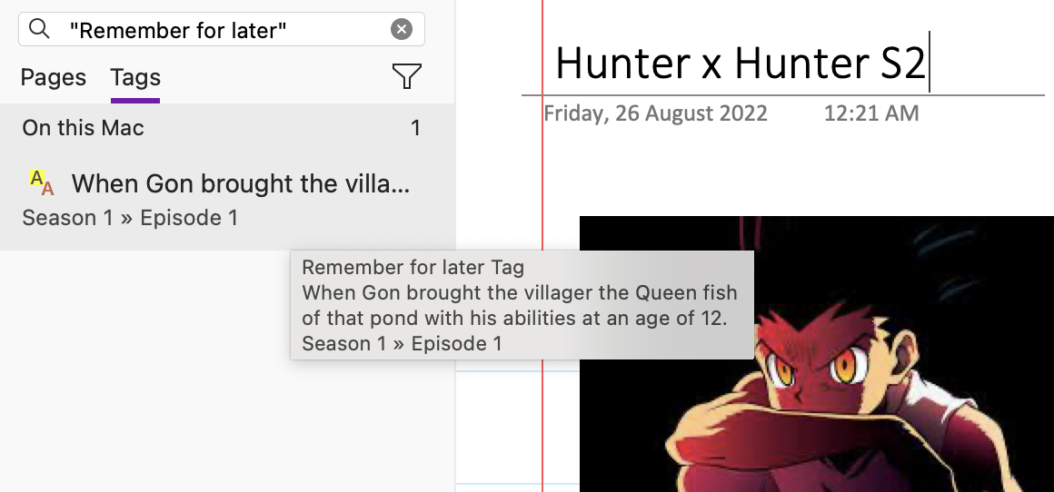Figure 4: Using Remember for later tag in Season 2 Section for
Hunter x Hunter

Gon is now 13 yrs old in season 2 hunter x hunter.
---

Tip-1: You can filter search if u like.
Consider another Notebook: House of Dragon.
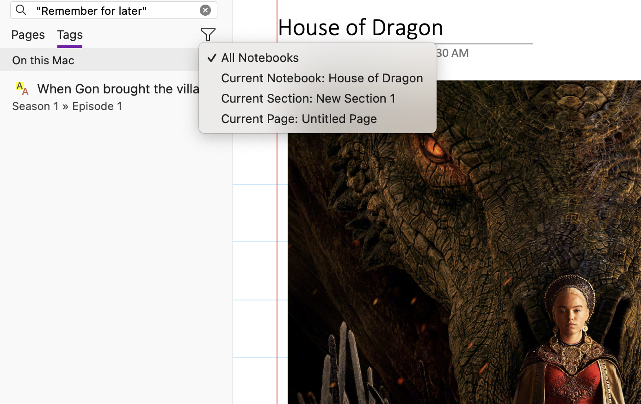Figure 5: You can access "Tags" outside of ur current notebook and you can filter that if u dont want

Tip-2: You can create your own tags
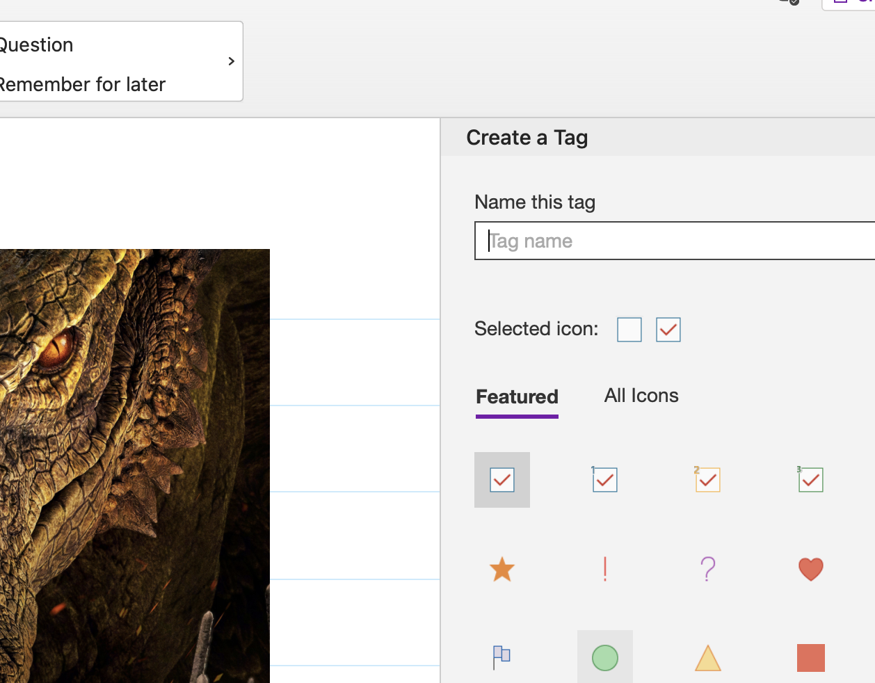Figure 6: Create your Own tags

Tip-3: Use of tags
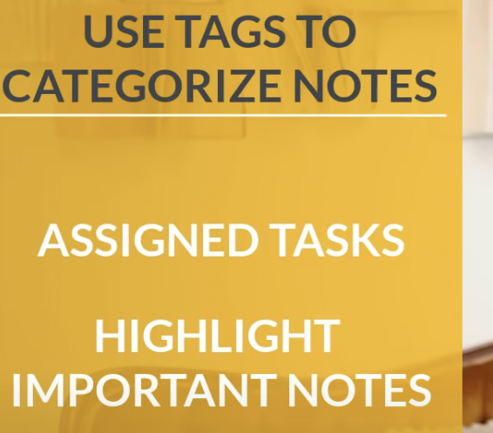

3. Extract text from Images
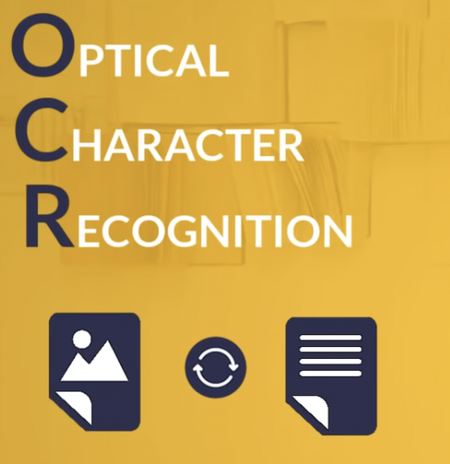

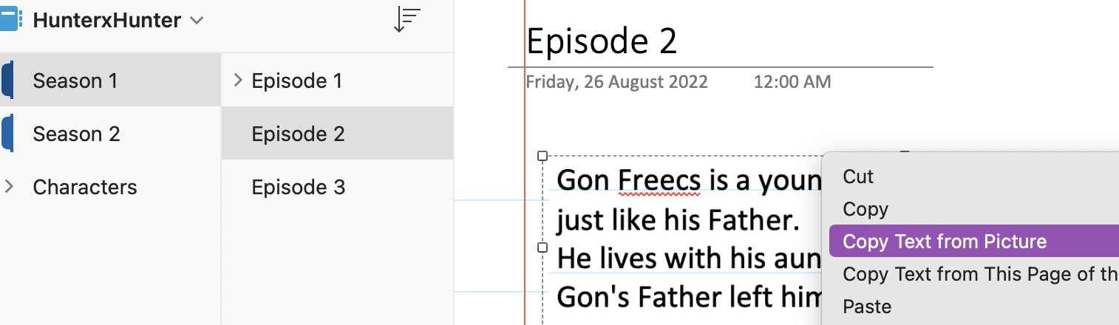Figure 7: Copy text from picture

Tip: You can search for text in images
Figure 8: Tip 2 is GREAT

Small other things (Draw):
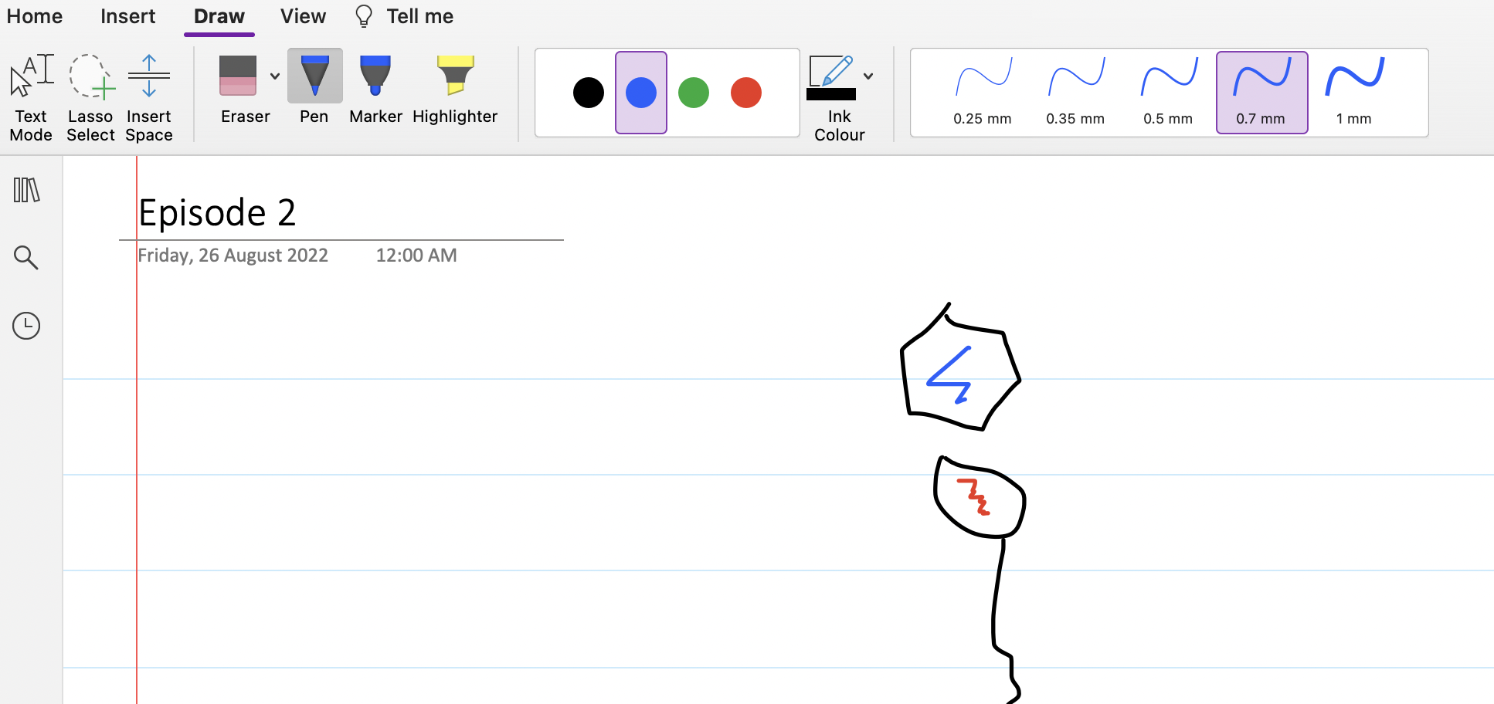
You can use Insert space which does
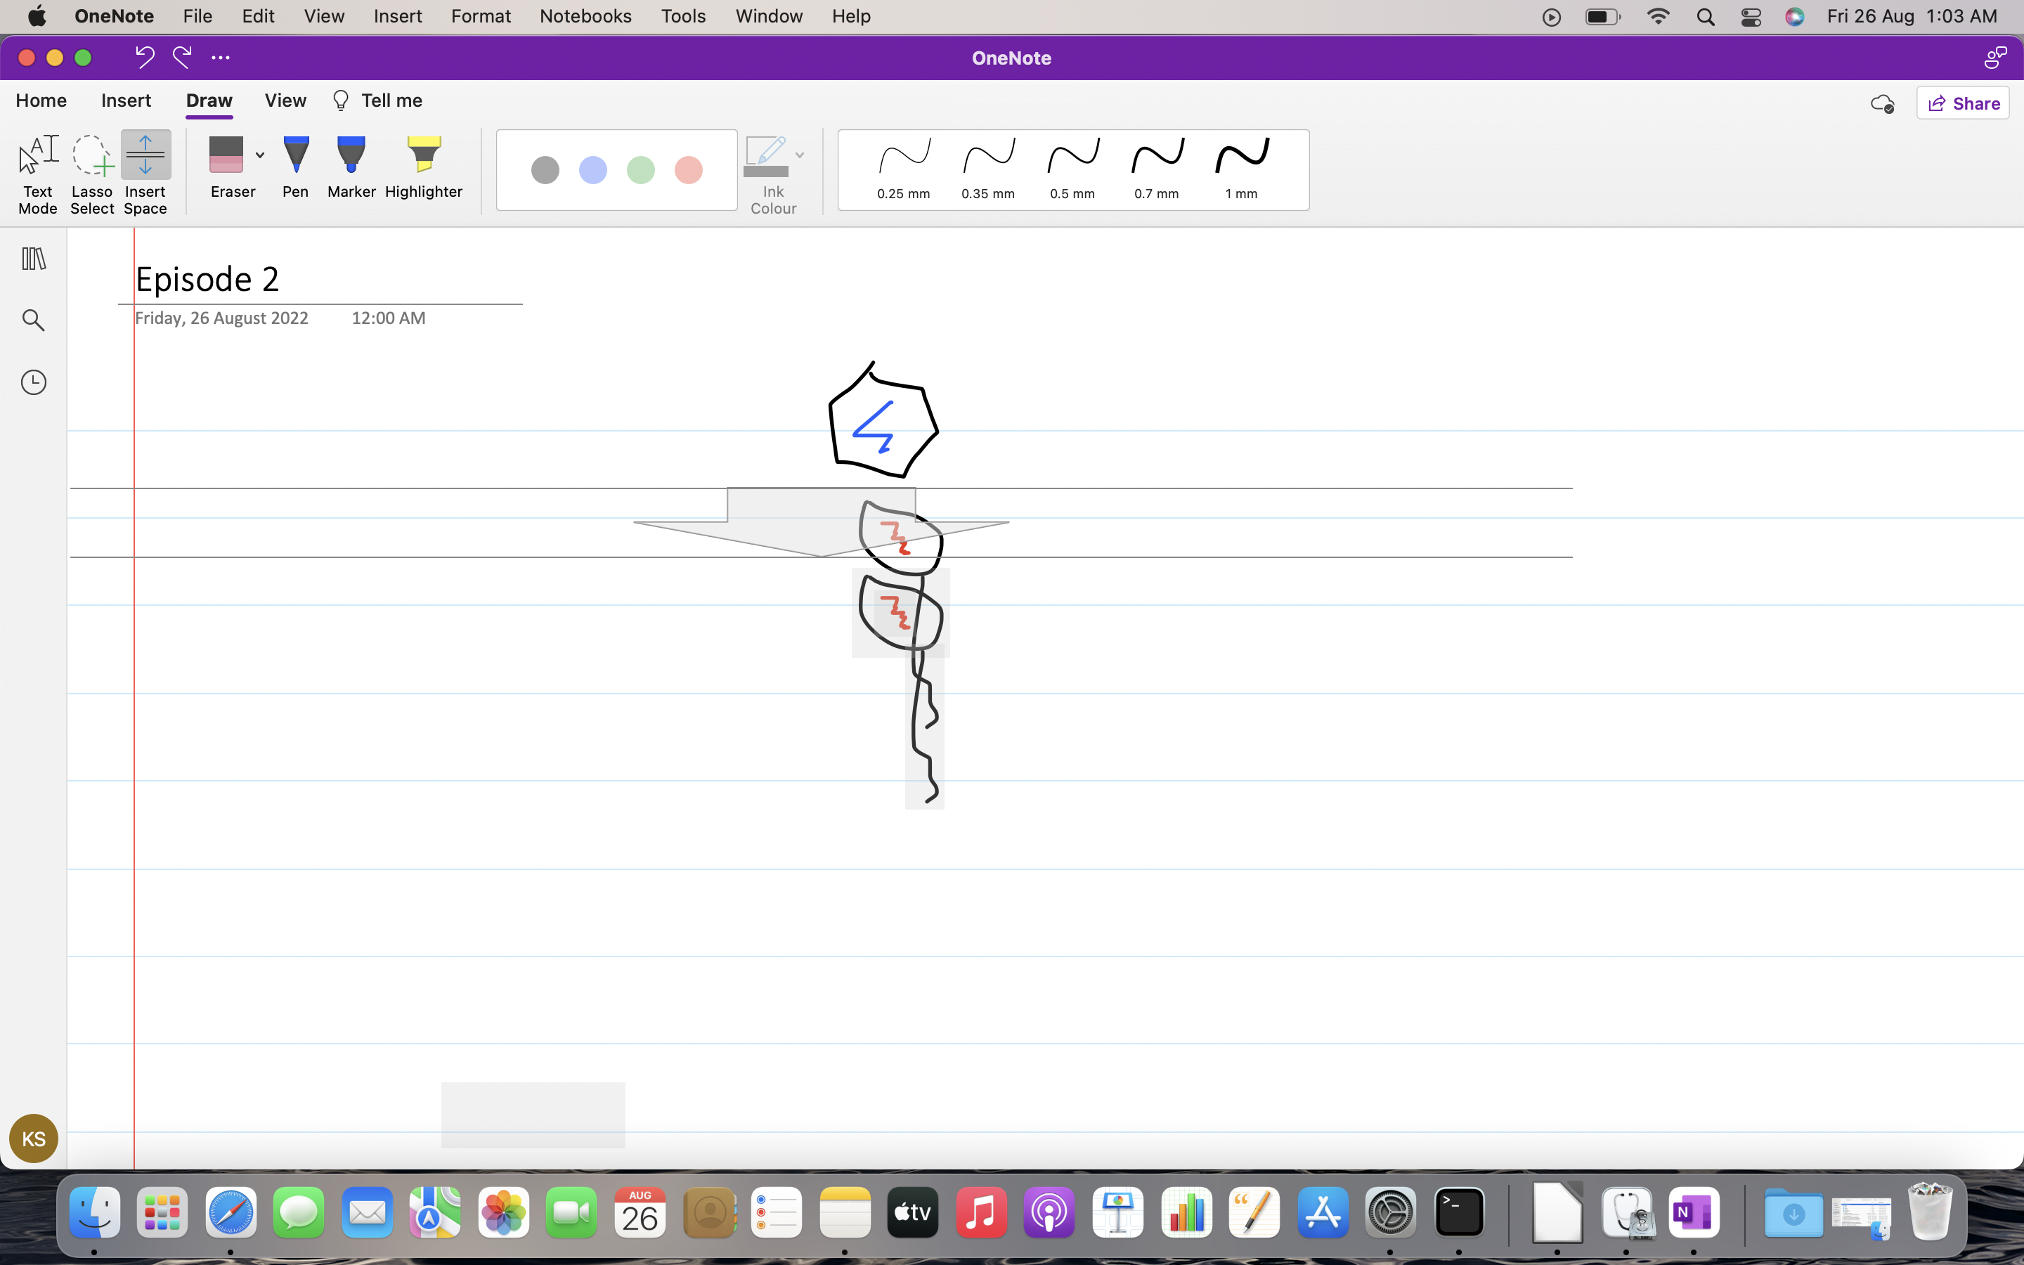

One note also has
ink to shape: meaning clicking on “ink to shape” button will convert it into straight edges hexagon.
It also work with your hand writing. Try it on Samsung tablet.
You also have maths which is not available in mac.

5 tips to unlock the power of One Note (2/2)

1. Protect your notes
You lock your personal info inside a section.
Figure 9: Password Protect

2. Share your notes, just like Google docs in Ms teams.
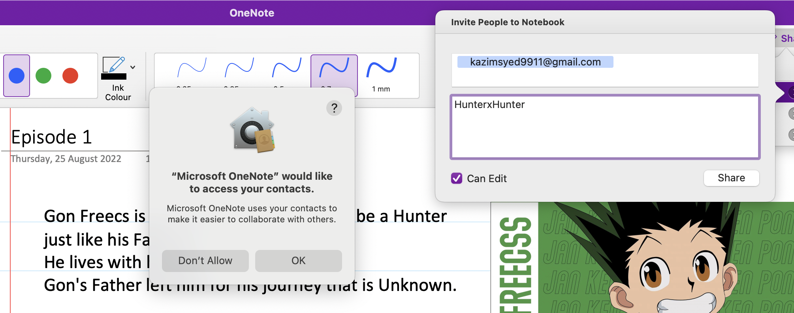
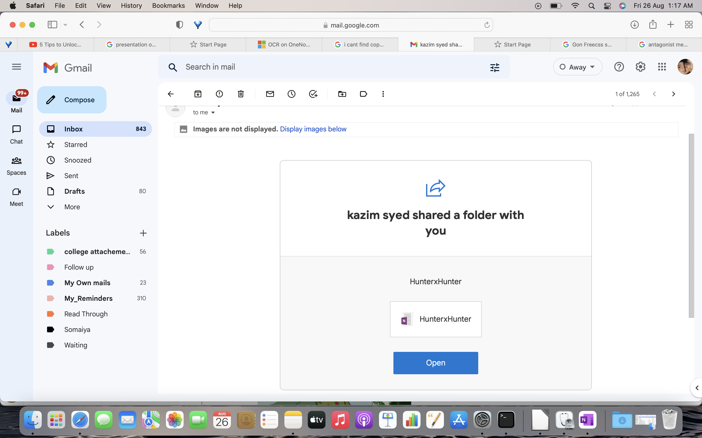Figure 10: Suprisingly easy share.

Tip: You can also have a group who you can specifically grant exclusive access to.
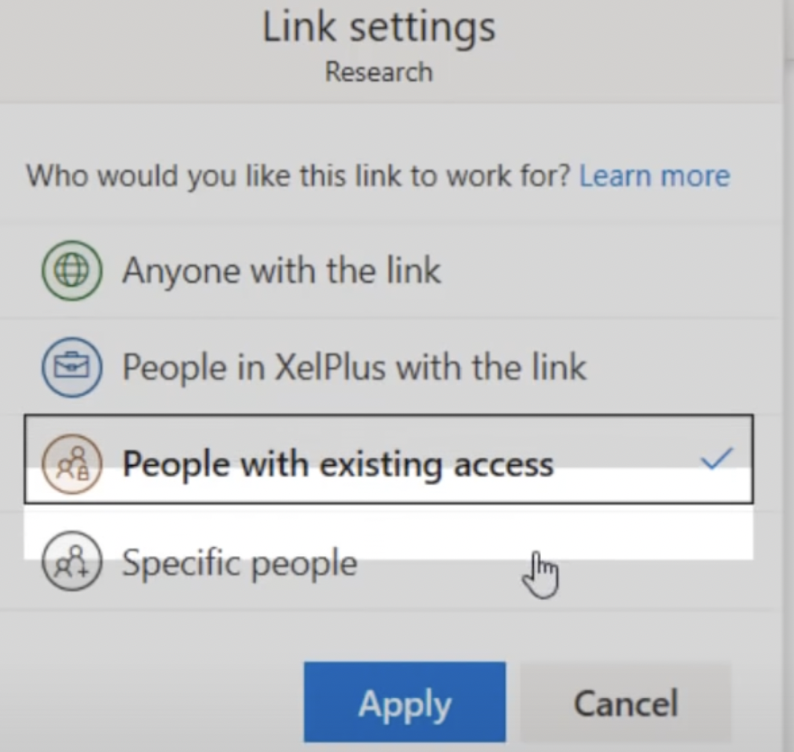Figure 11: The instructor has XelPlus Group

3. You can use One Note web clipper.
It is available for Chrome, edge, Fireforx as of rn.
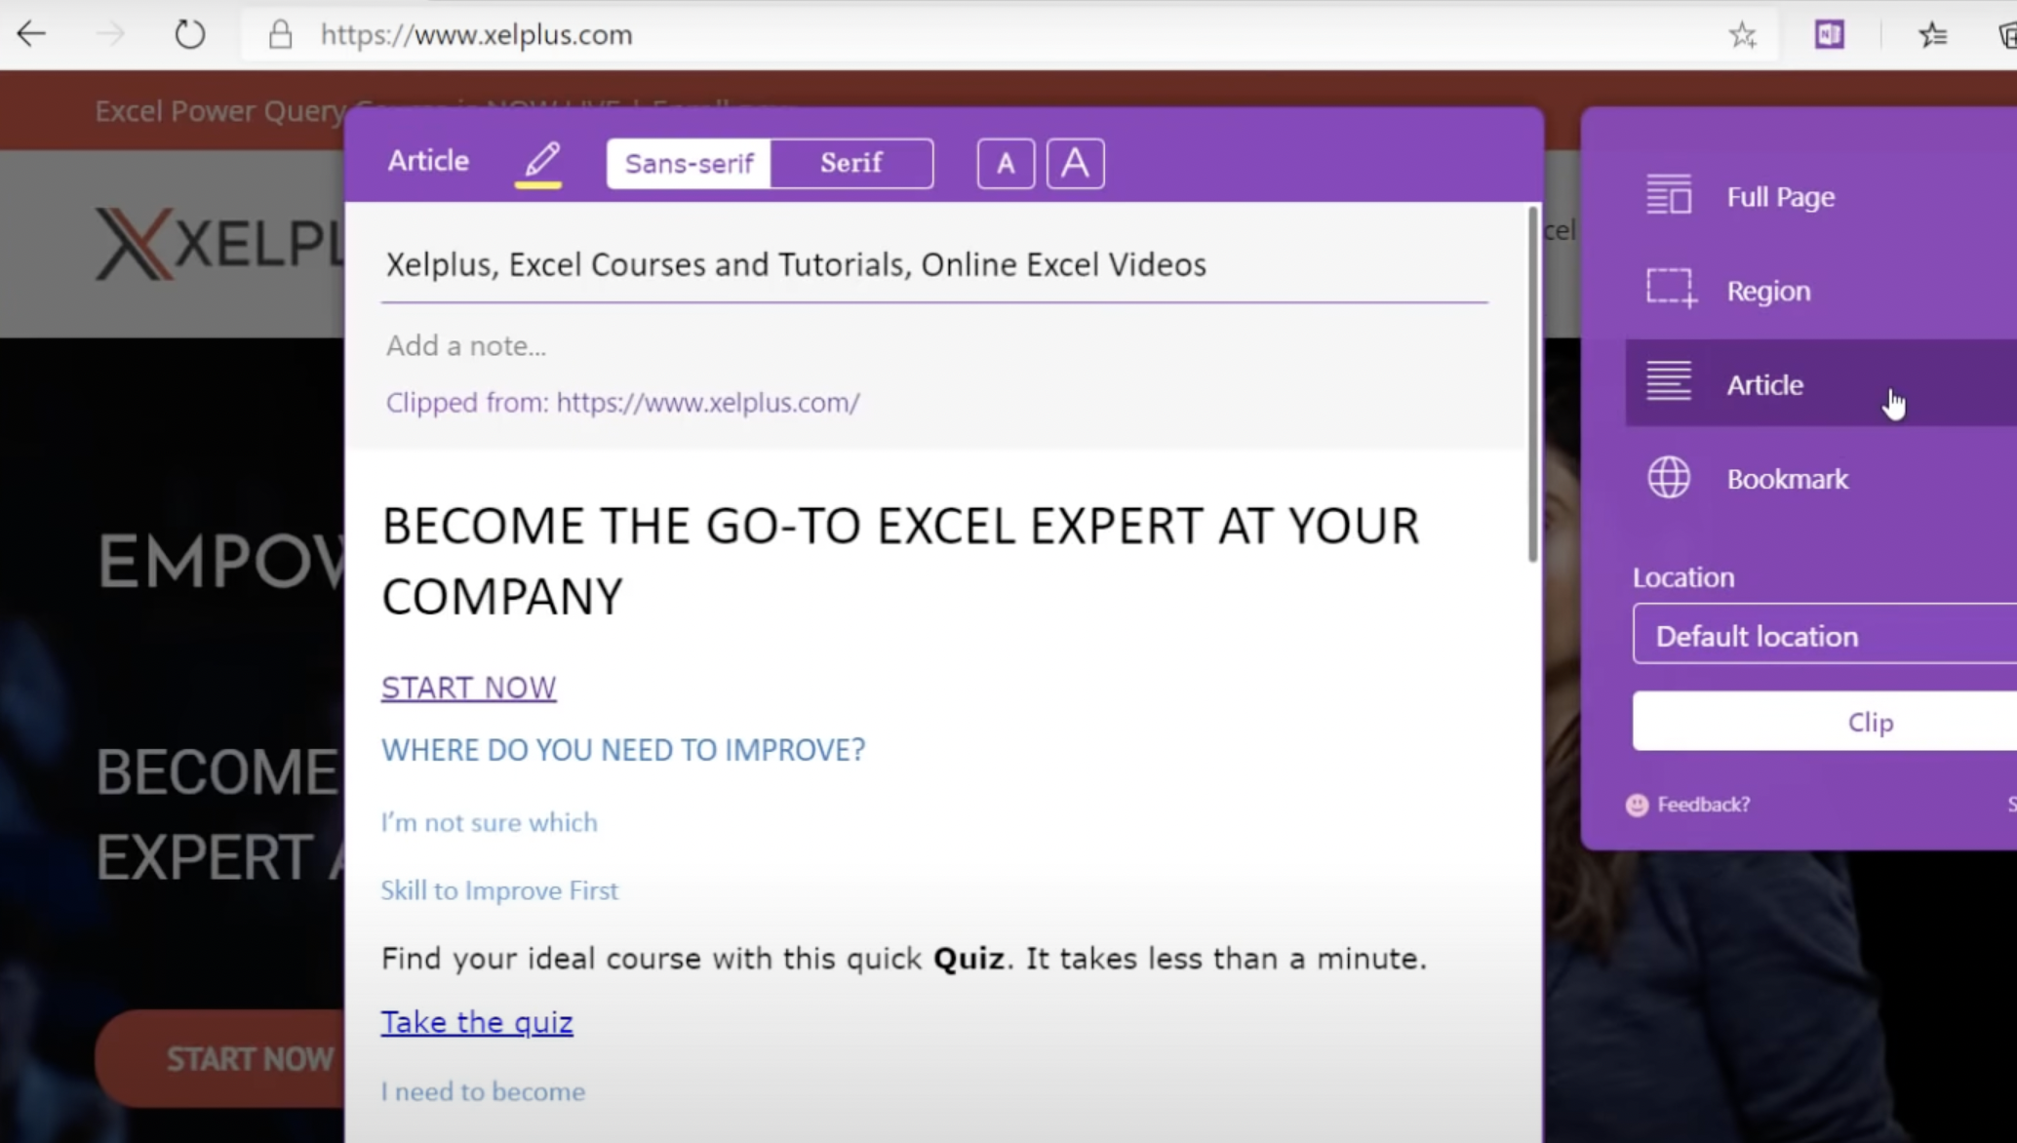Figure 12: clipping the web or entire page in this case.

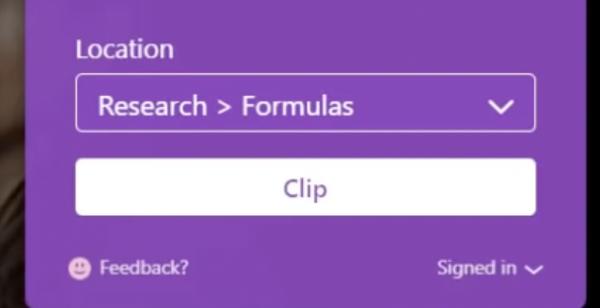Figure 13: You can have this info easily put into your desired notebook.

#Very Useful.

4. Hyper link Your notes
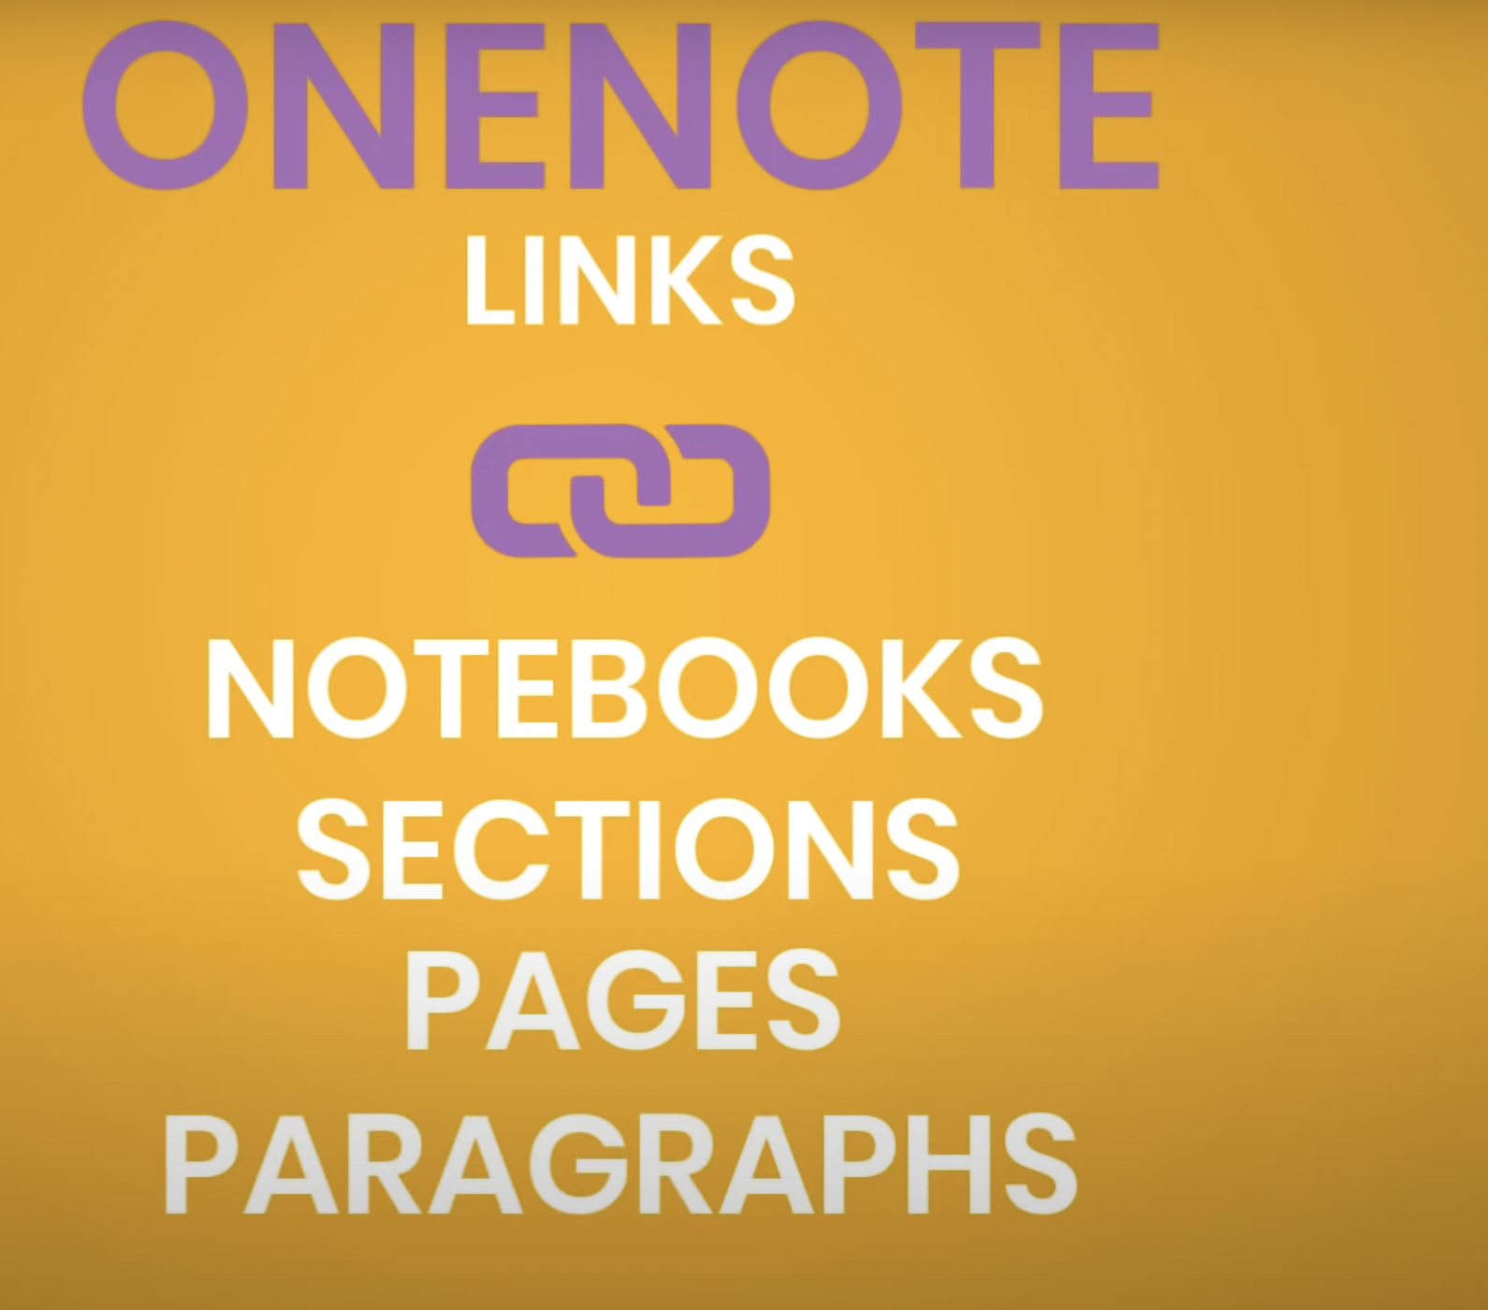

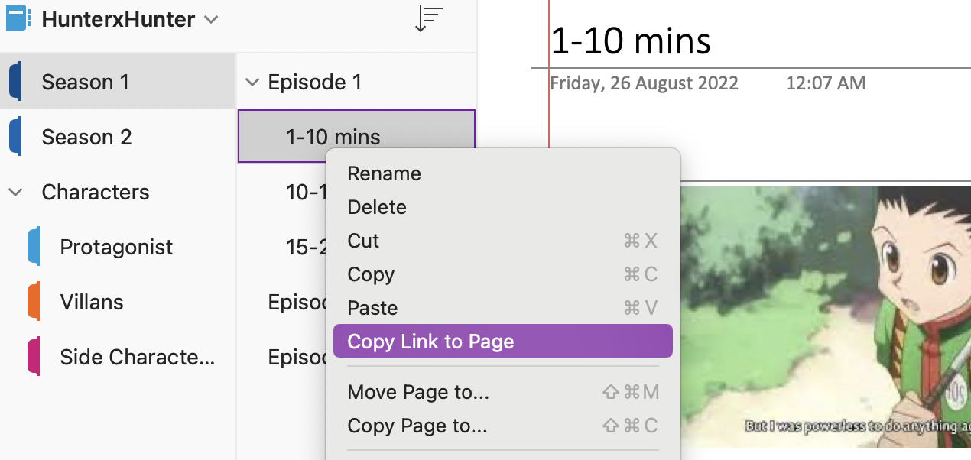Figure 14: As simple as using the right click functionality

Tip:
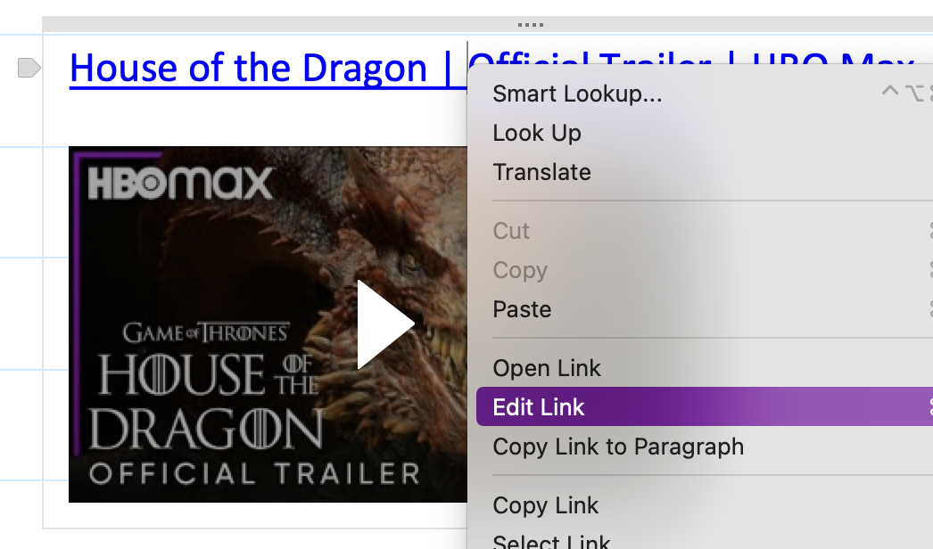Figure 15: You can use some label instead of link
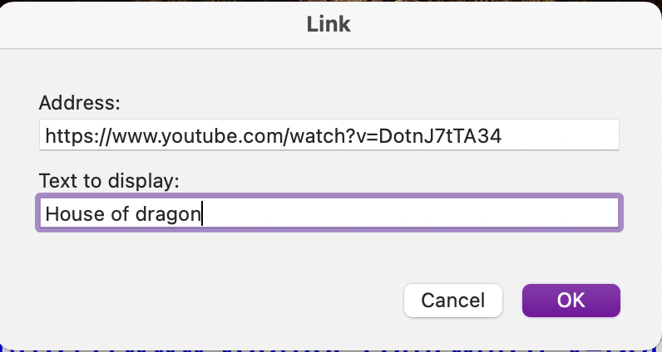Figure 16: that's how

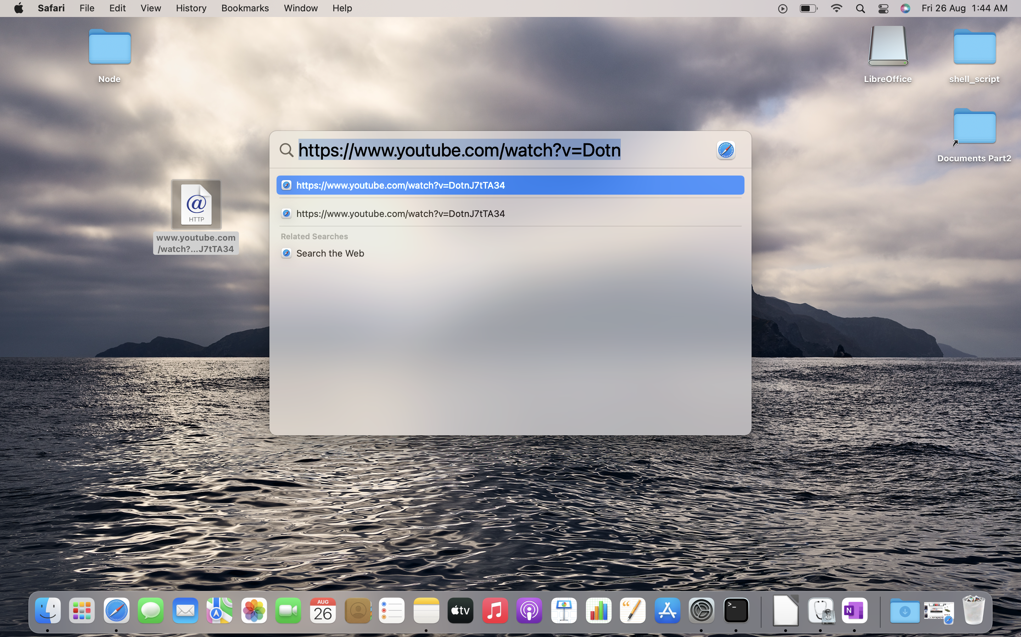Figure 17: This way you can have a shortcut on ur desktop screen.

You can rename it too.


5. Meeting Details:

You can summarize the outcome, hold people accountable.
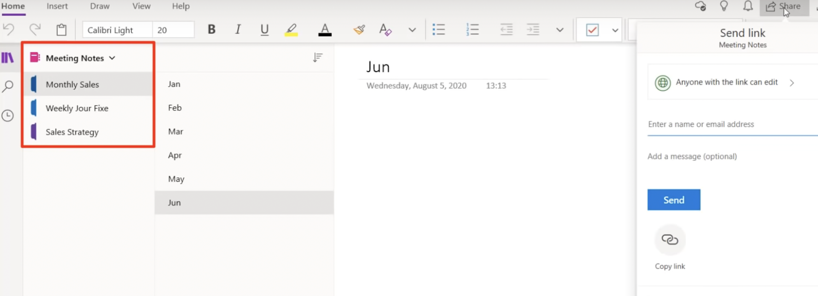
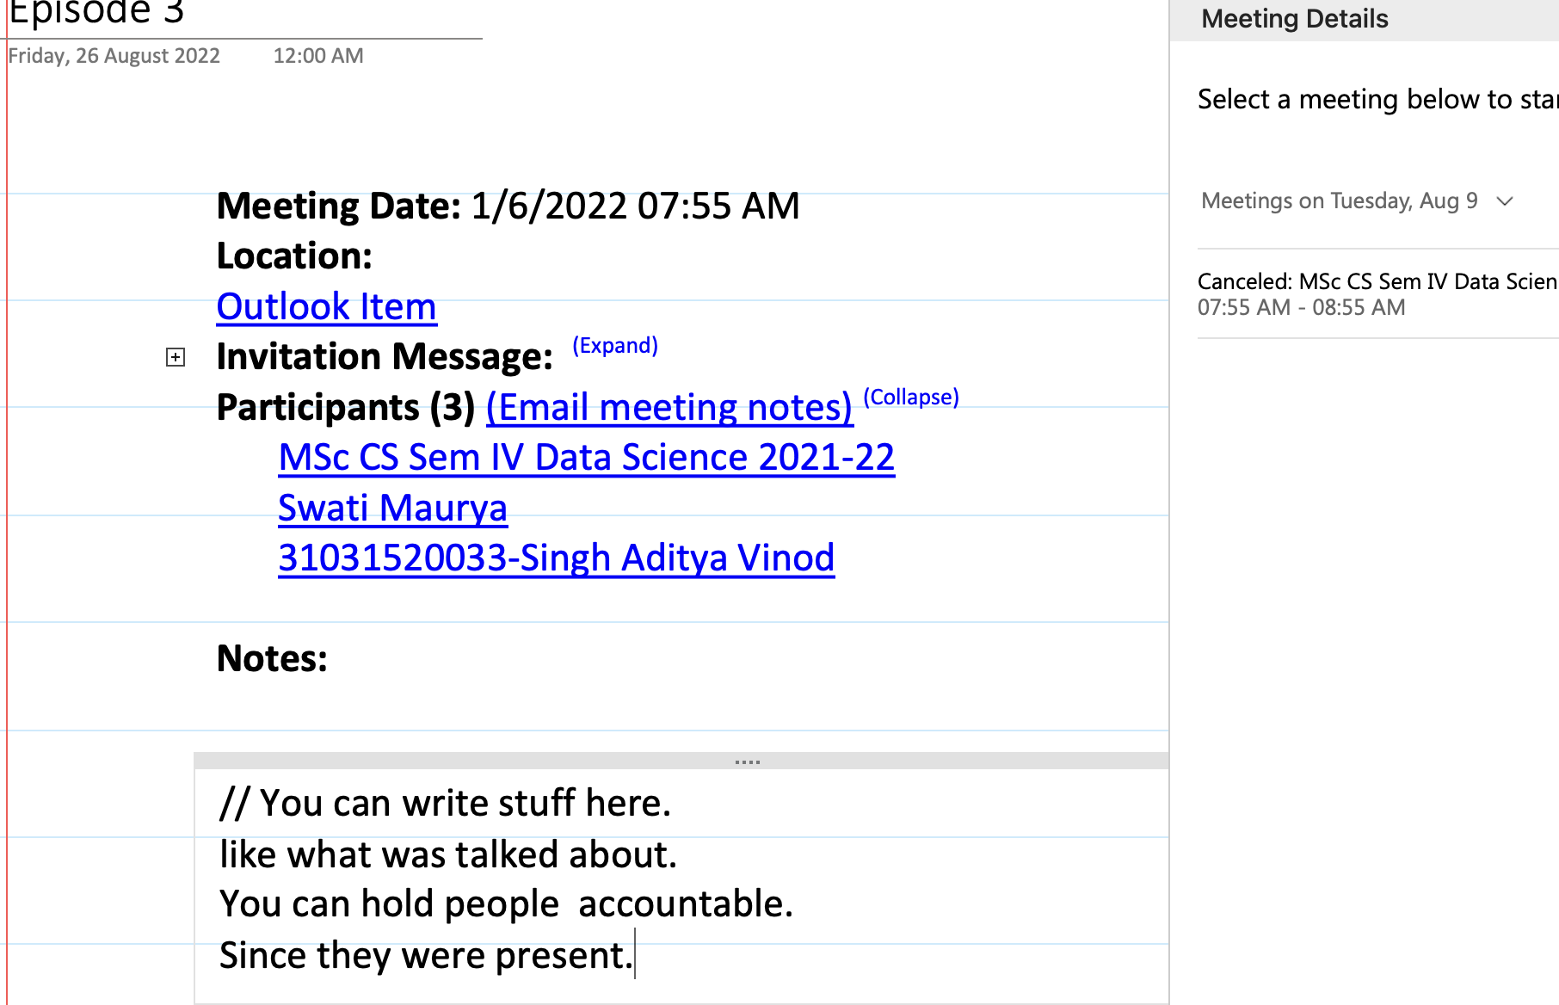

Usecase:
Also you can immediately distribute the notes to the participants.
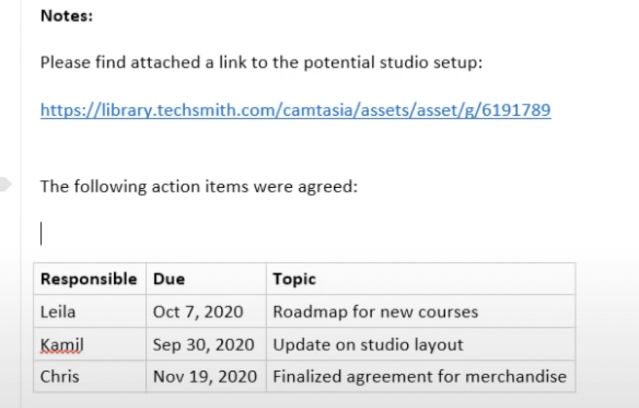Figure 18: You can assign action items to people.
Just click on Email meeting notes.
KNOW THAT: The receipent must have access to your notebook that u sharing.

