Predicting Port Congestion and Ship Delays
Will this ship wait more than 24 hours for a berth, how sure are we, and why?
[Your name] · Aiqon AI Internship assignment · October 2026

1. Problem statement
Ships queue for berths. When all of a port's berths are busy, arriving ships wait at anchor, and that wait is expensive: the ship sits idle, the cargo arrives late, and trucks and warehouses booked for it go unused. This happens at busy ports everywhere, and without a forecast a long wait usually becomes clear only when it is too late to re-plan.
The task: for every arriving ship, predict the likelihood of delay, give a confidence score, and explain the key factors, early enough for planners to act.

2. Our approach
We built a system that predicts whether a cargo ship arriving at a Brazilian port will wait more than 24 hours before it gets a berth. For every ship it gives four things: the chance of a delay, a confidence score, the expected wait in hours with a likely range, and the main reasons in plain words. It can predict when the ship arrives, or 3 days earlier, while there is still time to act.
It is trained on 85,606 real port calls at Brazil's 15 busiest ports (2020–2024) from ANTAQ, the national waterway regulator, plus daily weather at each port (rainfall, maximum wind speed and wind gusts) from the free Open-Meteo historical weather archive.
A demo app shows each prediction on a 3D view of the port, explains it, and lets a planner test "what if" changes such as more ships arriving or a berth closing.
What the system answers. For a cargo ship arriving at one of Brazil's 15 busiest ports, it answers four questions:
1. Will it be delayed? A ship is delayed if it waits more than 24 hours between arriving at the port and getting a berth. A one-day slip is where plans for trucks, warehouse slots and deliveries usually break. The cut-off is a setting and can be changed.
2. How sure are we? A confidence score: how likely the yes/no answer is to be right.
3. Why? The main causes in plain words: a long line of ships, busy berths, a terminal that has been slow lately, the ship's own track record, and so on.
4. For how long? The expected wait in hours, with a range the real wait falls inside 80% of the time.
When it answers. At two moments, using only what is known at that time:
Moment | Who uses it | What they can do
When the ship arrives | Port and landside planners | Plan berths, trucks and warehouse slots
3 days before | The ship operator | Slow down to save fuel, warn the customer, or consider another port

How well it works. Tested on all 17,417 arrivals of 2024, a year the system never saw while it was being built:
Measure | When the ship arrives | 3 days before | What it means, in one line
Accuracy | 78.7% | 75.1% | Out of 100 ships, about 79 get the right yes/no answer ("delayed" or "on time").
Delays caught | 94.8% | 93.8% | Out of 100 ships that really waited more than 24 hours, the alarm went off for about 95.
ROC-AUC | 0.873 | 0.836 | Pick one delayed and one on-time ship at random: 87 times out of 100 the delayed one gets the higher risk.
Typical hours error | 17.6 h | 20.2 h | Half of all wait estimates are within about 18 hours of the real wait.

3. System architecture
The system is built on four LightGBM models. All four models use the same 108 features and are retrained on the 1st of every month on every port call whose outcome is already known by that day.
1. Main model: LightGBM classifier (the delay model). Answers "will this ship wait more than 24 hours?" It outputs p, the chance of a delay between 0% and 100%. It uses 1,269 trees for the at-arrival prediction (773 for 3 days before), each with up to 63 leaves, added with a small learning rate (0.01) so that each tree only makes a small correction. The number of trees was set by early stopping on held-out data. From p come the yes/no answer (delayed if p ≥ 23%), the confidence score (max(p, 1 − p)), and the reasons (each feature's share of p, from TreeSHAP).
2–4. Range models: three LightGBM models for the waiting time. These answer "how long will it wait?" Instead of one single guess, each of the three models estimates one bound of the wait:
- Lower-bound model: estimates the shortest likely wait. Only 1 ship in 10 waits less than this.
- Expected-wait model: estimates the middle wait. This is the expected wait shown to the planner.
- Upper-bound model: estimates the longest likely wait. Only 1 ship in 10 waits longer than this.
The lower and upper bounds together give the expected waiting range, for example "expected wait 27 hours, likely between 4 hours and 3 days". We widen this range slightly so that the real wait falls inside it 80% of the time; on 2024 it did so for 79.8% of ships.

4. The system in use
Both figures show one real case: a container ship arriving at the TCP terminal in Paranaguá on 1 January 2024. The system gave a 55% chance of delay; the ship really waited 46 hours.
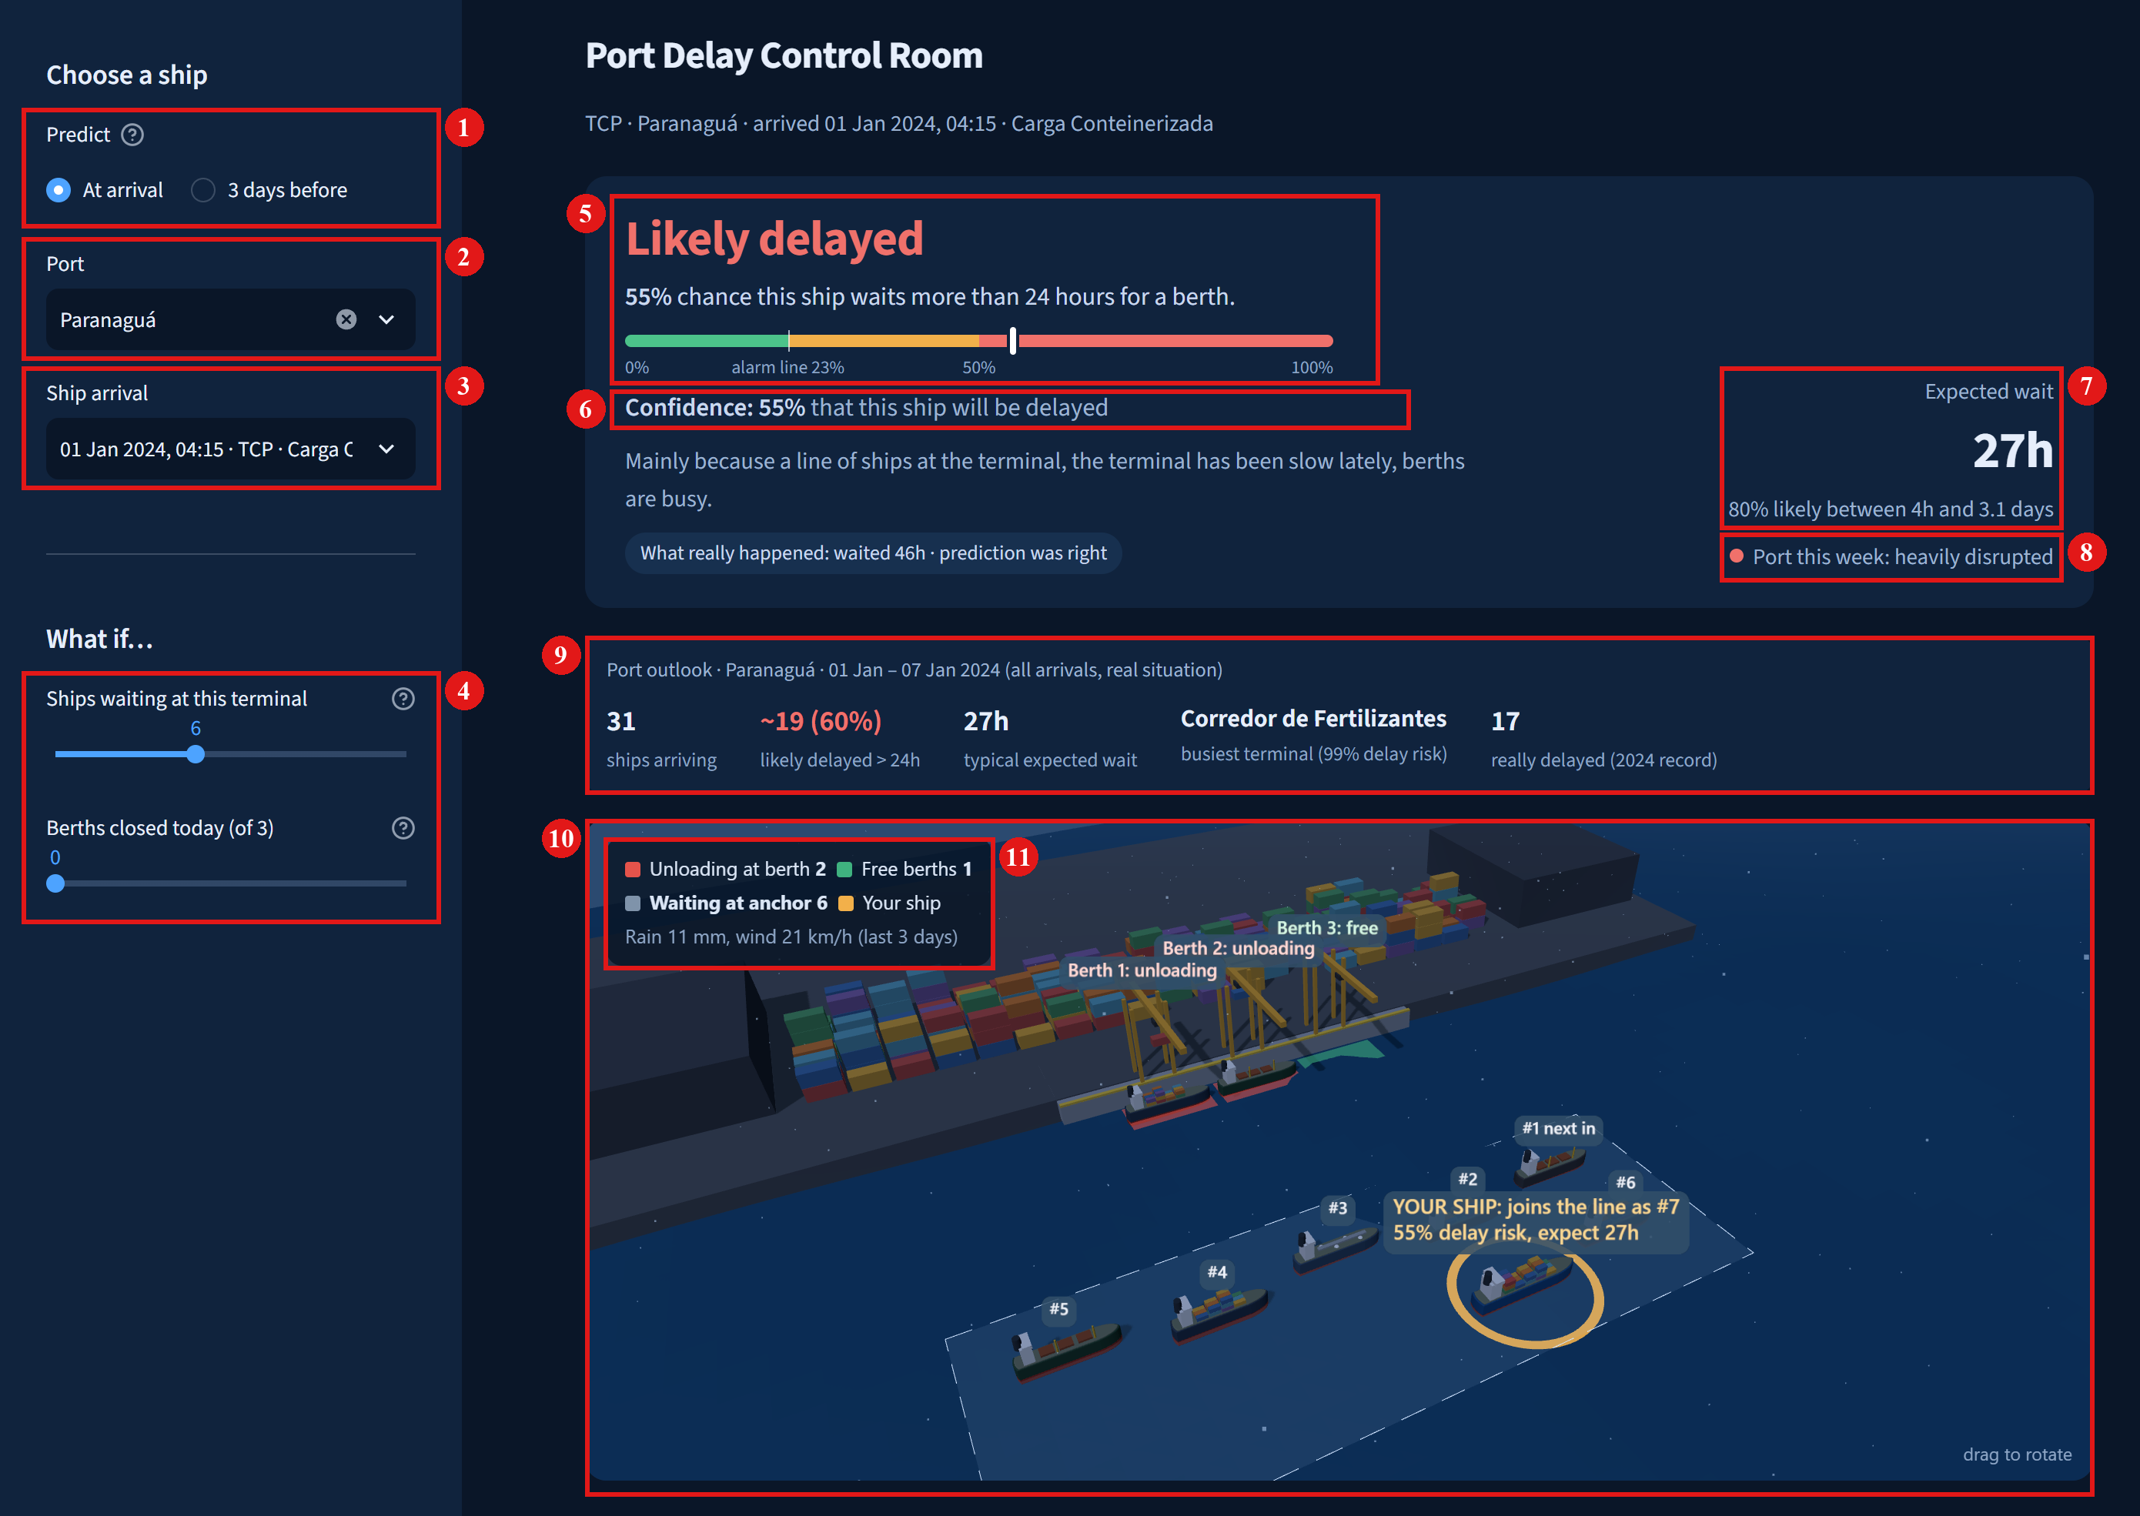
Figure 1. Choosing a ship and reading its prediction.
1. Prediction moment: predict when the ship arrives, or 3 days before.
2. Port: any of the 15 busiest Brazilian ports.
3. Ship: any real 2024 arrival at that port (2,282 at Paranaguá).
4. What-if sliders: add ships to the line at this terminal, or close some of its berths (this terminal has 3 berths); every number on the page updates.
5. Verdict: the chance of waiting more than 24 hours (55%), on a gauge that marks the 23% alarm line.
6. Confidence: how likely the yes/no answer is to be right.
7. Expected wait: 27 hours, and the range the real wait falls in 80% of the time (4 hours to 3.1 days).
8. Port status this week: normal, slightly disrupted or heavily disrupted, from the port's average wait over the last 7 days.
9. Port outlook: for the whole port this week, the ships arriving, how many are likely to be delayed, the typical wait and the busiest terminal.
10. 3D view of the terminal: its berths, the ships unloading, the ships waiting at anchor in order, and this ship highlighted.
11. Live counts: ships unloading, free berths, ships waiting at anchor, and the last 3 days of weather.
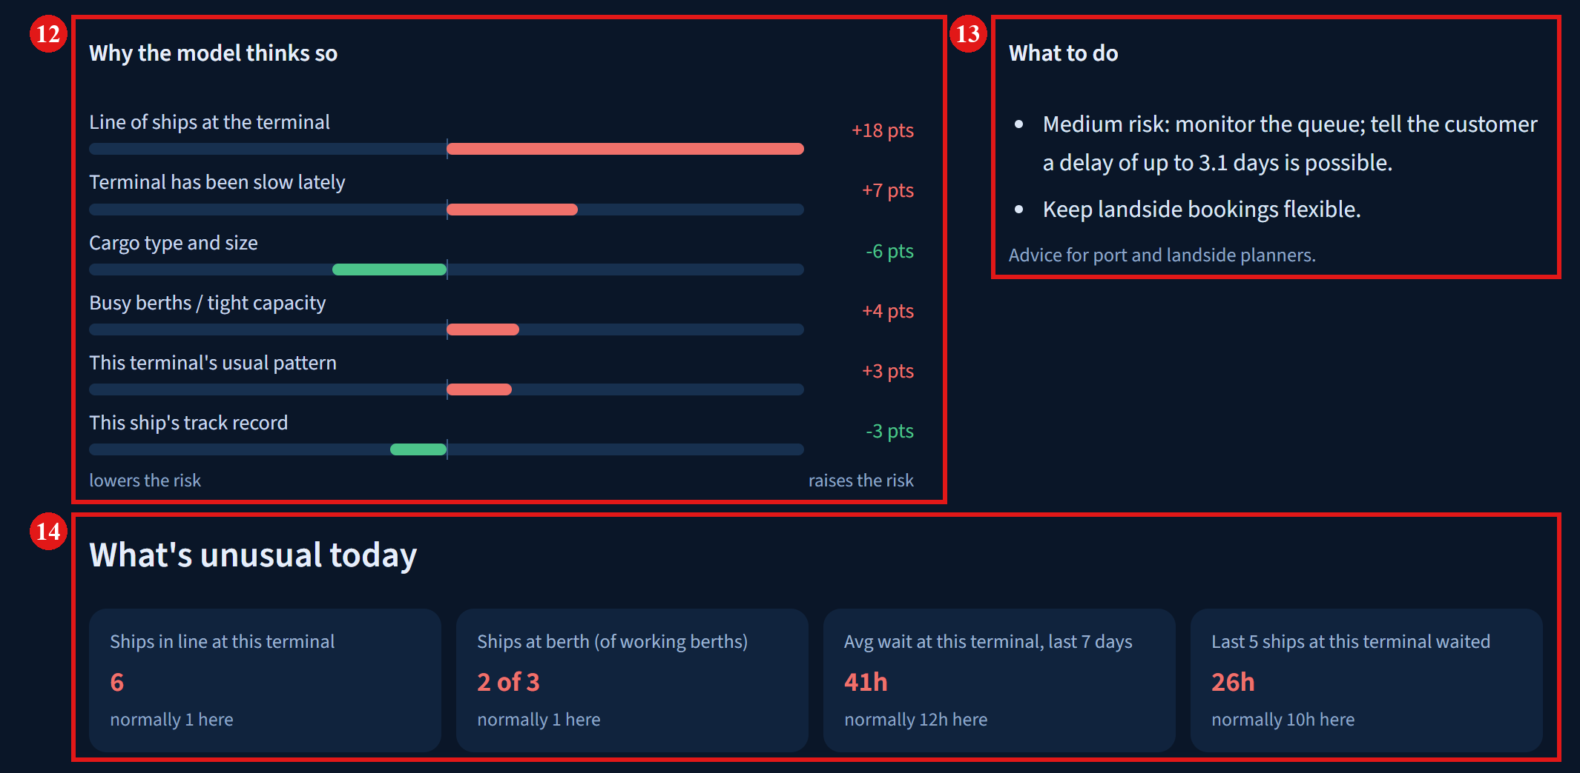
Figure 2. Why the ship is likely to be delayed, and how today differs from a normal day.
12. What led to the delay: the main causes, each with how many percentage points it adds to or removes from the chance of delay. Here a line of ships (+18 points) and a terminal that has been slow lately (+7) drive the risk.
13. What to do: suggested actions for planners, based on the risk and the expected wait.
14. Today vs a normal day: today's situation next to this terminal's normal (its typical value in 2020–2022). Here 6 ships are waiting where 1 is normal, and recent waits are 41 hours against a normal 12.

