Index

Design

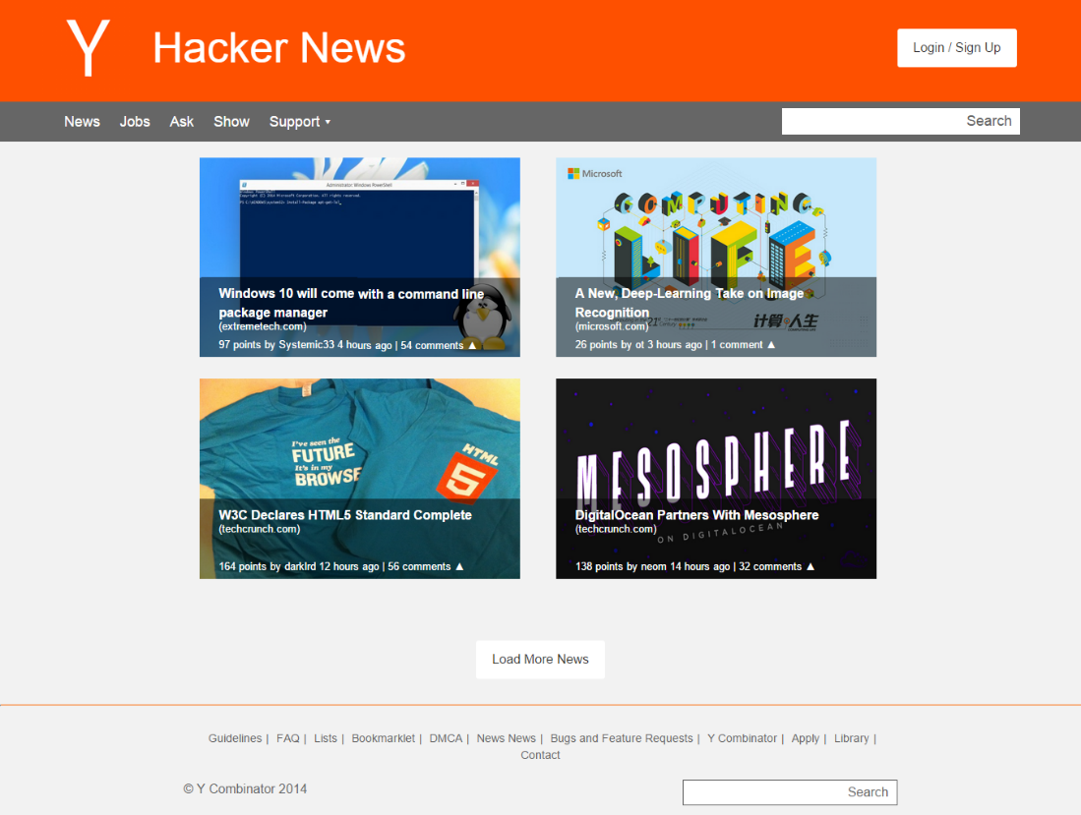

In-Browser

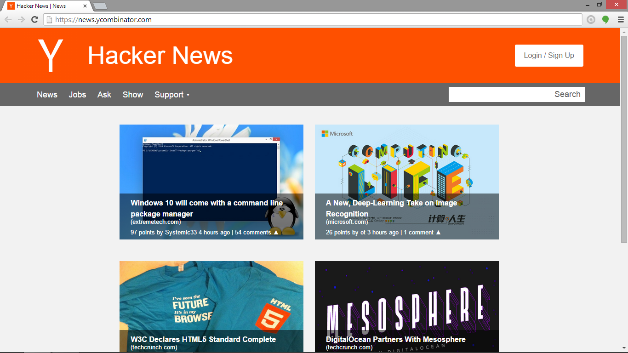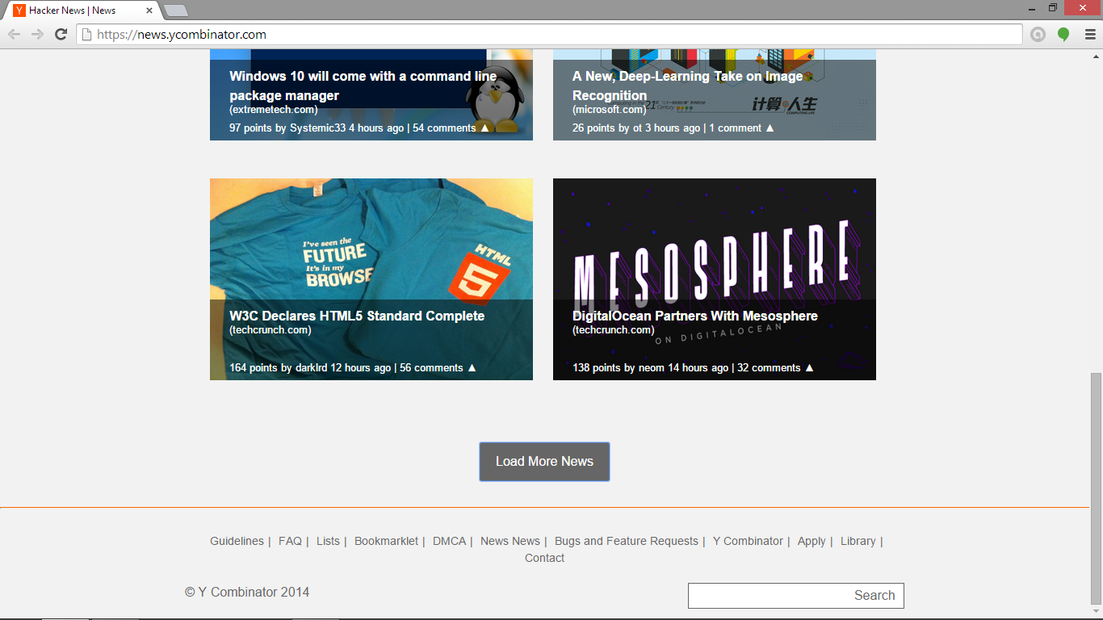
The landing page of the website. Users are asked to include a related image for the background, and the news article can be accessed by clicking the image or title. News is sorted by most recent, the load more button loads additional news with a slide animation.

Login

Design
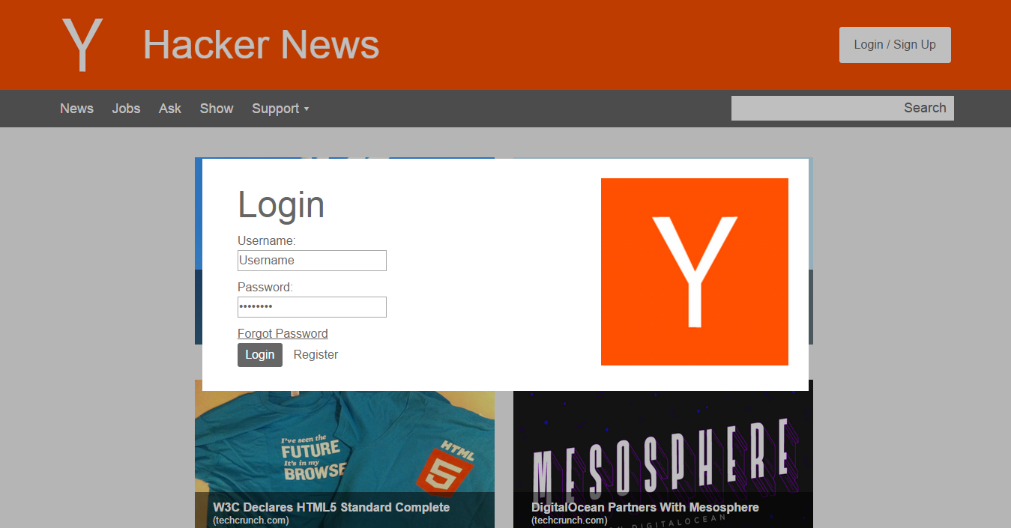

In-Browser
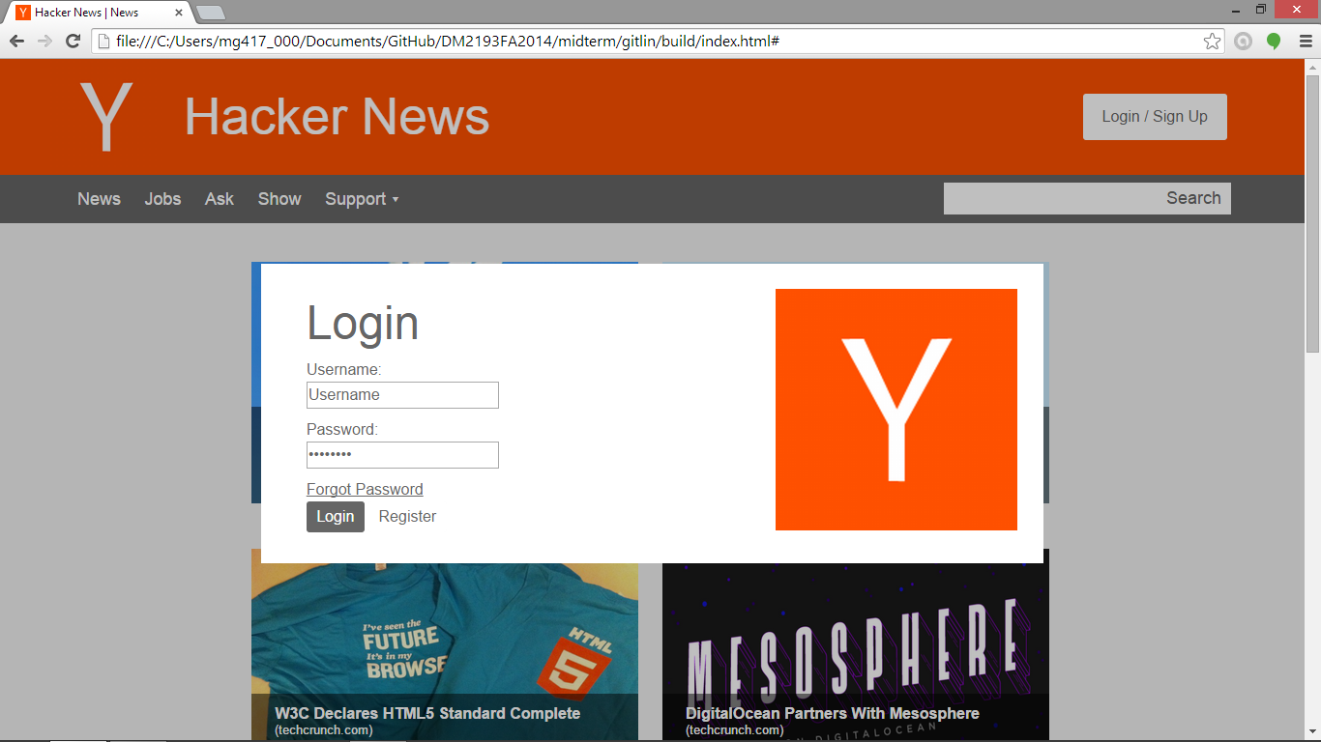
Login is done through a modal accessible through the button in the header of the website. The modal also includes links to the register and “forgot password” pages. Can be closed by clicking outside the modal or with a key press (esc).

Jobs

Design

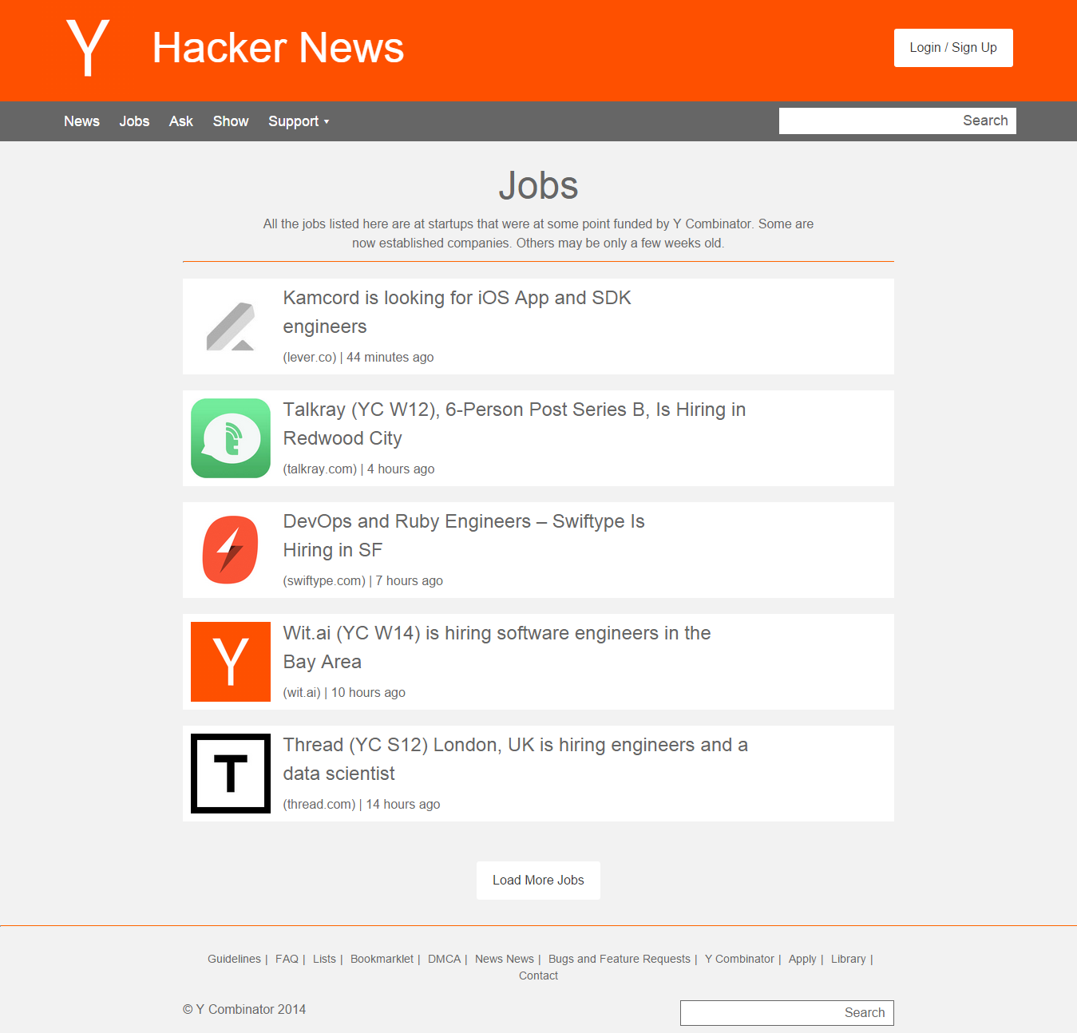

In-Browser

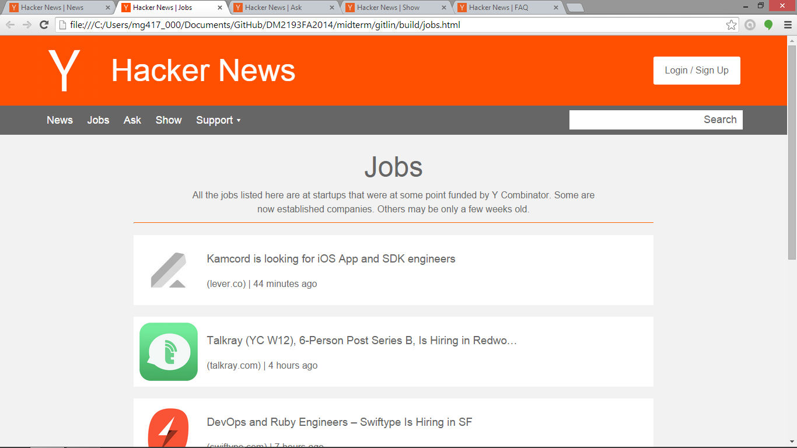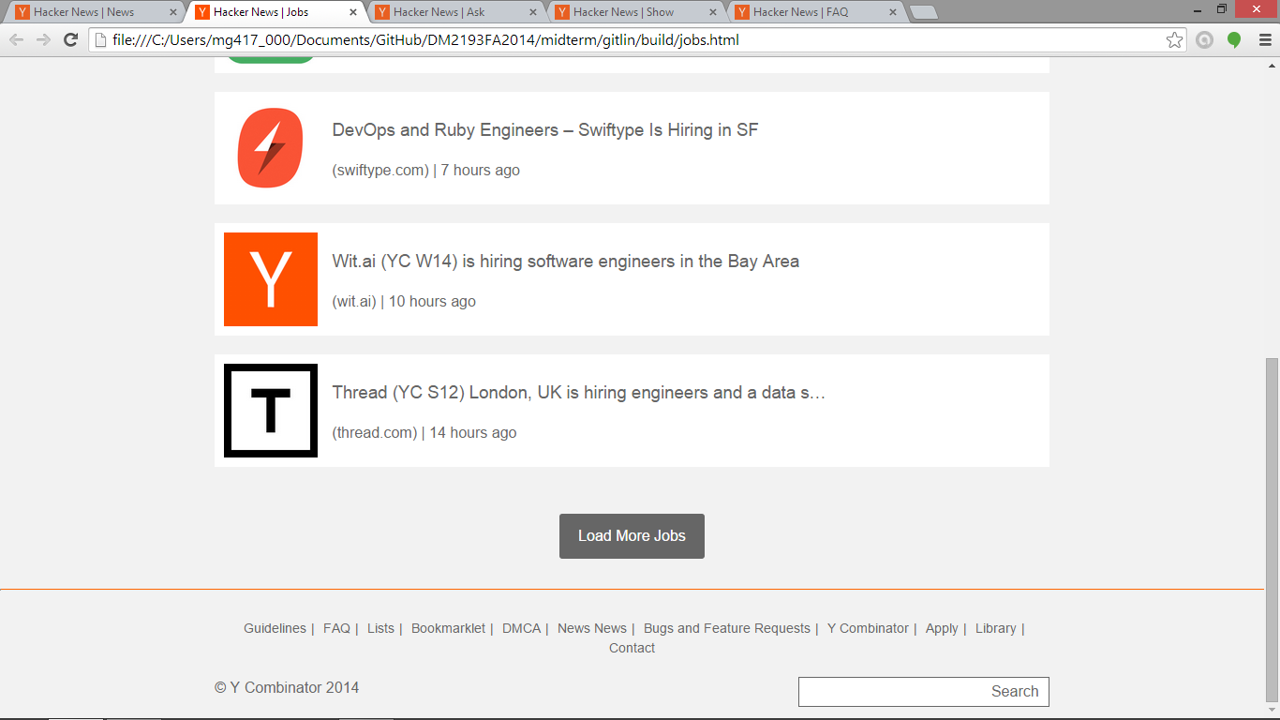
The jobs page of the website, where users can find Y-Combinator funded job opportunities. Jobs are sorted by most recent, the load more button loads additional jobs with a slide animation.
Ask

Design

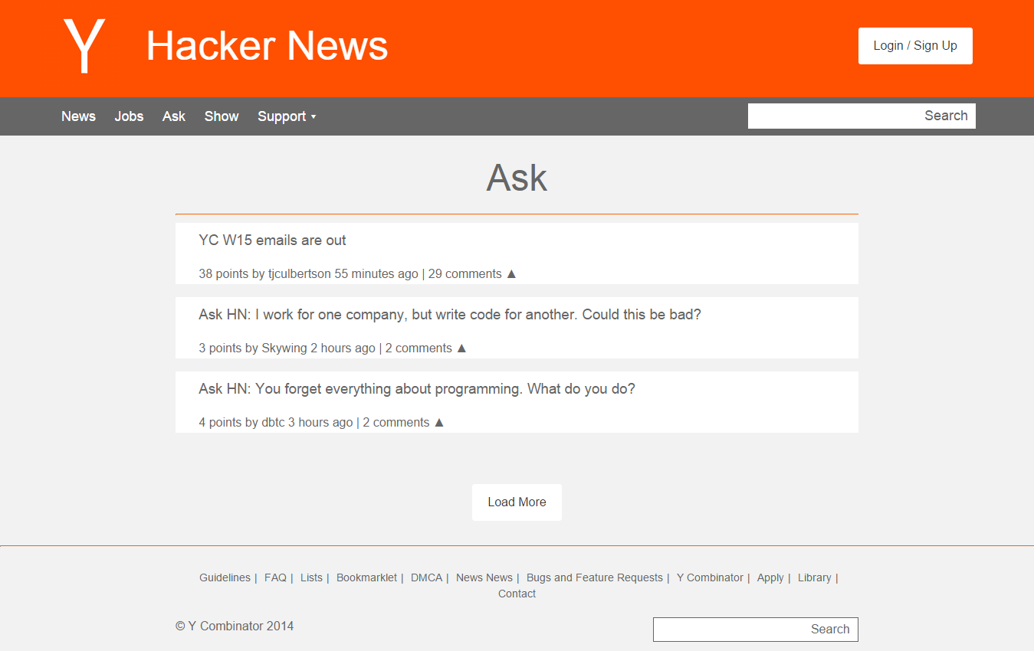

In-Browser

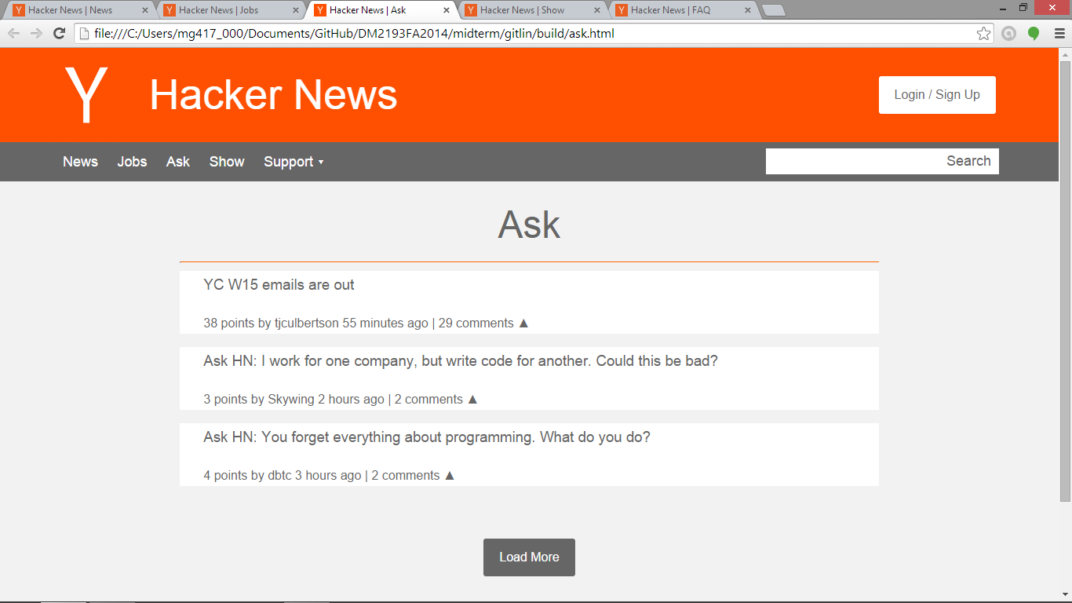
The ask page of the website, where users can ask any question they have. The posts are sorted by most recent, the load more button loads additional questions with a slide animation.
Show

Design

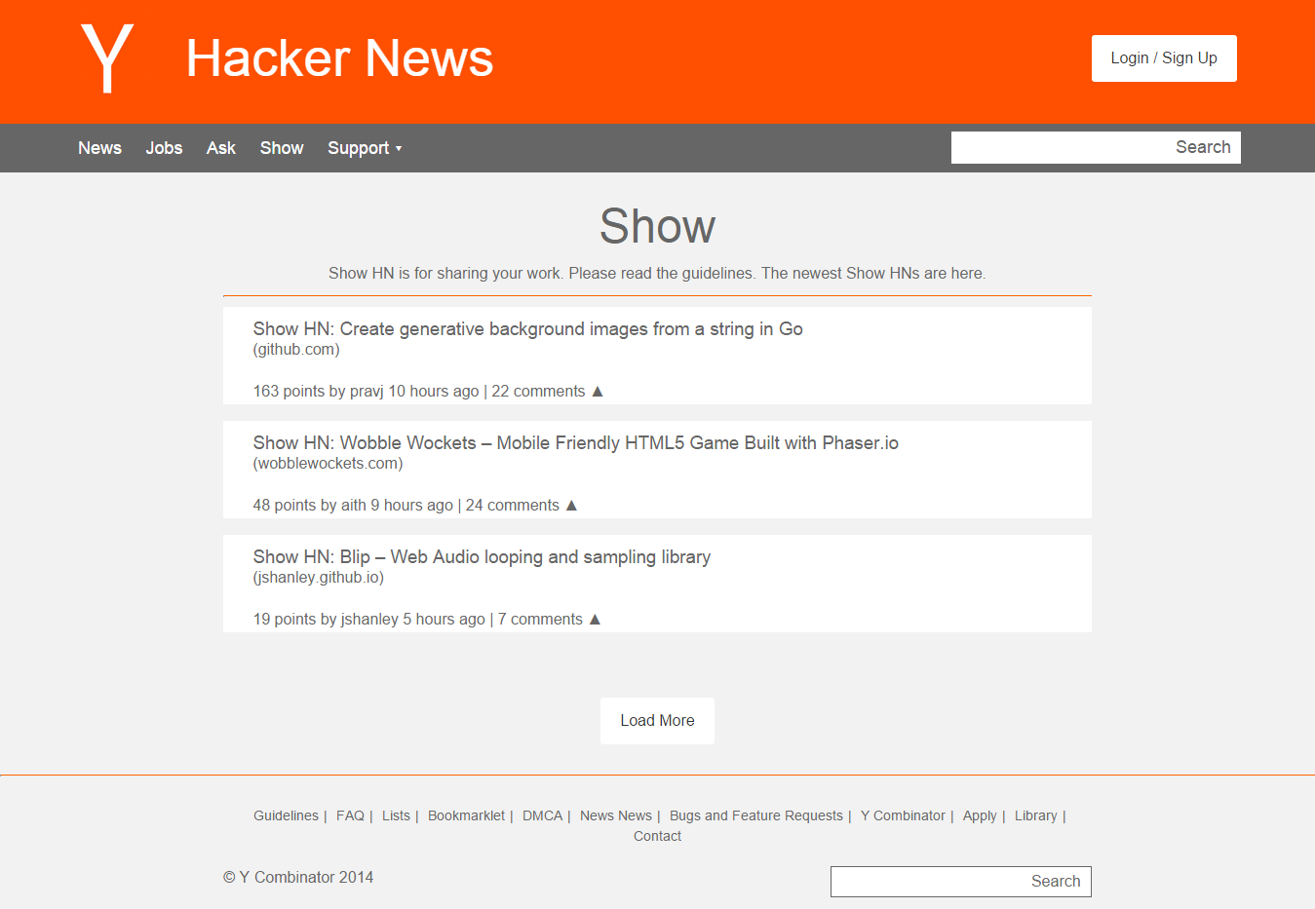

In-Browser

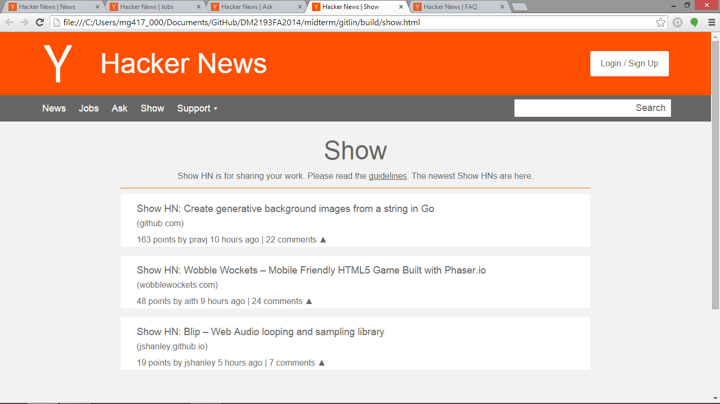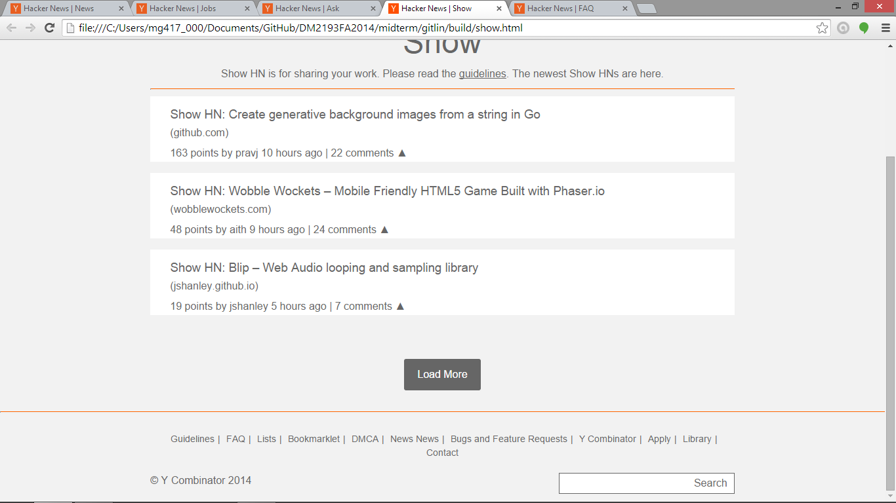
The show page of the website, users can share any of their stories or work on this page. The posts are sorted by most recent, the load more button loads additional posts with a slide animation.
Frequently Asked Questions (FAQ)

Design

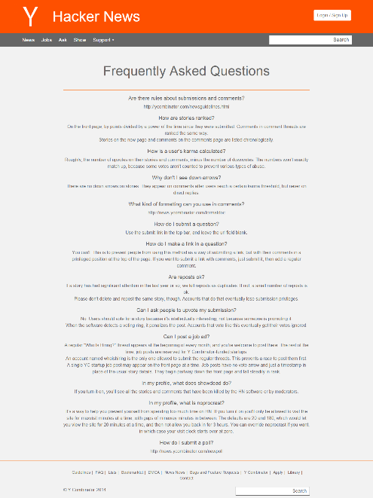

In-Browser
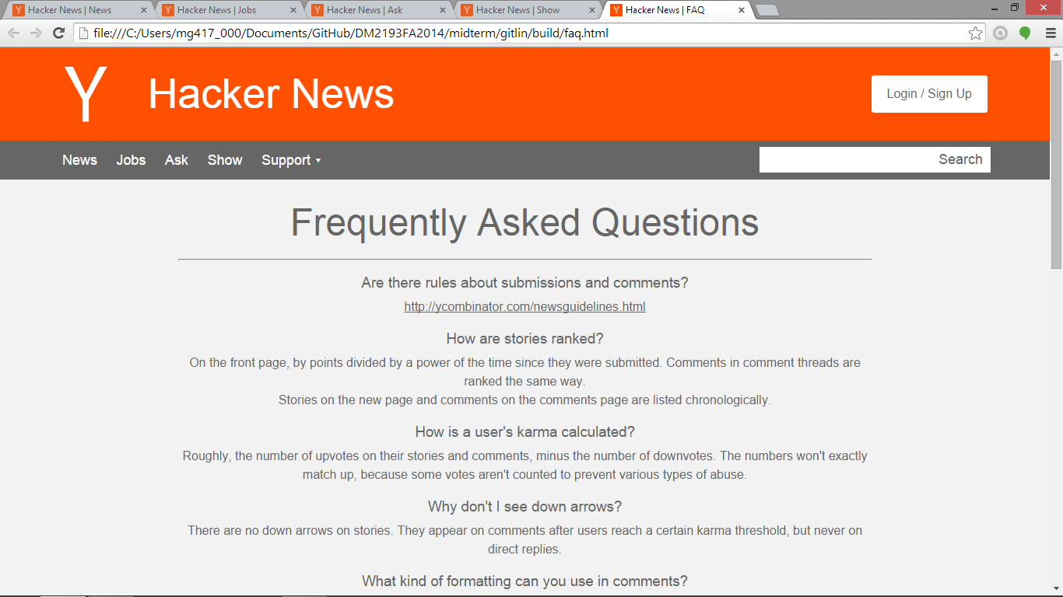
The frequently asked questions page of the website, all the frequently asked questions and their answers can be found on this page, there is no load button because it is all here.

Wireframes

Index

Login

Jobs

Ask

Show

FAQ

