DayWalker Theme Documentation

A Tumblr theme

dm2193 – Intro to web development

Matthew Gitlin



Main Page:

The ability to add multiple social media links:

* Facebook
* Twitter
* Google+
* Pinterest

Infinite Scrolling

Two Column Responsive Layout

Theme Features

Design:

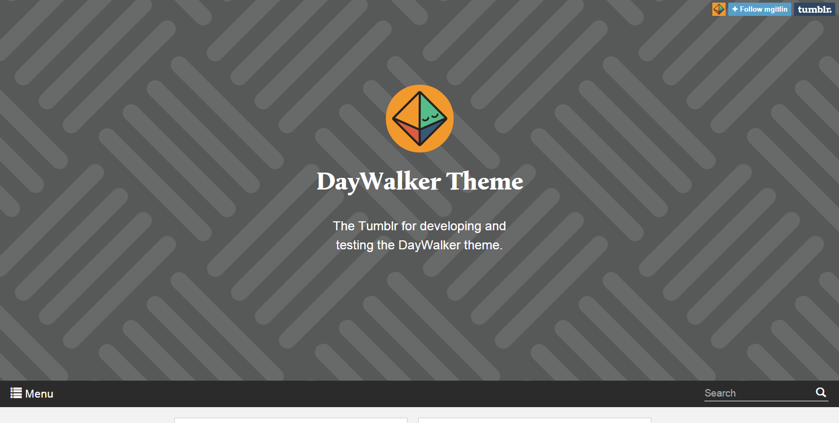

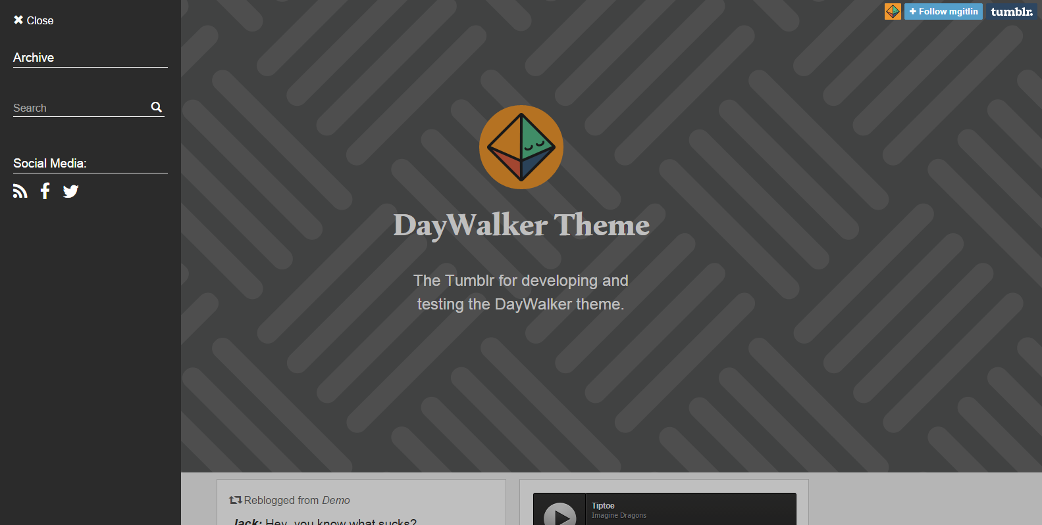

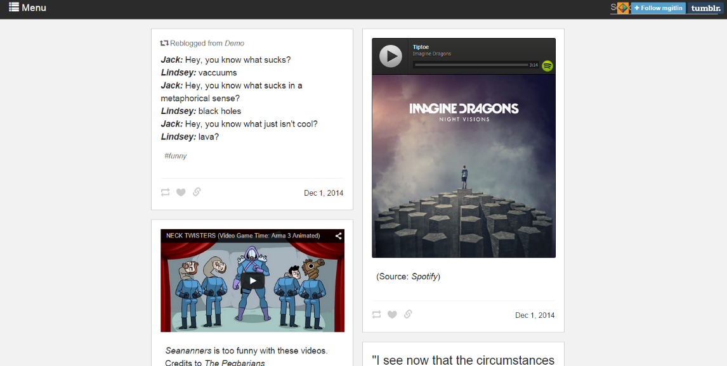

Main Page:

In-Browser:

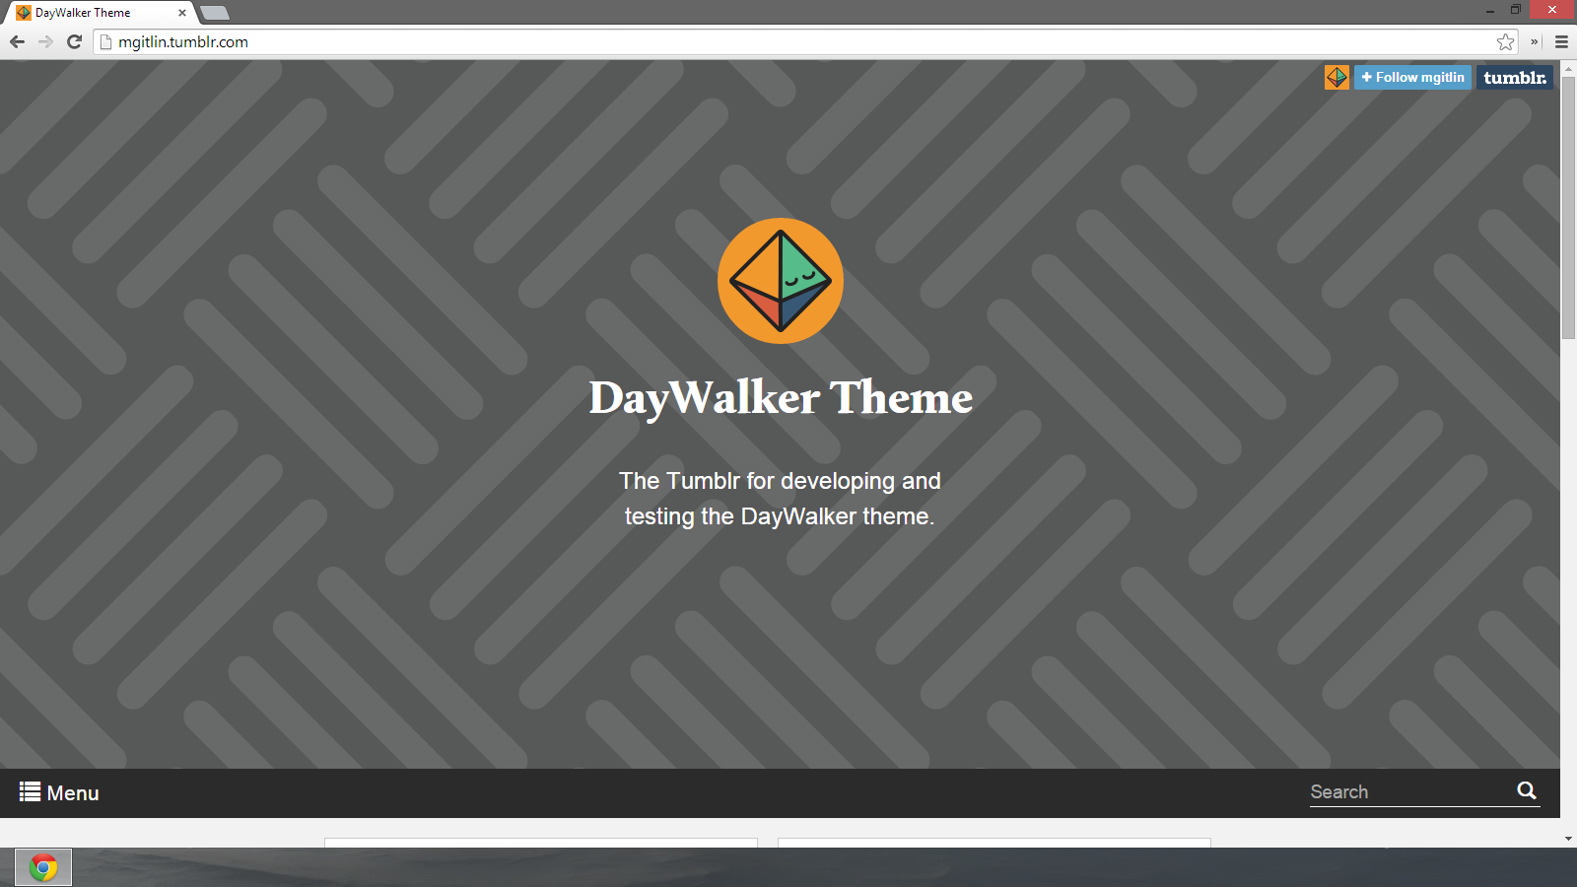

The top is a customizable header image where your avatar, title and description can be seen.

The menu bar underneath will stay at the top of the screen after scrolling.

The sidebar can be closed by pressing the escape key or clicking outside.

Posts are displayed in a 2 column layout thanks to the masonry plugin.

http://masonry.desandro.com/

Index

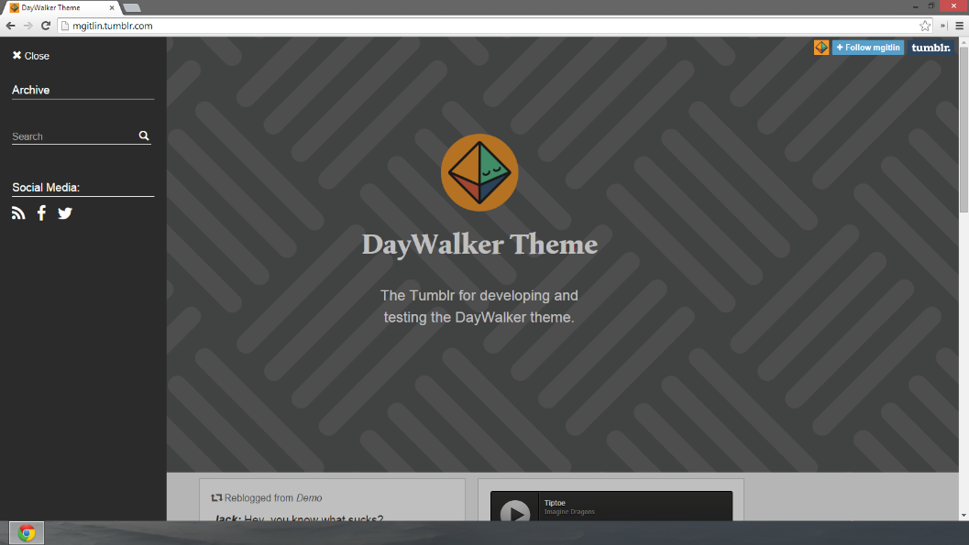

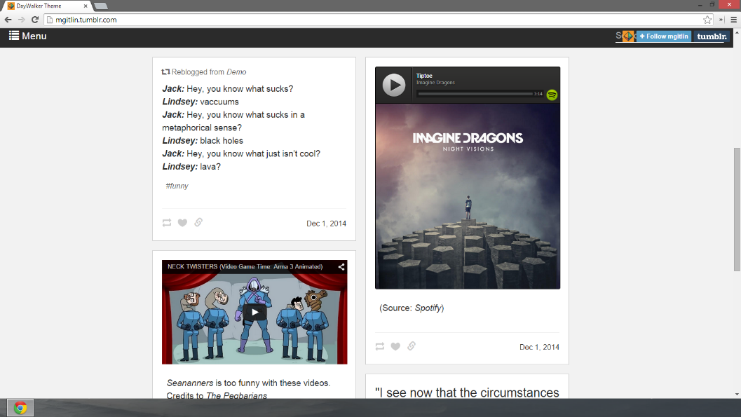

Permalink Page:

Shows a single post from its permalink.

Permalink page

Design:

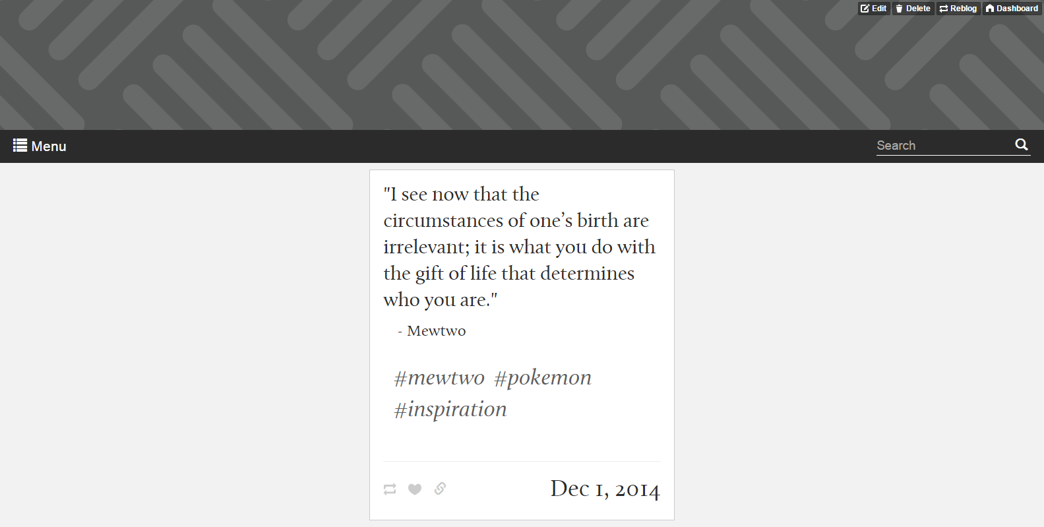

In-Browser:

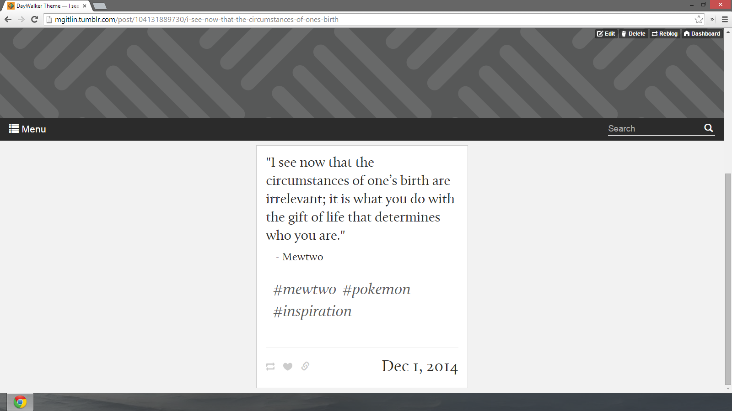

Search Page:

If not posts are found matching the search keywords this is what is displayed.

If posts are found, mimics index page.

Search page

Design:

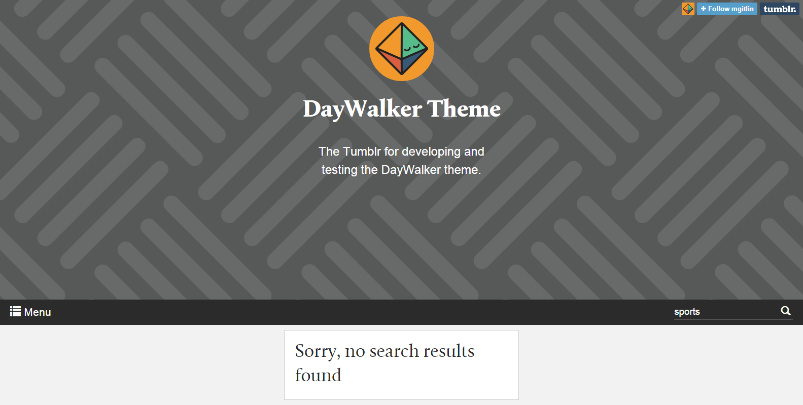

In-browser:

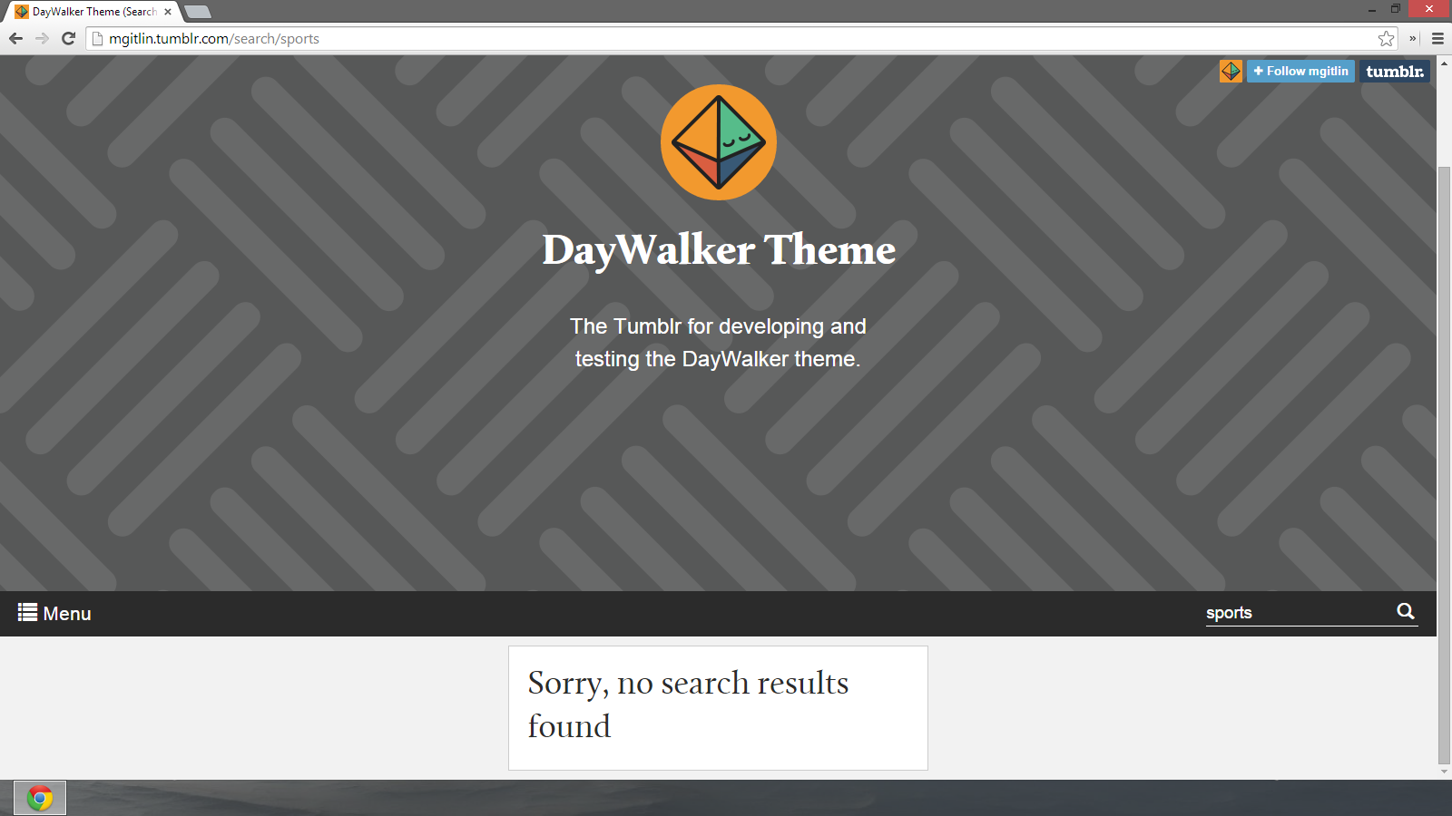

Posts:

Designs:

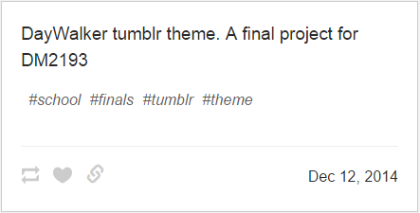

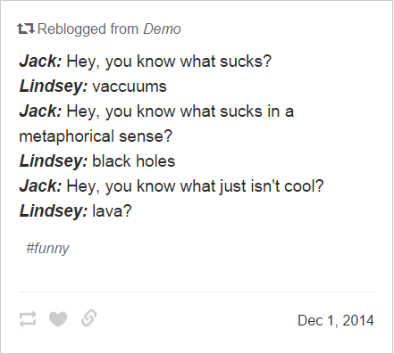

Text and Chat posts

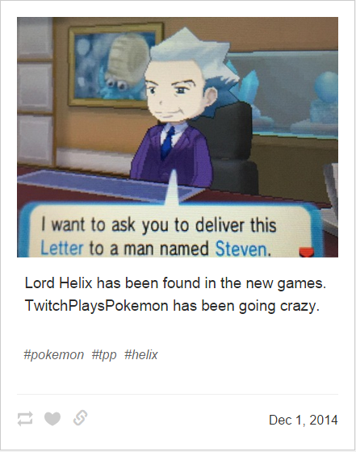

Photo Post

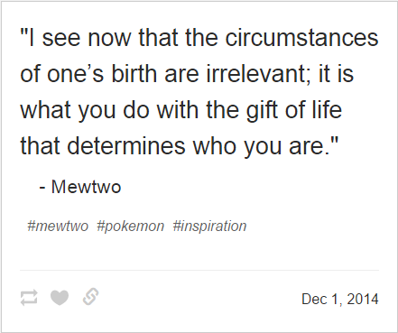

Quote and Link Posts

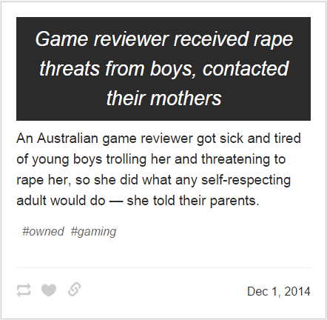

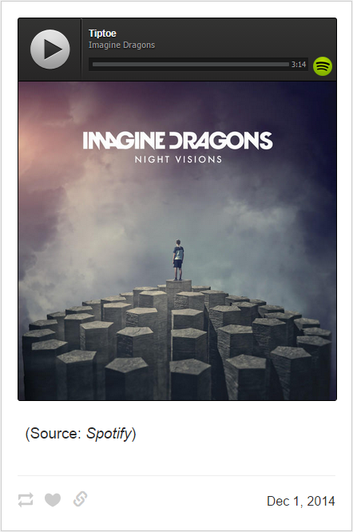

Audio Post

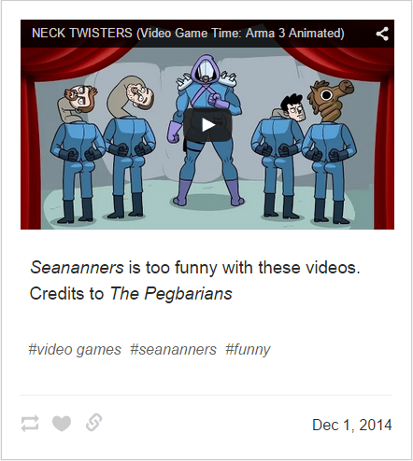

Video post

Wireframes:

Main Page:

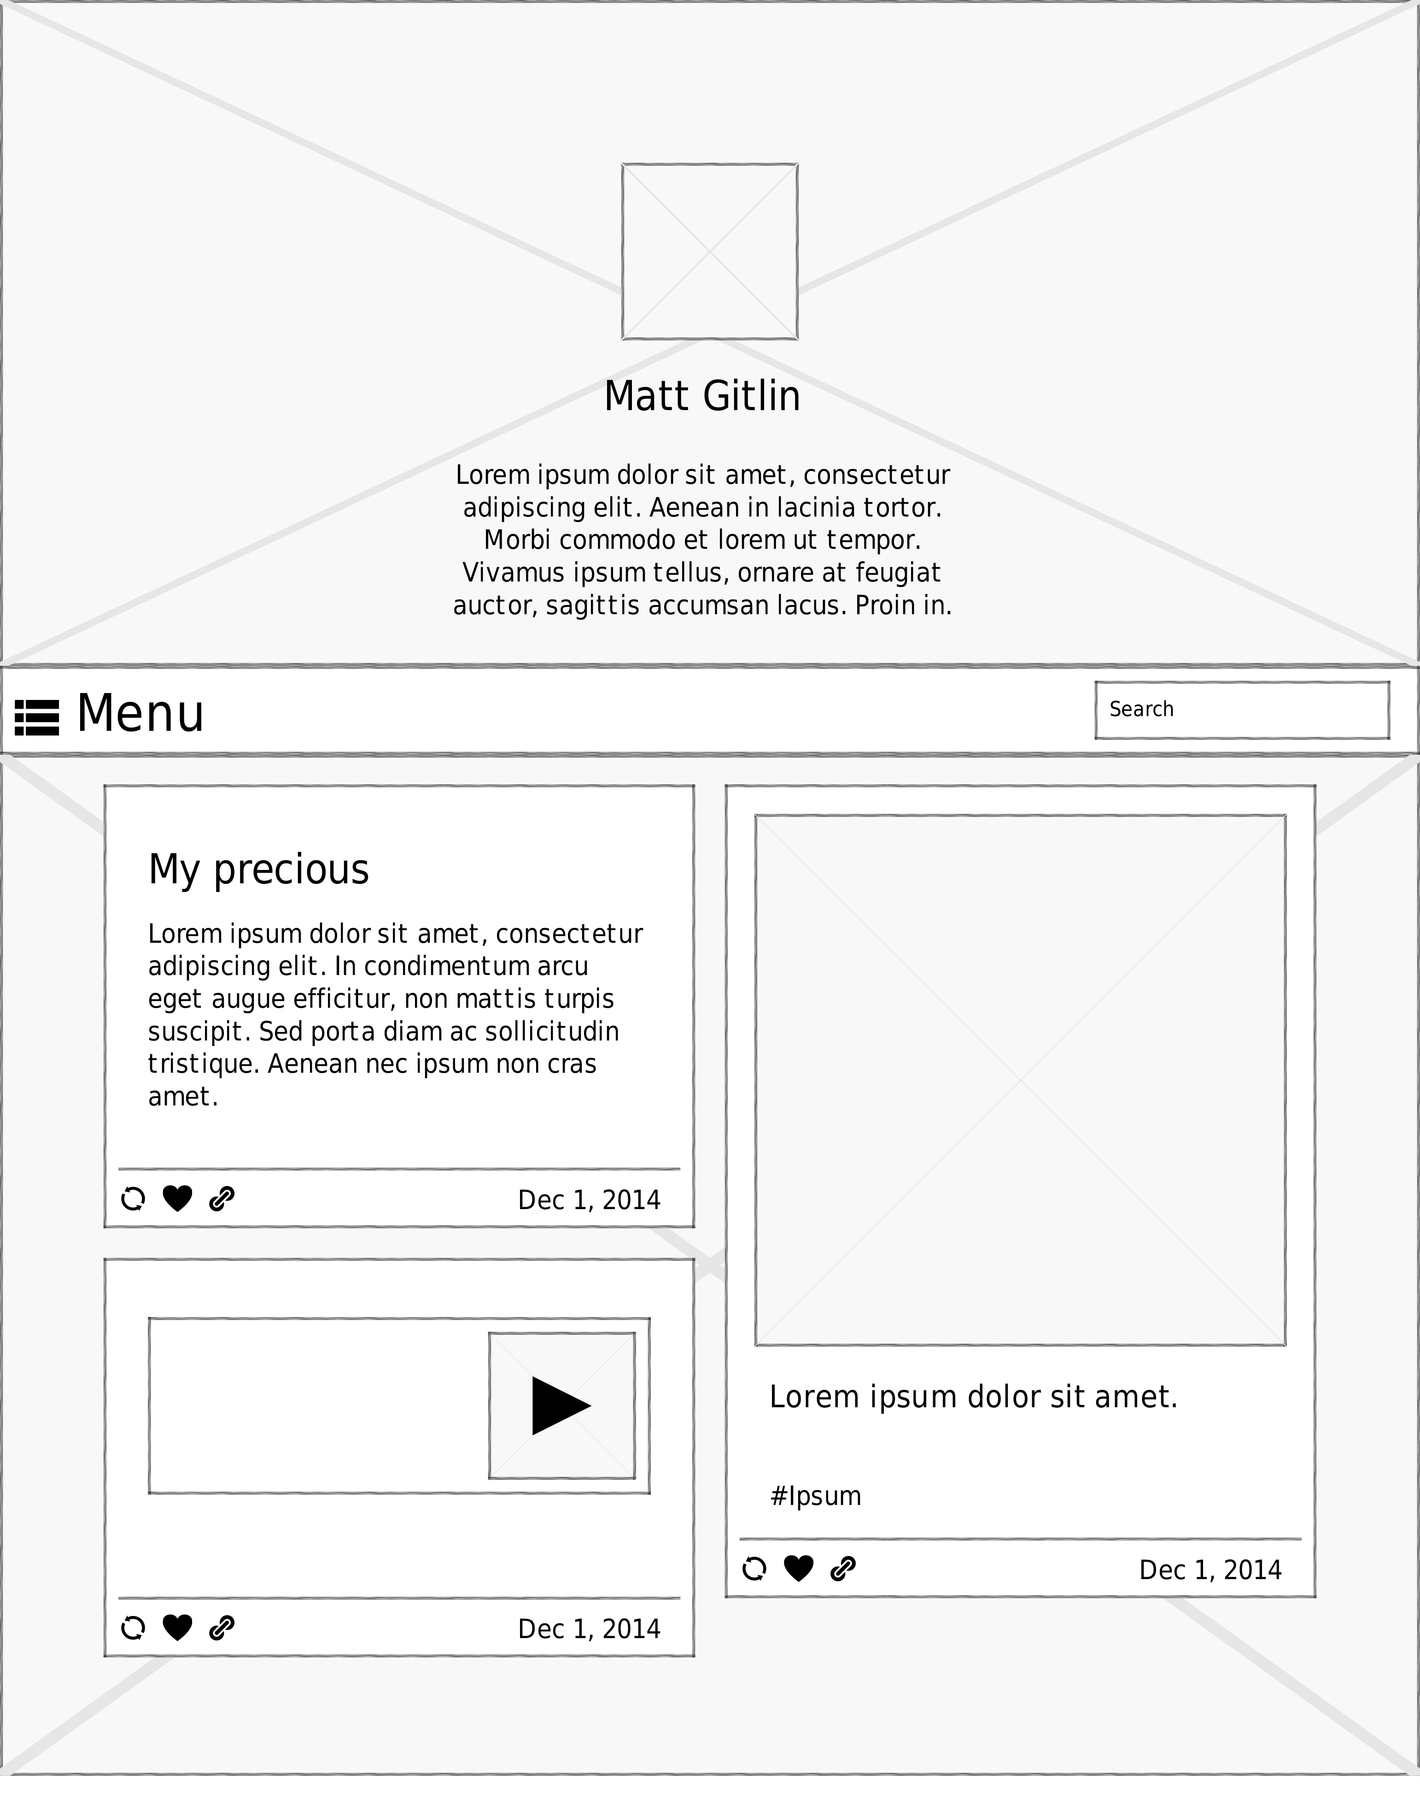

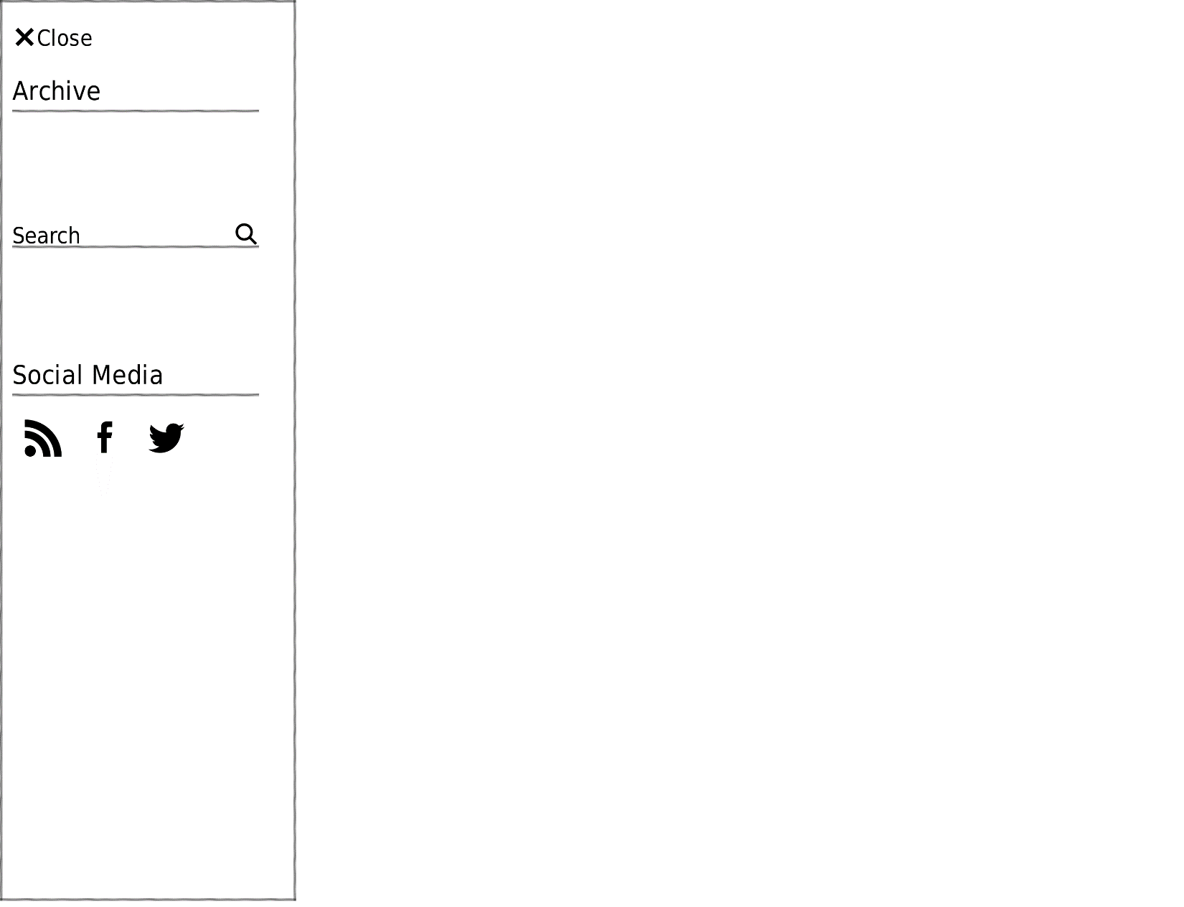

Permalink Page:

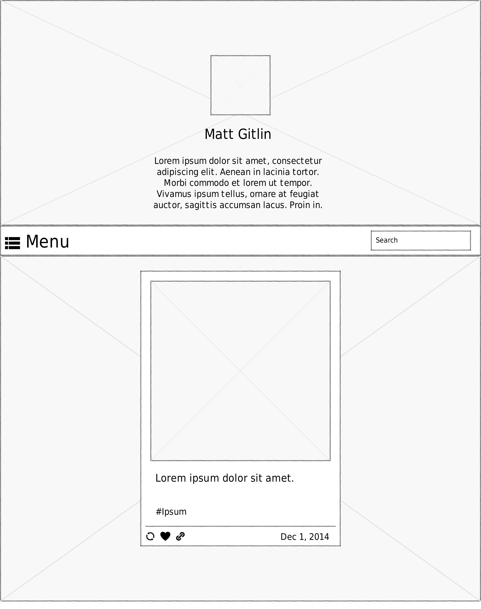

(This format is also used for the no search result page.)