**Home Page Pre-click**

* Clicking on a link will shift the links towards the left of the page and reveal a “hidden” page the clicked design title remains on top, and the sub headings appear under this. Under these, the content will appear. Extra add-ons will appear on the left as well.
* Each of the 9 categories have “shrunk” into their titles only. The header of this page, containing the two rows of content, is static and will appear on all pages for easy and consistent access

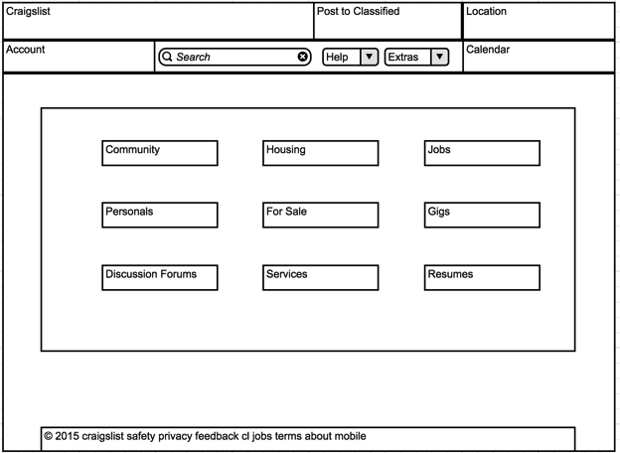

**Home Page Post-click**

* The categories will remain on the side when clicking and it will refresh the box containing the list or sub categories and content (using ajax to avoid having to refresh the entire page). Clicking on a sub category will add that category to the list, and selected categories will be highlighted. Selecting the category again will de-select it. The search options provided by the site will remain, moved to a box in the bottom left corner to keep list visibility. The list will be placed in an overflow box to keep all options on the page at all times in an organized fashion. The search bar will keep functionality.

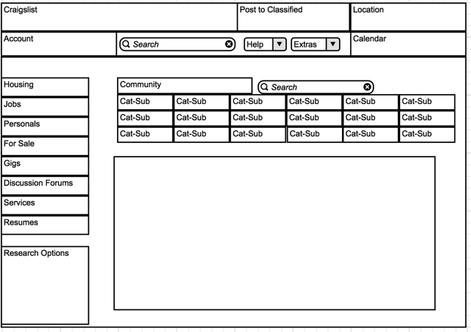

**Event Calendar**

* The page calendar will be a map: visited days will be highlighted while they are being viewed. Clicking the day again will deselect it and remove it from the content view, using ajax to reload the box which will be cssed to use overflow. Content organization will remain the same list format, and items to modify the search bar will remain in the left column.

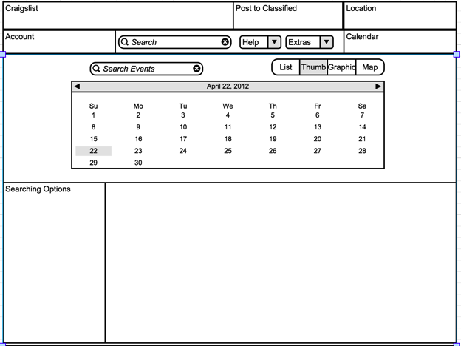

**The Plan**

What do we have to work with?

* Menu including sorting by state / area
  + Within these state areas, posts can also be sorted by regional grouping eg. Borough
* Grouping by category, under each category is more categories
  + In these categories you reach the postings which are organized in list form or picture form
* Search bar which scours the entire site, and can be pintpointed to the larger categories (will be known as cat-headings)
* Event Calendar
* Documentation links and extras

What might users want to be changed about this site?

* There’s an excess of information overloading their senses. They might want to see less at once
* After loading into the page, some may not want their locations to be known, others may not realize the site needs location to be used, and more may want to search in other locations but not know to click on the given menu. Things that follow them on the screen remain in their focus, and might help them realize the location necessity
* Helps, abouts, and other things are unnecessary clutter, and are accessed only when necessary, so users won’t want to have it in their eye view. Might want to place this off the screen but keep it easily accessible.
* The event calendar acts the same as the other categories and is confusing. When hearing calendar I want to see things posted on a calendar not listed out without dates. Might want to make calendar its own link, and have it mark events in calendar format. On clicking on that particular day, then we can see lists
* When I come to the site, I don’t know what I want. When others come, some may know what they want, others may not but will have an idea what category it’s in. For this reason the search is necessary, but not a major component for eye view. It should be placed in the fixed positon along with the menu bar and location identifier, but functionality remain the same
* The sub headings are useful, but hard to see. It’s natural for me to click bigger headings to see a larger list of under headings, from which I can click to see more options related to this subheading.

What do we want to do with this information?

* I know I definitely want to get the event calendar in its own page, so probably going to want a menu bar on each page of the remodeled craigslist
  + Hovering over the link in the menu bar can bring up the mini clickable calendar map
* The documentation links each lead to very different areas, so the menu bar will have a link labeled documentation, and this link will have a drop down menu
  + Two headings in the dropdown menu: help and extras. Under each of these will have the documentation links separated accordingly.
* I want users to know the site is using their location information, so the home page will have a popup that allows you to decide to use your location or not, which can obviously be changed but will remain on the top of your page at all times so you know where you’re searching in. Clicking the location will open a pop up selector menu containing all the other available regions with a search bar specified for locations. Selecting a new area closes the menu and refreshes the information
* My account should always be accessible, remain in fixed top bar as well
* I want the categories to be closed upon visiting the site. When I click it, then it can open up the larger selection, from which I can click and then visit the lists. But, if I don’t know what I want from the larger category then there should still be lists of things showing up upon a single click