Run full-stack Ethereum using Docker containers.

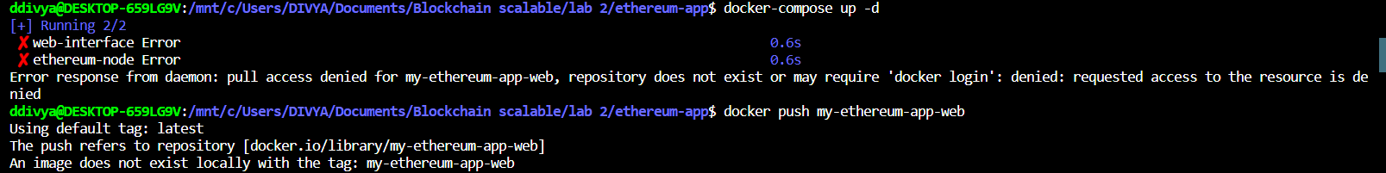

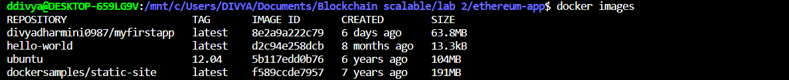



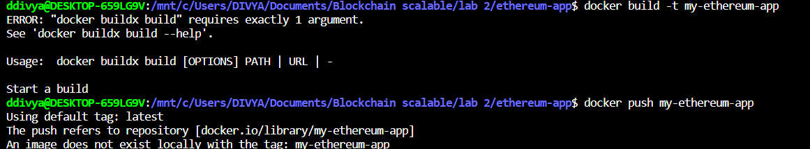

Kubernetes

