**VSim Testing Notes … August 8, 2018**

General:

1. Already mentioned this in an e-mail … some type of block is needed to prevent branding and narrative overlays from going off screen on window re-size.
2. Already mentioned this in an e-mail … conversion from old files still needs adjustment. Now all of the ERs are set as AutoLauch=Text. In the prototype, if there is no AutoLaunch entry for the ER, AutoLauch should be off; if it actually says AutoLaunch 0, then AutoLaunch should be on; and if it actually says AutoLaunch 2, then only the text should AutoLaunch. (This is important because it makes it easier for us to test.)
3. Change default on launch so that lighting is off
4. When saving settings for a model, should also save lighting condition (on or off), and ER filter settings (at minimum, Sort Local and Sort Global)
5. Crashed when I tried ‘Save As’ … worked the next time I did it … will continue to test this.
6. We’re continuing to test the ER import/export …

Embedded Resources:

1. You’re already working on this, and I can’t wait … we definitely need the ‘export all resources’ option on the export.
2. Please slow down the ER reposition speed to about half of what it is now (How is that controlled? It does not appear to change based on navigation speed. As is, the motion is lightning fast, too fast to allow users to track the motion and figure out the relative position of the origin and jump-to spot.)
3. Sorting doesn’t work in Show All view (see graphic below). If it’s easiest, just default Show All to an alphabetical sort.
4. Graphic adjustments to the ER display … slightly larger font on category … slightly larger font on title … fill in the gutter between the title and body … more spacing between lines of the body text. (See graphic below.)
5. Please enable basic text attributes in the ER (at minimum, Control i for *italic*, Control b for **bold** … these will be used for things like bibliographic entries)
6. Move the reposition icon to the upper left corner of the ER (see graphic below)
7. Replace current reposition icon with attached (an arrow pointing to a dot)
8. Replace current text/annotation icon with attached (a T)
9. Can the Filter menu be a ‘tear-off’ like the Node Editor? As is, it overlaps and conflicts with the ER text, so one is inclined to open and close it constantly.
10. Its currently very cumbersome to Show All by Category … and I’m feeling the loss of Show All by Type, and by Title … can you extend the ‘Show Local/Global’/’Show All’ toggle from just those two, and add additional options to ‘Show by Category,’ ‘Show by Type,’ and ‘Show by Title’? (Let’s talk about this … can you think of a more clever way to solve that request?)
11. The display of the AutoLaunch Text is rather jarring … can the ERs fade in slightly rather than just appearing.
12. Would you add a Launch button in the open space at the lower left bottom of the ER display? This would replicate the double-click action that launches the resource URL or file; it should be grayed out for annotations where there’s nothing to launch.

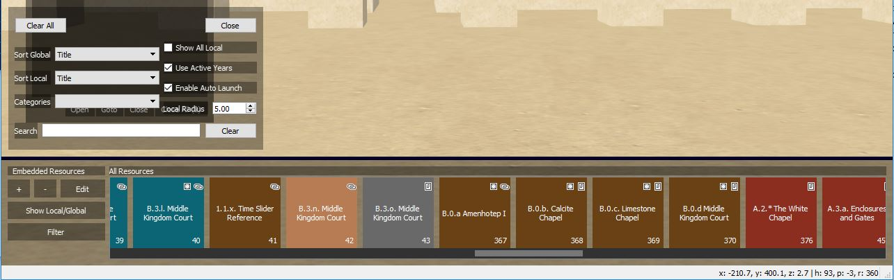

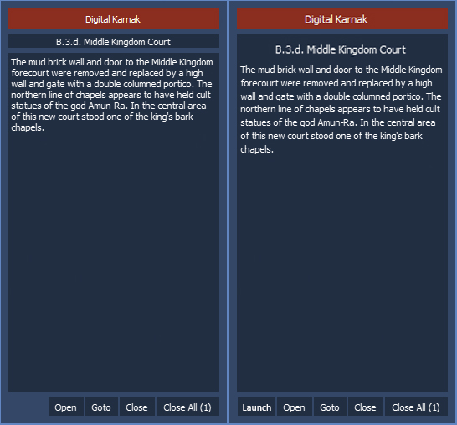

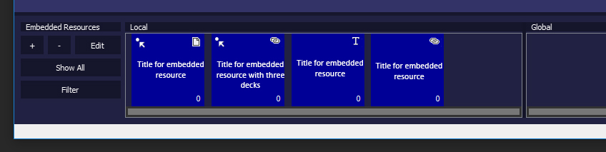

**VSim Testing Notes … July 23, 2018**

General:

1. Love the start position … there’s a weird flash of the original model position (basically a single frame) before the simulation jumps to the start position setting … can you fix or mask that?

Narratives:

1. Love the inclusion of the image tab on the style settings … the border width setting does not, however, appear to save (the color does)
2. Link the narrative thumbnails to their appropriate time on the time slider (when they re-draw at load, they re-draw at the default time)
3. The thumbnails always draw with lighting enabled. Can you check against the display settings before rendering them?
4. One can’t adjust the font and color styles unless there’s a narrative selected (which is good), but can you either 1) on the menu draw, check and if there’s not a narrative selected, grey out that option … or 2) throw an error message? (A narrative must be selected to modify styles.)
5. Can you add to the font and color styles the option of setting a size for the boxes? (Say someone wants to make their labels all consistent, or have body text boxes that are consistent … that’s hard without a place to set the size)
6. Saved dotted border … if one right-clicks on the text box, then click off, then clicks ‘Done’ … it saves with a slight dotted border.

Desirability

Embedded Resources:

1. We definitely need the ‘export all resources’ option on the export (we’ve been messing ourselves up with that as we’ve been testing paths)

**VSim Testing Notes … July 9, 2018**

General:

1. See list from May 30 below for additional items not yet addressed
2. Love the branding. Thanks. Please adjust so that the added content responds to changes of the Narrative and ER bars (check the prototype for guidance on behavior … we want this is to prevent logos from appearing weirdly placed once the user closes the two bars). Basically, anything put on the top half of the simulation window should move up/down with the Narrative Bar; anything put on the bottom half of the simulation window should move up/down with the ER Bar.
3. Love the speed reference in the status bar … it, however, doesn’t adjust automatically anymore as you use the wheel (you have to click once you are on the rate you think you want to be at and you will begin traveling at that rate of speed.) Please reinstate real-time speed updating.
4. Ground/Gravity with collision works fine. Turning Gravity on should, however, automatically turn collision on so that one doesn’t sink through the floor. Need a way to set eye height. (Model settings?) But if you don’t have a floor plane, Ground/Gravity causes you to sink endlessly. Could you add a check wherein if there’s no geometry below, gravity is either turned off or doesn’t turn on so that you don’t endlessly sink?
5. Add help hints … under About? (exact text to follow)
6. Update text on ‘About VSim’ to add in Phase 2 and mention the Repository and Archive (exact text to follow)

Narratives:

1. 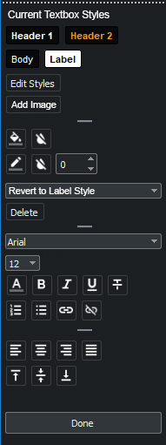Narrative Player … if slide has ‘Next Slide on Click’ for duration, add message in bar along the bottom: ‘Press Any Key To Continue’ (P currently only advances to the next slide; it should be toggle between Play and Pause … see prototype for behavior)
2. Narrative Player … add rule so that a long author field behaves the same as the description field if there’s more text than can be fully displayed (the description field wraps to two lines and concludes with ellipses (…))
3. Narrative Editor … thumbnails
4. Narrative Editor … low priority, but it is currently difficult to determine if an font attribute (e.g., bold or italic) is being utilized on not - it would be great if we could select some text with an attribute and see the buttons in a toggle-on state.
5. Narrative Editor/Styles … if you say you click to add a border, can the border size automatically jump to 1? (Right now it shows size=0, and there’s a border, which is confusing)
6. Node editor … see graphic at right for rearrangement and consolidation so it fits fully within the simulation window. I’ve organized the styles to be more space efficient … puts all style-related bits and ‘add’ commands at top, things related to the full selection in the middle, things related to selected text next, and alignment at the bottom (these can be applied to both the full selection or just the selected text.) Minor text adjustments … ‘Add Image’ and ‘Revert to *x* Style’
7. Node editor … hover over on commands?
8. Node editor … in ‘Revert to *x* Style’ do we need the ‘None’?
9. Node editor … low priority, can we add a ‘paste text only’ option to the menu that appears when one right clicks into a box?
10. Node editor … Can bullet points adjust with font coloring? (Numbering does, but not bullets)

Embedded Resources:

1. 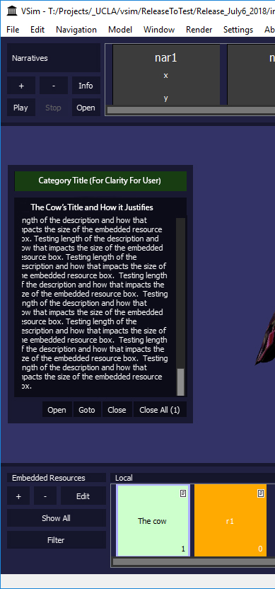Thanks for adding the right click to clear ERs … please extend it so that the right click can be anywhere in the simulation window, not just over the ER
2. Show All … filter setting of sort by title should work when show all … when showing all, disable re-ordering so that one can choose the ERs methodically (looking at everything in a category, for example)
3. Display of ERs (i.e., the box on the left … see graphic at right)
   1. Add another box at the top for category with centered white text and color of category as background … this is to give users a reference to the content being displayed)
   2. Move title down so that it appears as one with description (but keep as two separate boxes so the slider only moves the description)
   3. Give a slightly bigger margin on the left side of the description display
   4. Love the scroll bar on the description … please modify the visual so that it better matches with the sliders of the two bars
   5. Delete bottom box for author (that will get super repetitive and I don’t see many people thoroughly filling in that field)
   6. Make default box size bigger per image
   7. Make ER display box responsive so that it adjusts its size when the simulation window size is changed.
4. Search … doesn’t work yet … should search in title, description, authors/source, unique ER field
5. Add toggle to display anchor of ERs (a wish list item!)

VSim Testing Notes … May 30, 2018 … combines comments from both Lisa and Francesca

General:

1. **Make the ‘ground’ mode work for WASD and flight simulation modes of navigation … will also involve the ability for the content creator/user to set the eye height (1.65 works for models built in meters; 5.4 works for models built in feet; 165 works for a model built in centimeters)**
2. **Add code to recognize and allow changes of binary switches (you’d probably put the controls for this under the ‘Window’ tab with the Time Slider)**
3. ~~Add anti-aliasing~~
4. Performance is still an issue … the frame rate of the new build is still slower than the prototype, sometimes significantly (when comparing the two at rest in the same location in the WCE model, the prototype reports a frame rate around 22 while the new build reports around 15; that disparity is roughly maintained when flying the same motion; at another location, it’s not so bad … the prototype reports a resting frame rate of around 14, and the new build reports around 12.)
5. **Add branding per the prototype (the ability for a content creator to add information to an overlay (i.e., a single slide-like thing) that is always present during the simulation session**
6. **Locking (I’m thinking about this and we’ll talk at some point about the optimal/most efficient way to implement this)**
7. Just a question … what’s the difference between ‘New,’ ‘Open,’ and ‘Import’ when talking about models? (It seems to me that ‘New’ and ‘Open’ do the same thing at the moment.)

Narratives:

1. I LOVE everything you’ve added in the Node Editor!
2. **Fix thumbnails in the Narrative Editor**
3. Adjust the Fonts & Styles settings so that the default backgrounds have no border, and add the ability to specify a style’s border size and color.
4. Fix preview in the Fonts & Styles setting window
5. In the Node Editor, remove or fix “none” from the headers drop down menu. (Selecting “none” causes a crash.)
6. Adjust the code involving pressing ‘p’ to pause and play while on a narrative. If playing a narrative, one stops and click out to navigation, hitting “p” to resume play should continue the narrative at the last viewed slide. (Currently, the narrative begins again at slide 1.)
7. Minor adjustments:
   1. Eventually, we need to fix the Narrative titles so that they work better in the space allowed (we’re thinking about the rules for this, so don’t worry about it now).
   2. During narrative creation, adjust so that navigation is unfrozen after one hit of the spacebar after adding a new slide. (Currently, adding a slide freezes navigation and requires two hits of the spacebar to get moving again.)
   3. In the Node Editor, make “delete” and “edits styles” look more button-like so people understand they are clickable (i.e., add a border or similar).
   4. In the Node Editor, if it is super easy, can the label “alpha channel” in select color box be changed to “opacity?”
   5. In the Node Editor, allow for use of the arrows on the keyboard to move the text cursor
   6. In the Node Editor, add functionality to allow for the inclusion and management of hyperlinks in textboxes.

Embedded Resources:

1. When adding a resource, add a word limit for the ER title (40 characters?)
2. Allow longer descriptions, and add a scroll in the text display along the left side when necessary
3. Adjust the ER launch conditions in the ER dialog, and make the corresponding changes to the code:
   1. No action (the default condition with nothing clicked; during interaction, this requires the user to single-click the ER to show them and/or double-click them to launch)
   2. Auto launch text only (I think you’re conflating two ideas here – the ERs should always show in the Global or Local bars unless filtered out; if the ‘Popup when in range’ is set, what should happen is the text display pops up along the left side when triggered)
      1. For the moment, hide the ‘fx’ symbol on the ERs
      2. For the moment, hide the distance on the ERs
      3. In the spot of the distance, display a unique number for the ER (the number would be a reference for users to cite the information; I’m not sure how valuable the distance is to users)
   3. Auto launch resource (this needs to be added; what should happen is the text display pops up and the attendant program (if any) launches when triggered (e.g., Image Viewer or Movie Player)
   4. Auto reposition (this is equivalent of ‘goto on click,’ which works, but not in concert with the auto launch so the user is repositioned when the resource is triggered)
4. Default resource choice to ‘Local’ (currently Global)
5. When editing a resource, at ‘Save,’ ask if the position of the resource should be reset (Y or N, with Y resetting the HPR and XYZ; N does nothing).
6. Make ‘Show All’ work as in prototype
7. Add ‘right click’ to make the ER text display along the left side of the screen go away (yes, one can click in the Global or Local bar to do that, but I LOVE being able to make it go away with a fast right click; this should not change the right click uses in flight simulation mode)
8. Filter: Even if Local ERs are sorted by title, they should still display by distance (currently, if you have ‘by title’ selected, they don’t show in the ER panel at all) … the ‘sort by title’ should just govern how they are displayed when they display
9. ‘Clear All’ scares me. If we keep that in, we need to put an ‘Are you SURE?’ warning before it deletes everything!