Chocoholics Anonymous
CSC 470
Project 1
Team Members: Jean-Marcel Belmont, Gabriel Hairston, Shawn Thompson

Glossary

Chocoholics Anonymous (ChocAn): It is an organization that is dedicated to helping people that are addicted to all forms of chocolate.
ChocAn Data Center: This office reads week’s file of services provided and prints a number of reports.
Validated: If number is valid, then word validated printed onto one-line display.
Invalid Number: If the number is not valid, then the word invalid number is displayed.
Member Suspended: If the fees are owed, then the word member suspended is displayed.
Date of Service: If the member is validated, then the provider keys in the date that the service was provided.
Service Record: Each member who is consulted is provided a list of services including current date and time, date service was provided, provider number, member number, service code, and comments.
Provider Directory: It is an alphabetically ordered list of service names and corresponding service codes and fees.
Member Information: A report, which consists of member name, member number, member street address, member city, member state, and member zip code.
Summary Report: A report that is given to the manager for accounts payable.
Add Member: ChocAn operators allowed to add a member to member records.
Delete Member: ChocAn operators allowed to delete a member from member records.
Update Member: ChocAn operators allowed to update member information.
Accounting Services: Responsible for financial procedures in ChocAn Data Center.
Electronic Funds Transfer: Ensuring that providers receive payment.
Provider’s Terminal: A terminal interface for the provider to see and access the ChocAn Database.

Use Case Diagrams

Actors:

Member

Provider

ChocAn Operator

Use Case:

Send bill to ChocAn
Send Reports
Submit service report

Send payment to be processed

Manage member and provider accounts

Update member information
Update provider information

Validate member

Member validation check

Accounting services

Send provider directory

Request provider directory

Search provider directory

Prototype

Prototype
Log In:
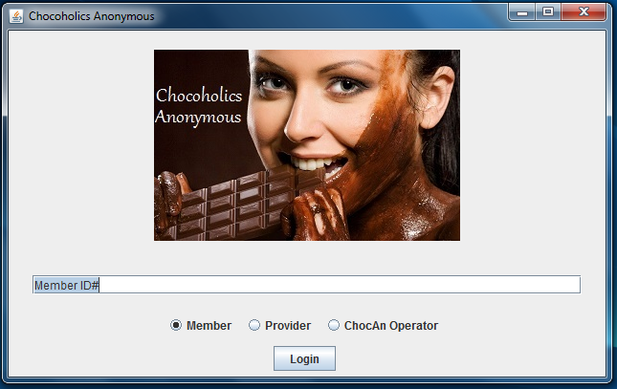
Use the radio buttons to login as Member, Provider, or ChocAn Operator.
Member Log In:
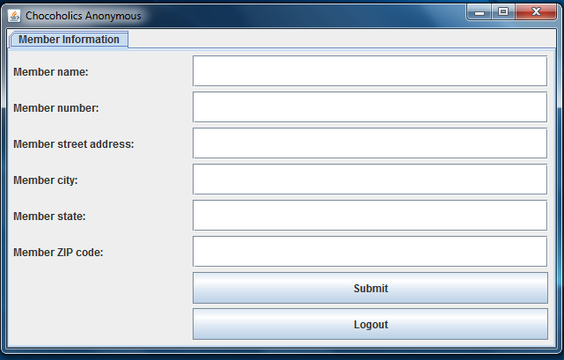
Allows members to update their information and submit it for review.

Provider Log In (Provider Information):
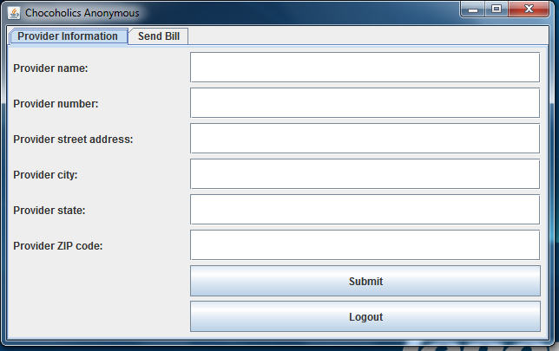
Allows Provider to update information and submit for review.

Provider Log In (Send Bill):
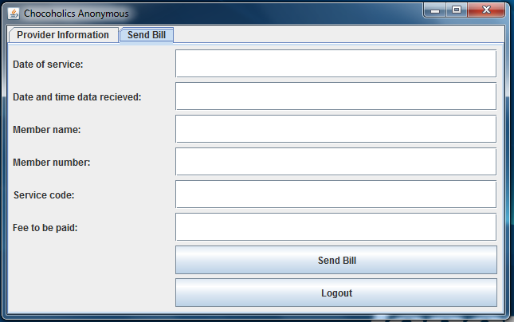
Allows Provider to send bill to ChocAn for services provided to members.

ChocoAn Operator Log In (Add Member/Provider):
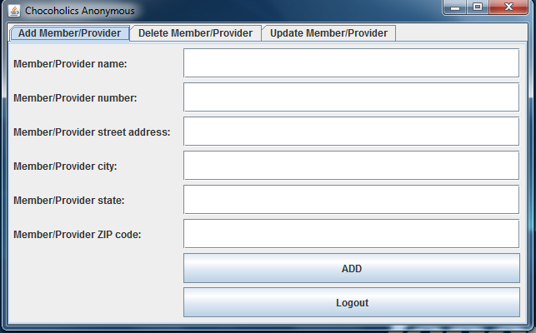
Allows ChocoAn Operator to add Member/Provider to ChocoAn.

ChocoAn Operator Log In (Delete Member/Provider):

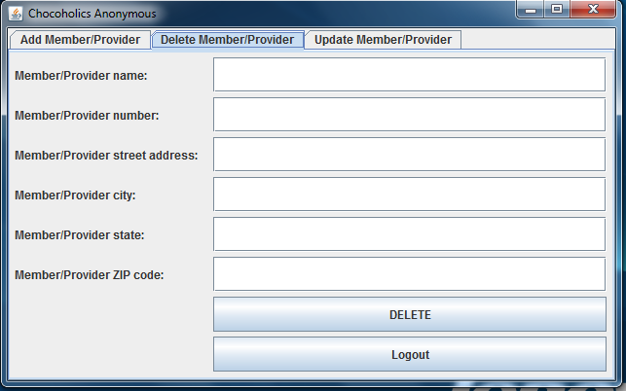
Allows ChocoAn Operator to delete Member/Provider from ChocoAn.

ChocoAn Operator Log In (Update Member/Provider):

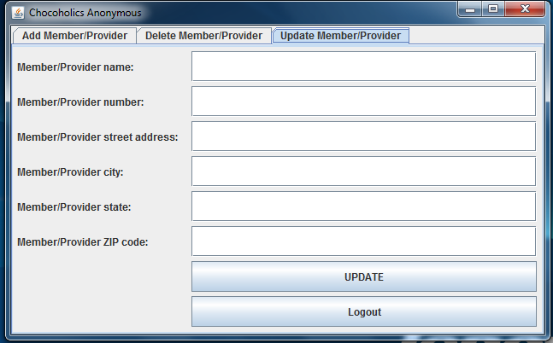

Allows ChocoAn to update Member/Provider information.

Log
October 29 2013 6pm - 9pm

Jean, Gabriel and Shawn completed the Glossary for Project.
started work on Case

October 30th 2013 6pm - 11:15pm

Jean, Gabriel and Shawn created 1st GUI panel for the Chocoholics project.

Username, Password inputs created.

Login button was created also.

Login button creates new window to display member's information.

October 31 2013 6:00pm - 9pm

Jean, Shawn, and Gabriel continued work on the project.

Today we worked on the USE CASE models for the project.

November 2 2013 6:00 pm - 8:00 pm

Shawn and Gabriel worked on the GUI for the project.

Radio buttons and and tabs modified.
Sunday November 3rd 2013 5:00pm - 8:30pm

Group met via Google Hangouts

Changed functionality to the GUI and also added new Use Case to the UML Diagram
Tabbed panes were able to be used in the GUI.

Monday November 4th 2013 6:00pm - 11:00pm

Finished the business model depicted described in the use case diagram.

Completed the GUI.

Finished the Glossary.

Tuesday November 5th 2013 6:00pm – 11:00pm

The project was completed

The Provider Send Bill pane was added

Case Tools Used:

Eclipse IDE
Cacoo is the UML Diagram software used
Git is the version control system used.

