ChocoHolics Anonymous

CSC 470

Team Members:

Description of Chocoholics Anonymous

…

Scenario

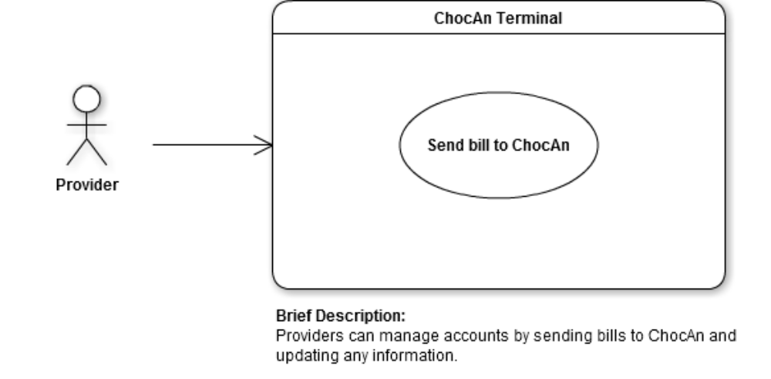

Step-by-step description:

1.
2.
3.
4.
5.
6.
7.

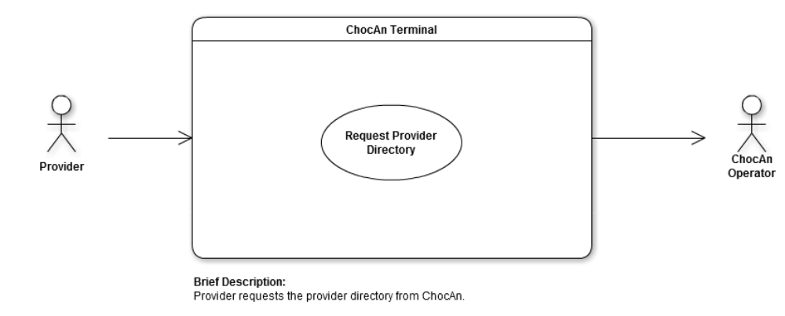

Step-by-step description:

1.
2.
3.
4.
5.
6.
7.

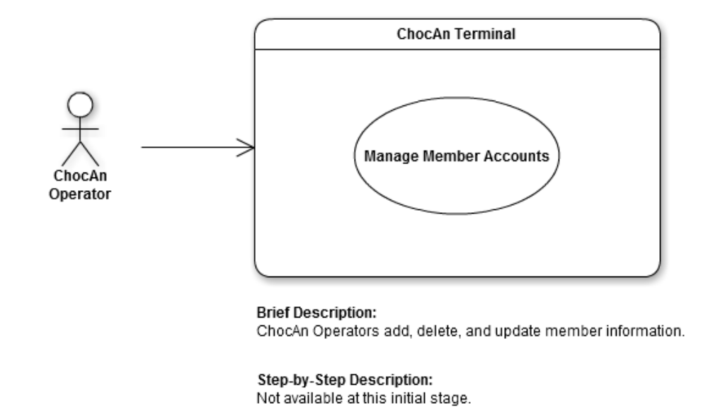

Step-by-step description:

1.
2.
3.
4.
5.
6.
7.

State Chart

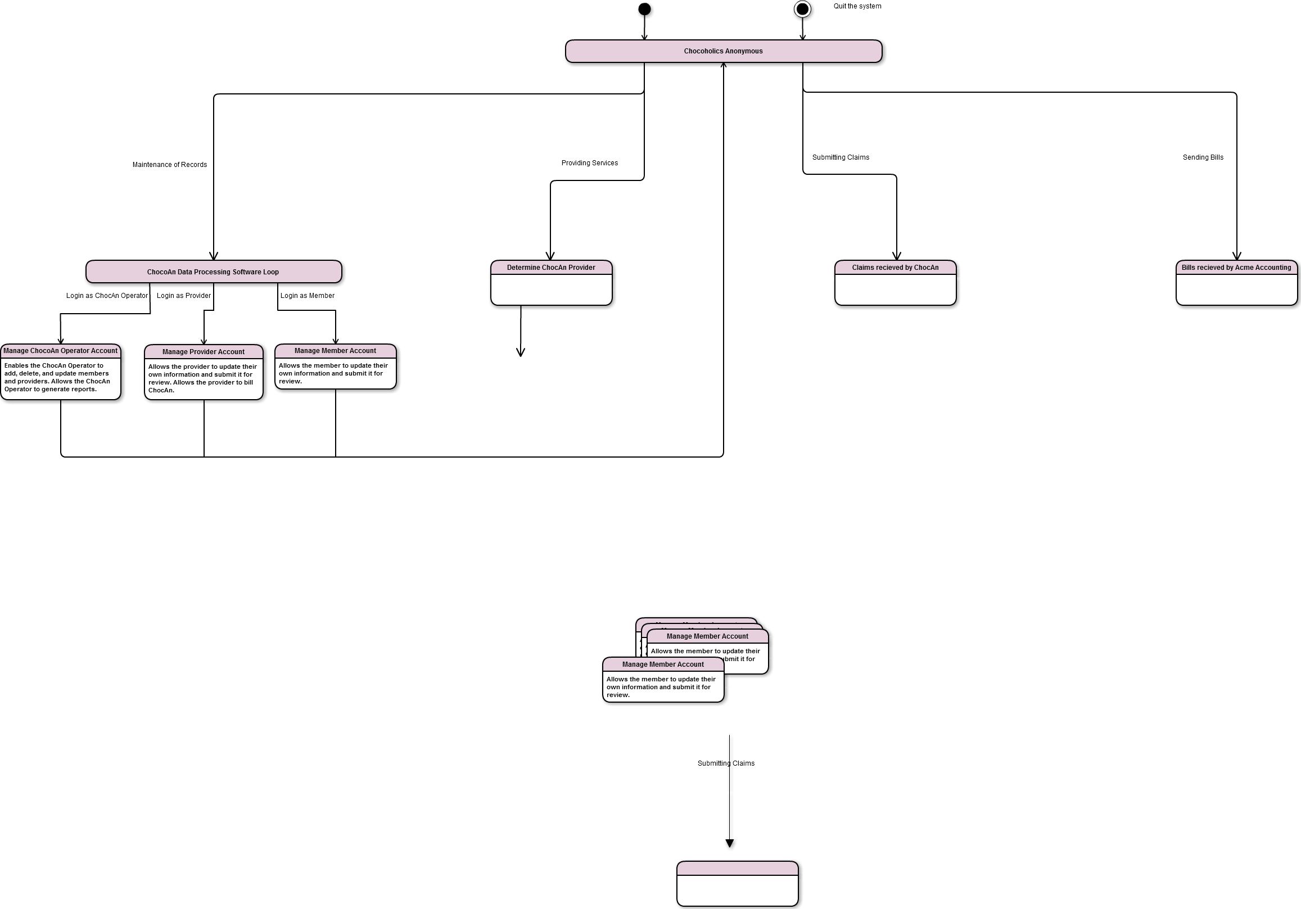

Collaboration diagrams for all non-trivial use cases

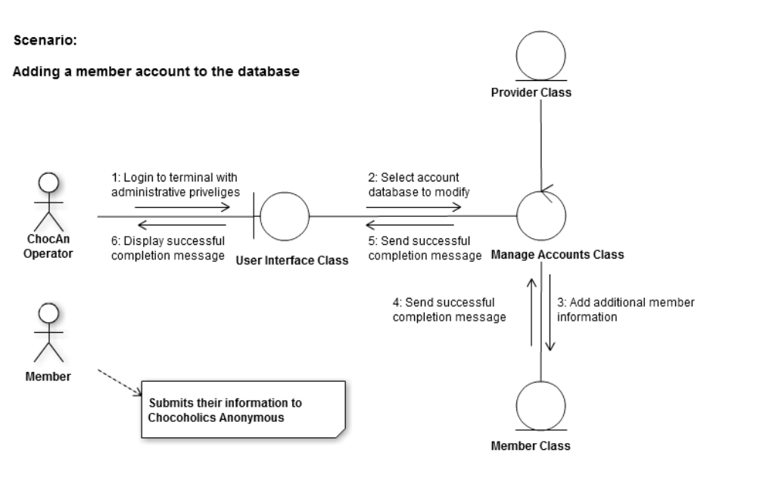
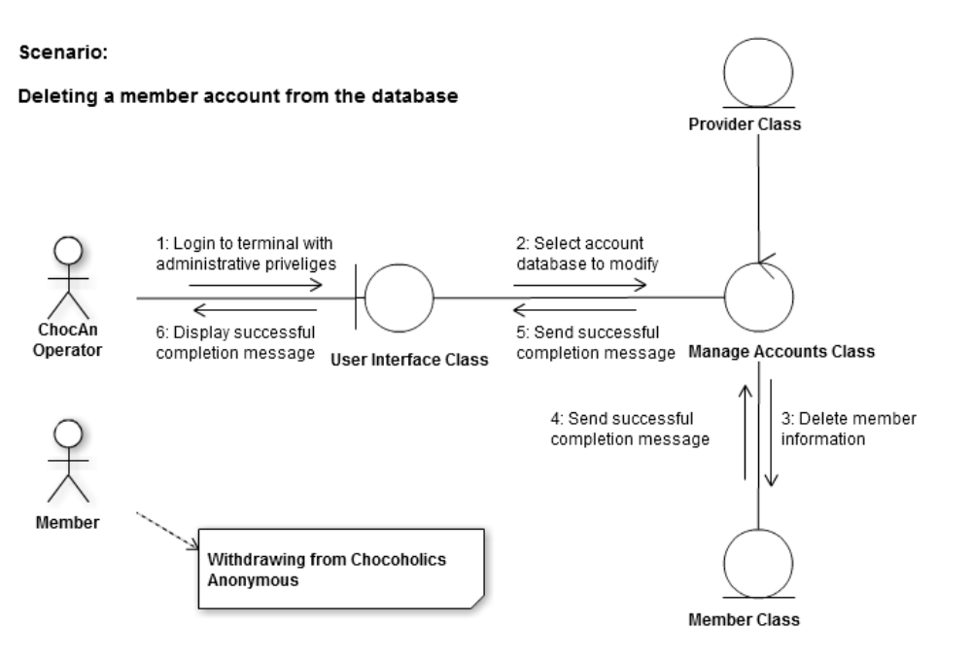

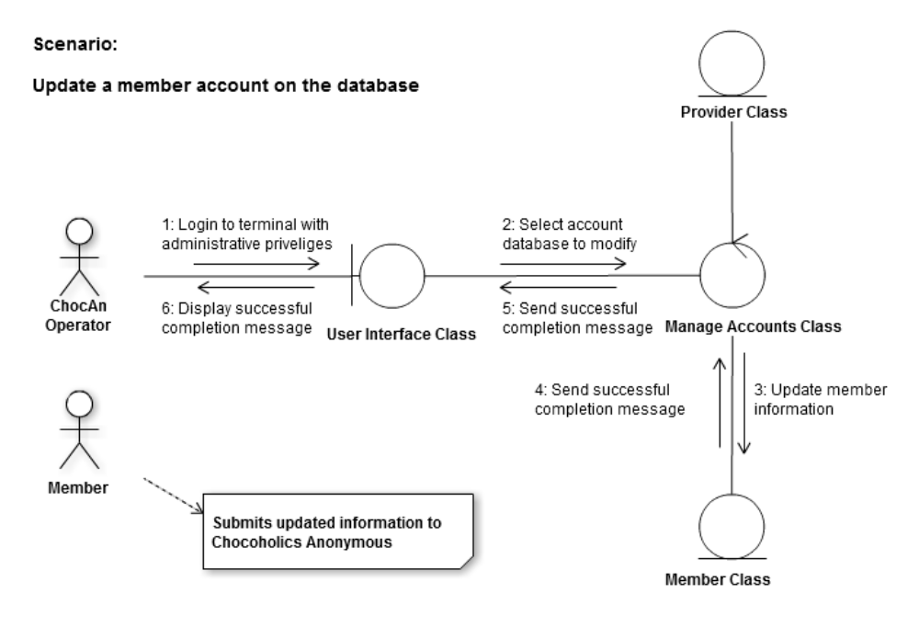

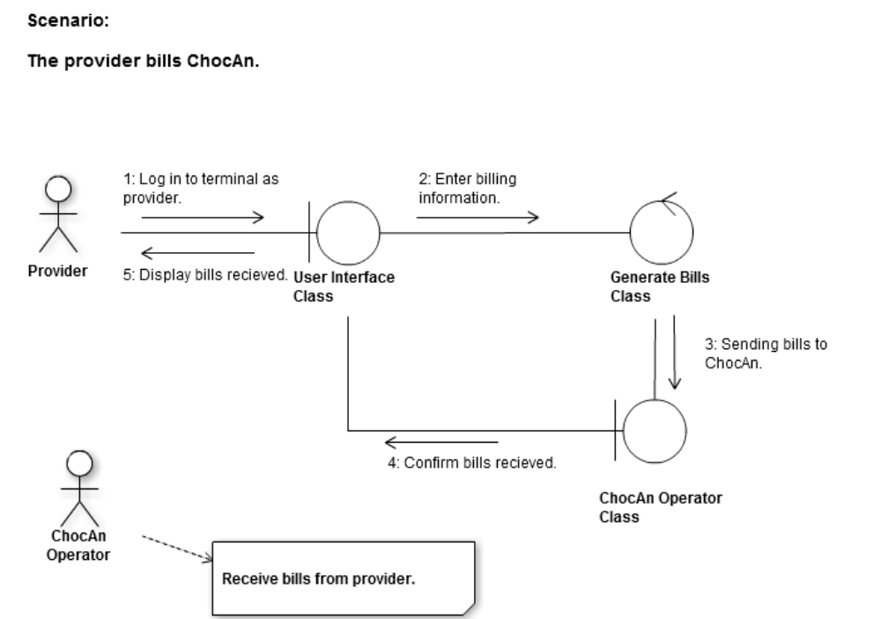

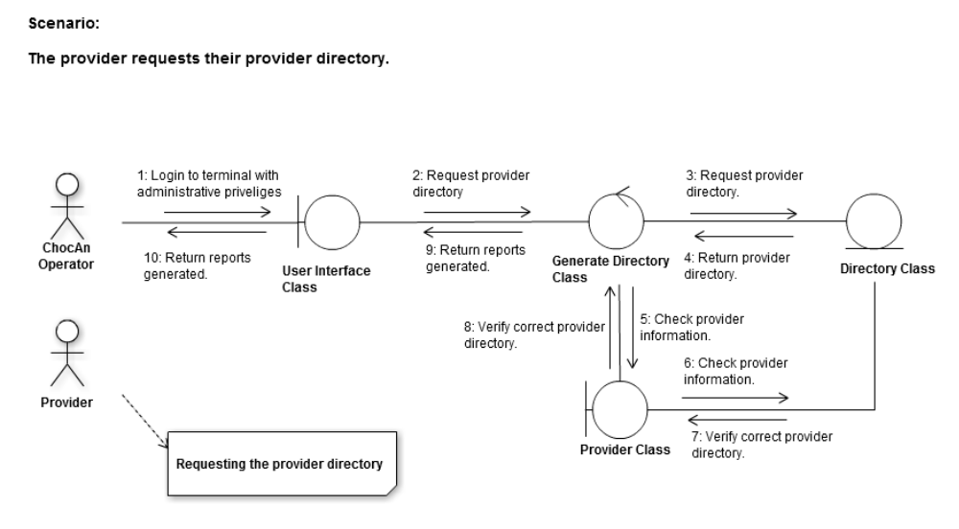

Class Diagrams

Log:

