Data, Code & RStudio

Lab 1A

Directions: Follow along with the slides and answer the questions in **red** font in your journal.

## Welcome to the labs!

* Throughout the year, you’ll be putting your data science skills to work by completing the labs.
* You’ll learn how to program in the R programming language.
  + The programming language used by actual data scientists.
* Your code will be written in RStudio which is an easy to use interface for coding using R.

## So let’s get started!

* The data for our first few labs comes from the Centers for Disease Control (CDC)
  + The CDC is a federal institution that studies public health.
* Type these two commands into your console:

data(cdc)

View(cdc)

* **Describe the data that appeared after running View(cdc):**
  + ***Who* is the information about?**
  + **What sorts of information about them was collected?**
* To find out more information about the cdc data, type the command below into your console.

?cdc

## Data: Variables & Observations

* Data can be broken up into two parts.
  1. *Observations*
  2. *Variables*
  + *Observations* are the *who* or *what* we are collecting data from/about.
  + *Variables* are the measurements or characteristics about our *observations*.
* If need be, re-type the command you used to View your data. Then answer the following:
  + **Based on the data, describe a few characteristics about the first observation.**
  + **What does the first column tell us about our observations?**
* In order to describe the first observation, notice that you had to look at the first row of the spreadsheet. Each row, in this case, describes a person.
* The columns of the spreadsheet represent variables.

## Uncovering our Data’s Structure

* Now that we’ve looked at our data, let’s look at how RStudio is organized.
* RStudio’s main window is composed of four *panes*
* Find the pane that has a *tab* titled *Environment* and click on the *tab*.
  + This pane contains a list of everything that’s currently available for R to use.
  + Notice that R knows we have our cdc data loaded.
* **How many students are in our cdc data set?**
* **How many variables were measured for each student?**

## Type the following commands into the console

dim(cdc)

nrow(cdc)

ncol(cdc)

names(cdc)

* **Which of these functions tell us the number of observations in our data?**
* **Which of these functions tell us the number of variables?**

## First Steps

* Typing commands into the console is your first step into the larger world of *programming* or *coding* (terms which are often used interchangeably).
* Coding is all about learning how to send instructions to your computer.
  + The way we *speak* to the computer, using a coding language, is *syntax*.
* R is one of many coding languages. Each coding language is slightly different, and these differences are reflected in the syntax.
* *Capitalization*, *spelling* and *punctuation* are REALLY important.

## Syntax matters

* **Run the following commands and write down what happens after each. Which does R understand?**

Names(cdc)

NAMES(cdc)

names(cdc)

names(CDC)

## R’s most important syntax

*function* (y~x, data = ____ )

* Notice the command and its corresponding plot.

bargraph(~grade, data = cdc)

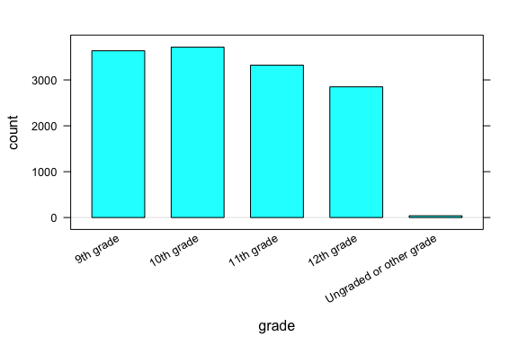

* Most of the commands you will be using follow the syntax below:

*function* (y~x, data = ____ )

* To create graphs or plots you need to provide R with the following:
  + The name of the R function, often the plot’s name, that tells the computer how to create your graph.
  + The variable(s) containing the information we want the function to use.
  + The data set containing the variables.
* Later on, we’ll see we can use this syntax to do more than create graphs.

## Syntax in action

*function* (y~x, data = ____ )

* Search through the different panes. Find and then click on the *Plots* tab.
  + To get back to the slides, find and then click on the *Viewer* tab.
* **Which one of these plots would be useful for answering the question: *Is it unusual for students in the CDC dataset to be taller than 1.8 meters?***

histogram(~height, data = cdc)

bargraph(~drive_text, data = cdc)

xyplot(weight~height, data = cdc)

* **Do you think it’s unusual for students in the data to be taller than 1.8 meters? Why or why not?**

## On your own:

* After completing the lab, answer the following questions:
  + **What is *public health* and do we collect data about it?**
  + **How do you think our data was collected? Does it include every high school aged student in the US?**
  + **How might the CDC use this data? Who else could benefit from using this data?**
  + **Write the code to visualize the distribution of weights of the students in the CDC data with a histogram. What is the *typical* weight?**
  + **Write the code to create a bargraph to visualize the distribution of how often students ate fruit. About how many students did not eat fruit over the previous 7 days?**