Export, Upload, Import

Lab 1C

Directions: Follow along with the slides and answer the questions in **red** font in your journal.

## Whose data? Our data.

* Throughout the previous labs, we’ve been using data that was already loaded in RStudio.
  + But what if we want to analyze our own data?
* This lab is all about learning how to load our own participatory sensing data into RStudio

## Export, upload, import

* Before we can perform any analysis, we have to load data into R.
* When we want to get our participatory sensing data into RStudio, we:
  + Export the data from your class’ campaign page.
  + Upload data to *RStudio* server
  + Import the data into R’s working memory

## Exporting

* To begin, go to the IDS Tools page.
  + Click on the Campaign Manager
  + Fill in your username and password and click “Sign in.”
  + 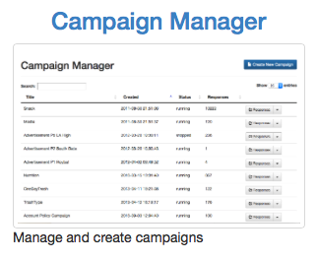
  + Campaign manager
  + If you forget your username or password, ask your teacher to remind you.

## Campaign Manager

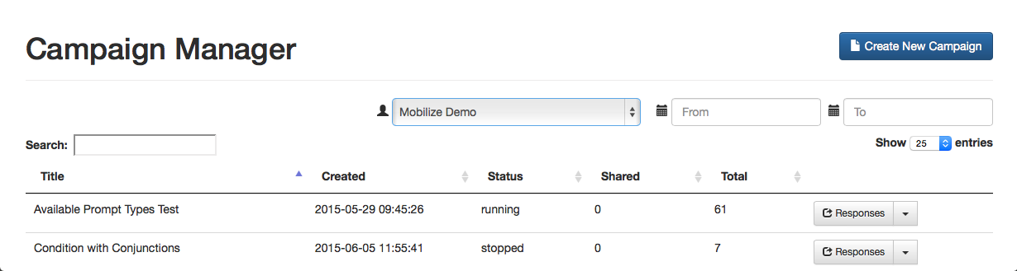

Campaign Manager

* After logging in, your screen should look similar to this.
* Click on the dropdown arrow for the campaign you are interested in downloading.

## Dropdown Arrow

* The options for the dropdown menu will look like this.
* 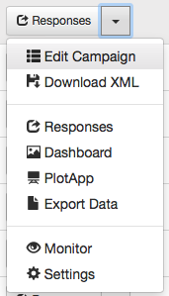
* Campaign tab
* Look for the option labeled Export Data. Click it.
  + Remember where you save your file!

## Exporting

* When you clicked the Export link a *.csv* file was saved on your computer.
* Now that the file is on your computer, we need to upload it into RStudio.

## Uploading

* Look at the four different *panes* in RStudio.
  + Find the *pane* with a Files tab.
  + Click it!

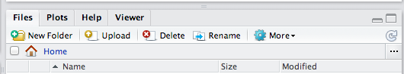

Upload Button

* Click the button on the Files pane that says “Upload”
  + Click on “Choose File” and find the SurveyResponses.csv file you saved to your computer.
  + Hit the *OK* button.
* Voila!
  + If you look in the Files pane, you should be able to find your data!

## Upload vs. Import

* By Uploading your data into RStudio you’ve really only given yourself access to it.
  + Don’t believe me? Look at the Environment pane … where’s your data?
* To actually use the data we need to Import it into your computer’s memory.
* To compute more quickly and efficiently, R will only keep a few data sets stored in its memory at a time.
  + By importing data, you are telling R that this is a data set that is important to store it in its memory so you can use it.

## Importing

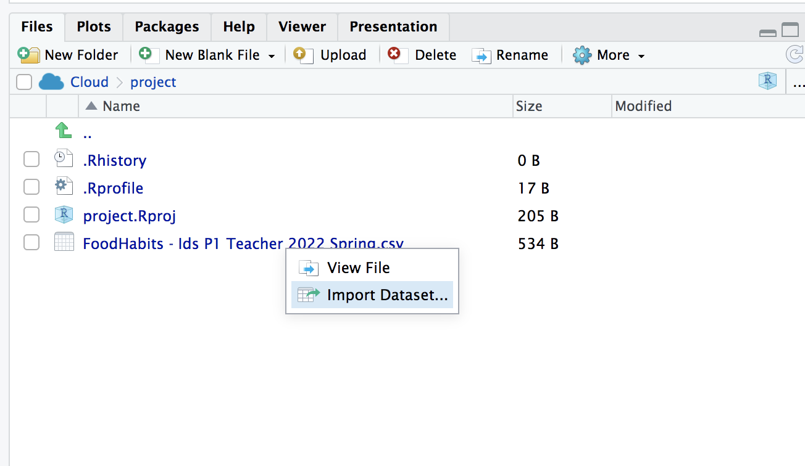

import data

* On the Files pane, find the data you want to import.
* Click on the name of the file and choose the option “Import Data set…”

## Data Preview

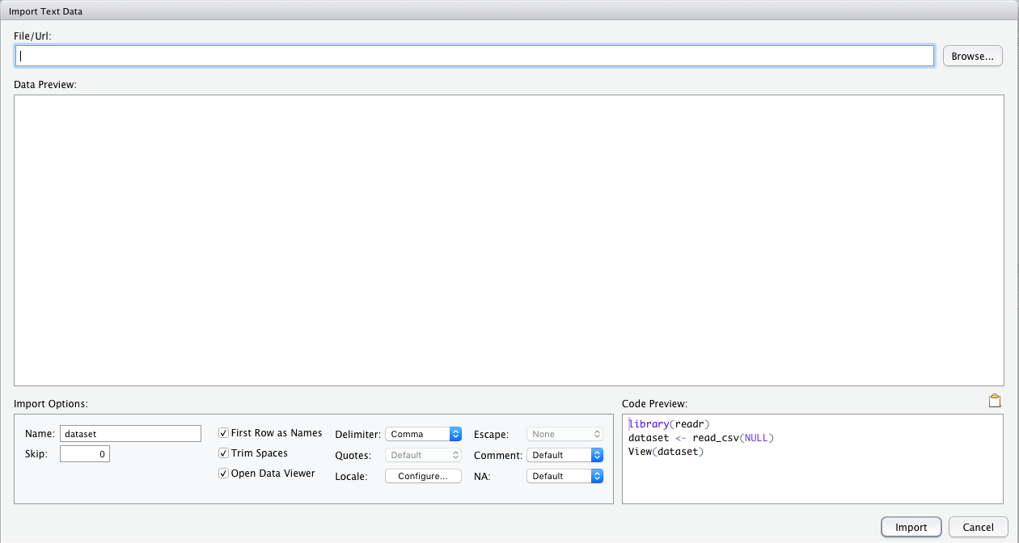

Data Preview

* You can give your data a name using the Name: field in the lower left corner.

## What’s in a name?

* The name you give your data is what you will use when you write code to analyze your data.
  + Good names are short and descriptive.
  + For your food habits campaign, some good names to use would be “foodhabits” or even just “food”.
* When you’re ready, click the *Import* button.

## read.csv()

* After you click import you might notice something appeared in your console.

data.file <- read_csv("~/SurveyResponse.csv")  
View(data.file)

* This is the actual code RStudio uses to read your data when you clicked the import button.
  + So instead of using the RStudio buttons, we can actually Import by writing code similar to what was output into the console!
  + This will come in handy later in the course.

## A word on staying organized…



Upload Button

* The Files tab has a few other features to help keep you organized.
  + *SurveyResponse* probably isn’t the best name for your data. Click Rename to give it a clearer name.
  + Often, it’s helpful to give your data file the same name as when you import your data.
  + So in this case, we could name our data file *foodhabits.csv*

## Export, upload, import

* After you *export*, *upload*, *import* your data you’re ready to analyze.
* **View your data, select a variable and try to make an appropriate plot for that variable.**
  + If you’re having issues, make sure you’re spelling the name of your data correctly.