**The Dementors**

Math Game

Contents

**1.Authors** 3

**2.Programs we used** 3

**3. Summary** 4

3.1 Goals 4

3.2 Stages of realization 4

3.3 Level of difficulty main problems during realization 4

**4. Diagram** 4

**5. Description of the functions used** 4

# **1.Authors**

* Miriam Kostadinova Georgieva 9g
* Scrum Trainer
* [MKGeorgieva19@codingburgas.bg](mailto:MKGeorgieva19@codingburgas.bg)
* Ivan Dyankov Staev 9v
* Developer 2 C++
* [IDStaev19@codingburgas.bg](mailto:IDStaev19@codingburgas.bg)
* Marieta Petkova Stoycheva 9g
* Developer 2 C++
* [MPS](mailto:MPS)toycheva19@codingburgas.bg
* Martin Valentinov Martinov 9b
* Developer 3 Code Check
* [MVMartinov19@codingburgas.bg](mailto:MVMartinov19@codingburgas.bg)
* Teodora Nikolaeva Kompanska 9a
* Developer 1 Front End
* [TNKompanska19@codingburgas.bg](mailto:TNKompanska19@codingburgas.bg)

# **2.Programs we used**

* Visual Studio 2019 – to write our code (in C++)
* Visual Studio Code – to make our README.md
* Discord – to communicate
* Git Hub – for better teamwork

# **3. Summary**

## 3.1 Goals

Our goals are to make a game that everyone can play, regardless the ages. We did two games in one on purpose, because we want more people to play our game. Especially Tic-Tac-Toe and War fans.

## 3.2 Stages of realization

***First stage*** – planning. First step we took was to create a group in Discord to distribute roles to each person in our team and to decide which days and which time we can talk to discuss our problems

***Second stage*** - realization. When we have discussed every problem and every role, we started to work on code and every day we had to talk about what's going on and who's got how far.

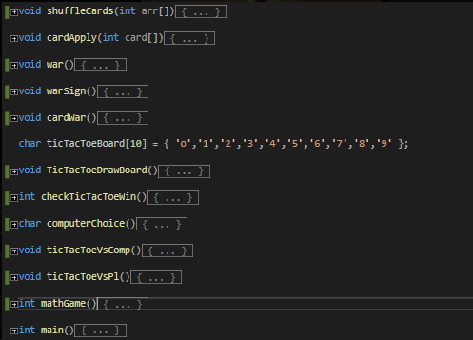***Third stage*** – documentation and presentation. When we have finished with work on code, we should write documentation and make presentation to present our project easier.

## 

## 3.3 Level of difficulty main problems during realization

First, we have to learn how to work with GitHub and with Command Prompt (cmd). Then we have a few problems with code such as bugs and with the design of the menu. We had some problems with our project, then our mentor helped us and after that we improved our work and finished our tasks at the end.

# **4. Diagram**

# **5. Description of the functions used**

|  |  |  |  |
| --- | --- | --- | --- |
| **Function name** | **Purpose** | **Arguments** | **Returned value** |
| **shuffleCards()** | Function for shuffling the cards for war | int arr[] | VOID |
| **cardApply()** | Function for applying numbers to index | int card[] | VOID |
| **war()** | Card War is checking how many cards does everyone have | - | VOID |
| **warSign()** | Function for displaying the “War” title | - | VOID |
| **cardWar()** | Main Function of the Card War game | - | VOID |
| **ticTacToeDrawBoard()** | Function for displaying the tic tac toe board | - | VOID |
| **checkTicTacToeWin()** | Function for checking who is the winner in the game | - | INT |
| **computerChoice()** | Function for generating a random free square | - | CHAR |
| **ticTacToeVsComp()** | Function for playing tic tac toe vs computer | - | VOID |
| **ticTacToeVsPl()** | Function for playing tic tac toe vs another player | - | VOID |
| **mathGame()** | The main function for the game | - | INT |