**RECONOCIMIENTO DE MATRICULAS**

Imagen original: “matricula.jpg”

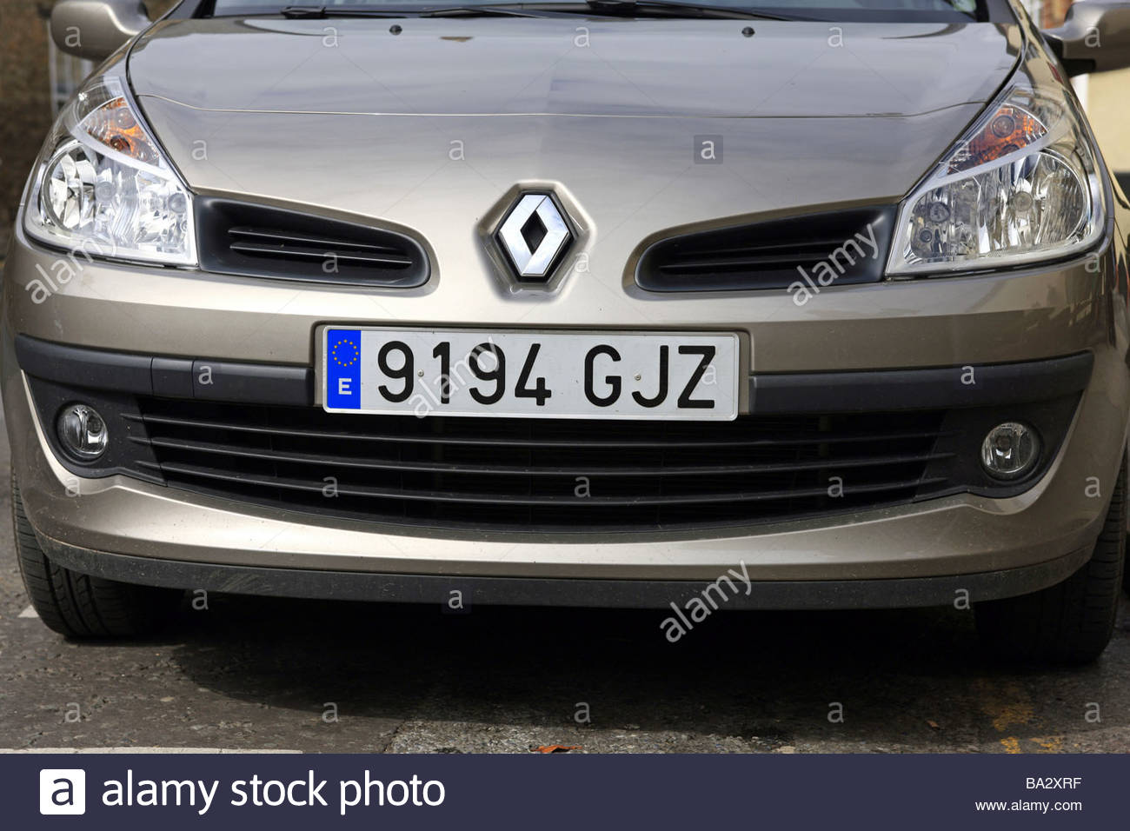

Estructura general del programa más resultado:

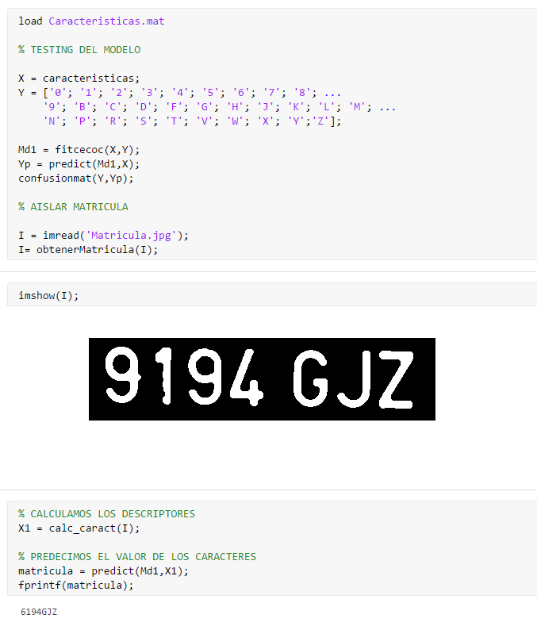

**Como podemos ver, el programa ha confundido el primer 9 con un 6. El resto de caracteres son correctos.**

Función busca la matricula en la imagen y devuelve un recorte que contiene la misma y binarizada:

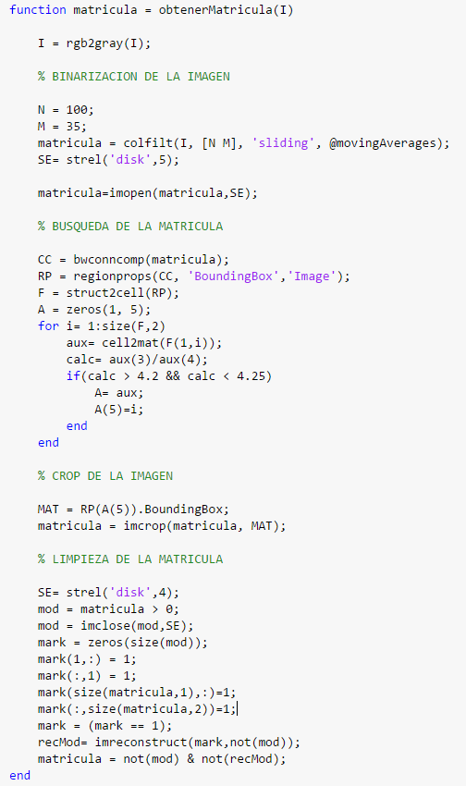

Función para calcular las características (entregada en la sesión 8):

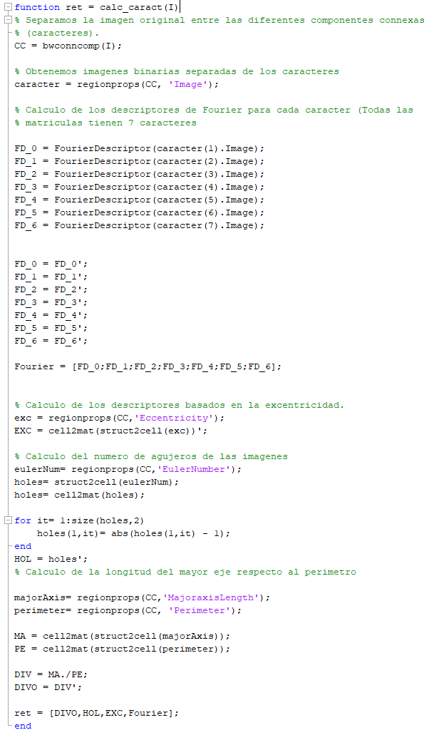

A a a a a a a a a a a a a a a a aa a a a a a a a a a a a a a a a a a a a a a a aa a a a a a a a a a a a a a a a a a aa a a a a a a a a a a a a a a a a a a a a a a aa a a a a a a a a a a a a a a a a a aa a a a a a a a a a a a a a a a a a a a a a a aa a a a a a a a a a a a a a a a a a aa a a a a a a a a a a a a a a a a a a a a a a aa a a a a a a a a a a a a a a a a a aa a a a a a a a a a a a a a a a a a a a a a a aa a a a a a a a a a a a a a a a a a aa a a a a a a a a a a a a a a a a a a a a a a aa a a a a a a a a a a a a a a a a a aa a a a a a a a a a a a a a a a a a a a a a a aa a a a a a a a a a a a a a a a a a aa a a a a a a a a a a a a a a a a a a a a a a aa a a a a a a a a a a a a a a a a a aa a a a a a a a a a a a a a a a a a a a a a a aa a a a a a a a a a a a a a a a a a aa a a a a a a a a a a a a a a a a a a a a a a aa a a a a a a a a a a a a a a a a a aa a a a a a a a a a a a a a a a a a a a a a a aa a a a a a a a a a a a a a a a a a aa a a a a a a a a a a a a a a a a a a a a a a aa a a a a a a a a a a a a a a a a a aa a a a a a a a a a a a a a a a a a a a a a a aa a a a a a a a a a a a a a a a a a aa a a a a a a a a a a a a a a a a a a a a a a aa a a a a a a a a a a a a a a a a a aa a a a a a a a a a a a a a a a a a a a a a a aa a a a a a a a a a a a a a a a a a aa a a a a a a a a a a a a a a a a a a a a a a aa a a a a a a a a a a a a a a a a a aa a a a a a a a a a a a a a a a a a a a a a a aa a a a a a a a a a a a a a a a a a aa a a a a a a a a a a a a a a a a a a a a a a aa a a a a a a a a a a a a a a a a a aa a a a a a a a a a a a a a a a a a a a a a a aa a a a a a a a a a a a a a a a a a aa a a a a a a a a a a a a a a a a a a a a a a aa a a a a a a a a a a a a a a a a a aa a a a a a a a a a a a a a a a a a a a a a a aa a a a a a a a a a a a a a a a a a aa a a a a a a a a a a a a a a a a a a a a a a aa a a a a a a a a a a a a a a a a a aa a a a a a a a a a a a a a a a a a a a a a a aa a a a a a a a a a a a a a a a a a aa a a a a a a a a a a a a a a a a a a a a a a aa a a a a a a a a a a a a a a a a a aa a a a a a a a a a a a a a a a a a a a a a a aa a a a a a a a a a a a a a a a a a aa a a a a a a a a a a a a a a a a a a a a a a aa a a a a a a a a a a a a a a a a a aa a a a a a a a a a a a a a a a a a a a a a a aa a a a a a a a a a a a a a a a a a aa a a a a a a a a a a a a a a a a a a a a a a aa a a a a a a a a a a a a a a a a a aa a a a a a a a a a a a a a a a a a a a a a a aa a a a a a a a a a a a a a a a a a aa a a a a a a a a a a a a a a a a a a a a a a aa a a a a a a a a a a a a a a a a a aa a a a a a a a a a a a a a a a a a a a a a a aa a a a a a a a a a a a a a a a a a aa a a a a a a a a a a a a a a a a a a a a a a aa a a a a a a a a a a a a a a a a a aa a a a a a a a a a a a a a a a a a a a a a a aa a a a a a a a a a a a a a a a a a aa a a a a a a a a a a a a a a a a a a a a a a aa a a a a a a a a a a a a a a a a a aa a a a a a a a a a a a a a a a a a a a a a a aa a a a a a a a a a a a a a a a a a aa a a a a a a a a a a a a a a a a a a a a a a aa a a a a a a a a a a a a a a a a a aa a a a a a a a a a a a a a a a a a a a a a a aa a a a a a a a a a a a a a a a a a aa a a a a a a a a a a a a a a a a a a a a a a aa a a a a a a a a a a a a a a a a a aa a a a a a a a a a a a a a a a a a a a a a a aa a a a a a a a a a a a a a a a a a aa a a a a a a a a a a a a a a a a a a a a a a aa a a a a a a a a a a a a a a a a a aa a a a a a a a a a a a a a a a a a a a a a a aa a a a a a a a a a a a a a a a a a aa a a a a a a a a a a a a a a a a a a a a a a aa a a a a a a a a a a a a a a a a a aa a a a a a a a a a a a a a a a a a a a a a a aa a a a a a a a a a a a a a a a a a aa a a a a a a a a a a a a a a a a a a a a a a aa a a a a a a a a a a a a a a a a a aa a a a a a a a a a a a a a a a a a a a a a a aa a a a a a a a a a a a a a a a a a aa a a a a a a a a a a a a a a a a a a a a a a aa a a a a a a a a a a a a a a a a a aa a a a a a a a a a a a a a a a a a a a a a a aa a a a a a a a a a a a a a a a a a aa a a a a a a a a a a a a a a a a a a a a a a aa a a a a a a a a a a a a a a a a a aa a a a a a a a a a a a a a a a a a a a a a a aa a a a a a a a a a a a a a a a a a aa a a a a a a a a a a a a a a a a a a a a a a aa a a a a a a a a a a a a a a a a a aa a a a a a a a a a a a a a a a a a a a a a a aa a a a a a a a a a a a a a a a a a aa a a a a a a a a a a a a a a a a a a a a a a aa a a a a a a a a a a a a a a a a a aa a a a a a a a a a a a a a a a a a a a a a a aa a a a a a a a a a a a a a a a a a aa a a a a a a a a a a a a a a a a a a a a a a aa a a a a a a a a a a a a a a a a a aa a a a a a a a a a a a a a a a a a a a a a a aa a a a a a a a a a a a a a a a a a aa a a a a a a a a a a a a a a a a a a a a a a aa a a a a a a a a a a a a a a a a a aa a a a a a a a a a a a a a a a a a a a a a a aa a a a a a a a a a a a a a a a a a aa a a a a a a a a a a a a a a a a a a a a a a aa a a a a a a a a a a a a a a a a a aa a a a a a a a a a a a a a a a a a a a a a a aa a a a a a a a a a a a a a a a a a aa a a a a a a a a a a a a a a a a a a a a a a aa a a a a a a a a a a a a a a a a a aa a a a a a a a a a a a a a a a a a a a a a a aa a a a a a a a a a a a a a a a a a aa a a a a a a a a a a a a a a a a a a a a a a aa a a a a a a a a a a a a a a a a a aa a a a a a a a a a a a a a a a a a a a a a a aa a a a a a a a a a a a a a a a a a aa a a a a a a a a a a a a a a a a a a a a a a aa a a a a a a a a a a a a a a a a a aa a a a a a a a a a a a a a a a a a a a a a a aa a a a a a a a a a a a a a a a a a aa a a a a a a a a a a a a a a a a a a a a a a aa a a a a a a a a a a a a a a a a a aa a a a a a a a a a a a a a a a a a a a a a a aa a a a a a a a a a a a a a a a a a aa a a a a a a a a a a a a a a a a a a a a a a aa a a a a a a a a a a a a a a a a a aa a a a a a a a a a a a a a a a a a a a a a a aa a a a a a a a a a a a a a a a a a aa a a a a a a a a a a a a a a a a a a a a a a aa a a a a a a a a a a a a a a a a a aa a a a a a a a a a a a a a a a a a a a a a a aa a a a a a a a a a a a a a a a a a aa a a a a a a a a a a a a a a a a a a a a a a aa a a a a a a a a a a a a a a a a a aa a a a a a a a a a a a a a a a a a a a a a a aa a a a a a a a a a a a a a a a a a aa a a a a a a a a a a a a a a a a a a a a a a aa a a a a a a a a a a a a a a a a a aa a a a a a a a a a a a a a a a a a a a a a a aa a a a a a a a a a a a a a a a a a aa a a a a a a a a a a a a a a a a a a a a a a aa a a a a a a a a a a a a a a a a a aa a a a a a a a a a a a a a a a a a a a a a a aa a a a a a a a a a a a a a a a a a aa a a a a a a a a a a a a a a a a a a a a a a aa a a a a a a a a a a a a a a a a a aa a a a a a a a a a a a a a a a a a a a a a a aa a a a a a a a a a a a a a a a a a aa a a a a a a a a a a a a a a a a a a a a a a aa a a a a a a a a a a a a a a a a a aa a a a a a a a a a a a a a a a a a a a a a a aa a a a a a a a a a a a a a a a a a aa a a a a a a a a a a a a a a a a a a a a a a aa a a a a a a a a a a a a a a a a a aa a a a a a a a a a a a a a a a a a a a a a a aa a a a a a a a a a a a a a a a a a aa a a a a a a a a a a a a a a a a a a a a a a aa a a a a a a a a a a a a a a a a a aa a a a a a a a a a a a a a a a a a a a a a a aa a a a a a a a a a a a a a a a a a aa a a a a a a a a a a a a a a a a a a a a a a aa a a a a a a a a a a a a a a a a a aa a a a a a a a a a a a a a a a a a a a a a a aa a a a a a a a a a a a a a a a a a aa a a a a a a a a a a a a a a a a a a a a a a aa a a a a a a a a a a a a a a a a a aa a a a a a a a a a a a a a a a a a a a a a a aa a a a a a a a a a a a a a a a a a aa a a a a a a a a a a a a a a a a a a a a a a aa a a a a a a a a a a a a a a a a a aa a a a a a a a a a a a a a a a a a a a a a a aa a a a a a a a a a a a a a a a a a aa a a a a a a a a a a a a a a a a a a a a a a aa a a a a a a a a a a a a a a a a a aa a a a a a a a a a a a a a a a a a a a a a a aa a a a a a a a a a a a a a a a a a aa a a a a a a a a a a a a a a a a a a a a a a aa a a a a a a a a a a a a a a a a a aa a a a a a a a a a a a a a a a a a a a a a a aa a a a a a a a a a a a a a a a a a aa a a a a a a a a a a a a a a a a a a a a a a aa a a a a a a a a a a a a a a a a a aa a a a a a a a a a a a a a a a a a a a a a a aa a a a a a a a a a a a a a a a a a aa a a a a a a a a a a a a a a a a a a a a a a aa a a a a a a a a a a a a a a a a a aa a a a a a a a a a a a a a a a a a a a a a a aa a a a a a a a a a a a a a a a a a aa a a a a a a a a a a a a a a a a a a a a a a aa a a a a a a a a a a a a a a a a a aa a a a a a a a a a a a a a a a a a a a a a a aa a a a a a a a a a a a a a a a a a aa a a a a a a a a a a a a a a a a a a a a a a aa a a a a a a a a a a a a a a a a a aa a a a a a a a a a a a a a a a a a a a a a a aa a a a a a a a a a a a a a a a a a aa a a a a a a a a a a a a a a a a a a a a a a aa a a a a a a a a a a a a a a a a a aa a a a a a a a a a a a a a a a a a a a a a a aa a a a a a a a a a a a a a a a a a aa a a a a a a a a a a a a a a a a a a a a a a aa a a a a a a a a a a a a a a a a a aa a a a a a a a a a a a a a a a a a a a a a a aa a a a a a a a a a a a a a a a a a aa a a a a a a a a a a a a a a a a a a a a a a aa a a a a a a a a a a a a a a a a a aa a a a a a a a a a a a a a a a a a a a a a a aa a a a a a a a a a a a a a a a a a aa a a a a a a a a a a a a a a a a a a a a a a aa a a a a a a a a a a a a a a a a a aa a a a a a a a a a a a a a a a a a a a a a a aa a a a a a a a a a a a a a a a a a aa a a a a a a a a a a a a a a a a a a a a a a aa a a a a a a a a a a a a a a a a a aa a a a a a a a a a a a a a a a a a a a a a a aa a a a a a a a a a a a a a a a a a aa a a a a a a a a a a a a a a a a a a a a a a aa a a a a a a a a a a a a a a a a a aa a a a a a a a a a a a a a a a a a a a a a a aa a a a a a a a a a a a a a a a a a aa a a a a a a a a a a a a a a a a a a a a a a aa a a a a a a a a a a a a a a a a a aa a a a a a a a a a a a a a a a a a a a a a a aa a a a a a a a a a a a a a a a a a aa a a a a a a a a a a a a a a a a a a a a a a aa a a a a a a a a a a a a a a a a a aa a a a a a a a a a a a a a a a a a a a a a a aa a a a a a a a a a a a a a a a a a aa a a a a a a a a a a a a a a a a a a a a a a aa a a a a a a a a a a a a a a a a