Instancing

1. Why did you implement instancing?
   1. The reason why I implement instancing is that it seems a basic optimization of graphic. Actually, I have had a doubt that how my computer cannot be slow while a chunk of rock and a tons of leaf are drawn. The answer of my doubt was instancing. Furthermore, I believed it can be used and adopted easily on my gam200 project. I choose instancing as a ‘A grade’
2. What is instancing?
   1. Briefly, it is a drawing technique that a chunk of object via only one call of draw function. If I give GPU an array of data, it draw same object that has same texture data with different a chunk of data kind of translation, size, and color. Fortunately, OpenGL already has a support function for instancing. What I have to do is to understand what instancing is and add a few of send uniform functions.
3. 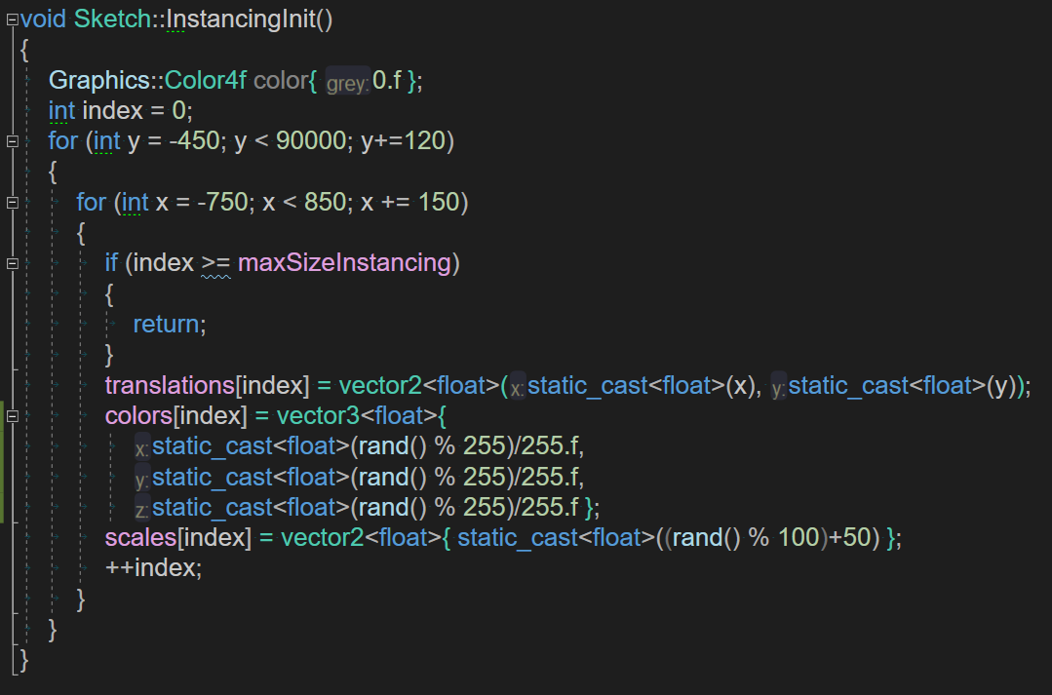How did you implement it?
   * 1. First of all, I initialize translations, colors, and scales value for instance.
     2. After then, I add two type of map which can store an array of vector2(translation, scale) and vector3(color).
     3. 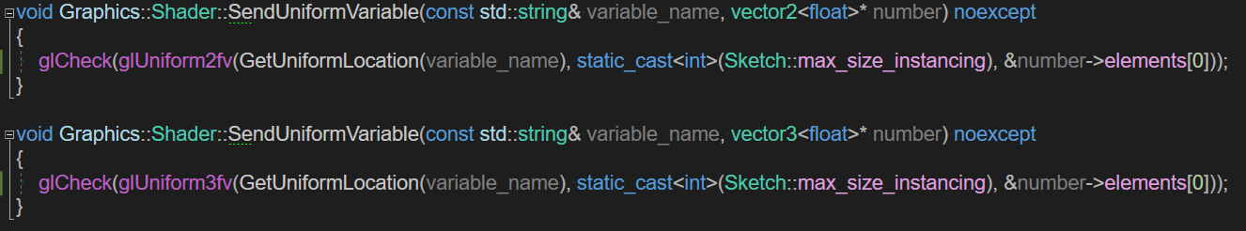In addition, I should implement the send uniform function to send these new type of data.
     4. 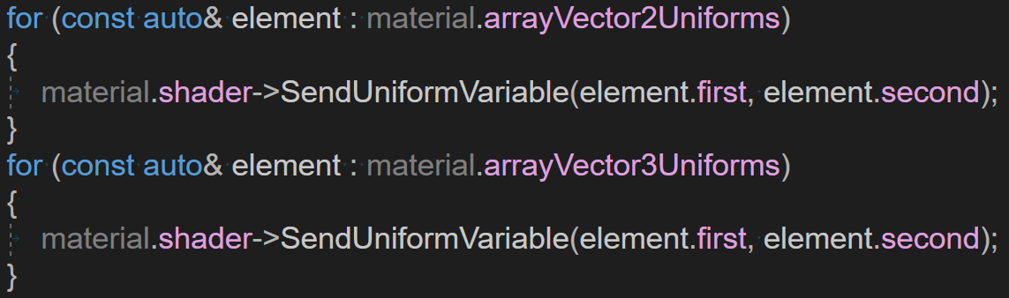Thus, I add two more overloaded SendUniformVariable
     5. and use it when uniform values should be transferred.
     6. Lastly, if we just call of glDrawArraysInstanced, everything works.
     7. It draw 100 of object with only one call with given translation, color, size value of each object.