Particle

1. Why did you implement particle?
   1. The reason why I implement particle is I don’t know about particle system. When I ask to professor what is your recommended one new features for B grade, he told me that he expect animation or particle system. I was able to determine to implement animation. Animation is easy for me because I already implemented animation in my gam 200 engine. Although I do not know high level of animation kind of spine, I can make animation seems work. However, I think it is silly and the behavior that make me stupid. Thus, I choose to implement particle system to learn about new graphics stuff.
2. What is particle?
   1. Simply, Particle is a set of tiny sprites. They are managed and emitted by particle emitter or particle generator. Each rectangles of particle have different life span. If one of them is dead, it become hibernation particle and wait to respawn.
3. How did you implement it?
   1. 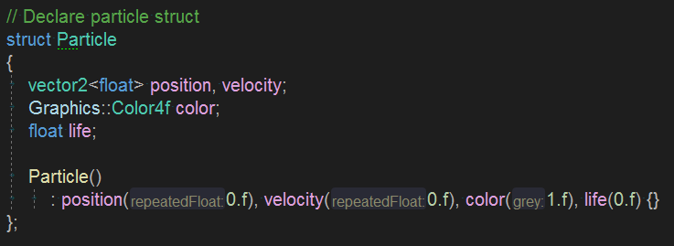First of all, I implement particle struct.
   2. 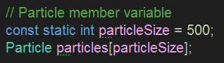Currently, it has position, velocity, color value, and life span.
   3. At the same time, I add an array of Particle.
   4. Currently the size of it is 500. It is a given number from the particle tutorial website that I referenced. It can be changed arbitrarily.
   5. 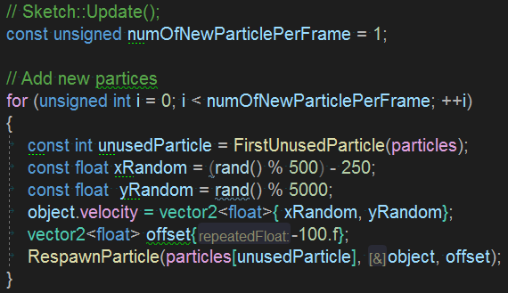In my version, there is no explicitly different shader with texture shader. It can be changed also arbitrarily and I guess it is one way to make particle fancy.
   6. What should do in at the beginning of each frame is add new particle.
   7. 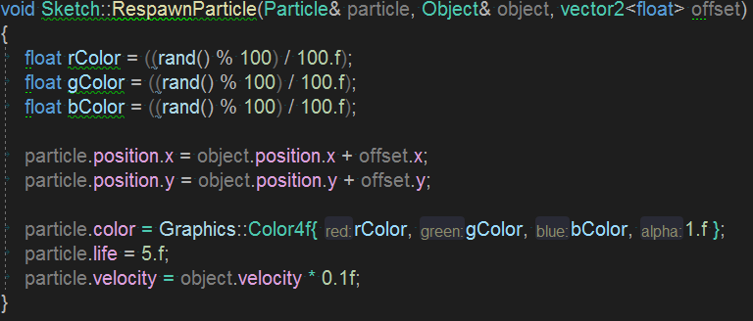The variable numOfNewParticlePerFrame indicated the number of particle that invoked in each frame.
   8. Loop try to find the index of unused particle from particle array.
   9. After find one particle, get a velocity with a random value via the function rand() and initialize it again.

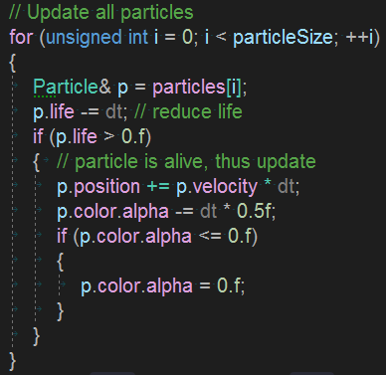

* 1. After respawn it, update every particle.
  2. First, remove their life. If it is still alive, update their value.
  3. Finally, render it!
  4. That’s the way I’ve implemented particle.

Reference: <https://learnopengl.com/In-Practice/2D-Game/Particles>