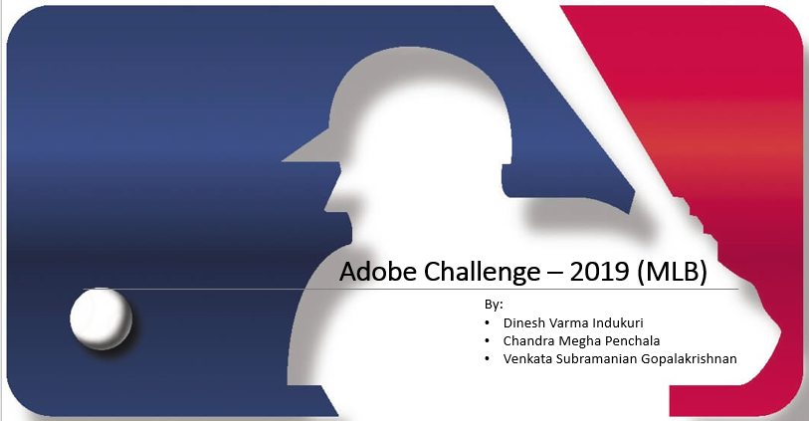

Page-1: Hi, welcome you to presentation of our analysis on Adobe challenge-2019 (MLB)

Page-2: The target of our analysis is to find out the areas of improvement for better in-stadium experience, online experience of audience, understand site performance.

For this purpose, the presentation focuses on key areas and corresponding KPI’s performance and possible recommendations.

Page-3: For our analysis we considered a year time from 1/Nov/2018 - 31/Oct/2019. This includes (off season) + (playoffs) + (world series).

Page-4: **Key areas of analysis:** For our analysis, we want to consider what makes audiences visit MLB website, how they spent time on the pages, what hinders them from making purchases/watch match streaming, …….

* MLB Audience
* MLB Online Experience
* Page Analysis
* Video-on Demand
* Ticket Purchases

Page-5: **MLB Audience**

During the 1-year time, Mobile + PC + Tablet together pulls 99% of the audience. With mobile phone visits occupying the majority share.

Most of the mobile phone visitors are from California, New York, Illinois, Texas, Florida. This helps us to target audience over a region rather than entire population.

Page-6: **MLB Audience**

Using Revenue waterfall, we can see that there is a 7% YOY decrease in revenue.

Conversion – generated a decline in 132.8 M

Visits- generated a decline in 17.2 M.

Let’s see which pages/websites have better AOV.

We can see that tickets.com, Ticketmaster are preforming better for flagship orders.

Recommendation: MLB must consider investing on referrer sites.

Page-7: **MLB Online Experience**

Visitors online experience may depend on many factors like Page UI, Ease of page navigation, layout, …..

The parameter for our consideration for online experience is page load time.

During the season’s peak time between Jun-2019 to Sep-2019,

Pages with less page load times are having more visits. And per visit the penetration is also more

Page-8: **MLB Online Experience**

Another parameter considered for online experience is Page layout/UI

During the game season, the two major teams NY Yankees, LA Dodgers are performing well. Even though NY Yankees has more generated more , but it has less conversion rate compared to LA Dodgers. It is observed that the factors that effects the conversion are availability of combo plans, Plans comparison, Page load times.

Page-9: **Page Analysis**

After visitors entering our website, let’s see which pages are making them to leave the website.

It’s observed that News page as max. exit rate from landing page.

Let’s see how much time on average a visitor spends on news articles. Majority of people spend less than 15 sec on news article page.

Recommendation: Since visitors spend less time on news article page, consider using carousel view of news which can increase viewers to glimpse the news.

Page-10: **Page Analysis** (Gameday)

Gameday page also being a popular page but don’t have any sign of navigation from Home page.

MLB must consider giving the room for Gameday page navigation from homepage.

Page-10: **Video-on-demand views**

For the matches viewed on demand, majority of unique visitors choose iOS devices. Surprisingly, most of them successfully completely viewing the videos on demand.

Page-11: **Ticket Purchases**

Among different products that perform well ticket purchase lead the table followed by Order handling fee, MLB TV subscription, Handling,….

Visitors reach our site from different sources (marketing channels). But only few of them make purchases. For the people who are dropping out the reasons can be may like price, plans comparison, page UI/ performance.

We see only 0.1% of total audience are make ticket purchases.

**Recommendations**

