**BUAN 6337 - MARKETING PREDICTIVE ANALYTICS**

**PROJECT REPORT**

**MARKETING STRATEGY FOR**

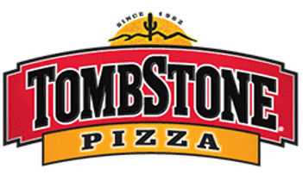

**(Category: Frozen Pizza)**

**Group 4**

**Dinesh Varma Indukuri**

**Yuting Kuang**

**Xuan Luo**

**Sehrish Rizvi**

**Zhijia Yang**

**Garima Bajaj**

**OVERVIEW**

**Introduction**:

Tombstone is a [brand](https://en.wikipedia.org/wiki/Brand) of [frozen pizza](https://en.wikipedia.org/wiki/Frozen_food) manufactured by Kraft Foods. It was introduced in 1962 and is now consumed nationwide.

Analysed the sales data of different brands of frozen pizzas across all states of Unites States at Grocery Stores with Demographics data of customers who bought them (Even though data is available for sales at drug stores, mass store our analysis was confined to Grocery stores because grocery stores contribute to nearly 80% of total Frozen pizza sales).

**Objective:**

Develop strong marketing strategies to increase revenue and market share of TOMBSTONE frozen pizza. This project contains the predictive and exploratory analysis performed with the goals to boost the units sold by TOMBSTONE and provide strategic insights to the marketing team

Our Strategy is built on following statistical analyses:

1. Descriptive Analysis
2. Panel Regression
3. Recency Frequency Monetary (RFM) Model
4. Survival Analysis

**Descriptive Analysis**

Visualization of Market share of top Brands across US in terms of volume Sales

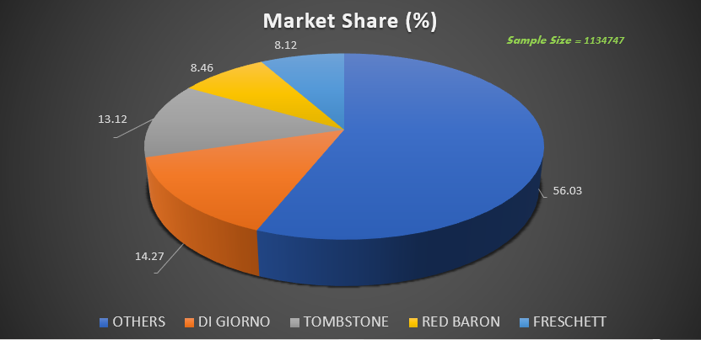

**Insight:** DIGIORNO & TOMBSTONE are the top competing brands as an individual in terms of volume sales.

**Average price per volume equivalent of Top brands**

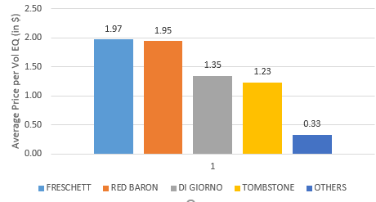

**Insight:** FRESCHETT has the Highest Average price per volume equivalent and TOMBSTONE has the second lowest average price per volume equivalent that might be the reason for TOMBSTONE to lead the market as majority people tend to buy cheap products in the consumption goods segment.

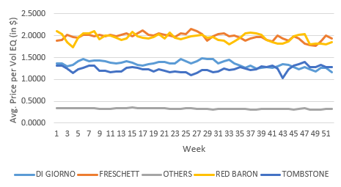

**Where to Target**

Analysed the TOMBSTONE sales data in stores at different locations. Below map shows the Dollar Sales of TOMBSTONE at various locations.

######## Waiting for XUAN Geo PLOT ################

We have sorted out 5 locations based on sales data and calculated the market share of all the brands at these locations. The finding is as below.

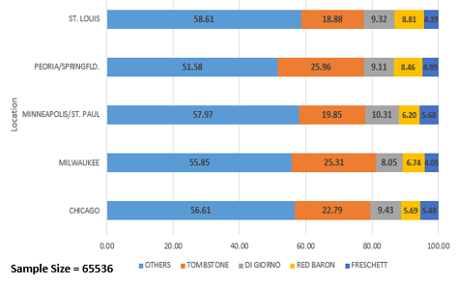

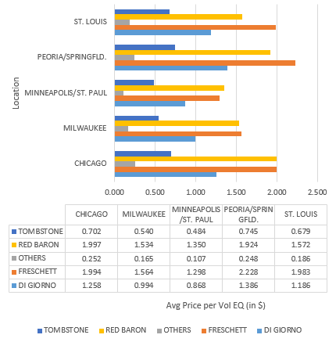

**Insight:** TOMBSTONE has a strong market as an individual in above locations varying from (20% – 25%).

**LINEAR REGRESSION ANALYSIS**

To understand the various factors affecting sales and price elasticity, linear regression was performed on full data set and sales data of TOMBSTONE. Sales amount in dollar was taken as dependent variable

|  |  |  |  |  |  |  |  |
| --- | --- | --- | --- | --- | --- | --- | --- |
| **Full Dataset** | | | | **TOMBSTONE** | | | |
| **Variable** | **Parameter** | **Standard** | **Pr > |t|** | **Variable** | **Parameter** | **Standard** | **Pr > |t|** |
| **Estimate** | **Error** | **Estimate** | **Error** |
| **Intercept** | 18.95385 | 0.06742 | <.0001 | **Intercept** | 19.18942 | 0.25294 | <.0001 |
| **PRICE_WT** | 7.64712 | 0.05506 | <.0001 | **PRICE_WT** | 2.90814 | 0.13353 | <.0001 |
| **fA** | 34.6408 | 0.20683 | <.0001 | **fA** | 32.72621 | 0.54845 | <.0001 |
| **fAP** | 37.7356 | 0.51921 | <.0001 | **fAP** | 60.5755 | 1.38807 | <.0001 |
| **fB** | 21.94923 | 0.22942 | <.0001 | **fB** | 23.94833 | 0.70211 | <.0001 |
| **fC** | 9.89757 | 0.64086 | <.0001 | **fC** | 11.28107 | 2.2728 | <.0001 |
| **dminor** | 81.25387 | 0.33985 | <.0001 | **dminor** | 83.92257 | 0.96592 | <.0001 |
| **dmajor** | 53.20874 | 0.22281 | <.0001 | **dmajor** | 53.77658 | 0.67916 | <.0001 |
| **PR** | 2.21162 | 0.11975 | <.0001 | **PR** | 0.74676 | 0.38237 | 0.0508 |

* **Change in Price per vol EQ has less impact on TOMBSTONE when compared to overall market:** We observe that an increase in the price/Vol EQ by $1 increases the total sales by $7.6 whereas increasing price/vol EQ by 1 cent for TOMBSTONE increases the total sales of our brand by $2.98 for each transaction.
* **A+ Ads have more impact on sales of TOMBSTONE when compared to the total sales of the other brands**:  The presence of A+ Ad (feature fAP) increases the total sales for TOMBSTONE from $37**.**7 which is for overall market sales to $60.5. Thus, it indicates that we need to continue to do more of A+ ads in feature which is more cost effective when compared to larger ad features.
* **When compared to the total sales for other brands, the effect of small aisle display is more for TOMBSTONE:** Small aisle displays generates as much sales ($83) for our brand when compared to the sales of other brands which is $81. Thus, we channel the marketing budget in small aisle displays.
* **Price Reduction Flag has lesser effect on TOMBSTONE when compared to the effect of price reduction flag for overall sales:** When compared to no price reduction in a week, sales for TOMBSTONE is affected by $0.74. Whereas for overall sales gets affected by $2.2 when there is price reduction.

**Regression (Panel Regression)**

In the fast-moving consumer good section, one of the major drivers of sales is price. Not only does the product’s own price impact sales but the price of the substitutes also have a big impact as this is a very price sensitive market – the consumers do not have any preference for a product.

**METHODOLOGY**

* PROC PANEL functions to account for Panel Data
* A Hausman Test was conducted to test if there is endogeneity. The P-value was

< 0.0001which is below the 5% significance level. Hence, we concluded that the fixed effects model is better. Also, intuitively it can be said that there is a simultaneous effect between quantity demanded and price which gives rise to endogeneity and hence FE is a better model as Random Effects does not have the capability to account for the problem of endogeneity

* Volume Equivalent sales was used as the dependent variable to show the change in sales when the price of the own product or the substitute’s product changes

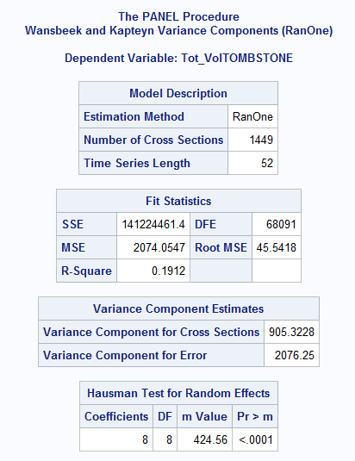

**TOMBSTONE:**

From the panel regression output, it’s clear that from the available alternatives that sales are not price elastic (own & cross).

* We can consider cross price effect of “OTHERS” on TOMBSTONE. We may say that TOMBSTONE sales are affected positively if average weighted price on OTHERS go up by 1 unit.
* Displays, Features and Price Reduction Flags by TOMBSTONE have huge positive impact on its Volume Equivalent sales. Most importantly, the combined effect (DF_CC) of major display, medium size feature and Price Reduction Flag is considerable which emphasizes that a price reduction and promotion have a major impact on sales.
* If TOMBSTONE increases weighted medium size features by 1%, its Volume equivalent sales would increase by 24.45 units
* If TOMBSTONE increases weighted major displays by 1%, its Volume equivalent sales would increase by 85.59 units
* If TOMBSTONE increases weighted Price Reduction flags by 1%, its Volume equivalent sales would increase by 10.21 units
* IF TOMBSTONE increases weighted Price Reduction flags by 1% and weighted major displays by 1% and weighted medium size features by 1% simultaneously, its Volume equivalent sales would decrease by 9.72 units
* From the below panel result it is evident that TOMBSTONE customers

tend to prefer different features among the product and inclined towards advertisements (Display) and price reduction flag has it’s own impact

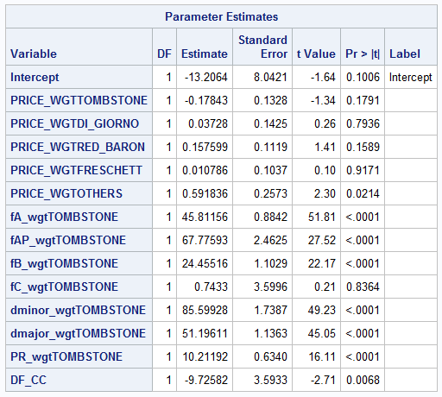

**Di GIORNO**

The other giant in this market is **Di GIORNO** which competes very closely with TOMBSTONE. These two have strong impact on market share as individual brands. Now let’s look at how our competitor’s sales are affected

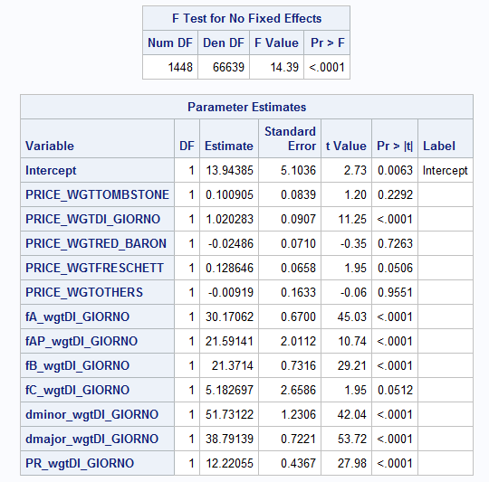

* **Own Price Effect:** 1 unit increase in average weighted price of **Di Giorno** will increase its volume equivalent Sales by around 1 unit.

Own Price Elasticity for Di Giorno**:** (1.020) *(3.03 / 23.128) = 0.1336

* **Cross Price Effect:**  A 1 unit increase in average weighted price of FRESCHETT increases the volume equivalent Sales of **Di Giorno** by around 0.128 units

Cross price elasticity **=** (0.128) * 2.77 / 23.128 = 0.015

This shows that **Di Giorno customers** are price elastic**.**

* Displays, Features and Price Reduction Flags by **Di Giorno** have significant impact on its volume equivalent Sales

**Recommendation:**

* TOMBSTONE must focus on increasing major displays, Price Reduction flags, medium & large size features Ads for its products to witness very high sales growth.

**RFM Analysis:**

We performed RFM analysis on the dataset to segment our customers based on RFM scores and to identify those customers who are most loyal, who are more responsive to marketing campaigns and who are at risk of leaving the brand. The panel data for grocery stores was combined with the product data to identify the brands chosen by different panellists. We choose only those panellists who purchased our brand "TOMBSTONE". Based on the RFM scores we have segmented our customers into 10 categories based on the following criteria.

|  |  |  |
| --- | --- | --- |
| **Customer segment** | **Recent Rank** | **Frequency & Monetary Rank** |
| Champion | 4-5 | 4-5 |
| Loyal customers | 2-5 | 3-5 |
| Potential loyal | 3-5 | 1-3 |
| Recent customers | 4-5 | 0-1 |
| Promising | 3-4 | 0-1 |
| Customers needing Attention | 2-3 | 2-3 |
| About to sleep | 2-3 | 0-2 |
| At risk | 0-2 | 2-5 |
| Hibernating | 1-2 | 4-5 |
| Lost | 0-2 | 0-2 |

**Visualization of Customer segments based on RFM and their percentage of total customers**

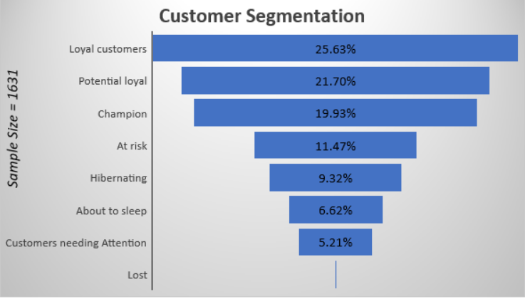

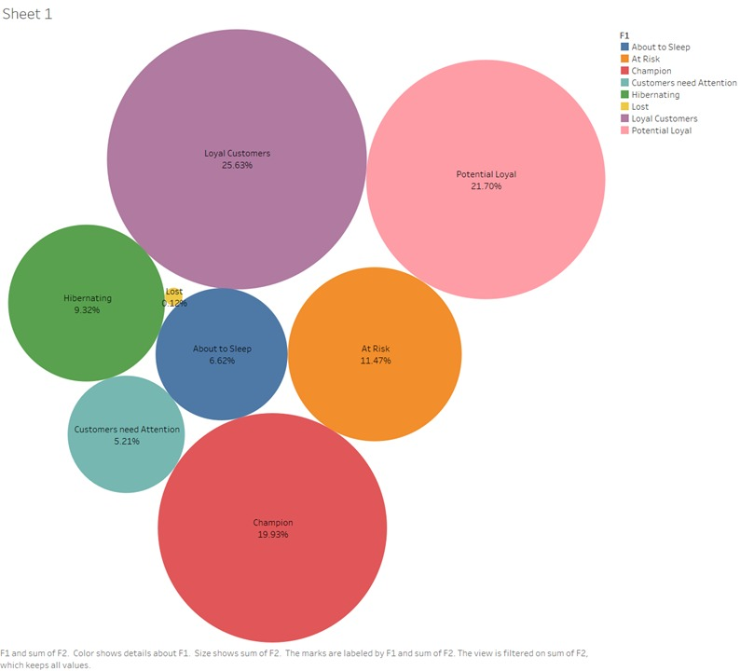

**Insights:**

1.) We have 21.7 % of Potential loyal customers which is a good sign as there are more chances that we can convert them to champions and loyalists.

2.) We have 25.63% of Loyal customers, 19.93% champions, 21.70% potential loyal customers, all together 67.26% of total customers who bought TOMBSTONE are loyal and most likely to buy it again.

3.) We have 6.62% of our customers who are about to leave our brand.

4.) Only 0.12% of customers left for other brands

**Recommendations:**

a.) We have 9.32% customer in hibernation mode, for them, we need to run an aggressive promotional campaign to win them over again.

b.) Must convert Potential Loyalist customers to champions through reward programs for their loyalty.

**Logistic Regression (Multinomial Logistic Regression)**

Multinomial Logistic regression was conducted to analyse the brand preference across various demographics.

Key findings from the multinomial logistic regression are as follows:

1) **Overall Brand Preference:**

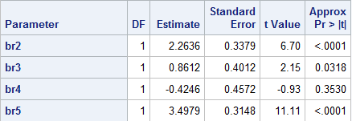

From the above it is seen that the order of brand preference at an overall level excluding the impact of customer income, family size and other demographics is as follows:

OTHER Brands > TOMBSTONE > RED BARON > FRESCHETT = DI GIORNO

**2) Effect of customer income on brand preference:**

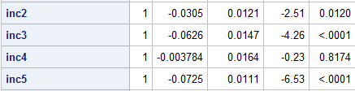

High income customers prefer TOMBSTONE & RED BARON.

3) **Effect of Family Size on brand preference:**

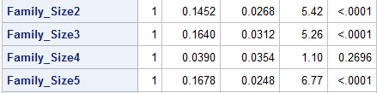

Large Families prefer TOMBSTONE & RED BARON.

4) **Effect of Age on brand preference:**

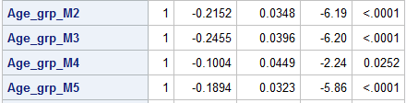

Higher age people prefer = DI GIORNO, younger age people prefer TOMBSTONE, RED BARON

**Survival Analysis**

We considered 20 weeks of data into a bucket and an compared with sales in the next 20-week bucket to compare the customer frequency to determine the churn rate.

After Creating the RFM scores, checked for the correlation between R, F, M values

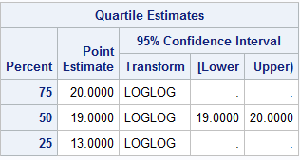

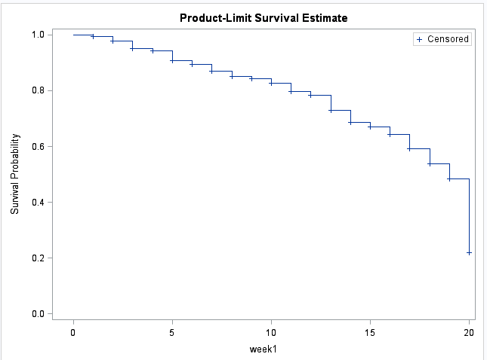

We performed survival analysis to target our customers better and reduce churn

**Insights:**

* If a customer is inactive for 13 weeks, then there is 25% chance that he would churn
* If a customer is inactive for 19 weeks, then there is 50% chance that he would churn
* If a customer is inactive for 20 weeks, then there is 75% chance that he would churn

**Recommendations:**

For TOMBSTONE to retain its customer base, it is recommended to

* Send a personal come back mail to the customer who is inactive for 13 weeks
* Send a special coupon to the customer who is inactive for 19 weeks