Design Elaboration

**Aim:** To help blind people stay distant from other individuals in order to ensure social distancing in the light of recent corona virus outbreak.

**Technical parts:**

* Arduino Uno: Arduino Uno is a microcontroller board based on the ATmega328P (datasheet). It has 14 digital input/output pins (of which 6 can be used as PWM outputs), 6 analog inputs, a 16 MHz ceramic resonator (CSTCE16M0V53-R0), a USB connection, a power jack, an ICSP header and a reset button. It contains everything needed to support the microcontroller; simply connect it to a computer with a USB cable or power it with a AC-to-DC adapter or battery to get started. It is robust, versatile, easily configurable for prototype purposes and compatible with pixy cam2.

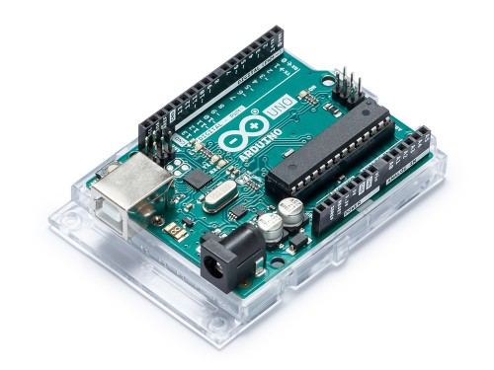

* Pixy cam2: This device is great for image recognition and processing. The pixy cam can be configured to distinguish an object from humans. This helps the device identify people and maintain distance from them rather than some other objects. Pixy2 comes with a special cable to plug directly into an Arduino.

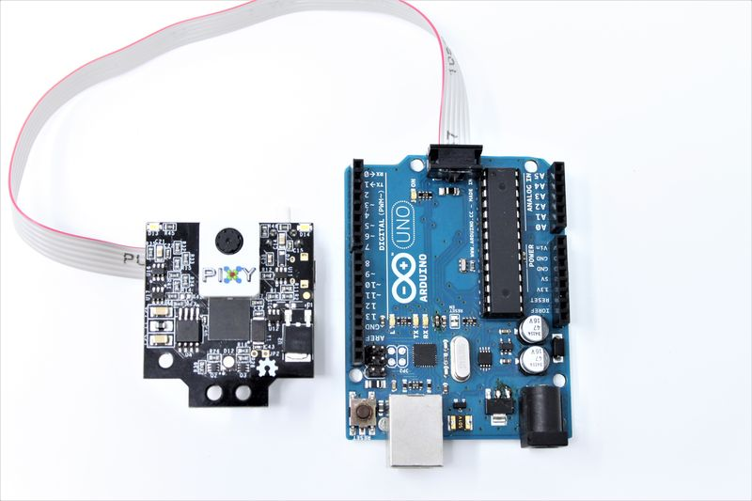

* Buzzer: To let the person know that someone is approaching them, or is within a distance of 3 feet.

**Working:**

This idea basically works by triangulation. We place 2 cameras at a known distance from one another. The angle from the cameras to the required object is measured. Using these values we find the distance between the object and the device worn around the collar of the user.

**Design:**

This device is designed as a wearable gadget to be worn around the collar of the user, something similar to a wireless Bluetooth earphone as depicted in the photos below.

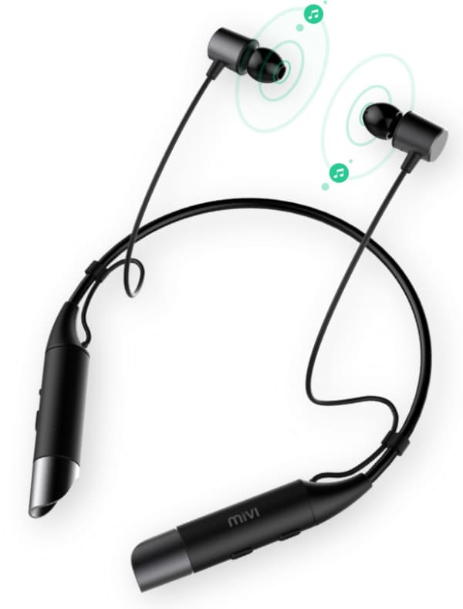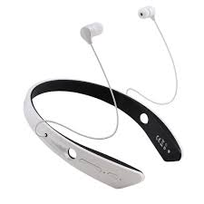

Most of the working components of this device will be housed inside the collar. The cameras can be mounted to the front and rear section of the collar to ensure full coverage of the surrounding of the user.

Another design possibility will be in the shape of a square collar with each corner having 2 cameras placed. This design differentiates from the former by achieving 360-degree coverage around the blind subject.

Placing the device around the collar of the user has the following advantages.

* The cameras can easily detect people as it is in the eye level of the user.
* The device will be less of a hinderance to the user while being used on a daily basis.
* The users can easily hear the buzzer as it is now closer to their ears.