ERRORS
1)render.plot error
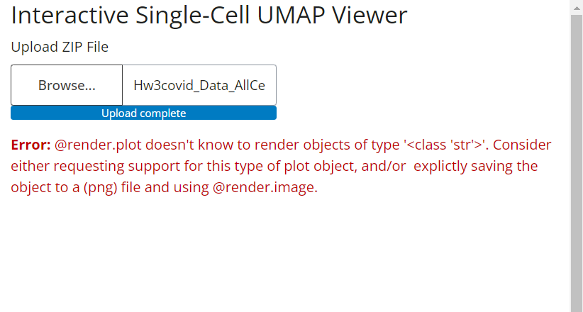
Error Explanation: The error message indicates that @render.plot does not know how to render an object of type str.
Solution: I wrote the UMAP function separately and did not use str inside it to avoid errors again.
2)set() method error
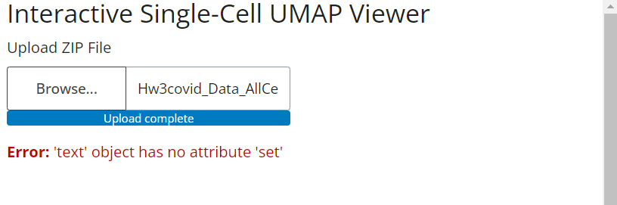
Error Explanation: The error 'text' object has no attribute 'set' occurs because you're trying to use the set() method on a string object in Python.
Solution: I used the set() method in the wrong place in my code, so I changed that part.
3)github large file error
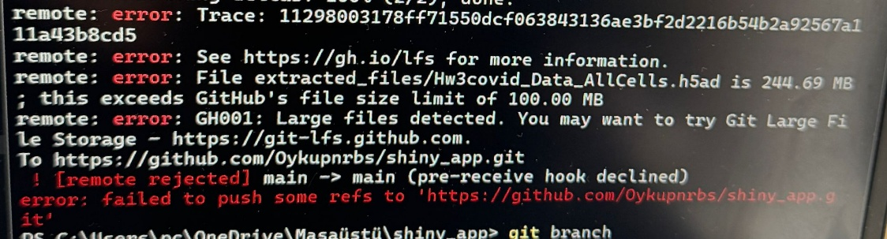
Error Explanation: The error occurs because the file size is bigger than 100.00 MB.
Solution: I pushed the files separately.

