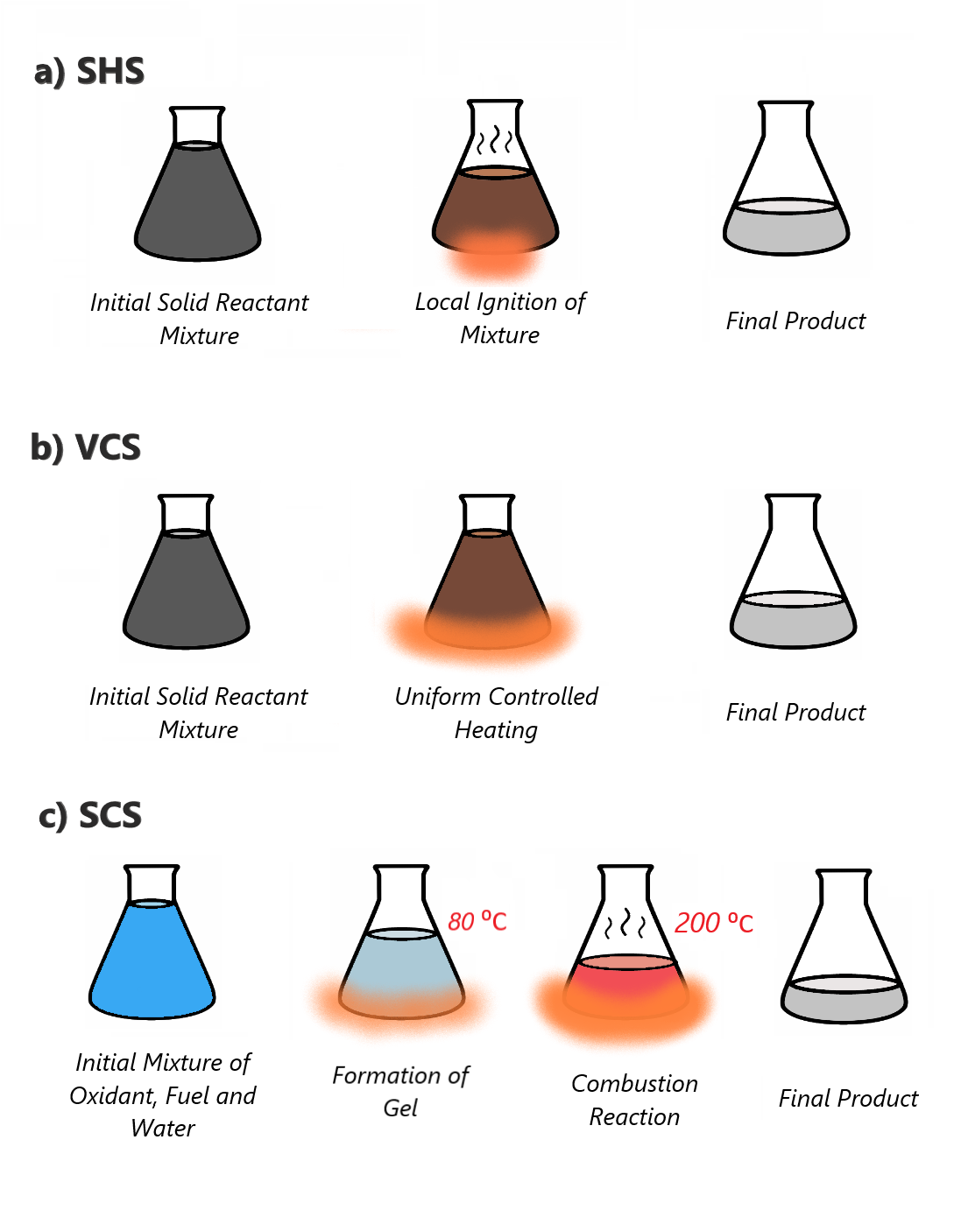

**a) SHS**

*Initial Solid Reactant*

*Mixture*

*Local Ignition of*

*Mixture*

*Final Product*

**b) VCS**

*Initial Solid Reactant*

*Mixture*

*Uniform Controlled*

*Heating*

*Final Product*

c) SCS

A

*80 °C*

*2:1 200 °C*

*- 1*

*Initial Mixture of Oxidant, Fuel and*

*Water*

*Formation of*

*Gel*

*Combustion Reaction*

*Final Product*