Save Scully

Norm Scully's days of luck have come to an end. The only way he can continue working is if he can be of more help to the team.
Scully has decided to make a Morse code communicator which can be used by his team since he is the only one that knows morse code (He used it to speak to his father... a tragic story that Gina interrupted).
Help him make a device that converts a message to Morse code and displays it as short and long blinks on an LED. Use TinkerCAD for simulating the same.

Scully has given you this letter-to-Morse conversion sheet before he went to eat.

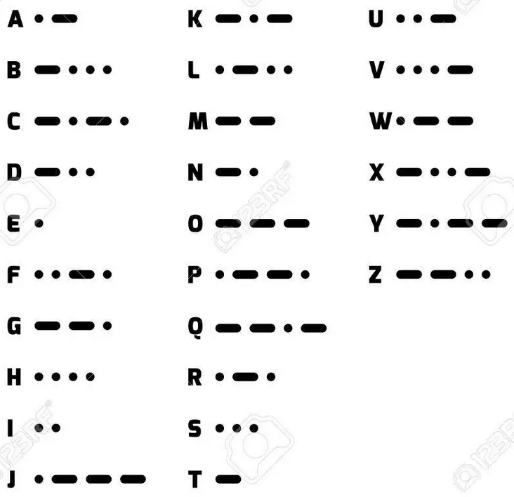

Make the code such that when a message is entered in the Serial Monitor, the LED blinks according to the Morse code of the same message. You do not need to list down all the letters in your code. Three to four letters should be sufficient for the execution.

For your submission, make a PDF file consisting of your code, and an image of your circuit.

