Power Stage Calculations

The battery voltage range is 2.5V to 3.65V per cell, 37.5V to 54.75V total, and the capacitor voltage will charge up to a bit less than that. To avoid extreme duty cycles, the converter should only be capable of 3:1 voltage step up, which still removes 86% of the capacitor’s stored energy. The output current is up to 190A

Output current up to 190A with up to 3:1 voltage step up, IIN = 190\*3 = 570 per phase Input voltage of 18V to 54V

Switching frequency of 500kHz, interleaved to make it effectively 1MHz for the capacitors RLoad = VOut/IOut = 3.2\*15/190 = 0.25 ohms

Duty Cycle = 1 - VI/VO DMin = 0

DMax = 1 - 18/55 = 67.3%

Peak IOut = 95\*2 = 190A



IL(avg) = (0.5\*190) / (1-0.673) = 290.5A

ΔIL = 290.5\*0.2 = 58.1A

IPeak = 290.5+58.1/2 = 320A

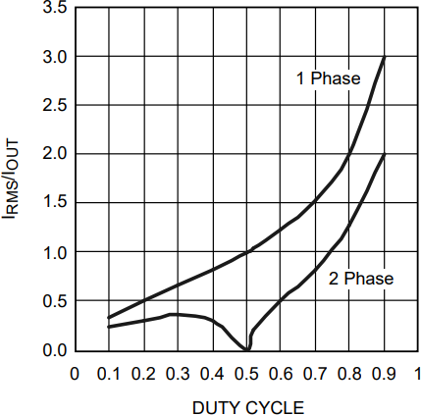LMin = 18\*0.673/(500000\*58.1) = 0.417 uH

ICap-RMS = 0.7\*190 = 133A

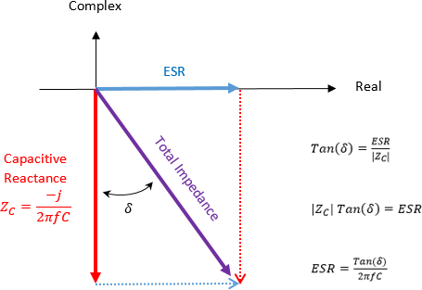

Use 4 x 10uF capacitors, X7R loses 10% of capacitance at 1 MHz, DF = 2.5% ESR = DF/(2π\*f\*C) = 0.025/(2\*3.14\*9) = 0.442 mohms

PCap = (133/4)^2\*0.000442 = 0.489 W



ΔVOut = 190\*(1-0.673)/(10^6\*4\*10\*0.9) + 320\*0.000442/4 = 35.4 mV

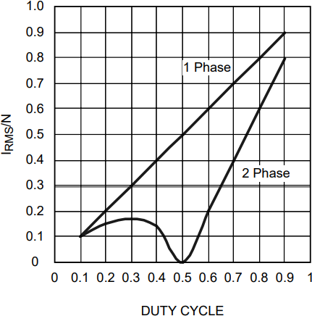

IN = 54/(0.47\*0.5) = 230A

IRipple = 0.35\*IN = 0.35\*230 = 80.5A

Again, use 4 x 10uF

PCap = (80.5/4)^2\*0.000442 = 0.179 W

PFET = 190/(2\*(1-0.673))\*0.0011\*0.673\*1.3 + 12\*0.178\*0.5 = 1.35 W