

Comments and Recommendations
of the
Student Advisory Board

University of Hawaii at Manoa
College of Engineering
Department of Electrical Engineering

A Report to the Industrial Advisory Board
in Regards to the
Accreditation Board for Engineering and Technology

October 16, 2002
Student Advisory Board

Byron Wolfe …………………………………………... Chairperson, Senior
bwolfe@ieee.org

Michael Hall …………………………………………... Member, Senior
hall@wiliki.eng.hawaii.edu

Seth Kamemoto …………………….…………………. Member, Senior
kamemot@wiliki.eng.hawaii.edu

Eric Lik Chee Kwong …………………….…………… Member, Senior
kwong@wiliki.eng.hawaii.edu

Blaine Murakami ………………………...……………. Member, Sophomore
murakam@wiliki.eng.hawaii.edu

Joshua Neuman ………………………………………... Member, Senior
neuman@wiliki.eng.hawaii.edu

Harry Newhart ………………………………………… Member, Freshman
newhart@hawaii.edu

Kristina Wong ………………………………………… Member, Sophomore
wongksy@hotmail.com

Questions and comments can be sent to: eesab@spectra.eng.hawaii.edu

The Student Advisory Board (SAB) would like to thank Dr. Audra Bullock, Dr. Wayne Shiroma, Aaron Ohta, Mike Tamamoto, and Jodi Enomoto for their dedication and continued support to the SAB.

This document reflects the concerns and opinions of the SAB, who by election and faculty appointment, represent the electrical engineering student body at the University of Hawaii at Manoa. It is under the SAB’s request that the following comments and recommendations be considered and/or addressed by the Industrial Advisory Board (IAB) in regards to the Accreditation Board for Engineering and Technology (ABET) evaluation. The effects of last years efforts have been outlined in the “Summary Report to Constituents” and will not be addressed in this document.

Due to efficiency and practicality, this report does not outline all students comments or suggestions. It is under the SAB’s discretion to summarize and generalize comments, while still attempting to properly address the range of concerns and represent the student body accordingly.

Note, the concerns and opinions in this document are those of the SAB and student body solely. In no way has this document been endorsed or influenced by the Department of Electrical Engineering or the College of Engineering.

- Student Advisory Board Survey

The purpose of the SAB Survey is to accurately poll the student body in their opinion and concerns in the following categories: Faculty, Laboratories, Coursework, Research Facilities, Student Projects, Student Activities, Ethics, and Registration and Academic Advising. A total of 159 surveys were collected, which account for 51% of the EE undergraduate student body. Learning from the previous years survey, general topics were dissected and known problem areas were given further attention. The survey was scored on a scale of 1 (poor) through 5 (excellent). The actual survey and average score in each question follow:

Questions: | Avg. Score:
1) Faculty instructional quality
a) Faculty present material in the context of real-world applications | 3.8
b) Faculty instill a sense of lifelong learning | 3.6
c) Faculty are technically proficient | 4.1
d) Faculty are able to effectively deliver course material | 3.7
e) Consistency in course material among faculty teaching the same course | 3.5
2) Quality of laboratory courses
a) Teaching Assistance (TA)
i) TAs are technically proficient | 3.2
ii) TAs are able to effectively deliver course material | 2.7
iii) TAs should be required to attend a short-course in verbal communication | 4.4
b) Lab Coursework
i) How well does the lab-work compliment the classroom-work? | 3.5
ii) Does the lab teach practical and applicable skills? | 3.5
iii) Do you feel labs effectively teach Troubleshooting? | 3.2
c) Lab facilities
i) Functionality | 3.3
ii) Quality of Equipment | 3.0
iii) Availability of quality components | 3.1
3) Coursework structure
a) Department’s adherence to the projected course schedule | 3.7
b) Feasibility of the recommended EE curriculum check sheet | 3.6
c) Consistency of course material from semester to semester | 3.6
d) Structure of prerequisites | 3.5
e) Track curricula is well organized and course are available to facilitate completion | 3.4
4) Quality of research facilities
a) Do you feel you have been sufficiently informed regarding the purpose and function of the EE research facilities? | 3.0
b) Have you had an opportunity to utilize one of the EE research facilities? | 3.2
i) If yes, please rate your experience. | 3.8
ii) If not, rate your desire to participate | 4.1
5) Quality of EE X96 Design Projects
a) Technical content and skills | 3.8
b) Development of Team working skills | 4.0
c) Motivation for life long learning in engineering | 4.0
d) Exposure to modern engineering tools and practices | 3.9
e) Use of creativity and design skills | 4.0
6) Quality of student activities in the department
a) Rate your ability/availability to participate in extracurricular student activities (e.g., activities outside of your classes including IEEE, HKN, etc.) | 3.1
b) Rate the Department’s efforts to accommodate extracurricular student activities | 3.3
7) Ethics
a) Rate your exposure to professional ethics in your coursework | 3.4
b) Rate the quality of ethics amongst students | 3.4
8) Registration and Academic advising
a) Rate the ease of registering for Electrical Engineering courses | 3.5
b) Rate the quality/utility of academic advising | 3.7
9) Please rate your overall experience in the Department of Electrical Engineering | 3.6

A more detailed analysis of the survey follows:
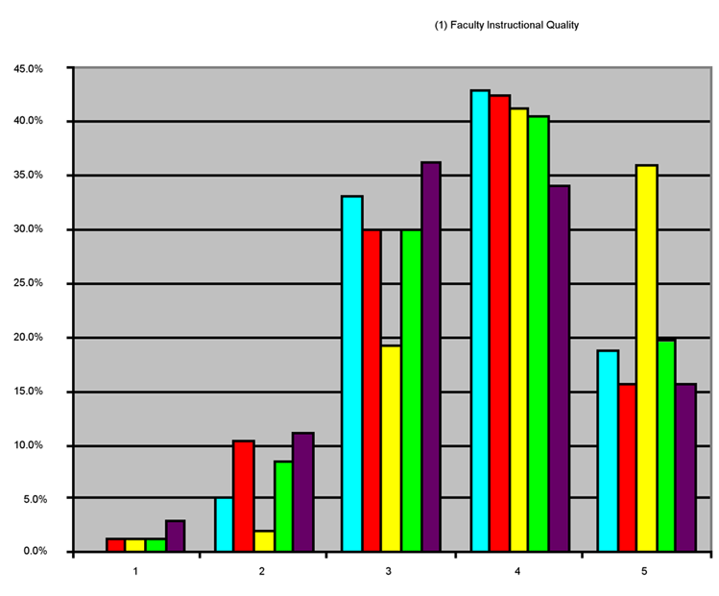
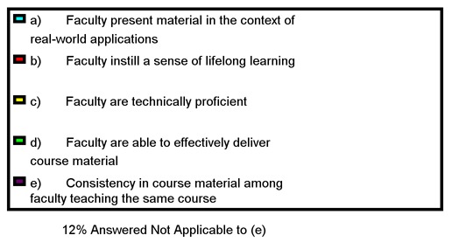

- SAB Comments and Recommendations

The following comments outline new issues not previously addressed last year, and are the opinions/concerns of the SAB. This section has been divided into Faculty, Coursework, Laboratories, Student Projects, and Student Experience (which includes activities, registration, advising, and overall experience). Additional comments with possible recommendations are included with the PowerPoint presentation.

  - Faculty
    - Outstanding faculty do not receive significant recognition from students.
      - A handsome semesterly Outstanding/Inspirational Award could be given to professors who go beyond the call of the classroom.
    - Lack of faculty orientation, such as the research they do and the facilities they work in.
      - “Faculty Day”, an short event where professors give a short introduction/presentation of themselves and the labs they utilize. This can open the door to x96 project possibilities, and produce an understanding of their professors specialty.
    - Student input from “Course Evaluations” have no effect.
      - Put up a student bulletin board, where comments on a professor, class, etc. can be left as an open forum (post surveys?).

  - Coursework
    - Lack of understanding/motivation in engineering.
      - EE101.
    - Misunderstanding/confusion of professional ethics.

  - Laboratories
    - Lack of trade skills (equipment/troubleshooting).
      - Integration with existing lab/course (EE211?).
    - Little integration of simulators, software assistance (i.e. MATLAB)
      - Integration with existing lab/course.
    - Little correlation between course and lab.
      - Professors stop by.
    - Lab experience poor.
      - Course re-evaluation, overhaul.

  - Student Projects
    - Currently doing well.

  - Student Experience
    - Lack of EE gathering location, hangout, lounge area.
      - Unknown solution. Would promote department cohesiveness.

- Improvements to the SAB next year
  - Improve/develop SAB Webpage
    - Informative
    - Logged minutes from SAB meetings
    - Suggestions/concerns box/forum
    - Future goals
  - Further refining Survey
    - Rewording of a few questions to allow for Yes/No.
    - Very precise directions to Non-EE majors filling out survey.
  - Student Interviews/Open Forum
  - Further developed board policy
  - Internal management, organization, policy
  - Organize future board by end of Spring ’03

Notes:

