**Course**

**Management**

**System**

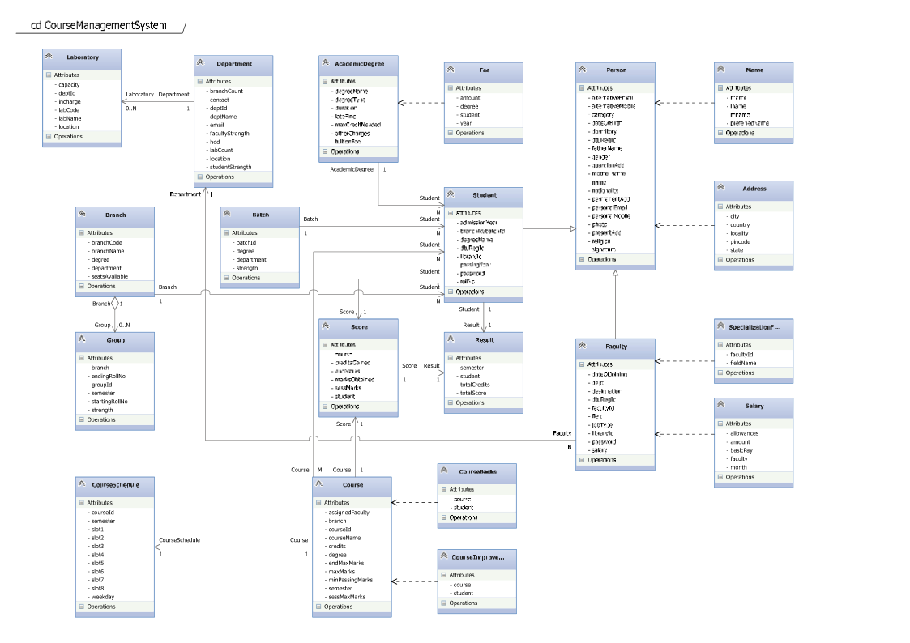

**Description of Classes**

**Person**

Defines the structure and functionality related to demographic details of any person, like student or faculty in a university.

|  |  |  |  |
| --- | --- | --- | --- |
| **Attributes** | **Description** | **Data Type** | **Variable Name** |
| DTU Registration ID | Registration identity of any person | String | dtuRegId |
| Name | Name of the person | Name | name |
| Permanent Address | Permanent address of the person | Address | permanentAdd |
| Present Address | Present address of the person | Address | presentAdd |
| Local Guardian Address | Local Guardian address of the person | Address | guardianAdd |
| Personal Mobile Number | Personal mobile number of the person | Number | personalMobile |
| Alternative Mobile Number | Alternative mobile number of the person | Number | alternativeMobile |
| Personal Email ID | Personal email ID of the person | String | personalEmail |
| Alternative Email ID | Alternative email ID of the person | String | alternativeEmail |
| Date of birth | Date of birth of the person | Date | dateOfBirth |
| Gender | Gender of the person | Character | gender |
| Category | Category of the person like SC, ST, OBC, Physically disabled | String | category |
| Nationality | Nationality of the person | String | nationality |
| Religion | Religion followed by person or by his/her family | String | religion |
| Dormitory | Does the person lives in university or college hall of residence, like hostel, flat, etc. | Boolean | dormitory |
| Father’s Name | Father’s name of the person | Name | fatherName |
| Mother’s Name | Mother’s name of the person | Name | motherName |
| Photograph | Photograph of the person | Binary Object | photo |
| Signature | Signature of the person | Binary Object | signature |

**Name**

Defines the format of name of any person.

|  |  |  |  |
| --- | --- | --- | --- |
| **Attributes** | **Description** | **Data Type** | **Variable Name** |
| First name | First name of the person | String | fname |
| Middle name | Middle name of the person | String | mname |
| Last name | Last name of the person | String | lname |
| Preferred name | Preferred name of the person to be display | String | preferredName |

**Address**

Defines the format of address of any person.

|  |  |  |  |
| --- | --- | --- | --- |
| **Attributes** | **Description** | **Data Type** | **Variable Name** |
| Locality | Locality of residence | String | locality |
| City | City of residence | String | city |
| State | State of residence | String | state |
| Country | Country of residence | String | country |
| PIN code | PIN Code of residence | Number | pincode |

**Student**

Defines the structure and functionality related to the student of a university.

|  |  |  |  |
| --- | --- | --- | --- |
| **Attributes** | **Description** | **Data Type** | **Variable Name** |
| Roll No | Roll number of the student | String | rollNo |
| DTU Registration ID | DTU registration identity | String | dtuRegId |
| Branch Code | Branch of the student | Branch | branch |
| Degree Name | Degree which the student is pursing | Degree | degree |
| Admission year | Admission year of the student for a particular degree programme | Number | admissionYear |
| Graduation Year | Graduation year of the student for a particular degree programme | Number | graduationYear |
| Library ID | Library identity of the student | String | libraryId |
| Password | Password of the student’s account | String | password |

**Faculty**

Defines the structure and functionality related to the faculty members of a university.

|  |  |  |  |
| --- | --- | --- | --- |
| **Attributes** | **Description** | **Data Type** | **Variable Name** |
| Faculty ID | Unique identity of the faculty member | String | facultyId |
| Designation | Designation of the faculty member | String | designation |
| Date of joining | Joining date of the faculty member | Date | dateOfJoining |
| Job type | Job type of the faculty member like permanent, guest, etc. | String | jobType |
| Department | Department of the faculty member | Department | department |
| DTU Registration ID | DTU registration of the faculty member | String | dtuRegId |
| Specialization Field | Specialization fields of the faculty member | SpecializationField | field |
| Salary | Salary of the faculty member | Salary | salary |
| Library ID | Library identity of the faculty member | String | libraryId |
| Password | Password of the faculty member’s account | String | password |

**Specialization Field**

Defines the specialization field or area of faculty.

|  |  |  |  |
| --- | --- | --- | --- |
| **Attributes** | **Description** | **Data Type** | **Variable Name** |
| Faculty ID | Unique identity of the faculty member | String | facultyId |
| Field Name | Specialization field name | String | fieldName |

**Academic Degree**

Defines the structure and functionality related to the degree provided by the university after the completion of all the courses in a particular branch.

|  |  |  |  |
| --- | --- | --- | --- |
| **Attributes** | **Description** | **Data Type** | **Variable Name** |
| Degree name | Name of the academic degree like BTech, MTech, PhD, MBA, etc. | String | degreeName |
| Degree type | Type of the academic degree like regular, part time, etc. | String | degreeType |
| Duration | Duration of the degree in years | Number | duration |
| Maximum credit needed | Maximum credit needed to complete the degree | Number | maxCredit |
| Annual fee | Annual fee of the degree programme | Decimal | annualFee |
| Late fine | Late fine applied in case of late submission of the fee | Decimal | lateFine |
| Admission Fee | Fee to be paid at time of admission | Decimal | admissionFee |

**Department**

Defines the structure and functionality related to a department in a university.

|  |  |  |  |
| --- | --- | --- | --- |
| **Attributes** | **Description** | **Data Type** | **Variable Name** |
| Department ID | Unique identity of the department | String | deptId |
| Department name | Name of the department | String | deptName |
| Head of department | Head of the department | Faculty | hod |
| Email ID | Common email ID of contact of the department | String | email |
| Location | Location of the department within the University | String | location |
| Branch count | Branches under the department | Number | branchCount |
| Student strength | Strength of students in the department | Number | studentStrength |
| Faculty strength | Strength of faculty members in the department | Number | facultyStrength |

**Laboratory**

Defines the structure and functionality related to the laboratories managed by any particular department in the university.

|  |  |  |  |
| --- | --- | --- | --- |
| **Attributes** | **Description** | **Data Type** | **Variable Name** |
| Lab Code | Unique code of the lab | String | labCode |
| Lab Name | Name of the lab | String | labName |
| Lab In-charge | In charge of the lab | Faculty | incharge |
| Department | Department manages the respective lab | Department | dept |
| Location | Location of the lab | String | location |
| Capacity | Capacity of the lab | Number | capacity |

**Branch**

Defines the structure and functionality related to the branches that are offered by the university.

|  |  |  |  |
| --- | --- | --- | --- |
| **Attributes** | **Description** | **Data Type** | **Variable Name** |
| Branch code | Code of the branch | String | branchCode |
| Branch name | Name of the branch | String | branchName |
| Seats available | Seats available in particular branch | Number | seatsAvailable |
| Degree | Degree awarded to student of particular branch | Degree | degree |
| Department | Department supervising particular branch | Department | dept |

**Batch**

Defines the structure and functionality of a batch of students created during first academic year of any degree.

|  |  |  |  |
| --- | --- | --- | --- |
| **Attributes** | **Description** | **Data Type** | **Variable Name** |
| Batch ID | Unique identity of the batch | String | batchId |
| Batch Type | Type of the batch like ‘A’ or ‘B’ | String | batchType |
| Degree | Degree which student of particular batch is pursing | Degree | degree |
| Department | Department supervising particular batch | Department | dept |
| Strength | Strength of the batch | Number | strength |

**Group**

Defines the structure and functionality of a group in which students under a particular branch is divided.

|  |  |  |  |
| --- | --- | --- | --- |
| **Attributes** | **Description** | **Data Type** | **Variable Name** |
| Group ID | Unique identity of the group in which strength of any particular branch is divided | String | groupId |
| Semester | Semester for which group is created | Number | semester |
| Strength | Strength of the group | Number | strength |
| Starting roll no | Starting roll number of the group | String | startRollNo |
| Ending roll no | Ending roll number of the group | String | endRollNo |
| Branch | Branch of the group | Branch | branch |

**Course**

Defines the structure and functionality related to the courses offered under a particular branch in a specific semester by the department.

|  |  |  |  |
| --- | --- | --- | --- |
| **Attributes** | **Description** | **Data Type** | **Variable Name** |
| Course ID | Unique identity of the course | String | courseId |
| Course Name | Name of the course | String | courseName |
| Course Type | Type of the course like core, applied or humanity | String | courseType |
| Credits | Credits can be gained in any particular course | Number | credits |
| Sessional marks | Maximum marks can be gained in any particular course during sessional evaluation | Decimal | sessMaxMarks |
| End semester marks | Maximum marks can be gained in any particular course in end semester examination | Decimal | endMaxMarks |
| Maximum marks | Maximum marks can be gained in any particular course | Decimal | maxMarks |
| Minimum passing marks | Minimum passing marks required for accomplishment of any particular course | Decimal | minPassingMarks |
| Semester | Semester to which course belong | Number | semester |
| Branch/Batch | Branch/Batch under which particular course will be offered | Branch/Batch | branch/batch |
| Degree | Degree programme for which course will be offered | Degree | degree |

**Course Group**

Defines the structure and functionality related to the courses offered to a particular group of students in a specific semester by the department.

|  |  |  |  |
| --- | --- | --- | --- |
| **Attributes** | **Description** | **Data Type** | **Variable Name** |
| Course | Course offered to group | Course | course |
| Group | Group enrolled in a course | Group | group |
| Instructor | Instructor assigned for the course to a group during a particular semester | Faculty | instructor |

**Score**

Defines the structure and functionality related to the scores obtained by any student in a particular course of his/her branch.

|  |  |  |  |
| --- | --- | --- | --- |
| **Attributes** | **Description** | **Data Type** | **Variable Name** |
| Student | Student who obtained the score | Student | student |
| Course | Course to which score belongs | Course | course |
| Sessional marks | Marks gained in any particular course during sessional evaluation | Decimal | sessMarks |
| End semester marks | Marks gained in any particular course in end semester examination | Decimal | endMarks |
| Total Marks Obtained | Total marks gained in any particular course | Decimal | marksObtained |
| Credits gained | Credits gained in any particular course | Number | creditsGained |

**Result**

Defines the structure and functionality related to the result of any student in any particular semester.

|  |  |  |  |
| --- | --- | --- | --- |
| **Attributes** | **Description** | **Data Type** | **Variable Name** |
| Student | Student to whom result belongs | Student | student |
| Semester | Semester of which result is stored | Number | semester |
| Total Credits | Total credits gained by the student in any particular semester | Number | totalCredits |
| Total Score | Total score obtained by the student in any particular semester | Decimal | totalScore |

**Course Backs**

Defines the structure and functionality related to the students who obtained a year back in any course.

|  |  |  |  |
| --- | --- | --- | --- |
| **Attributes** | **Description** | **Data Type** | **Variable Name** |
| Student | Student who have obtained a year back in any particular course | Student | student |
| Course | Course in which student obtained a year back | Course | course |

**Course Improvements**

Defines the structure and functionality related to the students who filled for improvement in any course.

|  |  |  |  |
| --- | --- | --- | --- |
| **Attributes** | **Description** | **Data Type** | **Variable Name** |
| Student | Student who have applied for improvement in any particular course | Student | student |
| Course | Course in which student have applied for improvement | Course | course |

**Course Schedule**

Defines the structure and functionality related to the weekly schedule of any particular course during a semester.

|  |  |  |  |
| --- | --- | --- | --- |
| **Attributes** | **Description** | **Data Type** | **Variable Name** |
| Course | Course for which schedule is set | Course | course |
| Weekday | Day of the week on which class is to be taken | String | day |
| Semester | Semester for which schedule is planned | Number | semester |
| Slot1 | Full day timing ranging from 9.00 A.M. to 5.00 P.M. is divided into 8 slots at intervals of one hour. | Timestamp | slot1 |
| Slot2 | Timestamp | slot2 |
| Slot3 | Timestamp | slot3 |
| Slot4 | Timestamp | slot4 |
| Slot5 | Timestamp | slot5 |
| Slot6 | Timestamp | slot6 |
| Slot7 | Timestamp | slot7 |
| Slot8 | Timestamp | slot8 |

**Fee**

Defines the structure and functionality related to the fee records of any student during any academic year.

|  |  |  |  |
| --- | --- | --- | --- |
| **Attributes** | **Description** | **Data Type** | **Variable Name** |
| Student | Student who deposits the fee | Student | student |
| Degree | Degree for which fee is charged | Degree | degree |
| Year | Academic year for which fee is charged | Number | year |
| Amount | Total amount of fee deposited | Decimal | amount |

**Salary**

Defines the structure and functionality related to the monthly salary received by any faculty member.

|  |  |  |  |
| --- | --- | --- | --- |
| **Attributes** | **Description** | **Data Type** | **Variable Name** |
| Faculty | Faculty member who receives salary | Faculty | faculty |
| Basic Pay | Basic salary of any particular faculty member | Decimal | basicPay |
| Other Allowances | Allowances given to any particular faculty member | Decimal | allowances |
| Month | Month for which salary is paid | Number | month |
| Amount | Total amount of salary given | Decimal | amount |