Advanced Programming Lab
[PCCCS495]

Hospital Management System

Name: -MD ARMAN ALI
Semester: -IV
Class Roll: - 66
Enrolment Number: - 12024052004063
Date: - 29/03/2026

Instructor name: - Susovan Jana, Soumadip Biswas, Swagatam Basu

Department of Information Technology
2026

2. Problem Statement
In modern healthcare systems, emergency departments face significant challenges in managing multiple patients arriving simultaneously with varying medical conditions. Efficient patient handling, prioritization, and timely treatment are crucial to ensure patient safety and optimal healthcare delivery. Manual systems often lead to delays, mismanagement, and lack of coordination.
This project aims to design and implement a Hospital Emergency Management System using Java and Object-Oriented Programming (OOP) principles. The system simulates real-world hospital operations where patients provide their details, select doctors, and receive treatment based on their medical condition. The application demonstrates automated decision-making where doctors assign appropriate treatments such as medication, first aid, or surgery.
Additionally, the system supports handling multiple patients through iterative processing and can be extended to incorporate multi-threading for real-time simulation. The primary objective is to showcase how OOP concepts can be effectively utilized to model real-world systems in a structured and scalable manner.

3. System Design
3.1 UML Class Diagram (Conceptual Representation)
Patient
- name : String
- condition : String
+ getName() : String
+ getCond() : String
Treatment
+ treat(Patient)
FirstAid
Surgery
Medicine
Doctor
- docName : String
+ treatPatient(Patient)
Hospital
+ main(String[])

3.2 Description of Major Classes
- Patient Class:
Represents patient details including name and medical condition. Implements encapsulation to protect data.
- Treatment Class:
Acts as a base class defining a general treatment method.
- FirstAid, Surgery, Medicine Classes:
Derived classes that override the treatment behavior, demonstrating inheritance and polymorphism.
- Doctor Class:
Responsible for analyzing patient conditions and assigning appropriate treatments.
- Hospital Class:
The main driver class that handles user input, system flow, and interaction between components.

3.3 Package Structure
All classes are implemented within the default package for simplicity. The project is modularized into multiple .java files representing different components.

3.4 Interaction Flow
- User inputs patient details
- Patient object is created
- Doctor is selected
- Doctor evaluates the patient’s condition
- Appropriate treatment is assigned
- Output is displayed
- Process repeats for multiple patients

4. OOP Concepts Demonstrated
4.1 Encapsulation
Usage: Patient class
Purpose: To protect sensitive patient data
class Patient{
private String name;
private String cond;
public String getName(){ return name; }
public String getCond(){ return cond; }
}
Explanation:
Data members are declared private and accessed via public methods, ensuring controlled access.

4.2 Inheritance
Usage: Treatment → FirstAid, Surgery, Medicine
Purpose: Code reuse and hierarchical design
class FirstAid extends Treatment{
public void treat(Patient p){
System.out.println("Providing first aid");
}
}
Explanation:
Child classes inherit from the parent class and extend functionality.

4.3 Polymorphism
Usage: treat() method overriding
Purpose: Dynamic method behavior
Treatment t;
t = new Medicine();
t.treat(p);
Explanation:
Same method behaves differently based on object type.

4.4 Abstraction
Usage: Treatment class
Purpose: Define a generalized structure for treatments

4.5 Collections
Usage: (Conceptual / Extendable)
Can be used to manage multiple patients efficiently using lists or queues.

4.6 Exception Handling
Usage: Input validation
Purpose: Prevent runtime errors due to invalid inputs

4.7 Threads (Conceptual Extension)
Patients can be simulated as threads to represent real-time arrivals in emergency systems.

5. Implementation Highlights
5.1 User Input Handling
Scanner sc = new Scanner(System.in);
String name = sc.nextLine();
Justification:
Allows real-time interaction with users.

5.2 Decision-Making Logic
if(p.getCond().equalsIgnoreCase("fever")){
t=new Medicine();
}
Justification:
Implements condition-based treatment assignment.

5.3 Loop for Multiple Patients
while(true){
...
}
Justification:
Enables continuous handling of multiple patients.

6. Testing & Error Handling
6.1 Test Cases
- Input: Fever → Output: Medicine
- Input: Injury → Output: First Aid
- Input: Heart → Output: Surgery

6.2 Edge Cases
- Unknown disease → General treatment
- Invalid doctor selection → Default handling

6.3 Failure Scenarios
- Empty input
- Incorrect numeric input
- Unexpected user behavior

7. Git Workflow

Development Progression
- Initial commit: Basic class structure
- Second commit: Treatment logic
- Third commit: User interaction
- Final commit: Loop and enhancements
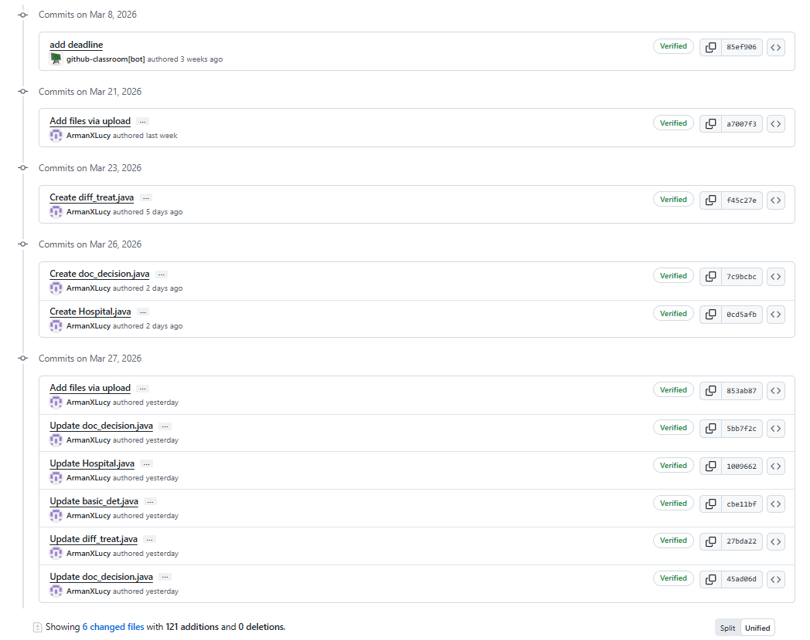

8. Conclusion & Future Scope
Conclusion
The project successfully demonstrates the application of Object-Oriented Programming concepts in simulating a hospital emergency management system. It effectively models patient handling, doctor decision-making, and treatment allocation in a structured and modular manner.

Future Scope
- Integration of graphical user interface (GUI)
- Database connectivity for persistent data storage
- Implementation of priority-based queue systems
- Real-time multi-threading simulation
- Online appointment and tracking system

Appendix
- Initial Project Proposal
- Approval Email (Approved_Minor )
- 